Smart Traffic Management – Final Rule-Based Algorithm
1. Project Objective
The objective of the system is to dynamically control traffic signals at a four-lane urban intersection by:
- Counting vehicles in each lane.
- Identifying the type of vehicle.
- Estimating the traffic demand and required green time.
- Providing priority to ambulances and fire brigades.
- Handling multiple emergency vehicles according to their priority. (max 2 )
- Maintaining a clockwise/sequential traffic flow.
- Preventing unnecessary fluctuation of the active timer.
- Performing safe switching using yellow and all-red phases.

2. System Assumptions
These assumptions should be clearly mentioned in your project report.
Assumption 1 – Four Lanes
The intersection consists of four approaches:
Lane 1 , Lane 2 , Lane 3 , Lane 4

Assumption 2 – Clockwise Sequence
Under normal conditions, the lanes follow:
1 → 2 → 3 → 4 → 1 → 2 → ...
This is the normal sequential order.

Assumption 3 – One Green Lane at a Time
Only one lane/approach is allowed to have a green signal at a time.
Lane 1 → GREEN , Lane 2 → RED , Lane 3 → RED , Lane 4 → RED

Assumption 4 – Defined Detection Area
A specific Region of Interest (ROI) is defined for every lane.
Only vehicles inside the ROI are considered for traffic calculation.
Camera
↓
AI Detection
↓
Lane-specific ROI
↓
Vehicle information
Vehicles outside the defined region are not considered for the current traffic calculation.

Assumption 5 – AI Detection
The AI model is responsible for detecting and tracking:
- Cars , Bikes , Auto-rickshaws , Buses , Trucks , Ambulances , Fire brigades
The AI provides the information to the rule-based controller.

Assumption 6 – Vehicle Type Has Different Clearance Demand
Different vehicle types require different amounts of time to pass through the intersection.
For example:
Bike → Low clearance demand
Car → Medium clearance demand
Auto → Medium clearance demand
Bus → High clearance demand
Truck → High clearance demand
Therefore, the system does not use only the number of vehicles.

Assumption 7 – Timer Is Locked
This is one of your main rules.
Once the green time has been calculated:
The timer is fixed for that complete green phase.
For example:
10 vehicles detected
↓
Green time = 20 seconds
↓
20 → 19 → 18 → ... → 0
If additional vehicles arrive during these 20 seconds, the timer does not change.
The new traffic information is considered during the next decision cycle.

Assumption 8 – Minimum and Maximum Green Time
Every lane has:
MIN_GREEN_TIME
MAX_GREEN_TIME
For example:
Minimum = 10 sec
Maximum = 50 sec
The exact values can be adjusted during testing.
This prevents extremely short or excessively long green phases.

Assumption 9 – Yellow Phase
Whenever the green lane changes, it first goes through:
GREEN → YELLOW
This provides a safe transition.

Assumption 10 – All-Red Clearance
After yellow:
YELLOW → ALL RED
A short all-red period is provided so vehicles already inside the intersection can clear it.
Then the next lane becomes green.

3. Traffic Parameters Considered
For every lane, the system maintains:
Vehicle Count
Vehicle Type
Emergency Status
Emergency Distance
Emergency ETA (optional)

4. Vehicle Count
The system counts vehicles inside the lane's ROI.
Example:
Lane 1 = 15 vehicles , Lane 2 = 8 vehicles , Lane 3 = 22 vehicles , Lane 4 = 5 vehicles

5. Vehicle Type
Instead of only: Lane 1 = 10 vehicles
the system knows:
Lane 1:
Cars = 4
Bikes = 4
Trucks = 1
Bus = 1
Each type is given a clearance weight.
Example:
Bike = 1
Car = 2
Auto = 2
Bus = 4
Truck = 5
These are project parameters and can be modified after testing.

6. Traffic Demand
The system calculates:
Vehicle Type Demand = Σ(Number of vehicles × Vehicle Type Weight)
For example:
5 Bikes
3 Cars
1 Truck
Then:
Demand
= (5 × 1) + (3 × 2) + (1 × 5)
= 5 + 6 + 5
= 16 units
Therefore, the system considers 16 units of traffic demand, rather than simply saying there are 9 vehicles.

7. Queue Length
Queue length means:
The number of vehicles that are stopped or moving very slowly near the signal.
For example:
Total vehicles in ROI = 20
Moving vehicles = 12
Waiting vehicles = 8
Queue Length = 8
Queue length helps identify lanes where vehicles are actually congested.

8. Waiting Time
Waiting time represents how long vehicles in a lane have been waiting at the red signal.
Example:
Lane 1 → 20 sec
Lane 2 → 35 sec
Lane 3 → 70 sec
Lane 4 → 15 sec
Lane 3 has the highest waiting time.

9. Maximum Waiting Rule
To prevent one lane from waiting indefinitely:
IF waiting_time > MAX_WAITING_TIME
THEN increase priority of that lane
For example:
MAX_WAITING_TIME = 60 sec
If:
Lane 3 waiting = 65 sec
then Lane 3 receives increased priority.
This prevents starvation.

10. Dynamic Green Time
Green time is calculated using:
Vehicle Count + Vehicle Type + Queue Length + Waiting Time
The vehicle type contributes to the traffic demand.
A simplified priority calculation can be:
Priority Score = W1 × Traffic Demand + W2 × Queue Length + W3 × Waiting Time
where W1, W2, and W3 are experimentally selected weights.
The final green time is restricted between the minimum and maximum values.

11. Emergency Priority
Emergency vehicles have the highest priority.
Emergency vehicles considered:
Ambulance
Fire Brigade
The system continuously checks all four lanes.
Lane 1 → No emergency
Lane 2 → Ambulance
Lane 3 → No emergency
Lane 4 → Fire Brigade
The system enters Emergency Mode.

12. Emergency Vehicle Priority
If emergency vehicles are detected in multiple lanes, the system determines priority using:
Primary factor
Distance from the signal
Nearest emergency vehicle gets higher priority.
Optional better factor
Estimated Time of Arrival (ETA)
ETA = Distance / Estimated Speed
The emergency vehicle with the lowest ETA receives priority.

13. Emergency Detection Confirmation
AI detection can sometimes temporarily miss an object.
Therefore:
An emergency vehicle should be confirmed only after it is detected for a predefined number of consecutive frames.
Similarly, when the ambulance disappears, the system should confirm that it has actually left the ROI rather than assuming it disappeared because of one missed detection.

14. Emergency Case 1 – Ambulance in a Red Lane
Example:
Lane 1 → GREEN
Lane 2 → RED
Lane 3 → RED
Lane 4 → RED
Ambulance → Lane 3
Suppose Lane 1 has 3 seconds remaining.
The rule is:
Lane 1 timer = 3 sec
3 → 2 → 1 → 0
Timer is NOT increased.
Timer is NOT reset.
↓
Lane 1 → YELLOW
↓
ALL RED
↓
Lane 3 → GREEN
The ambulance lane receives priority at the earliest safe switching point.

15. Emergency Case 2 – Ambulance in the Current Green Lane
This is the special case you discussed.
Example:
Lane 1 → GREEN
Timer = 20 sec

At 3 seconds remaining:
Ambulance detected in Lane 1
The normal timer remains locked:
3 → 2 → 1 → 0
The system does not reset the timer to 20 seconds.
At 0:
Check ambulance position
↓
Ambulance still approaching?
↓
YES
↓
Keep Lane 1 GREEN
↓
Allow ambulance to cross
↓
Emergency vehicle clears
↓
6–7 sec clearance
↓
YELLOW
↓
ALL RED
↓
Next lane
So there are two separate concepts:
Normal timer = fixed
Emergency clearance = separate condition
This distinction is very important for your implementation.

16. Emergency Case 3 – Ambulance Has Already Crossed
If the ambulance is detected and crosses before the timer reaches zero:
Lane 1 GREEN
↓
Ambulance crosses
↓
Continue current timer
↓
Timer = 0
↓
YELLOW
↓
ALL RED
↓
Next lane
No unnecessary emergency extension is required.

17. Multiple Emergency Vehicles
Suppose:
Lane 1 → Ambulance → 80 m
Lane 3 → Ambulance → 30 m
Then:
Lane 3 → Priority 1
Lane 1 → Priority 2
After Lane 3's emergency vehicle clears:
6–7 sec clearance
↓
Recheck emergency vehicles
↓
Lane 1 ambulance still present?
↓
YES
↓
Lane 1 GREEN
The system should recalculate emergency priority after every emergency phase, because vehicle positions can change.

18. Normal Operation After Emergency
Once all emergency vehicles have cleared:
Emergency Mode
↓
Check all lanes again
↓
Calculate:
Vehicle Count
Vehicle Type
Queue
Waiting Time
↓
Calculate Priority
↓
Select next lane
↓
Calculate new green time
↓
Normal Mode
The system then returns to normal operation.

19. Clockwise Sequence as Tie-Breaker
Your sequence:
1 → 2 → 3 → 4 → 1
should remain the normal order.
However, it should not completely override traffic demand.
For example, if:
Lane 2 Priority = 15
Lane 3 Priority = 15
then use the clockwise sequence to decide.
This makes the system predictable.

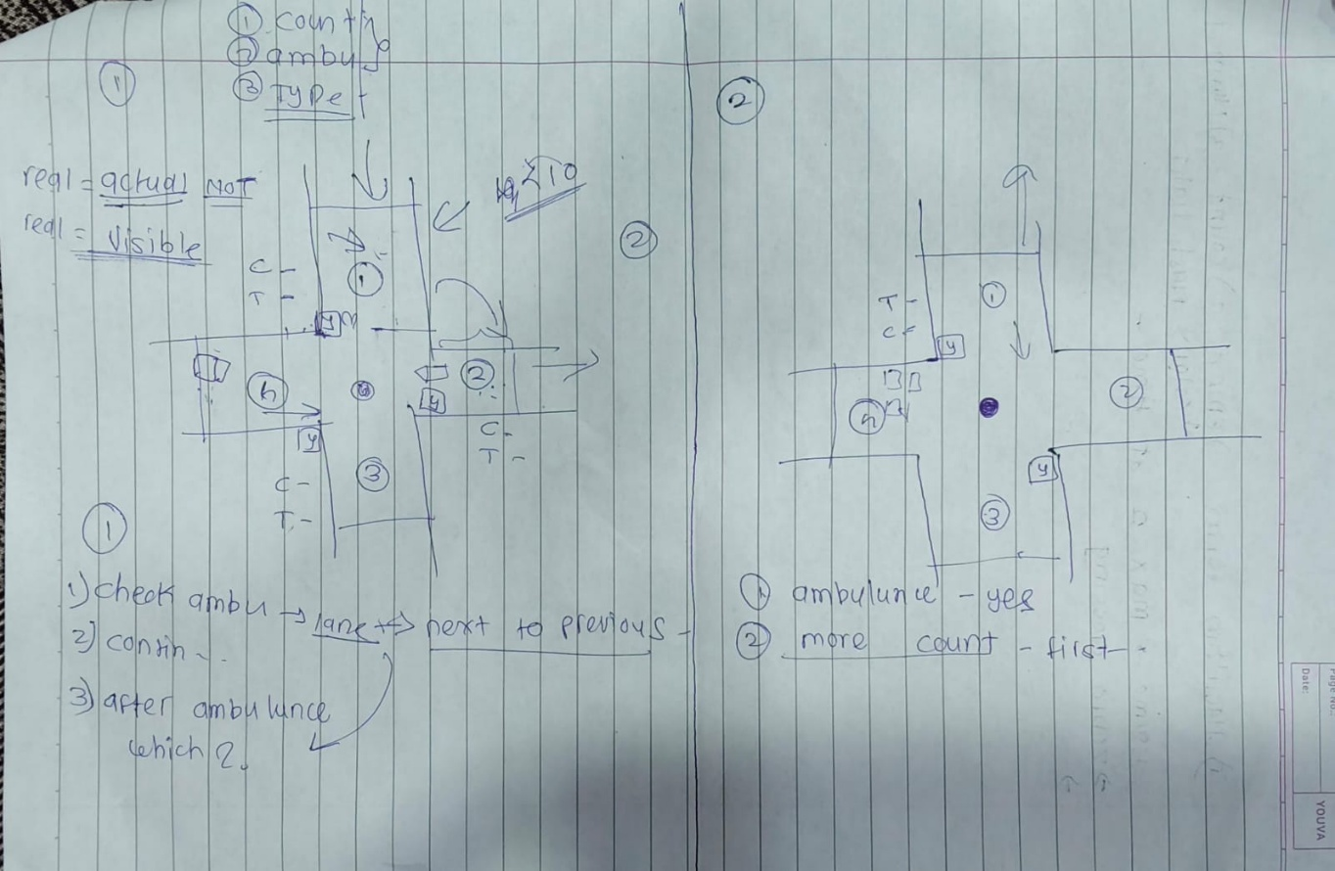
20. Complete Final Algorithm
Algorithm: AI-Based Dynamic Traffic Signal Control with Emergency Priority
START
1. Initialize four lanes:
Lane 1, Lane 2, Lane 3, Lane 4
2. Initialize normal sequence:
1 → 2 → 3 → 4 → 1
3. Set system parameters:
MIN_GREEN_TIME
MAX_GREEN_TIME
YELLOW_TIME
ALL_RED_TIME
EMERGENCY_CLEARANCE_TIME
MAX_WAITING_TIME
4. Define ROI for each lane.
5. Start camera/video input.
6. AI detects and tracks vehicles.
7. Identify vehicle type: Bike, Car , Auto , Bus , Truck , Ambulance , Fire Brigade
8. Assign every detected vehicle to its respective lane.
9. Count vehicles in each lane.
10. Calculate vehicle-type demand:
Demand = Σ(Type Count × Type Weight)
13. Check for emergency vehicles.
14. IF emergency vehicle is detected:
Enter EMERGENCY MODE.
15. Identify all emergency vehicles.
17. Select the highest-priority emergency vehicle.
18. IF emergency vehicle is in the CURRENT GREEN LANE:
Continue the existing green timer.
IF timer reaches zero AND emergency vehicle
has not crossed:
Keep lane GREEN.
Allow emergency vehicle to pass.

After emergency vehicle clears:
Wait emergency clearance period.
Change GREEN → YELLOW → ALL RED.
19. ELSE IF emergency vehicle is in a RED LANE:
Do not modify the current green timer.
Allow current green timer to finish.
Change:
GREEN → YELLOW → ALL RED
Give GREEN to emergency lane
20. Monitor emergency vehicle continuously.
21. Confirm that emergency vehicle has cleared the ROI.
22. Provide the defined 6–7 second emergency clearance period.
23. If another emergency vehicle is present:
Recalculate its priority.
Repeat emergency handling.
24. If no emergency vehicle remains:
Exit EMERGENCY MODE.
25. Enter NORMAL MODE.
26. Recalculate traffic information for all lanes:
Vehicle Count , Vehicle Type , Traffic Demand
27. Check maximum waiting condition.
28. Calculate priority score for each eligible lane.
29. Select the next lane:
Highest priority → selected lane.
If priority is approximately equal:
Follow clockwise sequence.
30. Calculate green time for selected lane.
31. Apply minimum and maximum green limits.
32. LOCK the calculated green timer.
33. Start green phase.
34. During green:
Continue detecting and tracking vehicles.
Update traffic information for the NEXT cycle.
DO NOT change the active timer.
35. When green timer reaches zero:
Change GREEN → YELLOW.
36. After yellow:
Change YELLOW → ALL RED.
37. At the decision point:
Check emergency vehicles first.
38. IF emergency exists:
Enter EMERGENCY MODE.
39. ELSE:
Select next lane using traffic priority
and clockwise sequence.
40. Repeat continuously.
END

21. Overall Decision Hierarchy
Your complete controller can be summarized as:
TRAFFIC SIGNAL CONTROLLER
│
↓
Emergency Detected?
/ \
YES NO
↓ ↓
Emergency Priority Waiting Time
↓ ↓
Traffic Demand
↓ ↓
Emergency Lane Queue Length
↓ ↓
Safe Switch Clockwise Order
↓ ↓
GREEN GREEN
│ │
└───────┬────────┘
↓
TIMER IS LOCKED
↓
Timer reaches 0
↓
YELLOW
↓
ALL RED
↓
Recalculate
↓
Next Phase
22. Points Considered in Your Project
For your project documentation/presentation, you can list the considered parameters as:
Traffic Parameters
- Vehicle count
- Vehicle type
- Vehicle-type clearance weight
- Traffic demand
- Queue length
- Waiting time
- Maximum waiting threshold
- Average speed (optional)
- Distance between vehicle and signal (optional)
Signal Parameters
- Four lanes
- Clockwise sequence
- Dynamic green time
- Minimum green time
- Maximum green time
- Fixed/locked active timer
- Yellow transition
- All-red clearance
- Decision point after every phase
Emergency Parameters
- Ambulance detection
- Fire brigade detection
- Emergency detection confirmation
- Emergency lane identification
- Emergency distance
- Emergency ETA (optional)
- Multiple emergency vehicles
- Emergency priority
- Emergency clearance
- 6–7 second clearance period
- Emergency priority over normal traffic
Safety Parameters
- No direct GREEN-to-GREEN switching
- Yellow phase before switching
- All-red clearance
- No timer fluctuation during an active phase
- Confirmation of emergency vehicle clearance
- Minimum and maximum green limits
- AI detection failure/fallback handling

