Orbit Customer Hub — Project & Submission Guide
Project type: WooCommerce CRM integration prototype Purpose: Bring WooCommerce customer and recent order information into one simple dashboard for review and follow-up planning.

Project status
The local project contains the dashboard, WooCommerce REST API connection flow, customer and order views, customer segmentation, CSV export, campaign draft helper, theme toggle, and a local sign-up/sign-in flow. The project has been prepared as a ZIP for sharing.
GitHub upload is still pending. At the time this guide was written, this project has no GitHub remote configured. The website running at http://127.0.0.1:4175/ is a local address and is not a public share link. Uploading this project to GitHub requires choosing or creating a destination repository.

What the app does
- Connects to a WooCommerce store using its URL and a read-only REST API key.
- Fetches customer records and recent orders through a local Node.js server.
- Associates registered-customer orders and guest orders matched by billing email where available.
- Shows overview metrics and separate Overview, Customers, Orders, and Campaigns pages.
- Lets a user search, filter, and inspect customer profiles and recent orders.
- Assigns customer segments such as New, Returning, At risk, and VIP using order and spend signals.
- Exports customer data to CSV.
- Prepares campaign message drafts for review. It does not send messages.
- Supports light and dark themes.
- Provides local account sign-up, sign-in, and sign-out.

Technical stack
Layer | Technology | Role
User interface | HTML, CSS, browser JavaScript | Dashboard, customer and order pages, campaign drafts, theme and account screens
Local server | Node.js 22+ built-in HTTP server | Serves the app, protects WooCommerce credentials, and handles local account sessions
Store integration | WooCommerce REST API v3 | Read-only access to customer and order data
Local account storage | JSON file with scrypt password hashes | Stores local demo account records
Version control/submission | Git and GitHub | Intended repository hosting; destination repository still needs to be selected

There are no external npm dependencies. The campaign helper uses deterministic segment-based templates; it is not a connected generative AI model or autonomous agent.

User flow
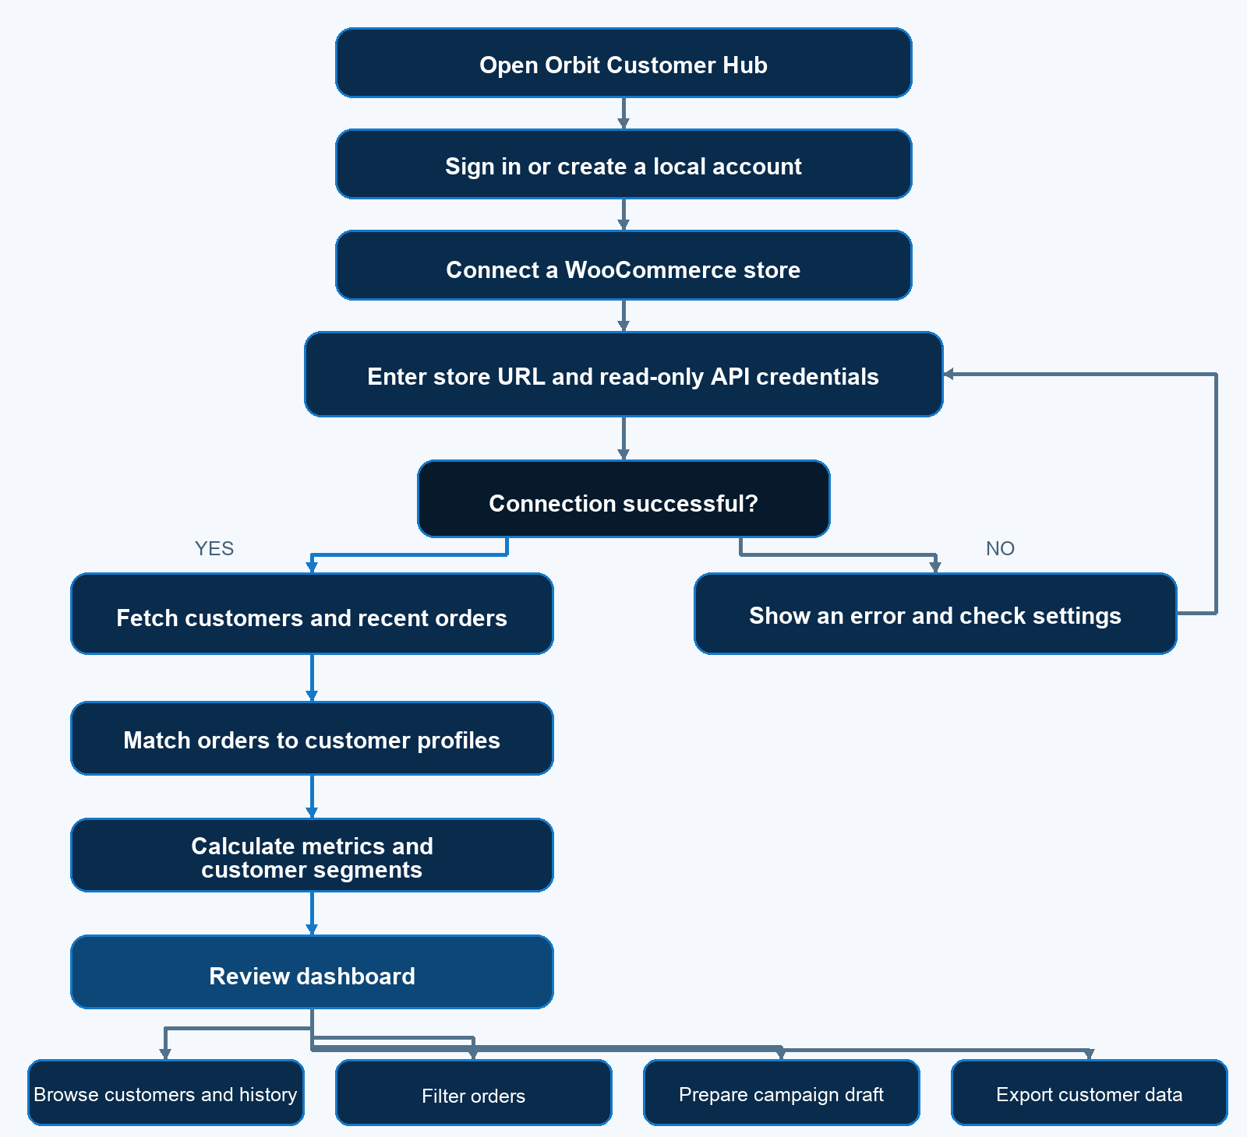
Figure 1. Planned Orbit Customer Hub user journey

Run the project
1. Extract this ZIP and open the orbit-woocommerce-crm-auth folder in VS Code.
2. Install Node.js 22 or newer if it is not already installed.
3. On macOS, double-click START-ORBIT.command. It looks for an available local port beginning at 4175 and opens the app in a browser. Alternatively, use the VS Code terminal: npm start, then open the localhost URL printed in the terminal (the default port is 4173).
4. On first launch, select Create account, enter a name, email, and password of at least eight characters. Use Sign in on later visits. The local session ends when the server restarts.
5. After signing in, open Settings, enter the WooCommerce store URL, a new read-only consumer key and secret, and the store currency. Select Save connection & sync.
6. Use Sync store to refresh the dashboard. The exact counts depend on the data currently in the WooCommerce store and the configured page limit.

WooCommerce credential setup
In WordPress, open WooCommerce → Settings → Advanced → REST API and create a new key with Read access for a user allowed to view customers and orders. Use HTTPS for a public store. Local development URLs such as http://beatz.local are supported by the server's signed WooCommerce OAuth 1.0a flow.
The server saves the store configuration to .env in the project folder. .env is ignored by Git. Never paste credentials into source code, README files, screenshots, or GitHub. API credentials visible in screenshots shared during this project should be considered exposed and revoked. Create a fresh read-only key before recording or sharing.

Architecture and data handling
1. The browser interface sends same-origin requests to the local server.
2. The server keeps the WooCommerce key and secret out of the browser and calls the WooCommerce customer and order endpoints.
3. The server aggregates the fetched records, computes segment labels, and returns the dashboard data.
4. The dashboard supports read-only review and CSV export. It does not create or modify WooCommerce customers or orders.
5. Campaign messages are drafts for a person to review; no delivery service is connected.

Account and deployment limitations
Sign-up/sign-in is a local demo account flow. Passwords are stored as scrypt hashes in the ignored auth-users.json; a session is represented by an HttpOnly, SameSite cookie. Session state is held in server memory and is cleared when the server stops. There is no password reset, email verification, multi-user store authorization, or production identity provider.
The server binds to localhost. Do not expose this demo server to the public internet. GitHub Pages can host static files, but it cannot run this Node backend or safely protect WooCommerce secrets. A public production deployment needs a protected HTTPS backend, secure account management, persistent data storage, access controls, and managed secrets.

Two-minute planning video script
Hi, I’m Anusha. I’m planning to build Orbit Customer Hub, a CRM dashboard that connects to WooCommerce and helps a store understand its customers and orders.
This flowchart shows my planned user journey. The user opens Orbit, signs in or creates a local account, and then connects a WooCommerce store by entering its URL and read-only API credentials. The system checks the connection. If it fails, it shows an error and lets the user review the settings before retrying.
If the connection succeeds, Orbit fetches customer and recent order data. It matches orders to customer profiles, then calculates useful metrics and customer segments, such as new, returning, at-risk, or VIP.
The user can review the dashboard, browse customer profiles and order history, filter orders, prepare a campaign message draft for human review, or export customer data.
For the planned technical stack, I’ll use HTML, CSS, and JavaScript for the interface, and a Node.js server to communicate with the WooCommerce REST API. The server will handle read-only credentials so they are not placed in browser code. I’ll use Git and GitHub for version control and submission.
This flowchart represents my plan; some details may change while I build and test the integration. My goal is to make customer and order information easier to review in one place.
Flowchart speaking order: Open Orbit → sign in/create account → connect store → enter URL and credentials → explain the success/error branches → data fetch and matching → metrics/segments → dashboard actions.

Four-to-five-minute final presentation script
Use this only as a guide. Show features that are present in the final version, and do not show API keys or customer personal details on screen.

0:00–0:30 — Introduction
Hi, I’m Anusha, and this is Orbit Customer Hub. It connects a WooCommerce store to a CRM-style dashboard, bringing customer and order information together so it is easier to review.
Screen: Show the sign-in screen, then sign in and show the Overview dashboard.

0:30–1:15 — WooCommerce integration
The app uses a local Node.js server to communicate with WooCommerce’s REST API. The store credentials are handled by the server rather than placed in the browser code. I use a read-only key for this integration. After syncing, the dashboard shows the customer and recent order data returned by the store.
Screen: Point out the connected store status and overview metrics. Keep Settings and credentials hidden.

1:15–2:10 — Customers and segmentation
On the Customers page, I can search and filter customer records. A profile includes details such as order count, spend, and recent order activity. Orbit uses those signals to group customers into segments such as new, returning, at-risk, or VIP.
Screen: Show the Customers page and a sample profile. Explain that VIP is calculated using the project’s rules and store data.

2:10–2:45 — Orders
The Orders page gives me a separate view of recent store orders. I can review the available order status, date, total, and customer information.
Screen: Show the Orders page and a non-sensitive row.

2:45–3:30 — Campaign drafts
The Campaigns page helps prepare a follow-up for a selected customer segment. It suggests a message draft that I can review and edit. This prototype uses rules and templates based on segments; it does not call a generative AI service or send campaigns automatically.
Screen: Select an audience and show the draft.

3:30–4:00 — Export and appearance
I can export customer records as a CSV file. The interface also has separate pages for customers, orders, and campaigns, with both light and dark themes.
Screen: Briefly show the theme toggle and CSV export button; avoid opening real customer data outside the app.

4:00–4:40 — Challenges and impact
One challenge was handling the WooCommerce connection and matching orders with customer profiles, including guest orders when a billing email is available. The result is one place to review store activity and prepare follow-ups. For a production version, I would add a hosted backend, persistent storage, stronger account management, and consent-aware message delivery.

4:40–5:00 — Closing
Thank you for watching. Orbit Customer Hub demonstrates how WooCommerce customer and order data can support a more organized customer-management workflow.

Submission checklist
- [ ] Revoke the API keys shown in shared screenshots and create a fresh read-only key.
- [ ] Start the updated project and confirm sign-in, store connection, and sync before recording.
- [ ] Close Settings and hide personal customer details before screen recording.
- [ ] Record the planning video using future/planned language; it explains intended design and stack.
- [ ] Record the result video based on features that actually work in the final build.
- [ ] Choose a GitHub destination and upload the project files. No GitHub remote is currently configured, so the project has not yet been uploaded.
- [ ] Do not upload .env, auth-users.json, API keys, or customer exports.

