Physics-Informed Neural Networks for Mechanics: Reproduction and Targeted Improvements
UE24CS352A Machine Learning · Mini-Project Write-up · Problem Statement 13

1. Problem statement
Our assigned paper, Zhang, Chen and Yang, "Data Driven Solutions and Discoveries in Mechanics Using Physics Informed Neural Network" (Stanford CS229), uses physics-informed neural networks (PINNs) to solve mechanics problems without a mesh or a labelled dataset. It studies three problems: (1) 1D soil consolidation, a diffusion equation pₜ = pₓₓ with an exact series solution; (2) 2D steady heat conduction, Tₓₓ + Tᵧᵧ + 1 = 0 on [−1, 1]² with T = 0 on the boundary; and (3) an inverse problem, recovering the damping c and stiffness k of a damped spring u″ + cu′ + ku = 0 from 50 observations (true c = 0.4, k = 4).
Our task: (i) reproduce all three results faithfully, and (ii) implement and test the two improvements the paper proposes but never tries: a hard boundary constraint for the heat problem (§4.2) and an adaptive training-point strategy (§5, future work).

2. Dataset
No external dataset is used, which is standard for PINNs. Training data are collocation points sampled uniformly at random from each domain with a fixed seed: 500 interior, 250 boundary and 125 initial points (consolidation); 1,500 interior and 500 boundary points (heat); 100 residual points plus the initial conditions (spring). For the inverse problem, 50 equispaced synthetic observations are generated from the exact solution with c = 0.4, k = 4. Reference solutions for evaluation are the analytical series (consolidation), the analytical formula (spring), and our own second-order finite-difference solver for heat on a 201 × 201 grid (grid refinement to 401 × 401 changes it by about 4 × 10⁻⁶). Test sets have 10,011, 10,201 and 10,000 points respectively.

3. Approach
PINN formulation. A fully connected tanh network maps coordinates to the solution. Automatic differentiation gives exact derivatives of the output, so the PDE residual can be evaluated at any point. The loss is L = w_{f} L_{f} + w_{b} L_{b} + w_{d} L_{d} (paper Eq. 3.3): mean squared PDE residual, boundary/initial-condition mismatch and data mismatch. For the inverse problem, c and k are extra trainable parameters.
Part 1: reproduction. We used the paper's settings throughout: networks of 5 × 50, 4 × 50 and 3 × 32; Glorot initialisation; loss weights 1/4 or 1/2; the output multiplied by x in consolidation so p(0, t) = 0 holds exactly; Adam for 50,000 epochs (lr 1e-3 or 5e-4) followed by L-BFGS, and Adam only (100,000 epochs) for the spring problem.
Fix 1: hard boundary condition (heat). Following the paper's suggestion, the output is multiplied by a smooth function that vanishes on the boundary: T̂ = (1 − x²)(1 − y²)·NN(x, y). T = 0 then holds exactly on all edges, and the boundary loss is removed.
Fix 2: residual-based adaptive refinement (consolidation). We implement RAR from Lu et al., DeepXDE (ref. [24] of the paper): five cycles of 10,000 Adam epochs; after each, 5,000 random candidates are scored by squared PDE residual and the 40 worst are added (500 → 700 points); then L-BFGS. A control run uses the same schedule and adds the same 200 points at random, to separate the effect of placement from the effect of point count. Network, seed and total budget match Part 1.

4. Implementation
Python and PyTorch, with NumPy, SciPy and Matplotlib; CPU only. src/ contains the network (model.py, with input scaling to [−1, 1] and an optional output transform), the Adam-then-L-BFGS trainer, the reference solutions and the plotting code. experiments/ has one script per run: consolidation.py, heat.py, spring_inverse.py (Part 1), heat_improved.py and consolidation_rar.py with a --random-add flag for the control (Part 2). run_all.py and run_part2.py reproduce everything (about 1 to 2 hours on a laptop). Each run saves metrics.json, history.json, the trained model and figures, and --load regenerates figures without retraining. Fixed seeds make reruns bit-identical; we confirmed this by running everything twice.

5. Results
All numbers are from one final run on a single laptop.
Experiment | Key metric | Paper / baseline | Ours
P1 Consolidation | Relative L2 error (max error, t > 0) | “perfect match” (≈ 0.045) | 1.29 % (0.069)
P1 Heat | Relative L2 error · mean boundary error | consistent with FEM | 0.90 % · 3.0 × 10⁻³
P1 Spring (inverse) | Identified c, k (true 0.4, 4) | 0.4013, 3.9933 | 0.4115, 3.9904
Fix 1 Heat, hard BC | Relative L2 error · boundary error | 0.90 % · 3.0 × 10⁻³ | 0.0040 % · exactly 0 (≈ 220× lower)
Fix 2 Random +200 (control) | Rel. L2 · max error (t > 0) · PDE test residual | 1.29 % · 0.069 · 18.7 | 0.84 % · 0.060 · 99.0
Fix 2 RAR +200 | Rel. L2 · max error (t > 0) · PDE test residual | 1.29 % · 0.069 · 18.7 | 0.79 % · 0.032 · 0.11
Observations. Part 1 reproduces the paper's findings: the consolidation error is concentrated near the origin, the heat error is largest along the boundary, and k converges quickly while c converges slowly. With the hard boundary condition, L-BFGS ran 4,019 iterations instead of stopping after 14, because the loss no longer has two competing terms; this drives most of the gain. RAR packed its added points along t ≈ 0. Compared with the random control, it halved the worst-case error and reduced the PDE test residual from 99 to 0.11, while the average error improved by a similar amount in both runs.
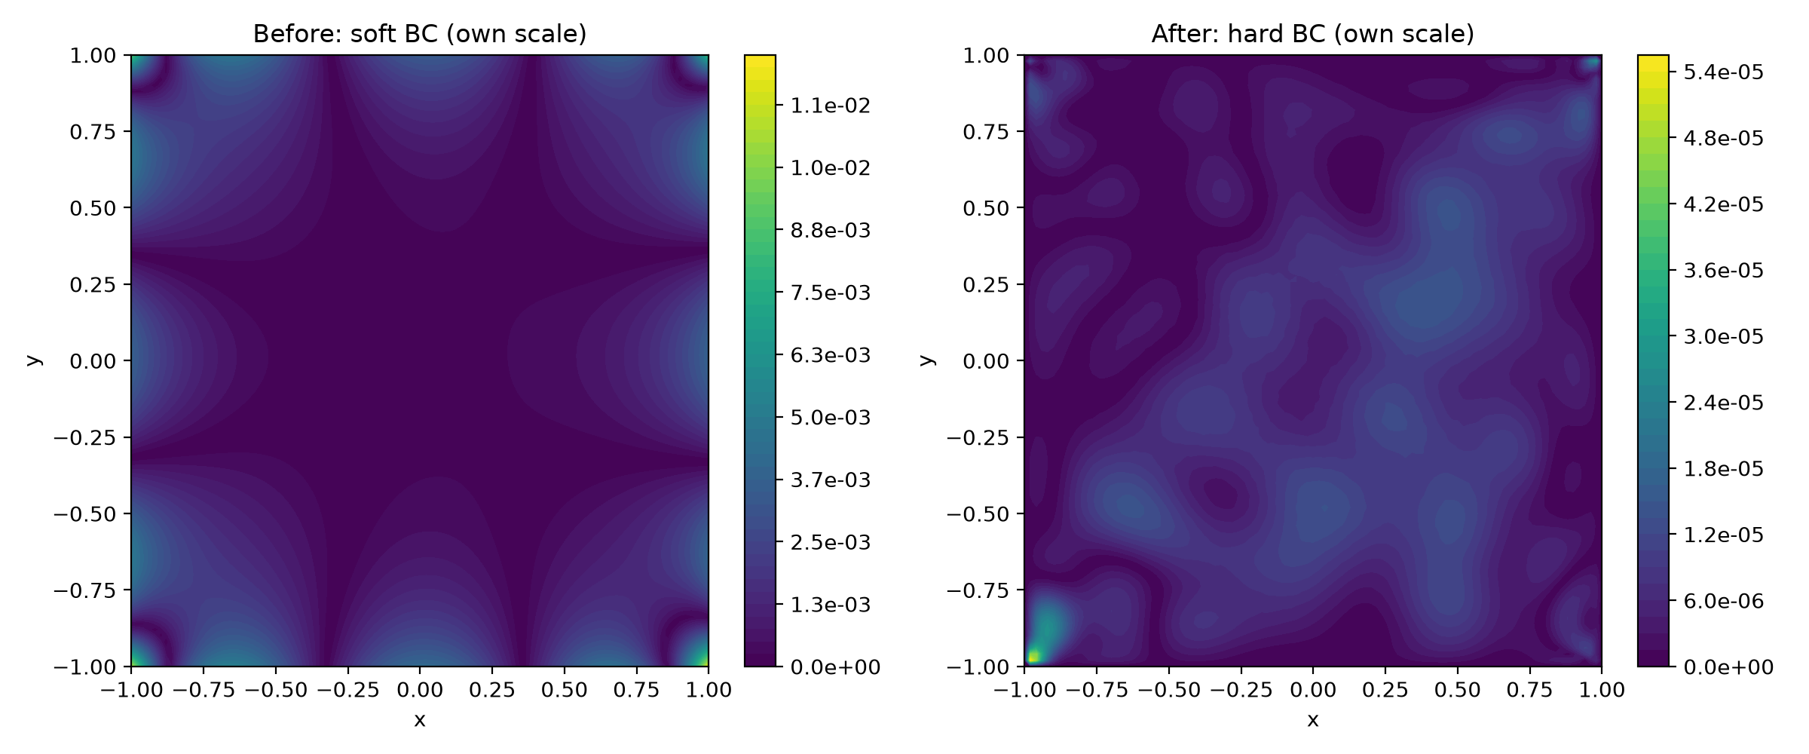  Fig. 1. Heat error, soft BC (left, up to 1.2 × 10⁻²) vs hard BC (right, up to 5.5 × 10⁻⁵). | 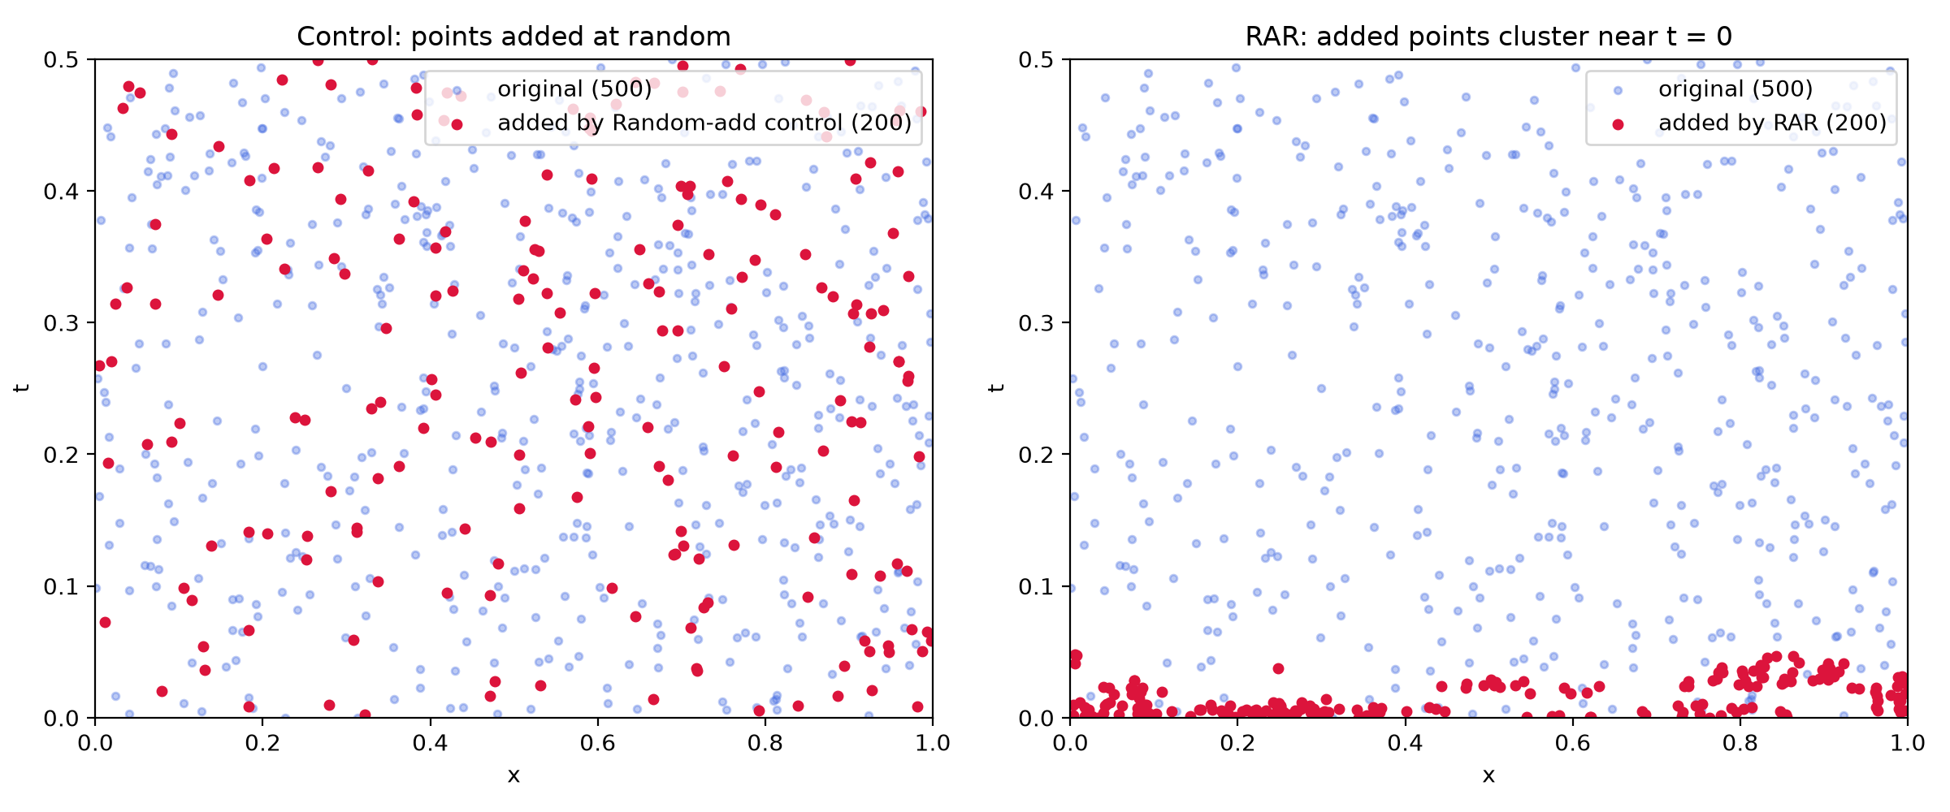  Fig. 2. Where the 200 added points go: random control (left) vs RAR (right).
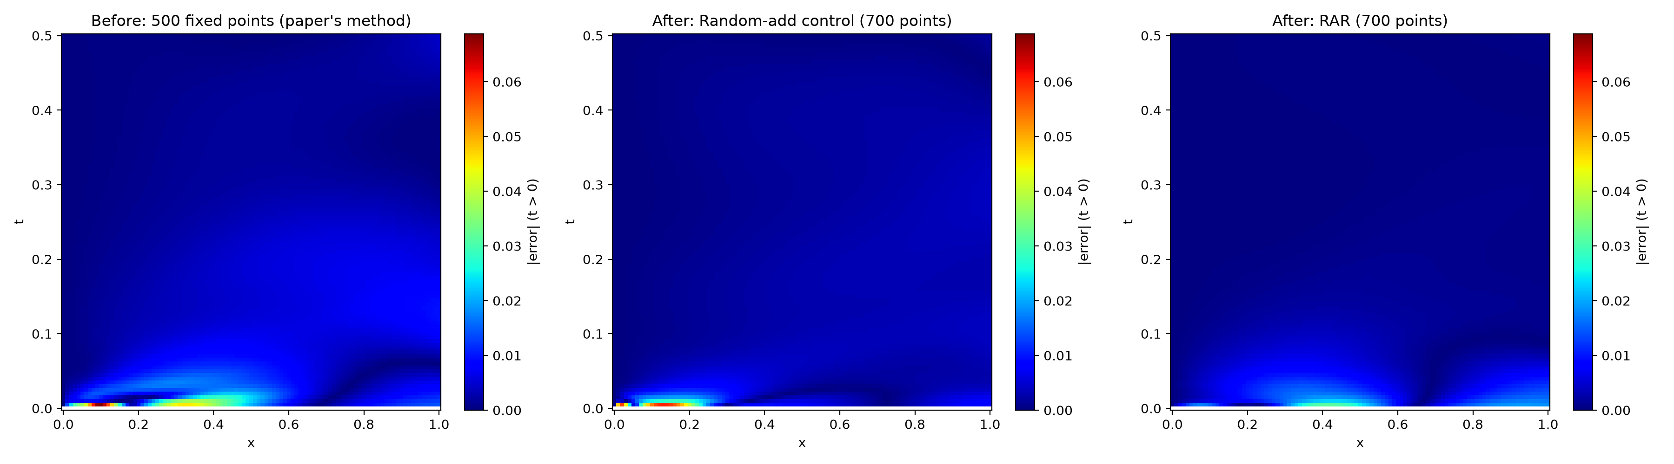
Fig. 3. Consolidation error (t > 0, one colour scale): baseline, random control, RAR.

6. Conclusions
- PINNs reproduced all three of the paper's results with about 1 % error, and recovered c and k within 3 %, from equations and 50 observations alone.
- Enforcing the boundary condition exactly reduced the heat error about 220 times and made the boundary error zero, largely because a single-term loss lets L-BFGS converge fully.
- Residual-based adaptive sampling fixed the worst-case error near the initial jump. The control experiment shows that the gain in average error comes from the extra points and the cycled schedule rather than from adaptivity, so claiming more without a control would have been wrong.
- Limitations: single seed (another machine gave slightly different numbers); the paper's output constraints (0 ≤ p ≤ 1, T > 0) were not implemented. Next steps: multi-seed averages, a hard initial condition for consolidation, and the coupled poromechanics equations named in the paper.
References: [1] Q. Zhang, Y. Chen, Z. Yang, Data Driven Solutions and Discoveries in Mechanics Using PINN, Stanford CS229 report. [2] M. Raissi et al., J. Comput. Phys. 378 (2019) 686–707. [3] L. Lu et al., DeepXDE, arXiv:1907.04502 (2019). [4] J. Berg, K. Nyström, Neurocomputing 317 (2018).

