Introduction

Analysis:-

Analysis is the process of breaking a complex topic or substance into smaller [arts in order to gain a better understanding of it. Analysis is also the process of studying and examining something in an organized way to learn more about it, or a particular study of something. Analysis is also the process to understand about something or the study of something in detail.

In analysis, people gather information from the particular organization or anything to get detailed information about it. Analysis are of various type. Any kind of analysis can be used according to the situation. Analysis helps to run business program easily like any business can run in a successful way if proper analysis is done.

Analysis should be performed before starting any project so that it may be successful. Analysis is essential because analytics assist in humans in making decisions. Therefore, conducting the analysis to produce the best results for the decisions to be made is an important part of the process, as is appropriately presenting the results. Analysis help people focus on their decision. To perform any project effectively, it is very important to not overcomplicate the analysis and to clearly and succinctly present results.

For this project, I have choose CATWOE analysis as my project is more concerned about customers, world view, actors, transformation Process, owners and environmental constraints.

Analysis helps in various factors like-:

* Elimination of costs-: A critical advantage to using value analysis is its potential for reducing costs, which is a benefit that permeates all advantages of the system.
* Modernizing-: The value analysis process often allows users to root out practices that have grown out of date and can be replaced with more modern approaches.
* Design flaws-: Analysis helps to reduce data flaws in the project which may create a great problem in the company.
* Customer service-: Analysis also helps to provide great service to the customer.

In this project we are going to study about three types of analysis which are mentioned below:-

* Pest analysis -: PEST Analysis (political, economic, socio-cultural and technological) describes a framework of macro-environmental factors used in the environment scanning component of strategic management .It is part of an external analysis when conducting a strategic analysis or doing market research,  and gives an overview of the different macro-environmental factors to be taken into consideration.

It is a strategic tool for understanding market growth or decline, business position, potential and direction for operations. The framework examines opportunities and threats due to Political, Economic, Social, Technological forces. Outputs from the analysis inform strategic planning processes and contribute to market research.

* SWOT Analysis-: SWOT Analysis (or SWOT matrix) is a strategic planning technique used to help a person or organization identify strengths, weaknesses, opportunities, and threats related to business competition or project planning. It is intended to specify the objectives of the business venture or project and identify the internal and external factors that are favorable and unfavorable to achieving those objectives.

Users of a SWOT analysis often ask and answer questions to generate meaningful information for each category to make the tool useful and identify their competitive advantage. SWOT has been described as the tried-and-true tool of strategic analysis.

* CATWOE Analysis-: CATWOE is an acronym that stands for Customers – Actors – Transformation process – World view – Owners – Environmental constraints. It’s a simple checklist to find solutions to problems. It offers surprising solutions and stimulates multiple approaches. The CATWOE Analysis makes it possible to identify problem areas, look at what a company wants to achieve, and which solutions can influence the stakeholders. The analysis uses thought solutions from multiple perspectives.
* Customer-: Generally, these are an organization’s customers. They are users and stakeholders of a system. The will undoubtedly benefit if a change is to occur within the system or process or if a problem is solved.
* Actors-: They are usually the employees within an organization. They ensure that a transformation process happens.
* Transformation Process-: Transformation is the change that a system or process leads to. It’s the process in which input (including raw materials and man-hours) is transformed by an organization into output (such as a final product or solution to a problem).
* World View-: This is about the ‘bigger picture’ and considers the different stakeholders and interested parties from the environment surrounding an organization and the influence they can have. It is also seen as the most crucial step in the CATWOE analysis.
* Owners-: This usually refers to the owner, entrepreneur or investor of an organization, who wants to make changes and who decides whether a project should start or stop.
* Environmental Constraints-: In contrast with World view, this is about the actual environmental elements that may influence the organization and can limit or restrict the system.

Feasibility Study-:

A feasibility study aims to objectively and rationally uncover the strengths and weaknesses of an existing business or proposed venture, opportunities and threats present in the natural environment, the resources required to carry through, and ultimately the prospects for success. In its simplest terms, the two criteria to judge feasibility are cost required and value to be attained.

Types of feasibility study are mentioned below:-

* Economic feasibility-: In economic feasibility, the most important is cost benefit analysis. As the name suggests, it is an analysis of the costs to be incurred in the system and benefits derivable out of the system.

Economic feasibility helps me to maintain the project by analyzing the cost which are included in this project. It determine the costs of the products used in the system, which makes more feasible to complete the work.

* Technical feasibility-: Once the technical feasibility is established, it is important to consider the monetary factors also. Since it might happen that developing a particular system may be technically possible but it may require huge investments and benefits may be less. For evaluating this, economic feasibility of the proposed system is carried out.

Technical feasibility, this is a complete study of the project of input, process, output, fields, programs and procedures. This feasibility is practical for long term planning and trouble shooting. It have help me to determine facility needs, raw materials and other input which are needed by the system.

* Schedule feasibility-: Schedule feasibility: The process of assessing the degree to which the potential time frame and completion dates for all major activities within a project meet organizational deadlines and constraints for affecting change.

It helps to me maintain the work till the deadline, which makes the work achievable and make my project realistic. And helped with the timetable of the work.

* Operational feasibility-: Operational feasibility is mainly concerned with issues like whether the system will be used if it is developed and implemented. Whether there will be resistance from users that will affect the possible application benefits?

This feasibility has help me by solving the problems which are arise during the project and helped me by identifying the requirements phase of system development.

* Legal feasibility-: It includes study concerning contracts, liability, violations, and legal other traps frequently unknown to the technical staff.

It help me to work effectively without violating the rules which are forced by government based on data protection act.

Requirement Analysis

Requirements analysis is critical to the success or failure of a systems or software project. The requirements should be documented, actionable, measurable, testable, traceable, related to identified business needs or opportunities, and defined to a level of detail sufficient for system design.

Requirement analysis are performed for the following reasons

* Fewer defect in the delivered products
* Less development rework
* Faster delivery of the finished product
* Less unused features
* Lower cost of development
* Less miss-communicated requirement
* Reduced project chaos
* Higher level of satisfaction from stakeholders.

We can gather information from different analysis process for the organization. For this project I have used all of the following requirement gathering process. I have gathered lots of information from these techniques. Some of the requirement gathering process are shown below:

1. Interview
2. Observation
3. Prototyping
4. Focus group
5. Interface analysis

For this project we are going to specify following types of requirements:

* Functional requirements-: Functional requirement defines a function of a [system](https://en.wikipedia.org/wiki/System) or its component, where a function is described as a specification of behavior between outputs and inputs. Functional requirements may involve calculations, technical details, data manipulation and processing, and other specific functionality that define what a system is supposed to accomplish. Generally, functional requirements are expressed in the form "system must do requirement" while non-functional requirements take the form "system shall be requirement”. The plan for implementing functional requirements is detailed in the system design.

Functional requirement includes input, output and process.

|  |  |
| --- | --- |
| Functional requirement Id | Title |
| F1 | Registration |
| F2 | Login |
| F3 | Select movie |
| F4 | Book tickets |
| F5 | Select time, date |
| F6 | Check payment process |
| F7 | Add, Update and modify customer details |

* Non-Functional requirements-: A non-functional requirement (NFR) is a [requirement](https://en.wikipedia.org/wiki/Requirement) that specifies criteria that can be used to judge the operation of a system, rather than specific behaviors. They are contrasted with [functional requirements](https://en.wikipedia.org/wiki/Functional_requirement) that define specific behavior or functions. The plan for implementing functional requirements is detailed in the [system design](https://en.wikipedia.org/wiki/Systems_design). The plan for implementing non-functional requirements is detailed in the [system architecture](https://en.wikipedia.org/wiki/Systems_architecture), because they are usually [architecturally significant requirements](https://en.wikipedia.org/wiki/Architecturally_significant_requirements).
* Performance-: Any requirement established by the regulatory authority to assure future compliance with the public health and water quality goals of the community, the state or tribe, and the federal government.  Performance requirements can be expressed as numeric limits or narrative descriptions of desired conditions or requirements.
* Reusability-: Requirements reusability is defined as the capability to use in a project requirements that have already been used before in other projects. This allows optimizing resources during development and reduce errors. Most requirements in today's projects have already been written before. Reusability is the use of existing assets in some form within the [software product development process](https://en.wikipedia.org/wiki/Software_development_process); these assets are products and by-products of the software development life cycle and include code, software components, test suites, designs and documentation.
* Usability-: An interface should be easy to learn how to use and easy to remember how to use. The latter pertains especially to devices that require infrequent use. Users should not be required to consult a manual each time they need to use a kitchen blender for instance. Bank ATMs and web-based forms, which may be used by anyone, should be simple to use the first time around without instructions.
* Security-: Security requirements are a class of Non-Functional Requirements (NFRs) that relate to system confidentiality, integrity and availability. Explicitly stating security requirements during project inception is the perfect complement to security testing.

A security requirement is a security feature required by system users or a quality the system must possess to increase the users trust in the system they use. In general, a security requirement is considered as a non-functional requirement.

|  |  |
| --- | --- |
| ID | Non-functional requirement Title |
| NFR1 | Performance |
| NFR2 | Reusability |
| NFR3 | Usability |
| NFR4 | Security |
| NFR5 | Portability |
| NFR6 | Browser support |

Prioritization:

We always prioritize when we are getting close to the delivery and find not everything works or when someone appears with a “more critical than anything else” requirement in the middle of development.

Without prioritization, when changes occur we have much less leeway on how we will proceed and may have to drop some of our previous “must have” requirements or, worse yet, not meet the schedule or budget constraints. All of these outcomes will adversely affect the customer’s expectation and the delivered product.

The importance of the prioritization are mentioned below:-

* Prioritization helps us to manage the requirement and resources.
* Prioritization also helps manage the unknown unknowns.
* Prioritization helps to improve communication as the guesswork are taking out of the project.
* Prioritization helps people tend to rethink their requirements.
* Prioritization id helpful when releasing software in phrases.

MoSCoW prioritization, also known as the MoSCoW method or MoSCoW analysis, is a popular prioritization technique for managing requirements. The method is commonly used to help key stakeholders understand the significance of initiatives in a specific release.

The acronym, MoSCoW, stands for 4 different categories of initiatives: must-haves, should-haves, could-haves, and will not have at this time.

Different categories contains different works

* Must have (M)-: As the name suggests, this category consists of initiatives that are “musts” for the organization. They represent non-negotiable needs for the project, product, or release in question. Anything in the “must-have” category is considered mandatory for the team to complete.
* Should have(S)-: Should-have initiatives are just a step below must-haves. They are important to the product, project, or release, but they are not vital. If left out, the product or project still functions. However, if they are included, they add significant value.

Should-have initiatives are different from must-have initiatives in that they can be slated for a future release without impacting the current one.

* Could have(C)-: Another way of describing “could-have” initiatives is nice-to-haves. Could-have initiatives are not necessary to the core function of the product. Compared with should-have initiatives, they have much smaller impact on the outcome if they are left out.

So, initiatives that are placed in the could-have category are often the first to be deprioritized if a project in the should-have or must-have category ends up larger than expected.

* Won’t have (W)-: One benefit of the MoSCoW prioritization is that it places several initiatives in the will-not-have category. This helps manage expectations about what will not be included in a specific release (or other time frame you’re prioritizing for.

For this project I have used MoSCoW prioritization mentioned in the table below:

|  |  |  |
| --- | --- | --- |
| ID | Functional Requirement | Priority |
| FR1 | User Registration | Must have |
| FR2 | User Login | Must have |
| FR3 | Select movie | Must have |
| FR4 | Book ticket | Should have |
| FR5 | Select time, date | Must have |
| FR6 | Select payment process | Should have |
| FR7 | Watch trailer | Should have |
| FR8 | Add review, comment | Should have |
| FR9 | Online message | Could have |
| FR10 | Rate movie | Should have |
| FR11 | Information about upcoming movie | Could have |
| FR12 | Internet service | Must have |
| FR13 | Log out | Should have |
| FR14 | Add, update, delete | Must have |
| FR15 | Online payment | Won’t have |
| FR16 | Special features for differently able people | Won’t have |
| FR17 | Change language | Won’t have |

Software requirement specification (SRS)

A software requirement specification (SRS) is a detailed description of a software system to be developed with its functional and non-functional requirements. The SRS is developed based the agreement between customer and contractors. It may include the use cases of how user is going to interact with software system. The software requirement specification document consistent of all necessary requirements required for project development.

* Software requirement--:

Programming language: PHP

Database: MYSQL

UI Design: HTML, JQUERY, CSS, PHP

Web browser: Mozilla, Google Chrome, Opera

Software used: XAMPP Server

* Hardware Requirement--:

Memory: 4GB RAM

Storage: 1GB

OS: Windows 10 64Bits

Use-Case

A use case is a methodology used in system analysis to identify, clarify, and organize system requirements. The use case is made up of a set of possible sequences of interactions between systems and users in a particular environment and related to a particular goal.

I have created Use Case diagram for the project which is shown below:

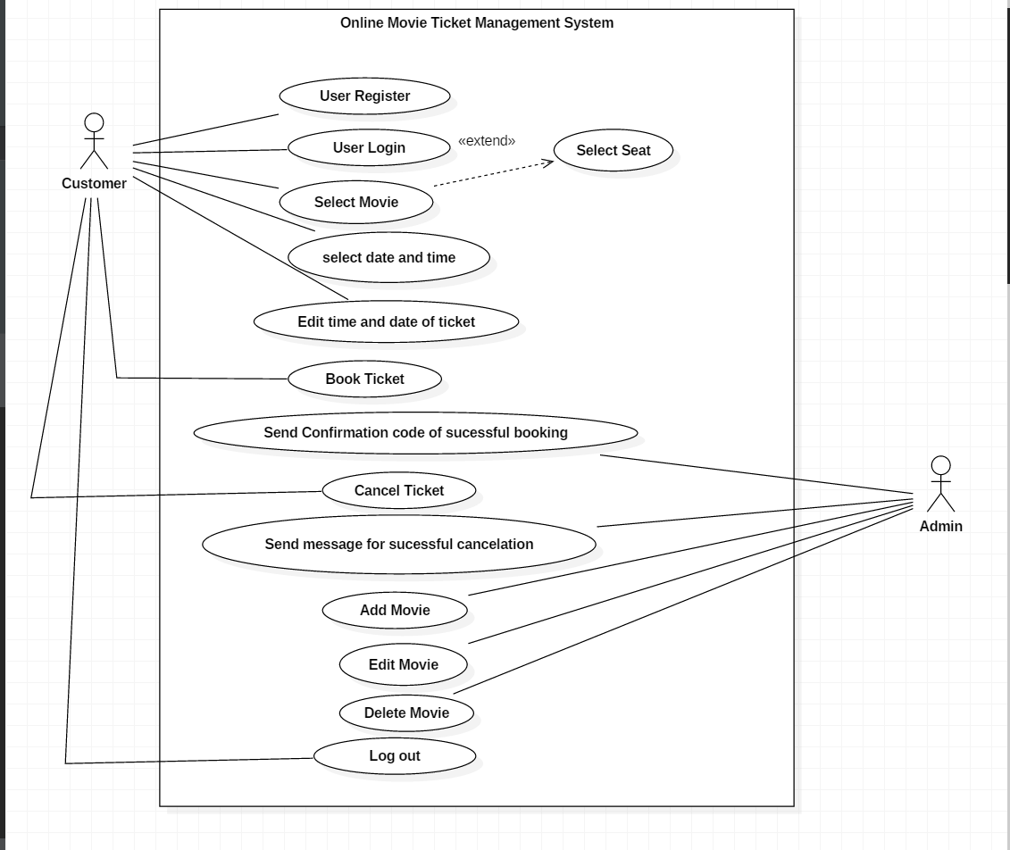

Fig: Use Case Diagram

Natural Language Analysis (NLA)

Natural Language Analysis (NLA) is the process of identifying verbs, adjectives and nouns. For the project I have listed some verbs, nouns and adjectives which can help to make class diagram, use-case and sequence diagram.

List of the noun I have selected for the NLA process are mentioned below:-

|  |  |  |  |
| --- | --- | --- | --- |
| S No | Identification of Noun | Selected as Candidate list | Explanation of selected and rejected noun |
| 1 | Visitor | Selected | It may contain attributes for the class diagram |
| 2 | Movie | Selected | It contains attributes for class diagram |
| 3 | Book Ticket | Selected | It is the major class which contain many attribute |
| 4 | Date | Rejected | As it is attribute of other class |
| 5 | Time | Rejected | As it is attribute of other class |
| 6 | Trailer | Rejected | It is immaterial to this system |
| 7 | Rate | Rejected | It is immaterial to the system |
| 8 | Comment | Rejected | It is consider as redundant to the system |
| 9 | Review | Rejected | It is redundant to the system |
| 10 | Admin | Selected | It may contain attributes. |
| 11 | Website | Rejected | It is immaterial to the system |
| 12 | Register user | Selected | It contains attributes for the class diagram |

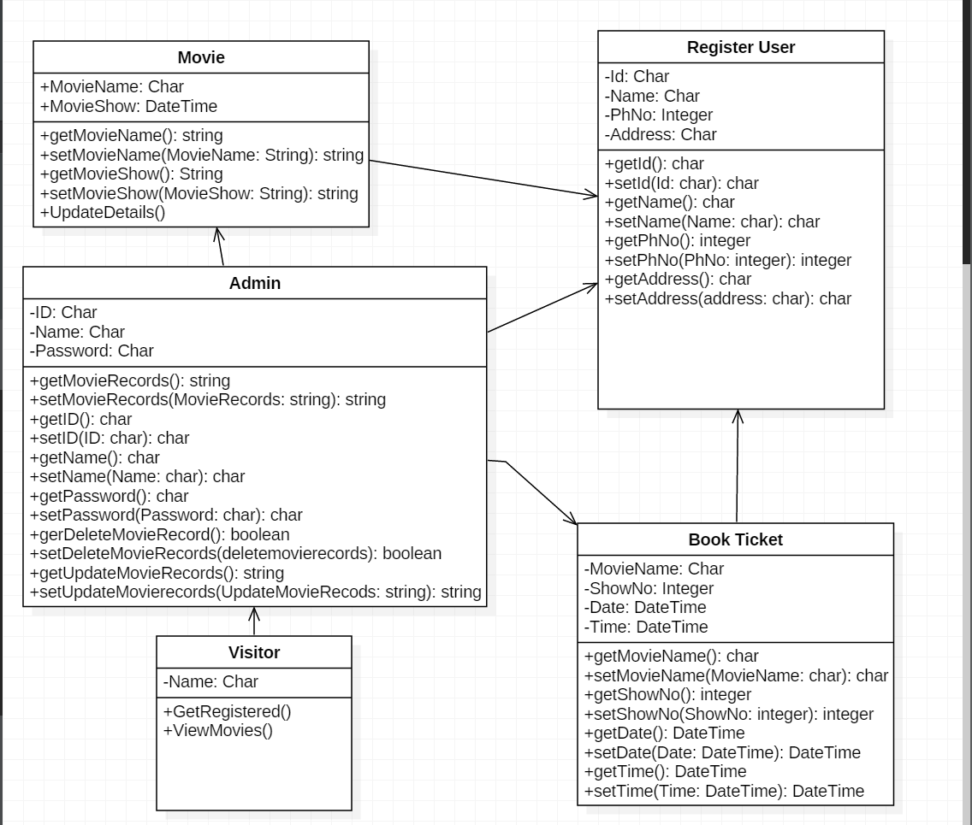

Fig: Class Diagram.