Contents

Introduction 3

Project Introduction:- 3

Justification for the project:- 3

Problem Statement:- 3

Overview of the project:- 4

1.5 Features of the project:- 4

2. Scope of the project: 4

2.1 Scope:- 5

2.2 Limitation:- 5

2.3 AIMS:- 5

2.4 Objectives:- 5

2.5 Overview of the Scope:- 5

3. Development methodology:- 6

3.1 Methodology used:- 6

3.2 Design Pattern-: 7

3.3 System Architecture:- 8

4. Project Plan-Work Breakdown:- 10

4.1 Work Break Down Structure:- 10

4.2 Milestone:- 12

Fig 6: Milestone 13

4.3 Description of Milestone-: 13

Scheduling: GANTT chart -: 14

Chapter -5 RISK Management-: 15

Chapter-6 Configuration Management 17

Conclusion 18

References-: 19

Figure 1:WaterFall Model 6

Figure 2 MVC Design Pattern 8

Figure 3:3-tier Structure 9

Figure 4:WBS structuure 10

Figure 5:Tabular form of WBS structure 11

Figure 6: Time Estimation Table 14

Figure 7: GANTT chart 14

# 

# Introduction

In this project, Users can book their movie ticket from their place and watch upcoming movies and trailers and rate the movie and review their perspectives for the movie and also rate the website. Further information related to the website is detailed below:

## Project Introduction:-

Online Movie Ticket Management System helps users to book their ticket for movie and visit theatre without worrying about the ticket. User can also watch trailer for the movies and can know about upcoming movies and many other. In the world of technology no one would wait for opportunities. Everyone wants to work digitally and this online movie ticket management system would help users through saving time and workload.

## Justification for the project:-

Online Movie Ticket Management System is a web portal which helps the user to book movie ticket and rate the movies. It helps users to watch trailer and information of upcoming movies. Users can leave comment for the website in the button of the website. This helps to save user’s time and should not stand in a queue for hours and can reserve seat wherever they like.

This website would help the users and is very user friend and easy to use. They just can book tickets by registering their basic information and login. They just need to click on book ticket to book. This website is user-friendly for age group and Basic English is only used.

To create this website, I have used PHP programming language and MY SQL for the database storage. Users can use this website and book their ticket at any time and visit the theatre just before time when movie starts.

## Problem Statement:-

There are many problems for booking tickets for movies. People have to stand in queue for long time and cannot get wanted seat for them. People should face lot of difficulties for just booking ticket and have to spend an hours for booking. People are also unaware about the playing movies and have to visit to the theater to know about that and also they need to visit theater to know about the timing of the movie.

Problem solution are:-

* Online ticket booking helps to reduce work load
* Online ticket helps to save time.
* Online ticket booking helps people to reserve their wanted seat.

## Overview of the project:-

## 1.5 Features of the project:-

Overall this website helps the user in different ways. It is useful for every users and is easy to operate. Some of the features of the website are mentioned below:

* User should Register and login to the system-:

User should register their basic information at first and then login with their username and password and create their own account.

* User should book ticket for the particular movie-:

User should book their tickets before visiting the theaters from their place and reserve their seat wherever they want.

* User can rate the movies:-

User can rate the movie after watching it.

* Users also can comment, review about the movie and website:-

User can comment about the website and the movies they have watch. User can review about the movie after watching it.

* User can watch trailer and information for upcoming movie:-

User can also watch trailer for the movie they are watching and also for the upcoming movie.

# 2. Scope of the project:

## 2.1 Scope:-

Online movies booking system is for theaters which help for storing database with information like movies date, price, upcoming movies, rating and reviews of movies and retrieve by user easily.

## 2.2 Limitation:-

Limitation of the Online Movie Ticket Management system are mentioned below:-

User should pay their bills after visiting the theater. Payment system from online is not available in this system.

## 2.3 AIMS:-

This Online Movie Ticket Management System is created with some aims. Aims of the project is:-

1. To provide user facilities by booking tickets from their place at any time.
2. To remove numbers of staff in ticket counter.
3. To help users save their time and work.
4. To develop the technology and digitalize the world.
5. To maintain customer satisfaction.

## 2.4 Objectives:-

The main objectives to develop this website is given below:

1. To manage all the activities like customer, ticket, movies etc.
2. It help to manage all the information related to movies, trailers, timing, seats and many other.
3. It helps the user to save their time. It helps to promote technology.
4. It helps to reduce manual work of the customer.

## 2.5 Overview of the Scope:-

Overview of scope is to provide the users proper facilities through the website by saving their time and effort. Technology have a huge scope in the current situation. Thus I have use technology to help customer.

# 3. Development methodology:-

## 3.1 Methodology used:-

For this project I have used waterfall model. Waterfall model is popular among the software development. In waterfall model, one should forward to another step only when the previous step is completed. Every step is divided in waterfall model. In software development, it tends to be among the less iterative and flexible approaches, as progress flows in largely one direction through the phases of analysis, design, final documentation, testing, proposal and implementation.

The waterfall development model originated in the manufacturing and construction industries; where the highly structured physical environments meant that design changes became prohibitively expensive much sooner in the development process

Outcomes for one step is input for next step in waterfall model. In waterfall model every step is divided into six phases like requirement analysis, Design, Implementation, testing, deployment. Every step should be completed.

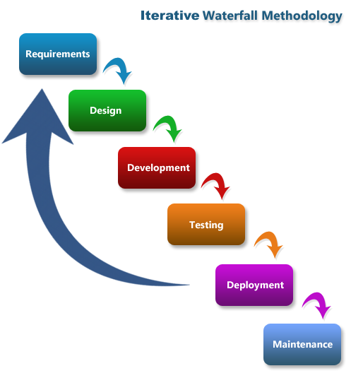

Figure :WaterFall Model

For this management system I have used waterfall model. I have choose waterfall model in this project due to some reasons like:

* It is very simple to understand and use
* In this model each phase must be completed before starting another phase which controls overlapping in the phases
* Waterfall model illustrates the software development process in a linear sequential flow.

Water fall model contains six phase each of the phases are described below:

1. Requirement Analysis -: Every information related to the management system are collected in this phase which helps in the design phase. All possible requirements required for the project are gathered in this process.
2. Design-: Information from the first phase that is requirements are gathered and design is created design helps in specifying hardware and system requirements and also helps to define the whole project.
3. Development-: After the design the system is developed in small programs called units, which is integrated into next phase.
4. Testing-: Every unit developed in the development phase is tested in this phase which is also called unit testing.
5. Deployment-: After all not functional and functional testing is completed, system is deployed in according to client requirement in this phase.
6. Maintenance-: Some issue might come up in the client environment, to fix those issue, patches are release. And maintenance is completed.

## 3.2 Design Pattern-:

In this project I have used Model View Controller (MVC) design pattern. Design pattern is repeatable solution to a usually occurring problem is software development. Design pattern isn’t a finished design that can be transformed directly into code. MVC design pattern is mostly used framework in software development in current situation.

Here I have used MVC design pattern for the following reasons like:

1. It helps in faster development process.
2. It has the ability to provide multiple view.
3. Support for asynchronous technique.
4. In this pattern modification does not affect the entire pattern.
5. It returns the data without formatting it.

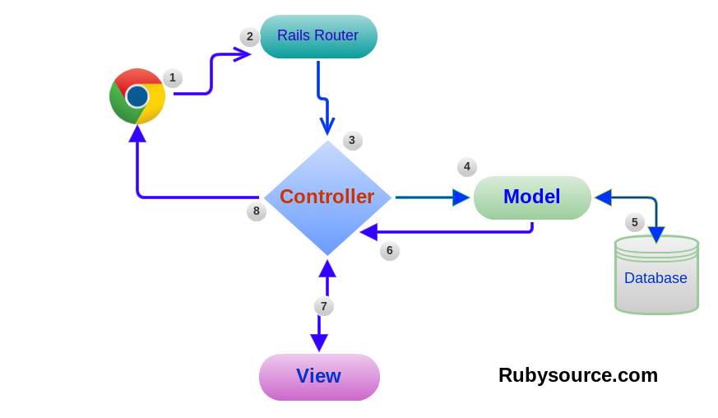

Figure MVC Design Pattern

* Model:

Model in model view controller handles all the logic related to the data. It represents data that is transfer between view and controller.

* View:

View in MVC design pattern handles all the UI Logic application. It contains any representation of information like chart, diagram or table.

* Controller: Controller in the MVC pattern acts as intermediary between model and view to process incoming request and logic.

## 3.3 System Architecture:-

It is the conceptual model which defines the structural, behavior and more views of the system. It describes the formal description and representation of a system. In this project I have used 3-tier structure.

The reasons why I have choose 3-tier structure is described below:

* Maintainability: Every tier in the 3-tier architecture are independent of other tier or layers.
* Scalability: Tiers are based on the deployment of layers, scaling out an application is reasonably straightforward.
* Flexibility: each tier or layer can be managed independently and flexibility increase.
* Reusability- components can be reused.
* Faster development- due to work division, task are completed quickly.

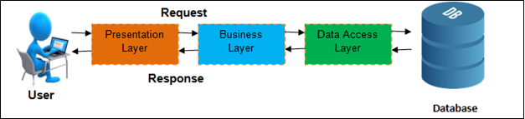

Figure :3-tier Structure

A 3-tier architecture is a type of software architecture which is formed of tiers or layers of logical computing. They are mostly used in applications as a specific type of client-server system.

# 4. Project Plan-Work Breakdown:-

## 4.1 Work Break Down Structure:-

Work Breakdown structure is a main project deliverable which organizes the team’s work into manageable form. Work Breakdown Structure is also known as deliverable oriented hierarchical decomposition of the work to be executed by the project team. Work Breakdown Structure for the project is shown below:

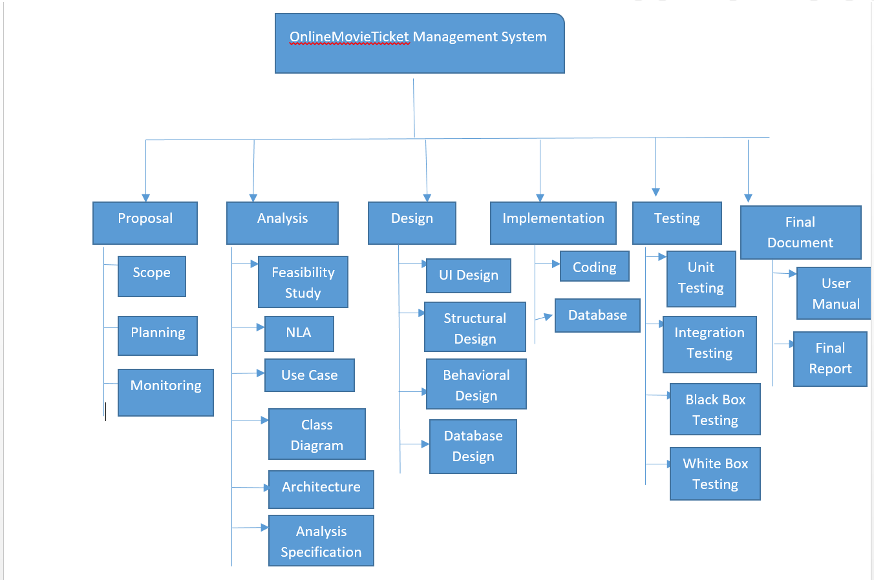

Figure :WBS structuure

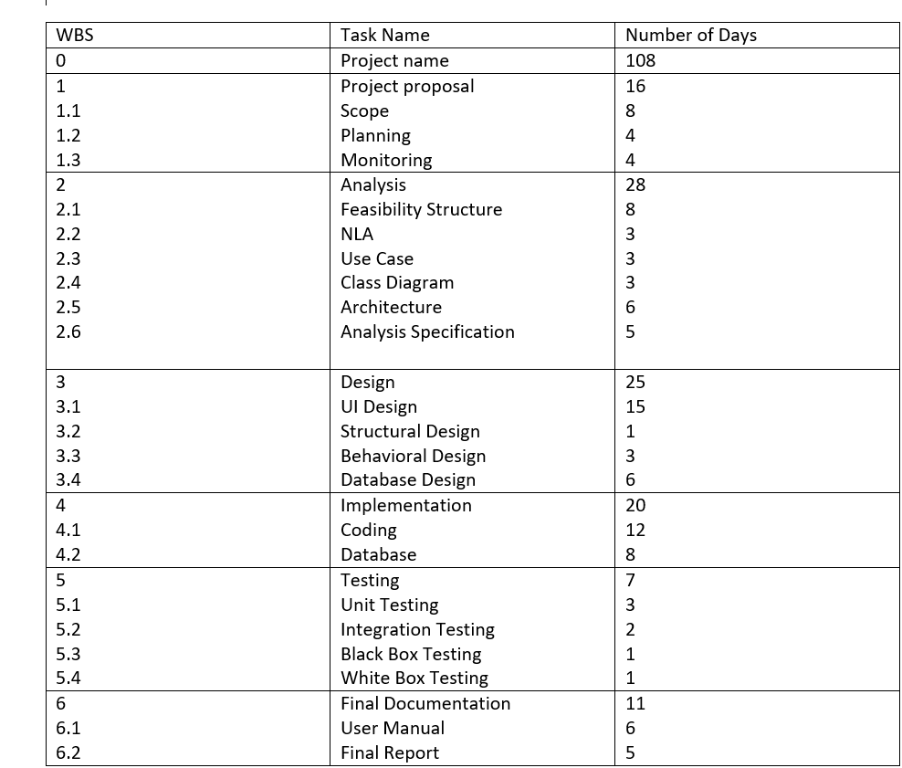

Figure :Tabular form of WBS structure

## 4.2 Milestone:-

|  |  |  |  |
| --- | --- | --- | --- |
| Milestone | Start Date | End Date | Number of Days |
| Proposal  Scope  Planning  Monitoring | 3/25/19  03/25/19  04/02/19  04/06/19 | 04/09/19  04/01/19  04/05/19  04/09/19 | 16  8  4  4 |
| Analysis  Feasibility Study  NLA  Use Case  Class Diagram  Architecture  Analysis Specification | 04/10/19  04/10/19  04/18/19  04/21/19  04/24/19  04/27/19  05/03/19 | 05/07/19  04/17/19  04/20/19  04/23/19  04/26/19  05/02/19  05/07/19 | 28  8  3  3  3  6  5 |
| Design  UI Design  Structural Design  Behavioral Design  Database Design | 05/08/19  05/08/19  05/23/19  05/24/19  05/27/19 | 06/01/19  05/22/19  05/23/19  05/26/19  06/01/19 | 25  15  1  3  6 |
| Implementation  Coding  Database | 06/02/19  06/02/19  06/14/19 | 06/21/19  06/13/19  06/21/19 | 20  12  8 |
| Testing  Unit Testing  Integration Testing  Black Box Testing  White Box Testing | 06/22/19  06/22/19  06/25/19  06/27/19  06/28/19 | 06/28/19  06/24/19  06/26/19  06/27/19  06/28/19 | 20  3  2  1  1 |
| Final Documentation  User Manual  Final Report | 06/29/19  06/29/19  07/05/19 | 07/09/19  07/04/19  07/09/19 | 11  6  5 |

# Fig 6: Milestone

## 4.3 Description of Milestone-:

* Proposal:-

For the proposal I have estimated 16 days. In 16 days I have estimates 8 days for scope, 4 days for planning and also 4 days for monitoring. I have completed my proposal for the project according to the estimated days.

* Analysis:-

For the analysis segment I have estimated total 28 days. Analysis contains 6 sub parts like feasibility study, NLA, Use Case, Class Diagram, Architecture and Analysis Specification. I have estimated 8 days for feasibility study,

2 days for NLA, 3days for Use Case, 3 days for Class Diagram, 6 days for architecture and also 5 days for analysis specification.

* Design:-

For the design section I have estimated total of 25 days. Here for UI design I have estimated 15 days, I have divided 1 day for structural design, 3 days for behavioral design, 6 days for database design. By this way I have divide 25 days for design.

* Implementation:-

For the implementation I have estimated 20 days. I have divided days for implementation in the following ways-:

I have 12 days for coding part and also 8 days for database part.

* Testing:-

For the testing part I have divided days in the following ways like:-

I have divide 3 days for unit testing, 2 days for integration testing, and also 1 days for black box testing and 1 days for white box testing.

* Final Documentation:-

For the implementation part I have estimated total of 11 days and also I have estimated 6 days for user manual and also for 5 days for final report.

## Scheduling: GANTT chart -:

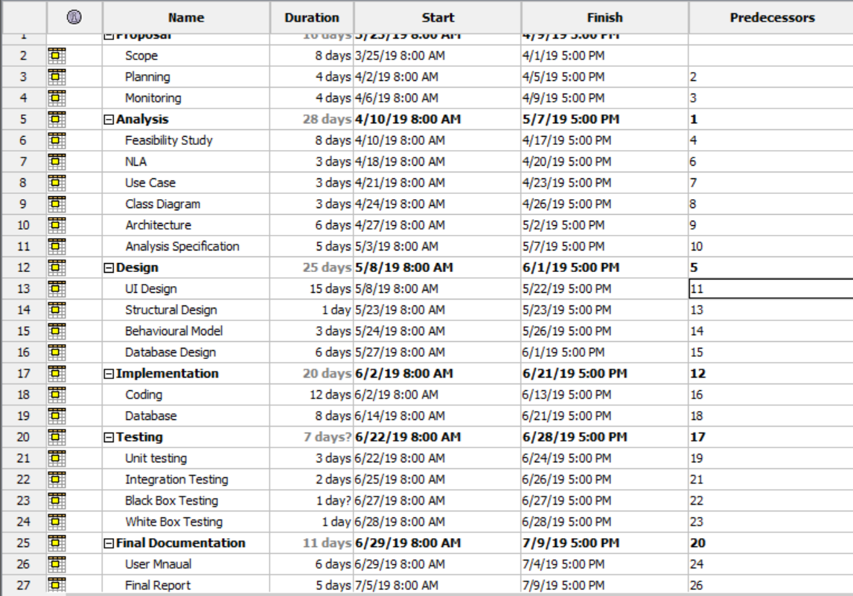

Figure : Time Estimation Table

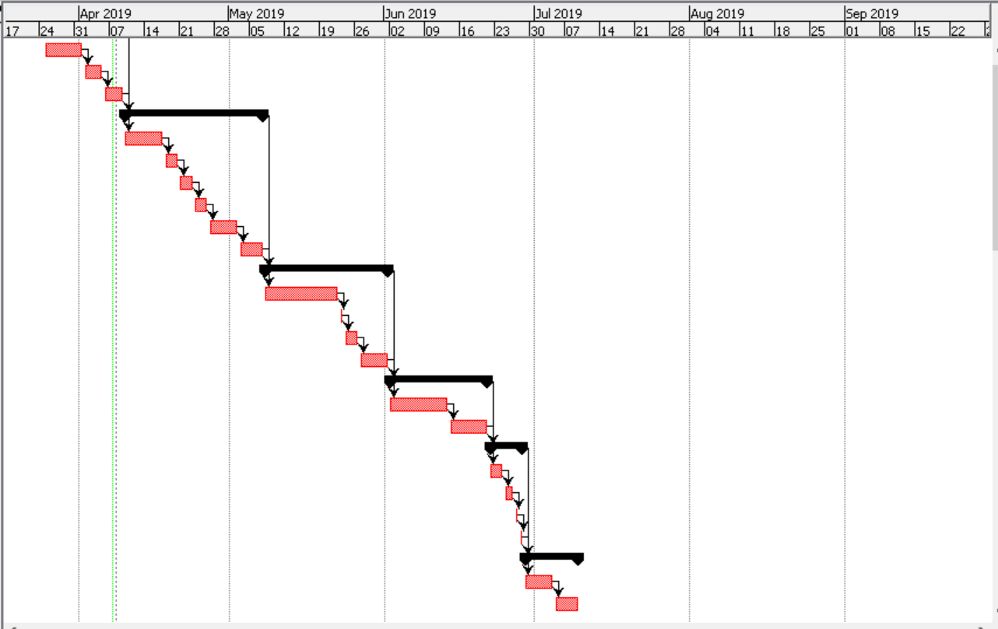

Figure : GANTT chart

# Chapter -5 RISK Management-:

Risk management is identification, evaluation and prioritization of risk followed by coordinated and economical application of resources to minimize, monitor, and control the probability or impact of unfortunate events or to maximize the realization of opportunities.

Following are the method to control risk in Project Management are -:

* Avoidance
* Reduction
* Sharing
* Retention

Impact = Likelihood * Consequence

Risk Likelihood values are shown as follows-:

|  |  |
| --- | --- |
| Likelihood | Value |
| Low | 1 |
| Medium | 2 |
| High | 3 |

Risk Consequence values are shown below

|  |  |
| --- | --- |
| Consequence | Value |
| Very low | 1 |
| Low | 2 |
| Medium | 3 |
| High | 4 |
| Very High | 5 |

Risk Consequence values are shown below

|  |  |  |  |  |  |
| --- | --- | --- | --- | --- | --- |
| S. No | Risks | Likelihood | Consequences | Impact | Solution |
| 1 | Bad Design | 2 | 4 | 8 | All required resources for the project should be rechecked. |
| 2 | Hard Disk Crash | 1 | 5 | 5 | Data must back up. |
| 3 | Natural Disaster | 2 | 5 | 10 | Data should be backup. |
| 4 | Wrong Time Estimation | 1 | 4 | 4 | Proper analysis before the estimation of work |
| 5 | Improper Planning | 1 | 3 | 3 | Training should provide for skills employees. |
| 6 | Continuously Changing Requirement | 2 | 4 | 8 | Proper planning should be done. |

# Chapter-6 Configuration Management

The deadline is rapidly approaching and the team is assembled, ready to implement the recent revision changes made to both the system hardware and software. The installation has gone well, and your team is making the final testing arrangements and preparing to demonstrate the results to the waiting clientele. The first test is executed and the initial screen display fails, panic erupts and your team scrambles to identify the problem. Within minutes the fault is identified. Due to inadequate configuration management procedures, the latest hardware and software revisions were uploaded and installed into a system with an outdated configuration, rendering the test a complete failure.

Importance of configuration management-:

* Increased efficiency
* Cost reduction
* Greater agility and faster problem
* Enhanced system and process reliability

Steps of Configuration Management are:-

* Identification of configuration manager
* Configuration Management Process
* Environment naming
* Execution of configuration management process
* Configuration tracking and metrics reporting

# Conclusion

In this project I have use PHP language. I have created Online Movie Ticket Management System. I have completed the proposal of my project. The aim of the project is to provide digital facilities to the customer and also to introduce technology to the user. Thus my proposal for the project is completed by this way.

# References-:

<https://www.izenda.com/5-benefits-3-tier-architecture/>

<https://en.wikipedia.org/wiki/Systems_architecture>

<https://www.interserver.net/tips/kb/mvc-advantages-disadvantages-mvc/>

<https://www.tutorialspoint.com/sdlc/sdlc_waterfall_model.htm>