**Testing**

Introduction

Software testing is defined as an activity to check whether the actual results match the expected results and to ensure that the software system is[defect](https://www.guru99.com/the-unconventional-guide-to-defect-management.html)free. It involves execution of a software component or system component to evaluate one or more properties of interest.

Importance of testing for the project are-:

* It helps to save money of the company.
* It provides security to the software.
* It helps to increase the product quality.
* It helps to make customer satisfy from the work of the organization.

For this project I would do two types of testing which are listed below-:

1. Unit testing
2. Black Box Testing
3. Unit testing

UNIT TESTING is a level of software testing where individual units/ components of a software are tested. The purpose is to validate that each unit of the software performs as designed.

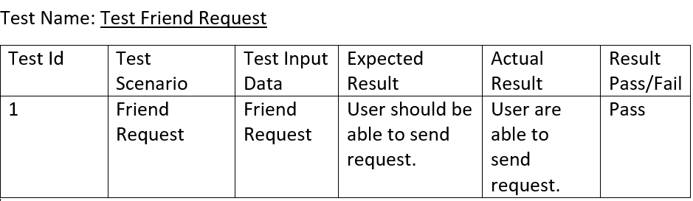

Figure friend request

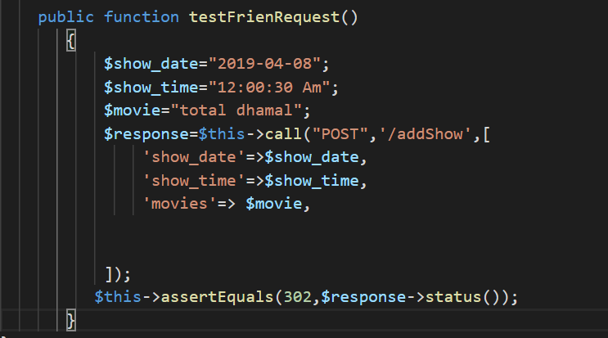

Figure test friend request

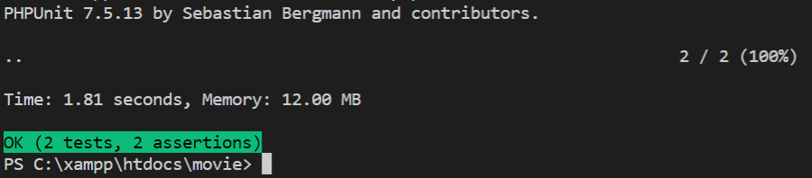

Figure test friend request sucessfull

Test Name: Change Password

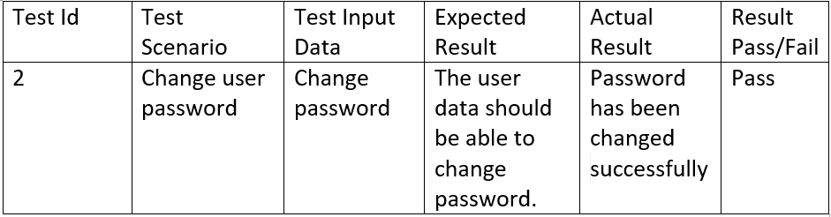

Figure Change password

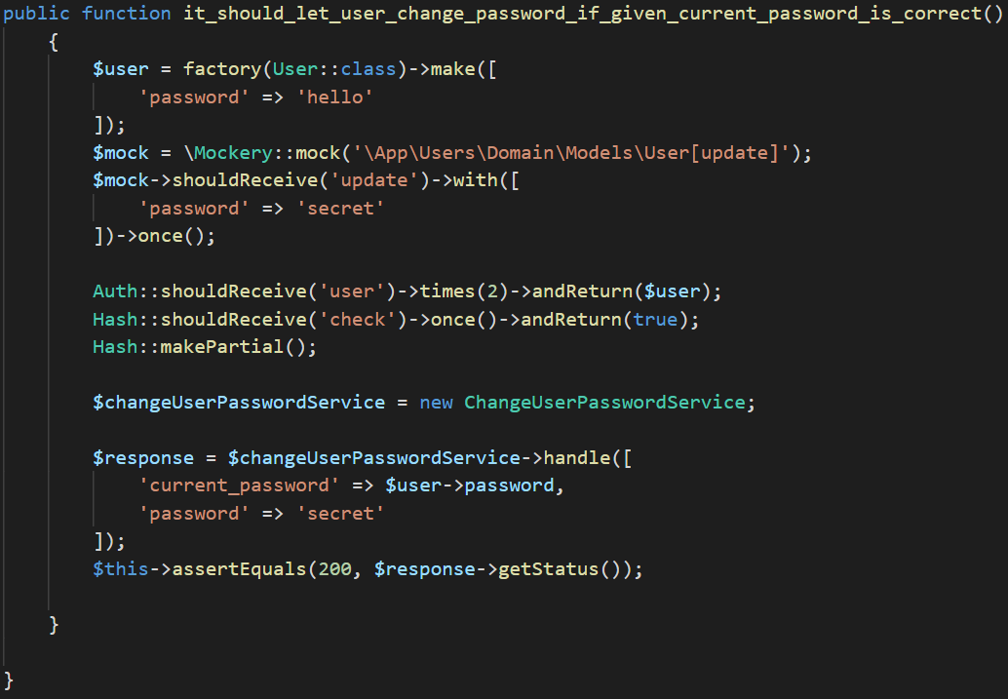

Figure Change Password

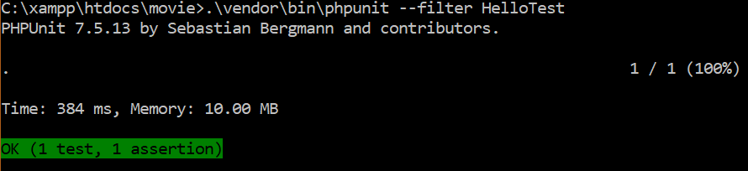

Figure change password successful

Test Name-: User Login

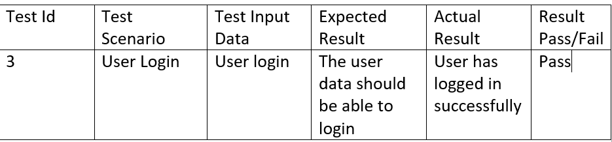

Figure User login

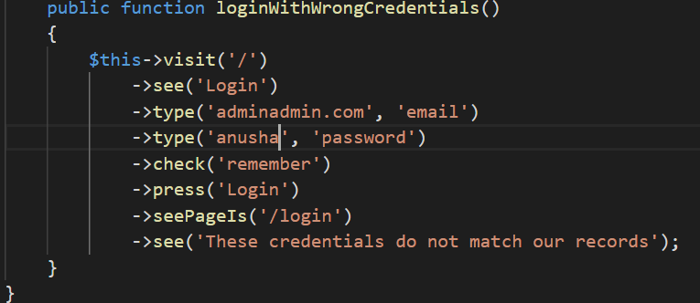

Figure User login

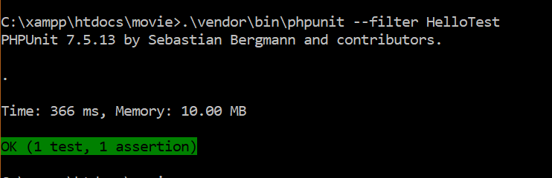

Figure user login

Test Name: Delete User

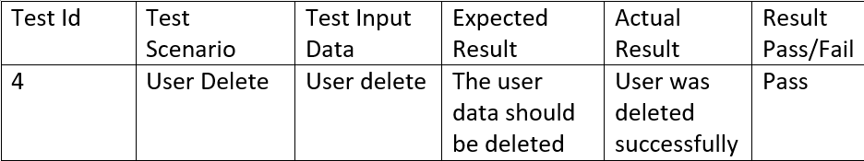

Figure user delete

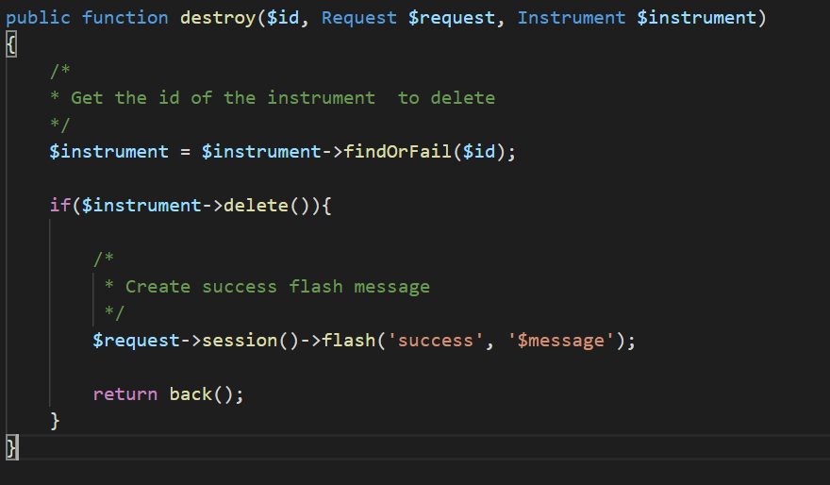

Figure delete

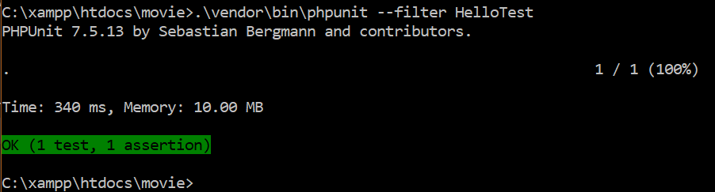

Figure user delete successfully

Test Name: Register User

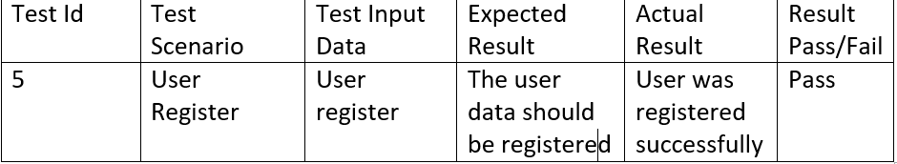

Figure user register

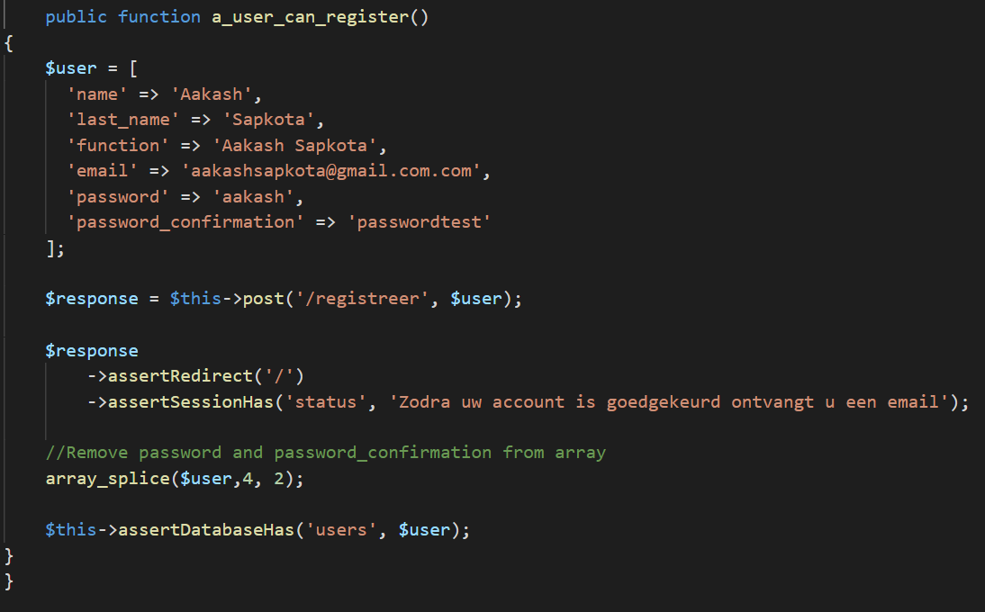

Figure user register

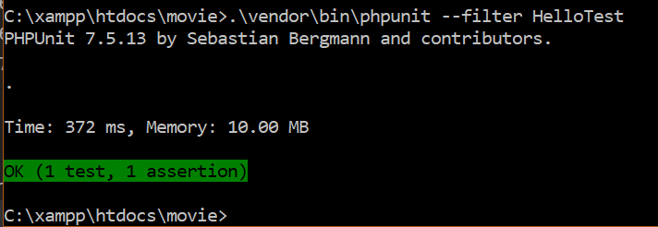

Figure user register successfully

Test Name: Choose Seat

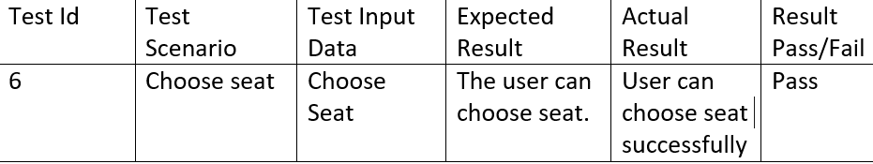

Figure choose seat

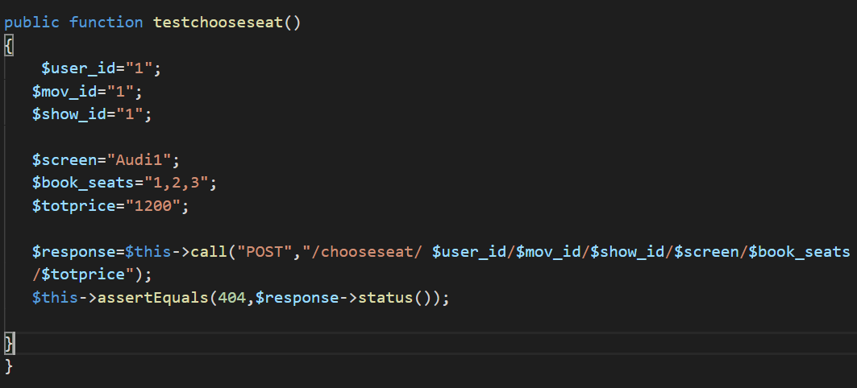

Figure choose seat

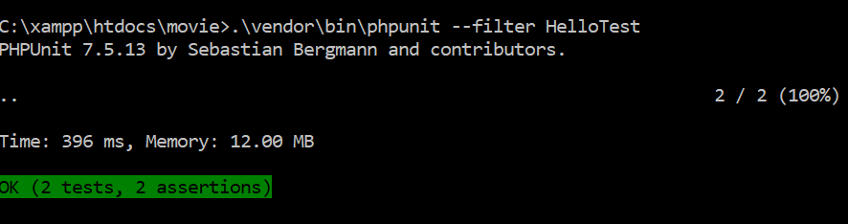

Figure Seat Choose successfully

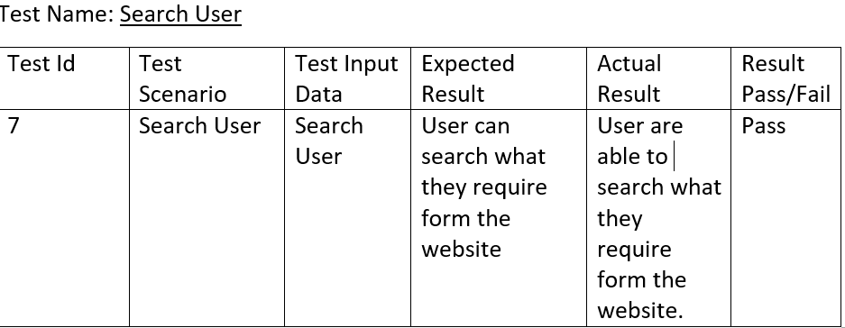

Figure Search User

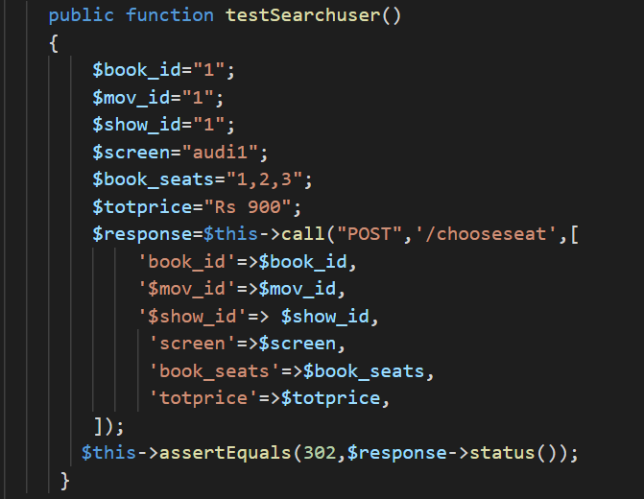

Figure test search user

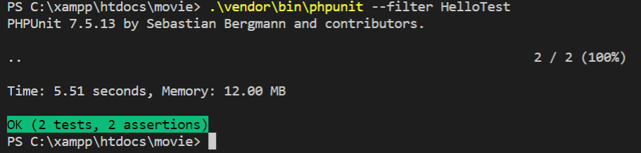

Figure search user

1. Black Box Testing-:

BLACK BOX TESTING, also known as Behavioral Testing, is a [software testing method](http://softwaretestingfundamentals.com/software-testing-methods/) in which the internal structure/design/implementation of the item being tested is not known to the tester.

For this project I would like to choose black box testing for the following reasons

* There is no requirement for code access, so it is easier to carry out
* Simplifies testing by focusing only on inputs and outputs
* Quicker test case development because only typical user experience is testing.

1. Test Name: Registration Test

Pre-condition: User must get registered into the system

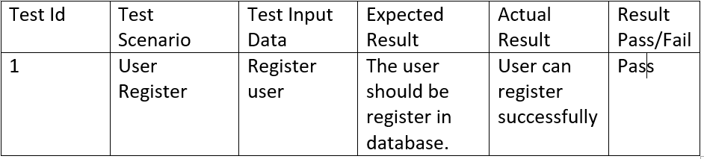

Figure user register

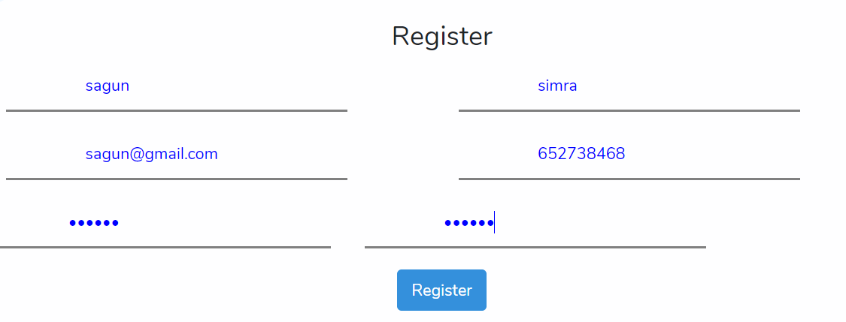

Figure Register



Figure Register

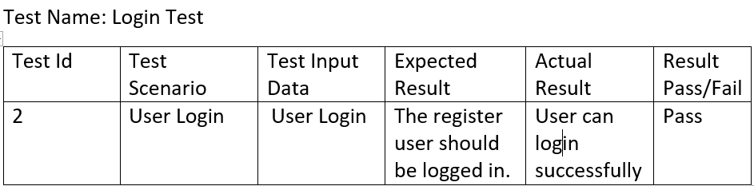

Figure login

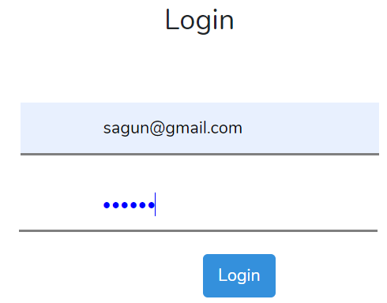

Figure Login

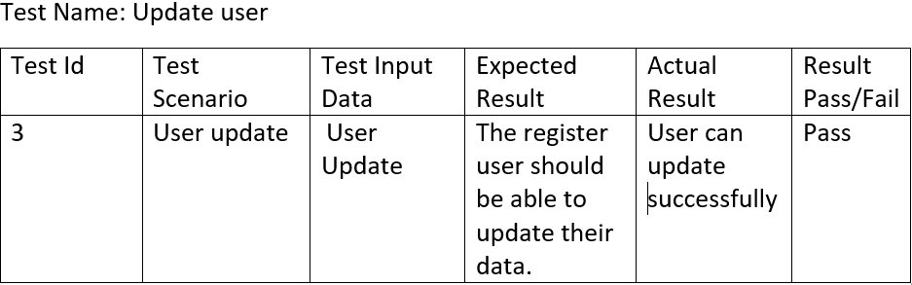

Figure update user

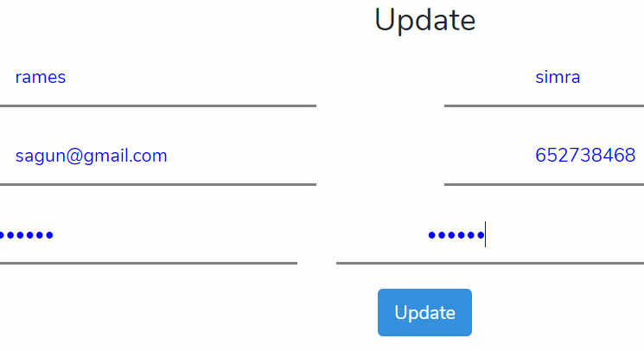

Figure Update



Figure update



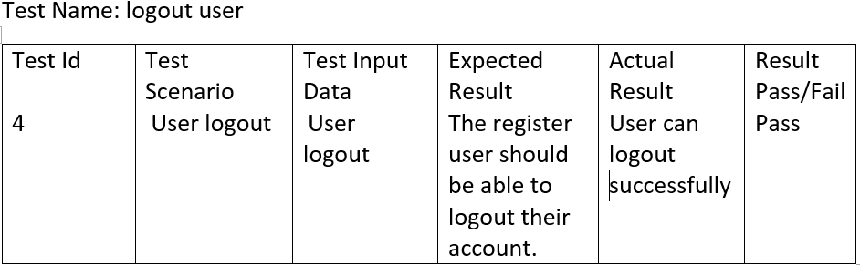

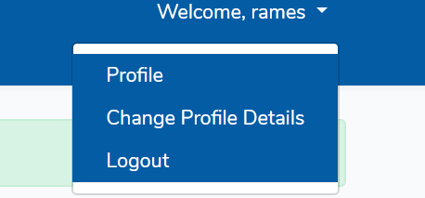

Figure logout

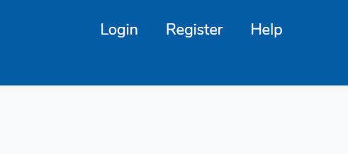

Figure logout

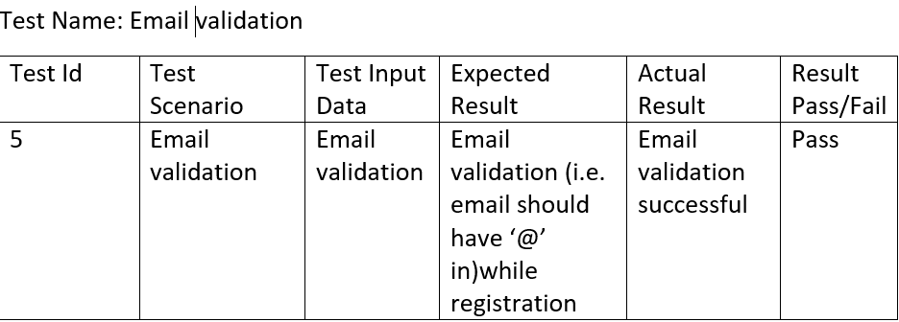

Figure email validation

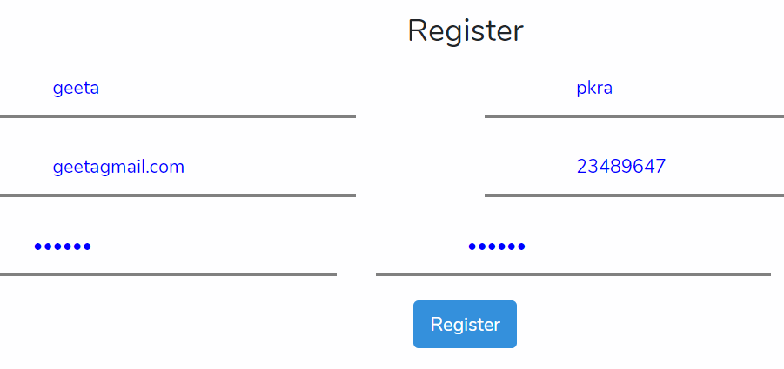

Figure email validation

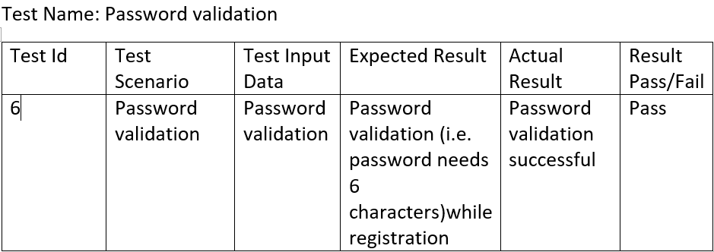

Figure password validation

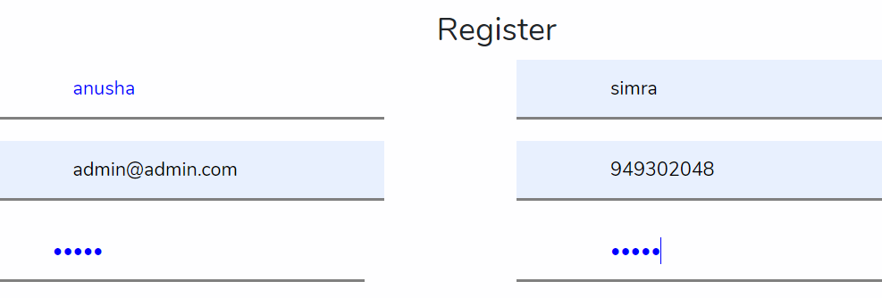

Figure Password validation

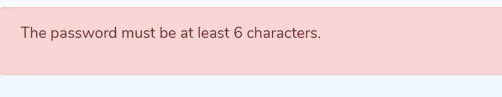

Figure Password validation

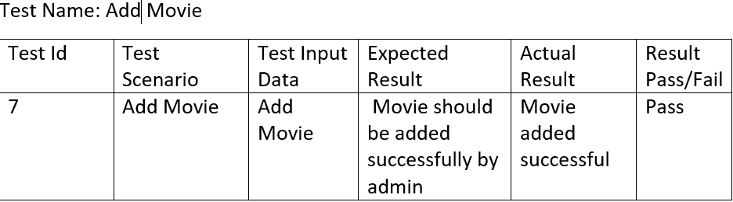

Figure add movie

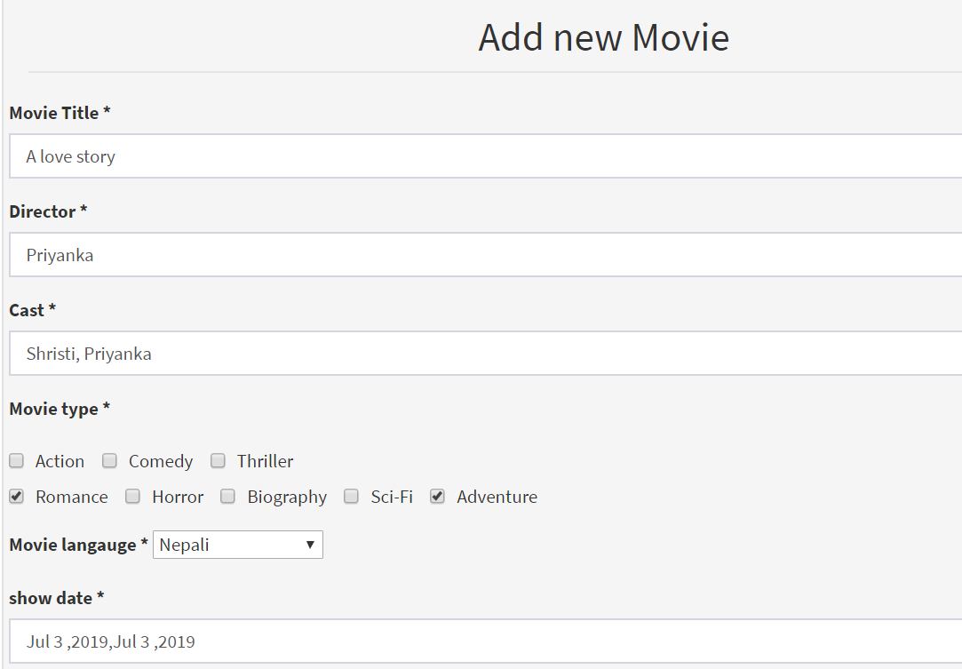

Figure test new movie



Figure test add movie



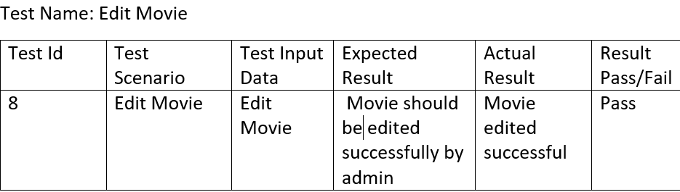

Figure Edit Movie

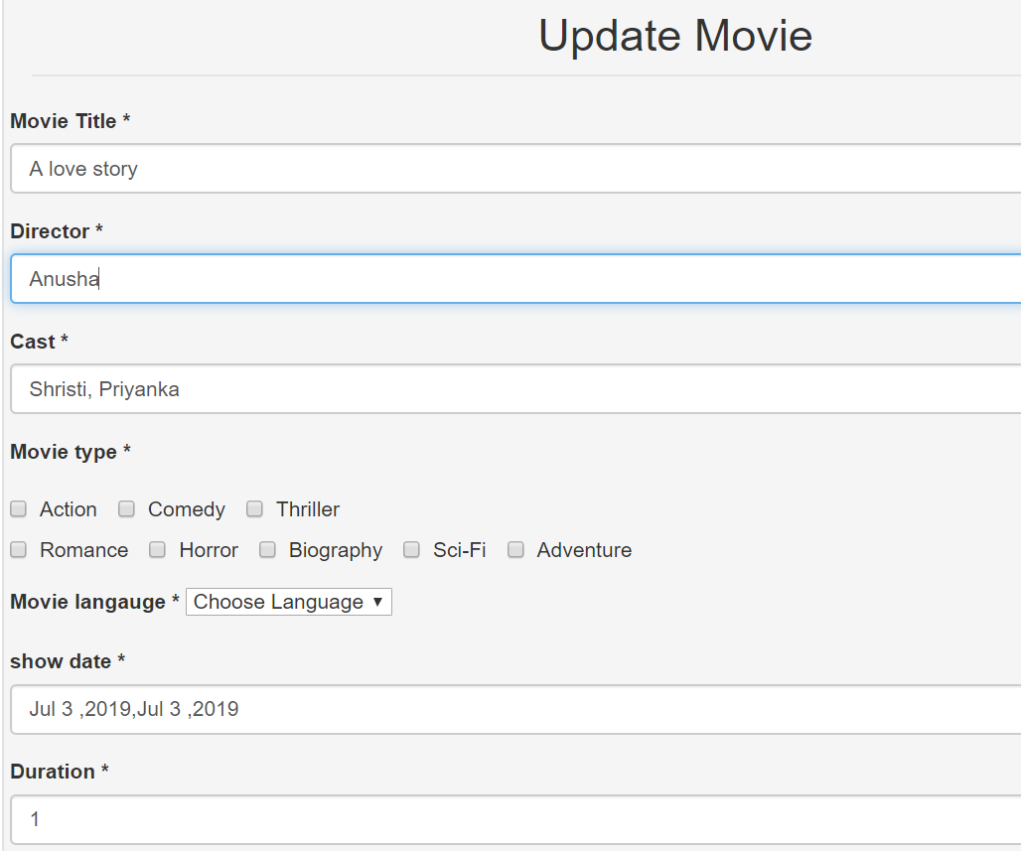

Figure Update Movie

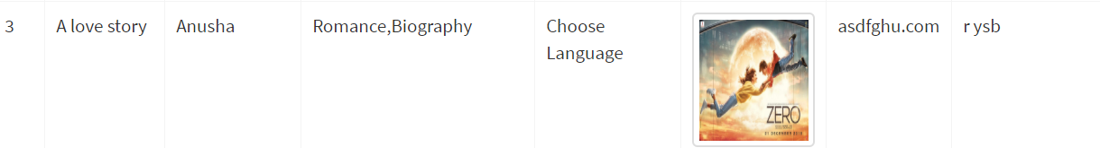

Figure Update Movie



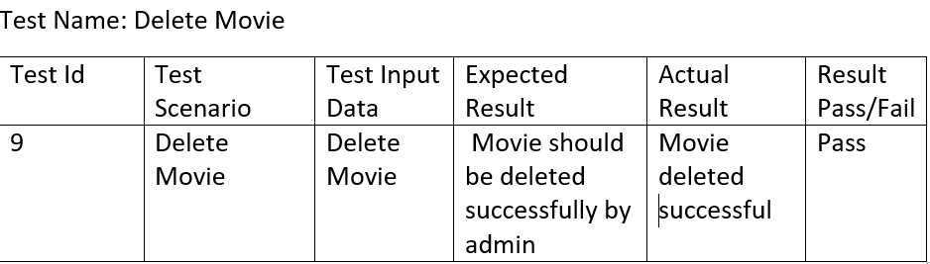

Figure delete movie

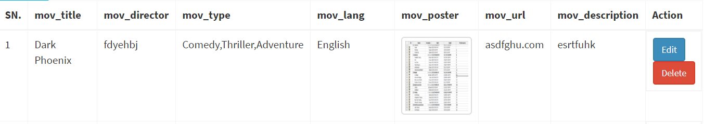

Figure Movie delete



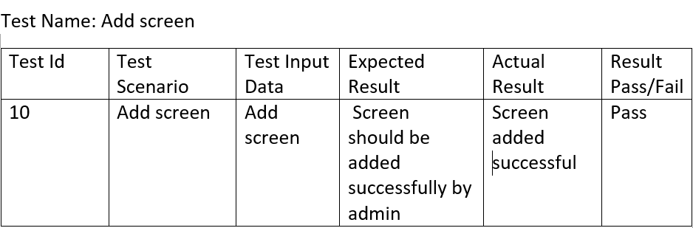

Figure add screen

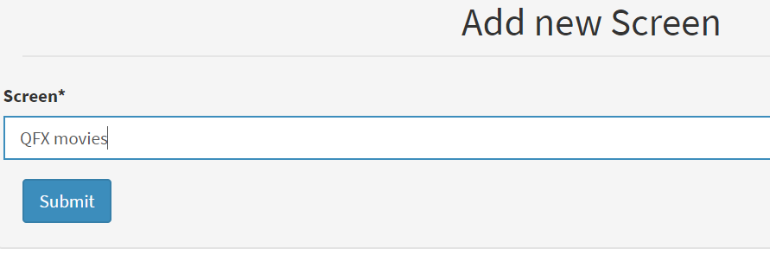

Figure add screen



Figure add screen



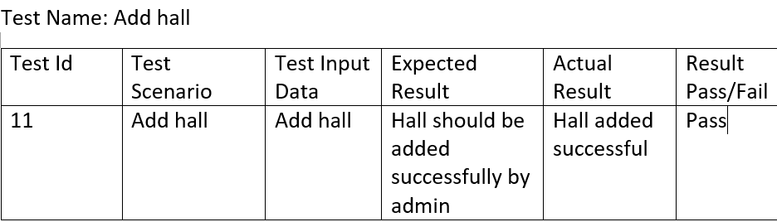

Figure add hall

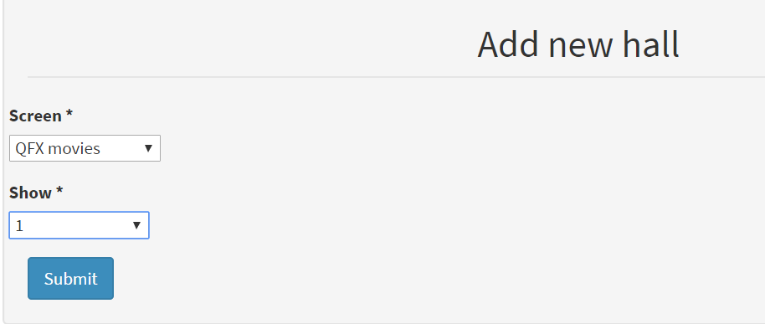

Figure add hall



Figure add hall



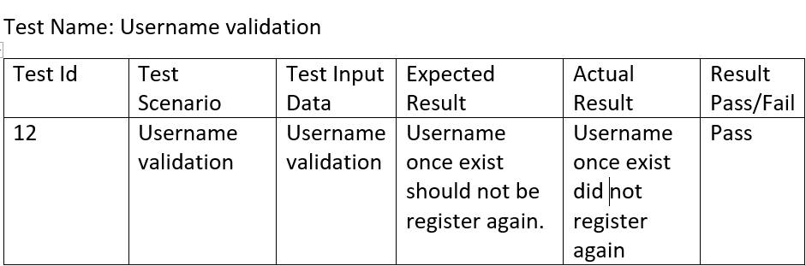

Figure user validation

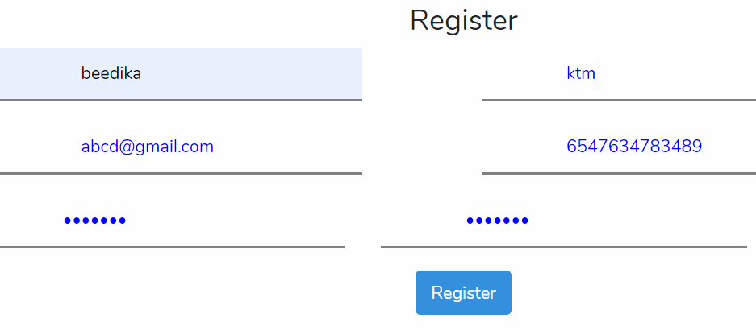

Figure Username validation

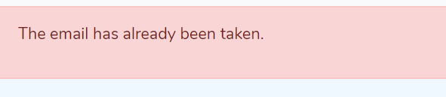

Figure Username validation



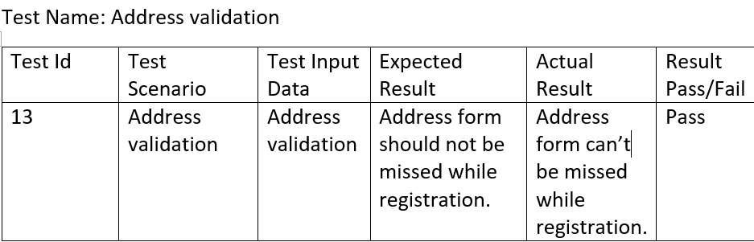

Figure Address validation

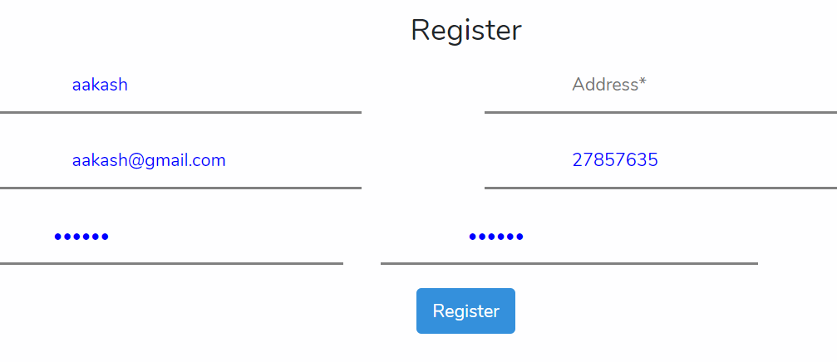

Figure address validation