# Project Name:

Smith Insights

# Group Members:

1. Helena Getachew (Group Leader)
2. Sharjeel Nawaz
3. Anusha Aligeti
4. Ei Aung

# Mission Statement:

To organize all necessary data sourced through several ranking agents about the overall rank of all the graduate programs at the University of Maryland’s Robert H. Smith School of Business between 2021-2023. To build insights about program characteristics associated with higher ranks for more tailored strategies aimed at increasing program rank.

# Mission Objective:

The project has 4 key objectives, however functionality of the database is dynamic and goes beyond following points:

1. To determine ***what factors are prioritized*** more heavily in a particular ***source’s ranking***

of a program

1. To determine the ***programs that improved*** in ranking within the past 3 years and examine their **characteristics**
2. To determine if ***higher statistics*** (average GPA, average starting salary, employment rate etc.) impacts a program’s ranking
3. To determine if ***high numbers of faculty*** impacts a program’s ranking

# Business Terms, Facts, Attributes and Identifiers:

We are consulting the University of Maryland Robert H. Smith School of Business on their graduate school program rankings from various organizations in 2021-2023. A database is required to keep track of all programs, program ranks provided by various sources, the rank source, students enrolled within each program, and faculty employed by each program. Every program has a unique program ID and is required to store the program name, degree type (M.S. or MBA), program type (Full-Time or Part-Time), average starting salaries from 2020-2023, percentage job growth, number of credits, average GPA, and number of faculty. Every year, a source ranks a program, and the year and source information are stored. Each source has its own unique source ID, source name, and source type (International or Domestic) will also be stored. The source releases a rank, and the ranking is recorded. Data on the students enrolled in each program must also be stored. Students enroll in programs. Each student has their own unique student ID and their first name, middle initial, last name, GPA, GMAT score (if any), GRE score (if any), start date (enrollment year and semester), and end date (expected graduation year and semester). When a student enrolls into a program, an enrollment date is recorded. Finally, faculty members are employed by programs. A faculty member can be employed by more than one program, and each student is taught by at least one faculty member. Faculty members have their own unique faculty ID and the faculty first name, middle initial, last name, course that they teach, designation (assistant professor, professor, dean, program director), and email address should also be stored.

# ER Schema & Diagram:

Source (**souId**, souName**,** souRankType)

Program(**prId**, prName, prDegType,prType,prEmpRate,prAvgStartSalary, prPercentJobGrowth, prNumofCredits, prAvgGPA, prNumOfFaculty)

Student(**stuId**, stuName, -stuFirstName, -stuMidInitial, -stuLastName, stuGPA, stuGMAT, stuGRE, stuStartDate, -stuEnrollYear, -stuSemester, stuEndDate, -stuGradYear, - stuGradSemester)

Faculty(**facId**, facName, -facFirstName, -facMidInitial, -facLastName, facCourse, facDesgination, facEmailAddress)

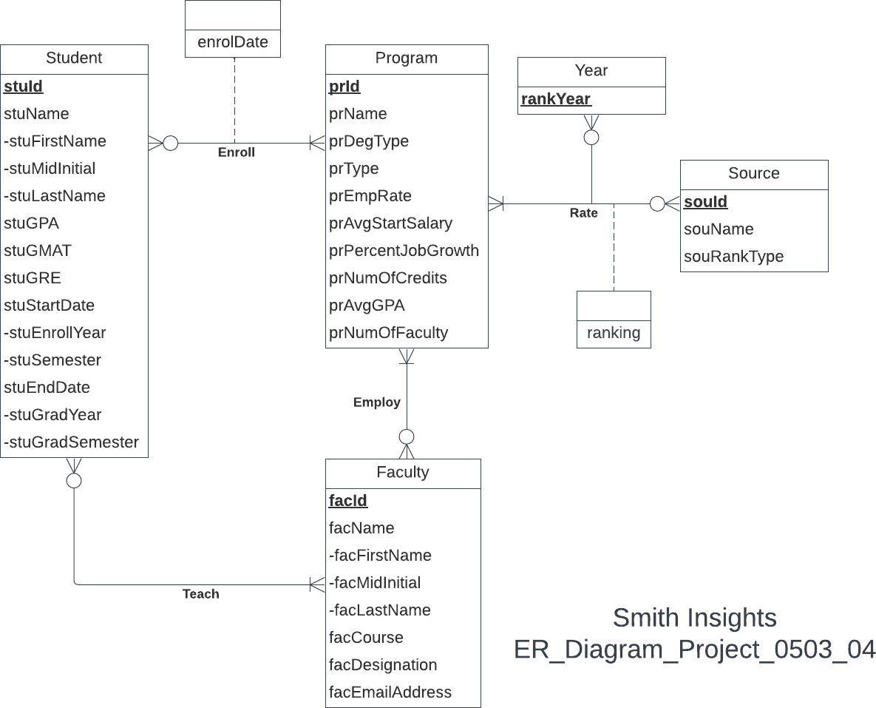

# Relational Schema:

**Enroll (enrolDate)**: binary relationship | Many-to-Many 1 Student enrolled in 1 or more Programs

1 Program has 0 or more Students enrolled

**Rate (ranking)**: ternary relationship | Many-to-Many 1 Source and 1 Year to 1 or more Programs

1 Program and 1 Year to 0 or more Sources 1 Source and 1 Program to 0 or more Years

**Teach**: binary relationship | Many-to-Many

1 Faculty member teaches 0 or more Students

1 Student is taught by one or many Faculty members

**Employ**: binary relationship | Many-to-Many

1 Faculty member is employed by 1 or more Programs 1 Program employs 0 or more Faculty members

# Relations:

Source (**souId**, souName, souRankType) Year(**rankYear**)

Program(**prId**, prName, prDegType, prType, prEmpRate, prAvgStartSalary, prPercentGrowth, prNumofCredits, prAvgGPA, prNumofFaculty)

Student(**stuId***,* stuFirstName, stuMidInitial, stuLastName, stuGPA, stuGRE, stuGMAT, stuEnrollYear, stuSemester, stuGradYear, stuGradSemester)

Faculty(**facId***,* facFirstName,facMidInitial, facLastName, facCourse, facDesgination, facEmailAddress)

Rate(***prId, souId*, *rankYear,*** ranking) Enroll(***stuId, prId****,* enrolDate) Employ(***facId, prId***)

Teach (***facId, stuId***)

# Functional Dependencies

souId → souName, souRankType

prId → prName, prDegType, prType, prEmpRate, prAvgStartSalary, prPercentJobGrowth, prNumOfCredits, prNumOfFaculty

facId → facFirstName, facMidInitial, facLastName, facCourse, facDesignation, facEmailAddress

stuId → stuFirstName, stuMidInitial, stuLastName, stuGPA, stuGMAT, stuGRE, stuEnrollYear, stuEnrollSemester, stuGradYear, stuGradSemester

rankYear →

prId, souId, rankYear → ranking stuId, prId → enrolDate

facId, prId →

facId, stuId →

# Business Rules & Referential Integrities

[R1]: When a student is deleted in the database, the enrollment date for the student in a program is not deleted.

[R2]: When a student is updated in the database, their corresponding enrollment date in a program should be updated as well.

[R3]: If a program is deleted, the student enrollment records for that program should not be deleted.

[R4]: If a program is updated in the database, the student enrollment records for that program should be updated.

[R5]: When a faculty member is teaching a student, the faculty and the student cannot be deleted or changed in the database.

[R6]: When there is a ranking issued on a program by one source in one year, the program, the source, and the year cannot be deleted or changed in the database.

[R7]: When a program employs a faculty member, the information about that faculty member and the program cannot be changed or deleted in the database.

|  |  |  |  |  |  |  |  |
| --- | --- | --- | --- | --- | --- | --- | --- |
| Relation | Foreign Key | Base Relation | Primary Key | Business Rule | Constraint: ON  DELETE | Busines s Rule | Constraint: ON  UPDATE |
| Enroll | stuId | Student | stuId | R1 | NO  ACTION | R2 | CASCAD  E |
| Enroll | prId | Program | prId | R3 | NO  ACTION | R4 | CASCAD  E |
| Teach | stuId | Student | stuId | R5 | NO  ACTION | R5 | NO  ACTION |
| Teach | facId | Faculty | facId | R5 | NO  ACTION | R5 | NO  ACTION |
| Rate | prId | Program | prId | R6 | NO  ACTION | R6 | NO  ACTION |
| Rate | souId | Source | souId | R6 | NO  ACTION | R6 | NO  ACTION |
| Rate | rankYear | Year | rankYear | R6 | NO  ACTION | R6 | NO  ACTION |
| Employ | facId | Faculty | facId | R7 | NO  ACTION | R7 | NO  ACTION |
| Employ | prId | Program | prId | R7 | NO  ACTION | R7 | NO  ACTION |

# Sample Data:

Student:

('111111111', 'Rohit', NULL, 'Abbireddi', NULL, NULL, NULL, '2023', 'Fall', '2024', 'Spring' )

Faculty:

('800000001', 'Suresh', NULL, 'Acharya', NULL, 'Professor', ['suresh12@umd.edu'](mailto:%27suresh12@umd.edu) )

Program:

('MSIS', 'Information Systems', 'MS', 'Full Time', 93, 85666, 16,

30, 3.5, 9)

Source:

('1', 'U.S. News', 'International')

Year:

('2021')

Rate:

('MSCM', '2', '2021', 24)

Enroll:

('111111111', 'MSIS', NULL)

Teach**:**

('800000088', '111111111' )

Employ**:**

('800000001', 'MSBA')