

Report On
Design and Implementation of an Information Retrieval System

Submitted To
Dr. Radhika M Pai
Department of Computer Science & Engineering

Submitted By
Anusha A Naik (251090130032)
II semester, M.Tech CSE

Table of Contents

Chapter | Title | Page No.
1 | Abstract | 1
2 | Introduction | 1
3 | Dataset Description | 1
4 | Methodology | 1-2
4.1 | Text Preprocessing and Indexing | 1
4.2 | Tolerant Retrieval | 1
4.3 | Index Compression | 2
4.4 | Term Weighting and Vector Space Model | 2
4.5 | Scoring and Complete Search System | 2
4.6 | Relevance Feedback via Rocchio Algorithm | 2
5 | System Implementation | 3
6 | Results | 3-4
6.1 | Spelling Correction | 3
6.2 | TF-IDF and cosine similarity ranking | 3
6.3 | Rocchio Query Expansion | 4
7 | Conclusion | 4
8 | References | 4

- Abstract
This project details the end-to-end development of a custom Information Retrieval (IR) system from scratch. The objective was to practically implement the core algorithms of IR, spanning from basic Boolean indexing to advanced Vector Space ranking and query expansion. The system was built using Python and evaluated on the standard Cranfield dataset collection. Key features include text preprocessing, Levenshtein based spelling correction, Variable-Byte index compression, TF-IDF scoring with Cosine similarity, and Rocchio Pseudo-Relevance Feedback. Finally, the engine was deployed via a FastAPI backend to provide an interactive graphical user interface.
- Introduction
Information Retrieval (IR) is the science of searching for documents, information within documents, and metadata about those documents. Modern search engines rely on complex pipelines to ensure both high-speed retrieval and high-quality ranking. The goal of this project is to demonstrate a deep practical understanding of fundamental IR concepts by building a complete search engine.
- Dataset Description
To accurately build and evaluate the system, the Cranfield Collection was used. This is a pioneering IR test collection consisting of:
- 1,400 documents: Scientific abstracts related to aerodynamics.
- 225 test queries: Standardized user search queries.
- Relevance Judgments: A ground-truth mapping of which documents are mathematically relevant to which queries, enabling rigorous system evaluation.

- Methodology
The system architecture was developed sequentially, corresponding to standard IR processing stages.
4.1. Text Preprocessing and Indexing
Raw text cannot be efficiently searched. The dataset was passed through a Natural Language Processing (NLP) pipeline using the NLTK library:
- Tokenization & Case Folding: Converting text to lowercase and splitting it into tokens.
- Stopword Removal: Eliminating non-informative words (e.g., "the", "is", "at").
- Stemming: Applying the Porter Stemmer algorithm to reduce terms to their morphological roots (e.g., "aerodynamics" to "aerodynam").
An Inverted Index was then constructed, mapping each of the 4,391 unique dictionary terms to a sorted list of Document IDs.
Code Snippet 1: Preprocessing Pipeline
def preprocess_text(text):
tokens = word_tokenize(text.lower())
return [stemmer.stem(w) for w in tokens if w.isalnum() and w not in stop_words]
4.2. Tolerant Retrieval
To handle user typos and misspelled queries, the system implements Tolerant Retrieval using the Levenshtein Edit Distance algorithm. If a query term is not present in the dictionary, a dynamic programming matrix calculates the minimum edits (insertions, deletions, substitutions) required to match an existing dictionary term, automatically suggesting the correction.
Code Snippet 2: Levenshtein Distance Matrix
def levenshtein_distance(s1, s2):
m, n = len(s1), len(s2)
dp = [[0] * (n + 1) for _ in range(m + 1)]
for i in range(m + 1): dp[i][0] = i
for j in range(n + 1): dp[0][j] = j
for i in range(1, m + 1):
for j in range(1, n + 1):
cost = 0 if s1[i - 1] == s2[j - 1] else 1
dp[i][j] = min(dp[i - 1][j] + 1, dp[i][j - 1] + 1, dp[i - 1][j - 1] + cost)
return dp[m][n]
4.3. Index Compression
To minimize memory footprint, the postings lists were compressed. Absolute Document IDs were first converted using Delta Encoding to represent the numerical gaps between IDs. As gap integers are generally small, Variable Byte (V-Byte) Encoding was applied, compressing standard 32-bit integers into 8-bit bytes using a continuation bit. Testing on high-frequency terms demonstrated a 75% reduction in memory storage.
4.4. Term Weighting & Vector Space Model
To transition from exact Boolean matches to Ranked Retrieval, the system utilizes the Vector Space Model (VSM).
- TF-IDF Weighting: Terms were weighted using Log-frequency Term Frequency and Inverse Document Frequency.
- Every document and user query is represented as a high-dimensional mathematical vector based on these term weights.
4.5. Scoring and Complete Search System
Documents are ranked based on their Cosine Similarity to the user's query vector. To optimize retrieval speed, Index Elimination is used. The system calculates the dot product only for documents that contain at least one term present in the query.
4.6. Relevance Feedback via Rocchio Algorithm
To improve the system's Recall, Pseudo-Relevance Feedback was integrated. When enabled, the system assumes the top-retrieved documents are highly relevant. It calculates the vector centroid of these documents, extracts the highest-weighted missing terms, and adds them to the original query.
Code Snippet 3: Rocchio Expansion Logic
# Calculate centroid of pseudo-relevant documents
for d in rel_docs:
for t, w in doc_vectors[d].items():
centroid[t] = centroid.get(t, 0.0) + float(w)
for t in centroid:
centroid[t] = float((centroid[t] / len(rel_docs)) * 0.75)
# Extract top terms to append to the user's query
sorted_new_terms = sorted(candidate_new_terms.items(), key=lambda x: x[1], reverse=True)[:2]
rocchio_terms = [str(t[0]) for t in sorted_new_terms]

- System Implementation
The core IR algorithms were wrapped in a FastAPI web framework. A Jinja2 HTML template was used to create an interactive, web-based search interface, allowing for real-time querying, pagination (top 10 results out of all matches), and dynamic toggling of the Rocchio algorithm. The system's retrieval effectiveness was analysed using standard IR metrics Precision and Recall. As Precision and Recall share an inverse trade-off, the system relies on Mean Average Precision (MAP), a unified metric that calculates the average precision across all recall levels for all 225 Cranfield queries.
6. Results
6.1. Spelling Correction Demonstration
When a user inputs a query with a typographical error, the system successfully intercepts it, calculates the Levenshtein distance, and proceeds with the corrected query.
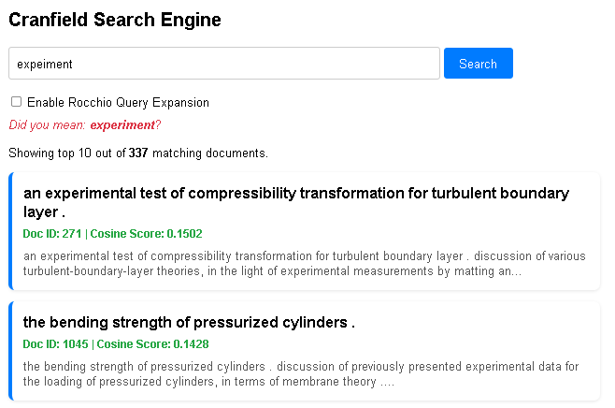
Fig 6.1 spelling correction
6.2. TF-IDF and Cosine Similarity Ranking
The baseline Vector Space Model accurately ranks documents. The stemmer successfully groups variations of words (e.g., searching "fly" retrieves documents containing "flight").
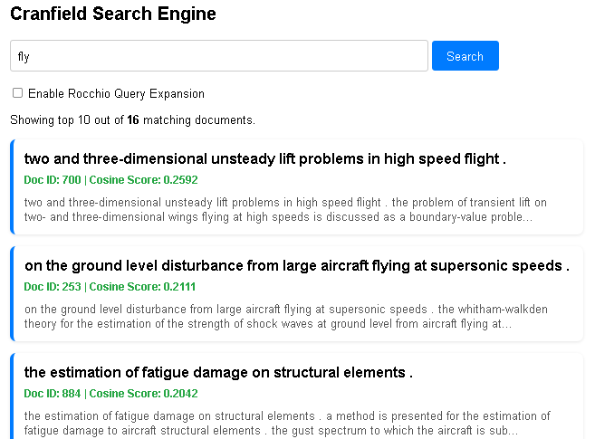
Fig 6.2: document ranking

6.3. Rocchio Query Expansion
When Pseudo-Relevance Feedback is enabled, the system successfully extracts domain-specific terminology from the initial results and expands the user's search, effectively increasing Recall.
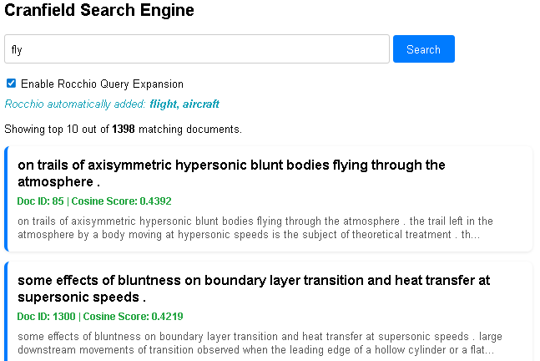
Fig 6.3 Rocchio Query Expansion

- Conclusion
The fundamental concepts of information retrieval were effectively put together in this work. By integrating NLTK preprocessing, it demonstrated the mathematical feasibility of the Vector Space Model, the memory efficiency of V-Byte encoding, and the accuracy improvements provided by Rocchio Relevance Feedback. The deployment of the engine via FastAPI demonstrates that the theoretical concepts covered can be successfully combined to build a modern, production-ready search architecture.
References
- C. D. Manning, P. Raghavan, and H. Schütze, Introduction to Information Retrieval. Cambridge, U.K.: Cambridge University Press, 2009.
- “Cranfield experiments,” Wikipedia. [Online]. Available: https://en.wikipedia.org/wiki/Cranfield_experiments
- J. Zobel and A. Moffat, "Inverted files for text search engines," ACM Computing Surveys (CSUR)ACM Computing Surveys (CSUR), vol. 38, no. 2, pp. 6–es, 2006.
- S. Bird, E. Klein, and E. Loper, Natural Language Processing with Python, O'Reilly Media, 2009.
- "Mean Average Precision (mAP) Explained," Built In, 2024. [Online]. Available: https://builtin.com/articles/mean-average-precision.

