**Plug-in Registration**

* **Download developer tool kit by following the instructions here**

https://docs.microsoft.com/en-us/dynamics365/customerengagement/on-premises/developer/download-tools-nuget?view=op-9-1

* **Install Dynamics 365 Developer Toolkit with Visual Studio 2015**

<https://community.dynamics.com/365/b/dynamics365fordevelopers/posts/install-dynamics-365-developer-toolkit-with-visual-studio-2017>

* Clone the project source code from GitHub From the repository Dynamics-for-USF and branch is “develop”.
* If you have to open the project, select open, project/solution

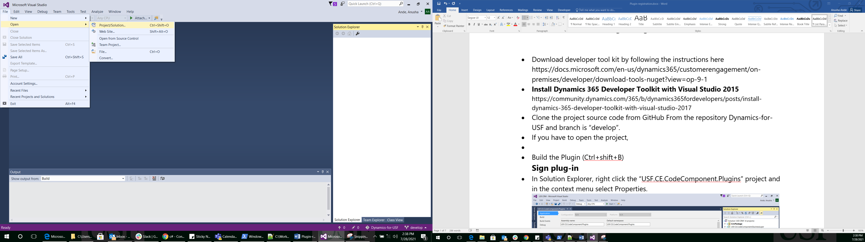

* Navigate to the folder where the project is cloned to

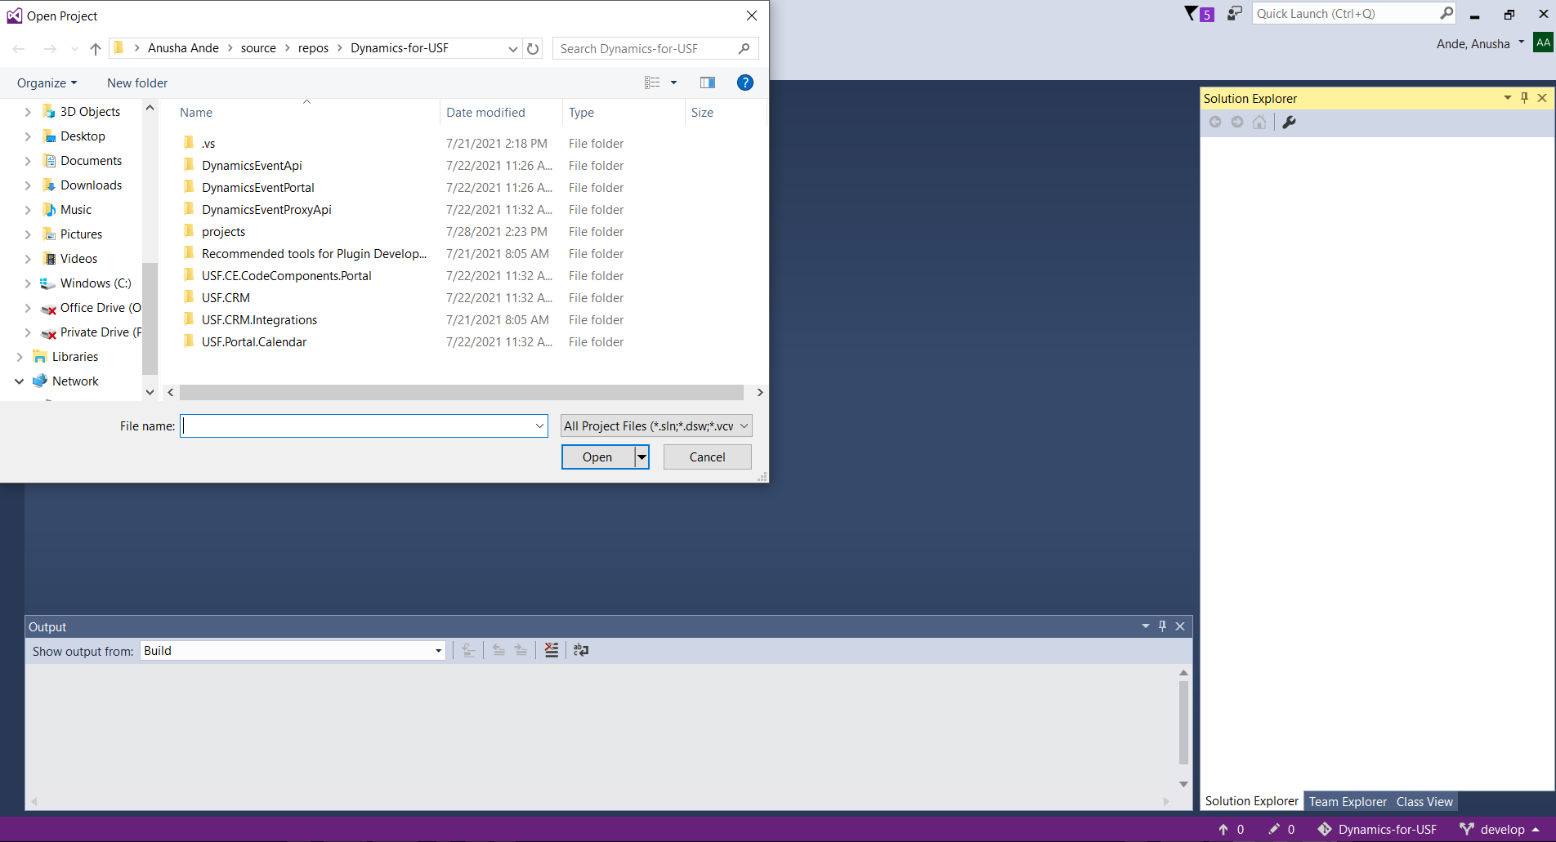

* Go to USF.CRM folder and double click on USF.CRM.sln

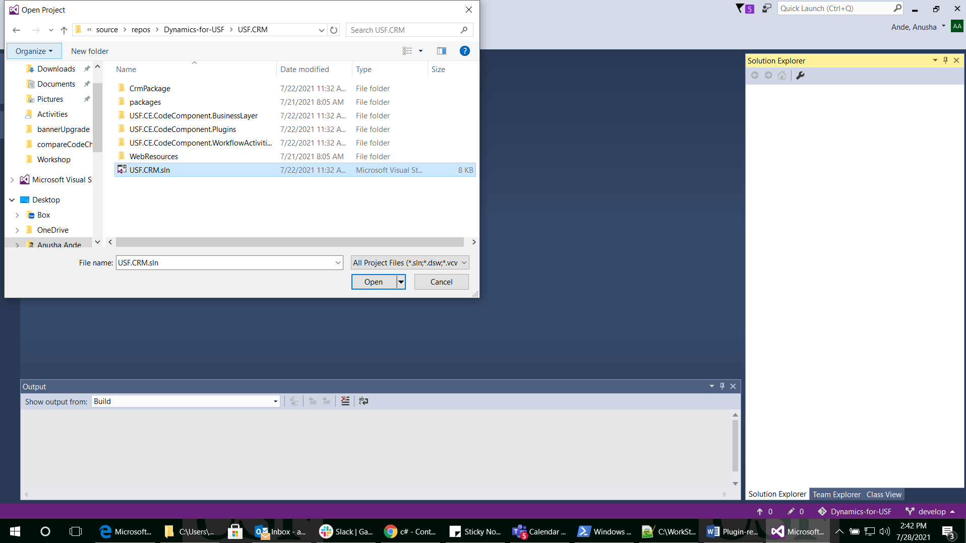

* Ignore the message you see here and click on cancel button

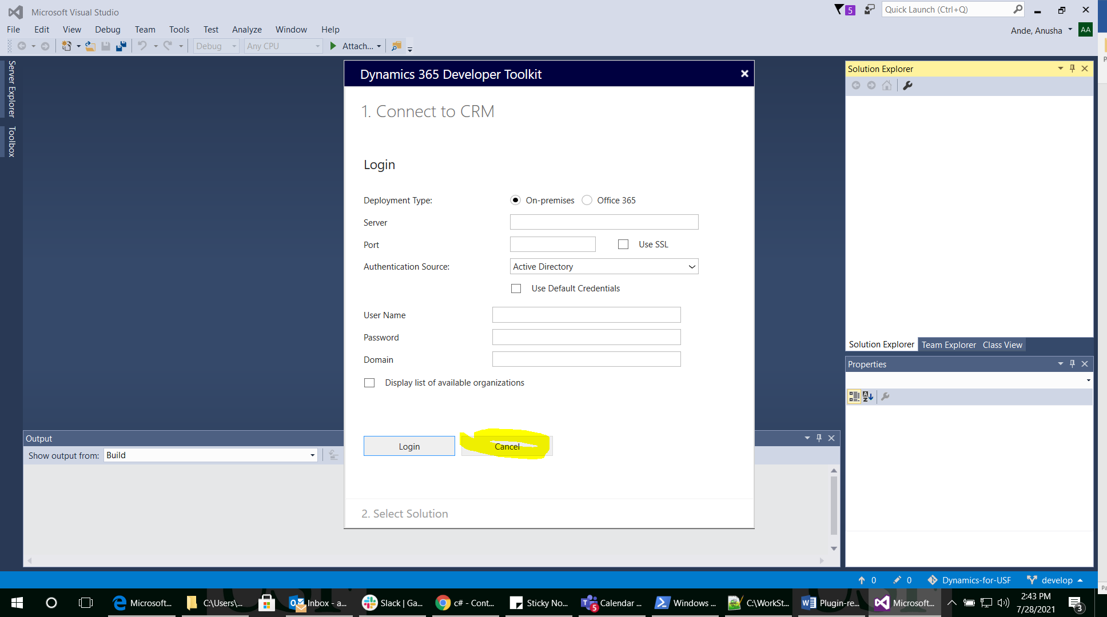

* Build the Plugin (Ctrl+shift+B)

**Sign plug-in**

* In Solution Explorer, right click the “USF.CE.CodeComponent.Plugins” project and in the context menu select Properties.

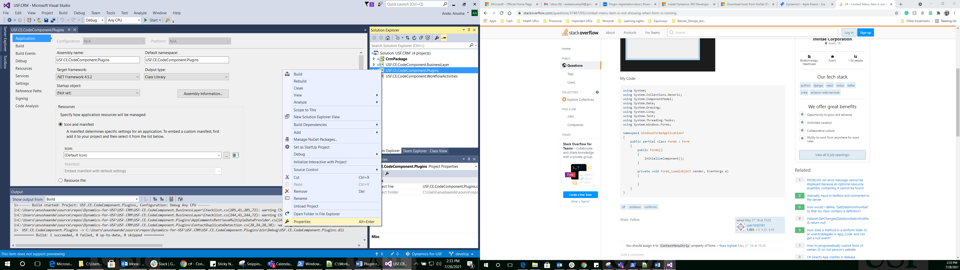

* In the project properties, select the Signing tab and Sign the assembly checkbox.

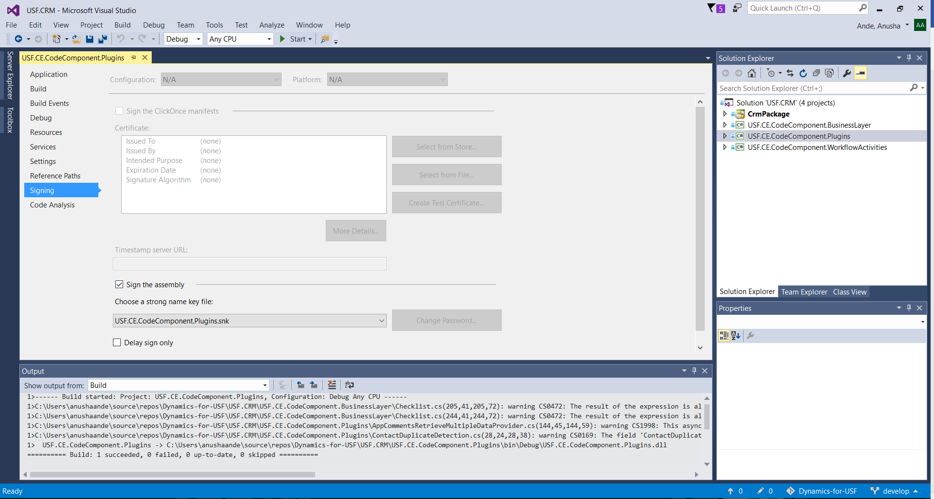

* In the Choose a strong name key file: dropdown, select USF.CE.CodeComponent.Plugins.snk and Click **OK**.
* In the project properties **Build** tab, verify that the **Configuration** is set to Debug.

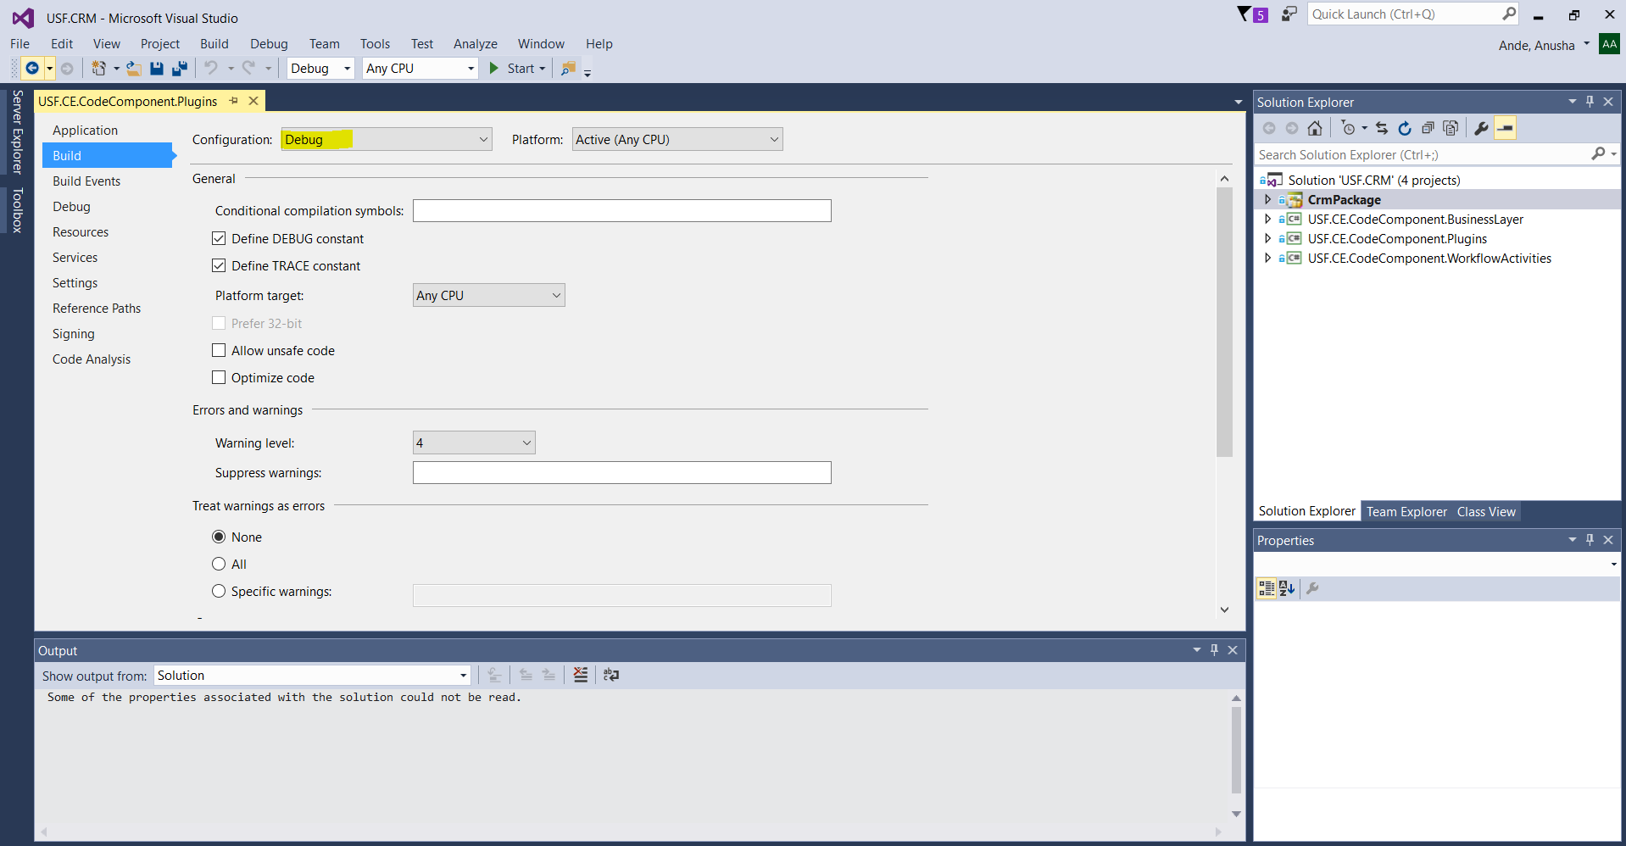

* Once the plugin code is built successfully, you will be able to find the dll file in the location mentioned in build log. (Usually its C:\Users\username\source\repos\Dynamics-for-USF\USF.CRM\CrmPackage\bin\Debug\USF.CRM.CrmPackage.dll)

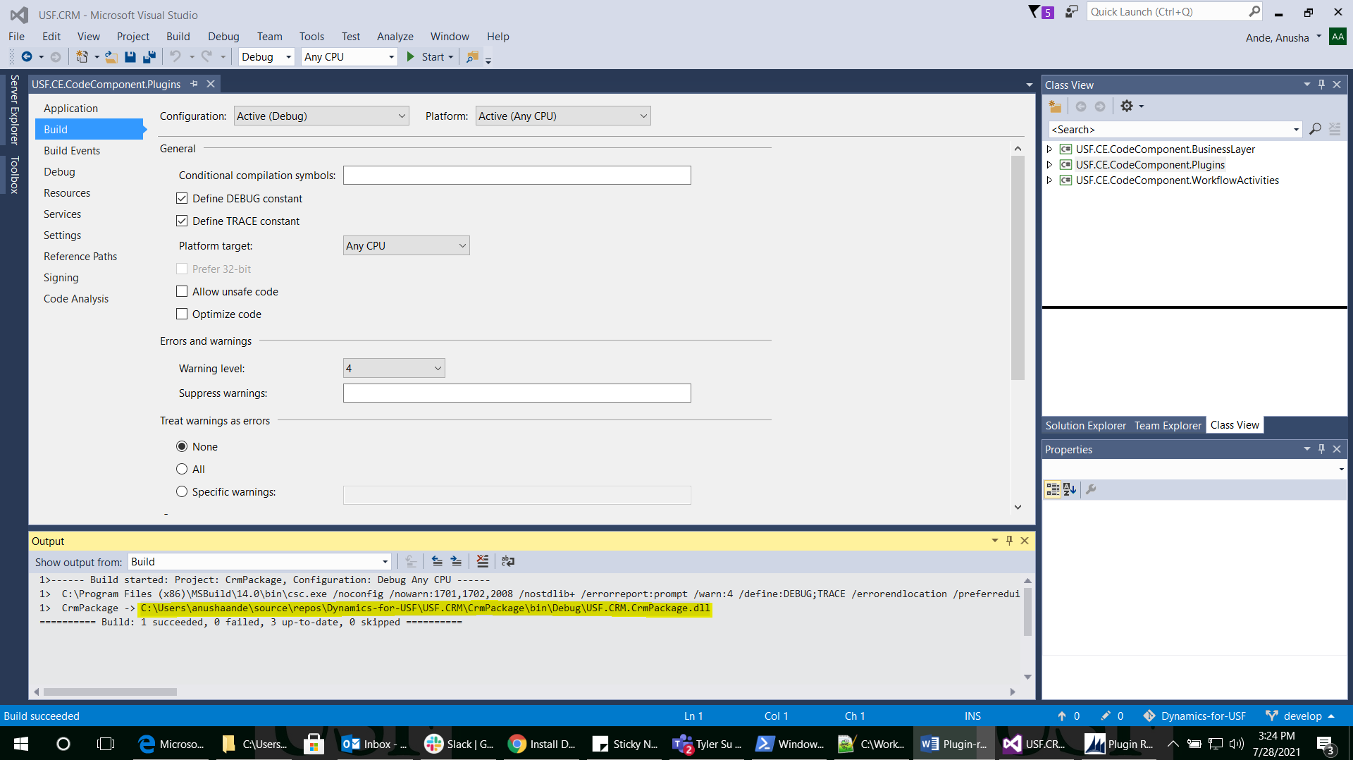

**Register Plug-in**

* To register a plug-in, you will need the plug-in registration tool

Go to Dynamics 365 Developer Toolkit and Click the Pluginregistration.exe to open it.

* Click Create new Connection to connect to instance.
* Make sure Office 365 is selected and check the box against “Display list of available regions” and click on Login.

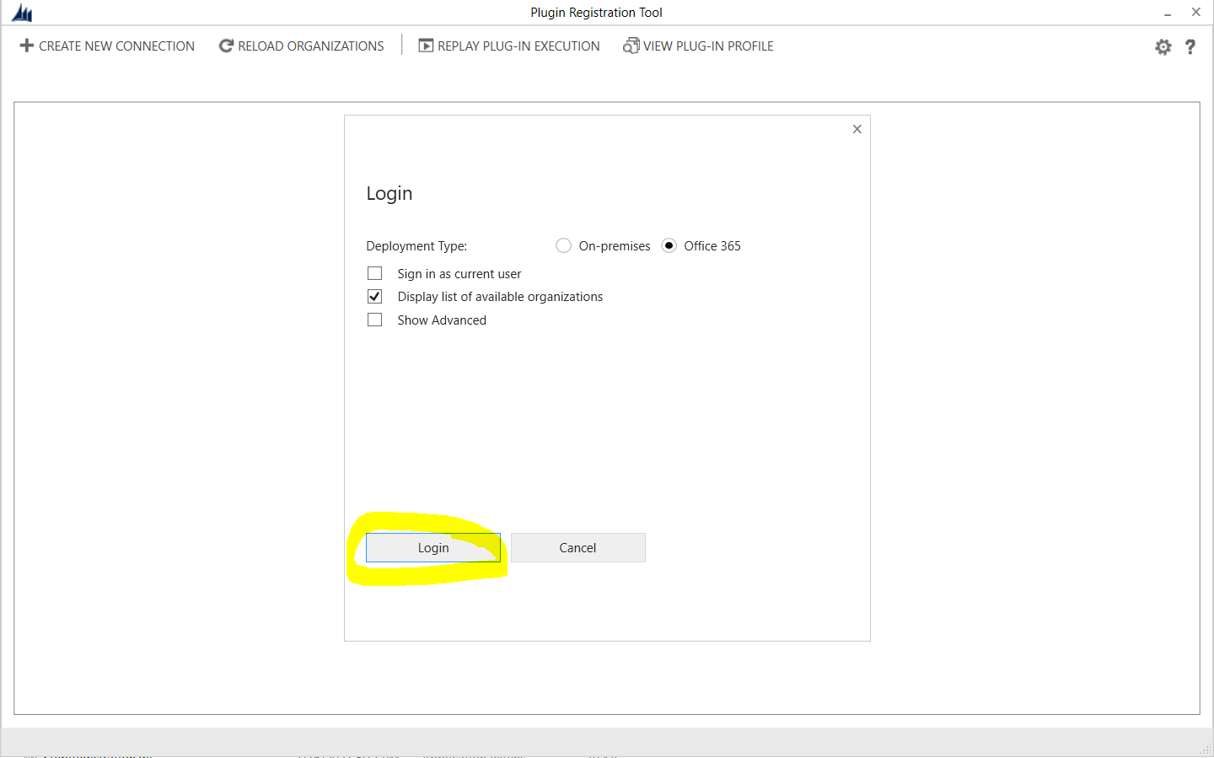

* Login with Microsoft account details and you will prompted with list of CRM Organizations

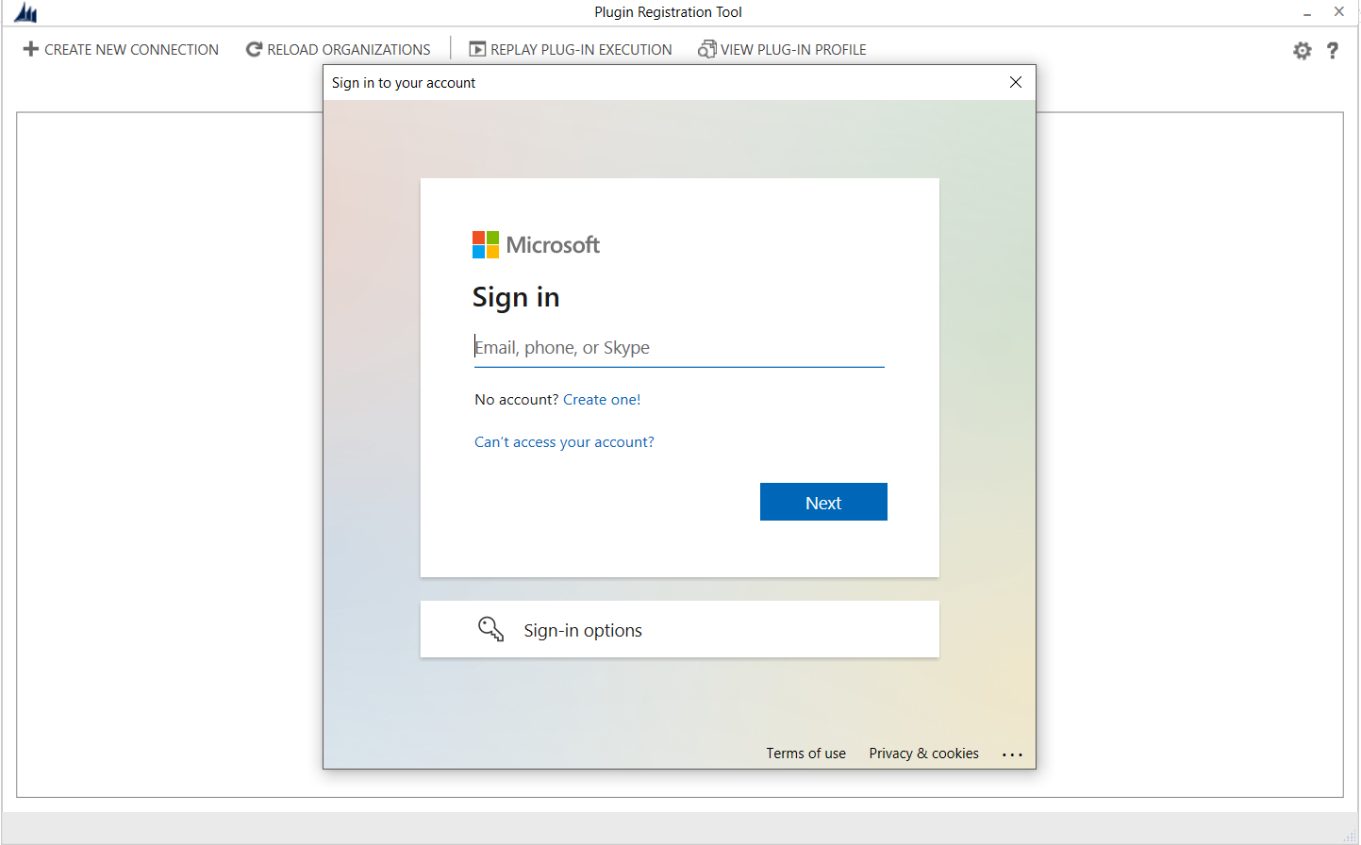

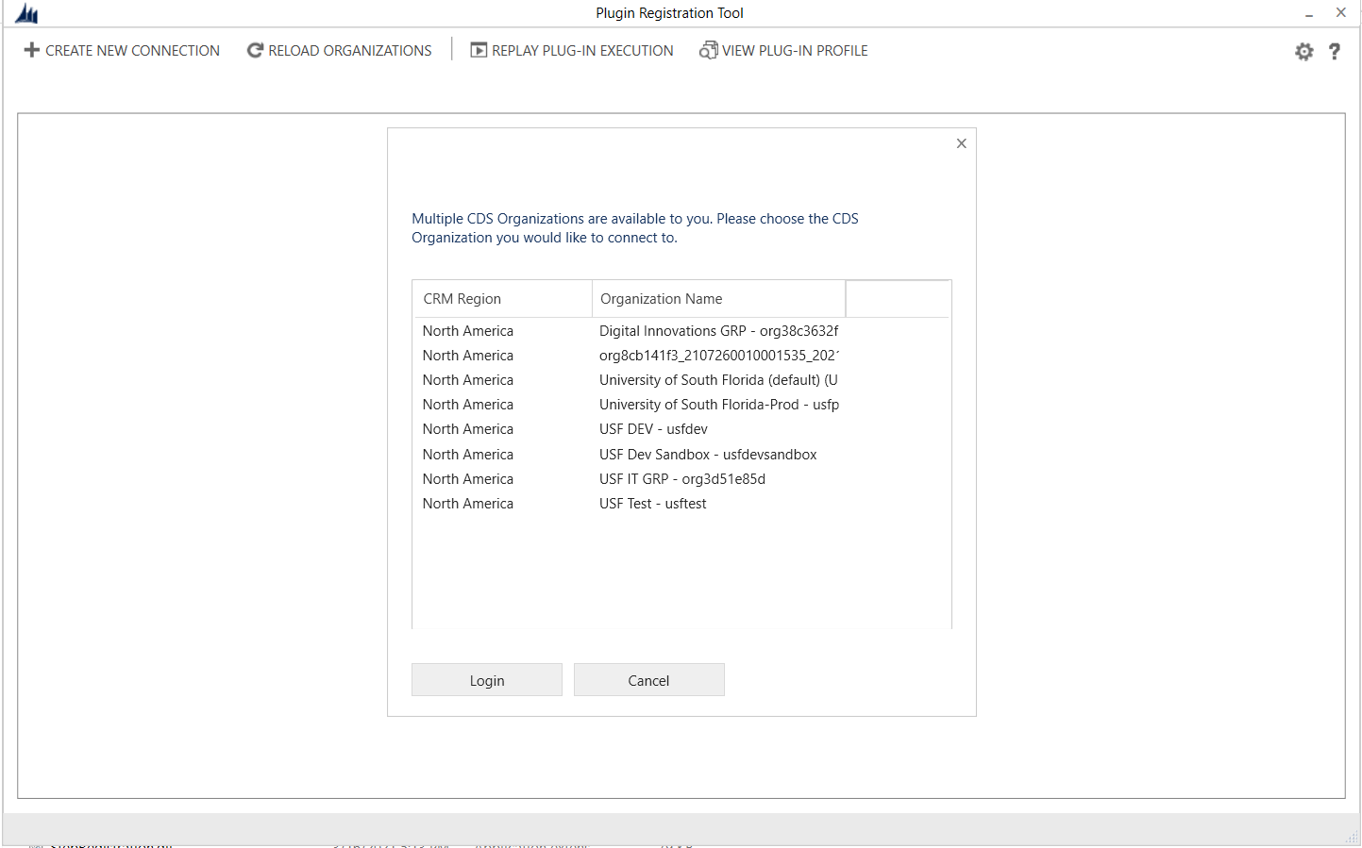

* You can select the organization you want to connect and click Login.
* After you are connected, you will see any existing registered plug-ins & custom workflow activities

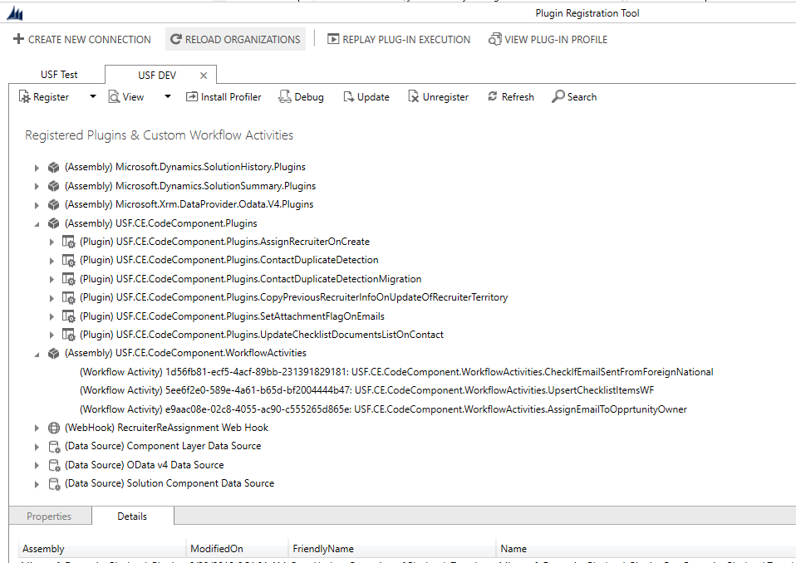

**Register your assembly**

* Right click on USF.CE.CodeComponent in the Register drop-down, select Register New Assembly.
* In the **Register New Assembly** dialog, select the ellipses (**…**) button and browse to the assembly you built.

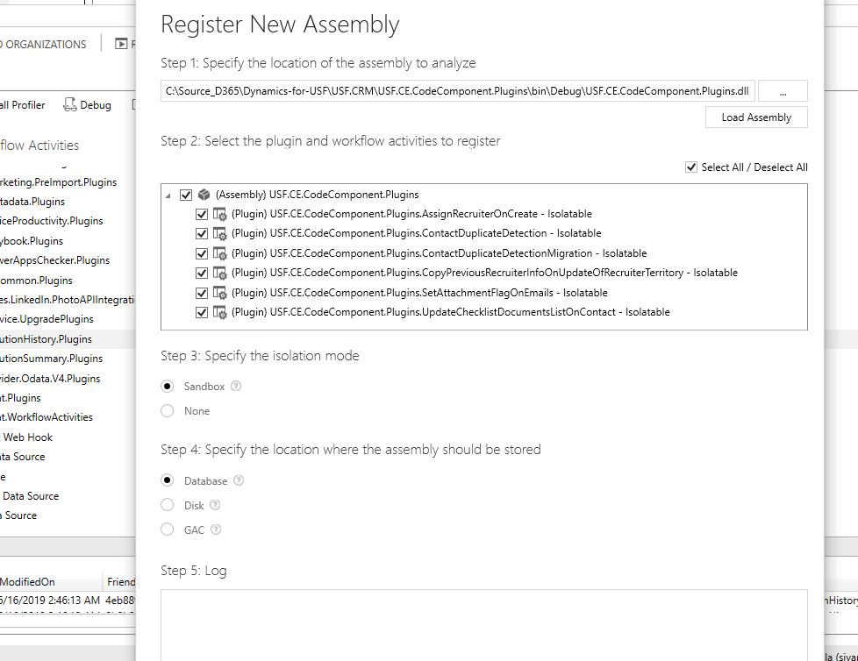

* Make sure isolation mode is sandbox and the location to store the assembly is Database.
* Click Register selected Plug-ins.
* You will see a Registered Plug-ins confirmation dialog, click OK to close dialog.
* You should now see (Assembly) USF.CE.CodeComponent.Plugins assembly which you can expand to view the (Plugin) USF.CE.CodeComponent.Plugins

