PRODIGY_DS_03.R

ANUSHAA

2024-07-30

# Load the iris dataset  
data(iris)  
  
# Load necessary libraries  
library(rpart)

## Warning: package 'rpart' was built under R version 4.3.3

library(rpart.plot)

## Warning: package 'rpart.plot' was built under R version 4.3.3

library(caret)

## Warning: package 'caret' was built under R version 4.3.3

## Loading required package: ggplot2

## Warning: package 'ggplot2' was built under R version 4.3.3

## Loading required package: lattice

# Train a decision tree classifier  
tree_model <- rpart(Species ~ ., data = iris, method = "class")  
  
# Plot the decision tree  
rpart.plot(tree_model, main = "Decision Tree for Iris Dataset")

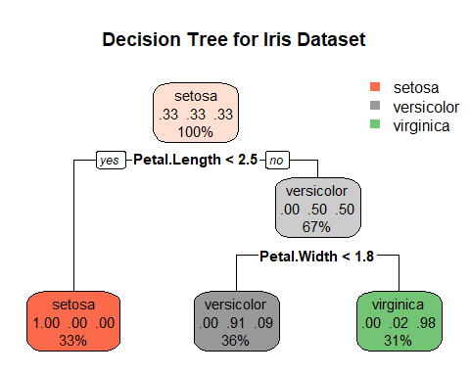

# Predict on the training data  
predictions <- predict(tree_model, iris, type = "class")  
  
# Evaluate the model  
confusionMatrix(predictions, iris$Species)

## Confusion Matrix and Statistics  
##   
## Reference  
## Prediction setosa versicolor virginica  
## setosa 50 0 0  
## versicolor 0 49 5  
## virginica 0 1 45  
##   
## Overall Statistics  
##   
## Accuracy : 0.96   
## 95% CI : (0.915, 0.9852)  
## No Information Rate : 0.3333   
## P-Value [Acc > NIR] : < 2.2e-16   
##   
## Kappa : 0.94   
##   
## Mcnemar's Test P-Value : NA   
##   
## Statistics by Class:  
##   
## Class: setosa Class: versicolor Class: virginica  
## Sensitivity 1.0000 0.9800 0.9000  
## Specificity 1.0000 0.9500 0.9900  
## Pos Pred Value 1.0000 0.9074 0.9783  
## Neg Pred Value 1.0000 0.9896 0.9519  
## Prevalence 0.3333 0.3333 0.3333  
## Detection Rate 0.3333 0.3267 0.3000  
## Detection Prevalence 0.3333 0.3600 0.3067  
## Balanced Accuracy 1.0000 0.9650 0.9450