**1.Add a key value pair in HashMap**

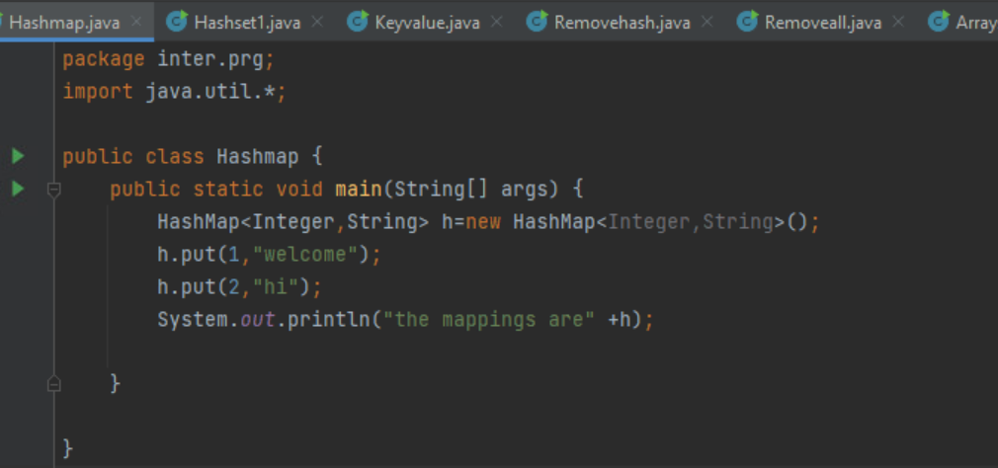

**2.Write a program to retrieve a value associated with a given key from the hash map**

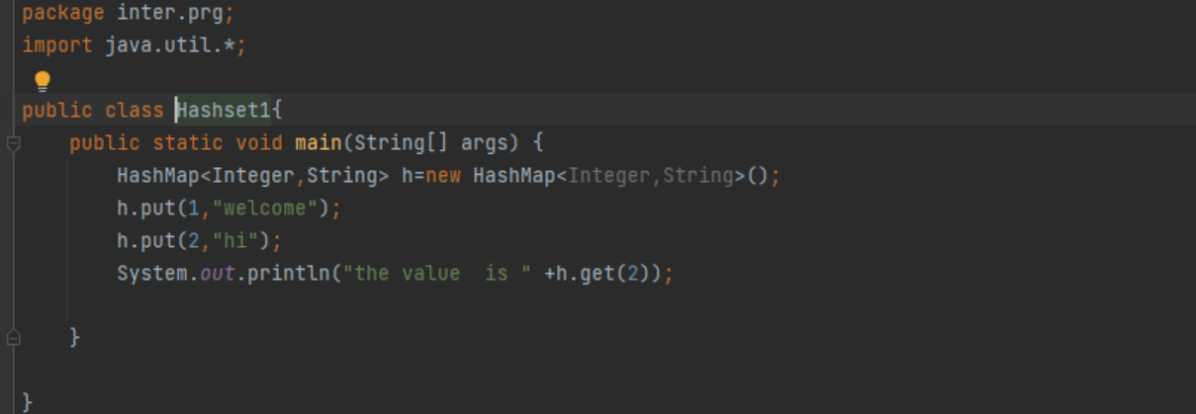

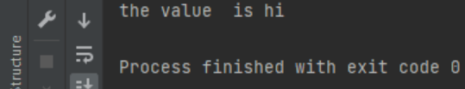**3.Program to check whether a particular key-value exist in hash map or not**

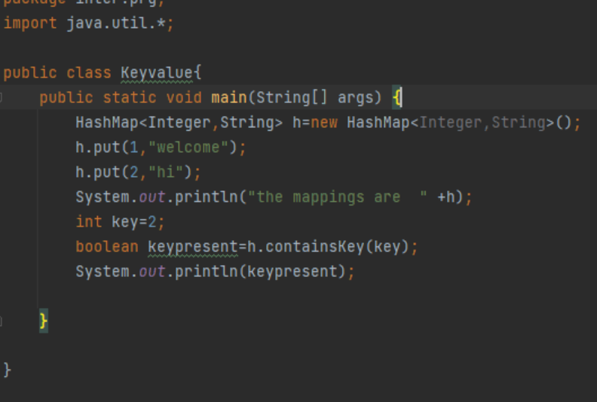



**4.Program for remove all key-value pairs from hash map**

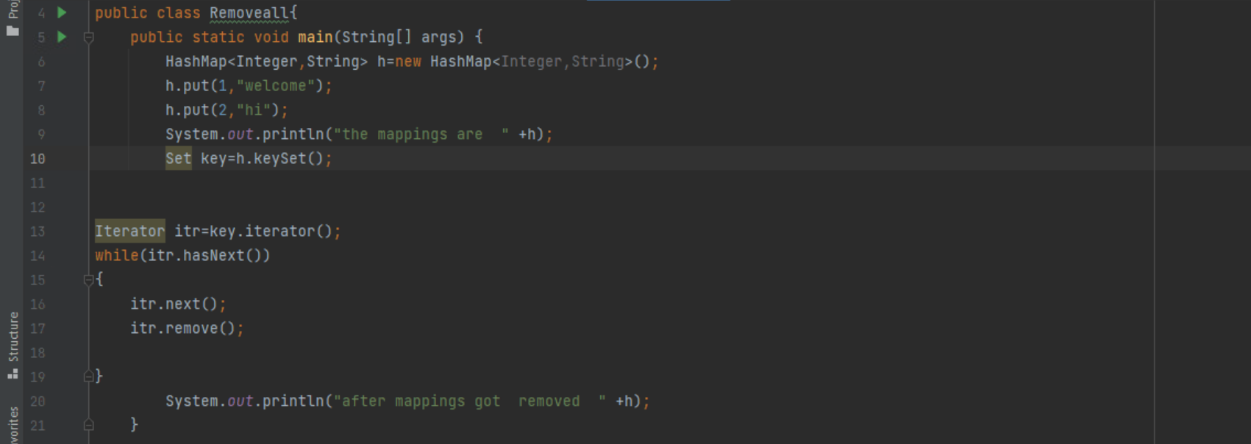**5.Program for clear hash map for reuse**

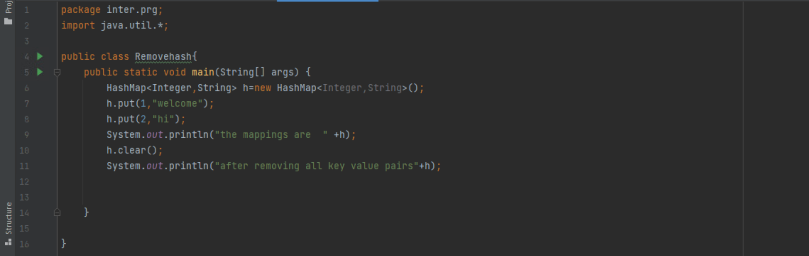

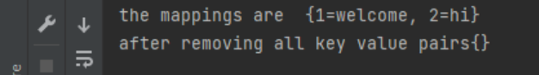

**6.Program for sort array list using collection sorting techniques**

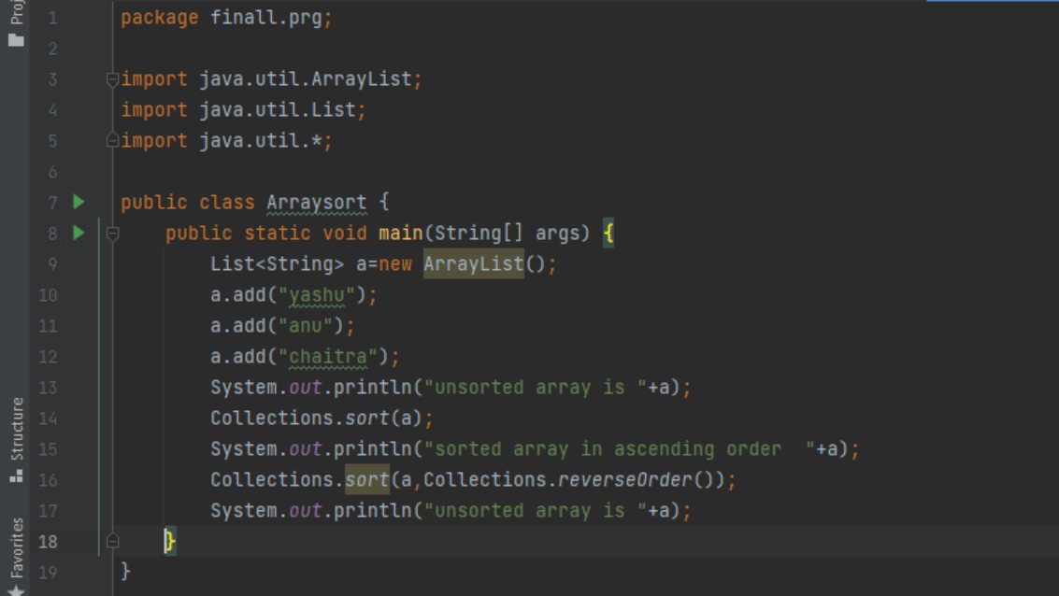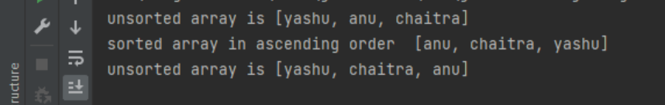

**7.Program for sort array list in ascending order**

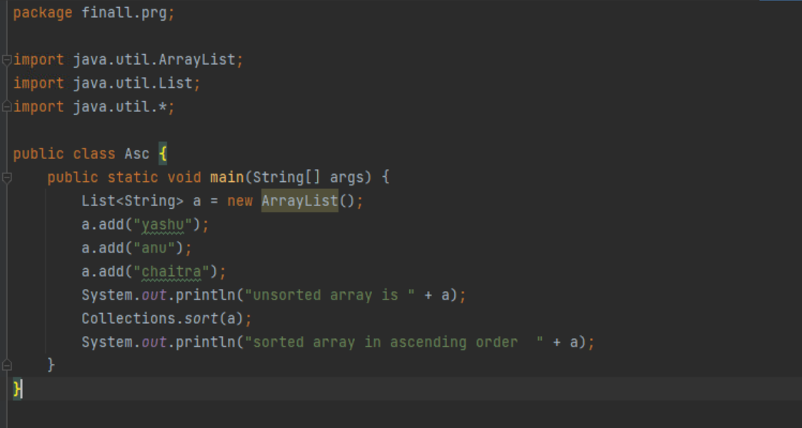

**8.Program to find minimum and maximum values from list using collections class methods**

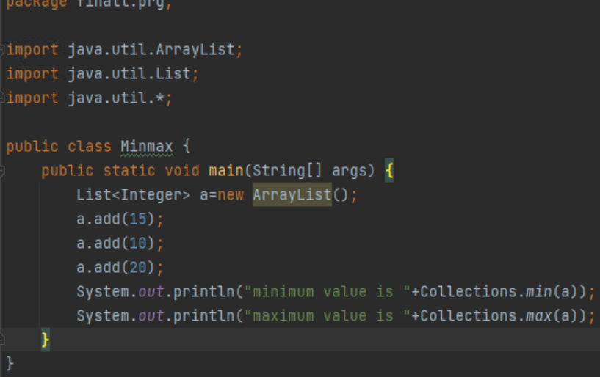**9.Program for sorting a list of integers**

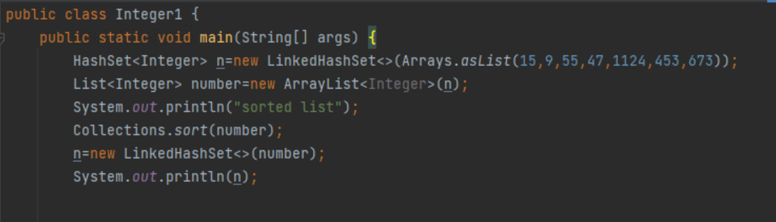

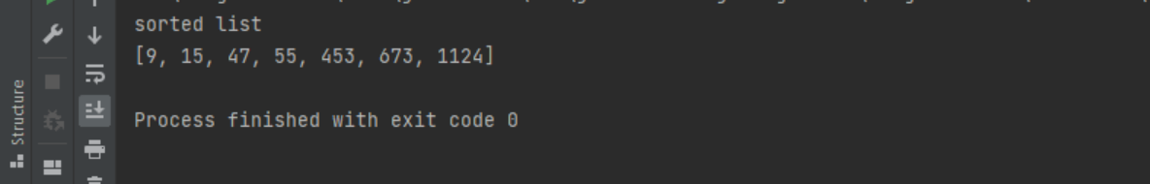

**10. Program for sorting a list of strings**

