**Linux:**

**Pwd (present working directory) and making a directory**

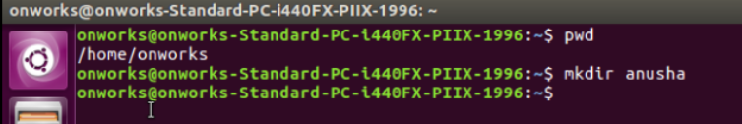

**Listing of files**

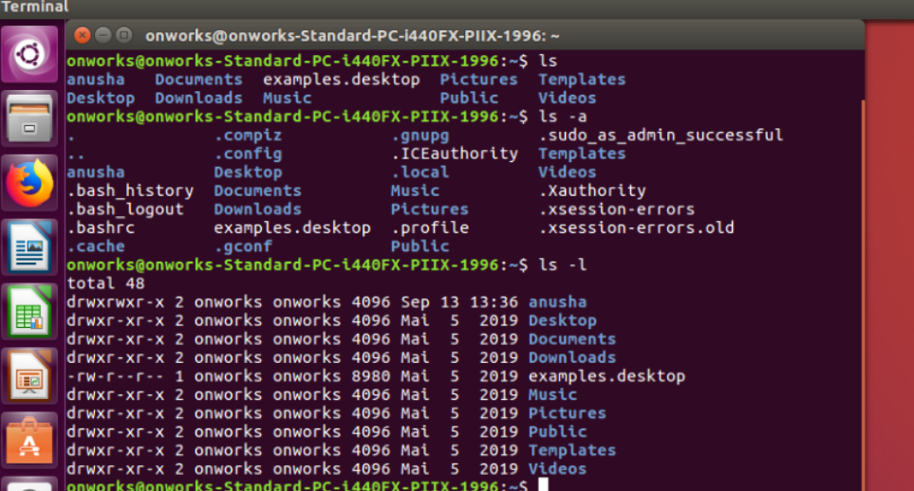

**Creation of files in a directory, removing a directory and a man command**

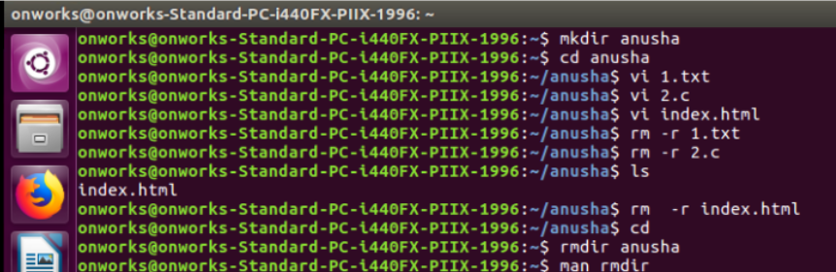

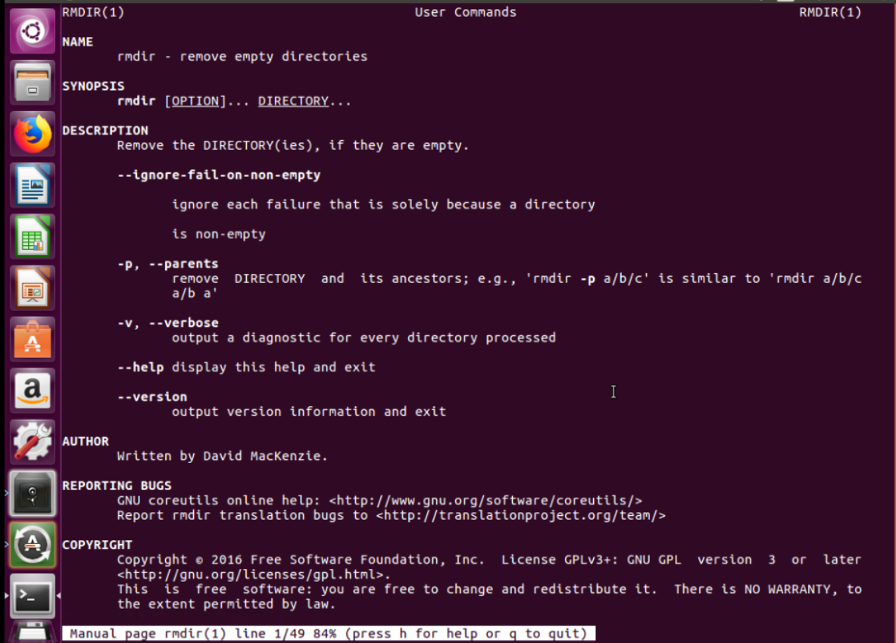

**Echo, Clear and Free command**

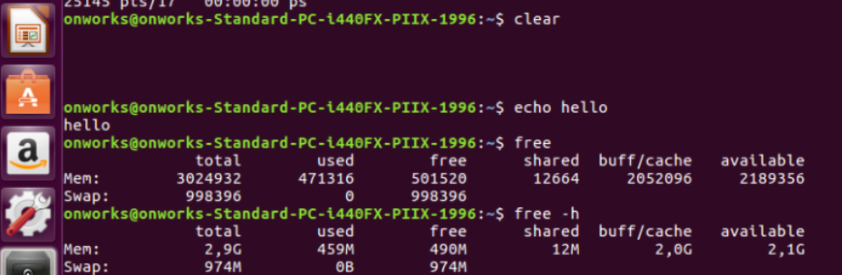

**DF: Disk space usage information**

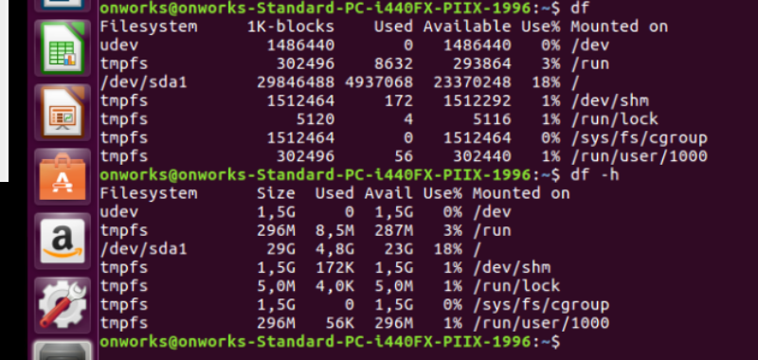

**PS command**

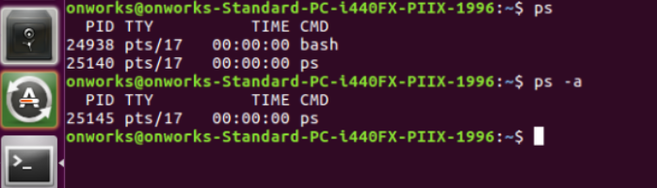

**lshw, lscpu, lsusb commands**

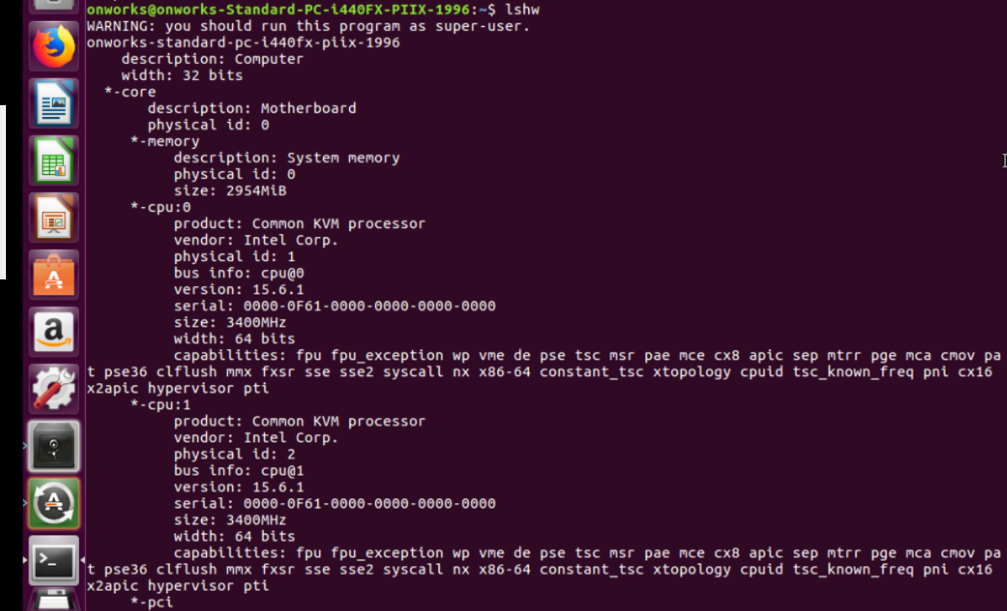

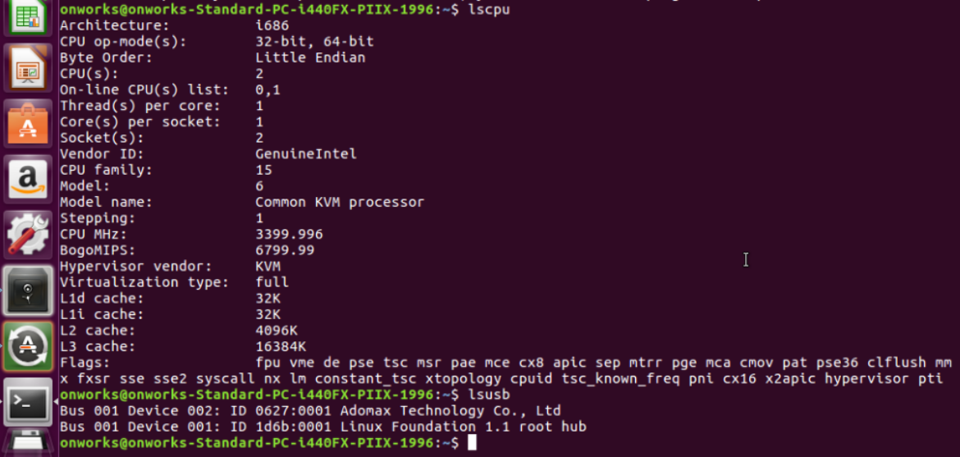

**Sudo and Top command**

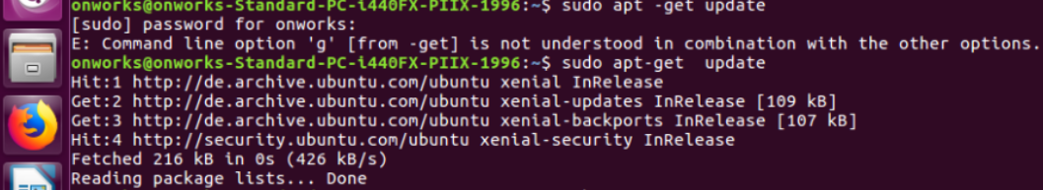

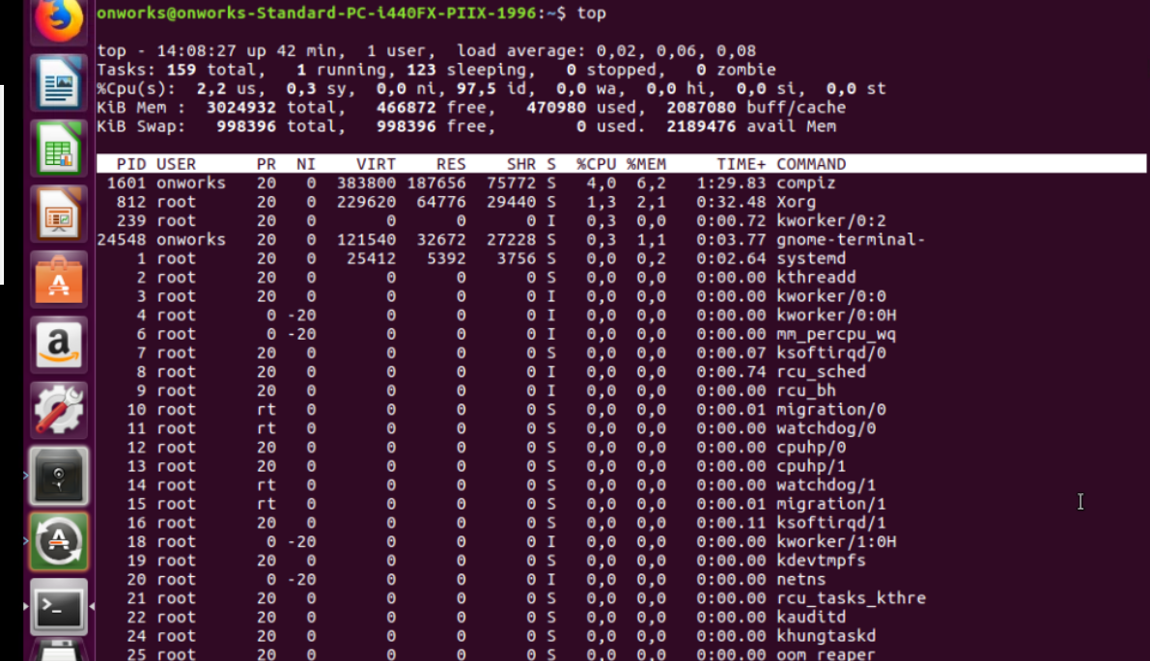

**Gedit and cat command**

