**Employee table**

Creation of a table is done by **DDL** command **CREATE,** inserting of a value is done by **DML** command **INSERT** and getting a values and structure of a table is done by **DQL** command **SELECT**.

**Primary Key:**

It should not be null and it should be unique

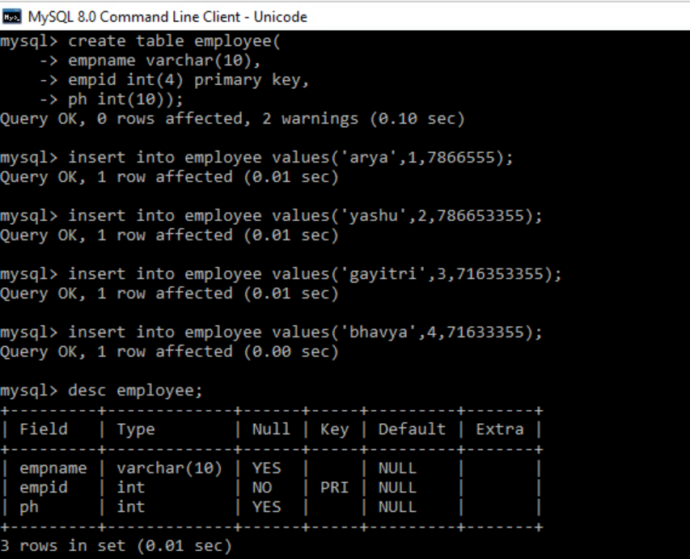

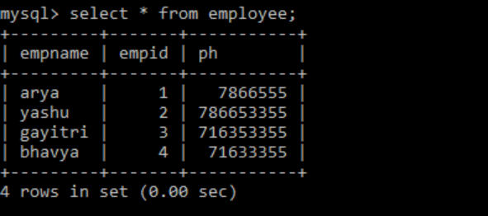

**Group by, order by clauses and count aggregate function**

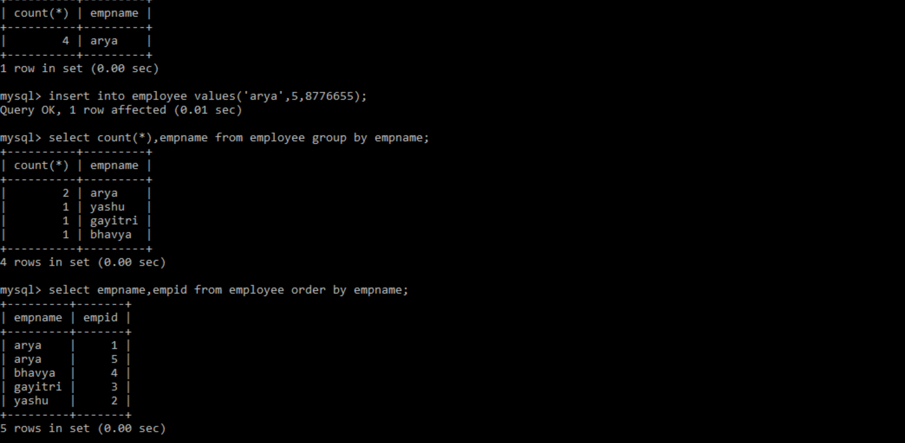

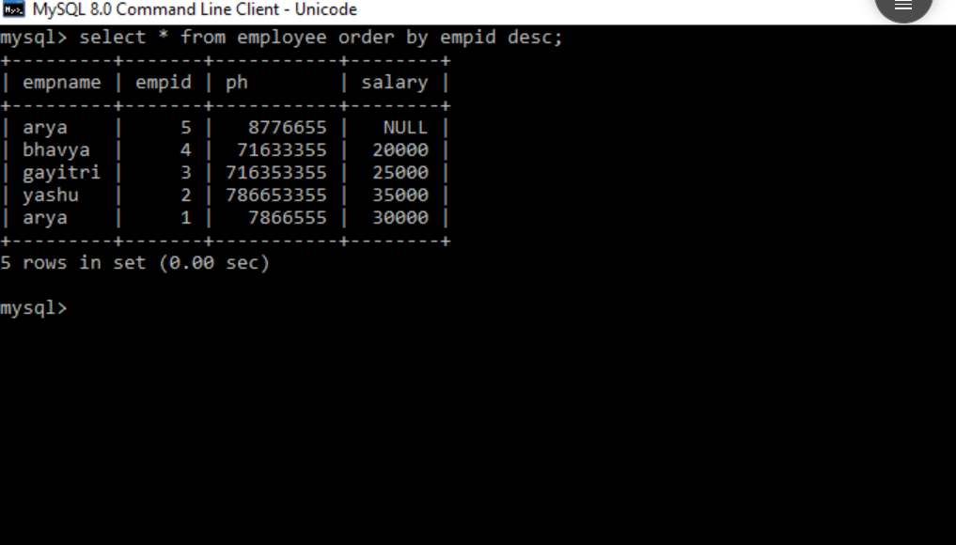

**Update DML command**

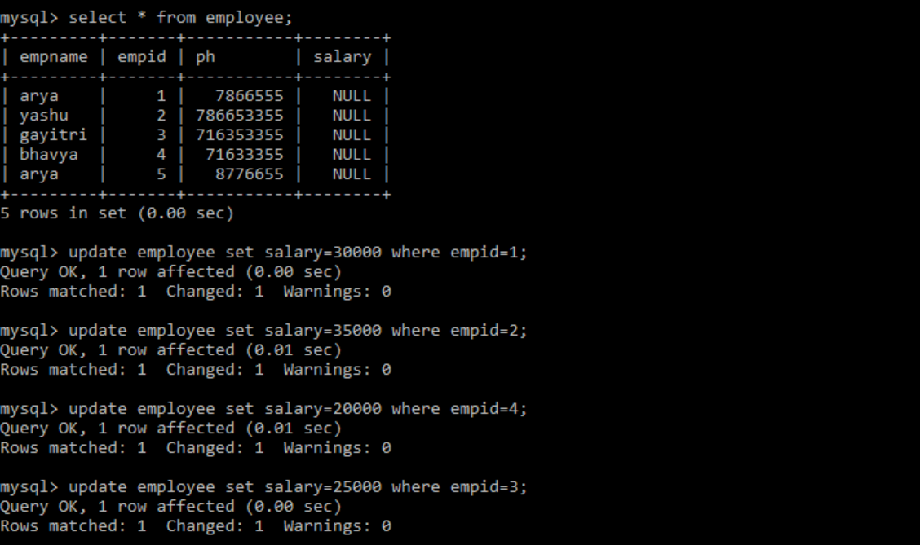

**Minimum, Maximum and Average aggregate functions**

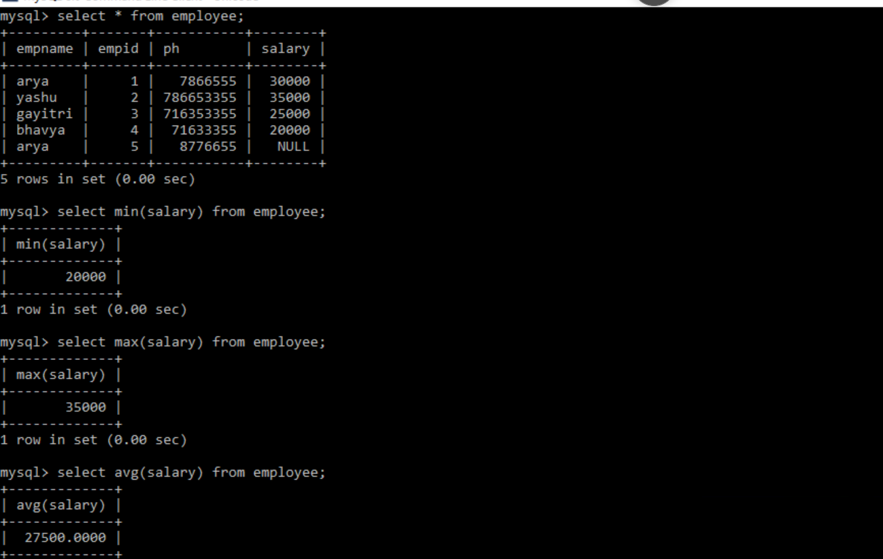

**Default Constraint**

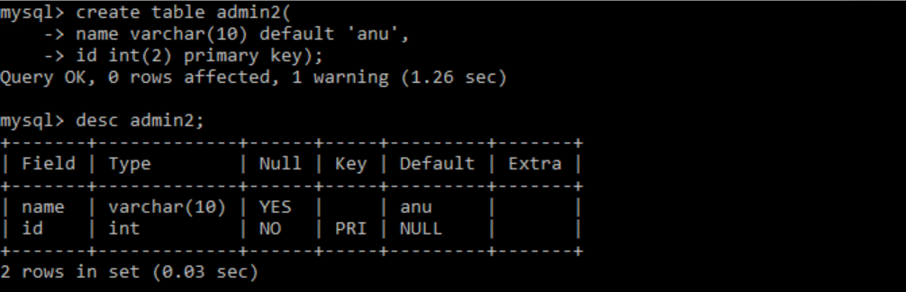

**Foreign key**

References to another table

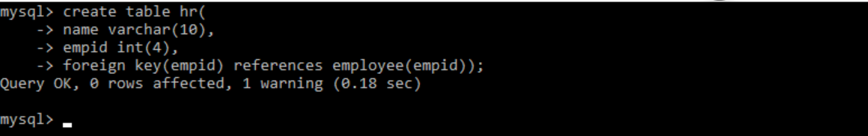

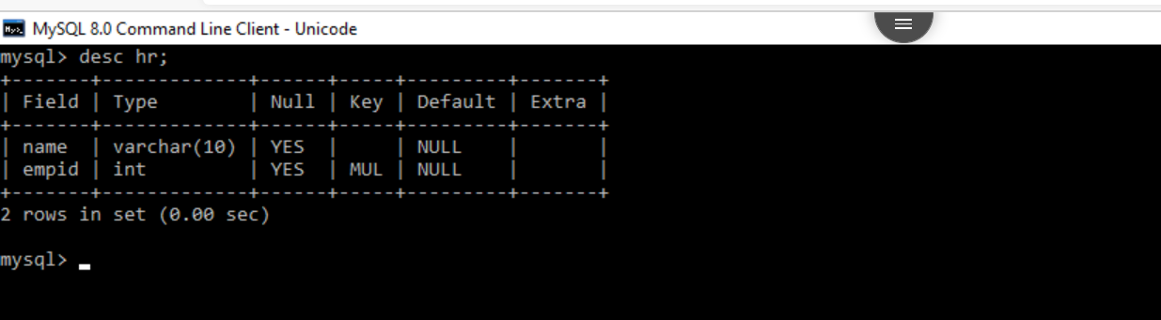

**Modify**

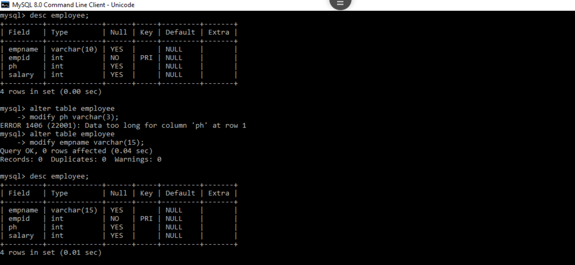

**Drop DDL command**

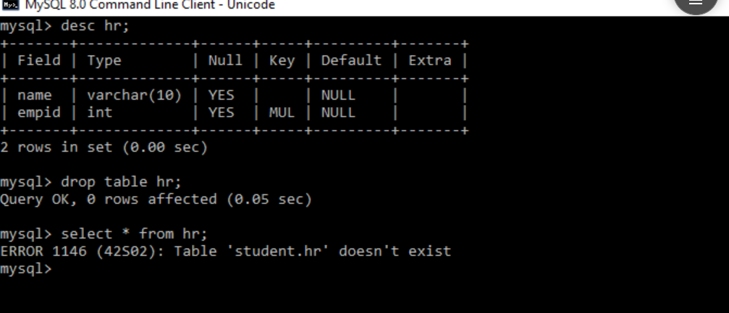

**DQL command**

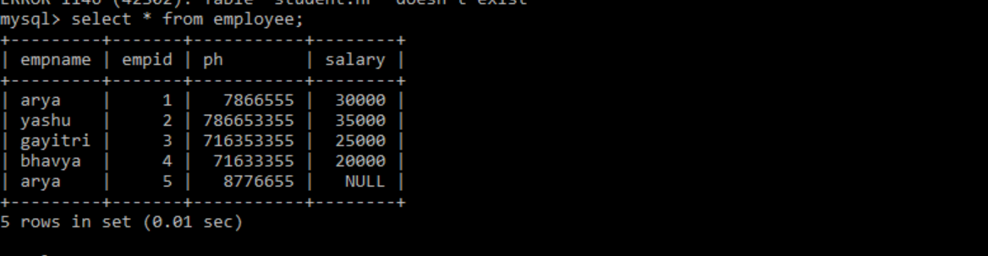

**Having clause**

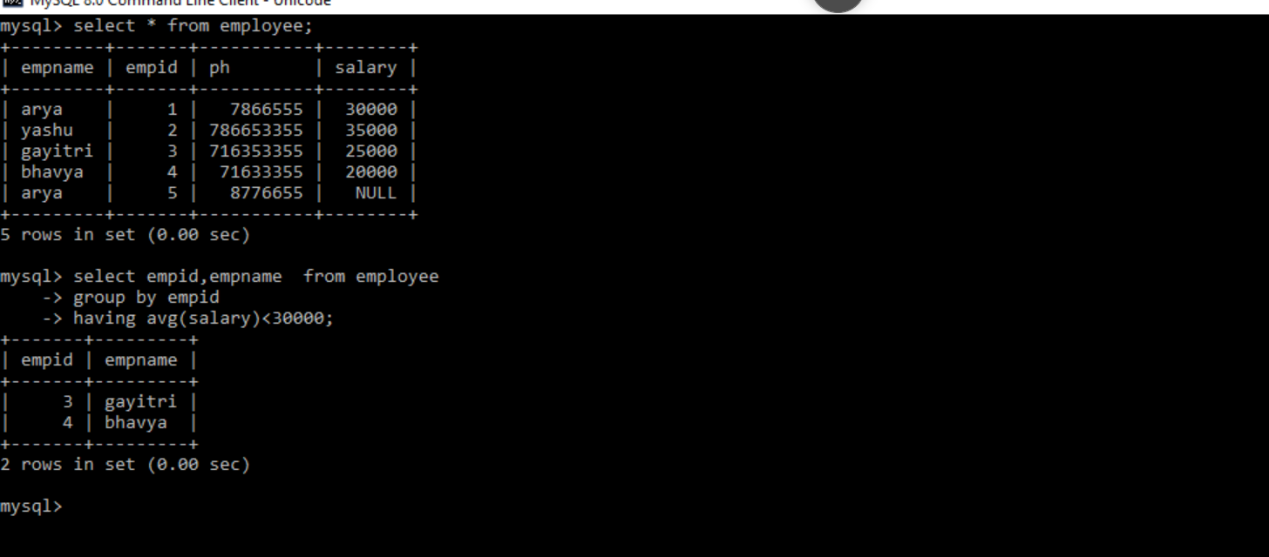

**Distinct keyword**

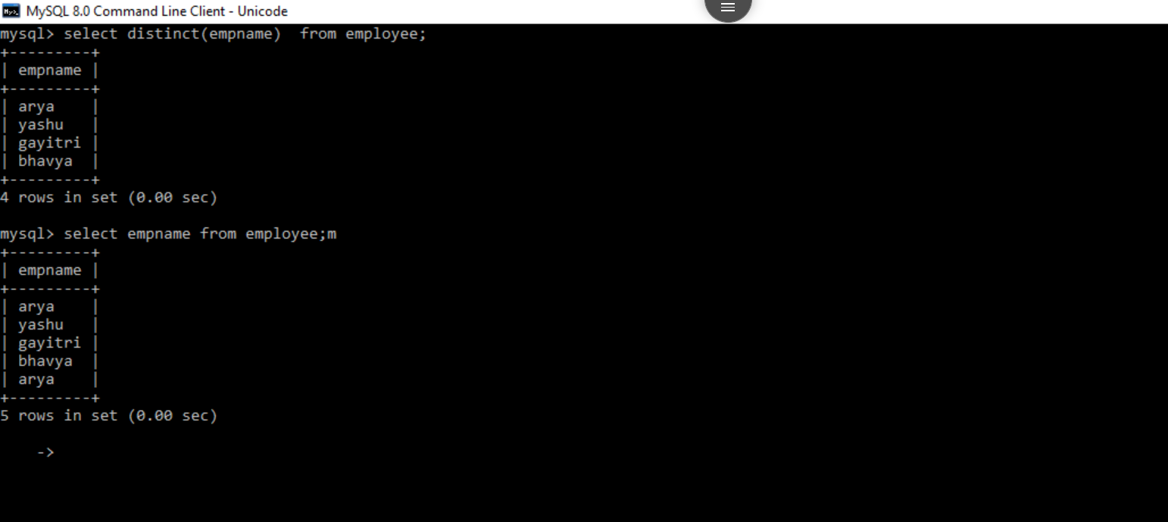

**Sum aggregate function**

