**1.Program for traverse or iterate a Arraylist**

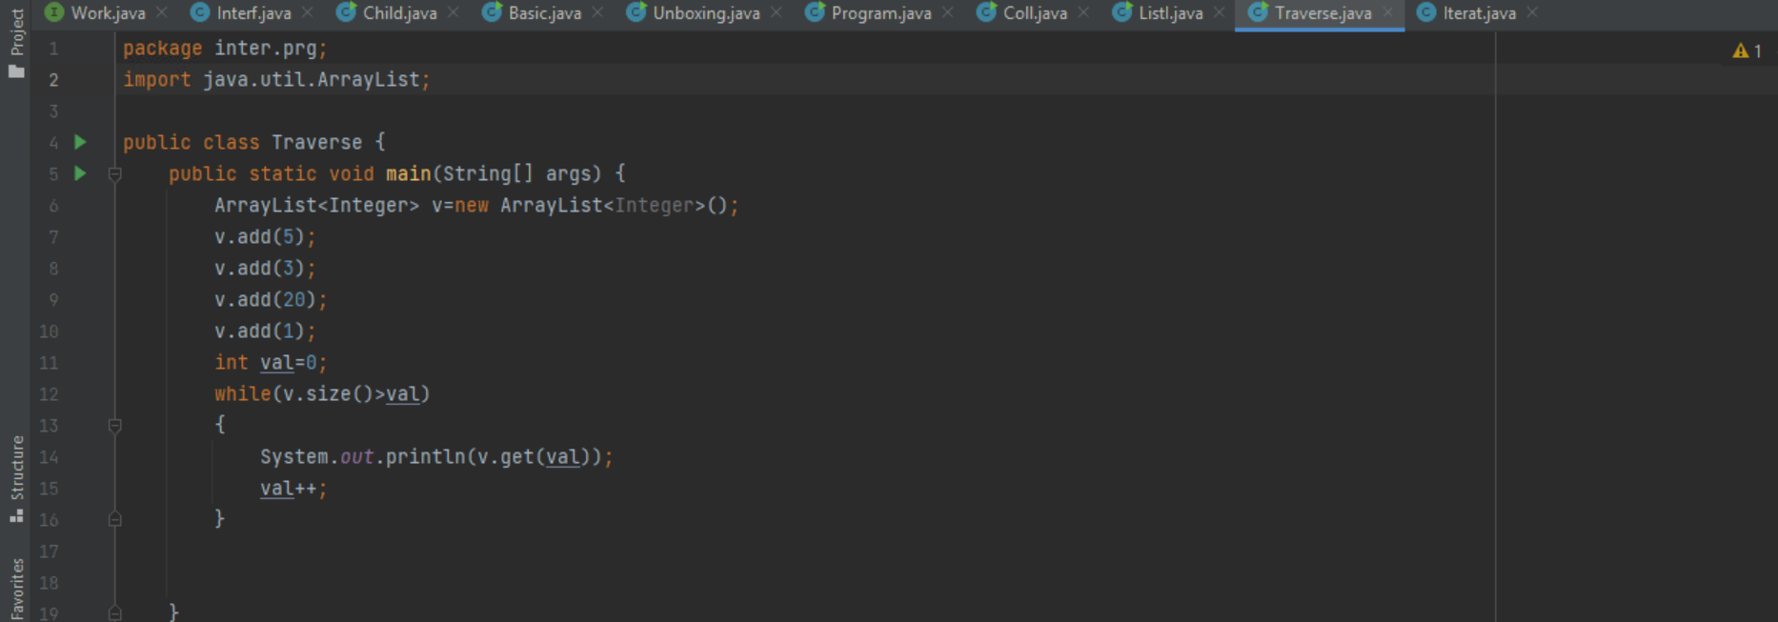

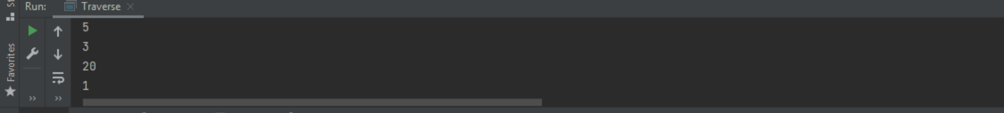

**2.Program for list to array conversion**

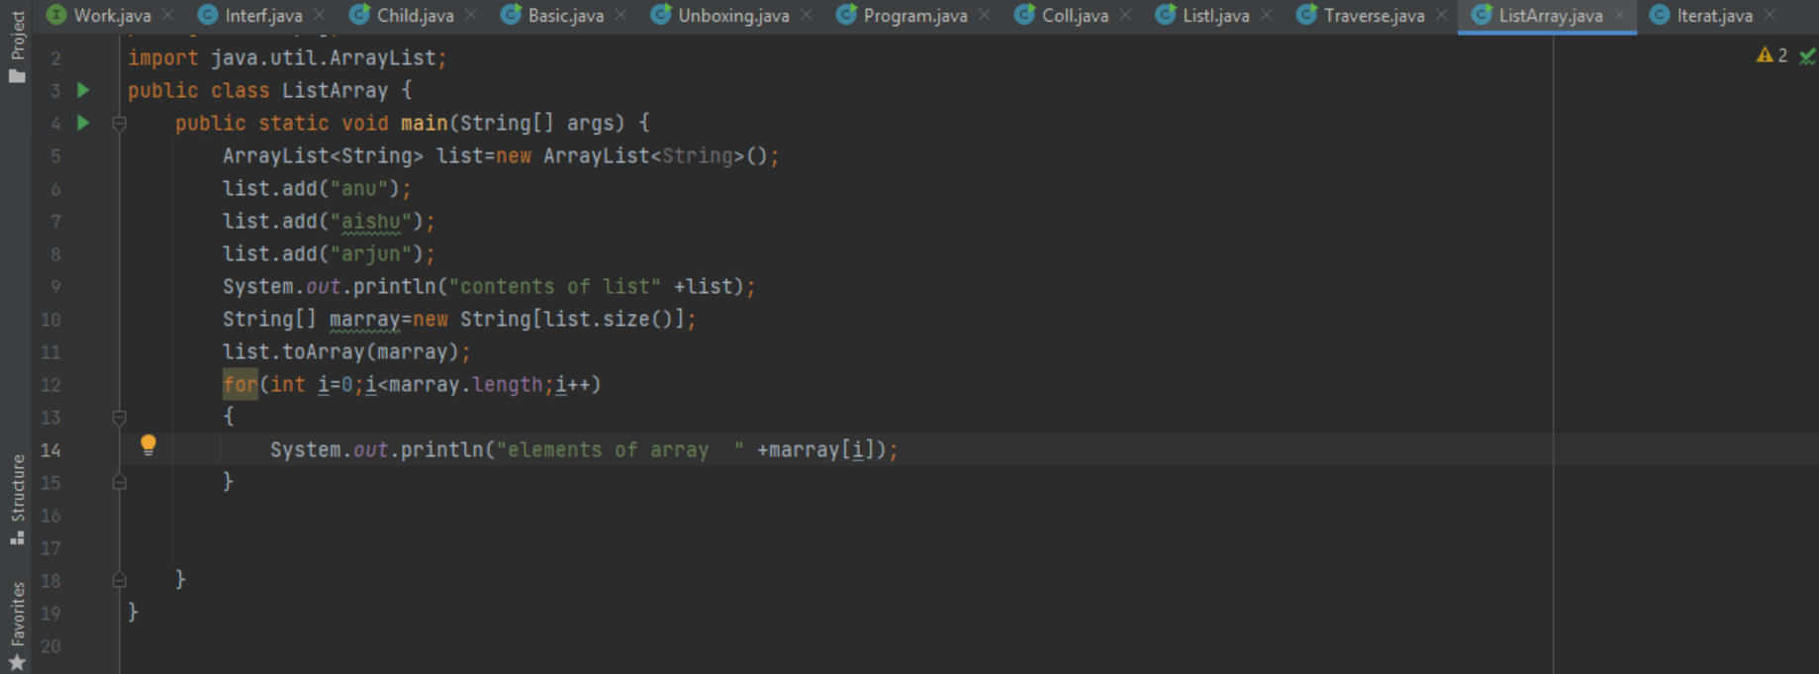

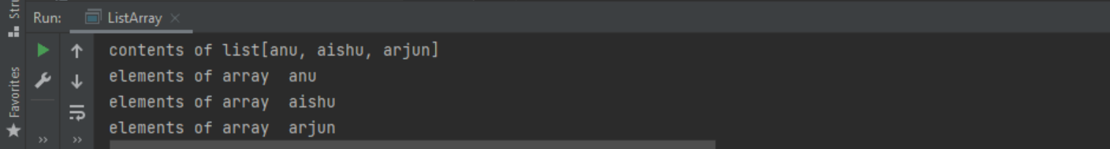

**3.Program for check if element exists in ArrayList**

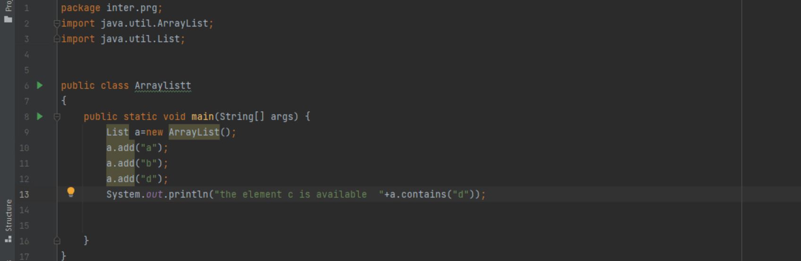

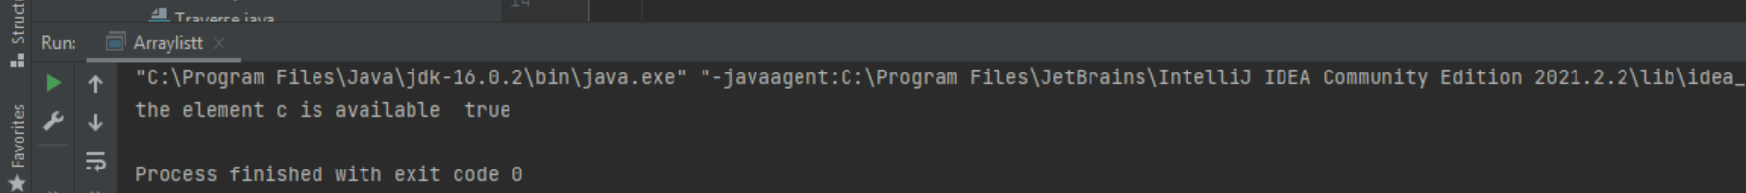

**4.Check element exists in HashSet or not**

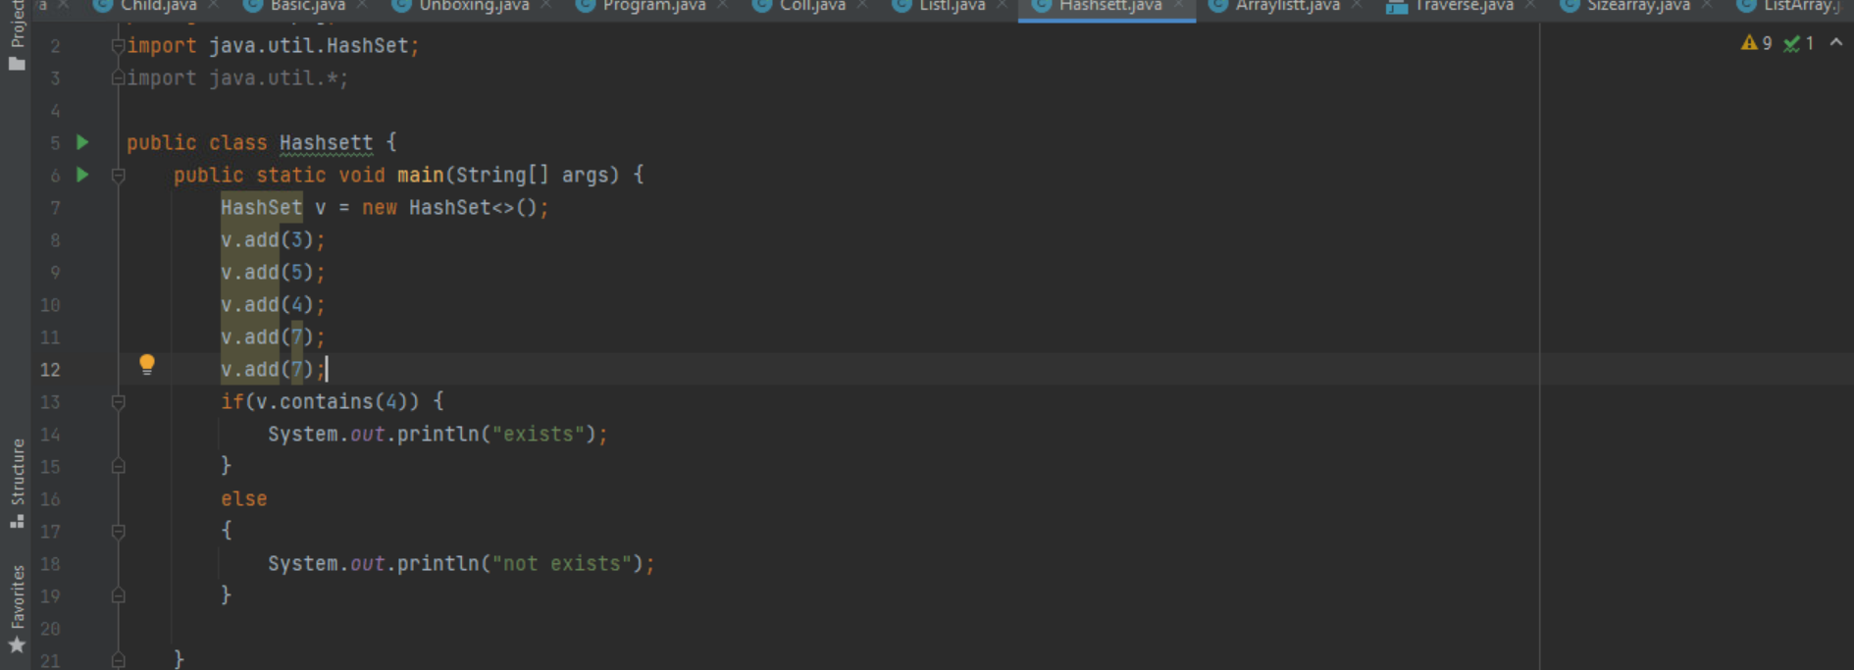

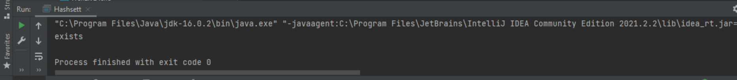

**5.Program for finding length of ArrayList**

