**Automation Deployment with Devops Tools**

**1.SetUp Jenkins**

1. Launch server on AWS ec2
2. Install the java 17 version
3. Install Jenkins
4. Start the Jenkins and see the status of Jenkins

**2.Setup Jenkins server**

1. Install required plugins - git,maven,sonarqube plugins
2. Create the job with free style or pipeline
3. If you created the job with free style, then initialize the git as shown in below figure
4. 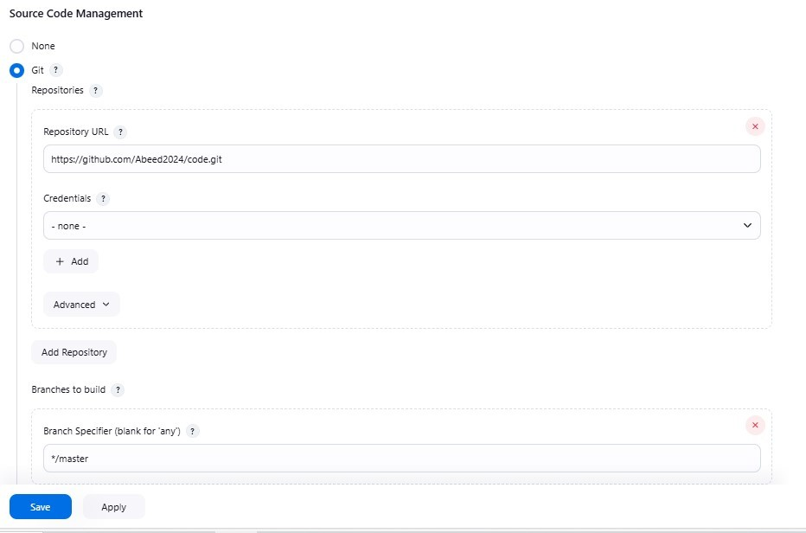  
   If the configure of git is done then perform the build, then the build get success it means work is done
5. Create the job with pipeline
6. By selecting the stage is checkout and the step is created by generating the pipeline syntax
7. 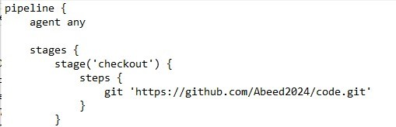 After the copying of pipeline syntax and paste in script to perform the build as shown in below figure
8. After that perform the build step with pipeline as shown in below figure

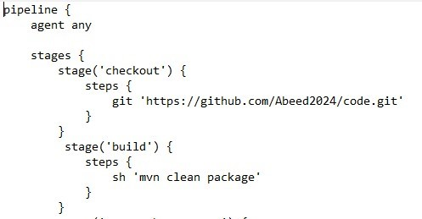

**Step** **SonarQube :**

1. Create the server for SonarQube
2. Install the java 17 version
3. Install unzip packages
4. Create the sonar user and switch to that created user
5. Copy the zip file and paste in terminal to install zip file
6. Unzip the zip file by using the file name
7. Give the owner permissions and file permissions to the unzip file
8. Start the SonarQube scanner to create the server of SonarQube
9. Switch to the SonarQube server and generate the token and copy the generated token
10. Install the plugins of SonarQube in the Jenkins server
11. Provide the credentials for SonarQube
12. 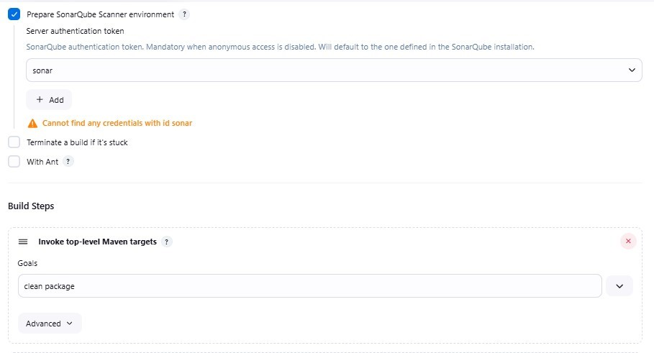Add the SonarQube credentials in created free style job as shown in below figure
14. Create the SonarQube with the pipeline syntax
15. Provide the credentials for SonarQube in pipeline and generate the pipe line syntax and copy the syntax and paste in the script as shown in below figure
16. 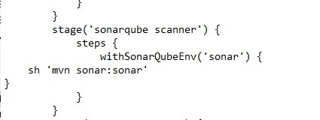

**Step Nexus:**

1. Create the server for nexus
2. Update the server
3. Install the java 17 version
4. Create the nexus user and switch to created user
5. Copy the file from nexus page and paste in created user terminal
6. Un tar the tar file and provide the owner permissions to the file and give the executable file permission to that file
7. Start the nexus for the nexus server
8. Switch to nexus server
9. Create the repository in the nexus server for the created free style job
10. Switch to Jenkins server and install the nexus plugins in the Jenkins server
11. After installing the plugins and restart the Jenkins server
12. Go to build steps in the Jenkins server and select the nexus artifacts uploader
13. Provide the credentials in the nexus artifacts uploader in build steps
14. Provide all the pom file related information in the nexus artifacts uploader as shown in below figure
15. 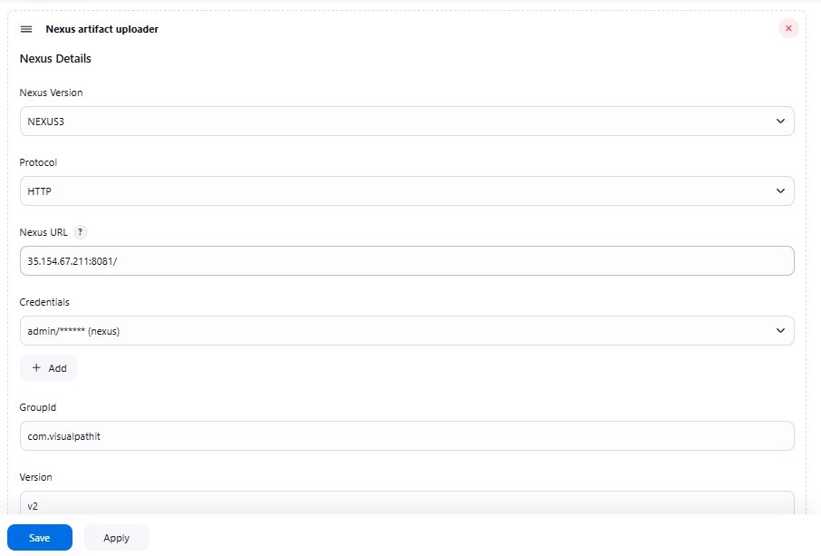
16. Create the nexus artifacts uploader by using the pipeline
17. Generate the pipeline script by using the nexus artifacts uploader
18. 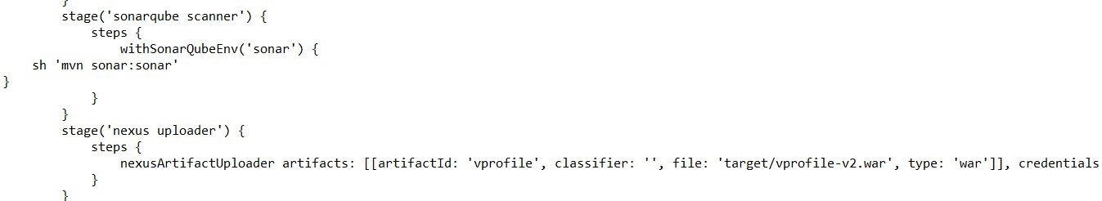Copy the generated script and paste the script in script as shown in below figure
19. If the build is done then the work is done

**Step Tomcat:**

1. Create the server for tomcat
2. Update the server
3. Install the java 11 version
4. Install the maven
5. Copy the tomcat file in the server and paste in the tomcat terminal
6. Un tar the tar file and modify the configure directory in the tomcat
7. Modify the web apps directory in tomcat server
8. Start the tomcat server
9. Give the credentials for tomcat in Jenkins server
10. 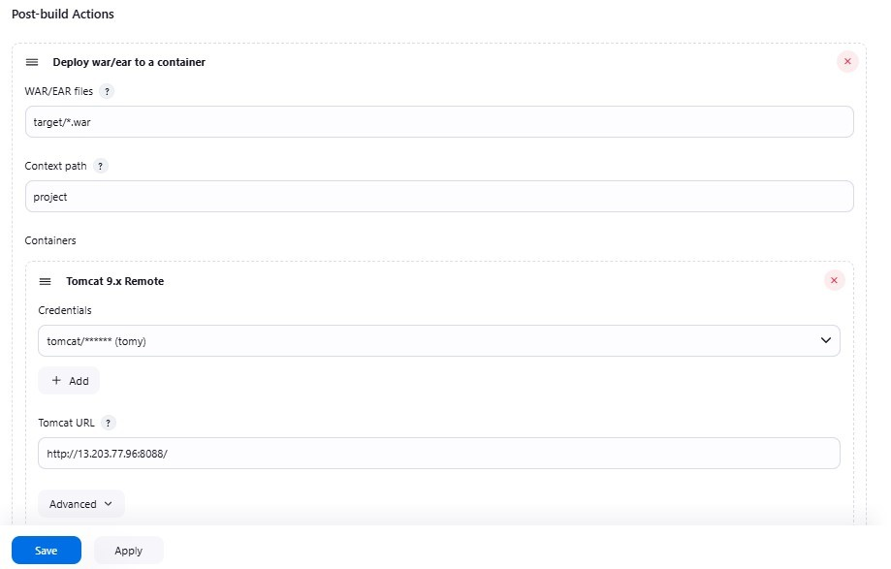By using post build option, we can select the deploy to war or ear option and provide the credentials in that as shown in below figure
11. Generate the pipeline syntax by providing the credentials of deploy to war or ear option and copy the syntax and paste the syntax in the script .
12. 