SUPERMARKET SALES ANALYSIS
Data Analytics Project Report
Submitted by: Anusha
IBM SkillsBuild Data Analytics with AI Academic Internship Program

1. Problem Statement
The aim of this project is to analyze supermarket sales data and find useful information about products, branches, categories, customers, payment methods, and customer ratings. The analysis converts transaction-level data into simple business insights that can support inventory planning, branch performance analysis, and customer-service decisions.

2. Dataset
The dataset contains 500 supermarket sales transactions. It includes Invoice ID, Date, Branch, City, Customer Type, Gender, Product, Category, Quantity, Unit Price, Payment, Rating, and Sales.
Dataset link:
https://docs.google.com/spreadsheets/d/1QIX__4VObHFMEXnRM2xJyXmB5JAB2peHrJcQ41_U9TE/edit?usp=sharing

3. Technologies Used
- Python
- Pandas
- NumPy
- Matplotlib
- Jupyter Notebook
- OpenPyXL for reading the Excel dataset

4. Steps Used for Analysis
1. Load the Excel dataset into Python using Pandas.
2. Check the dataset for missing values, duplicate rows, and incorrect data types.
3. Convert the Date column and required numeric columns into suitable formats.
4. Validate Sales using the formula Sales = Quantity × Unit Price.
5. Group and summarize the data using totals, counts, and averages.
6. Create charts to compare products, branches, categories, and payment methods.
7. Interpret the results and identify practical business decisions.

5. Data Cleaning and Validation
The dataset contains 500 rows and 15 original columns. The analysis checked missing values and duplicate rows before performing the main analysis. Sales was independently validated using Quantity × Unit Price. The calculated value matched the existing Sales value within a tolerance of ₹0.01 for all transactions.

6. Analysis and Findings
Question | Finding | Result
Which product generates the highest sales? | Cheese | ₹27,906.30
Which branch performs best? | Branch C (Mumbai) | ₹72,469.45
Which category sells the most? | Beverages | ₹56,108.24
What is the most popular payment method? | UPI | 127 transactions
Do Members spend more than Normal customers? | No | Member ₹483.14; Normal ₹497.07
What is the average customer rating? | Average rating | 3.99 / 5

7. Product Analysis
Cheese generated the highest sales among the products, with total sales of ₹27,906.30. Coffee and Shampoo were also among the higher-sales products.
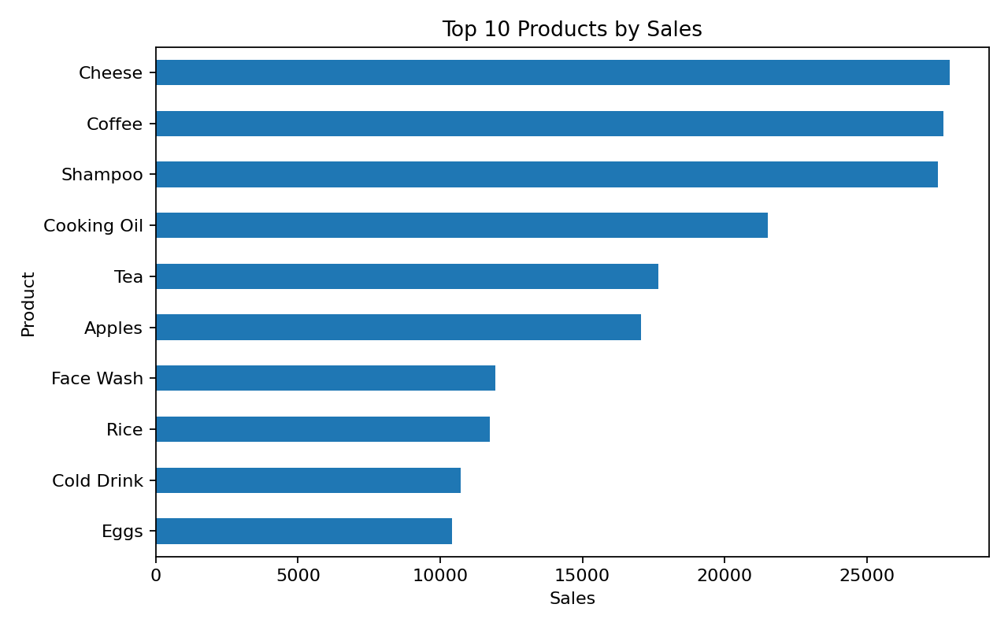

8. Branch Analysis
Branch C in Mumbai recorded the highest sales at ₹72,469.45. The branch comparison can help the supermarket study differences in customer demand, product mix, and sales performance across locations.
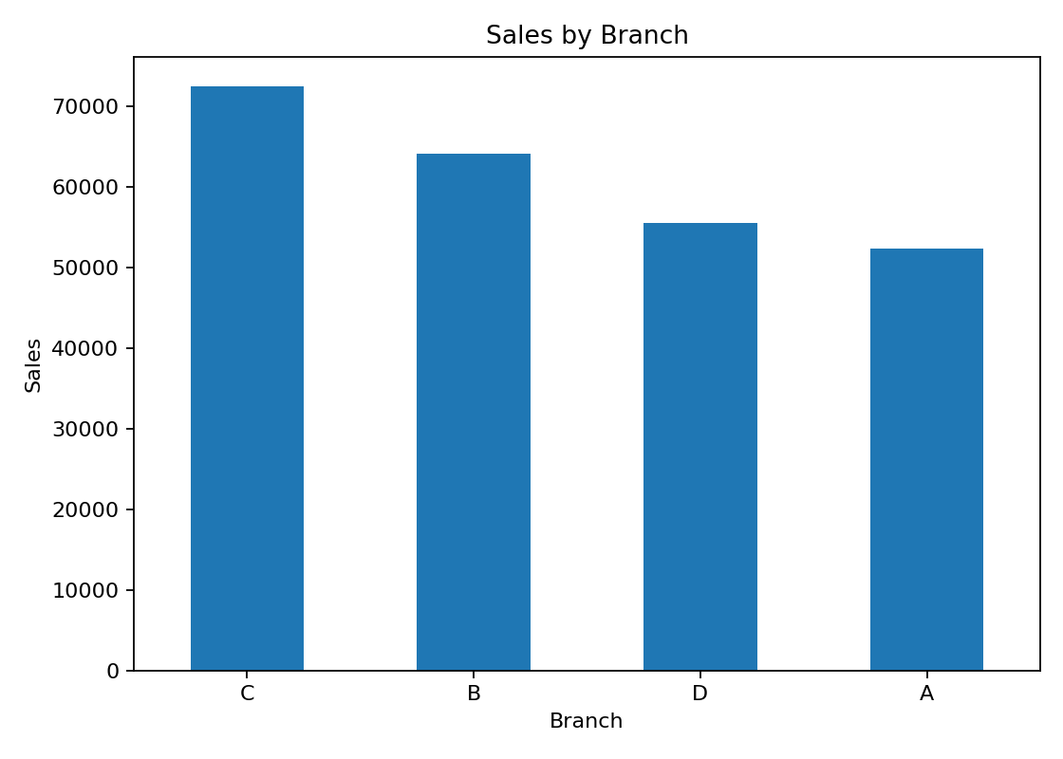

9. Category Analysis
Beverages was the highest-sales category, generating ₹56,108.24. This indicates that beverages represented an important part of the sales mix in this dataset.
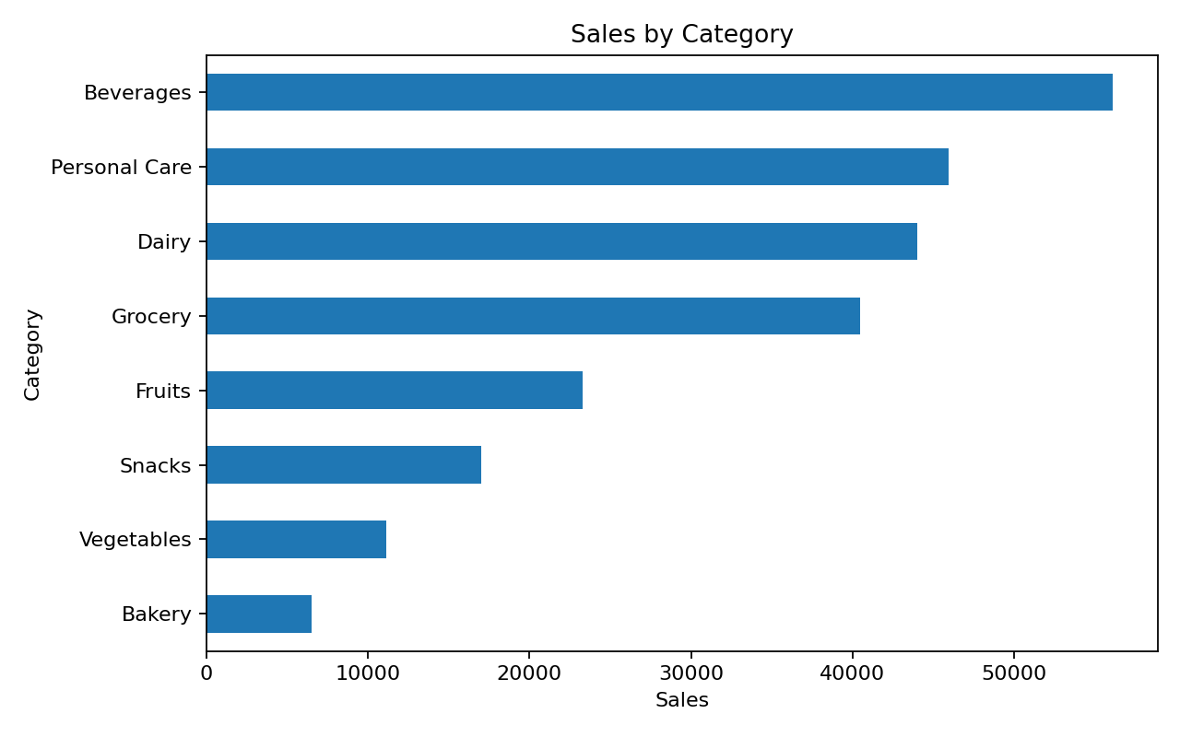

10. Payment Method Analysis
UPI was the most-used payment method with 127 transactions, followed closely by Net Banking and Card. This information can help the supermarket maintain convenient digital payment options for customers.
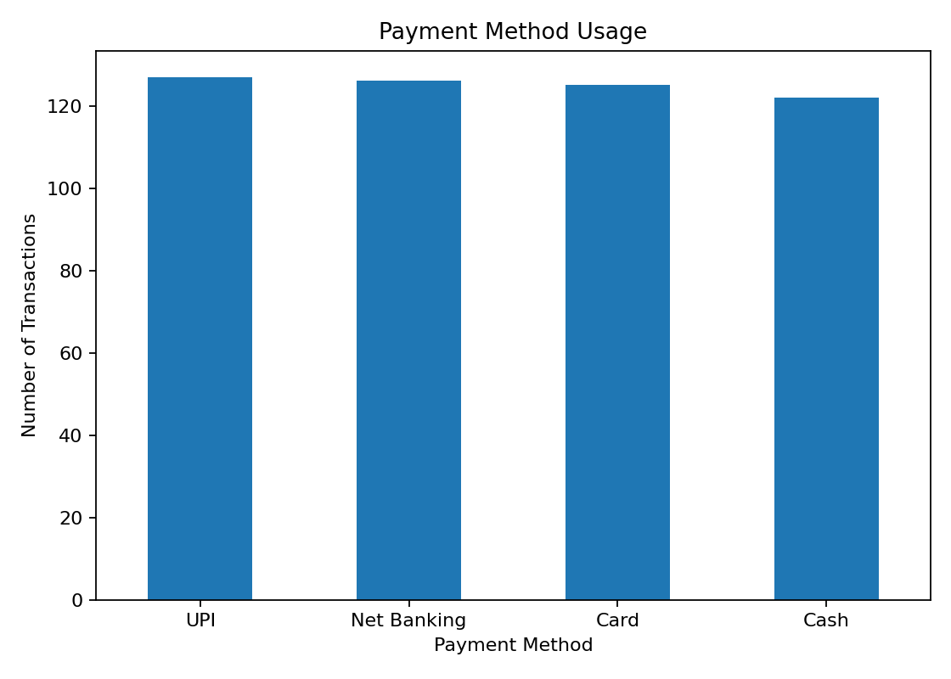

11. Customer Type Analysis
The average Member transaction value was ₹483.14, while the average Normal customer transaction value was ₹497.07. Therefore, Members did not have the higher average transaction value in this dataset. The difference can be considered when planning membership benefits and offers.

12. Customer Rating Analysis
The average customer rating was 3.99 out of 5. The supermarket can use customer feedback and ratings to identify service areas that may need improvement.

13. Business Decisions
- Keep sufficient stock of high-selling products such as Cheese.
- Monitor high-performing categories such as Beverages and plan inventory accordingly.
- Study the factors contributing to the sales performance of Branch C in Mumbai and apply useful practices where appropriate.
- Continue supporting commonly used payment methods, especially UPI.
- Use customer ratings and feedback to identify opportunities for service improvement.
- Use customer spending patterns to design and evaluate membership offers.

14. Conclusion
This project demonstrates how supermarket transaction data can be converted into useful business insights using Python-based data analytics. The analysis covered product sales, branch performance, category sales, payment methods, customer types, and customer ratings. The results provide a simple data-driven basis for inventory planning, branch review, payment support, and customer-service improvement.

15. Project Files
- Anusha_Supermarket_Sales_Analysis.ipynb – Complete Jupyter Notebook/code
- requirements.txt – Python libraries required to run the project
- Anusha_ProjectReport.docx – Complete project report
- README.md – Project overview, dataset link, technologies, and setup instructions

