Sardar Patel Institute of Technology - Department of Computer Engineering
Cryptography and Network Security Lab
Experiment 8: Evaluation of Classical and Post-Quantum Digital Signature Algorithms using Docker-Based Client-Server Communication
Lab Report
Name: Anusha Dalal UID: 2024300032 Date: 16 October 2026
Section | Submission item (Section 19) | Page content
1 | Hand-drawn digital-signature diagram (Part A) with name, UID and date | Handwritten sheet
2 | Table 1: execution environment + screenshots of docker ps, docker network inspect sig-net, ping test | Table 1, Screenshots 1-6
3 | Screenshots of key generation, signing, transfer (incl. sender's HTTP log) and verification | Screenshots 7-12
4 | Table 2 (sizes), Table 3 (tampering, original and modified text), Table 4 (timings) | Tables 2-4, Screenshots 13-19
5 | Seven graphs (Section 15), Tables 5, 6 and 7 | Graphs 1-7, Screenshot 20, Tables 5-7
6 | Answers to all discussion questions | Handwritten pages
7 | 200-250 word conclusion | Handwritten page
8 | Source code of common.py, keygen.py, sign.py, verify.py, tamper.py, bench.py, plot.py and the Dockerfile | Listings
9 | results.csv files (sender, receiver) and UID | Tables

1. Hand-drawn digital-signature diagram (Part A)
Name: Anusha Dalal UID: 2024300032 Date: ________
Drawn with pen/pencil and ruler: Sender (Alice), insecure channel, Receiver (Bob); M, H( ), h = H(M); SK_A (dashed, never sent) and PK_A; S = Sign(SK_A, h), output (M || S); PK_A distribution; h' = H(M'), Verify(PK_A, h', S); ACCEPT / REJECT decision box; Mallory modifying M to M' -> REJECT.
[ attach handwritten pages here ]

2. Execution environment and Docker setup (Part C)

Table 1: Execution environment
CPU model | Cores / threads | RAM | Host OS | Docker version | cryptography version | liboqs version
12th Gen Intel(R) Core(TM) i5-1235U | 12 threads (logical CPUs) | 3.7 GiB | Ubuntu 24.04.5 LTS (kernel 6.6.87.2-microsoft-standard-WSL2) | 29.8.2 | 50.0.2 | 0.16.0 (liboqs-python 0.16.0.1)
Host OS: Ubuntu 24.04.5 LTS. Container OS (image sig-lab:1.0, built from the Step C3 Dockerfile, FROM ubuntu:24.04): Ubuntu 24.04.5 LTS, Python 3.12.3. Container IPs on sig-net: sender 172.18.0.2, receiver 172.18.0.3.

Screenshot 1: Step C8: execution environment (CPU, RAM, OS, Docker, cryptography and liboqs versions) for Table 1
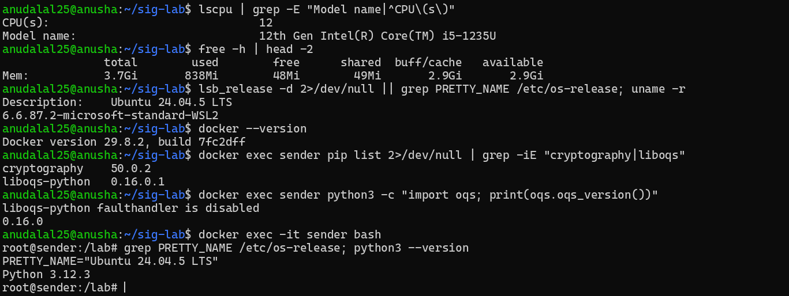

Screenshot 2: Step C4: the image sig-lab:1.0 has been built and is listed by docker images

Screenshot 3: Step C5: user-defined bridge network sig-net created and listed (no containers attached yet)
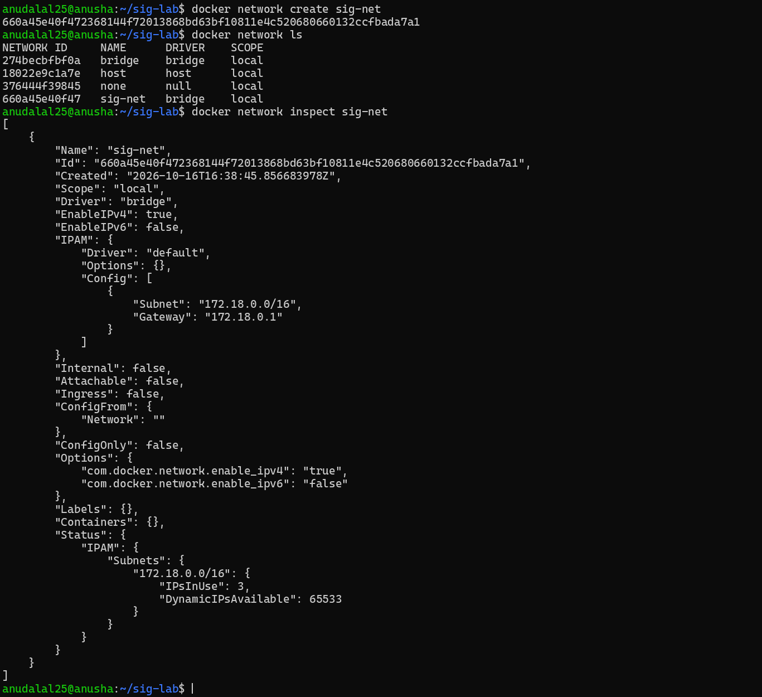

Screenshot 4: Step C6: sender and receiver containers started on sig-net with STUDENT_UID; docker ps shows both Up
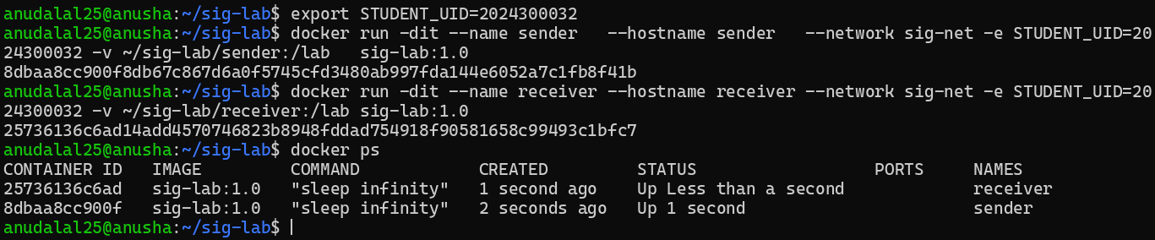

Screenshot 5: Step C7: docker network inspect sig-net now lists both containers with their IP addresses
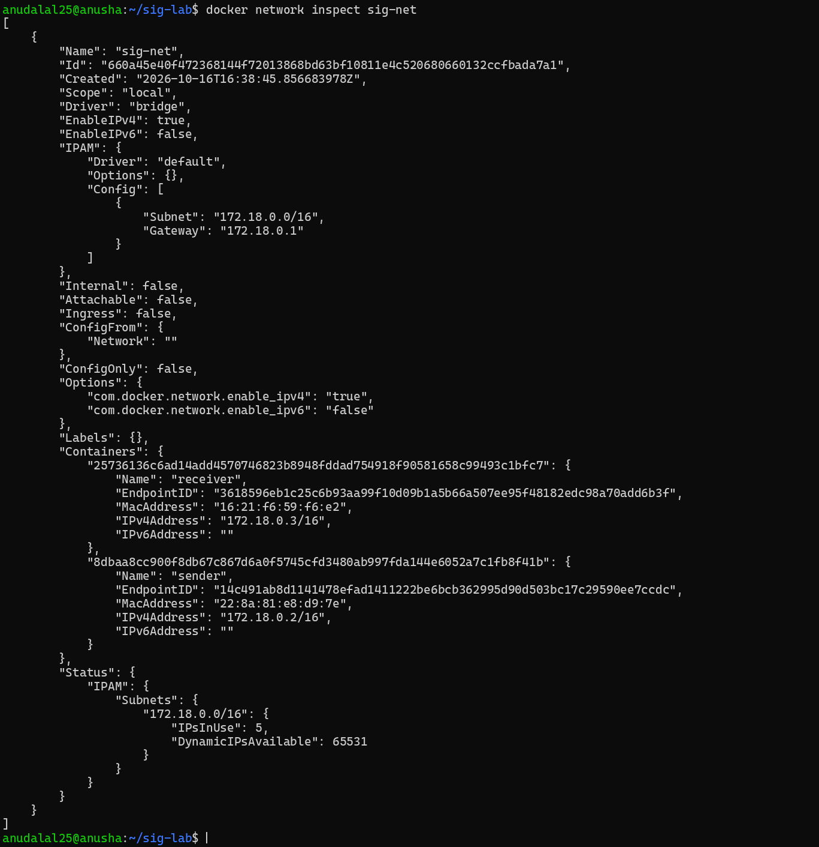

Screenshot 6: Step C7: ping by name from sender to receiver, STUDENT_UID inside the container, liboqs mechanisms and container IPs
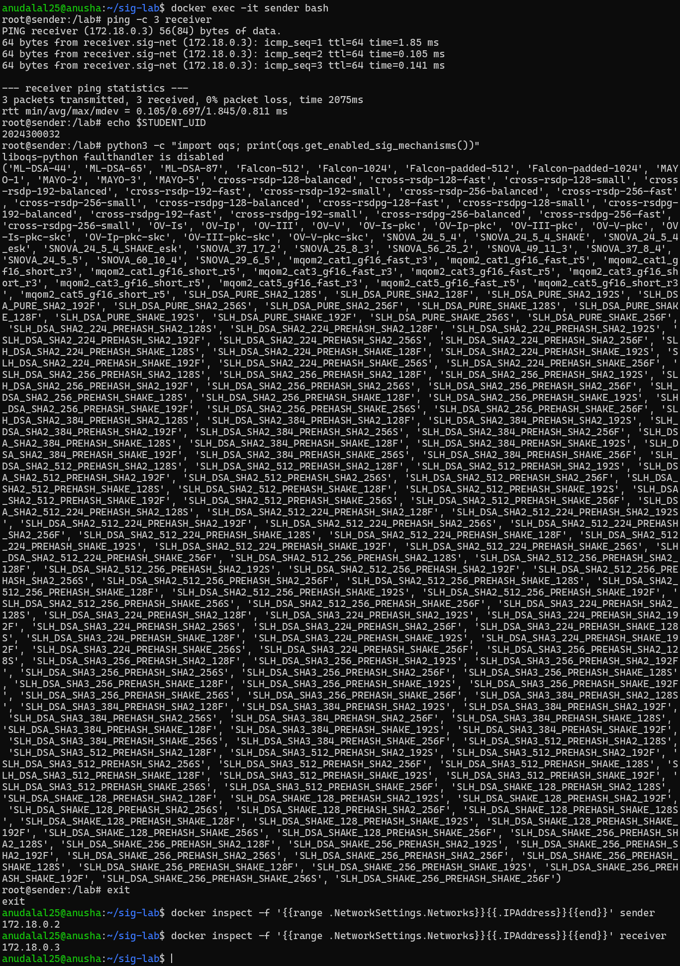

3. Key generation, signing, transfer and verification (Parts D-G)

Screenshot 7: Step D1: exact ML-DSA / SLH-DSA names in liboqs (ML-DSA-44, SLH_DSA_PURE_SHA2_128S)
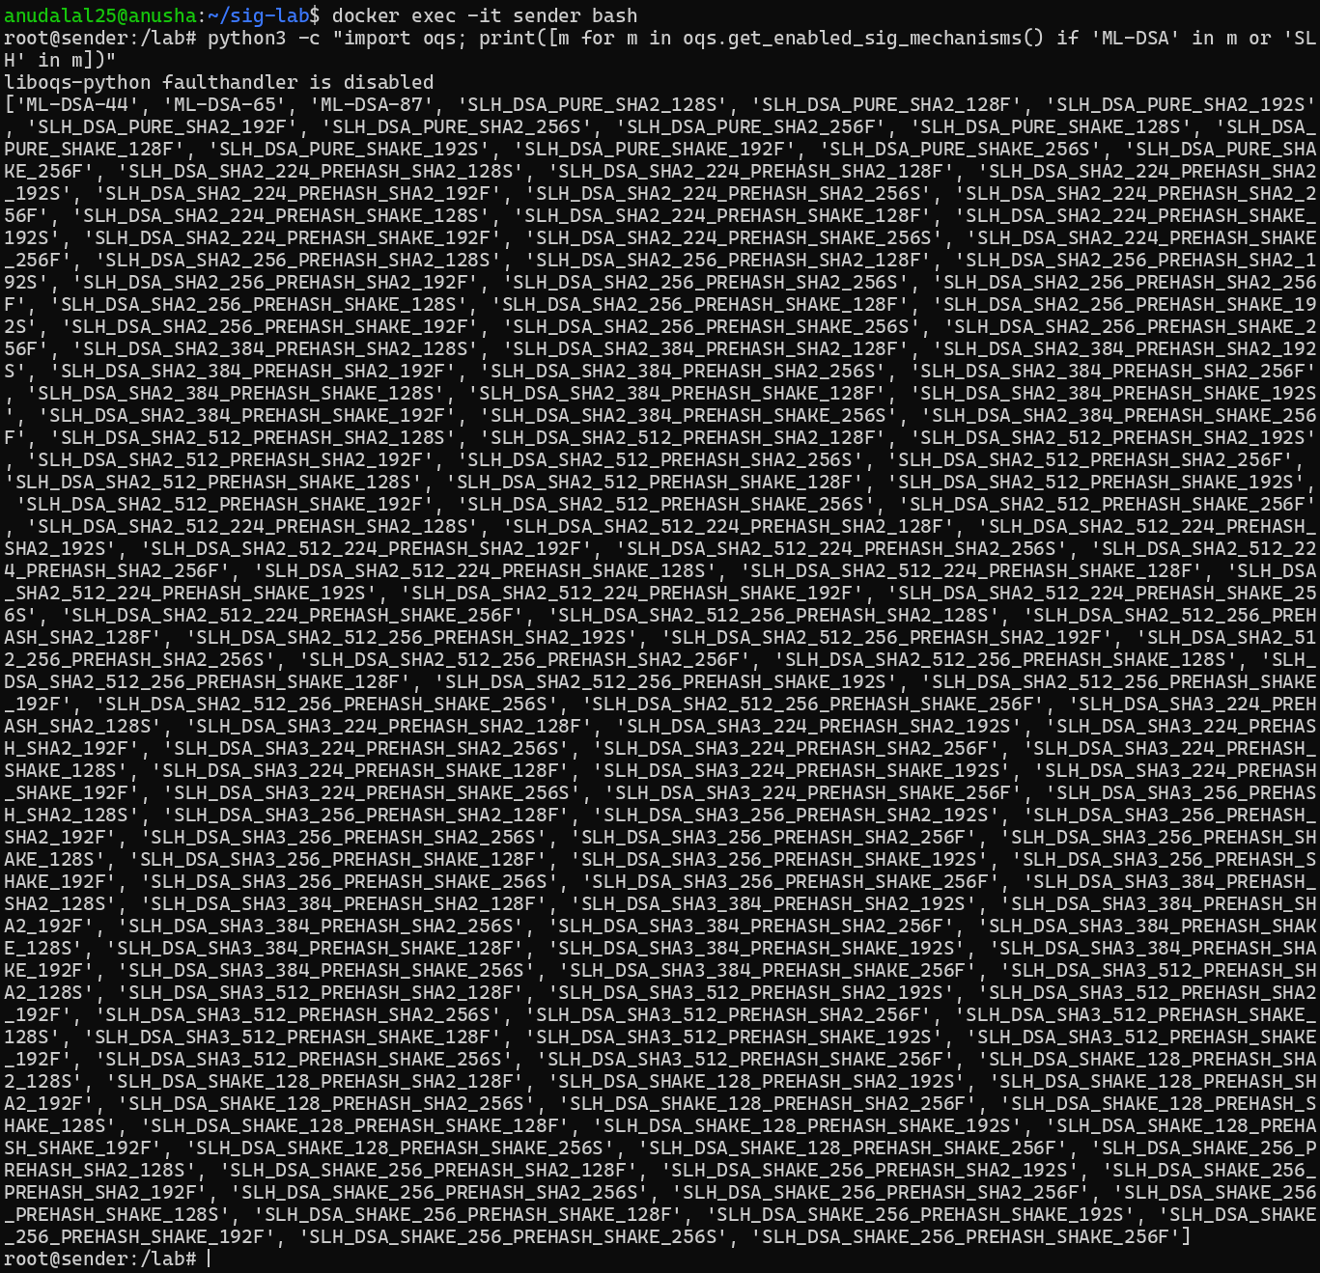

Screenshot 8: Step D3: keygen.py generates the ECDSA, RSA-PSS, ML-DSA and SLH-DSA key pairs and prints their sizes
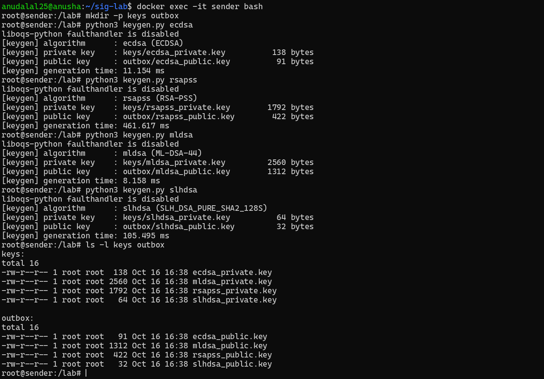

Screenshot 9: Part E: sign.py creates the UID document and signs it with all four algorithms; document SHA-256 noted
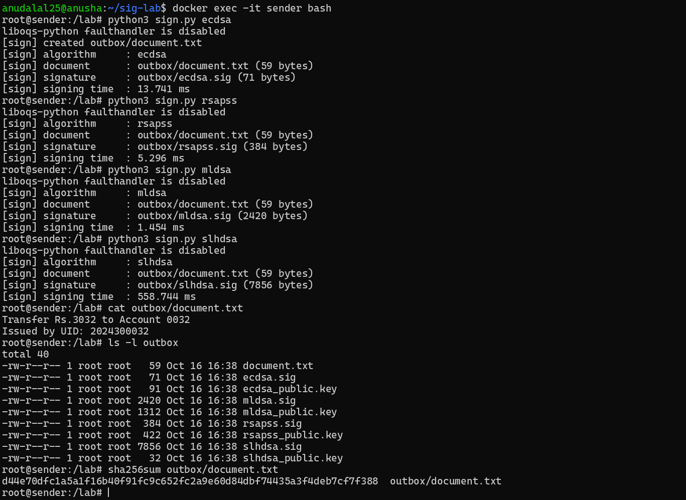

Screenshot 10: Part F: receiver downloads document, signatures and public keys from http://sender:8000; SHA-256 matches
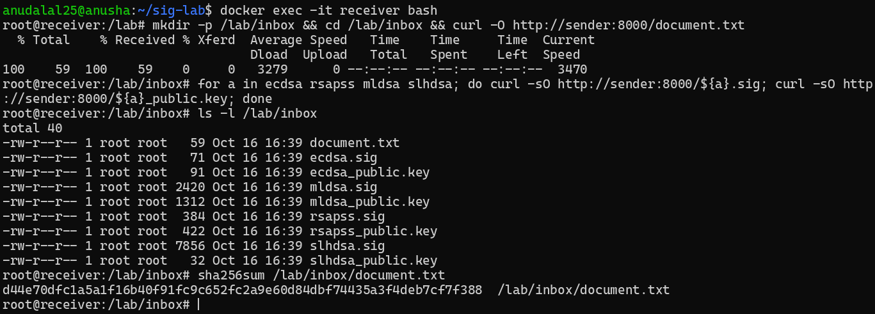

Screenshot 11: Part F: sender's HTTP server log showing every request coming from the receiver's IP (172.18.0.3)
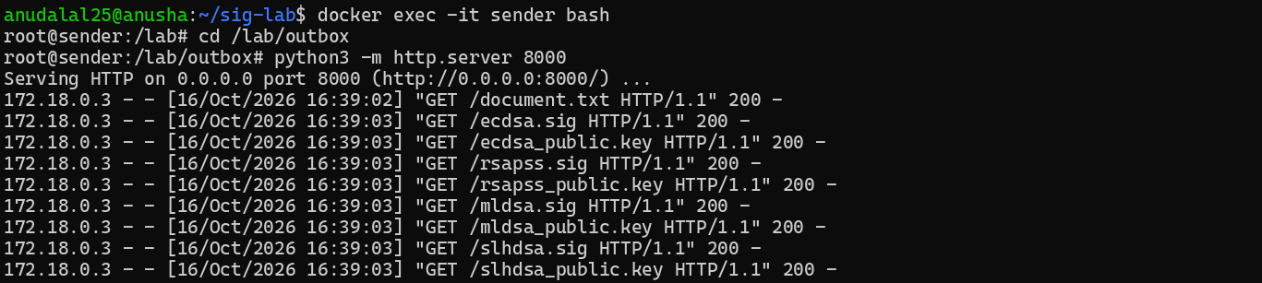

Screenshot 12: Part G: verify.py on the receiver prints PASS for all four algorithms
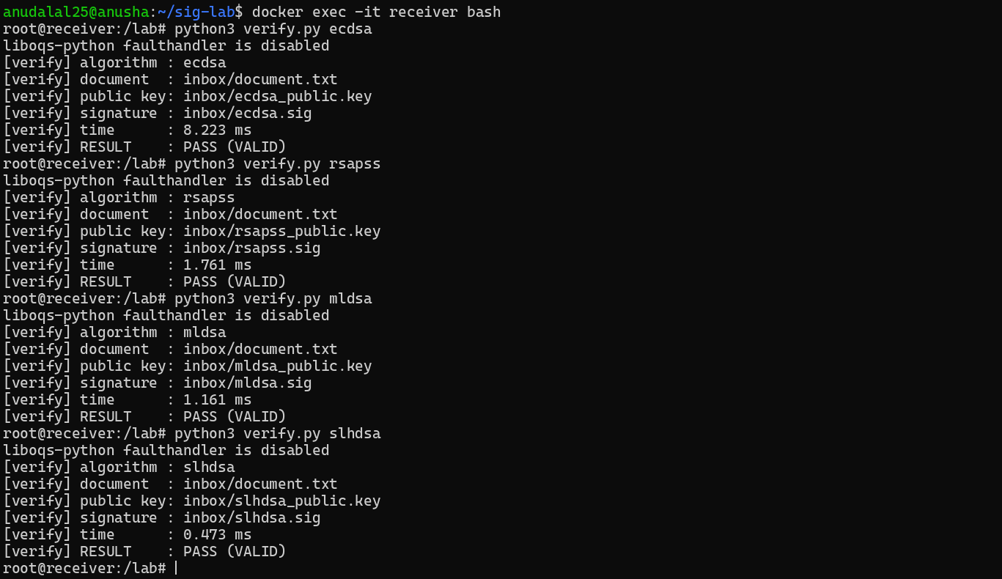

4. Sizes, tampering detection and timings (Parts G-I)

Table 2: Key, signature and transmission sizes (bytes)
Algorithm | Public key | Private key | Signature | Document | Transmitted (doc + sig + public key)
ECDSA | 91 | 138 | 71 | 59 | 221
RSA-PSS | 422 | 1792 | 384 | 59 | 865
ML-DSA | 1312 | 2560 | 2420 | 59 | 3791
SLH-DSA | 32 | 64 | 7856 | 59 | 7947
Sizes of the files actually written and transferred, measured with stat -c %s. Key formats as prescribed in Step D3: ECDSA and RSA-PSS private keys PKCS#8 DER, public keys SubjectPublicKeyInfo DER; ML-DSA and SLH-DSA raw keys from liboqs (these match the FIPS 204/205 sizes 1312/2560/2420 and 32/64/7856 B).

Screenshot 13: Part G: key, signature and document sizes (stat -c %s) on the sender and bytes received for Table 2
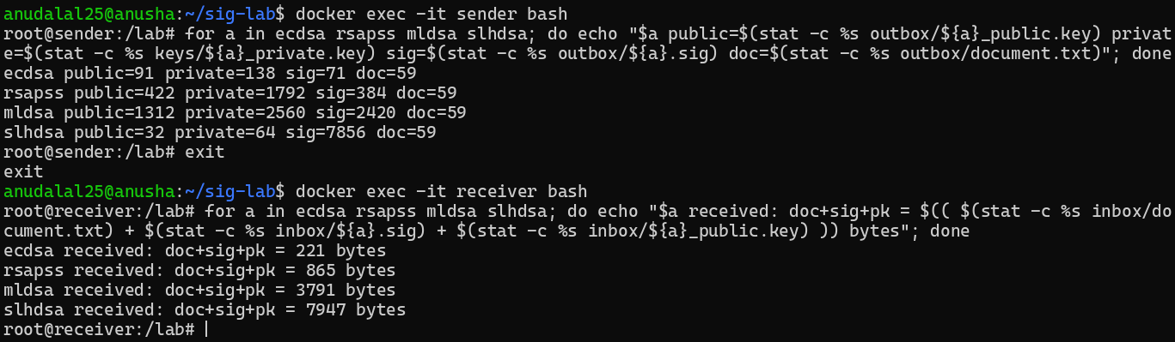

Table 3: Verification results
Test case | ECDSA | RSA-PSS | ML-DSA | SLH-DSA | Expected
1. Original document + original signature | PASS | PASS | PASS | PASS | PASS
2. One character of document changed | FAIL | FAIL | FAIL | FAIL | FAIL
3. One bit of signature changed | FAIL | FAIL | FAIL | FAIL | FAIL
4. Correct document + signature, wrong public key | FAIL | FAIL | FAIL | FAIL | FAIL

Document | Text (tamper index = UID mod 59 = 2: 'a' (0x61) changed to '`' (0x60))
Original | Transfer Rs.3032 to Account 0032 / Issued by UID: 2024300032
Modified | Tr`nsfer Rs.3032 to Account 0032 / Issued by UID: 2024300032
Test 3 flipped bit 0 of the signature byte at index UID mod length: ECDSA byte 4 (0x65 -> 0x64), RSA-PSS byte 256 (0x19 -> 0x18), ML-DSA byte 1492 (0x78 -> 0x79), SLH-DSA byte 5232 (0xf9 -> 0xf8). Test 4: the receiver generated its own key pairs; for ECDSA an independent key from the secure random generator was used (keygen.py ecdsa --independent), because a UID-derived key would be identical to the sender's key. cmp confirmed all four receiver public keys differ from the sender's.

Screenshot 14: Part H, Tests 1-2: one character of the document changed; original passes, modified document FAILS
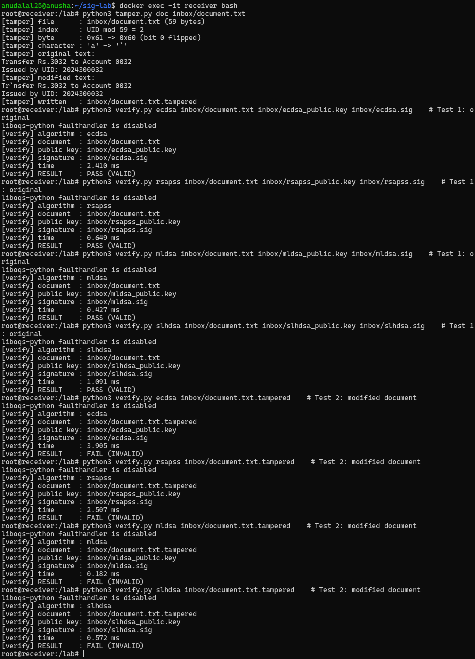

Screenshot 15: Part H, Test 3: one bit of each signature flipped at index UID mod length; all four FAIL
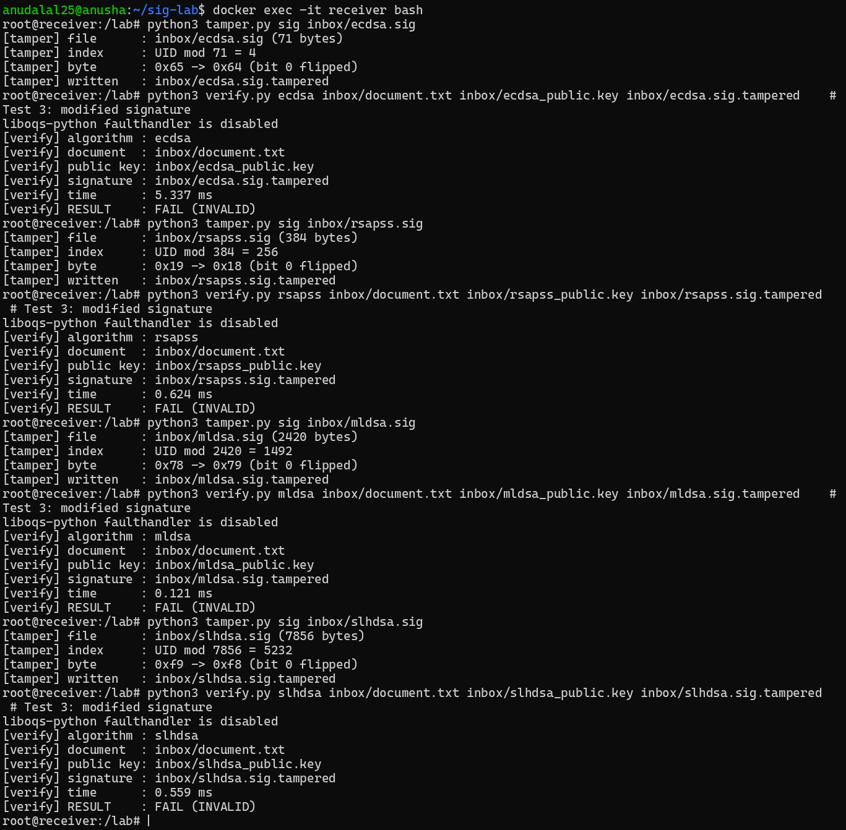

Screenshot 16: Part H, Test 4: receiver makes its own key pairs (independent ECDSA key) - verification with the wrong public key FAILS for all four
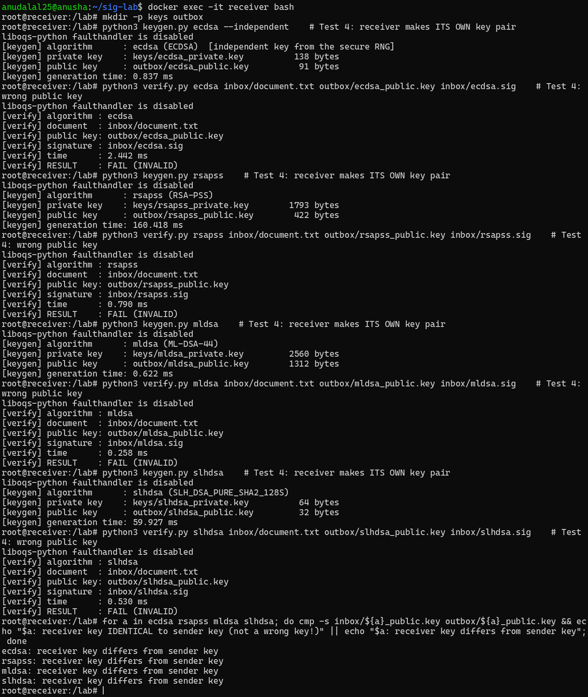

Table 4: Timing results (milliseconds, mean ± standard deviation)
Algorithm | Key generation | Signing | Verification | Sign / Verify ratio
ECDSA | 0.0922 ± 0.0324 | 0.0442 ± 0.0087 | 0.1239 ± 0.0092 | 0.36
RSA-PSS | 198.1258 ± 102.1346 | 1.3343 ± 0.0675 | 0.0342 ± 0.0017 | 39.01
ML-DSA | 0.0250 ± 0.0006 | 0.0659 ± 0.0337 | 0.0238 ± 0.0021 | 2.77
SLH-DSA | 55.5836 ± 14.4815 | 471.3847 ± 83.6407 | 0.4062 ± 0.0153 | 1160.47
Sender container, median of three bench.py runs (results.csv = results_run3.csv); 1024-byte UID-seeded message; 5 warm-up calls, then key generation x20, signing x100, verification x100, each call timed with time.perf_counter_ns().

Screenshot 17: Part I: bench.py on the sender, run three times (results_run1/2/3.csv)
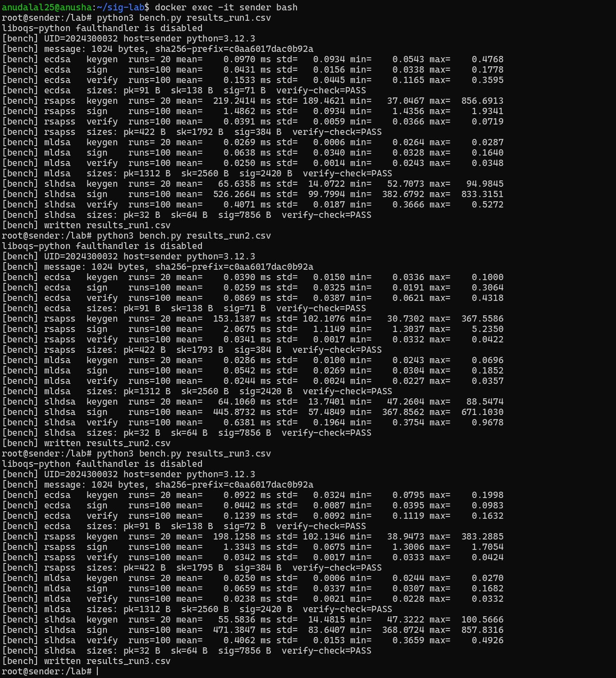

Screenshot 18: Part I: the median run (run 3) is kept as results.csv on the sender
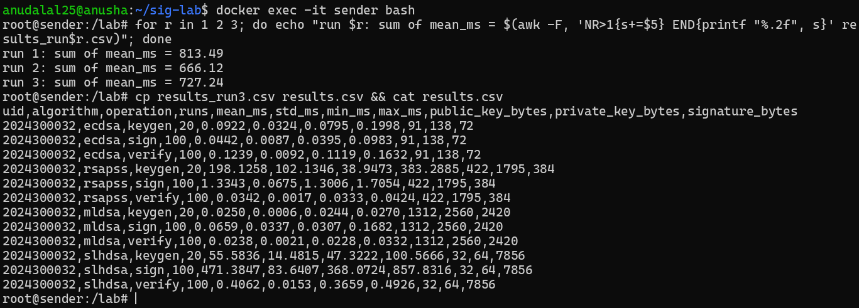

Screenshot 19: Part I: bench.py repeated on the receiver container (receiver results.csv)
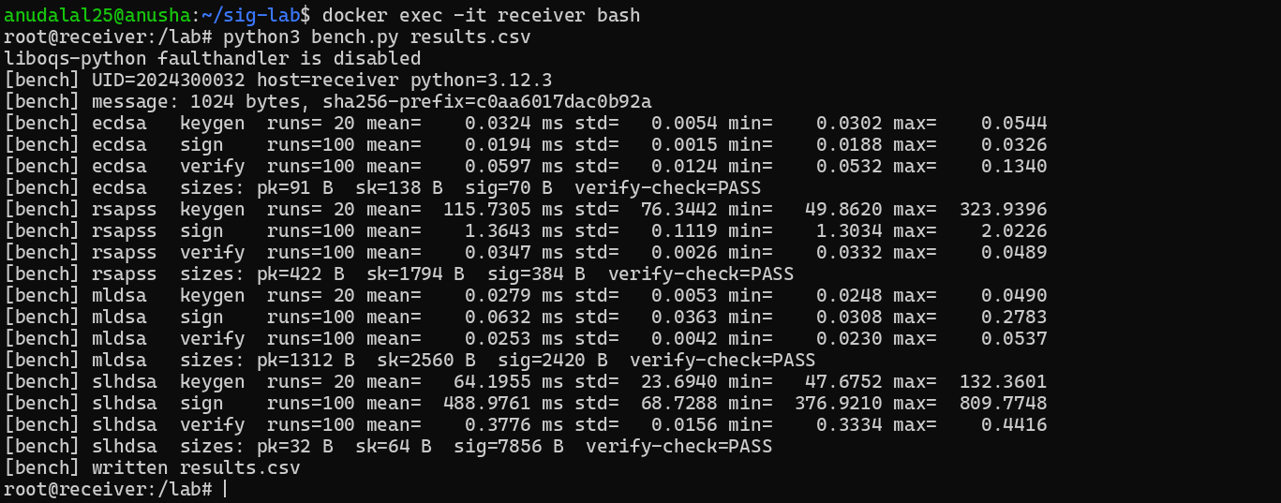

5. Graphical analysis (Section 15) and comparative analysis (Part J)
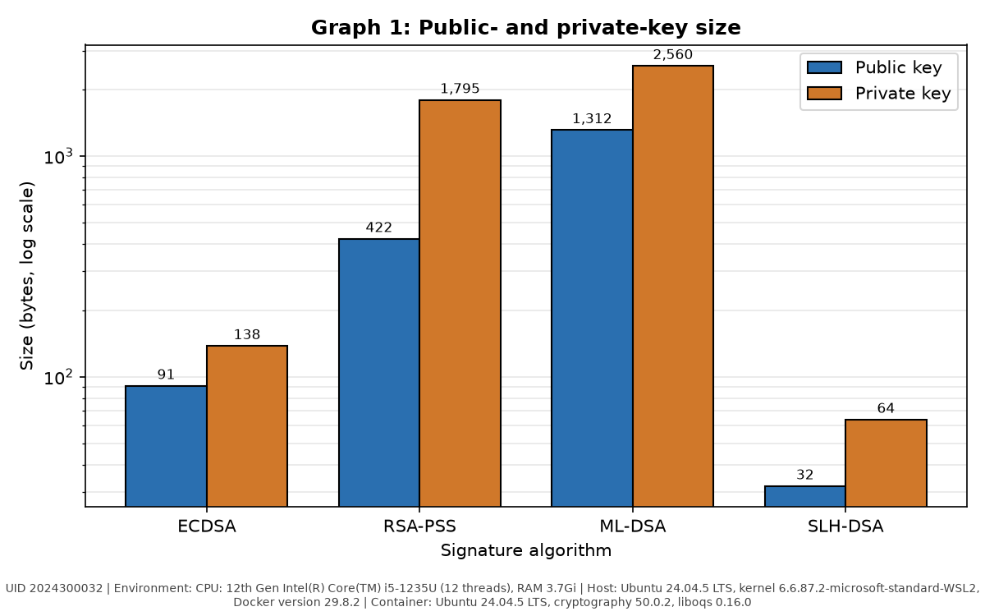
Graph 1: Public-key and private-key size (bytes, log scale). Environment: CPU: 12th Gen Intel(R) Core(TM) i5-1235U (12 threads), RAM 3.7Gi; Host: Ubuntu 24.04.5 LTS, kernel 6.6.87.2-microsoft-standard-WSL2, Docker version 29.8.2; Container: Ubuntu 24.04.5 LTS, cryptography 50.0.2, liboqs 0.16.0. UID 2024300032.
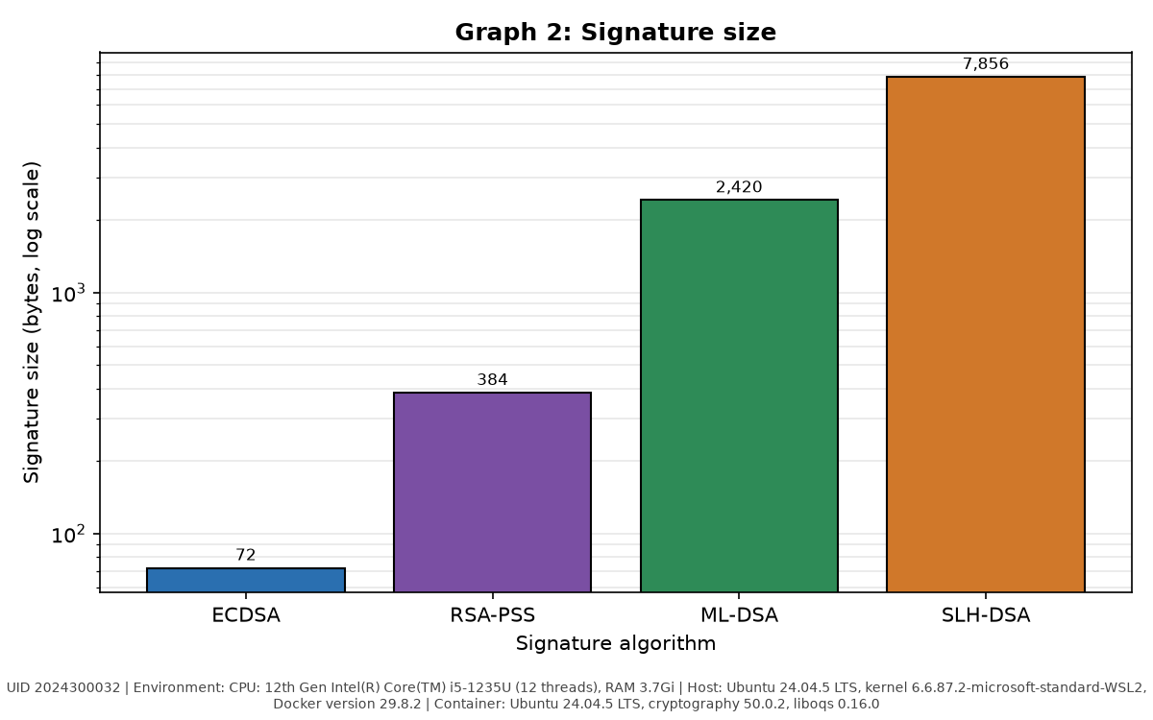
Graph 2: Signature size (bytes, log scale). Environment: CPU: 12th Gen Intel(R) Core(TM) i5-1235U (12 threads), RAM 3.7Gi; Host: Ubuntu 24.04.5 LTS, kernel 6.6.87.2-microsoft-standard-WSL2, Docker version 29.8.2; Container: Ubuntu 24.04.5 LTS, cryptography 50.0.2, liboqs 0.16.0. UID 2024300032.
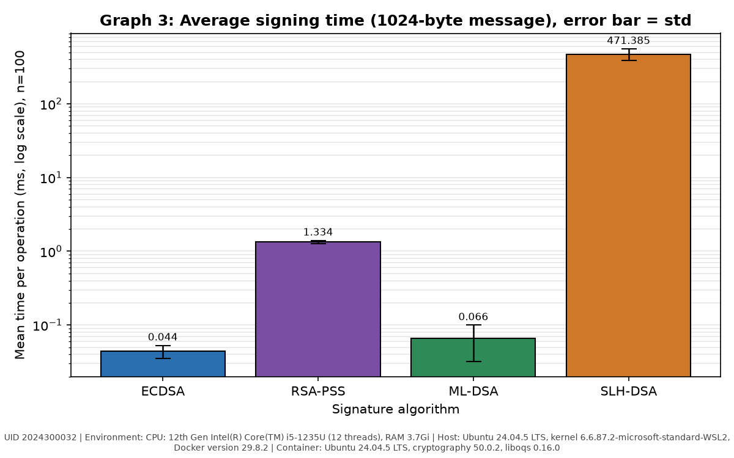
Graph 3: Average signing time (ms, log scale); error bar = standard deviation, n = 100. Environment: CPU: 12th Gen Intel(R) Core(TM) i5-1235U (12 threads), RAM 3.7Gi; Host: Ubuntu 24.04.5 LTS, kernel 6.6.87.2-microsoft-standard-WSL2, Docker version 29.8.2; Container: Ubuntu 24.04.5 LTS, cryptography 50.0.2, liboqs 0.16.0. UID 2024300032.
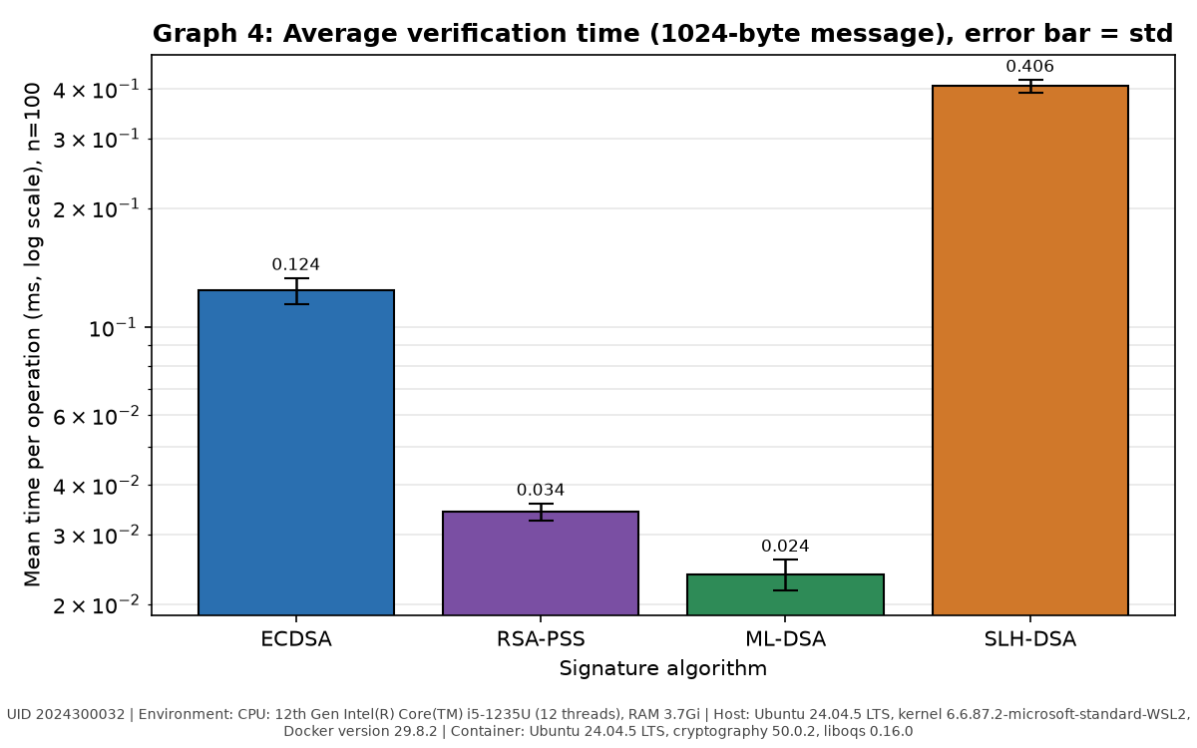
Graph 4: Average verification time (ms, log scale); error bar = standard deviation, n = 100. Environment: CPU: 12th Gen Intel(R) Core(TM) i5-1235U (12 threads), RAM 3.7Gi; Host: Ubuntu 24.04.5 LTS, kernel 6.6.87.2-microsoft-standard-WSL2, Docker version 29.8.2; Container: Ubuntu 24.04.5 LTS, cryptography 50.0.2, liboqs 0.16.0. UID 2024300032.
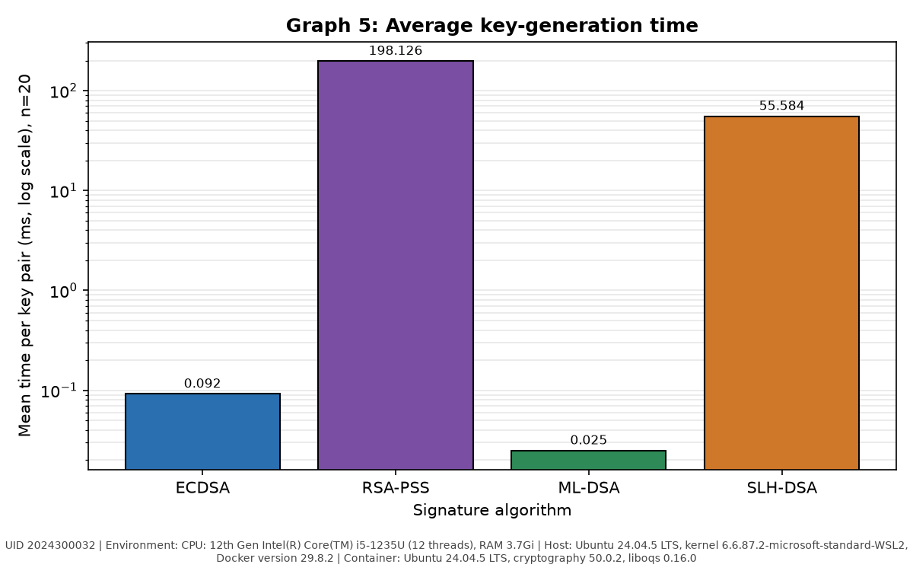
Graph 5: Average key-generation time (ms, log scale), n = 20. Environment: CPU: 12th Gen Intel(R) Core(TM) i5-1235U (12 threads), RAM 3.7Gi; Host: Ubuntu 24.04.5 LTS, kernel 6.6.87.2-microsoft-standard-WSL2, Docker version 29.8.2; Container: Ubuntu 24.04.5 LTS, cryptography 50.0.2, liboqs 0.16.0. UID 2024300032.
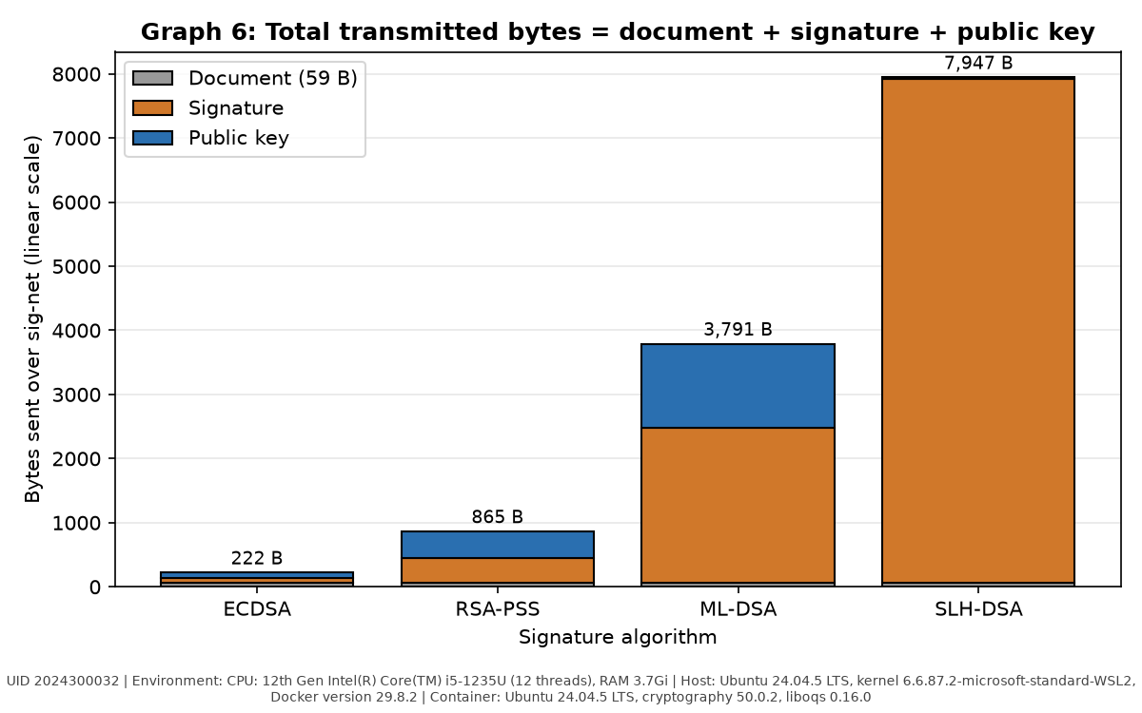
Graph 6: Total transmitted bytes = document + signature + public key. Environment: CPU: 12th Gen Intel(R) Core(TM) i5-1235U (12 threads), RAM 3.7Gi; Host: Ubuntu 24.04.5 LTS, kernel 6.6.87.2-microsoft-standard-WSL2, Docker version 29.8.2; Container: Ubuntu 24.04.5 LTS, cryptography 50.0.2, liboqs 0.16.0. UID 2024300032.
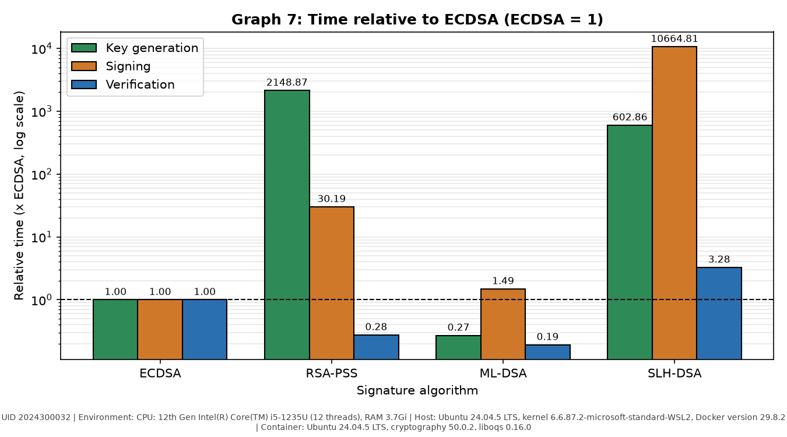
Graph 7 (extra): Sign, verify and key-generation time relative to ECDSA (ECDSA = 1, log scale). Environment: CPU: 12th Gen Intel(R) Core(TM) i5-1235U (12 threads), RAM 3.7Gi; Host: Ubuntu 24.04.5 LTS, kernel 6.6.87.2-microsoft-standard-WSL2, Docker version 29.8.2; Container: Ubuntu 24.04.5 LTS, cryptography 50.0.2, liboqs 0.16.0. UID 2024300032.

Screenshot 20: Section 15: plot.py draws the seven graphs; docker cp copies graphs/ to the host
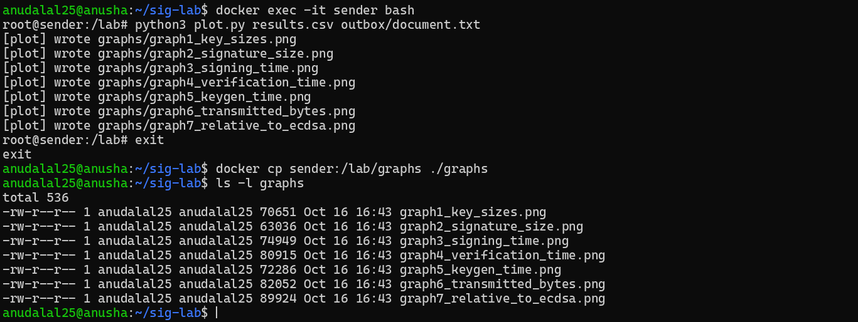

Table 5: Relative comparison with ECDSA as the baseline (measured value / ECDSA value)
Parameter | ECDSA | RSA-PSS | ML-DSA | SLH-DSA
Public key size | 1.0 | 4.64 | 14.42 | 0.35
Signature size | 1.0 | 5.41 | 34.08 | 110.65
Signing time | 1.0 | 30.19 | 1.49 | 10664.81
Verification time | 1.0 | 0.28 | 0.19 | 3.28
Key generation time | 1.0 | 2148.87 | 0.27 | 602.86
Total transmitted bytes | 1.0 | 3.91 | 17.15 | 35.96

Table 6: Property comparison
Property | ECDSA | RSA-PSS | ML-DSA | SLH-DSA
Standard | FIPS 186-5 | RFC 8017, FIPS 186-5 | FIPS 204 (2024) | FIPS 205 (2024)
Security parameter / category | P-256 (secp256r1), ~128-bit | RSA-3072, ~128-bit | ML-DSA-44, NIST category 2 | SLH-DSA-SHA2-128s, NIST category 1
Mathematical basis | Elliptic-curve discrete logarithm | Integer factorisation | Module lattices (Module-LWE / SIS) | Hash functions only (hypertree of Merkle / FORS trees)
Resistant to Shor's algorithm? | No | No | Yes | Yes
Public key size (small / medium / large) | Small (91 B) | Medium (422 B) | Large (1312 B) | Small (32 B)
Signature size | Small (71 B) | Medium (384 B) | Large (2420 B) | Very large (7856 B)
Fastest operation | Signing (0.044 ms) | Verification (0.034 ms) | Verification (0.024 ms) | Verification (0.406 ms)
Slowest operation | Verification (0.124 ms) | Key generation (198.1 ms) | Signing (0.066 ms) | Signing (471.4 ms)
Maturity / deployment | Very mature; TLS, SSH, code signing, smart cards | Very mature (decades); PKI, TLS, document signing | New (2024); being rolled out, often in hybrid mode | New (2024), conservative SPHINCS+ design; firmware, root keys
Main advantage | Smallest keys and signatures, fast signing | Very fast verification, universal support | Quantum-safe and fast (fastest verification measured) | Quantum-safe, relies only on hash functions; 32 B public key
Main disadvantage | Broken by Shor; needs secure nonces | Broken by Shor; slow key generation, larger keys | Large public key and signature | Very slow signing, very large signature

Table 7: Which algorithm would you choose?
Scenario | Chosen algorithm | Justification
Signing a firmware image for a device that stays in the field for 15 years | SLH-DSA | Must outlive quantum computers; hash-only security is the most conservative, signing is rare and verification was cheap in our tests.
Authenticating a short sensor message on a very low-bandwidth link | ECDSA | Smallest overhead (71 B signature, 91 B key) and the data is short-lived.
Signing a TLS server certificate in 2026 on a general web server | ECDSA (P-256) | Universally supported, tiny handshake; certificates live < 1 year, with a planned move to hybrid ECDSA + ML-DSA.
Root key of a certificate authority that must remain trusted for 30 years | SLH-DSA | Rarely signs, so slow signing and large signatures are acceptable; security rests only on hash functions.
High-volume server that verifies millions of signatures per second | ML-DSA | Fastest verification in our measurements (0.024 ms per signature on this setup) and quantum-safe.
Timings in Tables 4-7 are those measured in this experiment's containers on the machine in Table 1; absolute values depend on the hardware and library build, the relative ordering is what the choices rely on.

6. Answers to the discussion questions
Questions 1-11 (Section 17), handwritten.
[ attach handwritten pages here ]

7. Final conclusion (200-250 words)
Handwritten conclusion (Section 18).
[ attach handwritten pages here ]

8. Source code

Dockerfile
FROM ubuntu:24.04
ENV DEBIAN_FRONTEND=noninteractive
RUN apt-get update && apt-get install -y --no-install-recommends \
python3 python3-pip python3-venv git cmake ninja-build build-essential \
libssl-dev curl wget nano iproute2 iputils-ping tcpdump ca-certificates \
&& rm -rf /var/lib/apt/lists/*
RUN python3 -m venv /opt/venv
ENV PATH="/opt/venv/bin:$PATH"
RUN pip install --no-cache-dir cryptography matplotlib pandas liboqs-python
# The first import makes liboqs-python download and build liboqs (a few minutes)
RUN python3 -c "import oqs; print(oqs.oqs_version())"
WORKDIR /lab
CMD ["sleep", "infinity"]

common.py
"""common.py - shared helpers for the digital-signature lab (sender and receiver).

Contents (Step D2):
* STUDENT_UID read from the environment (must be exactly 10 digits)
* ALGS: lab name -> library name / parameters
* document text, ECDSA private scalar, benchmark message, tamper index (Section 5)
* file-path helpers and a millisecond timing helper
"""
import hashlib
import os
import random
import sys
import time

# ---------------------------------------------------------------- UID
def get_uid():
uid = os.environ.get("STUDENT_UID", "").strip()
if not uid:
sys.exit("ERROR: environment variable STUDENT_UID is not set "
"(start the container with -e STUDENT_UID=<your 10-digit UID>)")
if not (uid.isdigit() and len(uid) == 10):
sys.exit(f"ERROR: STUDENT_UID must be exactly 10 digits, got {uid!r}")
return uid

UID = get_uid()

# ---------------------------------------------------------------- algorithms
# Strings for the PQ schemes are the exact names printed by Step D1 on this system.
ALGS = {
"ecdsa": {"family": "classical", "label": "ECDSA", "curve": "SECP256R1", "hash": "SHA256"},
"rsapss": {"family": "classical", "label": "RSA-PSS", "key_size": 3072, "e": 65537,
"hash": "SHA256", "salt_length": 32},
"mldsa": {"family": "pq", "label": "ML-DSA", "oqs_name": "ML-DSA-44"},
"slhdsa": {"family": "pq", "label": "SLH-DSA", "oqs_name": "SLH_DSA_PURE_SHA2_128S"},
}
ALG_ORDER = ["ecdsa", "rsapss", "mldsa", "slhdsa"]

def check_alg(alg):
if alg not in ALGS:
sys.exit(f"ERROR: unknown algorithm {alg!r}; choose one of: {', '.join(ALG_ORDER)}")
return alg

# ---------------------------------------------------------------- UID-derived values (Section 5)
# Order n of the P-256 group
P256_N = int("FFFFFFFF00000000FFFFFFFFFFFFFFFF"
"BCE6FAADA7179E84F3B9CAC2FC632551", 16)

def document_text(uid=UID):
"""Line 1: Transfer Rs.<A> to Account <last 4 digits of UID>, A = 1000 + (UID mod 9000)
Line 2: Issued by UID: <UID>"""
amount = 1000 + (int(uid) % 9000)
return f"Transfer Rs.{amount} to Account {uid[-4:]}\nIssued by UID: {uid}\n"

def ecdsa_private_scalar(uid=UID):
"""d = ( int( SHA-256( UID || "CNS-DSIG-ECDSA-KEY" ) ) mod (n - 1) ) + 1"""
digest = hashlib.sha256((uid + "CNS-DSIG-ECDSA-KEY").encode()).digest()
return (int.from_bytes(digest, "big") % (P256_N - 1)) + 1

def bench_message(uid=UID):
"""1024 bytes produced by random.Random(int(UID)).randbytes(1024)"""
return random.Random(int(uid)).randbytes(1024)

def tamper_index(length, uid=UID):
"""index = UID mod (length of document or signature in bytes)"""
return int(uid) % length

# ---------------------------------------------------------------- file paths
KEYS_DIR, OUTBOX_DIR, INBOX_DIR = "keys", "outbox", "inbox"

def private_key_path(alg):
return os.path.join(KEYS_DIR, f"{alg}_private.key")

def public_key_path(alg, folder=OUTBOX_DIR):
return os.path.join(folder, f"{alg}_public.key")

def signature_path(alg, folder=OUTBOX_DIR):
return os.path.join(folder, f"{alg}.sig")

def document_path(folder=OUTBOX_DIR):
return os.path.join(folder, "document.txt")

def read_bytes(path):
with open(path, "rb") as f:
return f.read()

def write_bytes(path, data):
os.makedirs(os.path.dirname(path) or ".", exist_ok=True)
with open(path, "wb") as f:
f.write(data)

# ---------------------------------------------------------------- timing helper
def timed_ms(func, *args, **kwargs):
"""Run func once; return (result, elapsed milliseconds) measured with perf_counter_ns."""
t0 = time.perf_counter_ns()
result = func(*args, **kwargs)
t1 = time.perf_counter_ns()
return result, (t1 - t0) / 1e6

keygen.py
"""keygen.py <alg> [--independent] - generate the key pair of the chosen algorithm (Step D3).

--independent (wrong-key test, Part H Test 4 only): the ECDSA key comes from the secure random
generator instead of the UID. Without it, the receiver would re-derive the sender's exact ECDSA
key from the same STUDENT_UID, and the "wrong" key would really be the right one.

Private key -> keys/<alg>_private.key (never leaves the container)
Public key -> outbox/<alg>_public.key
"""
import sys

import oqs
from cryptography.hazmat.primitives import serialization
from cryptography.hazmat.primitives.asymmetric import ec, rsa

from common import (ALGS, check_alg, ecdsa_private_scalar, private_key_path,
public_key_path, timed_ms, write_bytes)

def _der_pair(private_key):
sk = private_key.private_bytes(encoding=serialization.Encoding.DER,
format=serialization.PrivateFormat.PKCS8,
encryption_algorithm=serialization.NoEncryption())
pk = private_key.public_key().public_bytes(
encoding=serialization.Encoding.DER,
format=serialization.PublicFormat.SubjectPublicKeyInfo)
return sk, pk

def generate(alg, independent=False):
"""Return (private_key_bytes, public_key_bytes) for alg."""
if alg == "ecdsa" and independent:
return _der_pair(ec.generate_private_key(ec.SECP256R1()))
if alg == "ecdsa":
# private key built from the UID-derived scalar d on curve P-256
return _der_pair(ec.derive_private_key(ecdsa_private_scalar(), ec.SECP256R1()))
if alg == "rsapss":
p = ALGS["rsapss"]
return _der_pair(rsa.generate_private_key(public_exponent=p["e"], key_size=p["key_size"]))
# ML-DSA / SLH-DSA: raw public key and raw secret key from liboqs
with oqs.Signature(ALGS[alg]["oqs_name"]) as signer:
pk = signer.generate_keypair()
sk = signer.export_secret_key()
return sk, pk

def main():
if len(sys.argv) not in (2, 3) or (len(sys.argv) == 3 and sys.argv[2] != "--independent"):
sys.exit("usage: python3 keygen.py <ecdsa|rsapss|mldsa|slhdsa> [--independent]")
alg = check_alg(sys.argv[1])
independent = len(sys.argv) == 3
(sk, pk), ms = timed_ms(generate, alg, independent)
write_bytes(private_key_path(alg), sk)
write_bytes(public_key_path(alg), pk)
name = ALGS[alg].get("oqs_name", ALGS[alg]["label"])
print(f"[keygen] algorithm : {alg} ({name})"
+ (" [independent key from the secure RNG]" if independent and alg == "ecdsa" else ""))
print(f"[keygen] private key : {private_key_path(alg):28s} {len(sk):6d} bytes")
print(f"[keygen] public key : {public_key_path(alg):28s} {len(pk):6d} bytes")
print(f"[keygen] generation time: {ms:.3f} ms")

if __name__ == "__main__":
main()

sign.py
"""sign.py <alg> - sign the UID document (Part E).

(1) create outbox/document.txt from the UID if it does not exist, (2) read it as bytes,
(3) load the private key, (4) sign, (5) write outbox/<alg>.sig, (6) print the signature size.
"""
import os
import sys

import oqs
from cryptography.hazmat.primitives import hashes
from cryptography.hazmat.primitives.asymmetric import ec, padding
from cryptography.hazmat.primitives.serialization import load_der_private_key

from common import (ALGS, check_alg, document_path, document_text, private_key_path,
read_bytes, signature_path, timed_ms, write_bytes)

def load_private(alg, sk_bytes):
"""Classical: cryptography key object. PQ: liboqs signer holding the secret key."""
if ALGS[alg]["family"] == "classical":
return load_der_private_key(sk_bytes, password=None)
return oqs.Signature(ALGS[alg]["oqs_name"], sk_bytes)

def sign_data(alg, key, data):
if alg == "ecdsa":
# SHA-256 with ECDSA, DER-encoded signature
return key.sign(data, ec.ECDSA(hashes.SHA256()))
if alg == "rsapss":
# PSS, MGF1(SHA-256), salt length = SHA-256 digest length (32), hash SHA-256
return key.sign(data,
padding.PSS(mgf=padding.MGF1(hashes.SHA256()),
salt_length=ALGS["rsapss"]["salt_length"]),
hashes.SHA256())
# ML-DSA / SLH-DSA: sign the whole document directly (no manual hashing)
return key.sign(data)

def main():
if len(sys.argv) != 2:
sys.exit("usage: python3 sign.py <ecdsa|rsapss|mldsa|slhdsa>")
alg = check_alg(sys.argv[1])

doc = document_path()
if not os.path.exists(doc):
write_bytes(doc, document_text().encode())
print(f"[sign] created {doc}")
data = read_bytes(doc)

key = load_private(alg, read_bytes(private_key_path(alg)))
sig, ms = timed_ms(sign_data, alg, key, data)
write_bytes(signature_path(alg), sig)

print(f"[sign] algorithm : {alg}")
print(f"[sign] document : {doc} ({len(data)} bytes)")
print(f"[sign] signature : {signature_path(alg)} ({len(sig)} bytes)")
print(f"[sign] signing time : {ms:.3f} ms")

if __name__ == "__main__":
main()

verify.py
"""verify.py <alg> [document] [public_key] [signature] - verify a signature (Part G).

Defaults: inbox/document.txt, inbox/<alg>_public.key, inbox/<alg>.sig
Uses exactly the same parameters as sign.py; prints PASS or FAIL and the verification time.
"""
import sys

import oqs
from cryptography.exceptions import InvalidSignature
from cryptography.hazmat.primitives import hashes
from cryptography.hazmat.primitives.asymmetric import ec, padding
from cryptography.hazmat.primitives.serialization import load_der_public_key

from common import (ALGS, INBOX_DIR, check_alg, document_path, public_key_path,
read_bytes, signature_path, timed_ms)

def load_public(alg, pk_bytes):
"""Classical: cryptography public-key object. PQ: (liboqs verifier, raw public key)."""
if ALGS[alg]["family"] == "classical":
return load_der_public_key(pk_bytes)
return oqs.Signature(ALGS[alg]["oqs_name"]), pk_bytes

def verify_data(alg, key, data, sig):
"""Return True if the signature is valid, False otherwise."""
if ALGS[alg]["family"] == "classical":
try:
if alg == "ecdsa":
key.verify(sig, data, ec.ECDSA(hashes.SHA256()))
else:
key.verify(sig, data,
padding.PSS(mgf=padding.MGF1(hashes.SHA256()),
salt_length=ALGS["rsapss"]["salt_length"]),
hashes.SHA256())
return True
except InvalidSignature: # cryptography raises on failure
return False
verifier, pk = key
return verifier.verify(data, sig, pk) # liboqs returns a boolean

def main():
if not 2 <= len(sys.argv) <= 5:
sys.exit("usage: python3 verify.py <alg> [document] [public_key] [signature]")
alg = check_alg(sys.argv[1])
doc = sys.argv[2] if len(sys.argv) > 2 else document_path(INBOX_DIR)
pub = sys.argv[3] if len(sys.argv) > 3 else public_key_path(alg, INBOX_DIR)
sig_file = sys.argv[4] if len(sys.argv) > 4 else signature_path(alg, INBOX_DIR)

data, sig = read_bytes(doc), read_bytes(sig_file)
try:
key = load_public(alg, read_bytes(pub))
ok, ms = timed_ms(verify_data, alg, key, data, sig)
except ValueError as exc: # e.g. malformed key / wrong key length
ok, ms = False, 0.0
print(f"[verify] error: {exc}")

print(f"[verify] algorithm : {alg}")
print(f"[verify] document : {doc}")
print(f"[verify] public key: {pub}")
print(f"[verify] signature : {sig_file}")
print(f"[verify] time : {ms:.3f} ms")
print(f"[verify] RESULT : {'PASS (VALID)' if ok else 'FAIL (INVALID)'}")
sys.exit(0 if ok else 1)

if __name__ == "__main__":
main()

tamper.py
"""tamper.py <doc|sig> <file> - Mallory modifies one character/bit (Part H).

index = UID mod (file length); the byte at that index is XORed with 0x01 (exactly one bit,
hence exactly one character, changes). The result is saved as <file>.tampered; the original
file is never overwritten.
"""
import sys

from common import read_bytes, tamper_index, write_bytes

def main():
if len(sys.argv) != 3 or sys.argv[1] not in ("doc", "sig"):
sys.exit("usage: python3 tamper.py <doc|sig> <file>")
kind, path = sys.argv[1], sys.argv[2]
data = bytearray(read_bytes(path))
idx = tamper_index(len(data))
old = data[idx]
data[idx] ^= 0x01
out = path + ".tampered"
write_bytes(out, bytes(data))

print(f"[tamper] file : {path} ({len(data)} bytes)")
print(f"[tamper] index : UID mod {len(data)} = {idx}")
print(f"[tamper] byte : 0x{old:02x} -> 0x{data[idx]:02x} (bit 0 flipped)")
if kind == "doc":
print(f"[tamper] character : {chr(old)!r} -> {chr(data[idx])!r}")
print("[tamper] original text:")
print(read_bytes(path).decode(errors="replace"), end="")
print("[tamper] modified text:")
print(bytes(data).decode(errors="replace"), end="")
print(f"[tamper] written : {out}")

if __name__ == "__main__":
main()

bench.py
"""bench.py [output.csv] - benchmark key generation, signing and verification (Part I).

Only the cryptographic call is inside the timed region (no Docker start-up, file I/O or
network). Per algorithm and operation: 5 un-recorded warm-up runs, then key generation x20,
signing x100, verification x100, each call timed individually with time.perf_counter_ns().
The message is the 1024-byte UID-seeded message from Section 5.
"""
import csv
import platform
import socket
import statistics
import sys
import time

from common import ALG_ORDER, ALGS, UID, bench_message
from keygen import generate
from sign import load_private, sign_data
from verify import load_public, verify_data

WARMUP = 5
RUNS = {"keygen": 20, "sign": 100, "verify": 100}

def measure(func, runs):
for _ in range(WARMUP): # warm-up, not recorded
func()
times, result = [], None
for _ in range(runs):
t0 = time.perf_counter_ns()
result = func()
t1 = time.perf_counter_ns()
times.append((t1 - t0) / 1e6) # ns -> ms
return times, result

def stats(times):
return {"mean_ms": statistics.mean(times), "std_ms": statistics.stdev(times),
"min_ms": min(times), "max_ms": max(times)}

def main():
out = sys.argv[1] if len(sys.argv) > 1 else "results.csv"
msg = bench_message()
assert len(msg) == 1024
print(f"[bench] UID={UID} host={socket.gethostname()} python={platform.python_version()}")
print(f"[bench] message: 1024 bytes, sha256-prefix={__import__('hashlib').sha256(msg).hexdigest()[:16]}")

rows = []
for alg in ALG_ORDER:
# key generation (the key pair produced last is used for signing/verification)
kg_times, (sk, pk) = measure(lambda: generate(alg), RUNS["keygen"])
priv, pub = load_private(alg, sk), load_public(alg, pk)

sg_times, sig = measure(lambda: sign_data(alg, priv, msg), RUNS["sign"])
vf_times, ok = measure(lambda: verify_data(alg, pub, msg, sig), RUNS["verify"])

# the signature from the last signing loop must verify, otherwise we timed failures
if not (ok and verify_data(alg, pub, msg, sig)):
sys.exit(f"ERROR: {alg} signature from the benchmark did not verify")

for op, times in (("keygen", kg_times), ("sign", sg_times), ("verify", vf_times)):
s = stats(times)
rows.append({"uid": UID, "algorithm": alg, "operation": op, "runs": len(times),
**{k: f"{v:.4f}" for k, v in s.items()},
"public_key_bytes": len(pk), "private_key_bytes": len(sk),
"signature_bytes": len(sig)})
print(f"[bench] {alg:7s} {op:7s} runs={len(times):3d} mean={s['mean_ms']:10.4f} ms "
f"std={s['std_ms']:9.4f} min={s['min_ms']:10.4f} max={s['max_ms']:10.4f}")
print(f"[bench] {alg:7s} sizes: pk={len(pk)} B sk={len(sk)} B sig={len(sig)} B "
f"verify-check=PASS")

fields = ["uid", "algorithm", "operation", "runs", "mean_ms", "std_ms", "min_ms", "max_ms",
"public_key_bytes", "private_key_bytes", "signature_bytes"]
with open(out, "w", newline="") as f:
w = csv.DictWriter(f, fieldnames=fields)
w.writeheader()
w.writerows(rows)
print(f"[bench] written {out}")

if __name__ == "__main__":
main()

plot.py
"""plot.py [results.csv] [document.txt] - draw the seven graphs of Section 15 into graphs/.

Every graph has a title, axis labels with units, a legend where required and the execution
environment in the caption (read from environment.txt if present). A logarithmic y-axis is
used wherever the values differ by orders of magnitude.
"""
import os
import platform
import sys

import matplotlib
matplotlib.use("Agg")
import matplotlib.pyplot as plt
import numpy as np
import pandas as pd

from common import ALG_ORDER, ALGS, UID

CSV = sys.argv[1] if len(sys.argv) > 1 else "results.csv"
DOC = sys.argv[2] if len(sys.argv) > 2 else os.path.join("outbox", "document.txt")
OUT = "graphs"
COLORS = {"ecdsa": "#2a6fb0", "rsapss": "#7a4fa3", "mldsa": "#2e8b57", "slhdsa": "#d0782a"}

def environment_caption():
if os.path.exists("environment.txt"):
with open("environment.txt") as f:
env = " | ".join(line.strip() for line in f if line.strip())
else:
env = f"{platform.processor() or platform.machine()} | {platform.platform()}"
return f"UID {UID} | Environment: {env}"

CAPTION = environment_caption()

df = pd.read_csv(CSV, dtype={"uid": str})
labels = [ALGS[a]["label"] for a in ALG_ORDER]
colors = [COLORS[a] for a in ALG_ORDER]
x = np.arange(len(ALG_ORDER))

def row(alg, op):
return df[(df.algorithm == alg) & (df.operation == op)].iloc[0]

def sizes(col):
return [int(row(a, "sign")[col]) for a in ALG_ORDER]

pk, sk, sig = sizes("public_key_bytes"), sizes("private_key_bytes"), sizes("signature_bytes")
doc = os.path.getsize(DOC)

def finish(fig, ax, name, title, ylabel, log=False, legend=False):
ax.set_title(title, fontsize=12, fontweight="bold")
ax.set_xlabel("Signature algorithm")
ax.set_ylabel(ylabel)
ax.set_xticks(x)
ax.set_xticklabels(labels)
if log:
ax.set_yscale("log")
ax.grid(axis="y", which="both", alpha=0.3)
ax.set_axisbelow(True)
if legend:
ax.legend()
fig.text(0.5, 0.01, CAPTION, ha="center", va="bottom", fontsize=6.5, wrap=True, color="#444")
fig.tight_layout(rect=(0, 0.06, 1, 1))
path = os.path.join(OUT, name)
fig.savefig(path, dpi=150)
plt.close(fig)
print(f"[plot] wrote {path}")

def annotate(ax, bars, fmt="{:,.0f}", tops=None):
for i, b in enumerate(bars):
h = b.get_height()
y = tops[i] if tops is not None else h
ax.annotate(fmt.format(h), (b.get_x() + b.get_width() / 2, y), ha="center",
va="bottom", fontsize=8, xytext=(0, 2), textcoords="offset points")

def bar_with_err(op, name, title):
mean = [row(a, op).mean_ms for a in ALG_ORDER]
std = [row(a, op).std_ms for a in ALG_ORDER]
fig, ax = plt.subplots(figsize=(8, 5))
bars = ax.bar(x, mean, yerr=std, capsize=6, color=colors, edgecolor="black",
error_kw={"elinewidth": 1.2})
annotate(ax, bars, "{:.3f}", tops=[m + sd for m, sd in zip(mean, std)])
n = int(row(ALG_ORDER[0], op).runs)
finish(fig, ax, name, title, f"Mean time per operation (ms, log scale), n={n}", log=True)

def main():
os.makedirs(OUT, exist_ok=True)

# Graph 1 - grouped bar: public and private key sizes
fig, ax = plt.subplots(figsize=(8, 5))
w = 0.38
b1 = ax.bar(x - w / 2, pk, w, label="Public key", color="#2a6fb0", edgecolor="black")
b2 = ax.bar(x + w / 2, sk, w, label="Private key", color="#d0782a", edgecolor="black")
annotate(ax, b1); annotate(ax, b2)
finish(fig, ax, "graph1_key_sizes.png", "Graph 1: Public- and private-key size",
"Size (bytes, log scale)", log=True, legend=True)

# Graph 2 - bar: signature size
fig, ax = plt.subplots(figsize=(8, 5))
annotate(ax, ax.bar(x, sig, color=colors, edgecolor="black"))
finish(fig, ax, "graph2_signature_size.png", "Graph 2: Signature size",
"Signature size (bytes, log scale)", log=True)

# Graphs 3, 4 - bars with error bars (std)
bar_with_err("sign", "graph3_signing_time.png",
"Graph 3: Average signing time (1024-byte message), error bar = std")
bar_with_err("verify", "graph4_verification_time.png",
"Graph 4: Average verification time (1024-byte message), error bar = std")

# Graph 5 - bar: key-generation time
fig, ax = plt.subplots(figsize=(8, 5))
kg = [row(a, "keygen").mean_ms for a in ALG_ORDER]
annotate(ax, ax.bar(x, kg, color=colors, edgecolor="black"), "{:.3f}")
finish(fig, ax, "graph5_keygen_time.png", "Graph 5: Average key-generation time",
f"Mean time per key pair (ms, log scale), n={int(row('ecdsa', 'keygen').runs)}", log=True)

# Graph 6 - stacked bar: document + signature + public key
fig, ax = plt.subplots(figsize=(8, 5))
d = np.array([doc] * len(ALG_ORDER)); s = np.array(sig); p = np.array(pk)
ax.bar(x, d, label=f"Document ({doc} B)", color="#999999", edgecolor="black")
ax.bar(x, s, bottom=d, label="Signature", color="#d0782a", edgecolor="black")
bars = ax.bar(x, p, bottom=d + s, label="Public key", color="#2a6fb0", edgecolor="black")
for b, tot in zip(bars, d + s + p):
ax.annotate(f"{tot:,} B", (b.get_x() + b.get_width() / 2, tot), ha="center",
va="bottom", fontsize=9, xytext=(0, 2), textcoords="offset points")
finish(fig, ax, "graph6_transmitted_bytes.png",
"Graph 6: Total transmitted bytes = document + signature + public key",
"Bytes sent over sig-net (linear scale)", legend=True)

# Graph 7 (extra) - grouped bar relative to ECDSA
fig, ax = plt.subplots(figsize=(9, 5))
w = 0.26
for i, (op, name, c) in enumerate((("keygen", "Key generation", "#2e8b57"),
("sign", "Signing", "#d0782a"),
("verify", "Verification", "#2a6fb0"))):
base = row("ecdsa", op).mean_ms
rel = [row(a, op).mean_ms / base for a in ALG_ORDER]
annotate(ax, ax.bar(x + (i - 1) * w, rel, w, label=name, color=c, edgecolor="black"),
"{:.2f}")
ax.axhline(1.0, color="black", linestyle="--", linewidth=1)
finish(fig, ax, "graph7_relative_to_ecdsa.png",
"Graph 7: Time relative to ECDSA (ECDSA = 1)",
"Relative time (x ECDSA, log scale)", log=True, legend=True)

if __name__ == "__main__":
main()
The same programs are used in the receiver container (receiver/ folder).

9. results.csv files and UID
UID: 2024300032 (first column of every result file)

Sender results.csv (median run = results_run3.csv)
uid | algorithm | operation | runs | mean_ms | std_ms | min_ms | max_ms | pk_bytes | sk_bytes | sig_bytes
2024300032 | ecdsa | keygen | 20 | 0.0922 | 0.0324 | 0.0795 | 0.1998 | 91 | 138 | 72
2024300032 | ecdsa | sign | 100 | 0.0442 | 0.0087 | 0.0395 | 0.0983 | 91 | 138 | 72
2024300032 | ecdsa | verify | 100 | 0.1239 | 0.0092 | 0.1119 | 0.1632 | 91 | 138 | 72
2024300032 | rsapss | keygen | 20 | 198.1258 | 102.1346 | 38.9473 | 383.2885 | 422 | 1795 | 384
2024300032 | rsapss | sign | 100 | 1.3343 | 0.0675 | 1.3006 | 1.7054 | 422 | 1795 | 384
2024300032 | rsapss | verify | 100 | 0.0342 | 0.0017 | 0.0333 | 0.0424 | 422 | 1795 | 384
2024300032 | mldsa | keygen | 20 | 0.0250 | 0.0006 | 0.0244 | 0.0270 | 1312 | 2560 | 2420
2024300032 | mldsa | sign | 100 | 0.0659 | 0.0337 | 0.0307 | 0.1682 | 1312 | 2560 | 2420
2024300032 | mldsa | verify | 100 | 0.0238 | 0.0021 | 0.0228 | 0.0332 | 1312 | 2560 | 2420
2024300032 | slhdsa | keygen | 20 | 55.5836 | 14.4815 | 47.3222 | 100.5666 | 32 | 64 | 7856
2024300032 | slhdsa | sign | 100 | 471.3847 | 83.6407 | 368.0724 | 857.8316 | 32 | 64 | 7856
2024300032 | slhdsa | verify | 100 | 0.4062 | 0.0153 | 0.3659 | 0.4926 | 32 | 64 | 7856

Receiver results.csv
uid | algorithm | operation | runs | mean_ms | std_ms | min_ms | max_ms | pk_bytes | sk_bytes | sig_bytes
2024300032 | ecdsa | keygen | 20 | 0.0324 | 0.0054 | 0.0302 | 0.0544 | 91 | 138 | 70
2024300032 | ecdsa | sign | 100 | 0.0194 | 0.0015 | 0.0188 | 0.0326 | 91 | 138 | 70
2024300032 | ecdsa | verify | 100 | 0.0597 | 0.0124 | 0.0532 | 0.1340 | 91 | 138 | 70
2024300032 | rsapss | keygen | 20 | 115.7305 | 76.3442 | 49.8620 | 323.9396 | 422 | 1794 | 384
2024300032 | rsapss | sign | 100 | 1.3643 | 0.1119 | 1.3034 | 2.0226 | 422 | 1794 | 384
2024300032 | rsapss | verify | 100 | 0.0347 | 0.0026 | 0.0332 | 0.0489 | 422 | 1794 | 384
2024300032 | mldsa | keygen | 20 | 0.0279 | 0.0053 | 0.0248 | 0.0490 | 1312 | 2560 | 2420
2024300032 | mldsa | sign | 100 | 0.0632 | 0.0363 | 0.0308 | 0.2783 | 1312 | 2560 | 2420
2024300032 | mldsa | verify | 100 | 0.0253 | 0.0042 | 0.0230 | 0.0537 | 1312 | 2560 | 2420
2024300032 | slhdsa | keygen | 20 | 64.1955 | 23.6940 | 47.6752 | 132.3601 | 32 | 64 | 7856
2024300032 | slhdsa | sign | 100 | 488.9761 | 68.7288 | 376.9210 | 809.7748 | 32 | 64 | 7856
2024300032 | slhdsa | verify | 100 | 0.3776 | 0.0156 | 0.3334 | 0.4416 | 32 | 64 | 7856
CSV header: uid,algorithm,operation,runs,mean_ms,std_ms,min_ms,max_ms,public_key_bytes,private_key_bytes,signature_bytes. Files: results_sender.csv, results_receiver.csv (and sender/results_run1.csv, results_run2.csv, results_run3.csv).

