Bharatiya Vidya Bhavan's
SARDAR PATEL INSTITUTE OF TECHNOLOGY
Department of Computer Engineering — Cryptography and Network Security Lab
Lab 9: Building and Securing a Two-Tier PKI with X.509
Field | Value
Name | Anusha Dalal
UID | 2024300032
Date of run | 29 October 2026
Environment | Ubuntu on WSL2 (Windows), nginx/1.24.0 (Ubuntu), curl/8.5.0, OpenSSL and tshark from the Ubuntu packages

Aim
To build a two-tier certificate authority (Root CA and Intermediate CA) with OpenSSL, issue server and client certificates, configure nginx for mutual TLS, revoke a certificate and enforce it with a CRL and an OCSP responder, analyse TLS 1.2 and TLS 1.3 handshakes, and reproduce the common certificate-validation failures.

Report layout
Section | Contents
Setup | Folder layout and CA databases
Part A | Root CA: configuration, key, self-signed certificate, inspection
Part B | Intermediate CA: CSR signed by the Root, chain file, pathlen and leaf-signing tests
Part C | Server and client certificates, verification, index.txt, purpose and SAN
Part D | Mutual TLS with nginx: valid client, missing client certificate, s_client
Part E | Revocation: CRLs, nginx ssl_crl, OCSP responder
Part F | TLS 1.2 and TLS 1.3 handshake captures (tshark output and Wireshark views)
Part G | Six failure scenarios with curl, OpenSSL and nginx error.log evidence
Reflection | Handwritten (150–250 words)
Submission | Files included in the zip (no private keys)

The answers to the Task questions follow each Part. The reflection is handwritten and attached at the marked place.

Setup
Working directory $PKI = ~/pki-lab with separate folders for the Root and the Intermediate CA. index.txt is each CA's database, serial the next serial number and crlnumber the next CRL number.
Figure 1: Setup: folder layout, index.txt, serial and crlnumber files
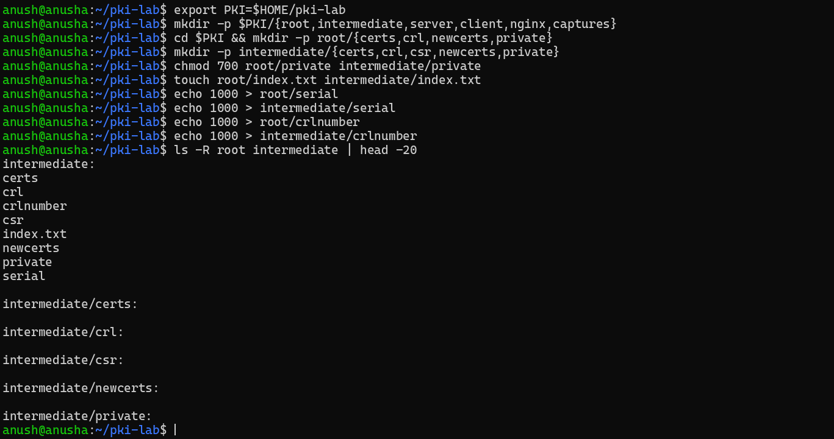

Part A — Root CA
root/openssl.cnf defines the Root CA (files, policy, default hash sha256) and the extension profiles v3_root_ca and v3_intermediate_ca. The Root key is 4096-bit RSA and the certificate is self-signed for 10 years (3650 days).
Figure 2: Part A.1: root/openssl.cnf
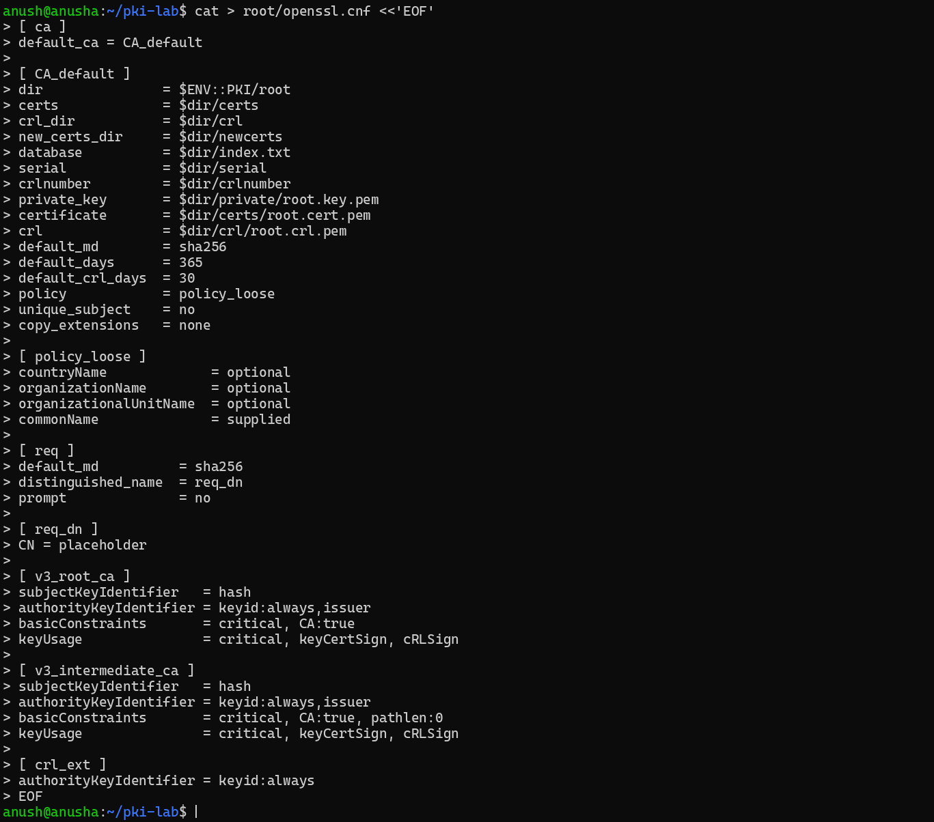
Figure 3: Part A.2: 4096-bit Root key and self-signed Root certificate (10 years)
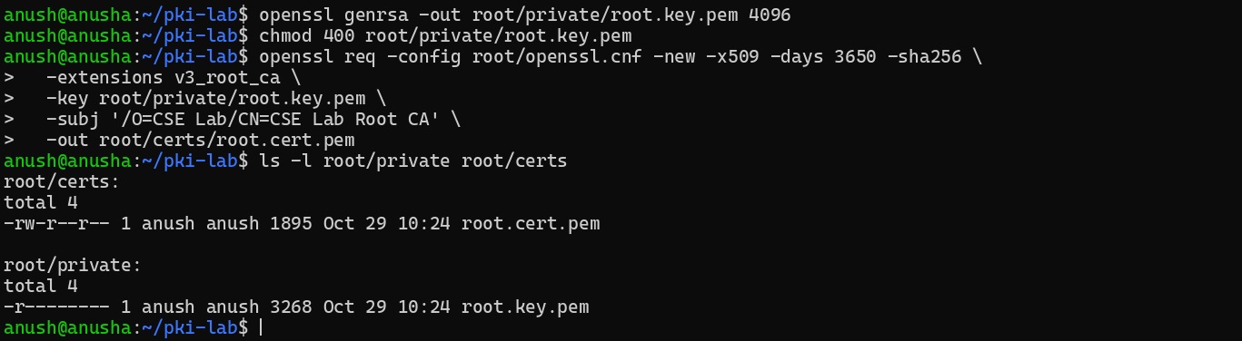
Figure 4: Part A.3: openssl x509 -text of the Root certificate (1/2)
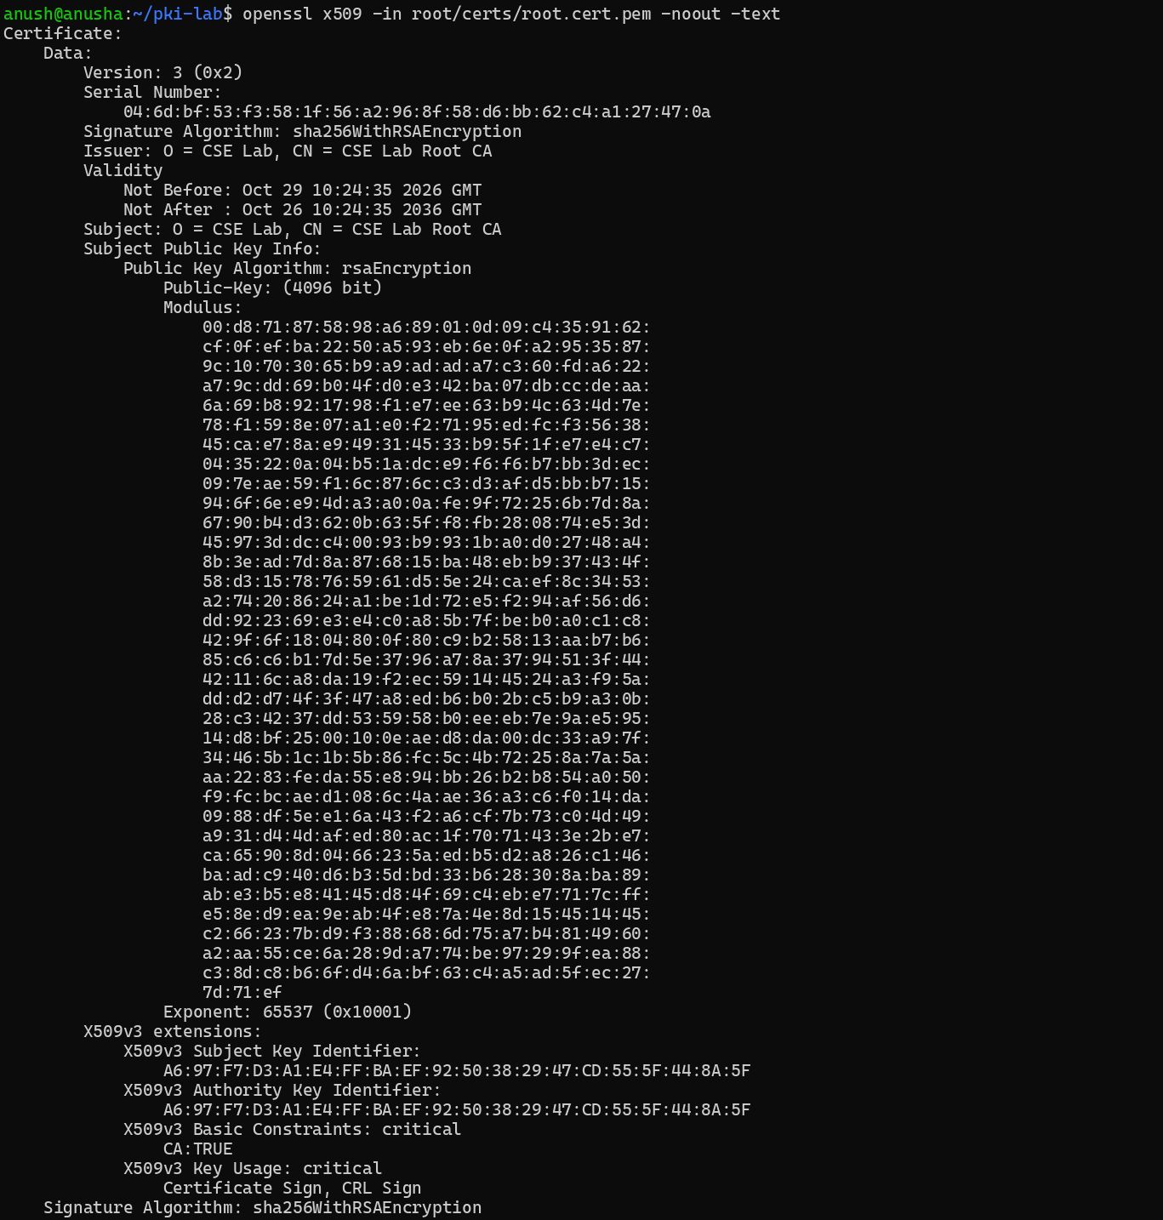
Figure 5: Part A.3: openssl x509 -text of the Root certificate (2/2)
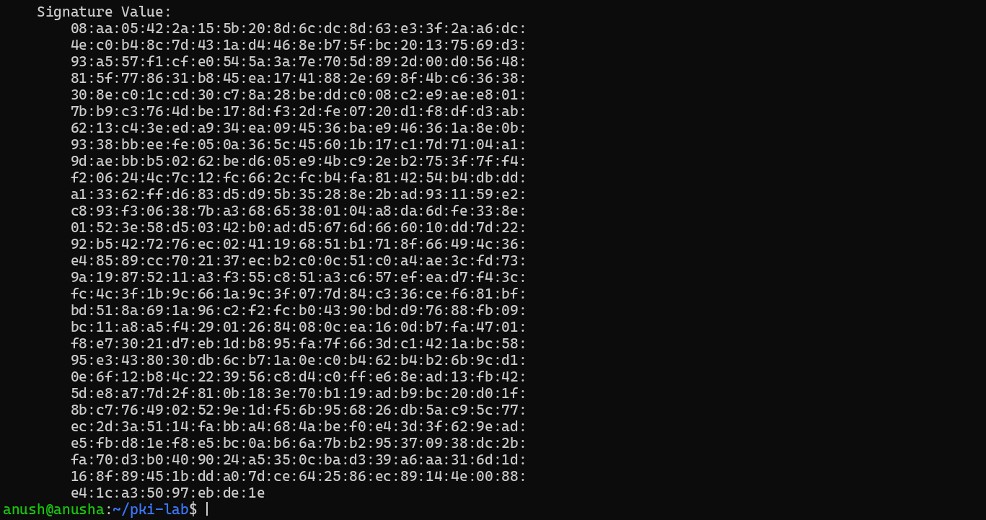

Answers: Task A — Root CA
Recorded values
- Serial number: 04:6d:bf:53:f3:58:1f:56:a2:96:8f:58:d6:bb:62:c4:a1:27:47:0a (a random 20-byte value; OpenSSL 3 makes it random for self-signed certificates)
- Validity: 10 years (3650 days): Oct 29 10:24:35 2026 GMT to Oct 26 10:24:35 2036 GMT
- Signature algorithm: sha256WithRSAEncryption
- Key size: RSA 4096 bits
- Extensions:
- Subject Key Identifier (hash of the public key)
- Authority Key Identifier (equals the SKI, because the root signs itself)
- Basic Constraints: critical, CA:TRUE
- Key Usage: critical, Certificate Sign, CRL Sign
Why is basicConstraints critical? It decides whether a key may sign other certificates, which is the most security-sensitive fact in a certificate. "Critical" forces every program to obey it or reject the certificate, so no software can ignore it and treat a normal certificate as a CA (or the reverse). RFC 5280 requires it to be critical in CA certificates.
Why is a Root CA self-signed (issuer = subject)? It is the top of the chain, so nobody higher can sign it. Its signature only makes it a well-formed certificate; trust in it comes out of band (installed in a trust store, or passed with --cacert). That is also why its AKI equals its SKI.

Part B — Intermediate CA
The Intermediate creates its own 4096-bit key and a CSR, and the Root signs it with the v3_intermediate_ca profile (CA:TRUE, pathlen:0) for 5 years. intermediate/openssl.cnf also holds the server_cert and client_cert profiles, the SAN list and the OCSP URL.
Figure 6: Part B.1: intermediate/openssl.cnf
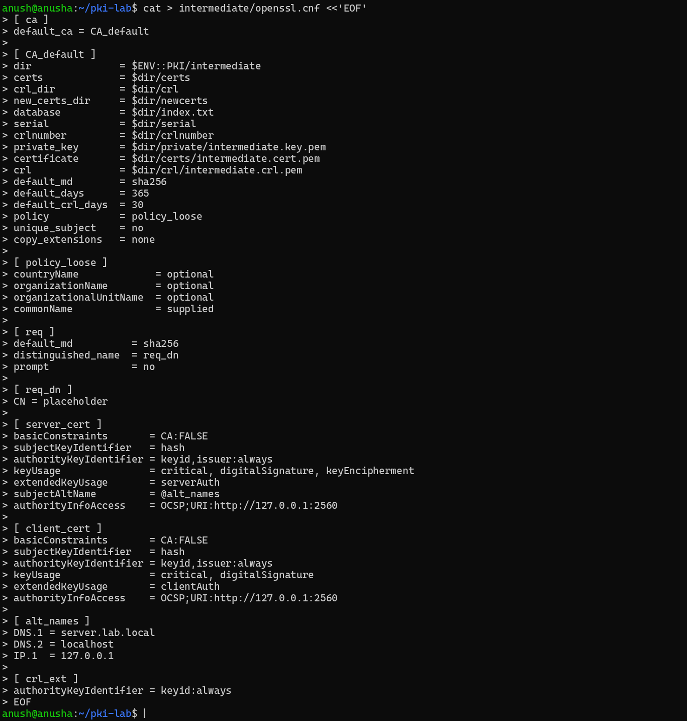
Figure 7: Part B.2: Intermediate key and CSR, signed by the Root (openssl ca)
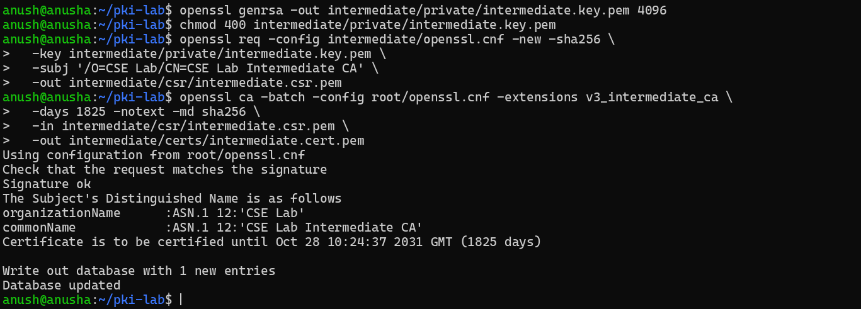
Figure 8: Part B.3: chain file and verification of the Intermediate against the Root
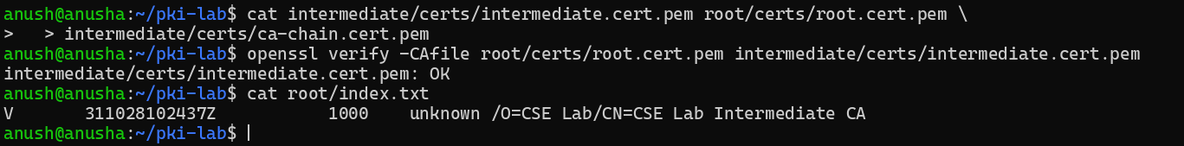
Figure 9: Part B: openssl x509 -text of the Intermediate certificate (1/2)
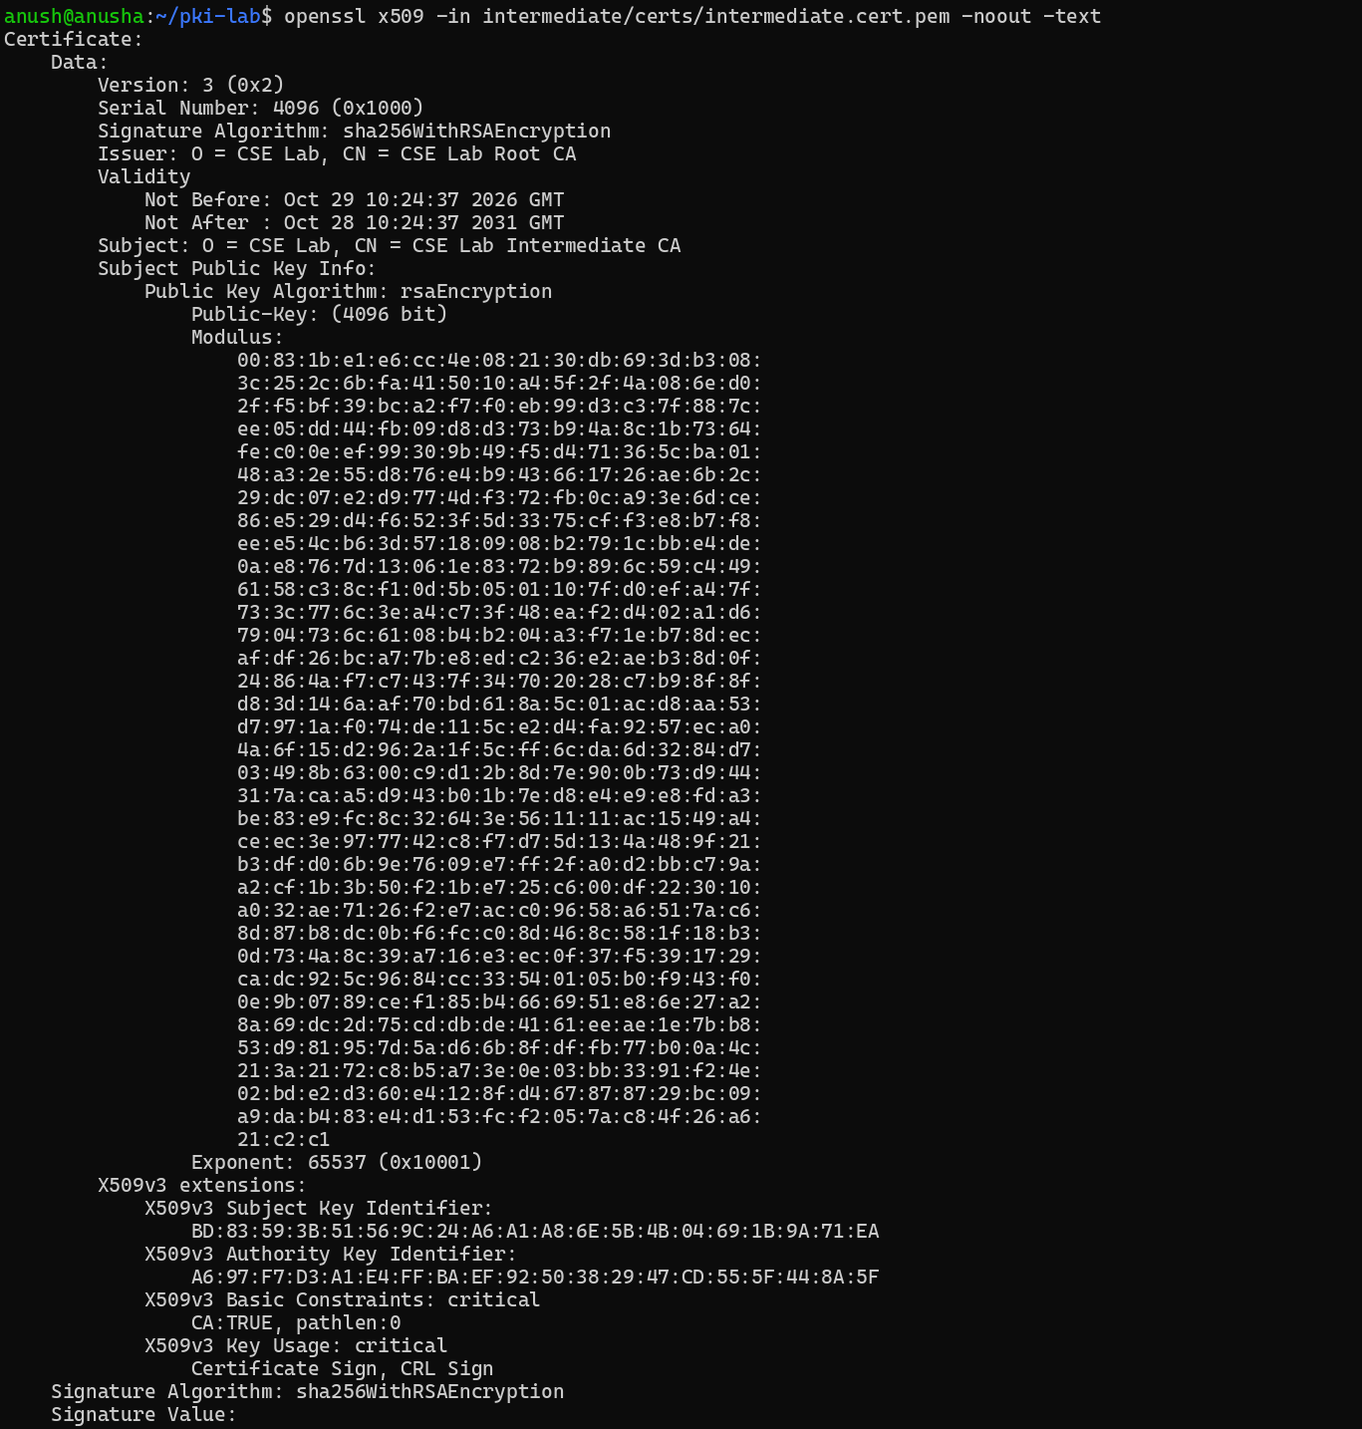
Figure 10: Part B: openssl x509 -text of the Intermediate certificate (2/2)
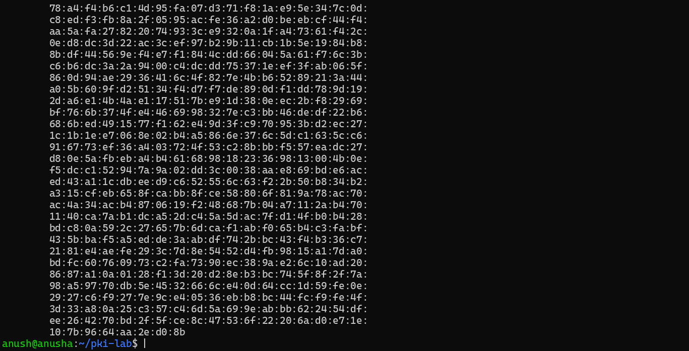
Figure 11: Task B: certificate signed by a leaf (Alice) and the pathlen:0 test
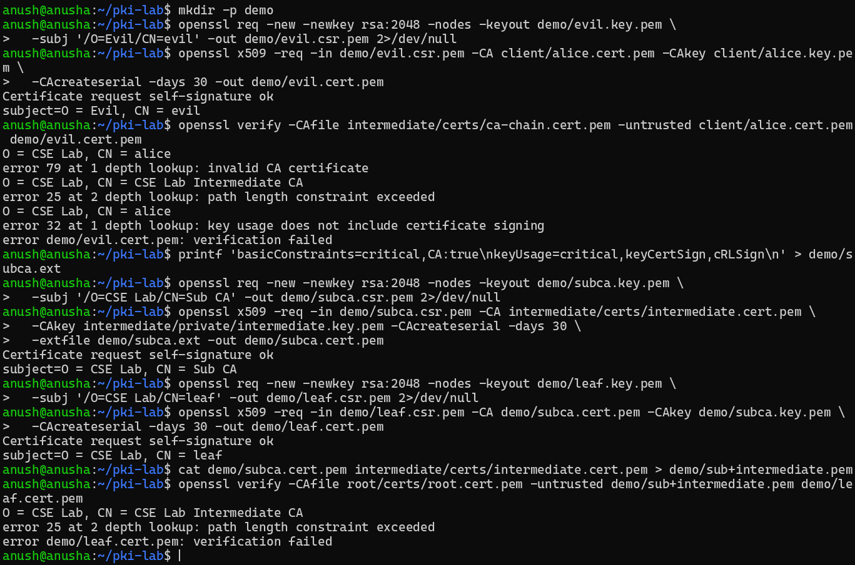

Answers: Task B — Intermediate CA
Root vs Intermediate
 | Root CA | Intermediate CA
Subject | O=CSE Lab, CN=CSE Lab Root CA | O=CSE Lab, CN=CSE Lab Intermediate CA
Issuer | itself | CSE Lab Root CA
Signed with | its own key | the Root's key
Validity | 10 years | 5 years (1825 days)
Key | RSA 4096 | RSA 4096
Serial | random 20 bytes | 0x1000 (from the Root's serial file)
Basic Constraints | critical, CA:TRUE | critical, CA:TRUE, pathlen:0
Key Usage | critical, keyCertSign, cRLSign | critical, keyCertSign, cRLSign
AKI | = its own SKI | = the Root's SKI

What does pathlen:0 do? It allows zero further CA certificates below the Intermediate, so it can sign only end-entity (leaf) certificates. If the Intermediate key is stolen, the thief still cannot create a valid sub-CA. My test: a Sub CA signed by the Intermediate, then a leaf signed by that Sub CA → error 25: path length constraint exceeded.
What if a certificate is issued from a leaf? It is rejected. A leaf has CA:FALSE and its key usage has no keyCertSign. My test (a certificate signed with Alice's key) → error 79: invalid CA certificate and error 32: key usage does not include certificate signing.

Part C — Server and client certificates
The Intermediate signs a 2048-bit server certificate (server_cert: serverAuth, SAN server.lab.local / localhost / 127.0.0.1, OCSP URL) and client certificates for Alice and Bob (client_cert: clientAuth). server.fullchain.pem = server certificate + Intermediate.
Figure 12: Part C.1: server key, CSR, certificate and full chain
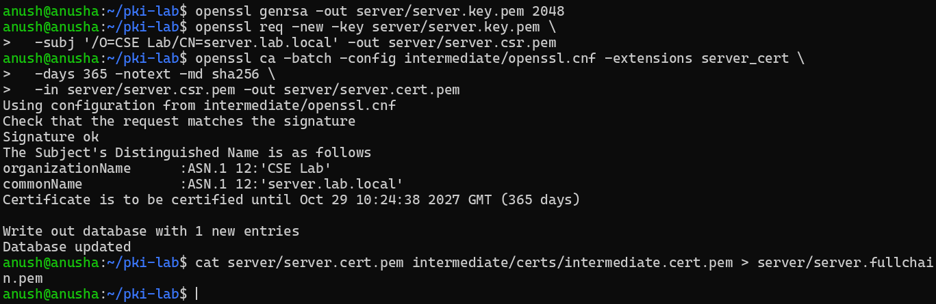
Figure 13: Part C.2: client certificates for Alice and Bob
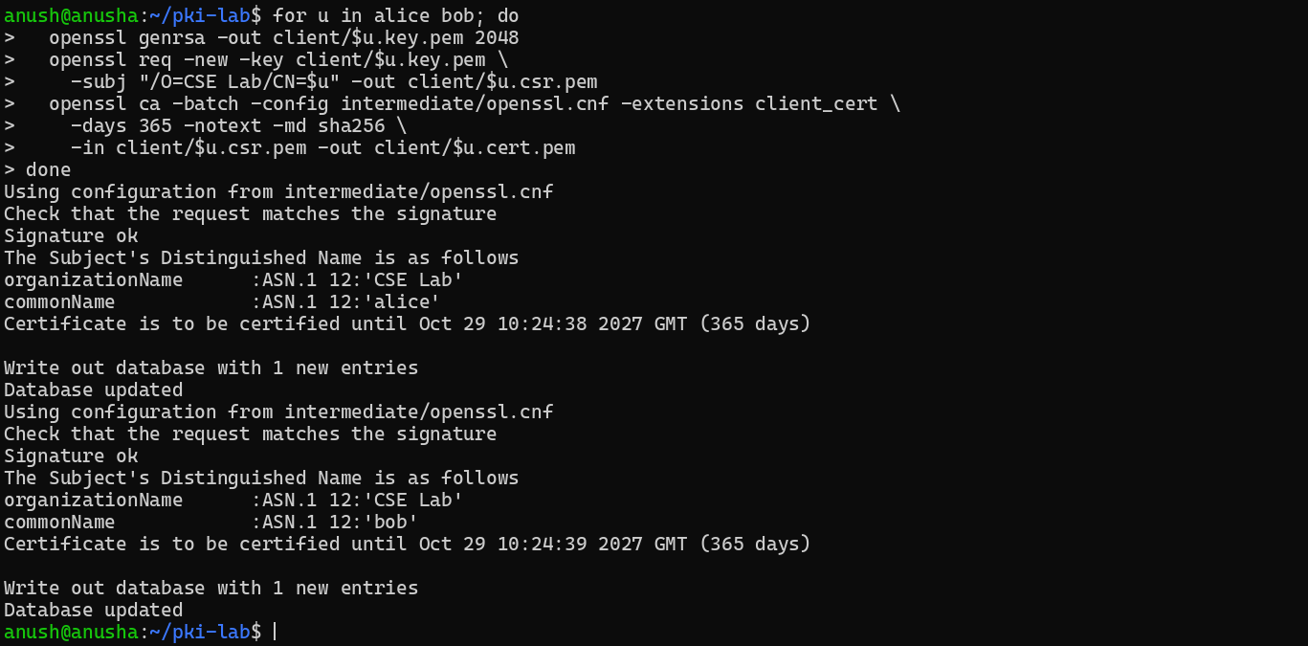
Figure 14: Part C.3: verification of server and client certificates
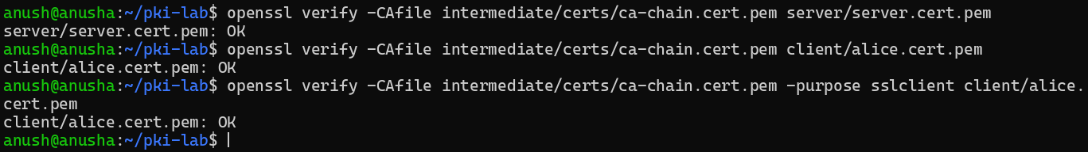
Figure 15: Task C: index.txt, Alice with -purpose sslserver, EKU and SAN
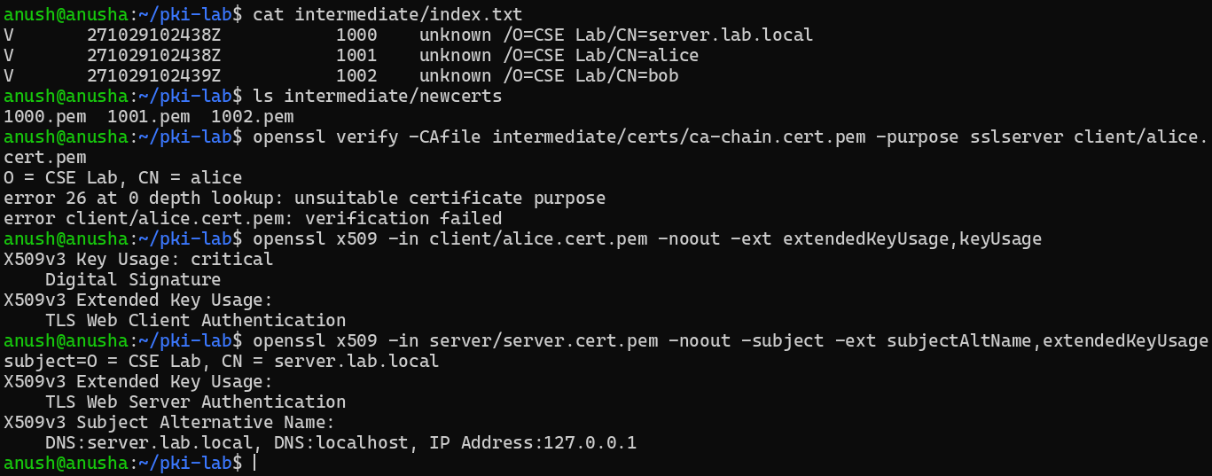
Figure 16: Part C: openssl x509 -text of the server certificate (1/2)
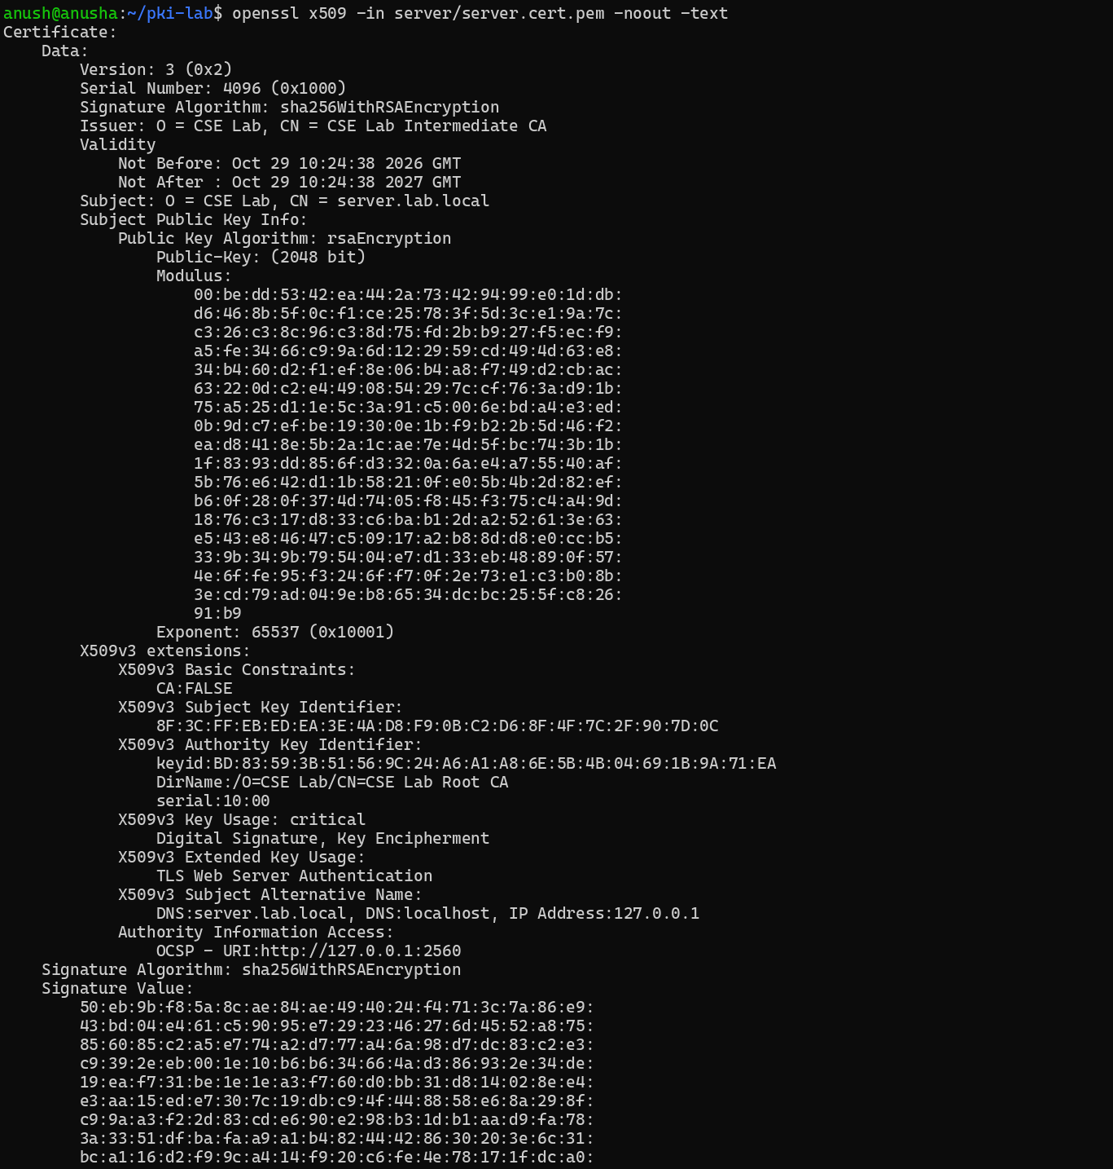
Figure 17: Part C: openssl x509 -text of the server certificate (2/2)
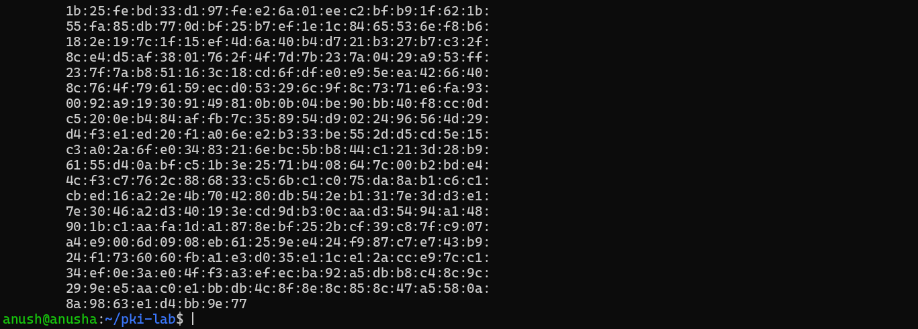

Answers: Task C — Server and client certificates
1. index.txt columns (TAB-separated):
1. Status: V = valid, R = revoked, E = expired
2. Expiry date-time, YYMMDDHHMMSSZ (UTC)
3. Revocation date and reason (empty while valid)
4. Serial number in hex (1000 = server, 1001 = alice, 1002 = bob; same as the files in newcerts/)
5. File name (always "unknown")
6. Subject DN (e.g. /O=CSE Lab/CN=alice)
2. Alice with -purpose sslserver: fails with error 26: unsuitable certificate purpose. Cause: the Extended Key Usage extension says only TLS Web Client Authentication (clientAuth), so it is not valid as a server certificate.
3. Why SAN when CN has the hostname? The CN is an old free-text field. Modern clients (RFC 6125/2818, browsers since ~2017) check host names only in the Subject Alternative Name, a structured list that can hold several DNS names and IP addresses. Our SAN covers server.lab.local, localhost and 127.0.0.1, so one certificate works for all three.

Part D — Mutual TLS with nginx
nginx listens on 8443 with the server full chain, requires a client certificate (ssl_verify_client on) and verifies it against the CA chain (ssl_client_certificate, ssl_verify_depth 2). The response prints the client DN, the verification result and the TLS version.
Figure 18: Part D.1: nginx.conf and starting nginx on port 8443
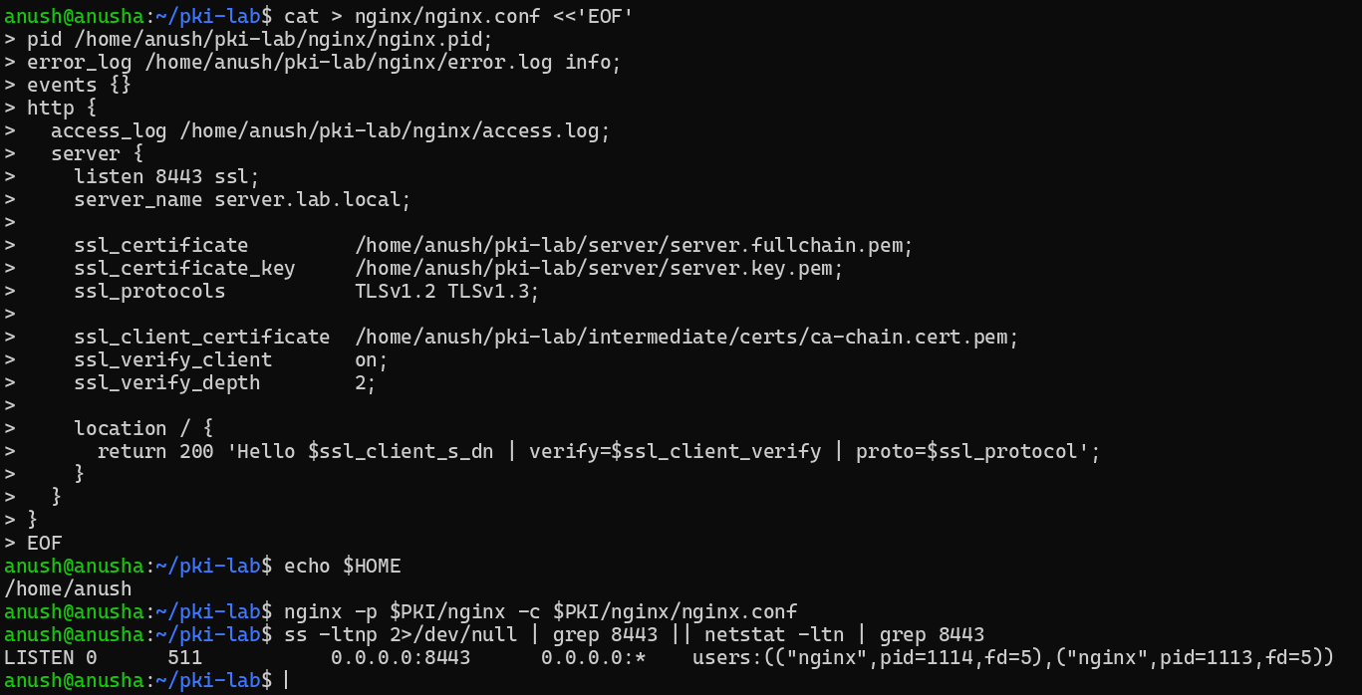
Figure 19: Part D.2: valid client (Alice) and no client certificate (HTTP 400), with error.log
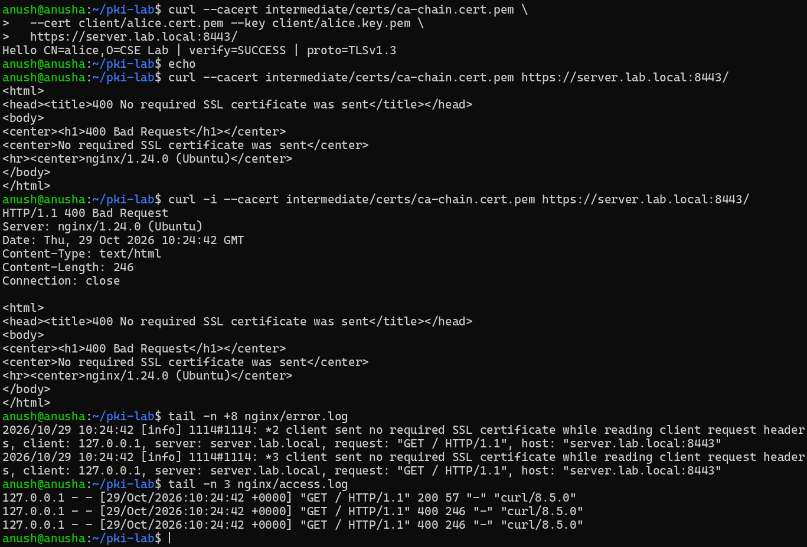
Figure 20: Part D.2: openssl s_client -showcerts (chain and acceptable client CA names) (1/2)
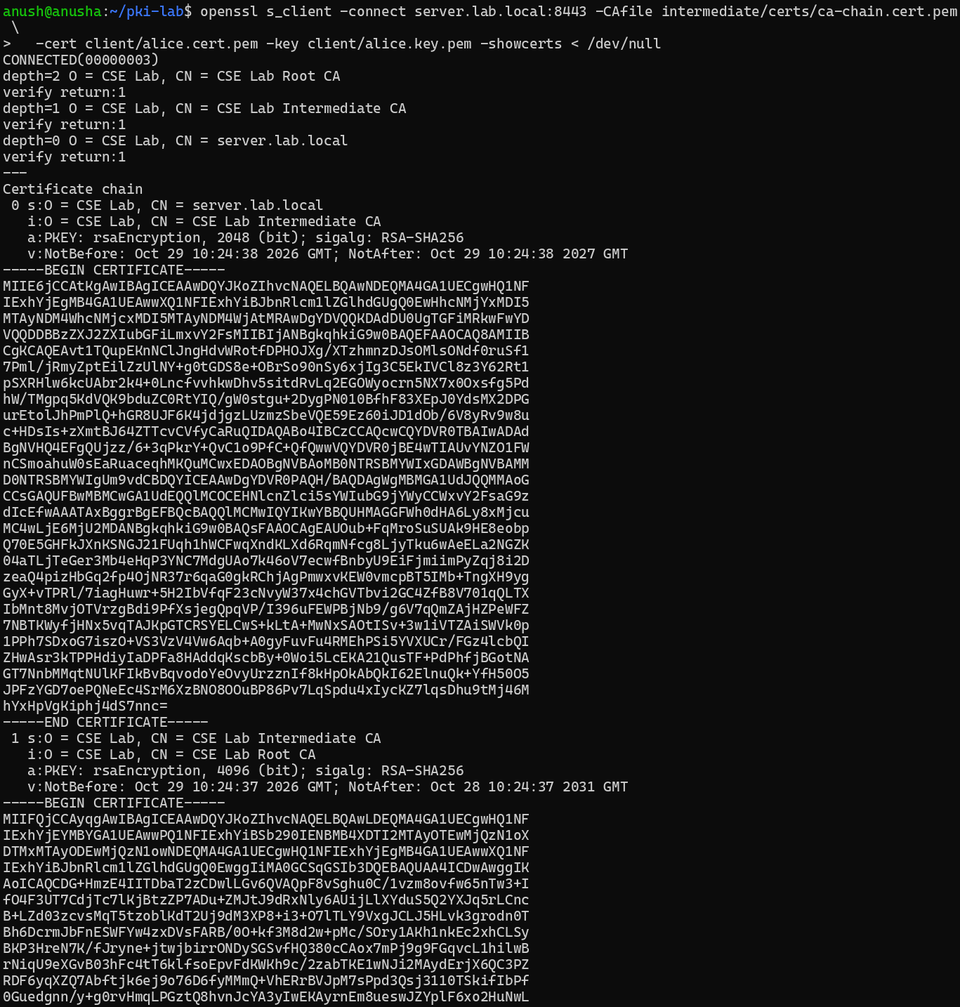
Figure 21: Part D.2: openssl s_client -showcerts (chain and acceptable client CA names) (2/2)
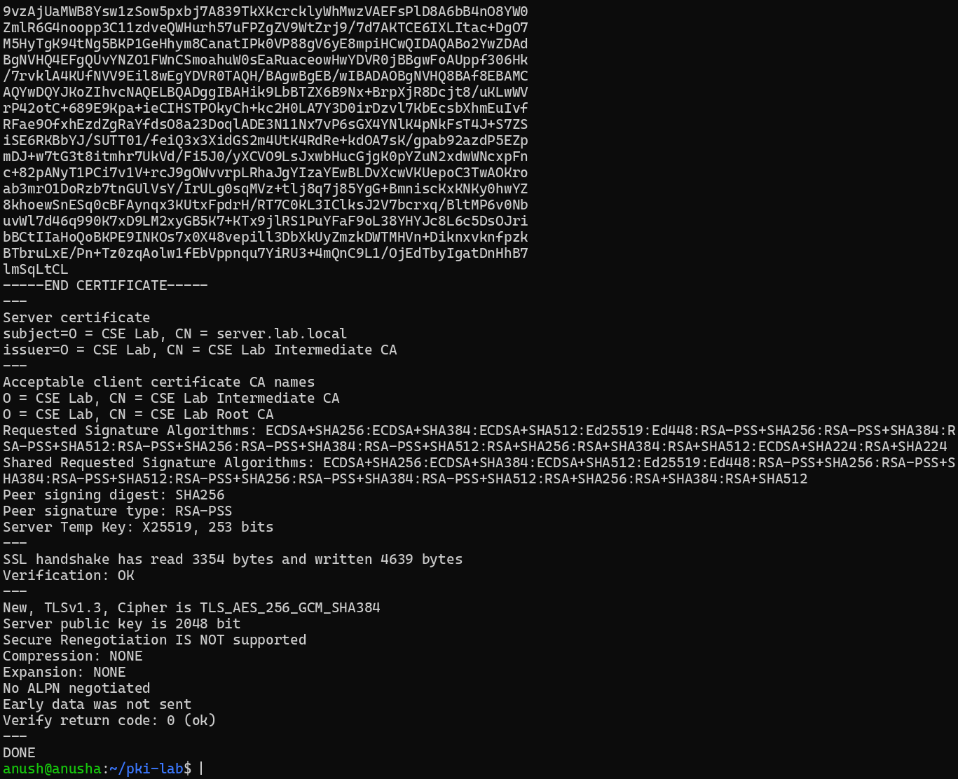

Answers: Task D — Mutual TLS with nginx
1. Outputs and status.
- Alice: Hello CN=alice,O=CSE Lab | verify=SUCCESS | proto=TLSv1.3
- No certificate: HTTP 400 Bad Request, "No required SSL certificate was sent". The TLS handshake itself completes; then nginx, with ssl_verify_client on, sees that no client certificate was sent and refuses the request with 400.
2. What identifies the client? The variable $ssl_client_s_dn (printed as CN=alice,O=CSE Lab). In error.log a missing certificate appears as "client sent no required SSL certificate" and a bad one as "client SSL certificate verify error: (N:reason)". (The default access.log does not show the DN.)
3. Why ssl_client_certificate and ssl_verify_depth 2? ssl_client_certificate gives nginx the trusted CA chain to check client certificates against; without it every client certificate would fail. ssl_verify_depth is the longest chain nginx will follow: client (0) → Intermediate (1) → Root (2), so 2 fits our chain.

Part E — Revocation (CRL and OCSP)
Bob's certificate (serial 1002) is revoked with reason keyCompromise, both CAs publish a CRL, and nginx enforces the combined CRL. An OCSP responder answers live status queries from the Intermediate's index.txt.
Figure 22: Part E.1: revoke Bob, generate both CRLs and the combined CRL (1/2)
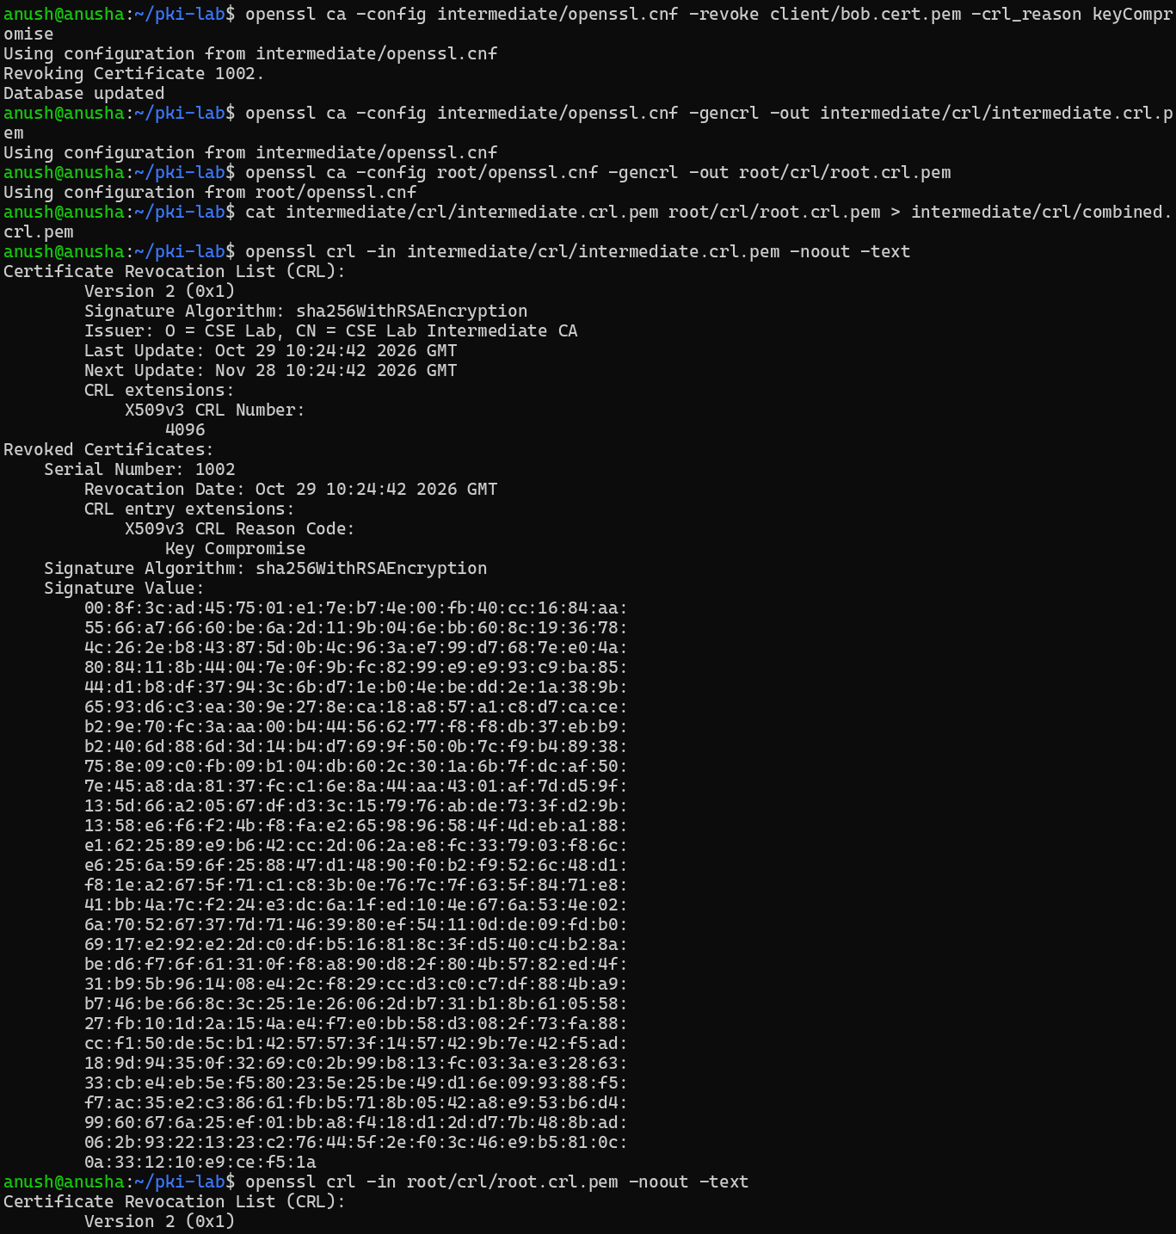
Figure 23: Part E.1: revoke Bob, generate both CRLs and the combined CRL (2/2)
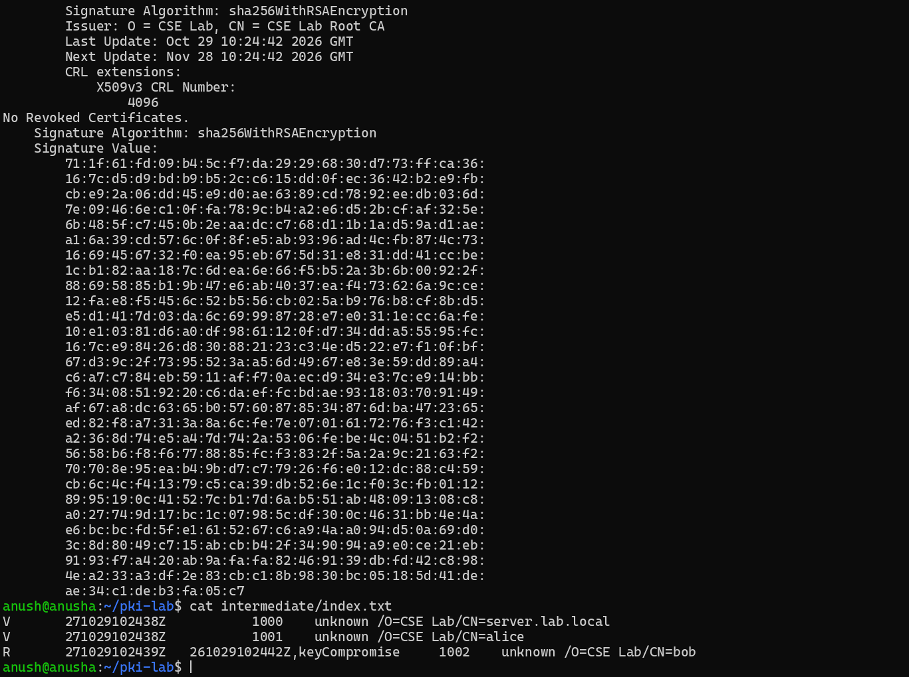
Figure 24: Part E.1: CRL check with OpenSSL (Bob revoked, Alice OK)
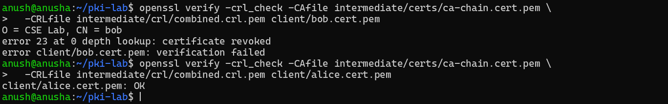
Figure 25: Part E.2: ssl_crl in nginx: Alice accepted, Bob rejected
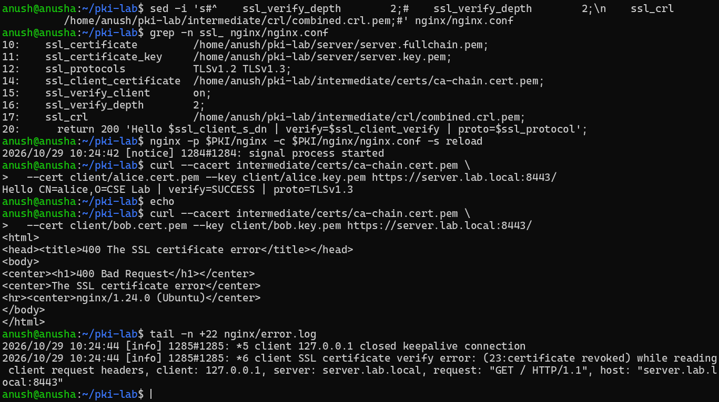
Figure 26: Part E.2: without the Root CRL even Alice fails (error 3), then restored
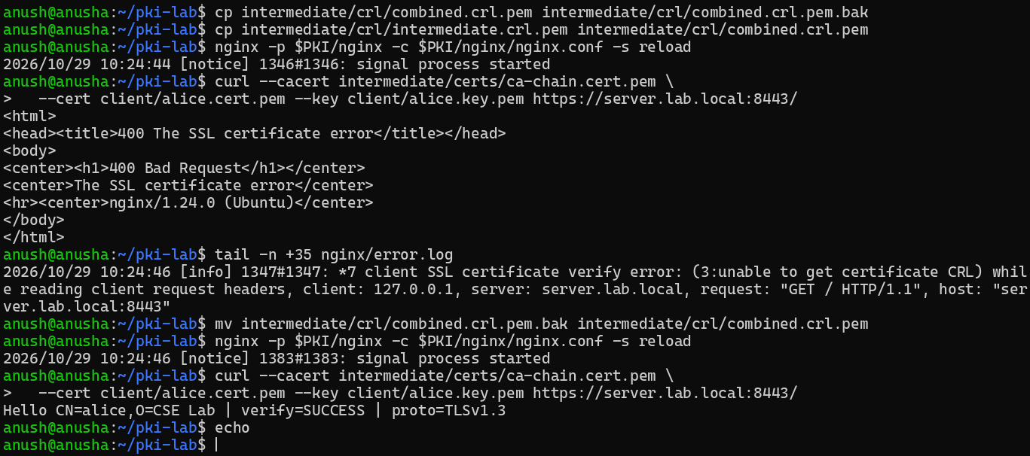
Figure 27: Part E.3 (terminal 2): OCSP responder on port 2560
Figure 28: Part E.3: OCSP query for Alice - response data
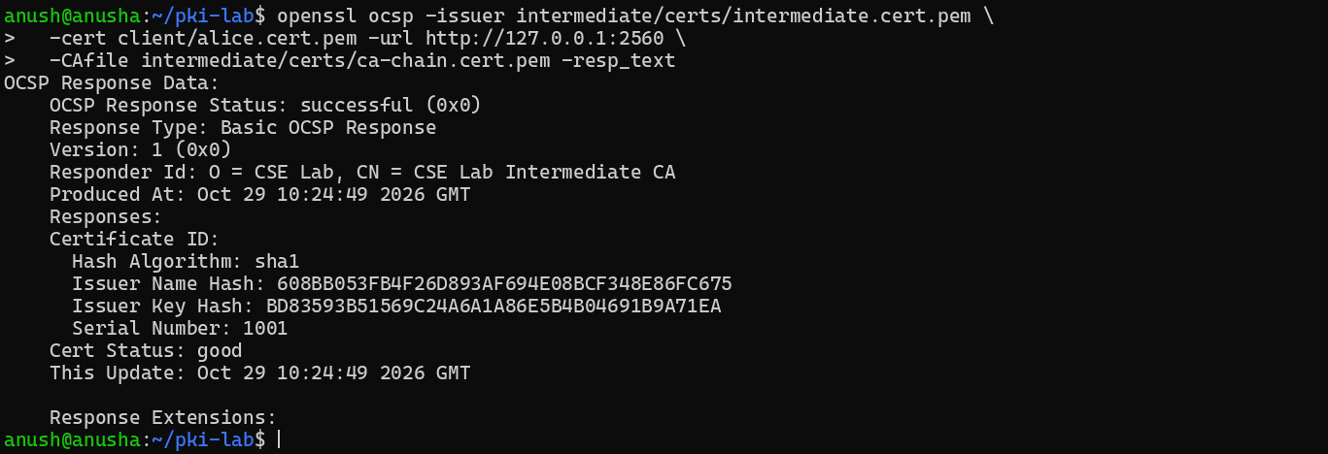
Figure 29: Part E.3: OCSP query for Alice - end of output (status good)
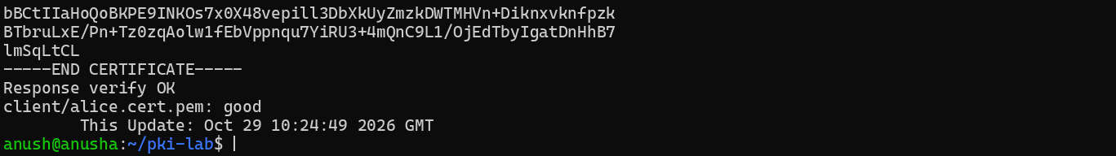
Figure 30: Part E.3: OCSP query for Bob - response data (revoked, keyCompromise)
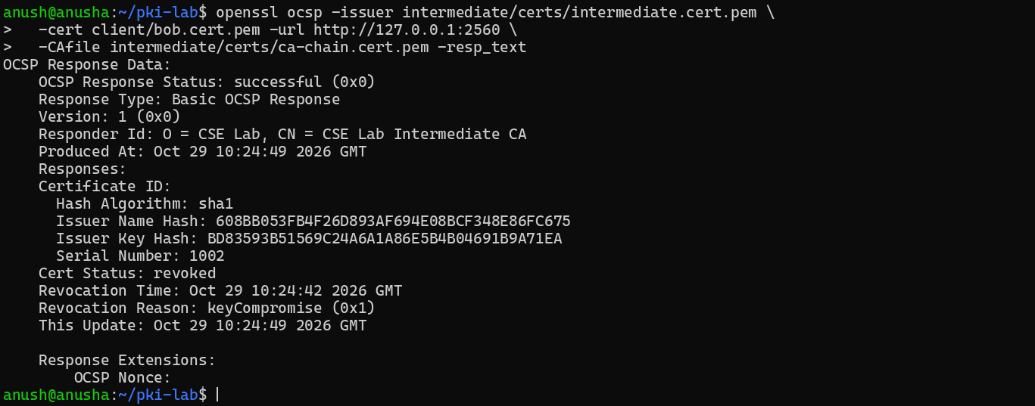
Figure 31: Part E.3: OCSP query for Bob - end of output (status revoked)
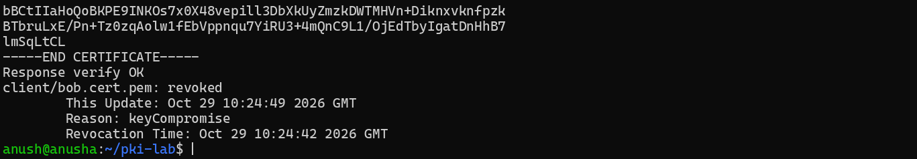
Figure 32: Task E: OCSP URL in the Authority Information Access extension

Answers: Task E — Revocation
1. Status.
- Alice: good
- Bob: revoked, revocation time Oct 29 10:24:42 2026 GMT, reason keyCompromise
2. CRL vs OCSP
 | CRL | OCSP
Freshness | Only as new as the last download (valid until Next Update, 30 days here) | Near real time (answers from the live database)
Size | Grows with every revoked certificate | One small request and response per certificate
Privacy | Good: the CA doesn't learn which certificate you check | Weak: the responder sees which certificate (site) you check
Latency | One download, then local look-ups | Extra round trip during connection (unless stapled)
Failure | nginx hard-fails if the CRL is missing (error 3) | Browsers usually soft-fail if the responder is down

3. OCSP stapling. The server fetches a signed, time-stamped OCSP response for its own certificate and attaches it to the TLS handshake. Clients don't contact the CA, which fixes OCSP's privacy leak, extra latency and dependence on the responder being up. It can't be forged, because the CA signs it.
4. Where is the OCSP URL? In the Authority Information Access extension: OCSP - URI:http://127.0.0.1:2560.

Part F — TLS handshake analysis
Both handshakes were captured on the loopback interface (lo) with the capture filter tcp port 8443, using Alice's certificate. For TLS 1.3 the session secrets were written to keys.log (SSLKEYLOGFILE) during the same captured connection, so that the capture can be decrypted.

F.1 TLS 1.2
Figure 33: Part F.1 (terminal 2): tshark capture on lo, tcp port 8443 (TLS 1.2)
Figure 34: Part F.1: TLS 1.2 handshake - ClientHello, ServerHello, Certificate, CertificateRequest, CertificateVerify (1/3)
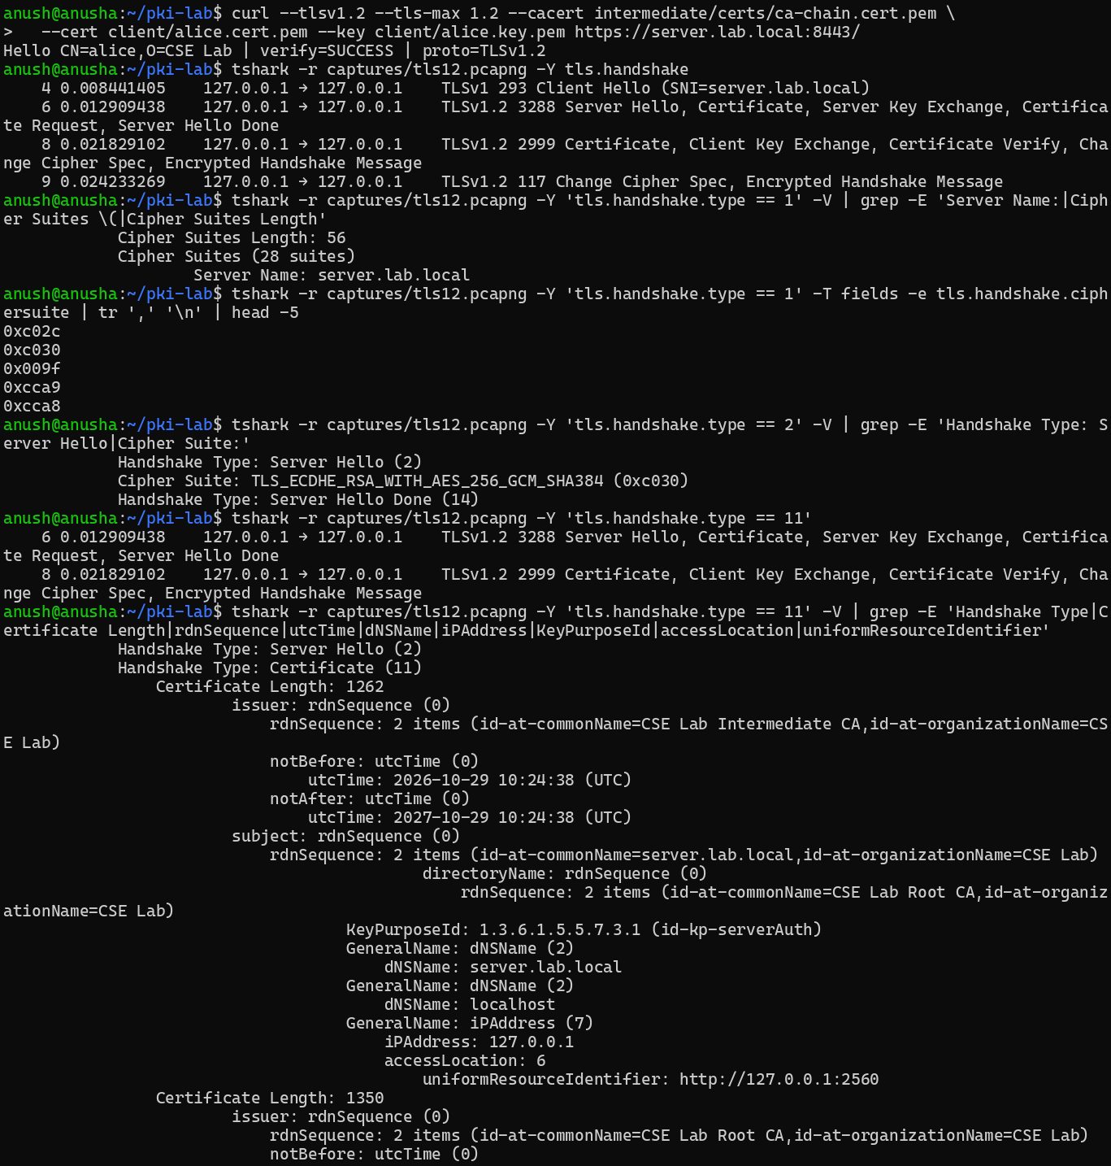
Figure 35: Part F.1: TLS 1.2 handshake - ClientHello, ServerHello, Certificate, CertificateRequest, CertificateVerify (2/3)
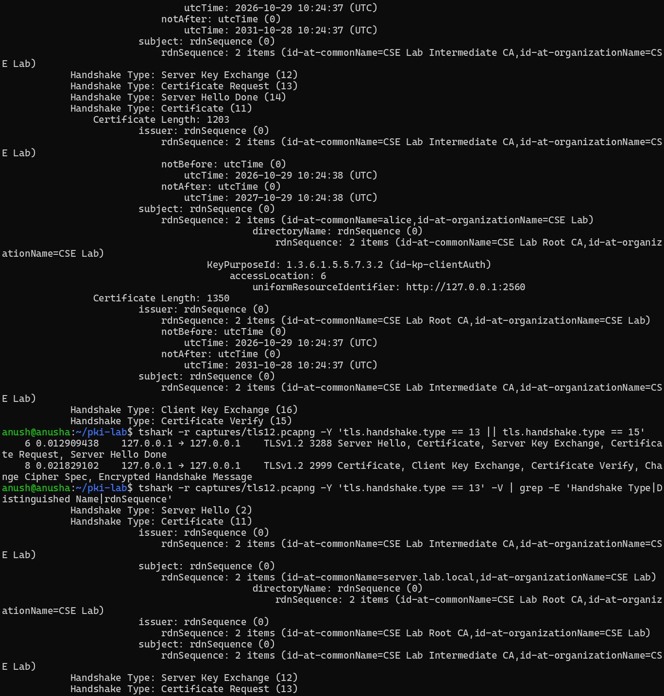
Figure 36: Part F.1: TLS 1.2 handshake - ClientHello, ServerHello, Certificate, CertificateRequest, CertificateVerify (3/3)
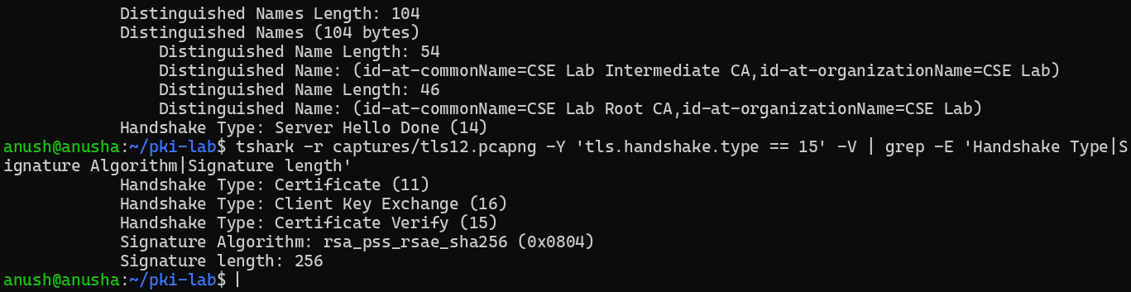
Figure 37: Wireshark: tls12.pcapng with display filter tls.handshake
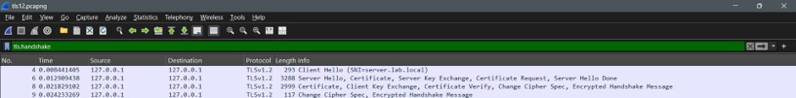
Figure 38: Wireshark: frame 4, Client Hello (TLS 1.2, 28 cipher suites)
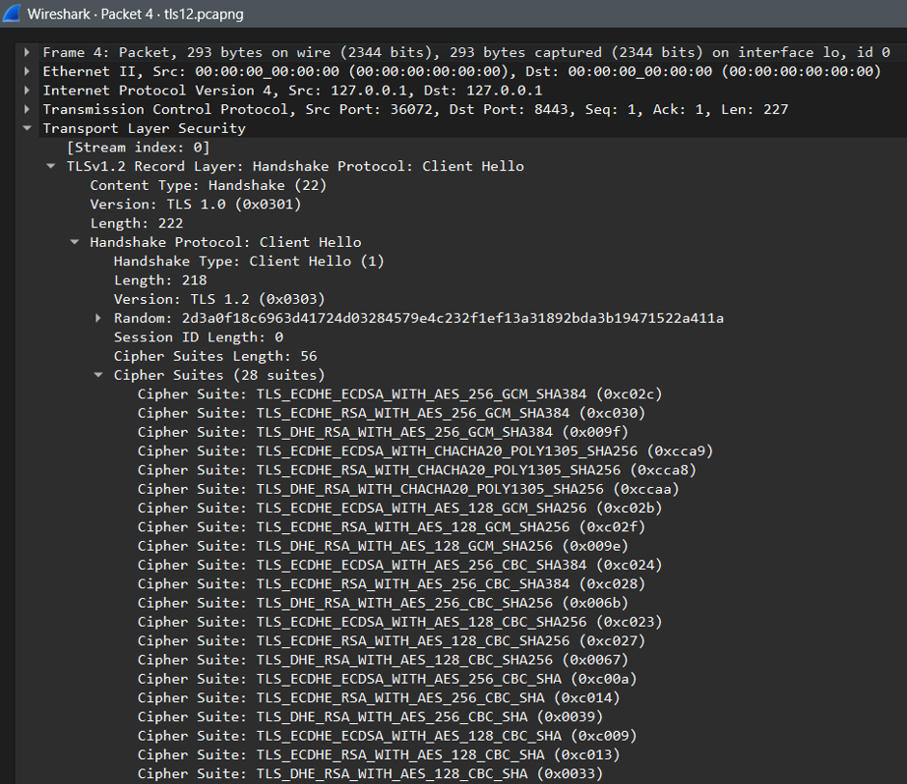
Figure 39: Wireshark view: frame 6, Server Hello - selected cipher suite
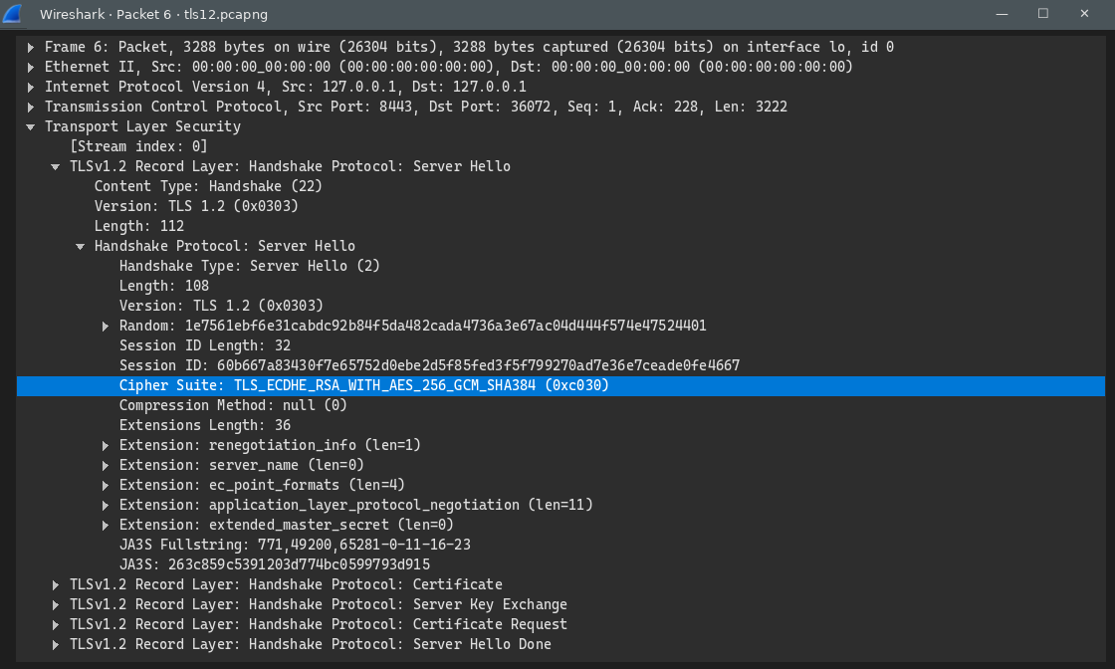
Figure 40: Wireshark view: frame 6, server Certificate - issuer, validity, subject, extensions (EKU, SAN, OCSP URL)
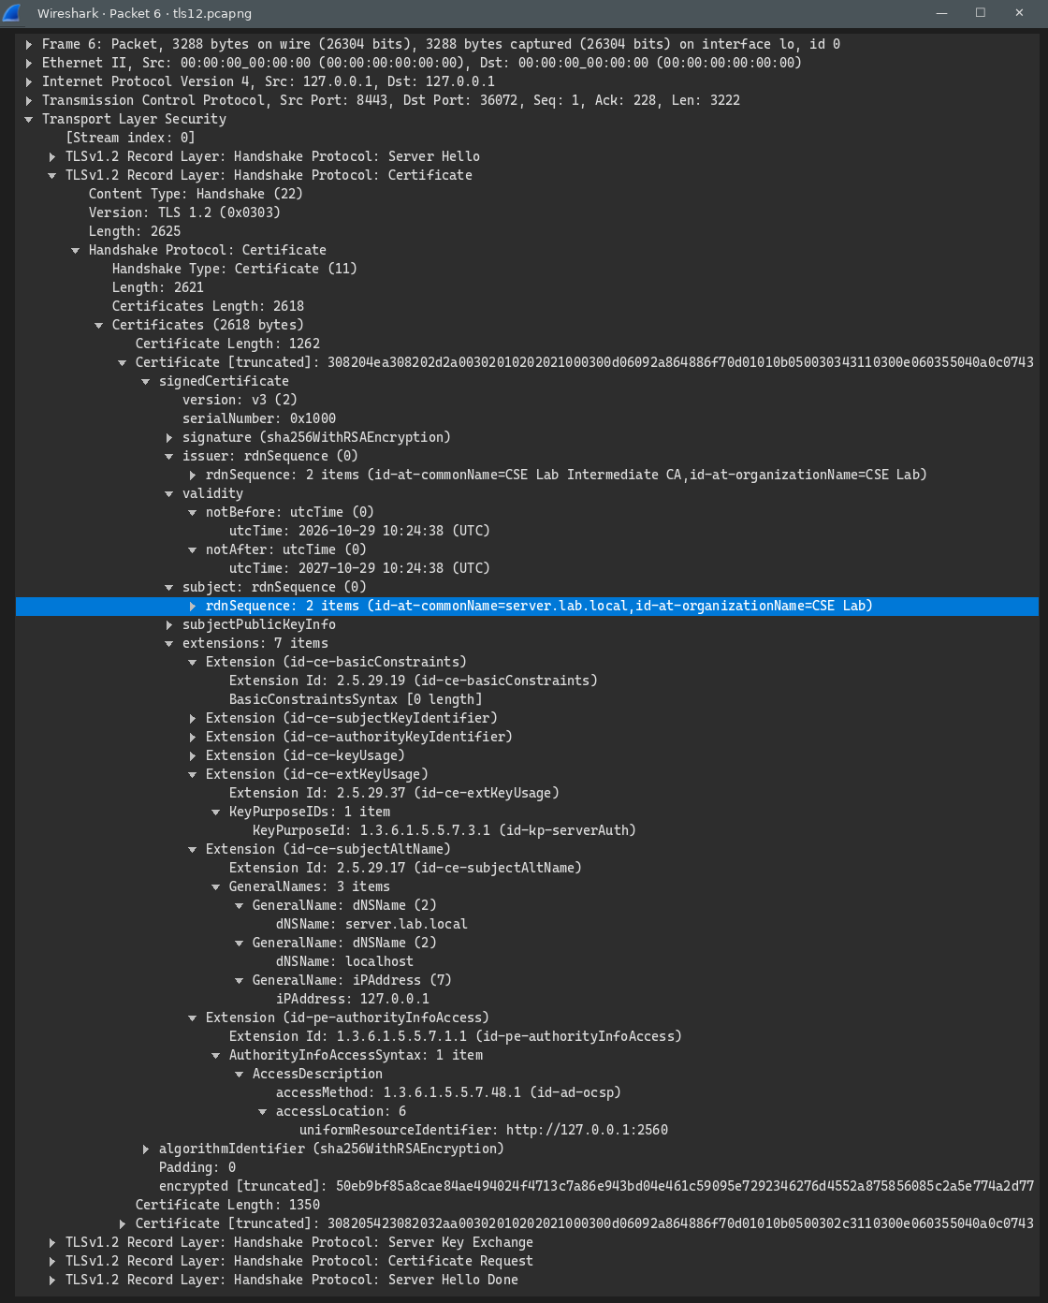
Figure 41: Wireshark view: frame 6, Certificate Request with the acceptable CA names
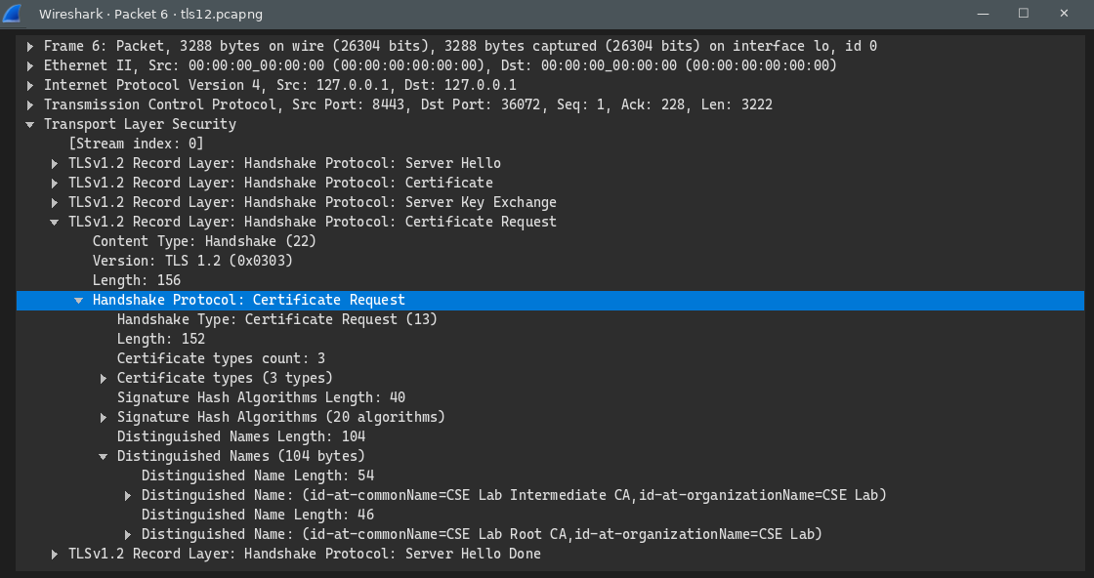
Figure 42: Wireshark view: frame 8, client Certificate (CN=alice) and Certificate Verify
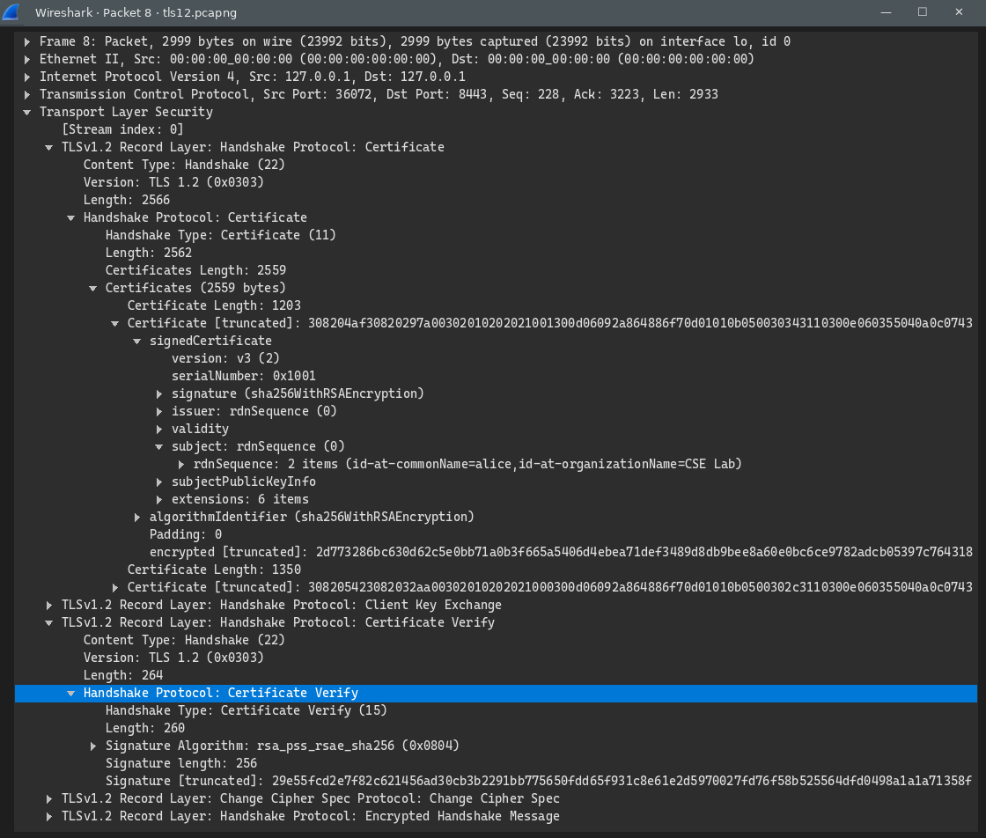

F.2 TLS 1.3 without the key log
Figure 43: Part F.2 (terminal 2): tshark capture on lo, tcp port 8443 (TLS 1.3)
Figure 44: Part F.2: TLS 1.3 handshake without the key log - everything after ServerHello is encrypted
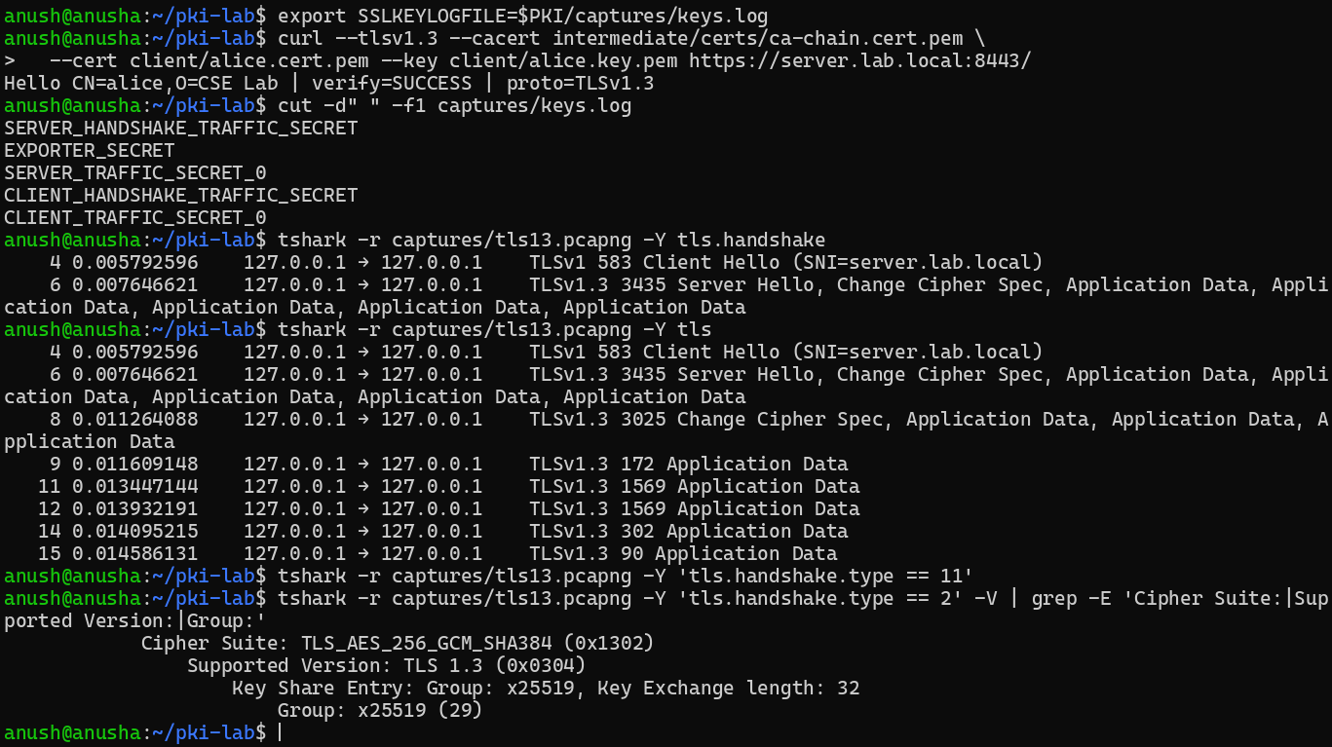
Figure 45: Wireshark view: tls13.pcapng, filter tls - after the Server Hello everything is Application Data
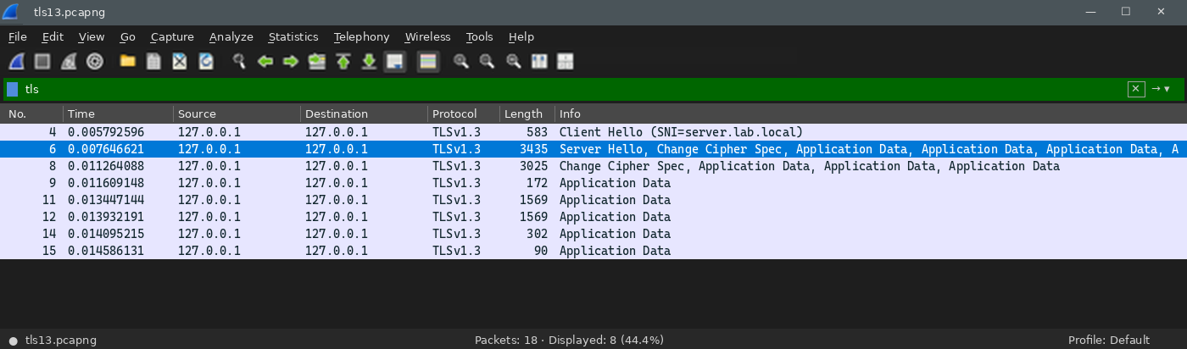
Figure 46: Wireshark view: tls13.pcapng, filter tls.handshake.type == 11 - no Certificate message is visible
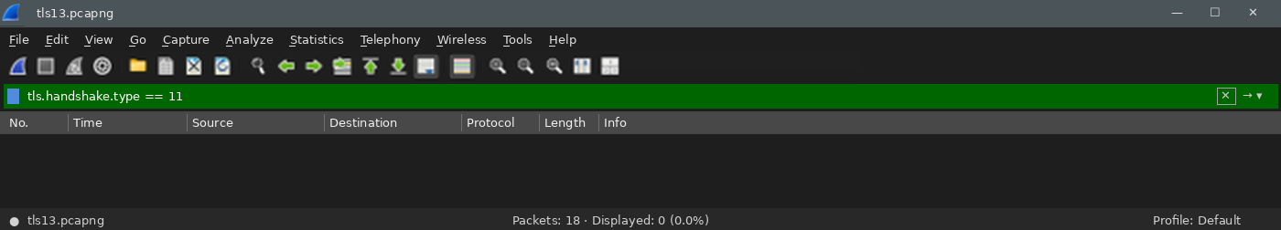

F.3 TLS 1.3 decrypted with keys.log
Figure 47: Part F.3: TLS 1.3 handshake decrypted with keys.log (1/2)
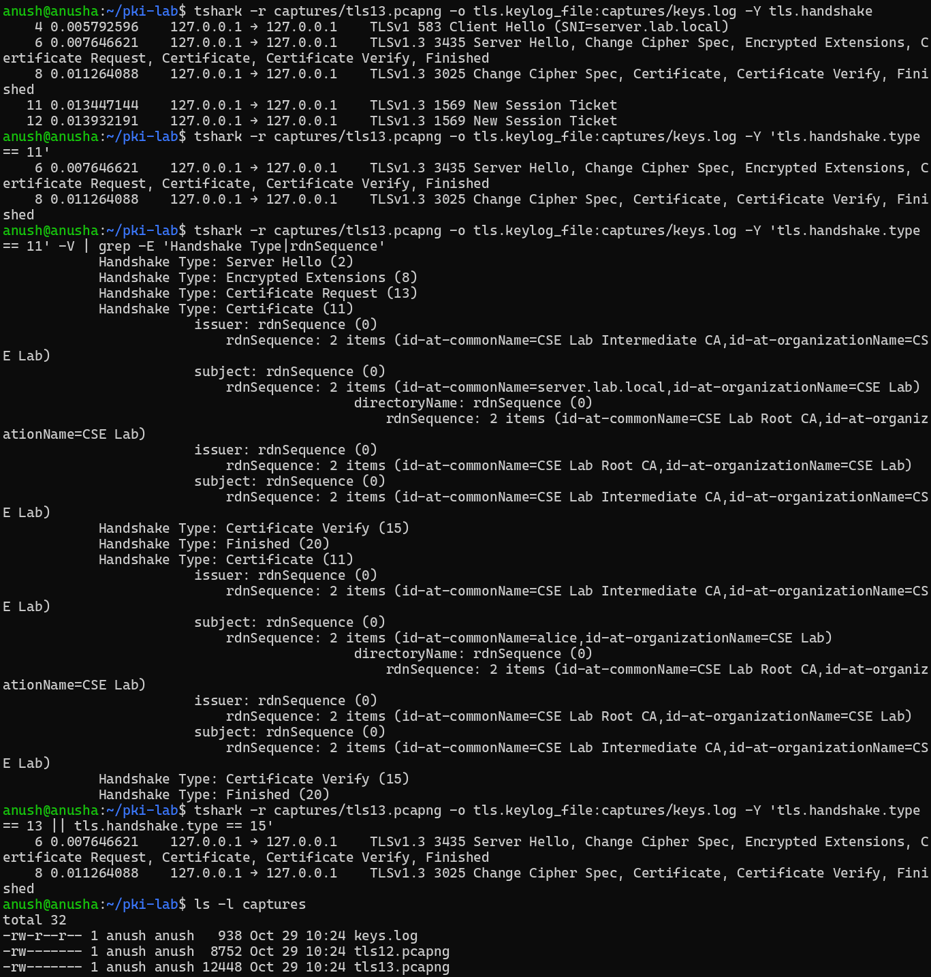
Figure 48: Part F.3: TLS 1.3 handshake decrypted with keys.log (2/2)
Figure 49: Wireshark view: tls13.pcapng with keys.log, filter tls.handshake - Certificate, Certificate Verify and Finished decrypted
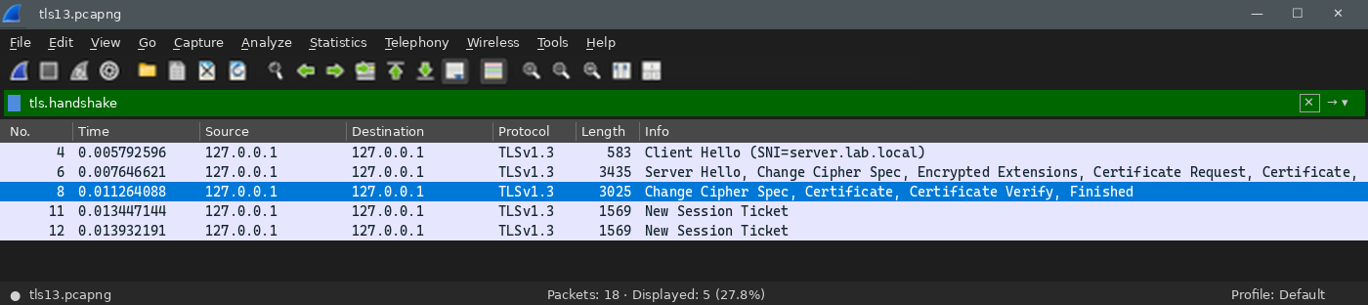
Figure 50: Wireshark view: frame 8 with keys.log - client Certificate (CN=alice, clientAuth) and Certificate Verify
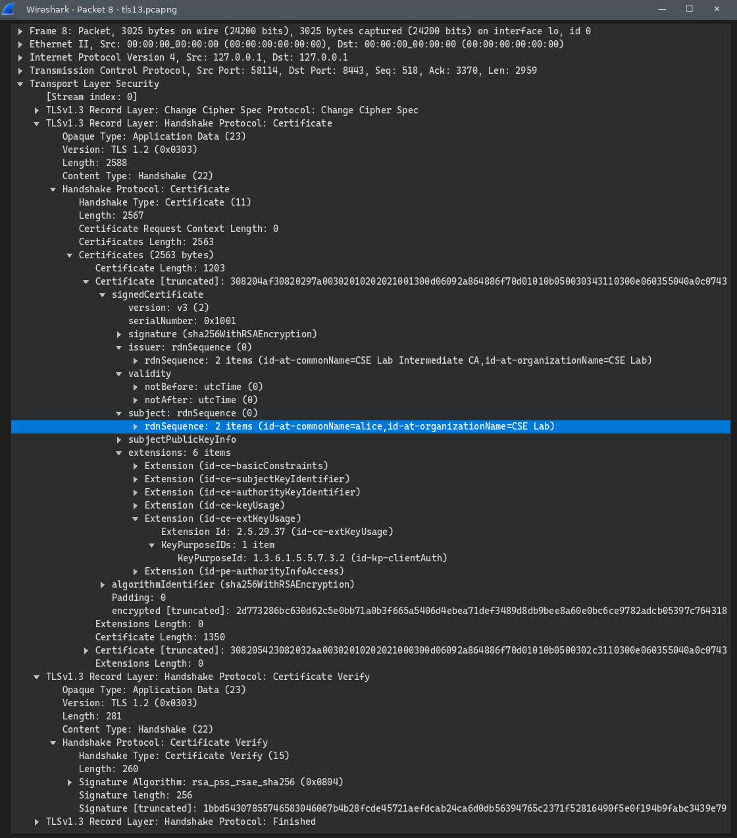

Answers: Task F — TLS handshake analysis
1. TLS 1.2 vs TLS 1.3
 | TLS 1.2 | TLS 1.3
Round trips before data | 2 RTT | 1 RTT
Server certificate visible? | Yes, plain text | No, encrypted (only with keys.log)
Client certificate visible? | Yes, plain text | No, encrypted
Key-exchange messages | Separate ServerKeyExchange and ClientKeyExchange | None: key shares sit in the ClientHello/ServerHello key_share extension
Cipher suite (my run) | ECDHE-RSA-AES256-GCM-SHA384 (0xc030) | TLS_AES_256_GCM_SHA384 (0x1302), x25519

2. Why is an encrypted client certificate a privacy gain? The client certificate names a person (CN=alice, O=CSE Lab). In TLS 1.2 any observer can read it and identify and track the user across sessions. In TLS 1.3 an observer still sees IP addresses, the SNI and packet sizes, but cannot read either certificate, so they can't tell who logged in.
3. Which message proves the client owns the private key? CertificateVerify: the client signs the handshake transcript with its private key, and the server checks it with the public key in the certificate. (A certificate alone proves nothing, since certificates are public.)
4. Screenshots: see the Part F figures above: ClientHello and ServerHello, the server Certificate, CertificateRequest and CertificateVerify (TLS 1.2); the encrypted TLS 1.3 handshake; and the TLS 1.3 handshake decrypted with keys.log, with the relevant packet or field selected.

Part G — Failure scenarios
Each failure was created on purpose and tested with curl, OpenSSL and the nginx error.log (level info). nginx had ssl_crl enabled from Part E during all scenarios.
Figure 51: Part G.1: expired client certificate (eve)
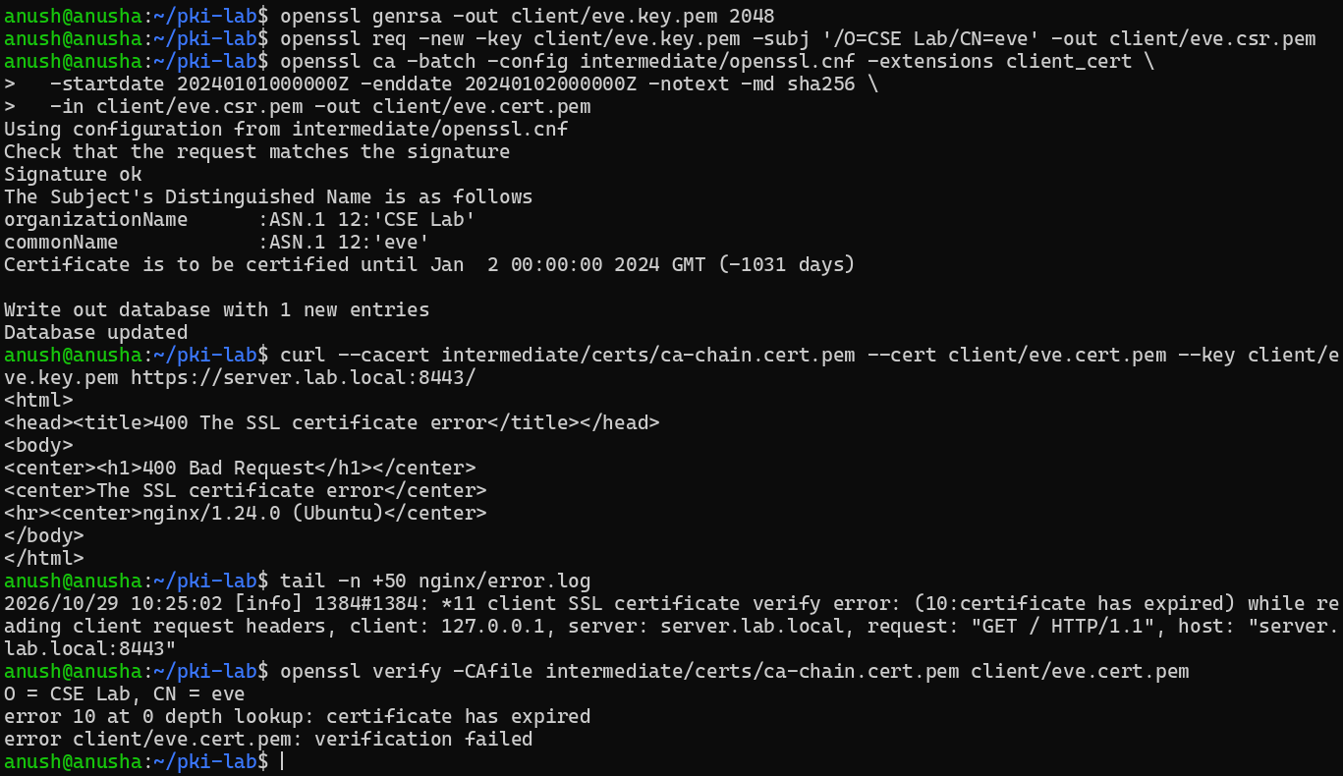
Figure 52: Part G.2: untrusted self-signed client (mallory)
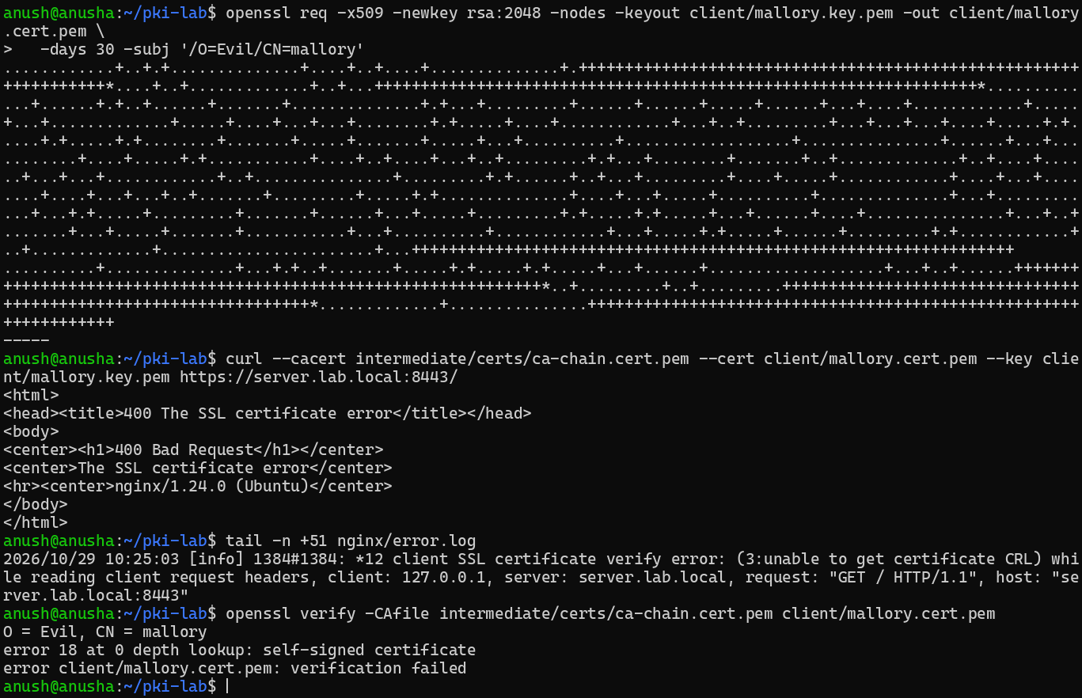
Figure 53: Part G.3: wrong purpose (server certificate used as a client certificate)
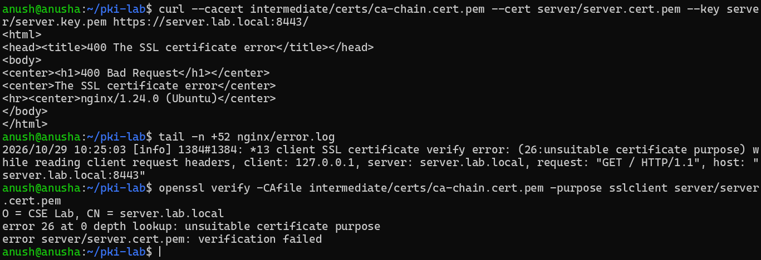
Figure 54: Part G.4: hostname mismatch (wrong.lab.local)
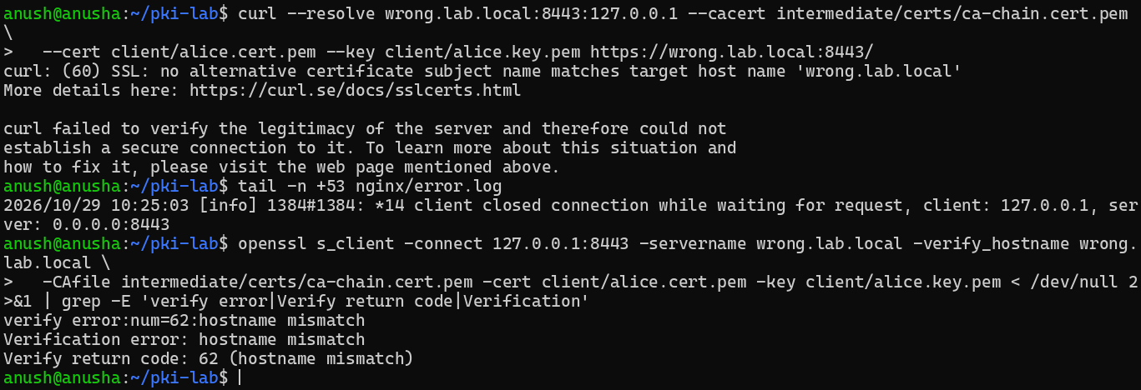
Figure 55: Part G.5: missing intermediate (leaf only as ssl_certificate), then restored
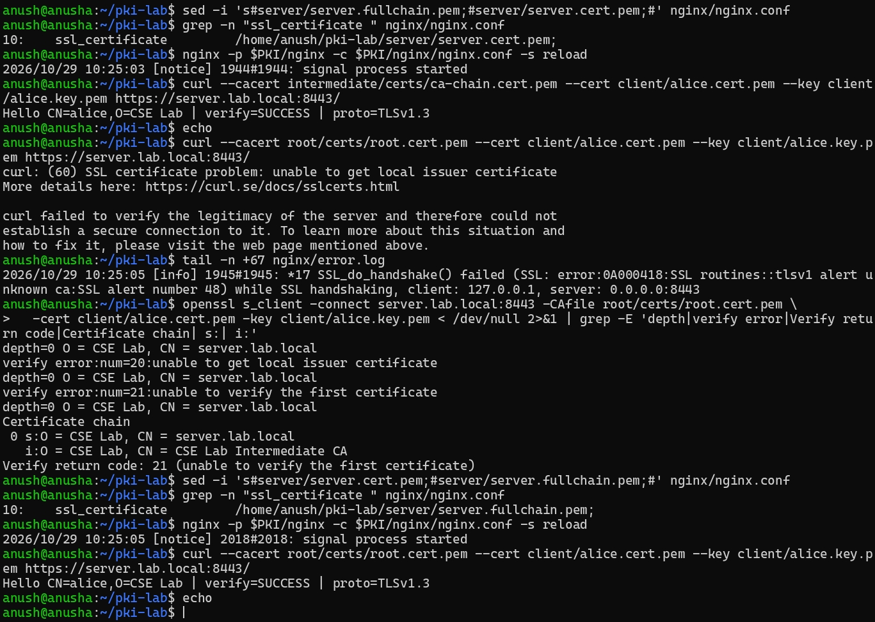
Figure 56: Part G.6: revoked certificate (Bob)
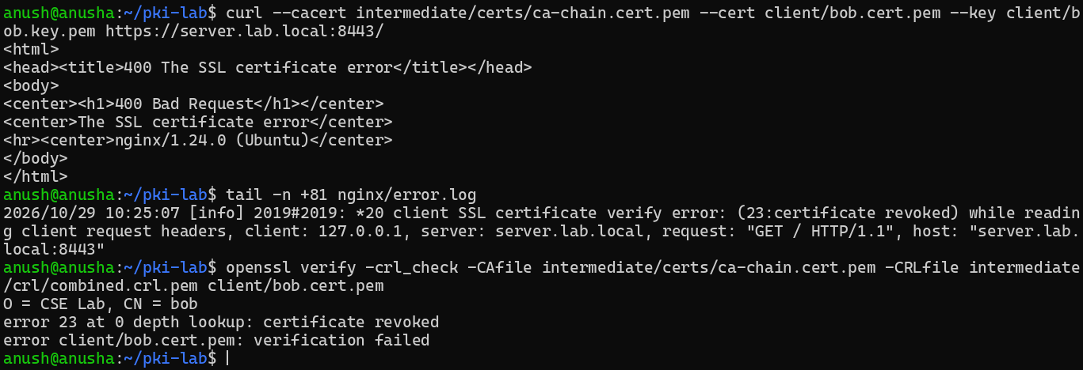
Figure 57: Part G: all client-certificate errors in nginx error.log
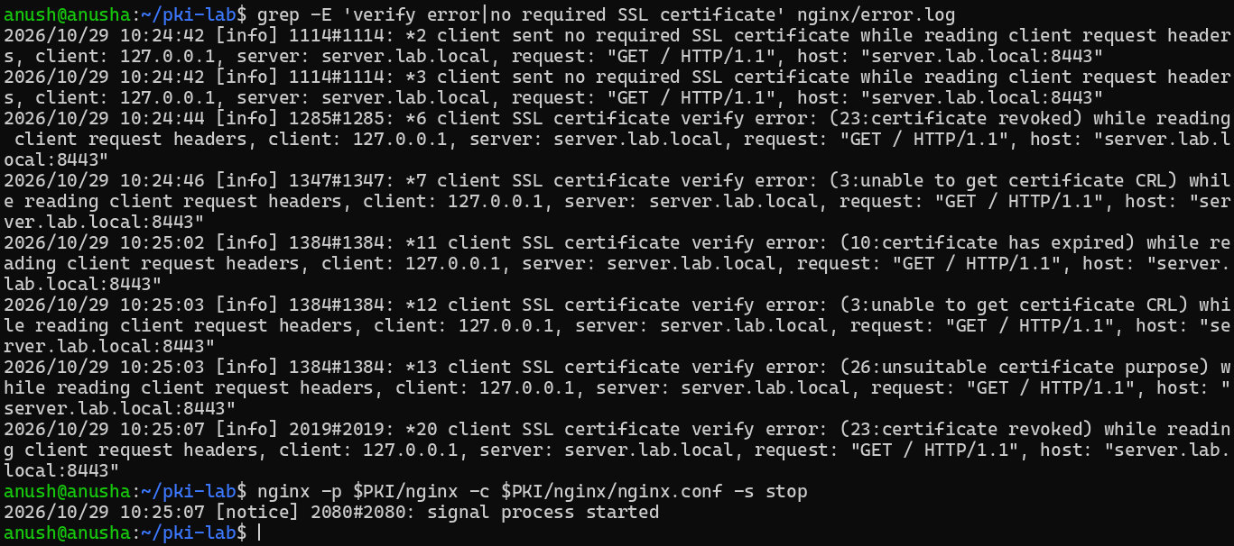

Observed results
# | Scenario | curl | nginx error.log | OpenSSL
1 | Expired client (eve) | HTTP 400 The SSL certificate error | 10: certificate has expired | verify: error 10
2 | Untrusted self-signed client (mallory) | HTTP 400 The SSL certificate error | 3: unable to get certificate CRL (ssl_crl on) | verify: error 18 self-signed certificate
3 | Wrong purpose (server cert as client) | HTTP 400 The SSL certificate error | 26: unsuitable certificate purpose | verify -purpose sslclient: error 26
4 | Hostname mismatch (wrong.lab.local) | curl (60): no alternative certificate subject name matches | client closed connection (no verify error) | s_client -verify_hostname: 62 hostname mismatch
5 | Missing intermediate (leaf only) | chain in --cacert: works; Root only: (60) unable to get local issuer certificate | SSL alert 48: unknown ca | s_client: 20, then 21
6 | Revoked (bob) | HTTP 400 The SSL certificate error | 23: certificate revoked | verify -crl_check: error 23

Answers: Task G — Failure scenarios (root causes)
1. Expired client (eve): the date is outside eve's validity (1–2 Jan 2024) → 10: certificate has expired.
2. Untrusted client (Mallory): her self-signed certificate doesn't chain to our Root. With ssl_crl on, nginx reports 3: unable to get certificate CRL (no CRL for an unknown issuer); openssl verify reports 18: self-signed certificate.
3. Wrong purpose: the server certificate's EKU is serverAuth only, not clientAuth → 26: unsuitable certificate purpose.
4. Hostname mismatch: wrong.lab.local is not in the server's SAN → curl (60) "no alternative certificate subject name matches"; s_client 62: hostname mismatch. The client aborts, so nginx logs no verify error.
5. Missing intermediate: the server sends only its leaf. With the full chain in --cacert it still works; with only the Root, curl fails "unable to get local issuer certificate" (s_client 20/21), because the client can't link the leaf to the Root.
6. Revoked (Bob): serial 1002 is on the Intermediate's CRL (keyCompromise) and nginx has ssl_crl on → 23: certificate revoked.

Reflection
What is the single most common reason real-world TLS deployments fail certificate validation, and how would you prevent it? (150 to 250 words)
Reflection
[handwritten answers attached]

Submission files
The zip file contains this report and the following files from ~/pki-lab. No private keys (*.key.pem) are included.
File | Contents
captures/keys.log | TLS 1.3 session secrets (SSLKEYLOGFILE)
captures/tls12.pcapng | TLS 1.2 capture
captures/tls13.pcapng | TLS 1.3 capture
client/alice.cert.pem | certificate
client/bob.cert.pem | certificate
client/eve.cert.pem | certificate
client/mallory.cert.pem | certificate
intermediate/certs/ca-chain.cert.pem | certificate chain
intermediate/certs/intermediate.cert.pem | certificate
intermediate/crl/combined.crl.pem | CRL
intermediate/crl/intermediate.crl.pem | CRL
intermediate/index.txt | CA database
intermediate/openssl.cnf | CA configuration
nginx/access.log | nginx access log
nginx/error.log | nginx error log (level info)
nginx/error_log_excerpts.txt | client-certificate errors only
nginx/nginx.conf | nginx configuration
root/certs/root.cert.pem | certificate
root/crl/root.crl.pem | CRL
root/index.txt | CA database
root/openssl.cnf | CA configuration
server/server.cert.pem | certificate
server/server.fullchain.pem | certificate chain

