Bharatiya Vidya Bhavan's
SARDAR PATEL INSTITUTE OF TECHNOLOGY
Department of Computer Science and Engineering — Cryptography and Network Security Laboratory
Experiment: Secure E-mail using PGP and S/MIME
Field | Value
Name | Anusha Dalal
UID | 2024300032
Date of experiment | 31 Oct 2026

Aim
To implement secure message exchange using Pretty Good Privacy (PGP/OpenPGP) and S/MIME, demonstrating public-key management, digital signatures, confidentiality through encryption, signature verification, decryption, and detection of message tampering.

Contents (order of Section 8)
# | Item
1 | Hand-drawn PGP and S/MIME workflow diagrams
2 | Table 1: execution environment
3 | PGP evidence: key listings and fingerprints, export/import, detached signature, encryption/decryption, signed-and-encrypted message, tampering
4 | S/MIME evidence: CA and user certificates, signed message, verification, encrypted message, decryption, tampering and untrusted-certificate results
5 | Tables 2 and 3, comparative analysis, answers to the discussion questions, conclusion
6 | Commands used and deviations caused by software versions

Every terminal capture shows the name and UID line and the prompt of the machine used (root@vm). No private keys are included in this report.

1. Hand-drawn workflow diagrams (Part A)
Drawn on paper before using the computer: Sender (Alice), Receiver (Bob), the insecure channel, key pairs/certificates, signing, encryption, decryption, verification, the ACCEPT/REJECT decision, an attacker modifying the message, and private keys never transmitted.
PGP / OpenPGP workflow diagram
[hand-written page attached]

S/MIME workflow diagram
[hand-written page attached]

2. Table 1: Execution environment
Parameter | Observed value
Operating system and version | Ubuntu 24.04.5 LTS (kernel 6.18.44-fc-v185)
GnuPG version | GnuPG 2.4.4 (libgcrypt 1.10.3)
OpenSSL version | OpenSSL 3.0.13 30 Jan 2024
CPU / RAM (optional) | Intel(R) Xeon(R) Processor @ 2.10GHz, 4 logical CPUs / 15 GiB
Date of experiment | Sat Oct 31 16:27:44 UTC 2026

Figure 1: Table 1 evidence: operating system, kernel, GnuPG and OpenSSL versions, CPU, RAM, date
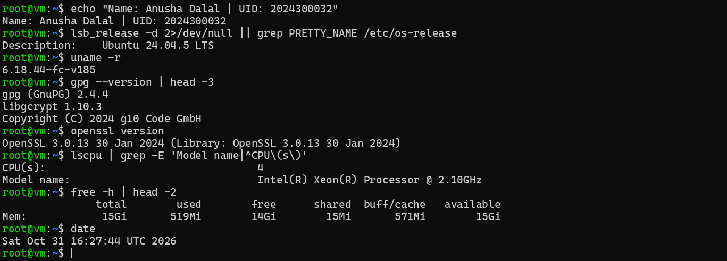

3. PGP / OpenPGP evidence (Part B)
Alice and Bob each have a separate GnuPG home directory, so each private key stays in its own keyring. Only public keys, the message, the signature and encrypted files are placed in the transfer folder.
Figure 2: Step B1: GnuPG installed - gpg --version
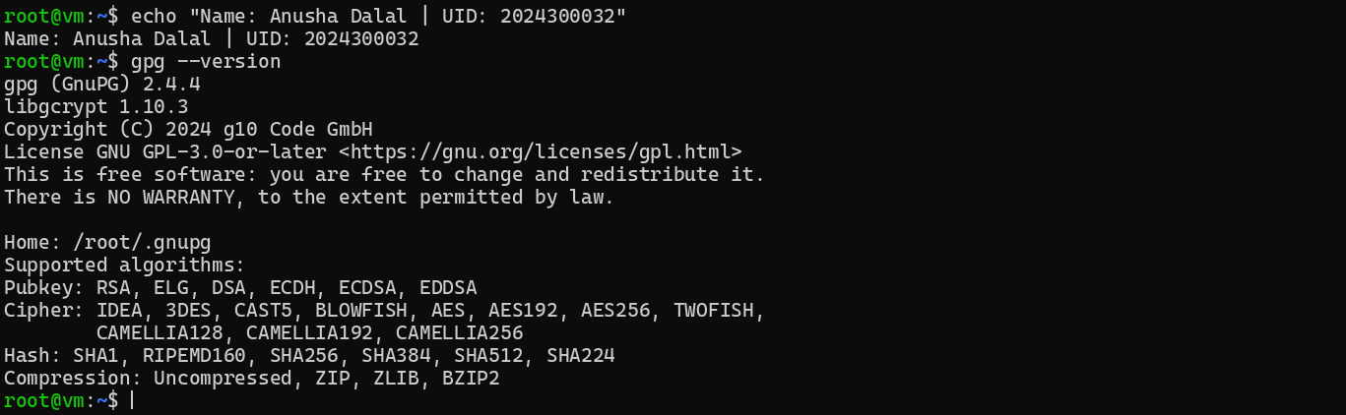
Figure 3: Step B2: separate working directories and GnuPG homes for Alice and Bob
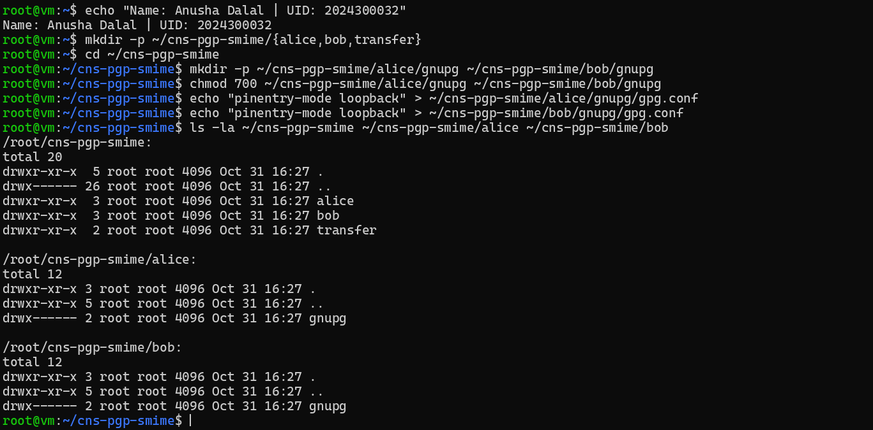
Figure 4: Step B3: Alice's key pair (RSA and RSA, 3072 bits) - gpg --full-generate-key, list-keys, list-secret-keys (1/2)
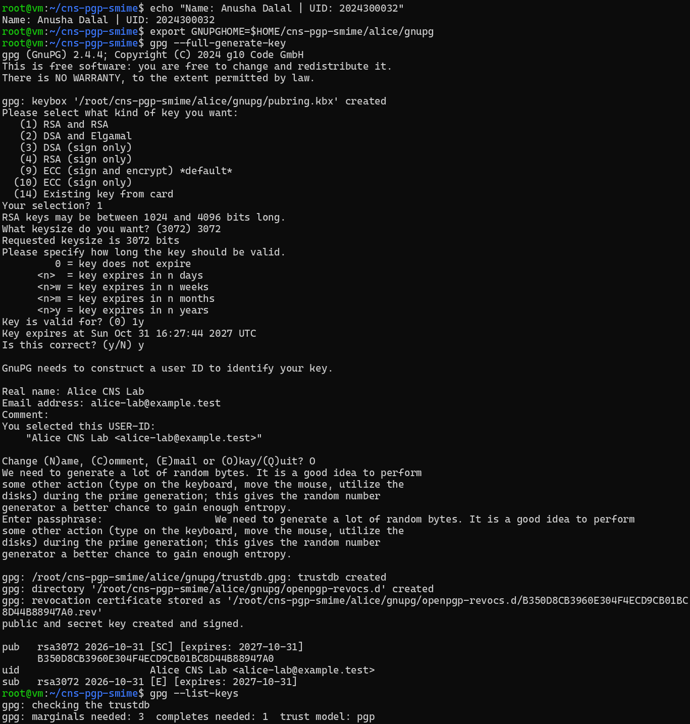
Figure 5: Step B3: Alice's key pair (RSA and RSA, 3072 bits) - gpg --full-generate-key, list-keys, list-secret-keys (2/2)
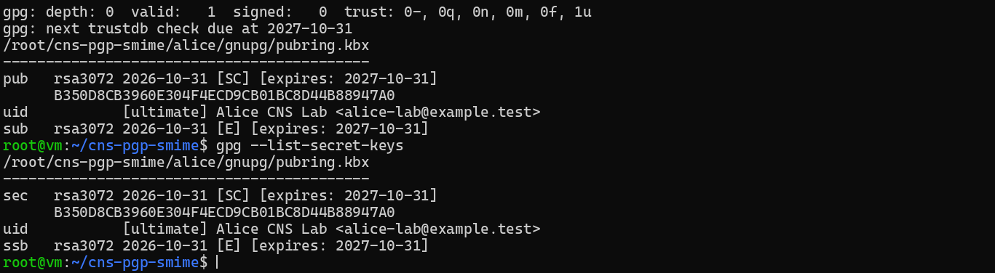
Figure 6: Step B3: Bob's key pair (RSA and RSA, 3072 bits) and key listing (1/2)
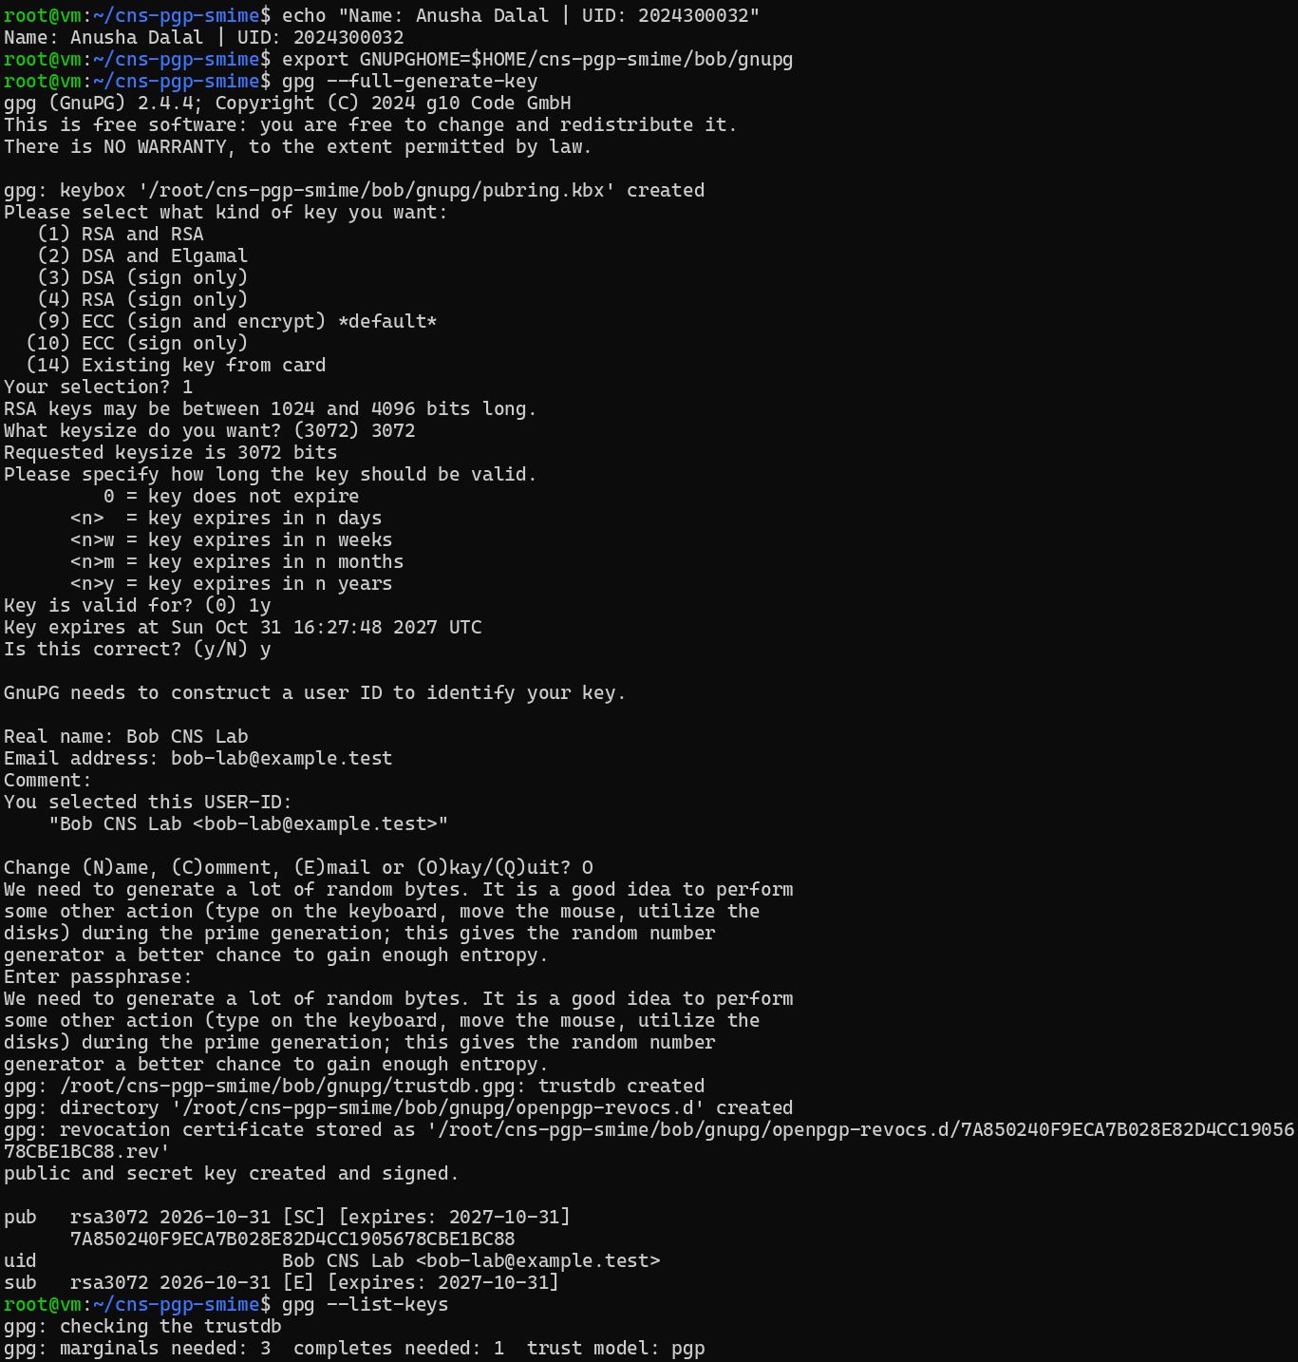
Figure 7: Step B3: Bob's key pair (RSA and RSA, 3072 bits) and key listing (2/2)
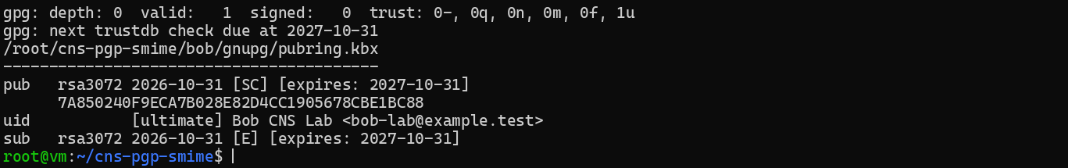
Figure 8: Step B4: export public keys only, import into the other keyring, compare fingerprints
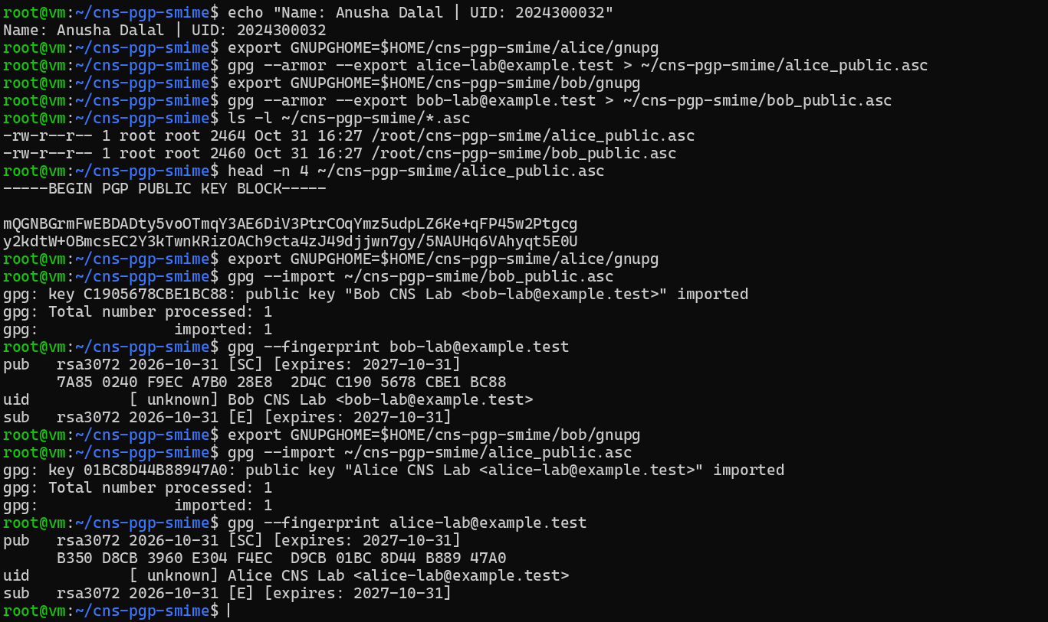
Figure 9: Step B5: message created and signed by Alice (detached ASCII-armored signature)
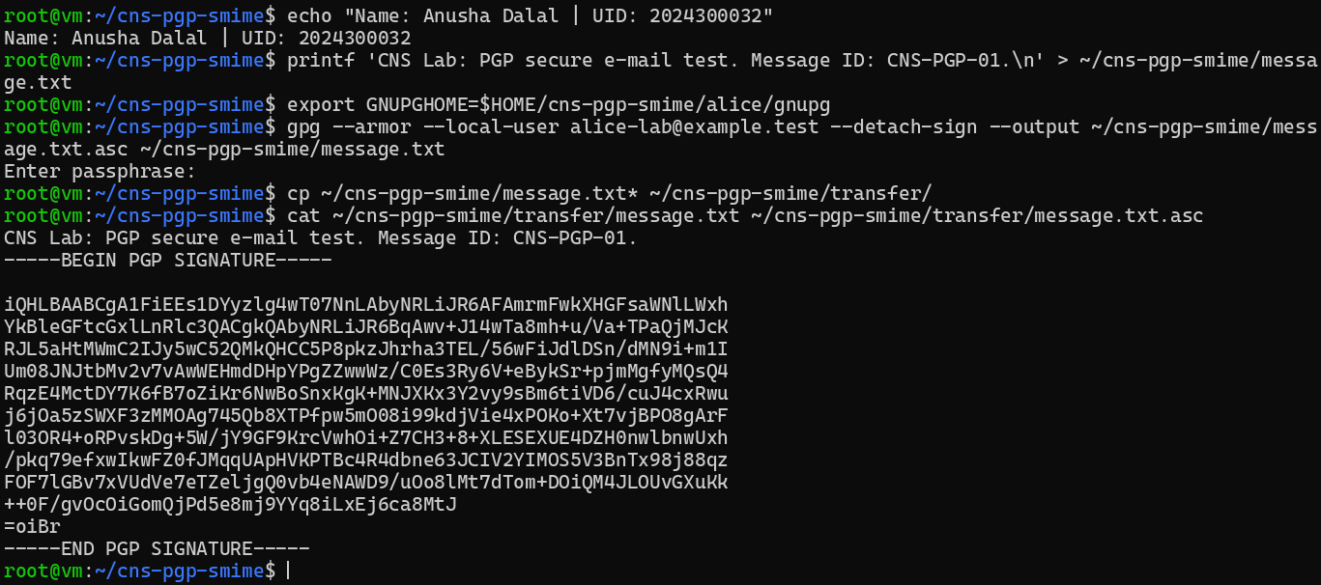
Figure 10: Step B6: Bob verifies Alice's detached signature - Good signature (trust warning noted separately)
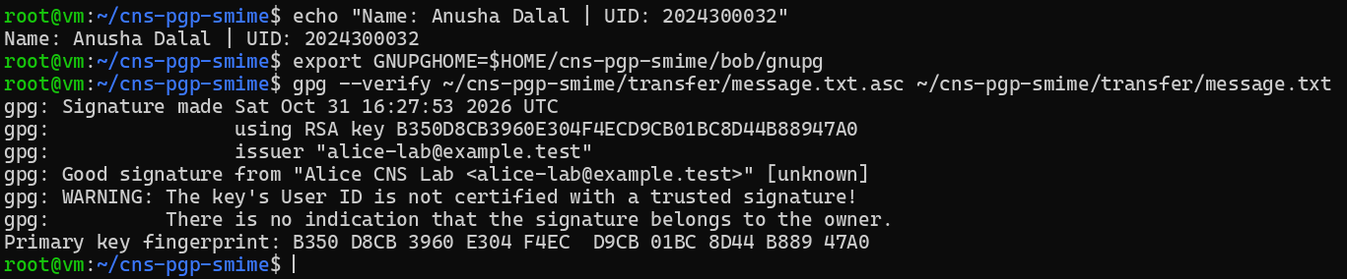
Figure 11: Step B7: Alice encrypts for Bob; Bob decrypts with his private key
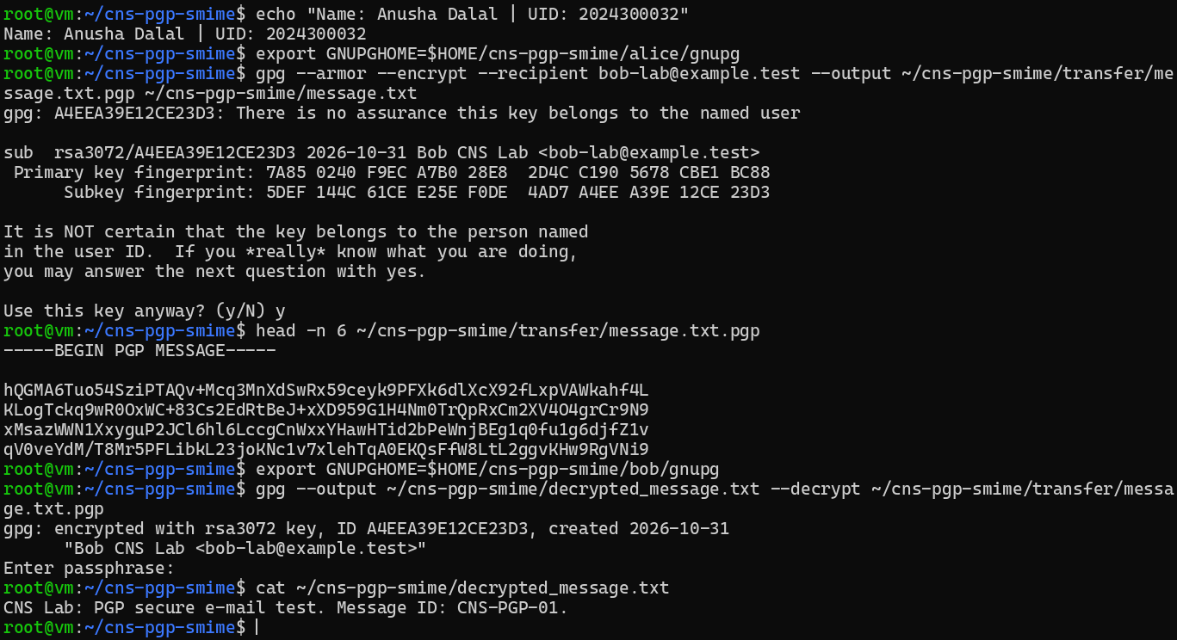
Figure 12: Step B7: signed-and-encrypted message; Bob decrypts and sees the signature status
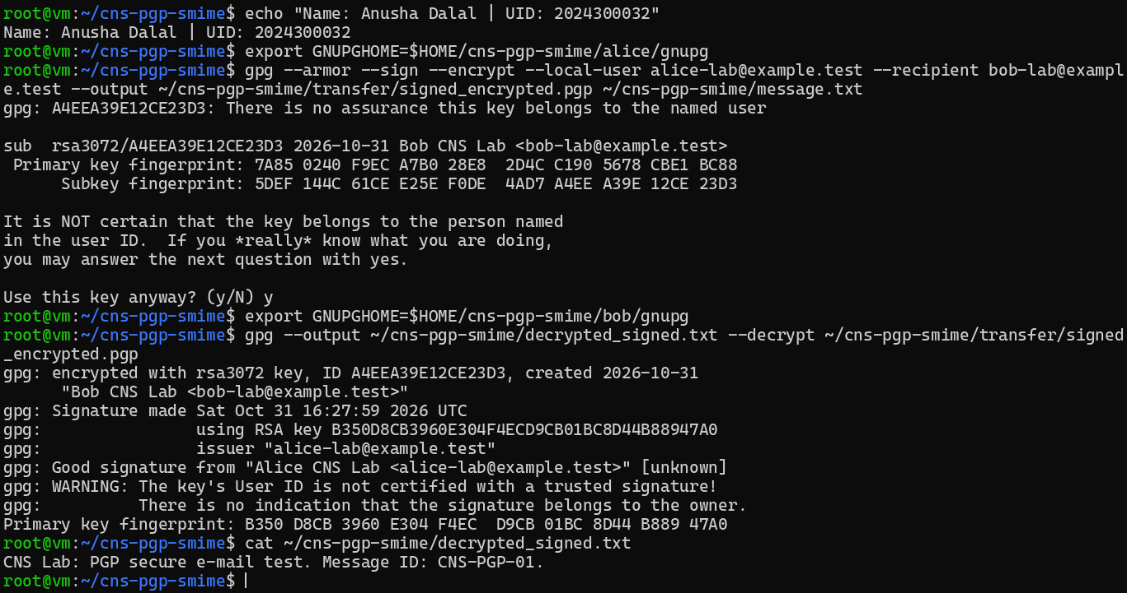
Figure 13: Step B8: tampered message checked against the original signature - BAD signature
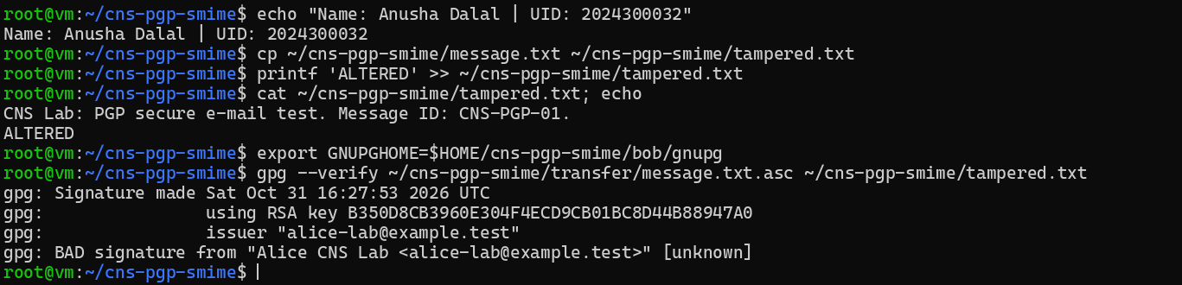
Figure 14: Table 2 (optional row): decryption with a non-matching private key fails; transfer folder contents
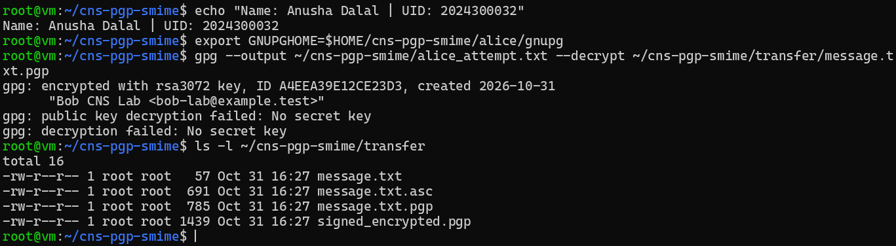

4. S/MIME evidence (Part C)
A local lab CA issues X.509 certificates for Alice and Bob; OpenSSL's smime command signs, verifies, encrypts and decrypts the message.
Figure 15: Step C1: OpenSSL version and S/MIME workspace
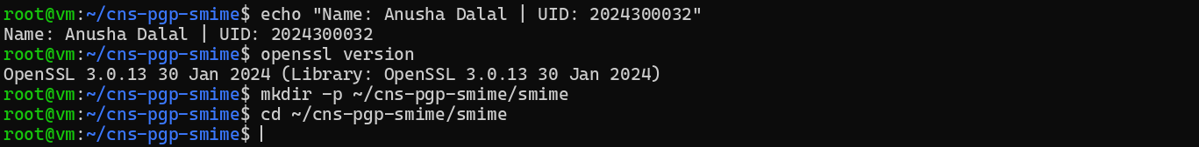
Figure 16: Step C2: lab CA certificate (CA:TRUE, keyCertSign, cRLSign)
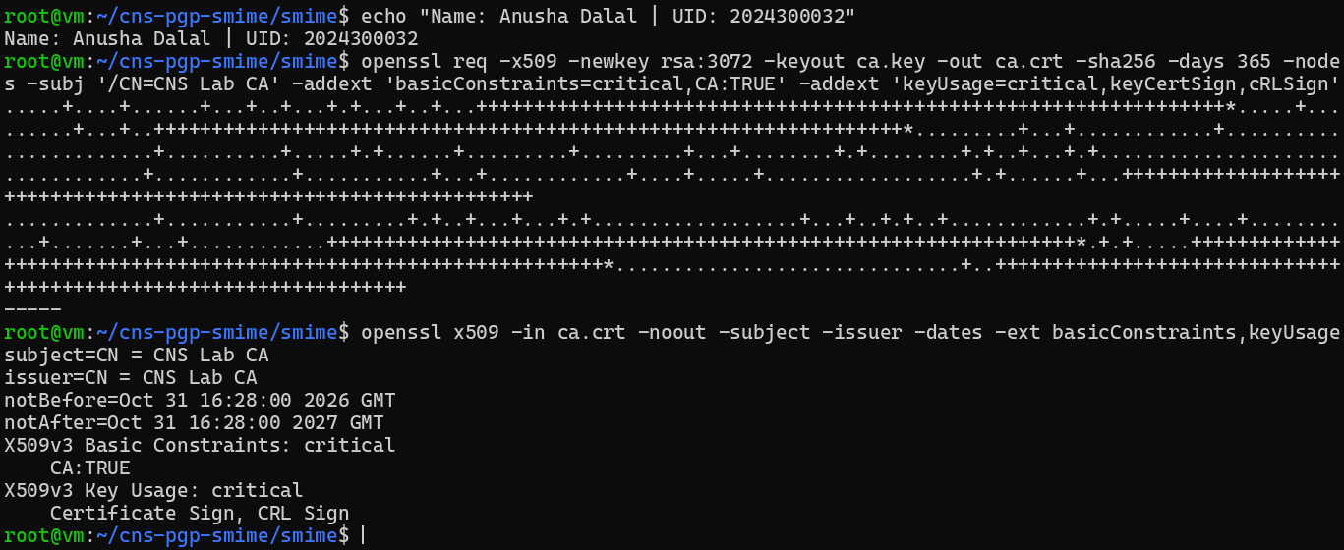
Figure 17: Step C3: Alice's key, CSR and certificate signed by the lab CA
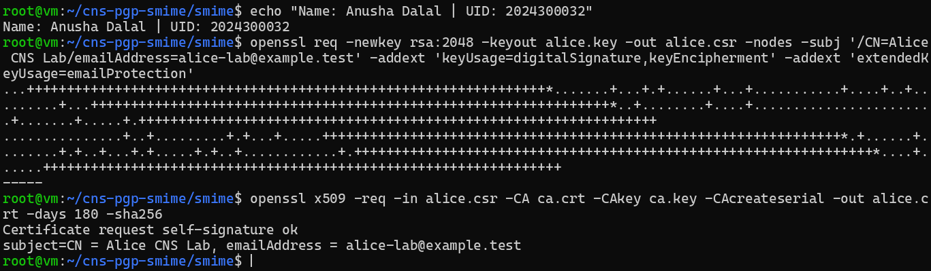
Figure 18: Step C4: Bob's key, CSR and certificate; subject, issuer and validity of both certificates
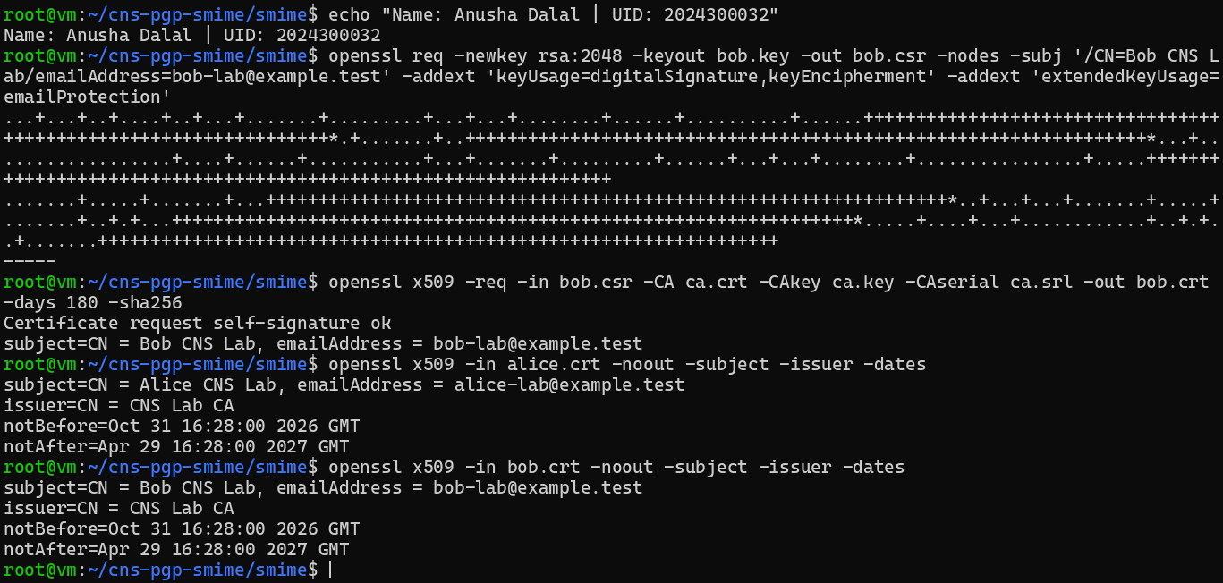
Figure 19: Certificate details: openssl x509 -text of Alice's certificate
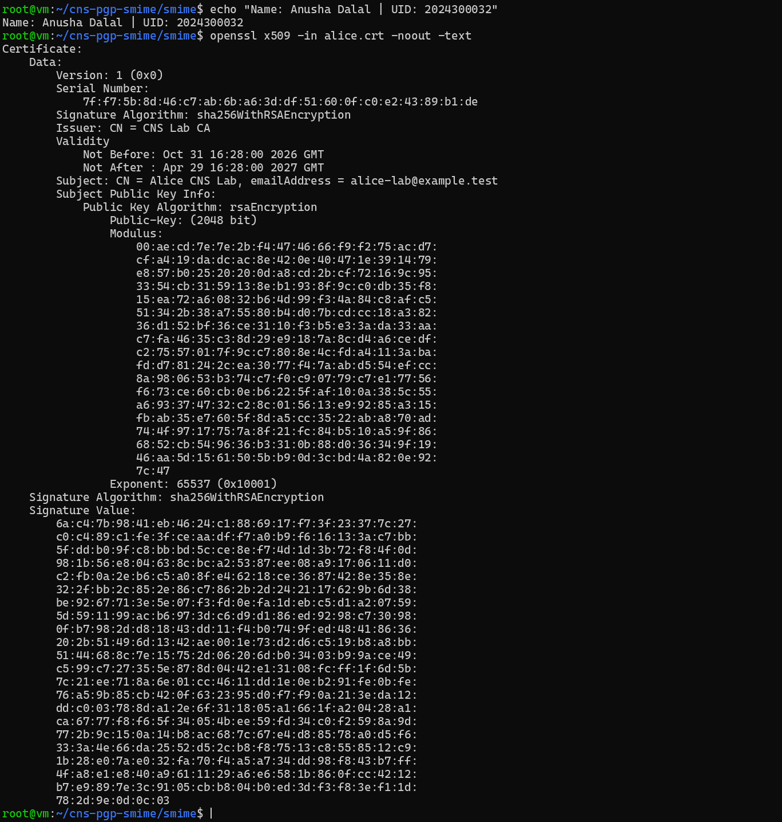
Figure 20: Step C5: S/MIME signed message (first 15 lines)
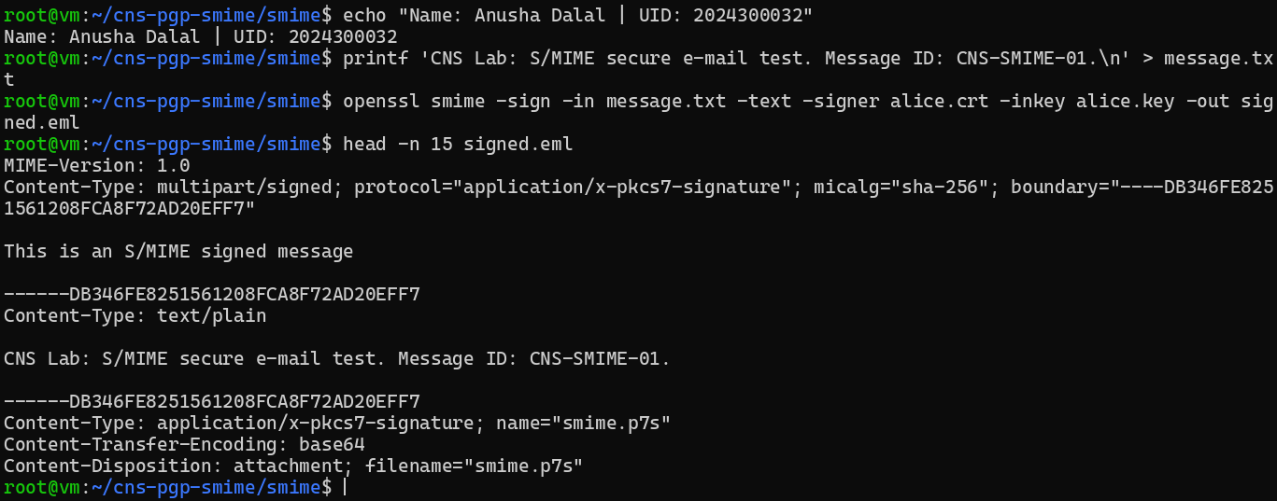
Figure 21: Step C6: signed message verified with the lab CA - Verification successful
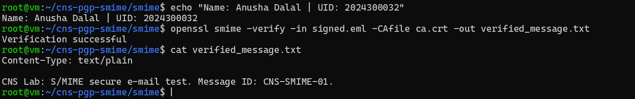
Figure 22: Steps C7-C8: encrypted for Bob (enveloped data) and decrypted with bob.key
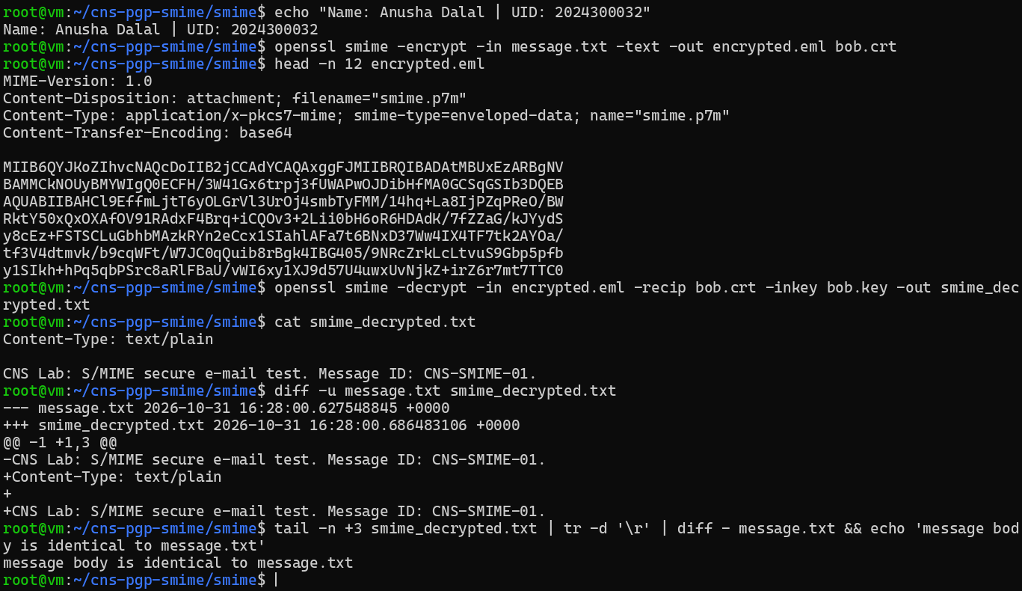
Figure 23: Step C9: sign then encrypt; Bob decrypts and verifies the recovered signed message
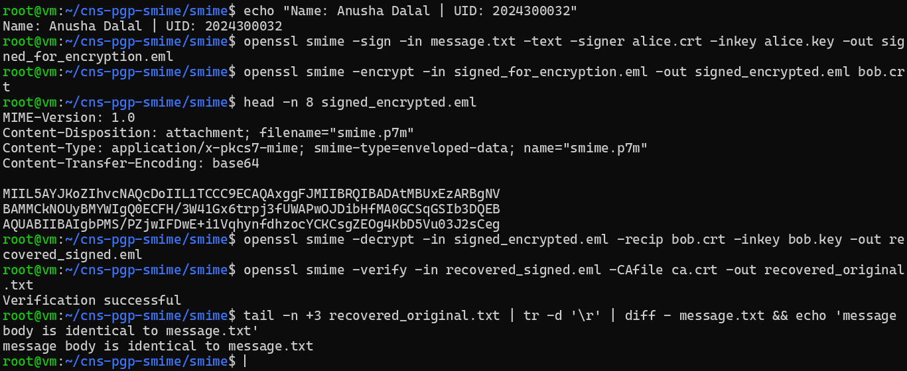
Figure 24: Step C10: one character of the signed body changed - Verification failure (digest failure)
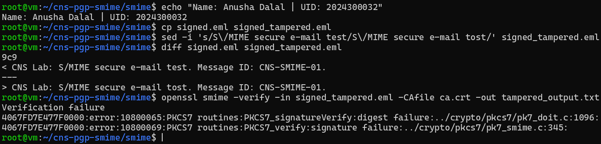
Figure 25: Step C10: wrong CA / no CA file - certificate trust failure; with -noverify the signature itself is valid
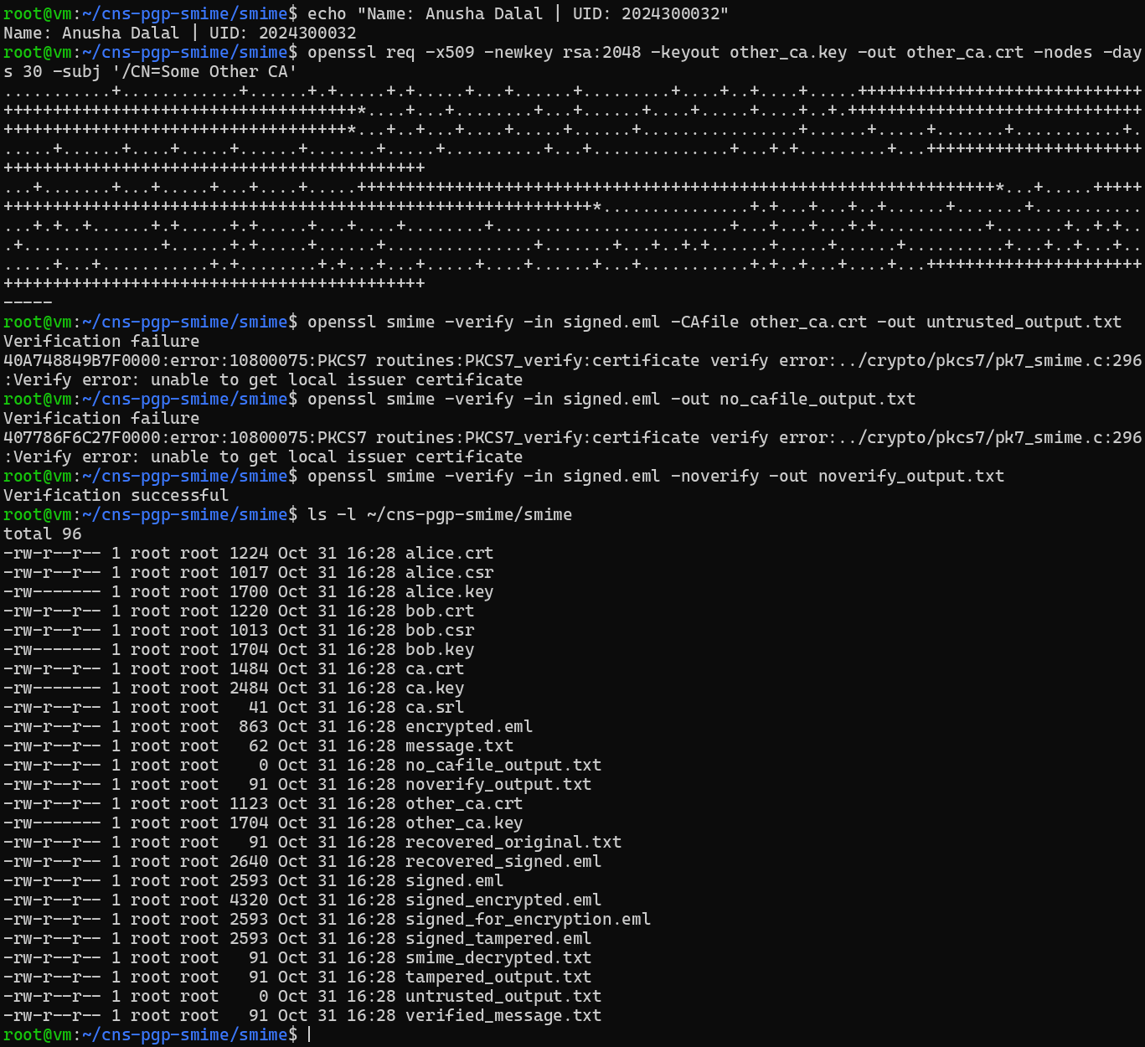

5. Results, comparative analysis, discussion and conclusion

Table 2: PGP Results
Test | Expected result | Observed result / evidence
Public key export/import | Keys imported; fingerprints can be inspected | Both keys exported as ASCII-armored .asc files and imported into the other keyring ("public key imported"); fingerprints shown with gpg --fingerprint: Alice B350 D8CB 3960 E304 F4EC D9CB 01BC 8D44 B889 47A0, Bob 7A85 0240 F9EC A7B0 28E8 2D4C C190 5678 CBE1 BC88
Detached signature on original message | Good signature (trust status noted separately) | Good signature from "Alice CNS Lab <alice-lab@example.test>" [unknown]; separately: WARNING, the key is not certified with a trusted signature
Encrypt for Bob and decrypt as Bob | Decryption succeeds; content matches original | Decrypted with Bob's rsa3072 subkey; decrypted_message.txt = "CNS Lab: PGP secure e-mail test. Message ID: CNS-PGP-01."
Signed-and-encrypted message | Bob decrypts and signature status is displayed | Bob decrypted it and GnuPG showed Good signature from Alice (with the same trust warning); content matches
Modified message checked against original signature | Signature verification fails | BAD signature from "Alice CNS Lab" (tampered.txt had "ALTERED" appended)
Attempt to decrypt with a non-matching private key (optional) | Decryption fails | Alice tried to decrypt the message for Bob: "decryption failed: No secret key"

Table 3: S/MIME Results
Test | Expected result | Observed result / evidence
Inspect Alice/Bob certificate | Subject, issuer and validity displayed | Subject CN=Alice CNS Lab / CN=Bob CNS Lab with their e-mail addresses; issuer CN=CNS Lab CA; valid 180 days (Oct 31 16:28:00 2026 GMT to Apr 29 16:28:00 2027 GMT)
Verify original signed message using lab CA | Verification succeeds | Verification successful; recovered text written to verified_message.txt
Encrypt for Bob and decrypt using bob.key | Decryption succeeds; content matches original | encrypted.eml is enveloped-data (smime.p7m); decryption succeeded; message body identical to message.txt (only the MIME header added by -text and CRLF line endings differ)
Sign and encrypt workflow | Bob recovers the signed message | Bob decrypted signed_encrypted.eml, Verification successful on the recovered signed message, body identical to message.txt
Modified signed content | Signature verification fails | Verification failure: PKCS7_signatureVerify: digest failure and signature failure (one character changed: "test" → "tost")
Verify with untrusted/missing CA | Certificate trust validation fails or warns | With another CA or no -CAfile: Verification failure: unable to get local issuer certificate (a trust failure). With -noverify the same message verifies, so the signature itself is valid

Comparative analysis
Parameter | PGP / OpenPGP | S/MIME
Key / identity representation | OpenPGP public key and fingerprint | X.509 certificate containing public key and identity fields
Trust model | Often decentralized; fingerprints and user certifications | Usually CA-issued certificate chain and validation
Typical message representation | OpenPGP packet / ASCII-armored data | MIME with CMS/PKCS #7 structures
Confidentiality mechanism | Hybrid encryption; session key protected for recipient | Hybrid encryption; content key protected for recipient
Signature verification requires | Correct sender public key and valid signature | Sender certificate/public key, valid signature and applicable trust checks
Common deployment | OpenPGP-compatible clients and workflows | Enterprise e-mail and certificate-based environments
Observed challenge | Public-key authenticity and trust decisions | Certificate issuance, chain validation and lifecycle management

PGP was easier to set up in the lab: each user generated a key pair and exchanged public keys directly, with no third party. Its extra trust step is manual: each user must compare the full key fingerprint over a separate trusted channel (and could certify the key), otherwise GnuPG warns that the key is not certified. S/MIME needed more setup, because a CA had to be created first and had to issue a certificate for each user. In return, the recipient only has to trust the CA certificate, after which every certificate it issued can be validated automatically, but the CA's issuance, chain validation, renewal and revocation must be managed.

Answers to the discussion questions
1. PGP vs S/MIME: key management and trust model.
PGP users create and exchange their own key pairs, and trust is decentralised: you decide who to trust by checking fingerprints or through signatures from people you trust (web of trust). S/MIME uses X.509 certificates issued by a Certificate Authority; trust is hierarchical, so you trust the CA and therefore every certificate in its chain.
2. Why hybrid encryption?
Symmetric encryption (e.g. AES) is fast and suits large message content, but needs a shared key. Public-key encryption solves key distribution but is slow and limited in size. So a random one-time session key encrypts the message, and only that small key is encrypted with the recipient's public key.
3. Signing and verifying keys.
The sender signs with her own private key; anyone verifies with the sender's public key (in S/MIME, the public key inside her certificate).
4. Encrypting for Bob and decrypting.
The message is encrypted with Bob's public key (his certificate in S/MIME); Bob decrypts with his own private key.
5. Why never send private keys?
Whoever has a private key can decrypt everything sent to that person and sign messages in their name. The transfer folder and e-mail are insecure channels, so a sent private key must be assumed compromised; confidentiality, authentication and non-repudiation would all be lost.
6. Valid signature vs trusted identity.
A valid signature only proves the message was signed by the private key matching the public key used, and was not changed. It does not prove whose key it is. Trust in the identity needs separate checking: fingerprint verification (PGP) or a valid CA chain (S/MIME). That is why GnuPG said "Good signature" and also "not certified with a trusted signature".
7. Why import without fingerprint check enables MITM.
An attacker on the channel could replace Alice's public key with their own key carrying Alice's name. Bob would then accept the attacker's signatures as Alice's, and messages Bob encrypts "to Alice" could be read by the attacker. Comparing the full fingerprint over a trusted channel detects the substitution.
8. Role of the CA certificate in S/MIME verification.
It is the trust anchor. OpenSSL checks that Alice's certificate was signed by a CA in the -CAfile; with the CA it reported "Verification successful", and without it "unable to get local issuer certificate", even though the signature itself was valid.
9. What happened when the message was modified?
Verification failed: GnuPG reported "BAD signature" and OpenSSL "digest failure". The signature is over a hash of the exact content; any change gives a different hash that no longer matches the signed hash, so integrity violation is detected.
10. Why is a lab/self-signed certificate not trusted in production?
Mail clients trust only CAs in their built-in trust store, which are audited and verify identities. Our lab CA is not in that store, and anyone can create a self-signed CA claiming any name, so trusting it automatically would let attackers forge identities.
11. Can a signed message also be encrypted?
Yes. Sign first, then encrypt: the signature covers the real content and is itself hidden inside the encryption, so only Bob sees who signed and what was signed. Bob decrypts first, then verifies. We did this in both parts (--sign --encrypt in PGP; sign then encrypt in S/MIME).
12. One advantage and one limitation of each.
- PGP: advantage: free, no CA needed, users control their own keys. Limitation: key authenticity depends on users checking fingerprints; weak usability for non-experts.
- S/MIME: advantage: built into enterprise mail clients, and automatic validation through a CA chain. Limitation: requires obtaining, renewing and revoking certificates from a CA (cost and management overhead).

Conclusion (150–200 words)
Conclusion
[hand-written page attached]

6. Commands used and deviations

Commands used
Step | Commands
Table 1 | lsb_release -d 2>/dev/null || grep PRETTY_NAME /etc/os-release  uname -r  gpg --version | head -3  openssl version  lscpu | grep -E 'Model name|^CPU\(s\)'  free -h | head -2  date
B1 | gpg --version
B2 | mkdir -p ~/cns-pgp-smime/{alice,bob,transfer}  cd ~/cns-pgp-smime  mkdir -p ~/cns-pgp-smime/alice/gnupg ~/cns-pgp-smime/bob/gnupg  chmod 700 ~/cns-pgp-smime/alice/gnupg ~/cns-pgp-smime/bob/gnupg  echo "pinentry-mode loopback" > ~/cns-pgp-smime/alice/gnupg/gpg.conf  echo "pinentry-mode loopback" > ~/cns-pgp-smime/bob/gnupg/gpg.conf  ls -la ~/cns-pgp-smime ~/cns-pgp-smime/alice ~/cns-pgp-smime/bob
B3 (Alice) | export GNUPGHOME=$HOME/cns-pgp-smime/alice/gnupg  gpg --full-generate-key  gpg --list-keys  gpg --list-secret-keys
B3 (Bob) | export GNUPGHOME=$HOME/cns-pgp-smime/bob/gnupg  gpg --full-generate-key  gpg --list-keys
B4 | export GNUPGHOME=$HOME/cns-pgp-smime/alice/gnupg  gpg --armor --export alice-lab@example.test > ~/cns-pgp-smime/alice_public.asc  export GNUPGHOME=$HOME/cns-pgp-smime/bob/gnupg  gpg --armor --export bob-lab@example.test > ~/cns-pgp-smime/bob_public.asc  ls -l ~/cns-pgp-smime/*.asc  head -n 4 ~/cns-pgp-smime/alice_public.asc  export GNUPGHOME=$HOME/cns-pgp-smime/alice/gnupg  gpg --import ~/cns-pgp-smime/bob_public.asc  gpg --fingerprint bob-lab@example.test  export GNUPGHOME=$HOME/cns-pgp-smime/bob/gnupg  gpg --import ~/cns-pgp-smime/alice_public.asc  gpg --fingerprint alice-lab@example.test
B5 | printf 'CNS Lab: PGP secure e-mail test. Message ID: CNS-PGP-01.\n' > ~/cns-pgp-smime/message.txt  export GNUPGHOME=$HOME/cns-pgp-smime/alice/gnupg  gpg --armor --local-user alice-lab@example.test --detach-sign --output ~/cns-pgp-smime/message.txt.asc ~/cns-pgp-smime/message.txt  cp ~/cns-pgp-smime/message.txt* ~/cns-pgp-smime/transfer/  cat ~/cns-pgp-smime/transfer/message.txt ~/cns-pgp-smime/transfer/message.txt.asc
B6 | export GNUPGHOME=$HOME/cns-pgp-smime/bob/gnupg  gpg --verify ~/cns-pgp-smime/transfer/message.txt.asc ~/cns-pgp-smime/transfer/message.txt
B7 | export GNUPGHOME=$HOME/cns-pgp-smime/alice/gnupg  gpg --armor --encrypt --recipient bob-lab@example.test --output ~/cns-pgp-smime/transfer/message.txt.pgp ~/cns-pgp-smime/message.txt  head -n 6 ~/cns-pgp-smime/transfer/message.txt.pgp  export GNUPGHOME=$HOME/cns-pgp-smime/bob/gnupg  gpg --output ~/cns-pgp-smime/decrypted_message.txt --decrypt ~/cns-pgp-smime/transfer/message.txt.pgp  cat ~/cns-pgp-smime/decrypted_message.txt
B7 (sign + encrypt) | export GNUPGHOME=$HOME/cns-pgp-smime/alice/gnupg  gpg --armor --sign --encrypt --local-user alice-lab@example.test --recipient bob-lab@example.test --output ~/cns-pgp-smime/transfer/signed_encrypted.pgp ~/cns-pgp-smime/message.txt  export GNUPGHOME=$HOME/cns-pgp-smime/bob/gnupg  gpg --output ~/cns-pgp-smime/decrypted_signed.txt --decrypt ~/cns-pgp-smime/transfer/signed_encrypted.pgp  cat ~/cns-pgp-smime/decrypted_signed.txt
B8 | cp ~/cns-pgp-smime/message.txt ~/cns-pgp-smime/tampered.txt  printf 'ALTERED' >> ~/cns-pgp-smime/tampered.txt  cat ~/cns-pgp-smime/tampered.txt; echo  export GNUPGHOME=$HOME/cns-pgp-smime/bob/gnupg  gpg --verify ~/cns-pgp-smime/transfer/message.txt.asc ~/cns-pgp-smime/tampered.txt
Table 2 (optional) | export GNUPGHOME=$HOME/cns-pgp-smime/alice/gnupg  gpg --output ~/cns-pgp-smime/alice_attempt.txt --decrypt ~/cns-pgp-smime/transfer/message.txt.pgp  ls -l ~/cns-pgp-smime/transfer
C1 | openssl version  mkdir -p ~/cns-pgp-smime/smime  cd ~/cns-pgp-smime/smime
C2 | openssl req -x509 -newkey rsa:3072 -keyout ca.key -out ca.crt -sha256 -days 365 -nodes -subj '/CN=CNS Lab CA' -addext 'basicConstraints=critical,CA:TRUE' -addext 'keyUsage=critical,keyCertSign,cRLSign'  openssl x509 -in ca.crt -noout -subject -issuer -dates -ext basicConstraints,keyUsage
C3 | openssl req -newkey rsa:2048 -keyout alice.key -out alice.csr -nodes -subj '/CN=Alice CNS Lab/emailAddress=alice-lab@example.test' -addext 'keyUsage=digitalSignature,keyEncipherment' -addext 'extendedKeyUsage=emailProtection'  openssl x509 -req -in alice.csr -CA ca.crt -CAkey ca.key -CAcreateserial -out alice.crt -days 180 -sha256
C4 | openssl req -newkey rsa:2048 -keyout bob.key -out bob.csr -nodes -subj '/CN=Bob CNS Lab/emailAddress=bob-lab@example.test' -addext 'keyUsage=digitalSignature,keyEncipherment' -addext 'extendedKeyUsage=emailProtection'  openssl x509 -req -in bob.csr -CA ca.crt -CAkey ca.key -CAserial ca.srl -out bob.crt -days 180 -sha256  openssl x509 -in alice.crt -noout -subject -issuer -dates  openssl x509 -in bob.crt -noout -subject -issuer -dates
C4 (details) | openssl x509 -in alice.crt -noout -text
C5 | printf 'CNS Lab: S/MIME secure e-mail test. Message ID: CNS-SMIME-01.\n' > message.txt  openssl smime -sign -in message.txt -text -signer alice.crt -inkey alice.key -out signed.eml  head -n 15 signed.eml
C6 | openssl smime -verify -in signed.eml -CAfile ca.crt -out verified_message.txt  cat verified_message.txt
C7–C8 | openssl smime -encrypt -in message.txt -text -out encrypted.eml bob.crt  head -n 12 encrypted.eml  openssl smime -decrypt -in encrypted.eml -recip bob.crt -inkey bob.key -out smime_decrypted.txt  cat smime_decrypted.txt  diff -u message.txt smime_decrypted.txt  tail -n +3 smime_decrypted.txt | tr -d '\r' | diff - message.txt && echo 'message body is identical to message.txt'
C9 | openssl smime -sign -in message.txt -text -signer alice.crt -inkey alice.key -out signed_for_encryption.eml  openssl smime -encrypt -in signed_for_encryption.eml -out signed_encrypted.eml bob.crt  head -n 8 signed_encrypted.eml  openssl smime -decrypt -in signed_encrypted.eml -recip bob.crt -inkey bob.key -out recovered_signed.eml  openssl smime -verify -in recovered_signed.eml -CAfile ca.crt -out recovered_original.txt  tail -n +3 recovered_original.txt | tr -d '\r' | diff - message.txt && echo 'message body is identical to message.txt'
C10 (tamper) | cp signed.eml signed_tampered.eml  sed -i 's/S\/MIME secure e-mail test/S\/MIME secure e-mail tost/' signed_tampered.eml  diff signed.eml signed_tampered.eml  openssl smime -verify -in signed_tampered.eml -CAfile ca.crt -out tampered_output.txt
C10 (trust) | openssl req -x509 -newkey rsa:2048 -keyout other_ca.key -out other_ca.crt -nodes -days 30 -subj '/CN=Some Other CA'  openssl smime -verify -in signed.eml -CAfile other_ca.crt -out untrusted_output.txt  openssl smime -verify -in signed.eml -out no_cafile_output.txt  openssl smime -verify -in signed.eml -noverify -out noverify_output.txt  ls -l ~/cns-pgp-smime/smime

Deviations caused by software versions or the environment
- Passphrase prompt in the terminal: without a graphical desktop, GnuPG's pinentry pop-up is not available, so each keyring's gpg.conf contains pinentry-mode loopback; GnuPG then asks for the passphrase directly in the terminal (the passphrase is not echoed). The key-generation answers were exactly those in the manual (RSA and RSA, 3072 bits, expiry 1 year, the given names and e-mail addresses).
- "Use this key anyway? (y/N)": when Alice encrypts for Bob, GnuPG 2.4 asks this because Bob's imported key is not yet certified; it was answered y after the fingerprint was compared (Step B4).
- C10 edit with sed instead of a text editor: one character of the signed body was changed with sed ("test" to "tost"); diff shows that only that line changed and the MIME structure is intact.
- Certificate extensions: in OpenSSL 3.0, openssl x509 -req does not copy extensions from the CSR unless -copy_extensions copy is given, so alice.crt and bob.crt contain no keyUsage/extendedKeyUsage. S/MIME still works, because a certificate without these extensions is not restricted.
- Decrypted file vs message.txt: the -text option wraps the message in a Content-Type: text/plain MIME header and S/MIME uses CRLF line endings, so the files differ by the header and line endings only; the message body was compared with tail -n +3 | tr -d '\r' | diff and is identical.
- Untrusted CA test: in addition to omitting -CAfile, a second unrelated CA ("Some Other CA") was used, and -noverify was run to show that the failure is a certificate-trust failure, not a content failure.

