Sardar Patel Institute of Technology - Department of Computer Engineering
Cryptography and Network Security Lab
Experiment 8: Evaluation of Classical and Post-Quantum Digital Signature Algorithms using Docker-Based Client-Server Communication
Screenshots (in order of execution)
Name: Anusha Dalal UID: 2024300032 Date: 16 October 2026

Screenshot 1: Step C4: the image sig-lab:1.0 has been built and is listed by docker images

Screenshot 2: Step C5: user-defined bridge network sig-net created and listed (no containers attached yet)
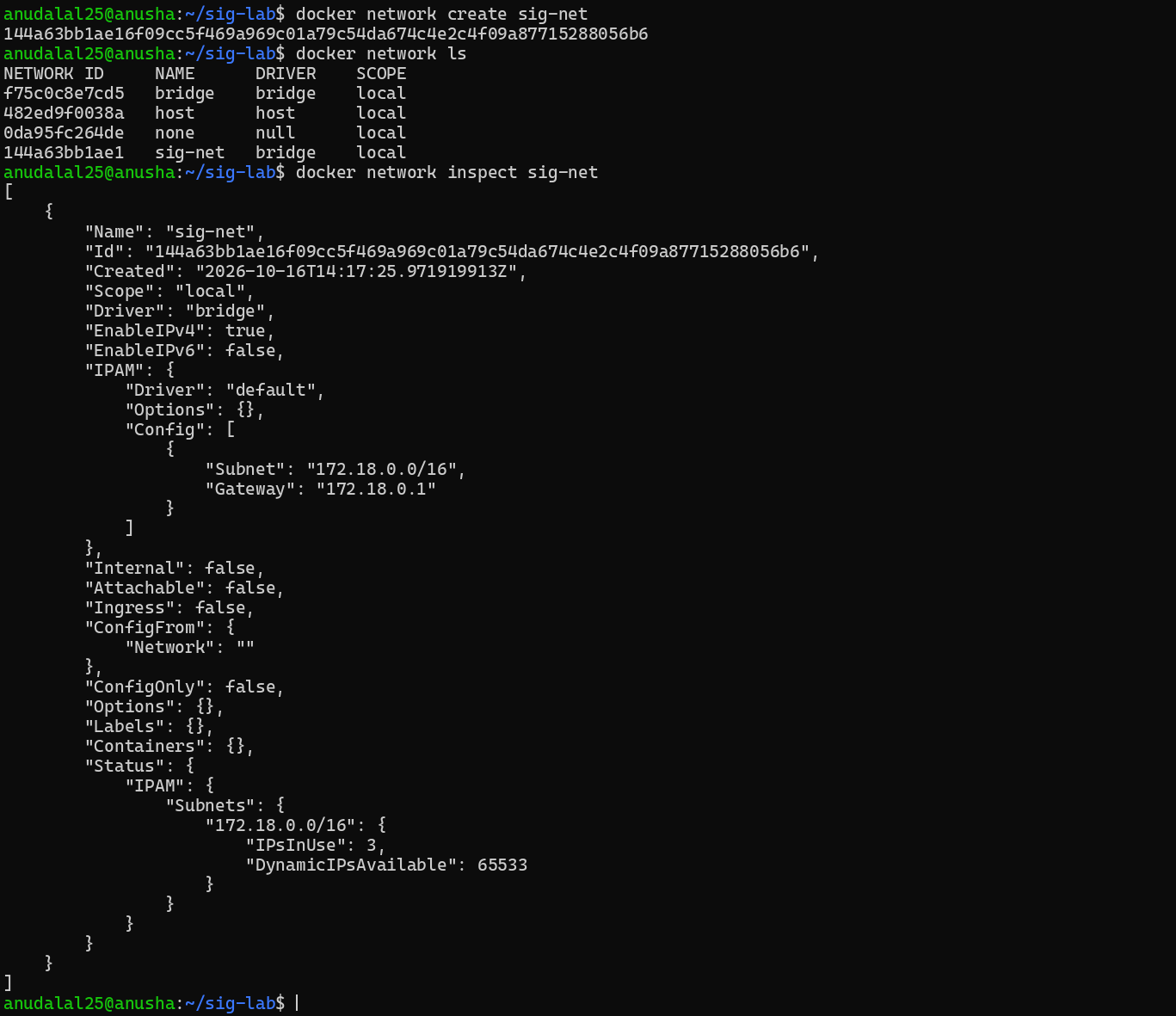

Screenshot 3: Step C6: sender and receiver containers started on sig-net with STUDENT_UID; docker ps shows both Up
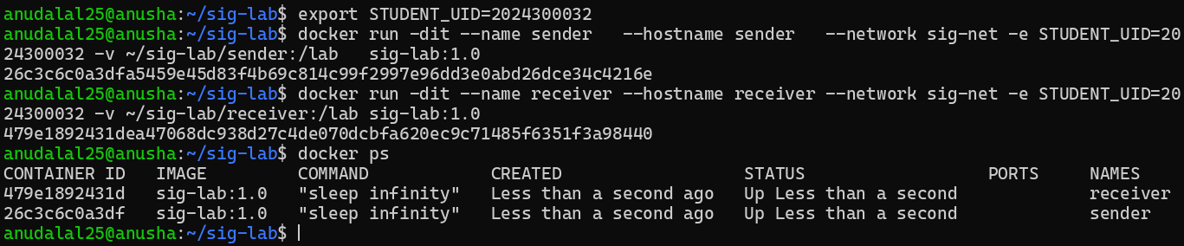

Screenshot 4: Step C7: docker network inspect sig-net now lists both containers with their IP addresses
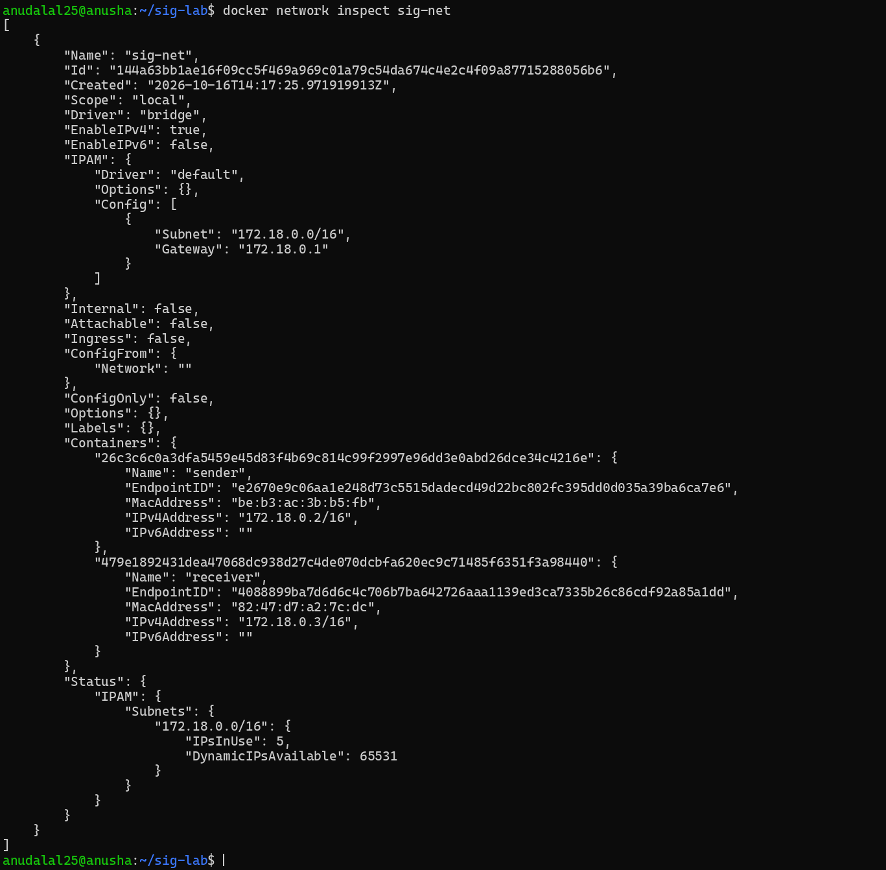

Screenshot 5: Step C7: ping by name from sender to receiver, STUDENT_UID inside the container, liboqs mechanisms and container IPs
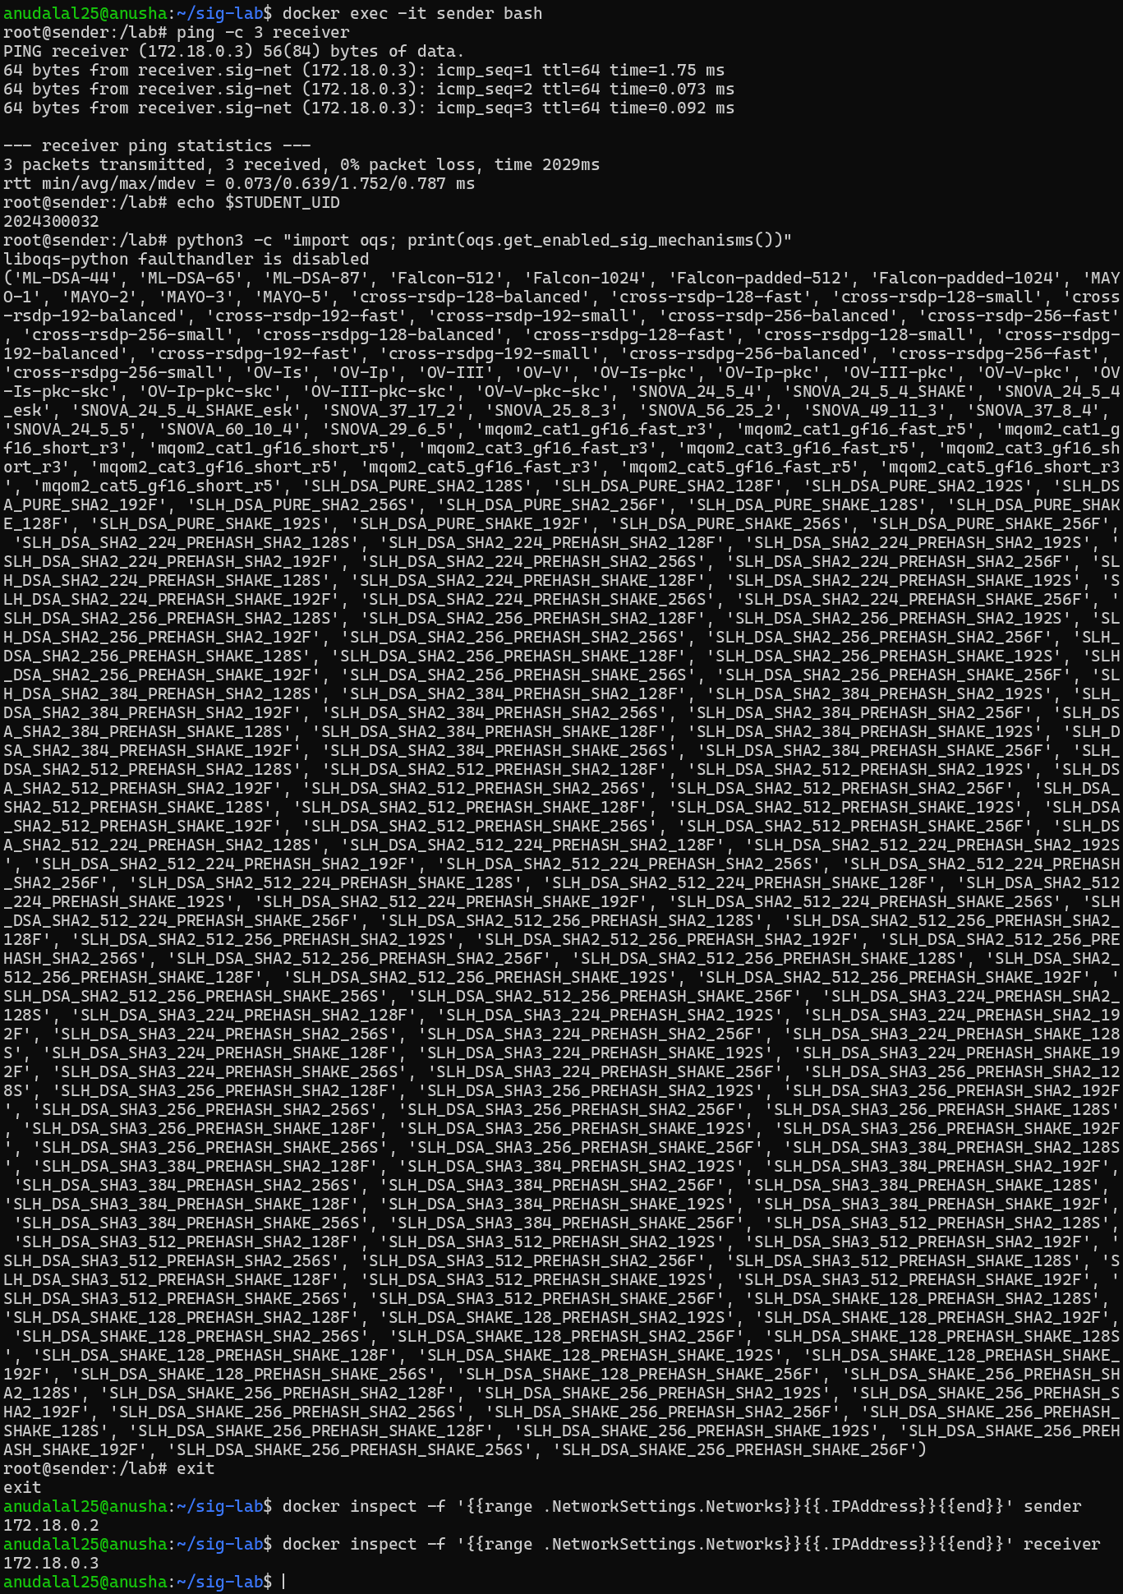

Screenshot 6: Step C8: execution environment (CPU, RAM, OS, Docker, cryptography and liboqs versions) for Table 1
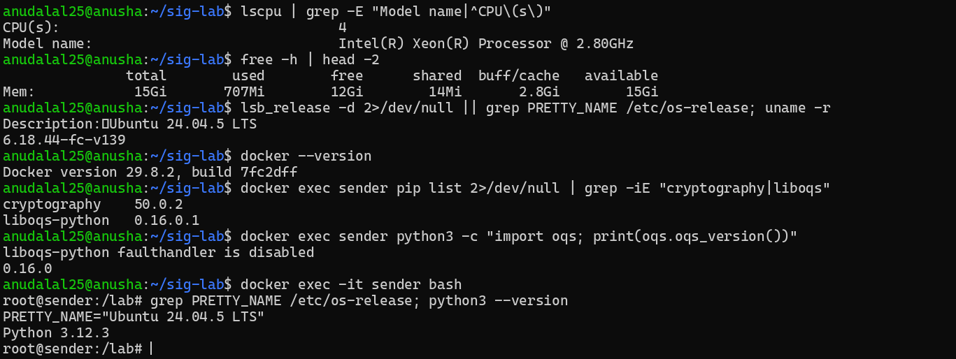

Screenshot 7: Step D1: exact ML-DSA / SLH-DSA names in liboqs (ML-DSA-44, SLH_DSA_PURE_SHA2_128S)
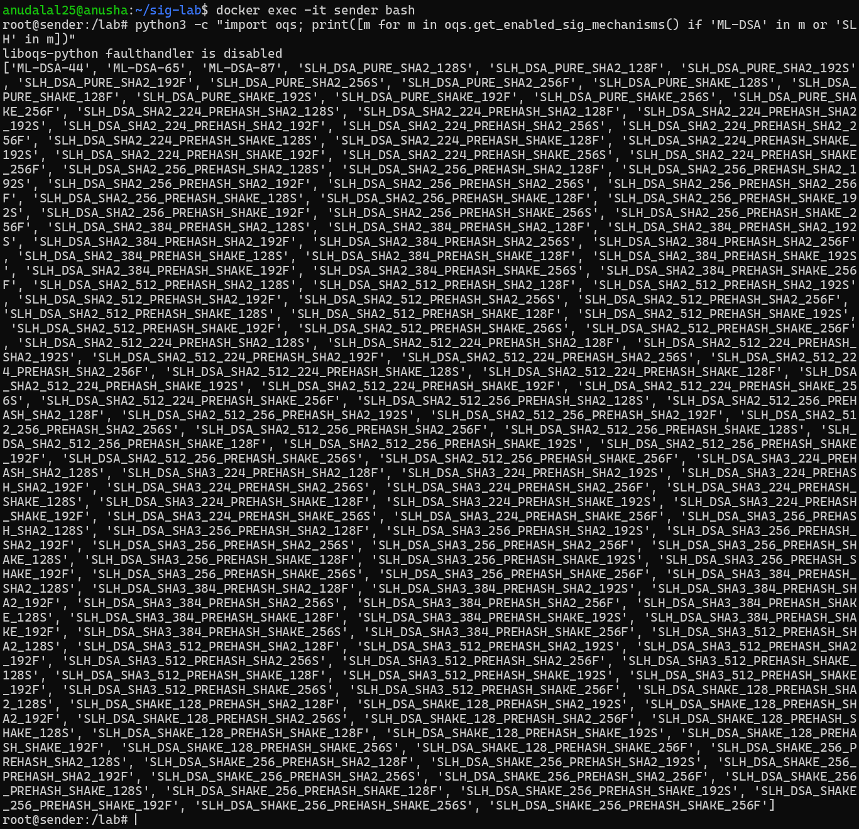

Screenshot 8: Step D3: keygen.py generates the ECDSA, RSA-PSS, ML-DSA and SLH-DSA key pairs and prints their sizes
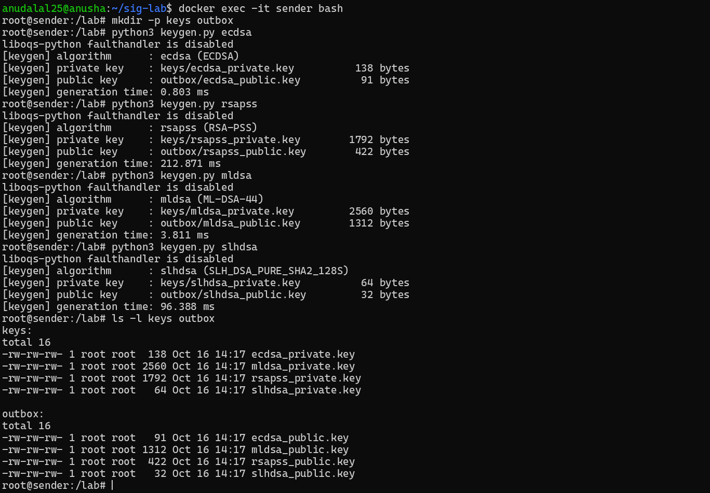

Screenshot 9: Part E: sign.py creates the UID document and signs it with all four algorithms; document SHA-256 noted
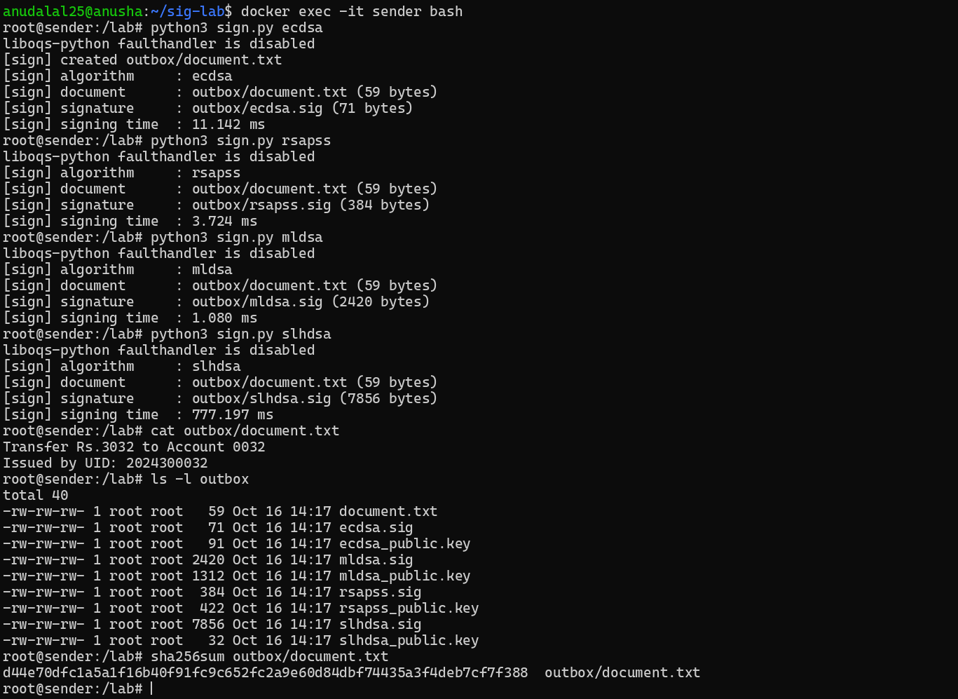

Screenshot 10: Part F: receiver downloads document, signatures and public keys from http://sender:8000; SHA-256 matches
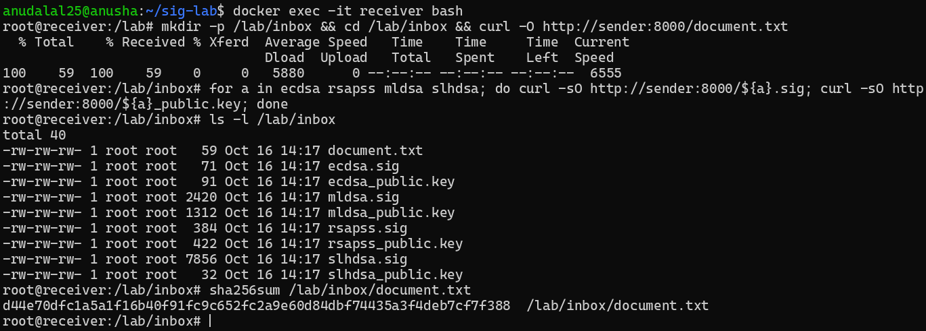

Screenshot 11: Part F: sender's HTTP server log showing every request coming from the receiver's IP (172.18.0.3)
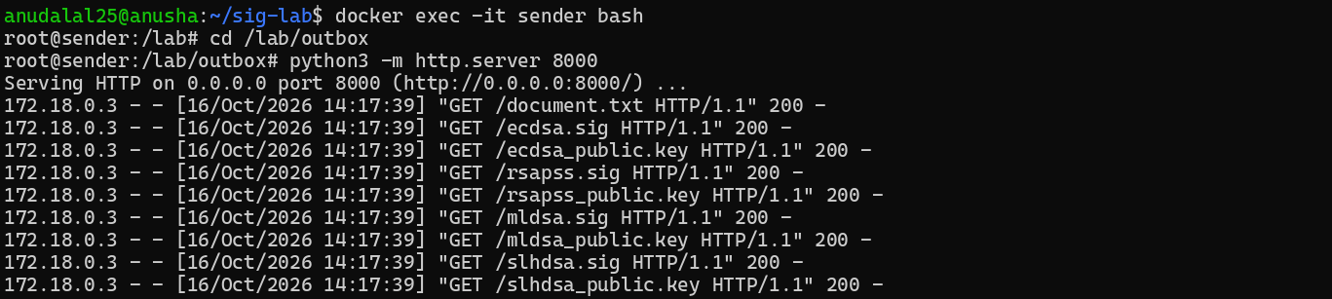

Screenshot 12: Part G: verify.py on the receiver prints PASS for all four algorithms
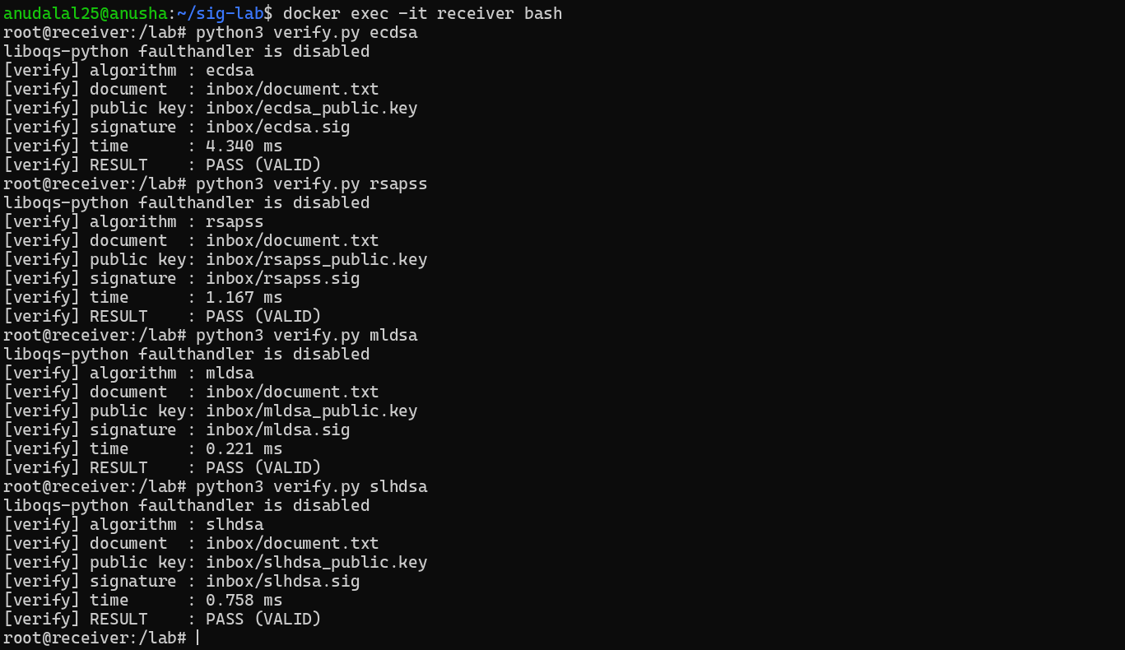

Screenshot 13: Part G: key, signature and document sizes (stat -c %s) on the sender and bytes received for Table 2
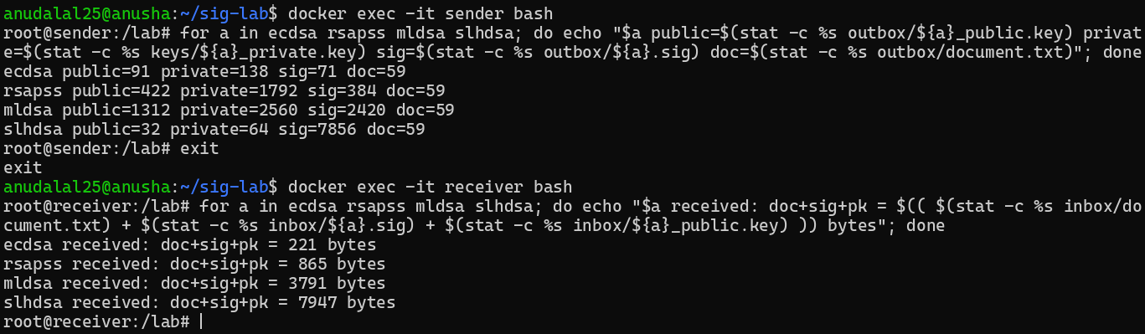

Screenshot 14: Part H, Tests 1-2: one character of the document changed; original passes, modified document FAILS
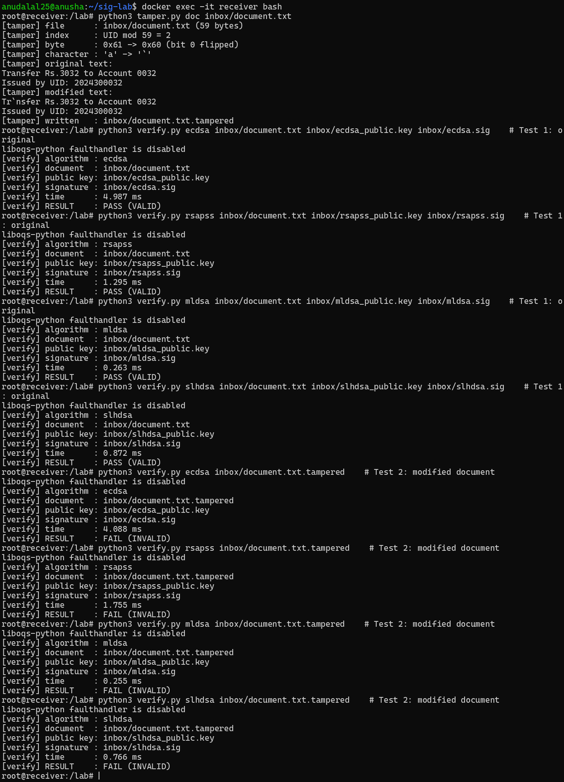

Screenshot 15: Part H, Test 3: one bit of each signature flipped at index UID mod length; all four FAIL
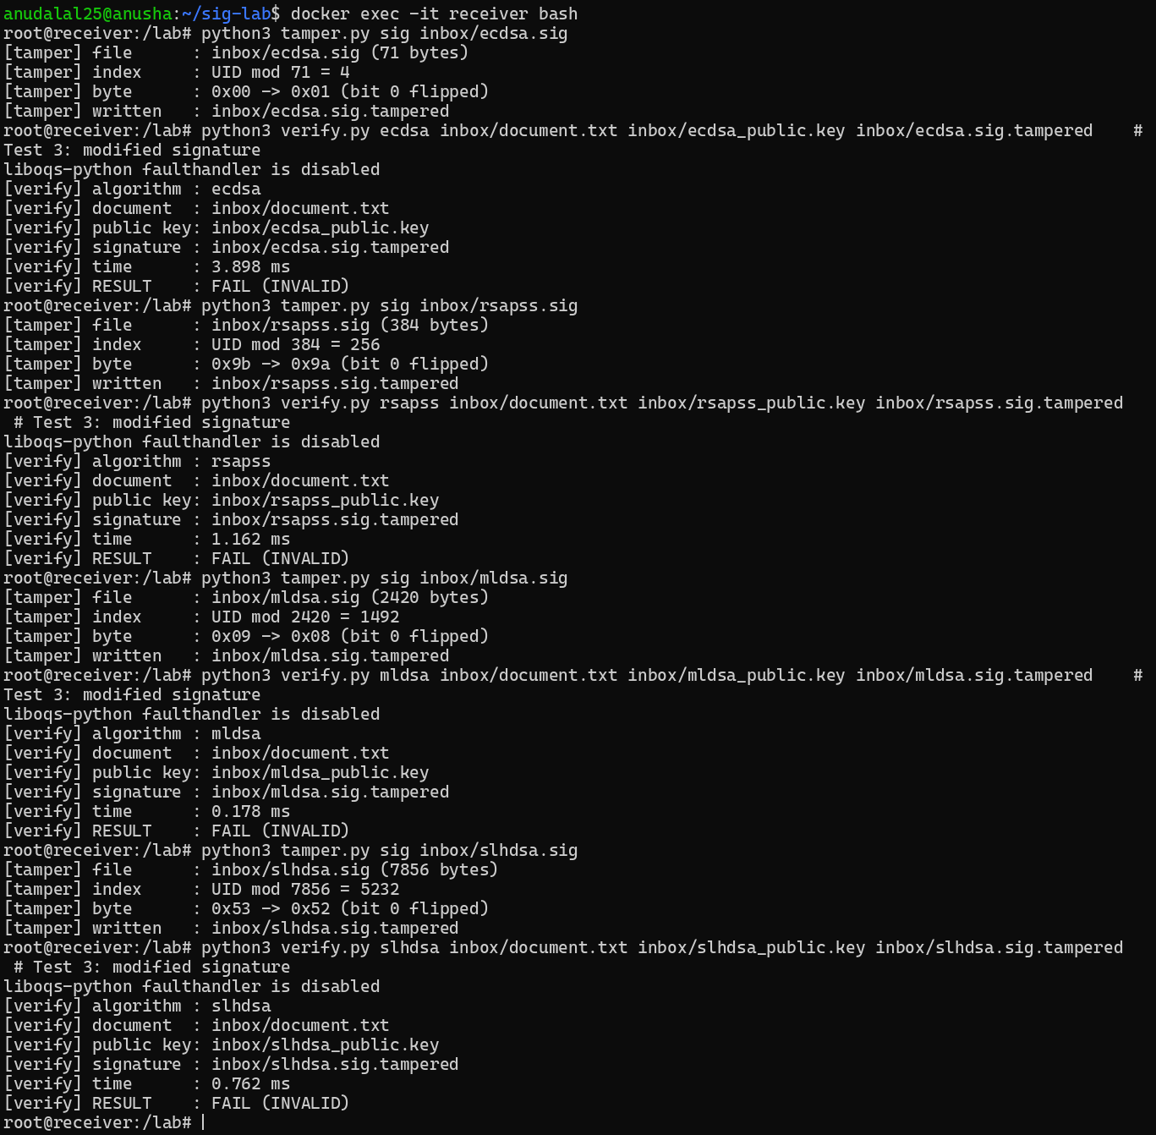

Screenshot 16: Part H, Test 4: receiver makes its own key pairs and verifies with them (wrong public key)
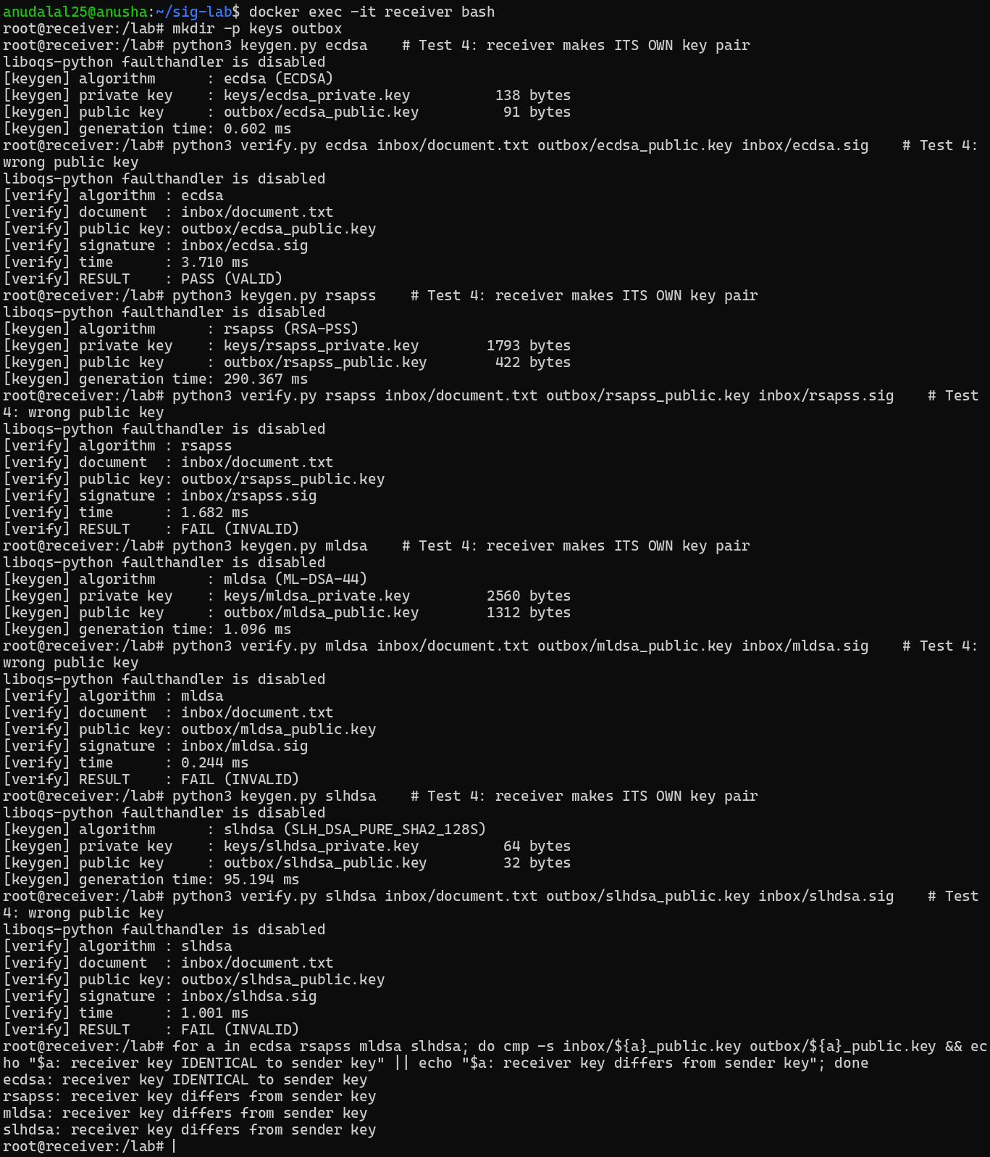

Screenshot 17: Part I: bench.py on the sender, run three times (results_run1/2/3.csv)
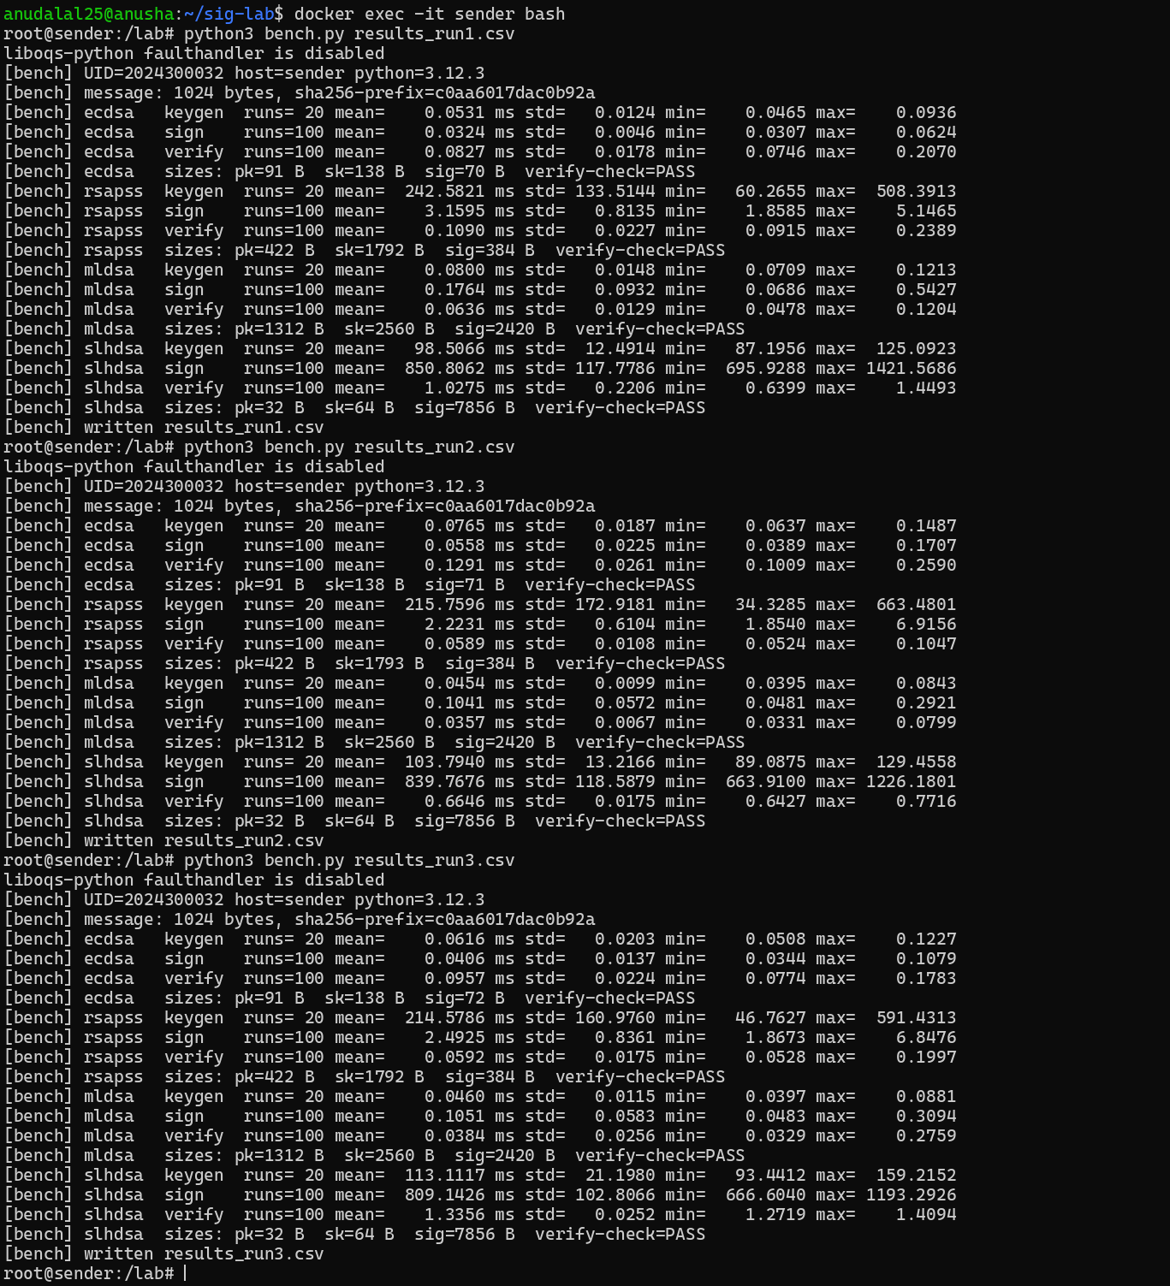

Screenshot 18: Part I: the median run (run 2) is kept as results.csv on the sender
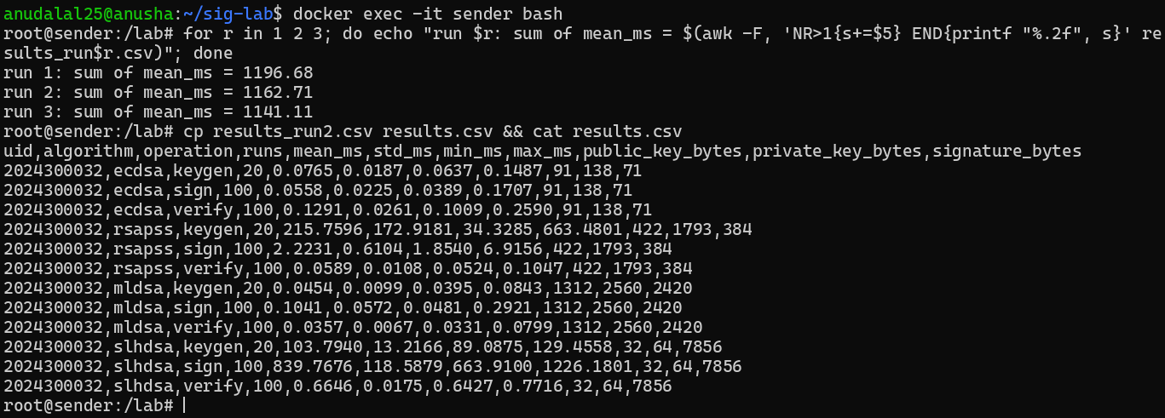

Screenshot 19: Part I: bench.py repeated on the receiver container (receiver results.csv)
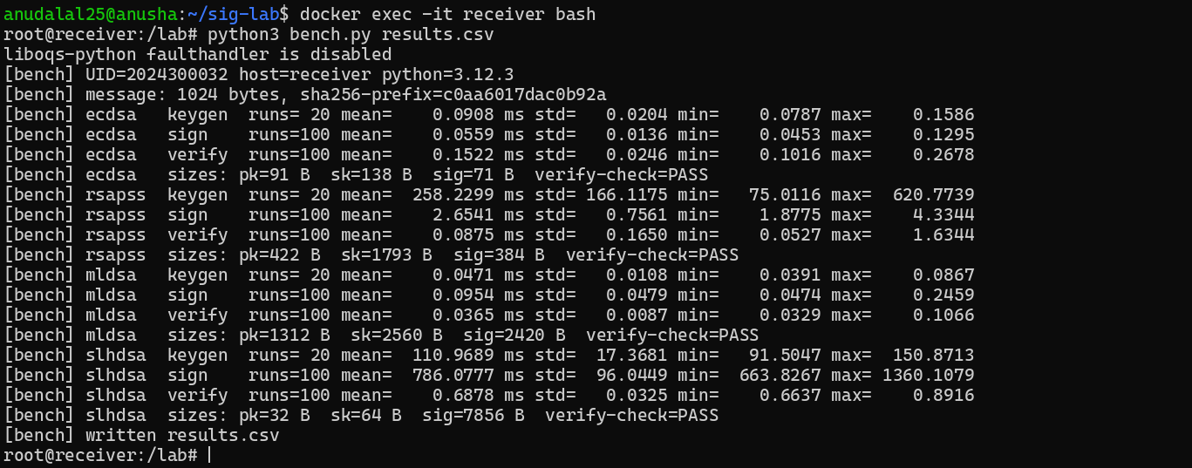

Screenshot 20: Section 15: plot.py draws the seven graphs; docker cp copies graphs/ to the host
