Sardar Patel Institute of Technology - Department of Computer Engineering
Cryptography and Network Security Lab
Experiment 8: Evaluation of Classical and Post-Quantum Digital Signature Algorithms using Docker-Based Client-Server Communication
Tables and Graphs
Name: Anusha Dalal UID: 2024300032 Date: 16 October 2026

Table 1: Execution environment
CPU model | Cores / threads | RAM | Host OS | Docker version | cryptography version | liboqs version
Intel(R) Xeon(R) Processor @ 2.80GHz | 4 / 4 | 15 GiB | Ubuntu 24.04.5 LTS (kernel 6.18.44) | 29.8.2 | 50.0.2 | 0.16.0 (liboqs-python 0.16.0.1)
Containers: image sig-lab:1.0 (Ubuntu 24.04.5 LTS, Python 3.12.3); sender 172.18.0.2, receiver 172.18.0.3 on sig-net.

Table 2: Key, signature and transmission sizes (bytes)
Algorithm | Public key | Private key | Signature | Document | Transmitted (doc + sig + public key)
ECDSA | 91 | 138 | 71 | 59 | 221
RSA-PSS | 422 | 1792 | 384 | 59 | 865
ML-DSA | 1312 | 2560 | 2420 | 59 | 3791
SLH-DSA | 32 | 64 | 7856 | 59 | 7947
Sizes from stat -c %s. ML-DSA-44 (1312 / 2560 / 2420) and SLH-DSA-SHA2-128s (32 / 64 / 7856) match the standards' raw sizes; ECDSA and RSA-PSS keys are DER encoded (PKCS#8 / SubjectPublicKeyInfo).

Table 3: Verification results
Test case | ECDSA | RSA-PSS | ML-DSA | SLH-DSA | Expected
1. Original document + original signature | PASS | PASS | PASS | PASS | PASS
2. One character of document changed | FAIL | FAIL | FAIL | FAIL | FAIL
3. One bit of signature changed | FAIL | FAIL | FAIL | FAIL | FAIL
4. Correct document + signature, wrong public key | PASS | FAIL | FAIL | FAIL | FAIL

Document | Text (tamper index = UID mod 59 = 2: 'a' (0x61) changed to '`' (0x60))
Original | Transfer Rs.3032 to Account 0032 / Issued by UID: 2024300032
Modified | Tr`nsfer Rs.3032 to Account 0032 / Issued by UID: 2024300032
Test 3 flipped bit 0 of byte UID mod length: ECDSA byte 4, RSA-PSS byte 256, ML-DSA byte 1492, SLH-DSA byte 5232. Test 4, ECDSA = PASS: the ECDSA private key is derived from the UID (Section 5) and both containers have the same UID, so the receiver's key pair is identical to the sender's (confirmed with cmp) - the 'wrong' key is actually the right one.

Table 4: Timing results (milliseconds, mean ± standard deviation)
Algorithm | Key generation | Signing | Verification | Sign / Verify ratio
ECDSA | 0.0765 ± 0.0187 | 0.0558 ± 0.0225 | 0.1291 ± 0.0261 | 0.43
RSA-PSS | 215.7596 ± 172.9181 | 2.2231 ± 0.6104 | 0.0589 ± 0.0108 | 37.74
ML-DSA | 0.0454 ± 0.0099 | 0.1041 ± 0.0572 | 0.0357 ± 0.0067 | 2.92
SLH-DSA | 103.7940 ± 13.2166 | 839.7676 ± 118.5879 | 0.6646 ± 0.0175 | 1263.57
Sender, median of three bench.py runs (run 2); 1024-byte UID-seeded message; 5 warm-up calls, then key generation x20, signing x100, verification x100, each call timed with time.perf_counter_ns().

Graphs (Section 15)
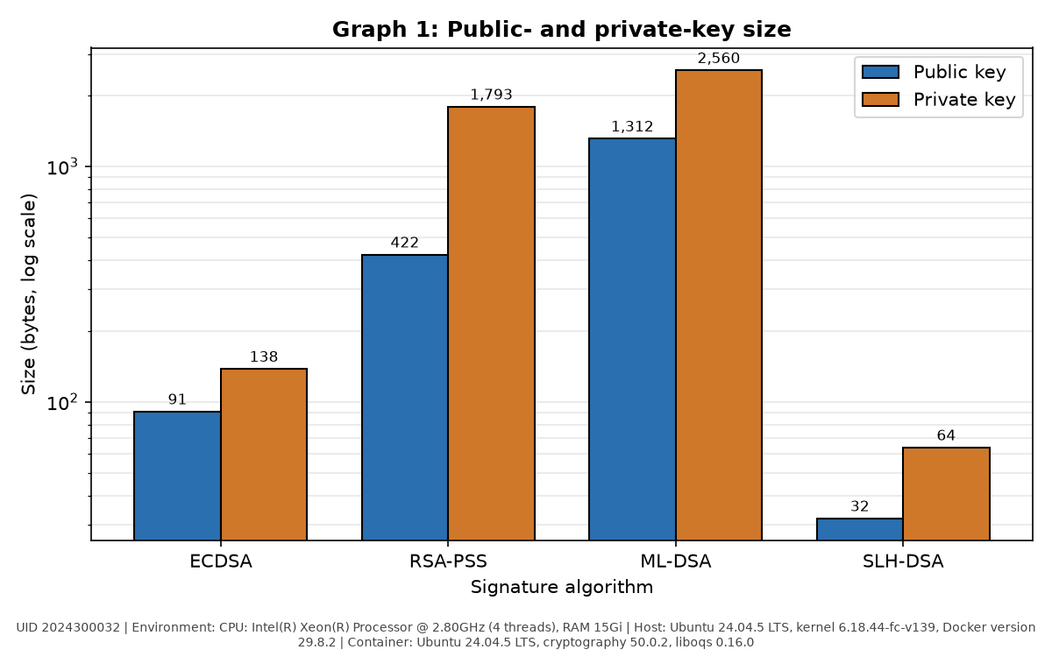
Graph 1: Public-key and private-key size (bytes, log scale). Environment: CPU: Intel(R) Xeon(R) Processor @ 2.80GHz (4 threads), RAM 15Gi; Host: Ubuntu 24.04.5 LTS, kernel 6.18.44-fc-v139, Docker version 29.8.2; Container: Ubuntu 24.04.5 LTS, cryptography 50.0.2, liboqs 0.16.0. UID 2024300032.
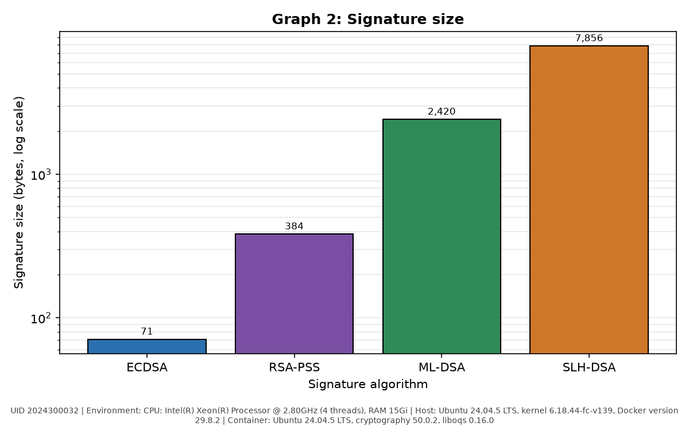
Graph 2: Signature size (bytes, log scale). Environment: CPU: Intel(R) Xeon(R) Processor @ 2.80GHz (4 threads), RAM 15Gi; Host: Ubuntu 24.04.5 LTS, kernel 6.18.44-fc-v139, Docker version 29.8.2; Container: Ubuntu 24.04.5 LTS, cryptography 50.0.2, liboqs 0.16.0. UID 2024300032.
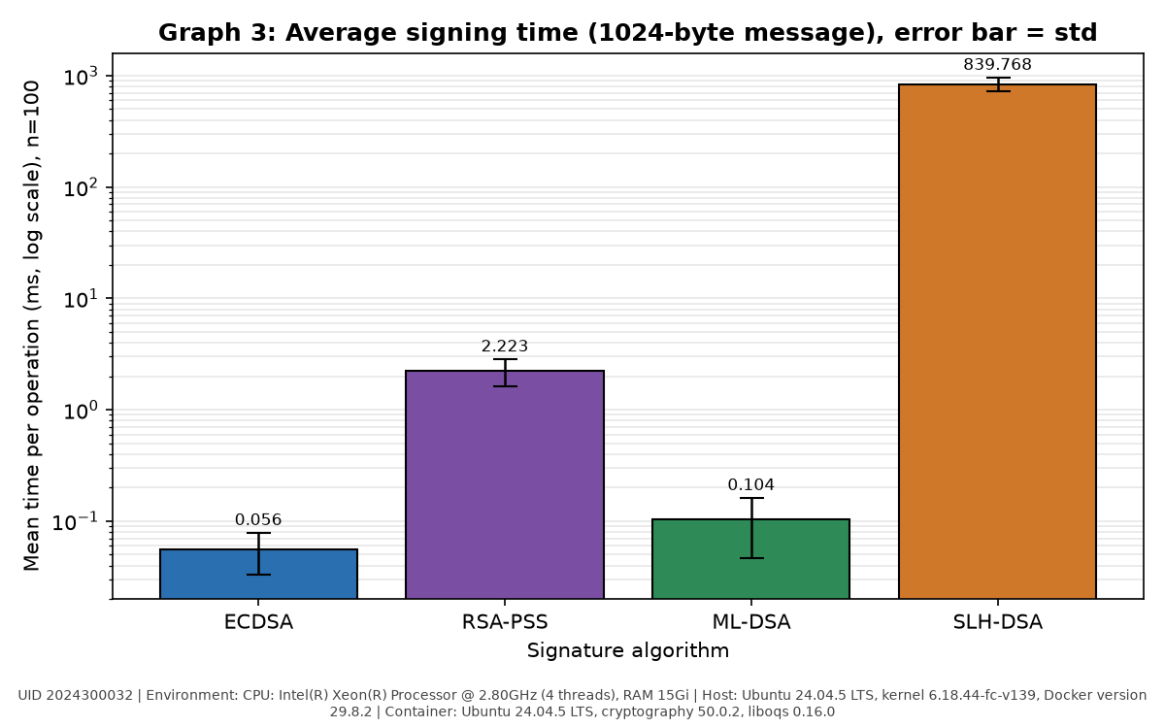
Graph 3: Average signing time (ms, log scale); error bar = standard deviation, n = 100. Environment: CPU: Intel(R) Xeon(R) Processor @ 2.80GHz (4 threads), RAM 15Gi; Host: Ubuntu 24.04.5 LTS, kernel 6.18.44-fc-v139, Docker version 29.8.2; Container: Ubuntu 24.04.5 LTS, cryptography 50.0.2, liboqs 0.16.0. UID 2024300032.
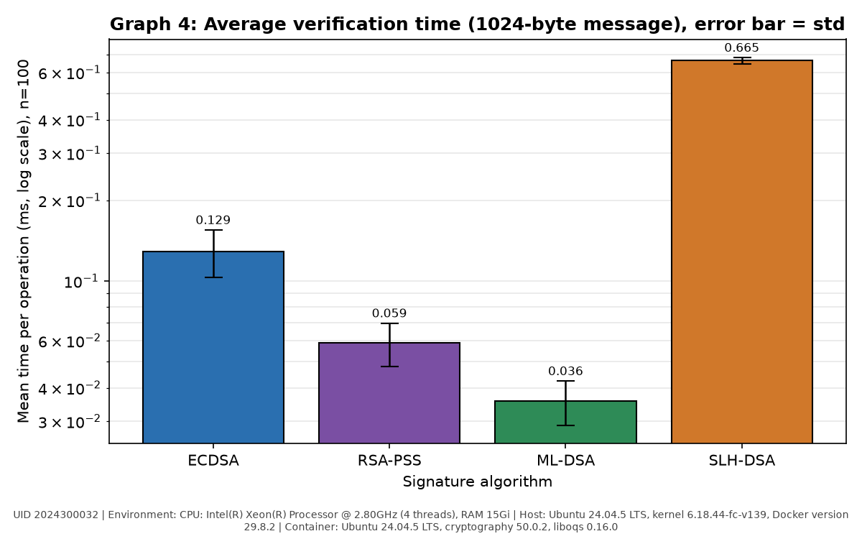
Graph 4: Average verification time (ms, log scale); error bar = standard deviation, n = 100. Environment: CPU: Intel(R) Xeon(R) Processor @ 2.80GHz (4 threads), RAM 15Gi; Host: Ubuntu 24.04.5 LTS, kernel 6.18.44-fc-v139, Docker version 29.8.2; Container: Ubuntu 24.04.5 LTS, cryptography 50.0.2, liboqs 0.16.0. UID 2024300032.
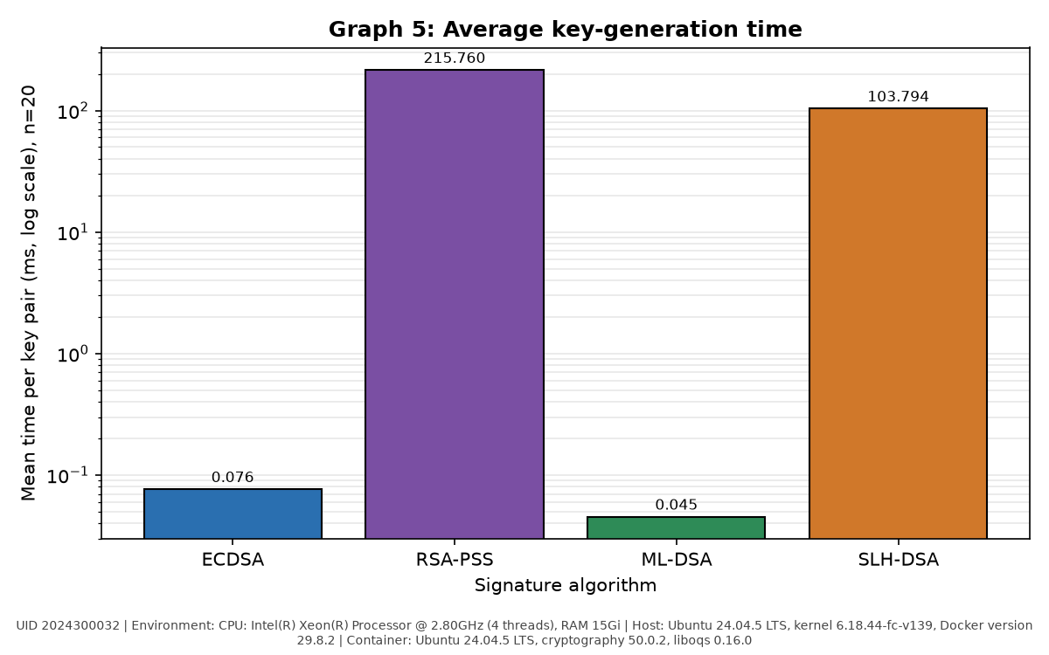
Graph 5: Average key-generation time (ms, log scale), n = 20. Environment: CPU: Intel(R) Xeon(R) Processor @ 2.80GHz (4 threads), RAM 15Gi; Host: Ubuntu 24.04.5 LTS, kernel 6.18.44-fc-v139, Docker version 29.8.2; Container: Ubuntu 24.04.5 LTS, cryptography 50.0.2, liboqs 0.16.0. UID 2024300032.
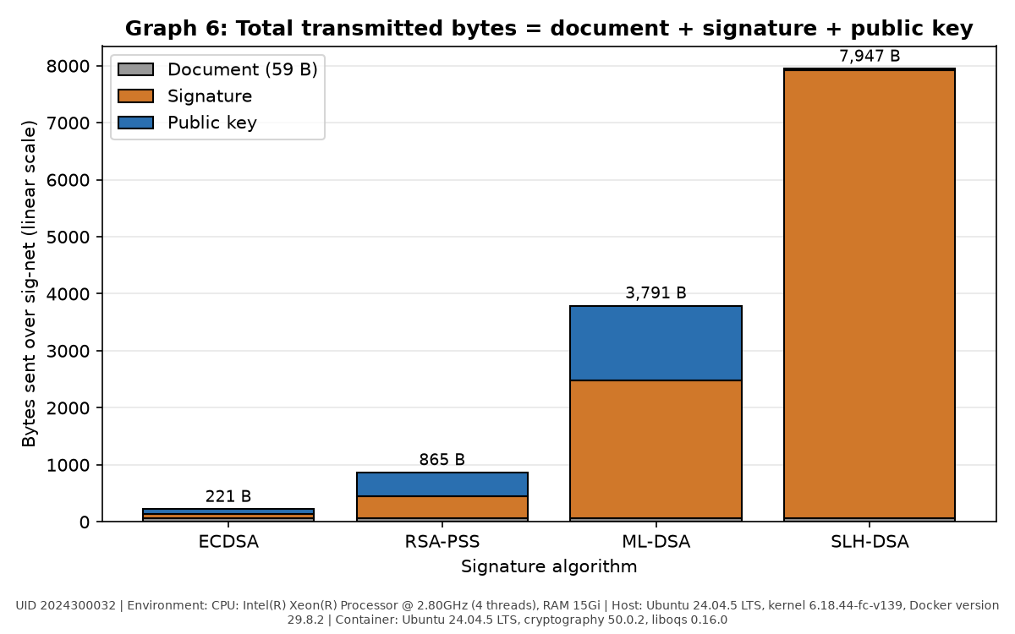
Graph 6: Total transmitted bytes = document + signature + public key. Environment: CPU: Intel(R) Xeon(R) Processor @ 2.80GHz (4 threads), RAM 15Gi; Host: Ubuntu 24.04.5 LTS, kernel 6.18.44-fc-v139, Docker version 29.8.2; Container: Ubuntu 24.04.5 LTS, cryptography 50.0.2, liboqs 0.16.0. UID 2024300032.
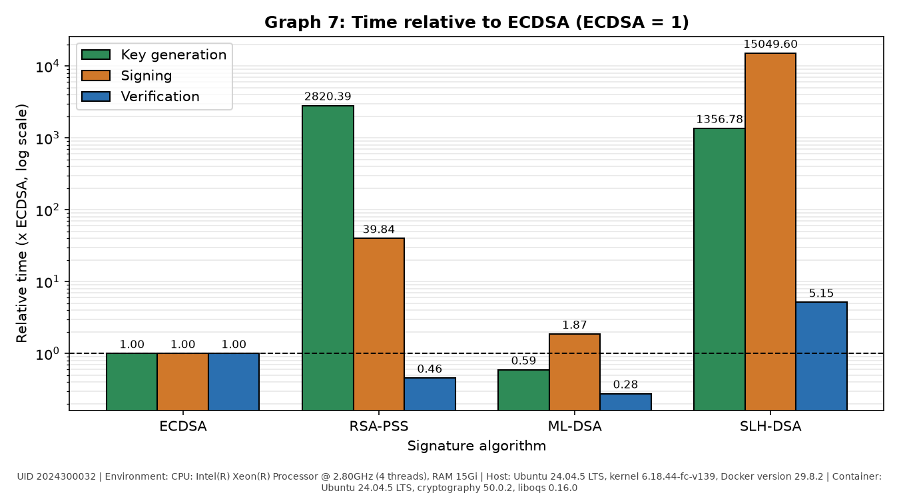
Graph 7 (extra): Sign, verify and key-generation time relative to ECDSA (ECDSA = 1, log scale). Environment: CPU: Intel(R) Xeon(R) Processor @ 2.80GHz (4 threads), RAM 15Gi; Host: Ubuntu 24.04.5 LTS, kernel 6.18.44-fc-v139, Docker version 29.8.2; Container: Ubuntu 24.04.5 LTS, cryptography 50.0.2, liboqs 0.16.0. UID 2024300032.

Table 5: Relative comparison with ECDSA as the baseline (measured value / ECDSA value)
Parameter | ECDSA | RSA-PSS | ML-DSA | SLH-DSA
Public key size | 1.0 | 4.64 | 14.42 | 0.35
Signature size | 1.0 | 5.41 | 34.08 | 110.65
Signing time | 1.0 | 39.84 | 1.87 | 15049.60
Verification time | 1.0 | 0.46 | 0.28 | 5.15
Key generation time | 1.0 | 2820.39 | 0.59 | 1356.78
Total transmitted bytes | 1.0 | 3.91 | 17.15 | 35.96

Table 6: Property comparison
Property | ECDSA | RSA-PSS | ML-DSA | SLH-DSA
Standard | FIPS 186-5 | RFC 8017, FIPS 186-5 | FIPS 204 (2024) | FIPS 205 (2024)
Security parameter / category | P-256 (secp256r1), ~128-bit | RSA-3072, ~128-bit | ML-DSA-44, NIST category 2 | SLH-DSA-SHA2-128s, NIST category 1
Mathematical basis | Elliptic-curve discrete logarithm | Integer factorisation | Module lattices (Module-LWE / SIS) | Hash functions only (hypertree of Merkle / FORS trees)
Resistant to Shor's algorithm? | No | No | Yes | Yes
Public key size (small / medium / large) | Small (91 B) | Medium (422 B) | Large (1312 B) | Small (32 B)
Signature size | Small (71 B) | Medium (384 B) | Large (2420 B) | Very large (7856 B)
Fastest operation | Signing (0.056 ms) | Verification (0.059 ms) | Verification (0.036 ms) | Verification (0.665 ms)
Slowest operation | Verification (0.129 ms) | Key generation (215.8 ms) | Signing (0.104 ms) | Signing (839.8 ms)
Maturity / deployment | Very mature; TLS, SSH, code signing, smart cards | Very mature (decades); PKI, TLS, document signing | New (2024); being rolled out, often in hybrid mode | New (2024), conservative SPHINCS+ design; firmware, root keys
Main advantage | Smallest keys and signatures, fast signing | Very fast verification, universal support | Quantum-safe and fast (fastest verification measured) | Quantum-safe, relies only on hash functions; 32 B public key
Main disadvantage | Broken by Shor; needs secure nonces | Broken by Shor; slow key generation, larger keys | Large public key and signature | Very slow signing, very large signature

Table 7: Which algorithm would you choose?
Scenario | Chosen algorithm | Justification
Signing a firmware image for a device that stays in the field for 15 years | SLH-DSA | Must outlive quantum computers; hash-only security is the most conservative, signing is rare and verification is cheap.
Authenticating a short sensor message on a very low-bandwidth link | ECDSA | Smallest overhead (71 B signature, 91 B key) and the data is short-lived.
Signing a TLS server certificate in 2026 on a general web server | ECDSA (P-256) | Universally supported, tiny handshake; certificates live < 1 year, with a planned move to hybrid ECDSA + ML-DSA.
Root key of a certificate authority that must remain trusted for 30 years | SLH-DSA | Rarely signs, so slow signing and large signatures are acceptable; security rests only on hash functions.
High-volume server that verifies millions of signatures per second | ML-DSA | Fastest verification measured (0.036 ms) and quantum-safe.

