**Media Release**

**Sentosa, Brewerkz team up to launch Singapore’s first**

**leisure destination-inspired beers, Islander Brew**

* *Four unique craft beers inspired by edible plants found in Sentosa – cacao, lime, jasmine, nutmeg*
* *Named after island’s landmarks, Islander Brew gives guests a fresh take on Sentosa experience*
* *Islander Brew marks Singapore’s first carbon-neutral beers*

**Singapore, 26 November 2020 –** The Sentosa Development Corporation (SDC), in collaboration with Brewerkz, Singapore’s original craft brewery, launch Islander Brew, the country’s first leisure destination-inspired beers.

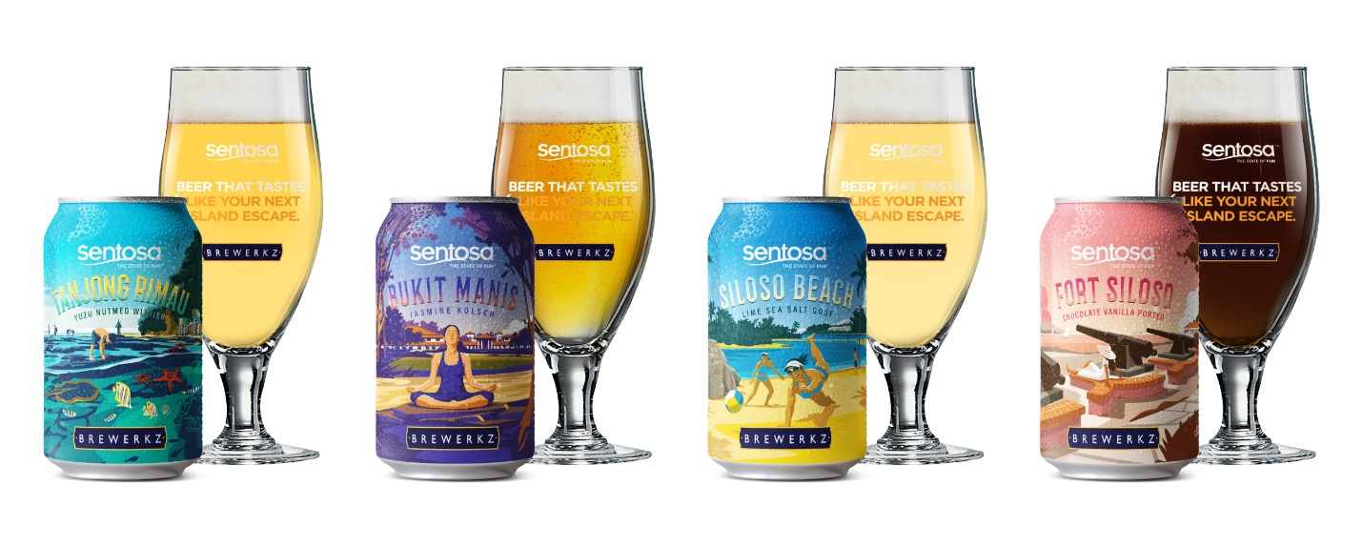

A series of four exciting flavours, each craft beer features a unique taste inspired by edible plants found in Sentosa - cacao, lime, jasmine and nutmeg - and are named after the island’s landmarks - Siloso Beach, Tanjong Rimau, Fort Siloso, Bukit Manis. The landmarks were chosen to represent leisure offerings that embody one of the four themes under Sentosa’s ‘Make Time for a Holiday’ campaign – Island Life, Heritage Discovery, Wellness Escape, and Nature Adventure:

* Siloso Beach: Renowned for being the hippest beach on Sentosa, Siloso Beach is the place to head to for thrills and fun, with its golden sands lined with water sports and the trendiest bars and restaurants. This beer is a refreshing gose brewed with sea salt and kaffir lime.
* Tanjong Rimau: One of Singapore’s best-kept secrets, Tanjong Rimau at the western tip of Sentosa is home to one of the region’s most unique rock formations, and is a coastal headland rich in marine life, natural reefs and even hidden caves. This classic wheat beer has hints of nutmeg and coriander and a citrusy yuzu aroma.
* Fort Siloso: Built by the British in 1879, Fort Siloso is Singapore’s last remaining preserved coastal fort. An homage to the heritage of the British base on Sentosa, this English-styled Porter is velvety in texture with a rich chocolatey flavour and hints of coffee and vanilla notes.
* Bukit Manis: Home to some of Sentosa’s wellness spas and lush nature, Bukit Manis is a gem for those looking to indulge in some true relaxation and pampering. This Jasmine Kolsch brew is crisp, sparkling and slightly fruity with the aromatic hint of jasmine.

SDC and Brewerkz have also joined hands to make the Islander Brew Singapore’s first carbon neutral beers. This effort is part of SDC’s broader decarbonisation roadmap for Sentosa, and Brewerkz’s aspirations to create increasingly sustainable products in its business activities. This initiative illustrates how individuals and organisations can make environmentally sustainable choices and reduce one's carbon footprint.

“We are thrilled to partner Brewerkz to launch the Islander Brew, as part of our collaboration with the industry to roll out over 50 new and diverse offerings under our Make Time for a Holiday campaign. Together, the beers will give guests a fresh take on the Sentosa getaway. Choose to unwind with the Islander Brew at some of Sentosa’s dining establishments or in the comfort of your home. Alternatively, take an island getaway in Sentosa with the campaign’s other offerings,” said Mira Bharin, Director of Brand, Marketing and Communications, SDC.

“This is our first destination-inspired beer collection, and marks our biggest and most comprehensive collaboration ever. We are proud to partner Sentosa, and grateful for the opportunity to showcase our capabilities as a local home-grown brand for Singapore’s iconic leisure destination,” commented Tan Wee Han, Owner and CEO of Brewerkz. “With Islander Brew, we hope to enhance visitors’ experience when they visit the island, and offer them a small piece of the Sentosa holiday vibe – all in a beverage that can be enjoyed anywhere, anytime.”

**Where to get your Islander Brew**

Sentosa’s guests will be the first to get their hands on the Islander Brew. The craft beer will be made available in individual cans, four-packs and other variations. From 1 December 2020, the beers will be rolled out at participating Sentosa food and beverage establishments, and subsequently hit the shelves at participating supermarkets and online retail channels from 7 December 2020. The Islander Brew will be available for one year, and guests can look forward to a series of exciting activities alongside its roll-out, including contests with Sentosa staycations and Sentosa Fun Passes up for grabs. Please refer to **Annex A** for full list of distribution channels.

Brewerkz and Islander Brew are part of ‘Made With Passion’, a joint initiative by the Singapore Brand Office and Singapore Tourism Board, supported by Enterprise Singapore. ‘Made With Passion’ is a national marketing initiative to promote consumer awareness and appreciation for local lifestyle brands by showcasing the many facets of passion that go into creating the products enjoyed today.

For more information on Sentosa’s Islander Brew, please visit [www.sentosa.com.sg/sentosabeer](http://www.sentosa.com.sg/sentosabeer) or refer to **Annex B**.

- END –

**About Sentosa**

Sentosa is Asia’s leading leisure destination and Singapore’s premier island resort getaway, located within 15 minutes from the central business and shopping districts. The island resort is managed by Sentosa Development Corporation, which works with various stakeholders in overseeing property investments, attractions development, and operation of the various leisure offerings and management of the residential precinct on the island.

The 500-hectare island resort is home to an exciting array of themed attractions, award-winning spa retreats, lush rainforests, golden sandy beaches, resort accommodations, world-renowned golf courses, a deep-water yachting marina and luxurious residences – making Sentosa a vibrant island resort for business and leisure. Making Sentosa its home, too, is Singapore’s first integrated resort, Resorts World Sentosa, which operates South East Asia’s first Universal Studios theme park.

Situated on the eastern end of Sentosa Island is Sentosa Cove, an exclusive oceanfront and residential enclave bustling with some 2,000 homes, romantic quayside restaurants, retail and specialty shops. The Island is also proud to be home to Sentosa Golf Club and its two acclaimed golf courses, The Serapong and The New Tanjong. Sentosa Golf Club hosts the SMBC Singapore Open and the HSBC Women’s World Championship, featuring some of the world’s best golf professionals.

Welcoming a growing number of local and international guests every year, Sentosa is an integral part of Singapore’s goal to be a global destination to work, live and play. For more information, please visit: [www.sentosa.com.sg](http://www.sentosa.com.sg).

Image result for instagram iconhttp://www.rwsentosa.com/Portals/0/RWS/images/btn_twitter.pnghttp://www.rwsentosa.com/Portals/0/RWS/images/btn_fb.png /SentosaOfficial @sentosa_island #thestateoffun

**About Brewerkz**

Brewerkz kick-started Singapore's craft beer story in 1997. Bringing full-flavoured fun to the local indie beverage scene, the constant flow of tasty experimental beers is a product of their love for exploration and a passion for the artisanal craft. As a true original, this home-grown brand is dedicated to creating exciting experiences to tickle the senses of craft beer lovers anywhere in the world.

Brewerkz operates multiple restaurants, a 9,000 sqft standalone brewery, brew and distribute an

extensive line-up of craft beverages, and have a strong presence at major at large-scale

outdoor events.

Brewerkz is part of the Easy and Light Group which owns Crystal Wines, distributes Fiji Water and operates a portfolio of Mexican and Japanese restaurants.

**ANNEX A – List of distribution channels for Islander Brew**

|  |  |
| --- | --- |
| **On-island** | **Off-island** |
| **F&B establishments**   * Arbora Hilltop Garden & Bistro * Dusk Restaurant & Bar * Golfer’s Terrace * Harry’s * LeBar, Sofitel Singapore Sentosa Resort & Spa * Mykonos on the Bay * Panamericana * Rock Bar Burger & Steakhouse * SolePomodoro Trattoria Pizzeria * The Cliff, Sofitel Singapore Sentosa Resort & Spa * Trapizza * Two Chefs Bar | **Retailers**   * Cheers * Cold Storage * Fairprice Finest * Fairprice Xtra |
| **Retail**   * Cable Car Gift Shop, Faber Peak * Cable Car Gift Shop, Imbiah Lookout * Sentosa FUN Shop, Beach Plaza | **E-tailers**   * Shopee * Redmart * KrisShop |
|  | **Brewerkz F&B outlets and e-store**   * [Brewerkz outlets](https://brewerkz.com/restaurant/outlets/?gclid=CjwKCAiAkan9BRAqEiwAP9X6UVg-aJrjb9ojEcfRi0zjn2xh7y-ijrd0jUzFks9BKCLQFp2D43-fDxoCthIQAvD_BwE) * Brewerkz e-store: <http://store.brewerkz.com/> |

*This list is accurate as of distribution.

**ANNEX B – Details of Islander Brew**

|  |  |
| --- | --- |
| **Islander Brew (330ml)** | **Description** |
| Siloso Beach (Lime Sea Salt Gose) | Renowned for being the hippest beach on Sentosa, Siloso Beach is a place to head to for thrills and fun, with a wide sandy beach lined with water sports and the trendiest bars and restaurants. A refreshing Gose brewed with sea salt and kaffir lime. Zesty flavours and hints of herbal sourness and salt. |
| Tanjong Rimau (Yuzu Nutmeg Witbier) | One of Singapore’s best-kept secrets, Tanjong Rimau is a coastal headland at the western tip of Sentosa and home to one of the region’s most unique rock formations. Rich in marine life, natural reefs and even hidden caves -- perfect for an adventure with nature. This is a classic wheat beer with hints of nutmeg and coriander and a citrusy yuzu aroma. |

|  |  |
| --- | --- |
| Fort Siloso (Chocolate Vanilla Porter) | Built by the British in 1879, Fort Siloso is now our nation’s last remaining preserved coastal fort. It was designed to ward off a seafront attack. This English-styled Porter is an homage to the heritage of the British base on Sentosa. Velvety in texture with a rich chocolatey flavour and hints of coffee and vanilla notes. |
| Bukit Manis (Jasmine Kolsch) | Inspired by the lush nature and wellness sanctuaries of Sentosa - Bukit Manis is the path to rejuvenation away from the bustling city life. Embark on a journey through hidden gems and indulge in true relaxation and pampering. Crisp, sparkling and slightly fruity with the aromatic hint of jasmine. |