**Qlik Sense**

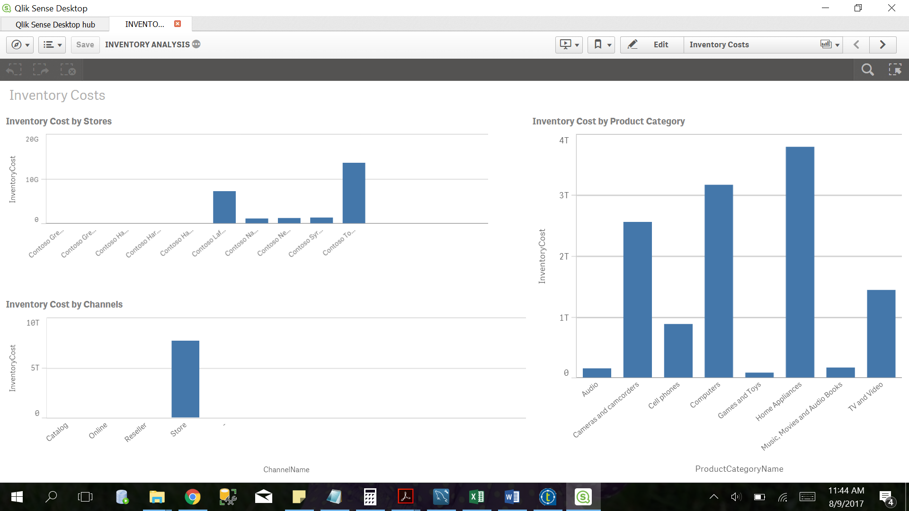

Figure : Inventory Costs by store, channel and product category

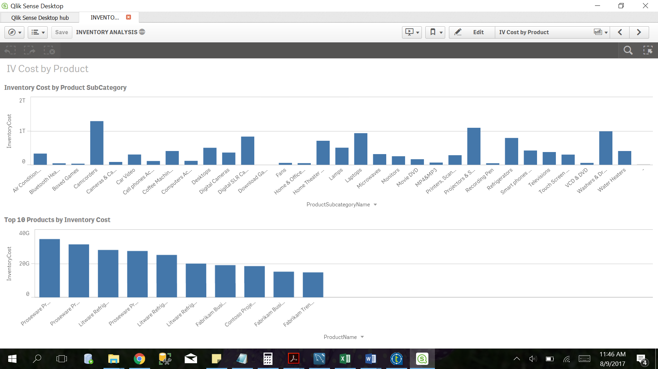

Figure : Inventory analysis by product subcategory

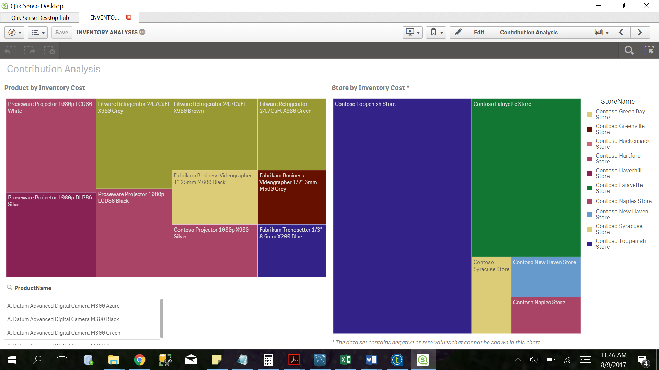

Figure : Contribution Analysis by inventory cost

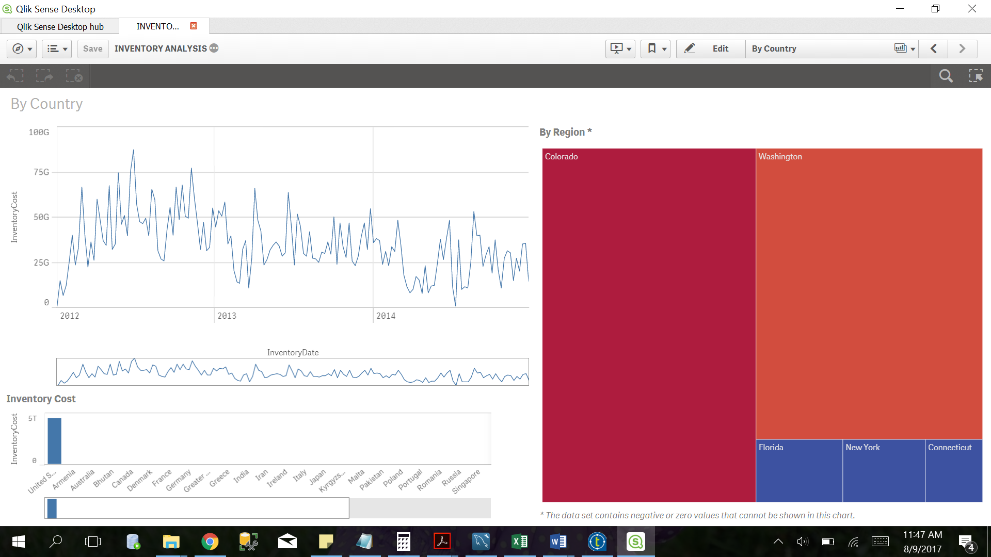

Figure : Inventory Analysis by country and region

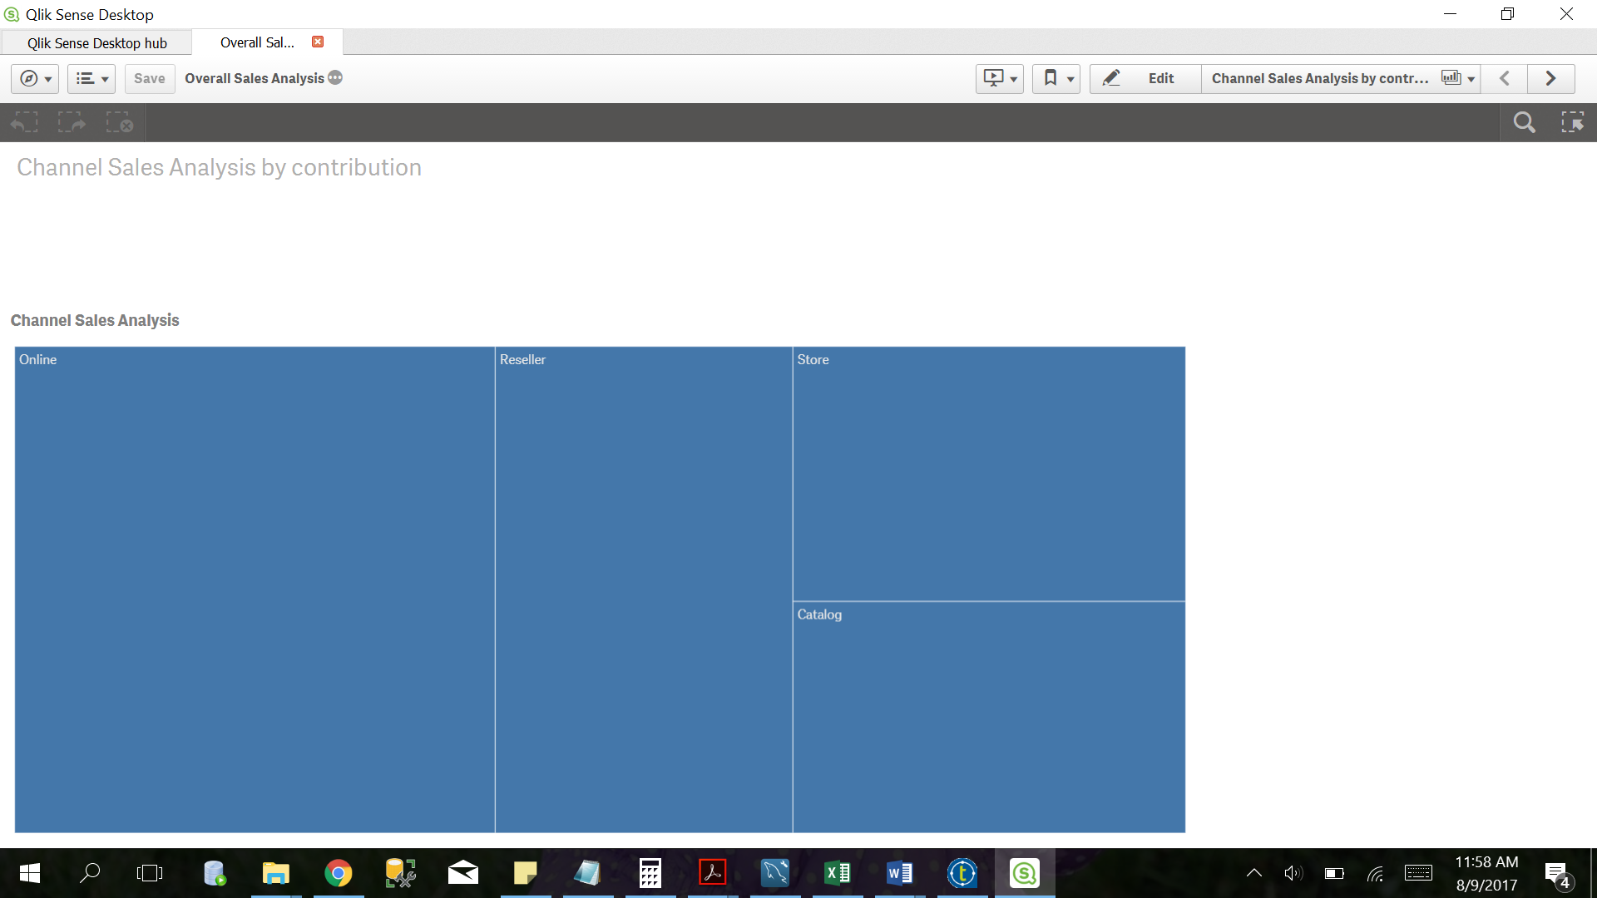

Figure : Sales Analysis by contribution

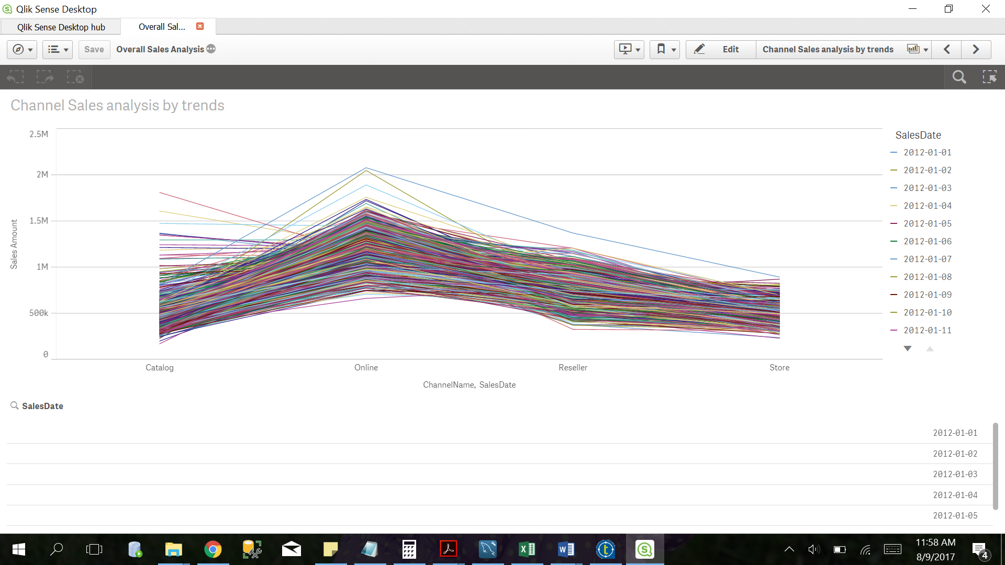

Figure : Sales Analysis by trends

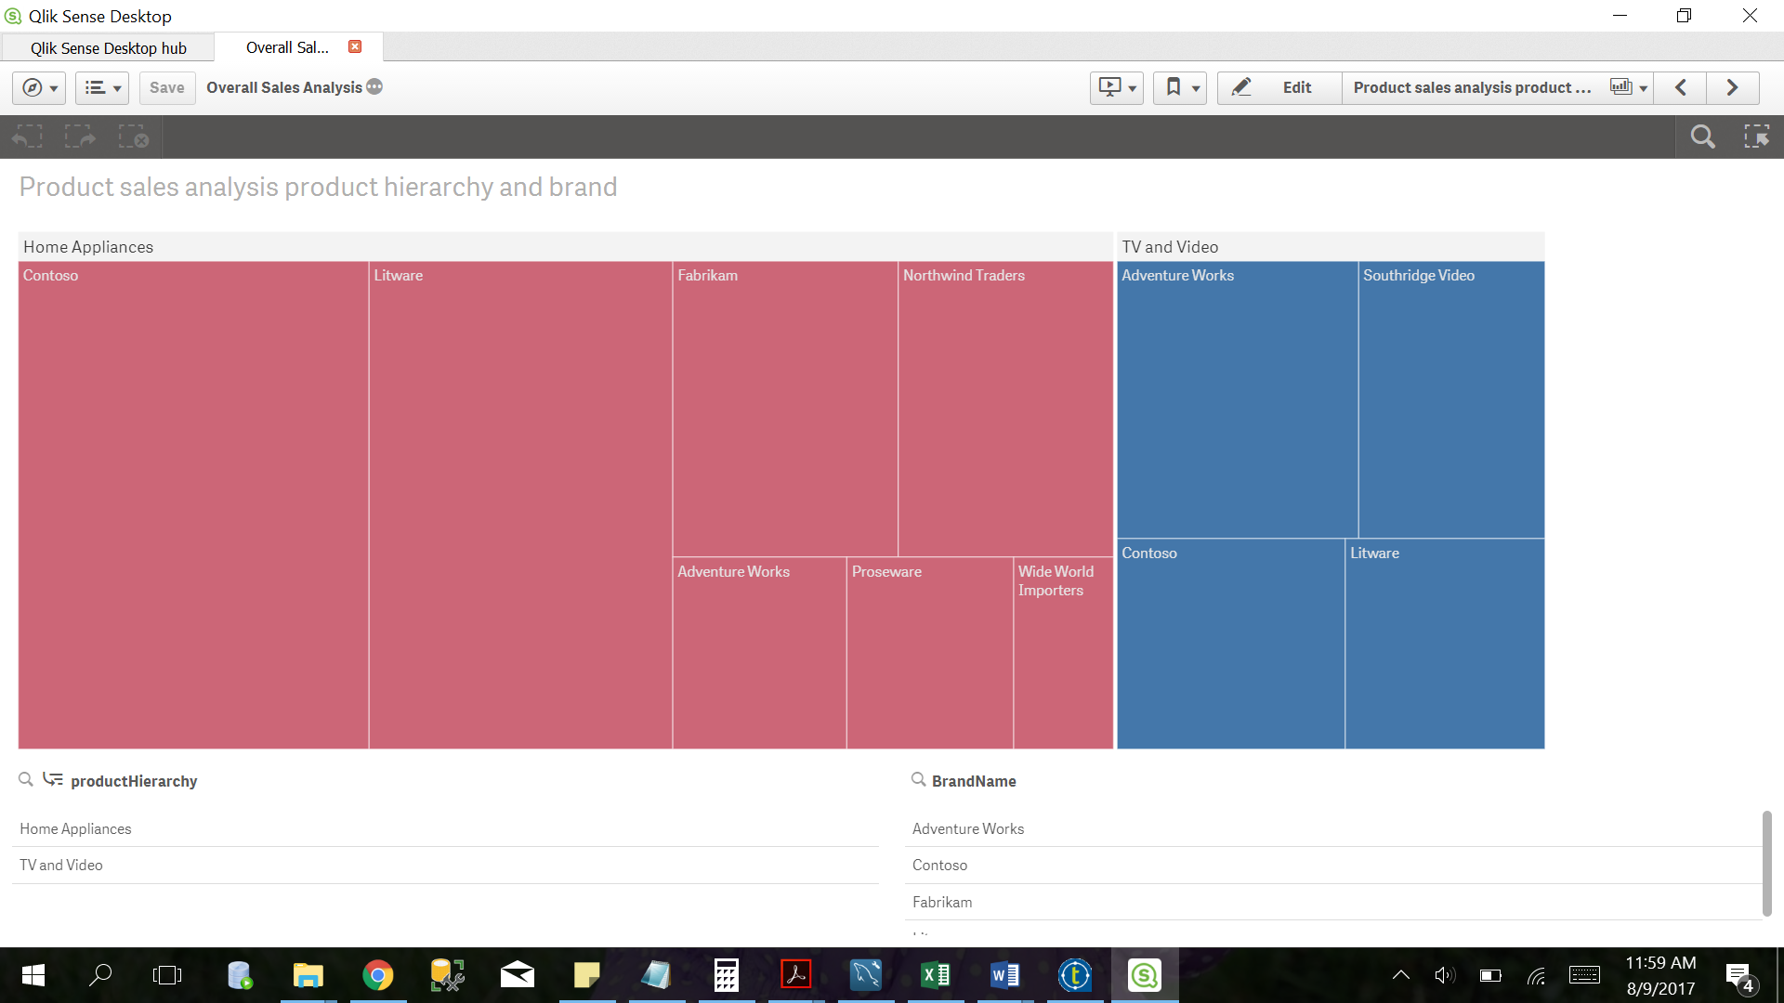

Figure : Sales analysis by product hierarchy and brand

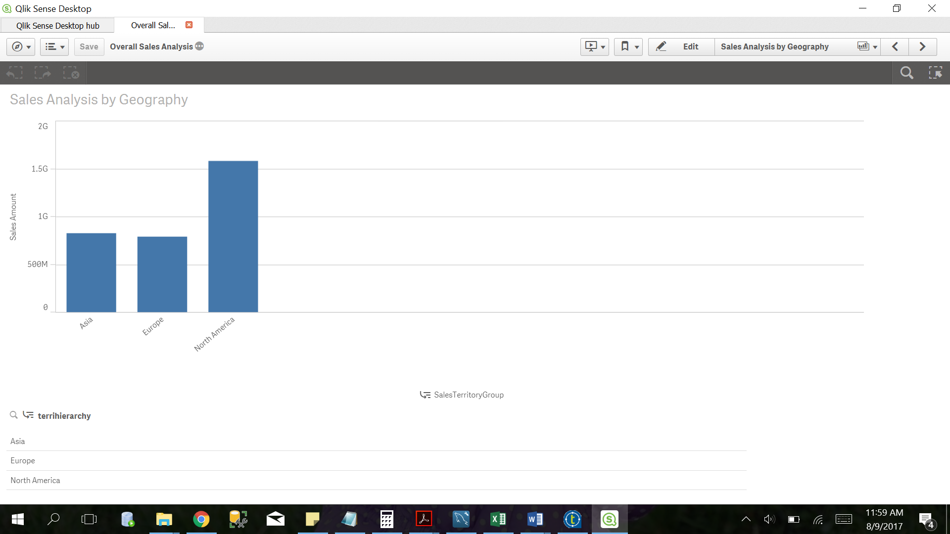

Figure : Sales Analysis by geography

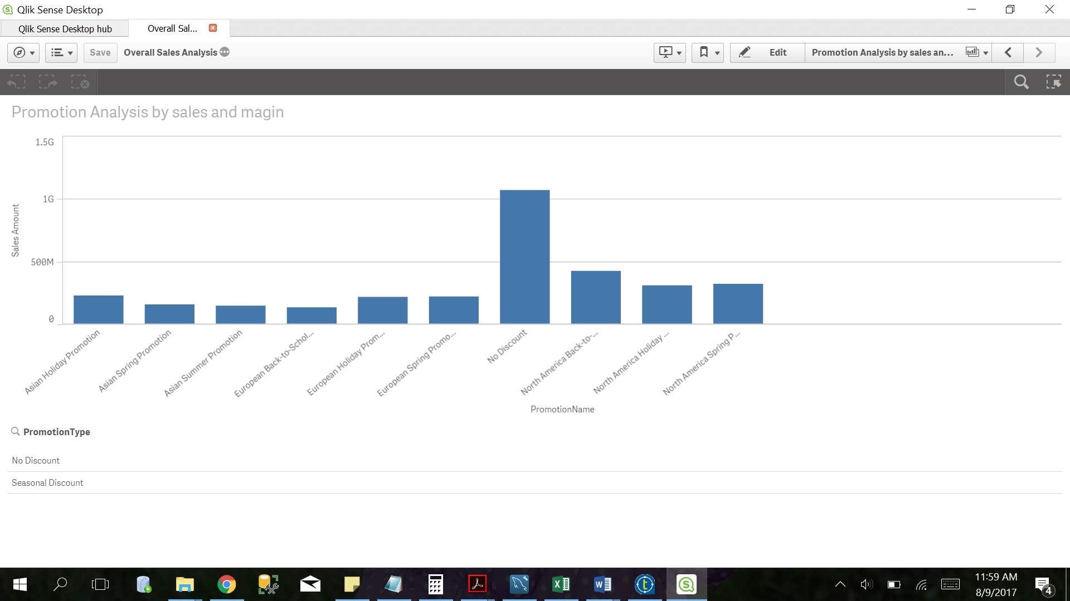

Figure : Promotion Analysis by sales and margin

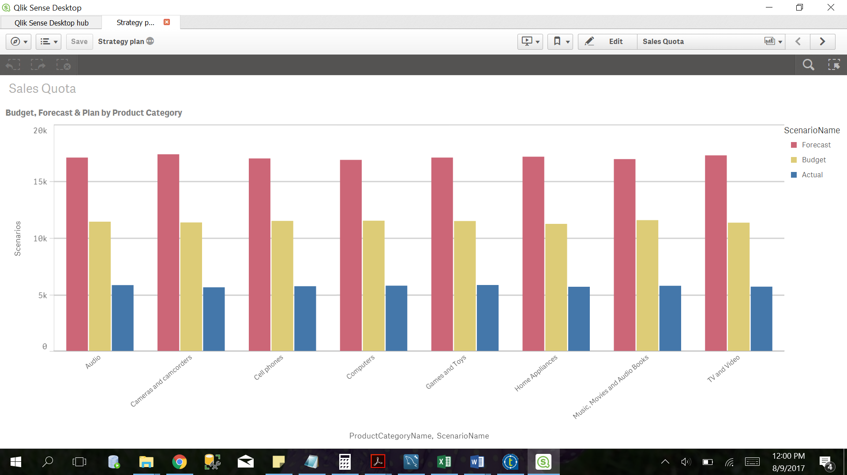

Figure : Strategy Plan analysis by product category

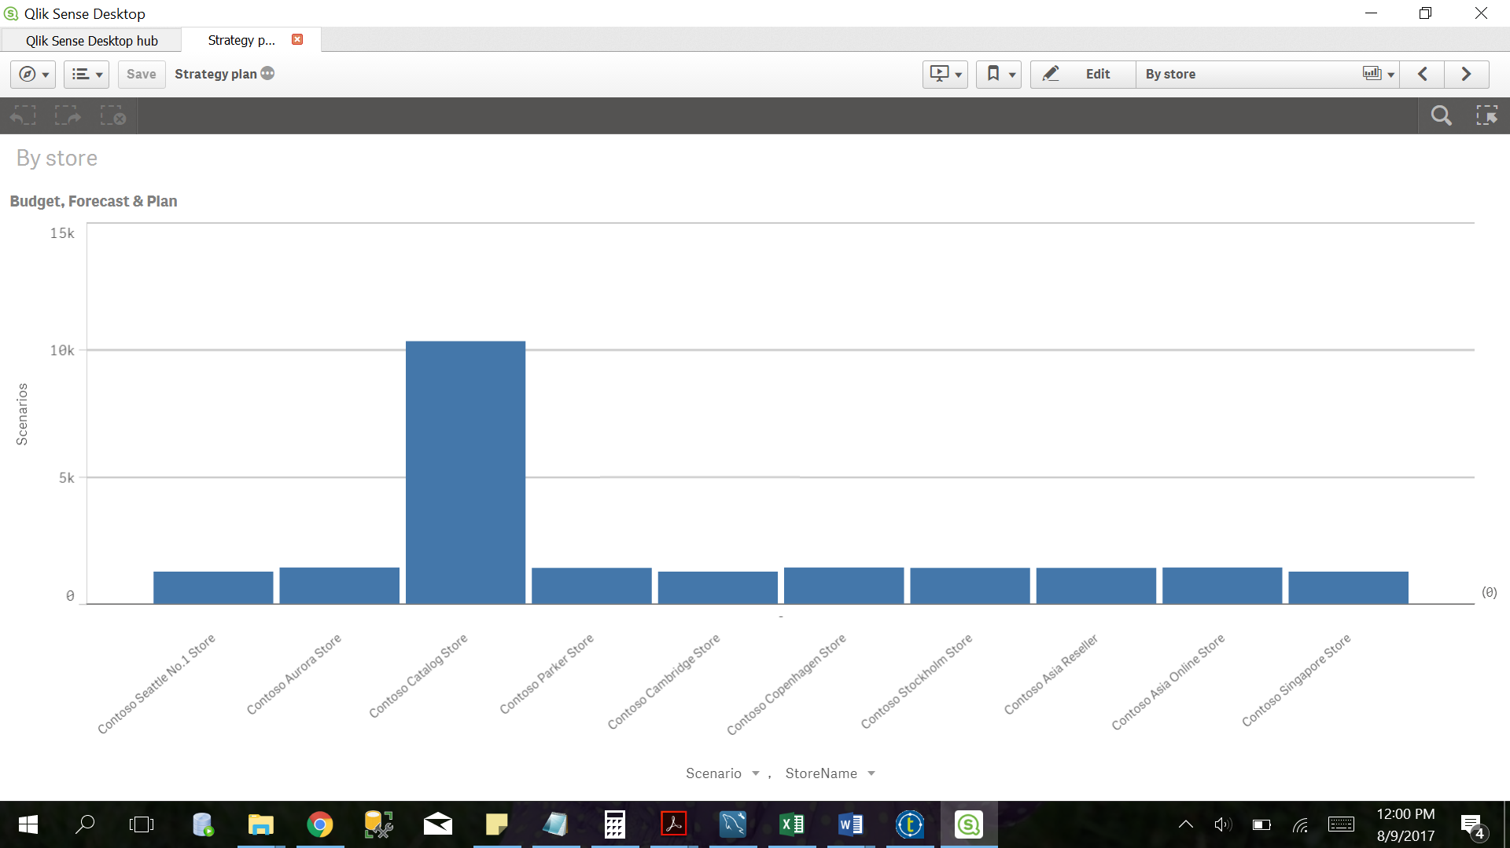

Figure : Strategy Analysis by store

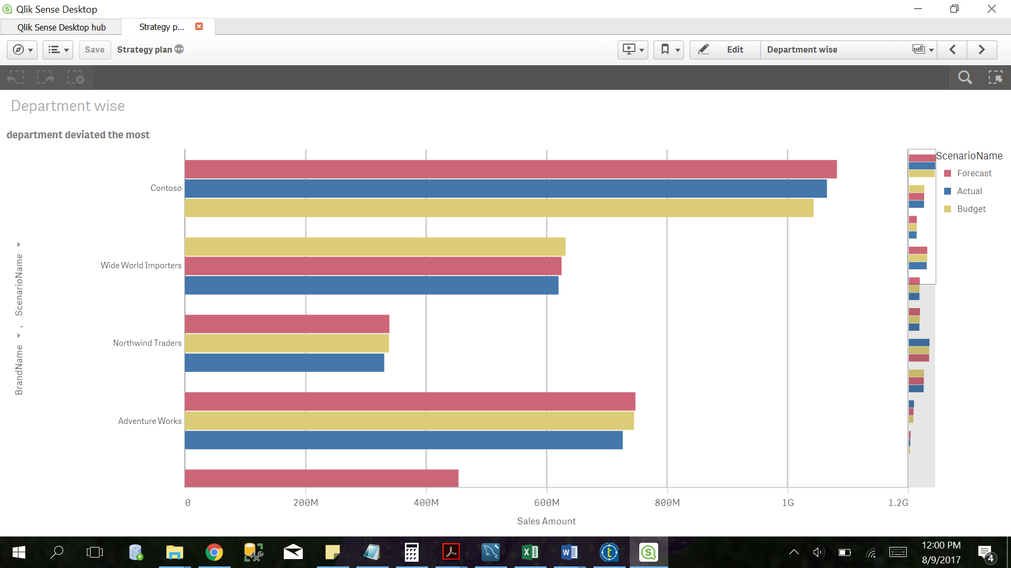

Figure : Strategy Analysis by department

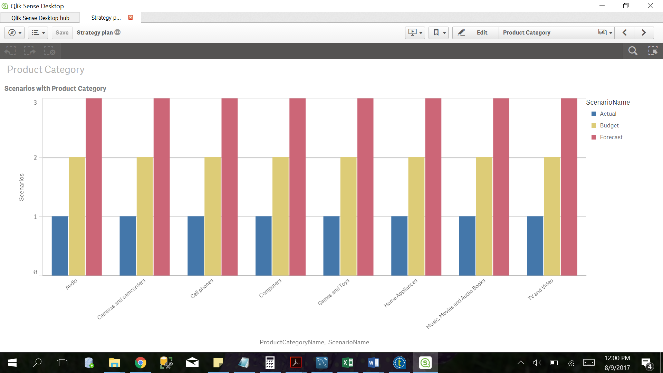

Figure : Strategy Analysis by scenarios

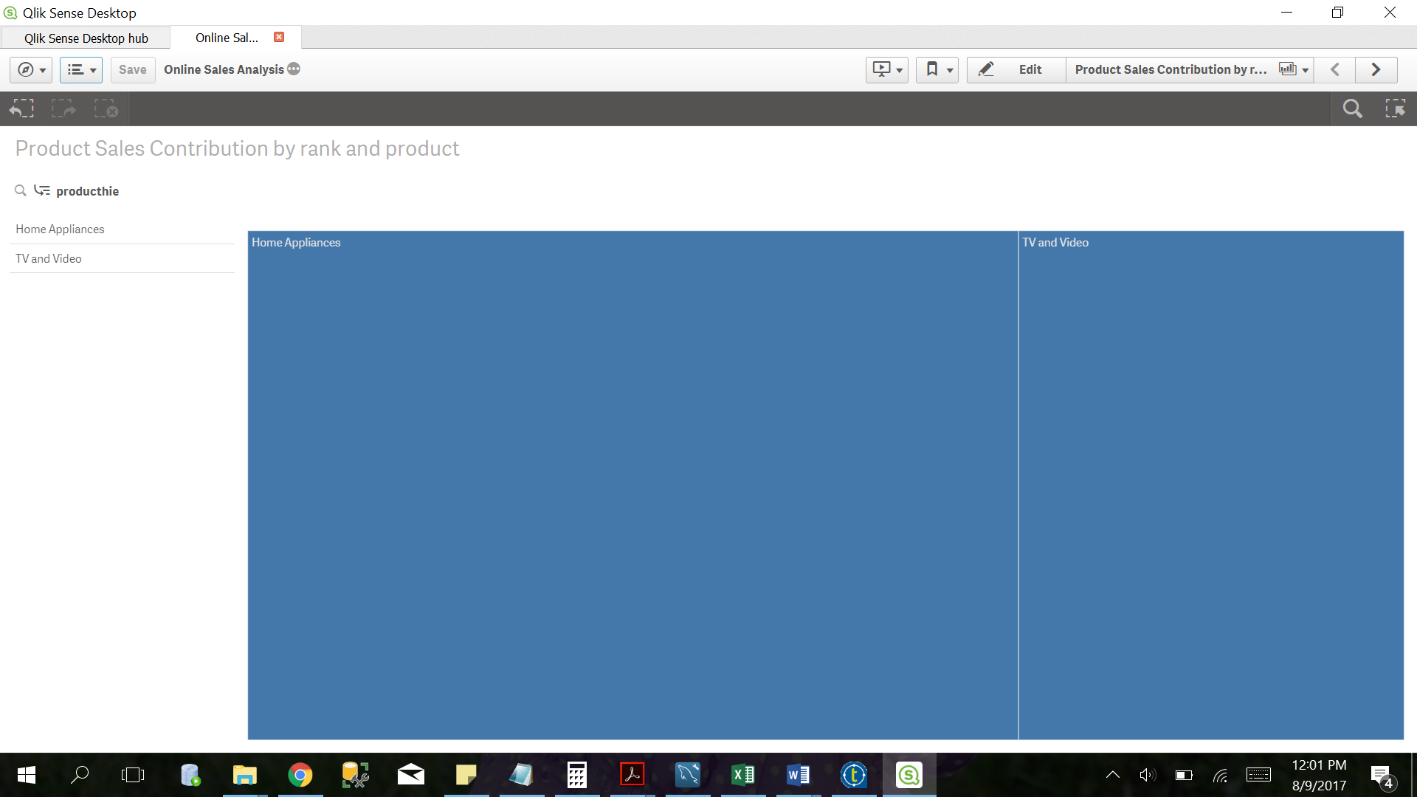

Figure : Online Sales Analysis by rank

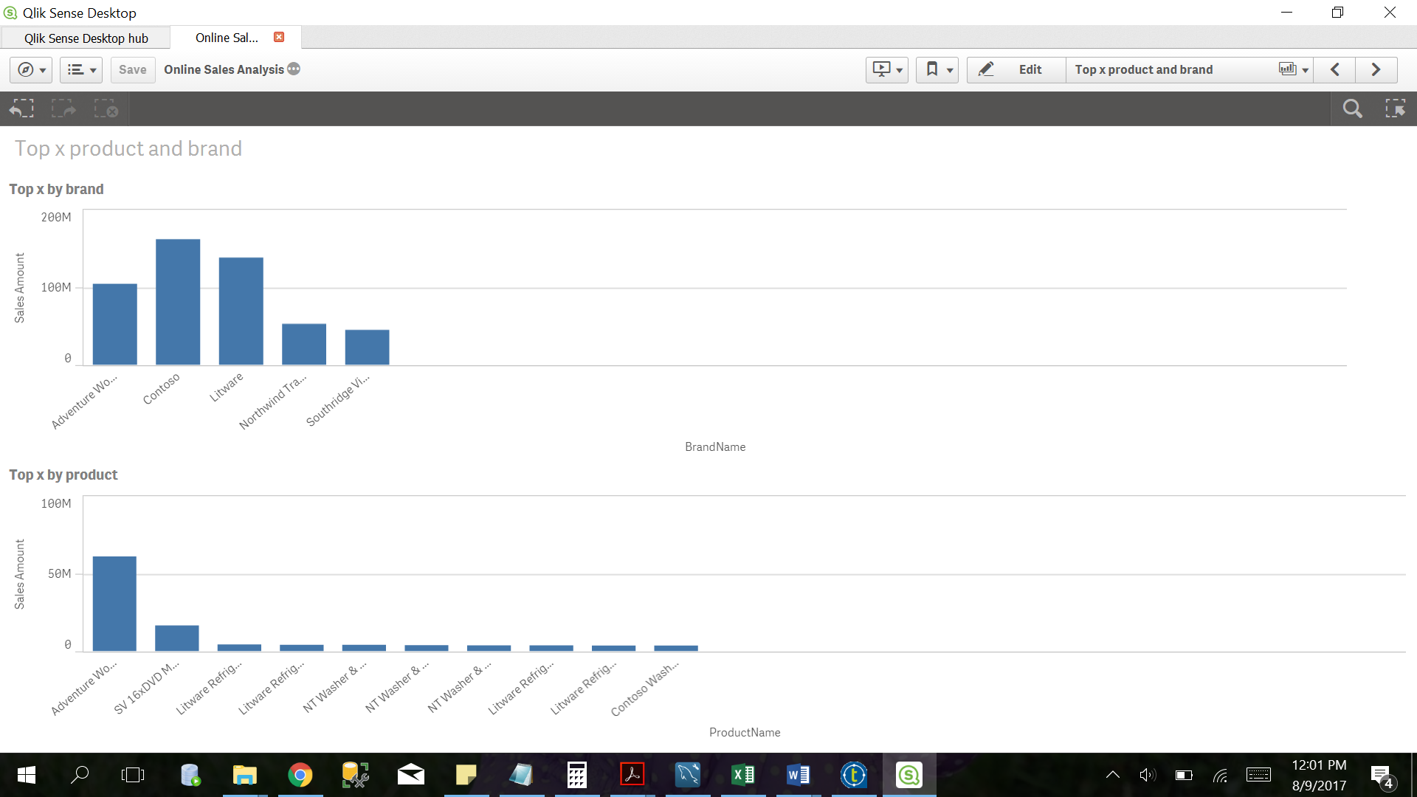

Figure : Online Analysis by product

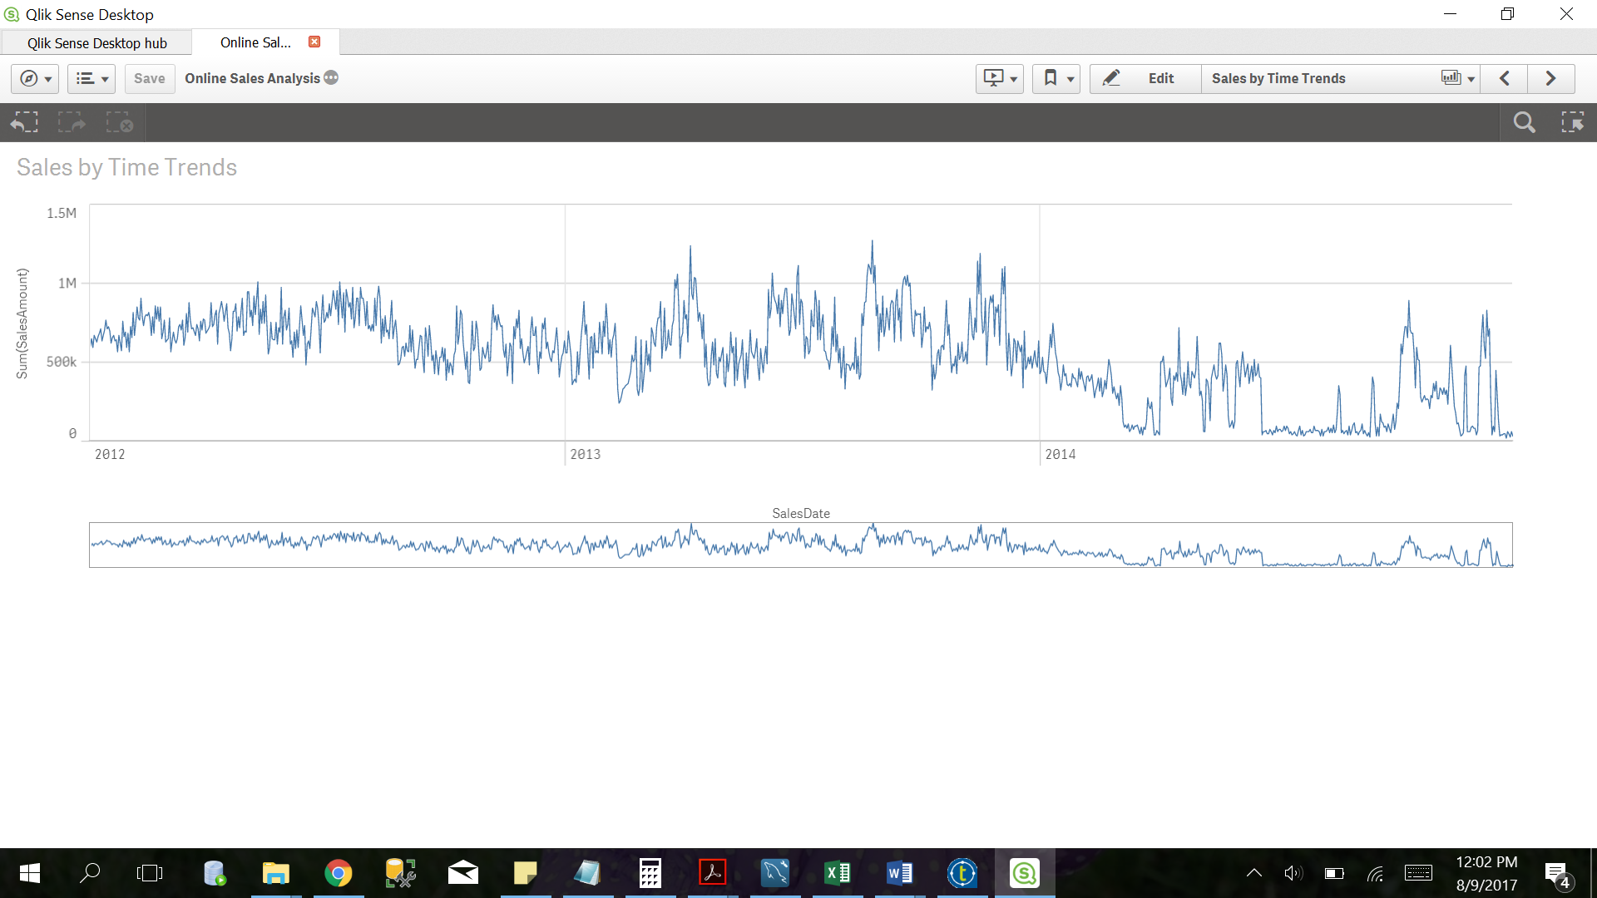

Figure : Online Sales Analysis by time trends

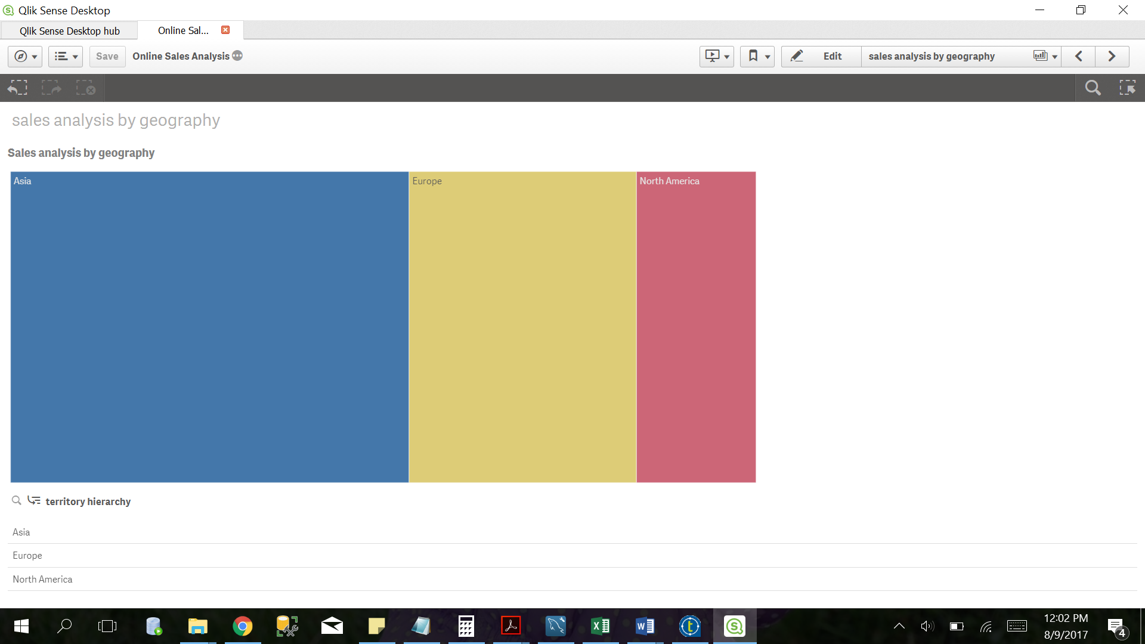

Figure : Online Sales Analysis by geography

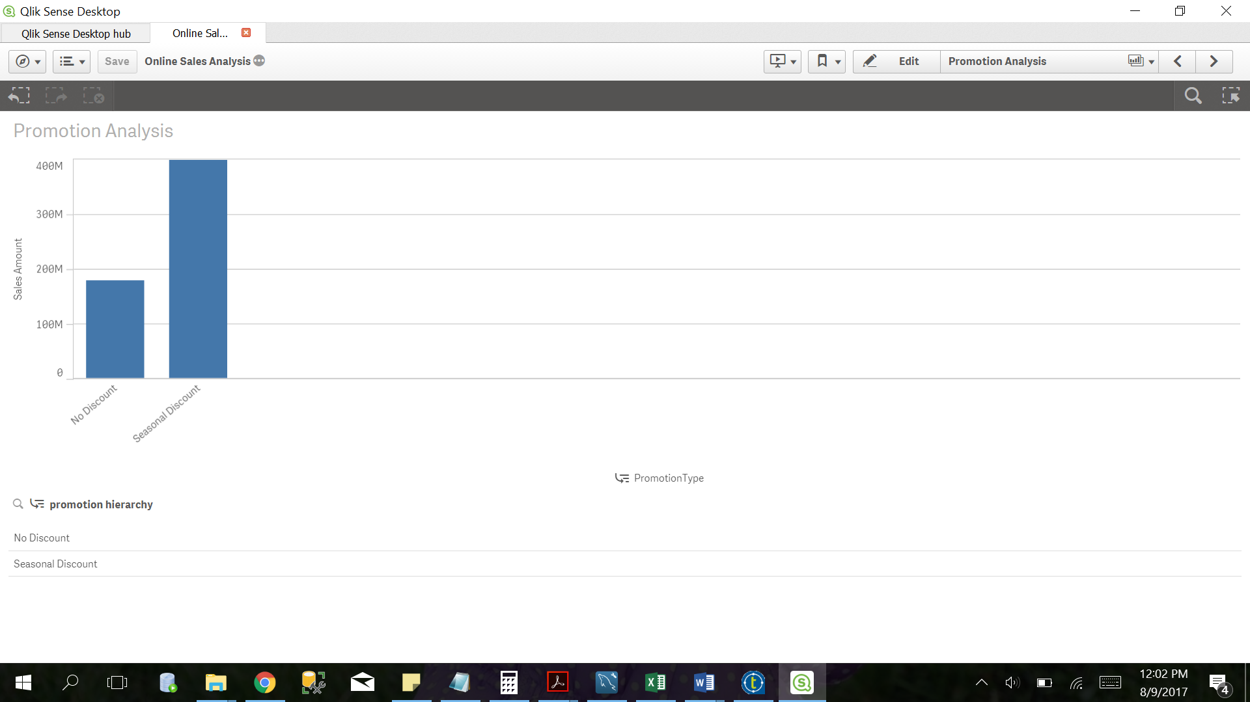

Figure : Promotion Analysis by discount