

Customer Retention

Submitted by:

Anusha K

**INTRODUCTION**

* Business Problem Statement

Customer satisfaction has emerged as one of the most important factors that guarantee the success of online store; it has been posited as a key stimulant of purchase, repurchase intentions and customer loyalty. A comprehensive review of the literature, theories and models have been carried out to propose the models for customer activation and customer retention. Five major factors that contributed to the success of an e-commerce store have been identified as: service quality, system quality, information quality, trust and net benefit. The research furthermore investigated the factors that influence the online customers repeat purchase intention. The combination of both utilitarian value and hedonistic values are needed to affect the repeat purchase intention (loyalty) positively. The data is collected from the Indian online shoppers. Results indicate the e-retail success factors, which are very much critical for customer satisfaction.

* Conceptual Background of the Domain Problem

Online Retail has become very trendy in the recent past years and huge number of People are getting attracted towards the online shopping all the time. Online Shopping has become very simpler and reachable to common man due to the emerge of new mobile phones and the number of internet users are also growing at a higher rate everywhere. Its easier and more variety of products are available in online retail compared to the physical shopping. E-stores usually offers them the convenience, variety of products, availability round the clock, flexible pricing, and seasonal offers-discounts on each of the products. This aspect attracts more and more customers towards the online shopping.

Several researchers have attempted to identify the factors necessary for online retail business success. Studies have mostly emphasized on creating value for customer, managing the customers online, improvement of e-retail service quality, e-retail strategy, customer retention and website quality. Repeat customer purchase resulting from a long-standing loyalty positively affects an e-retailer growth and profitability. Numerous studies have concluded that maintaining a long-standing customer loyalty is a vital determinant of success of an e-retailer.

**Analytical Problem Framing**

For this project, the data is collected from the Indian online shoppers. Results indicate the e-retail success factors, which are very much critical for customer satisfaction.

The dataset contains set of 71 questionnaires which is a customer satisfaction survey. The data was collected from the Indian online shoppers. All the datapoints are of object type. Below is the snapshot of the data.

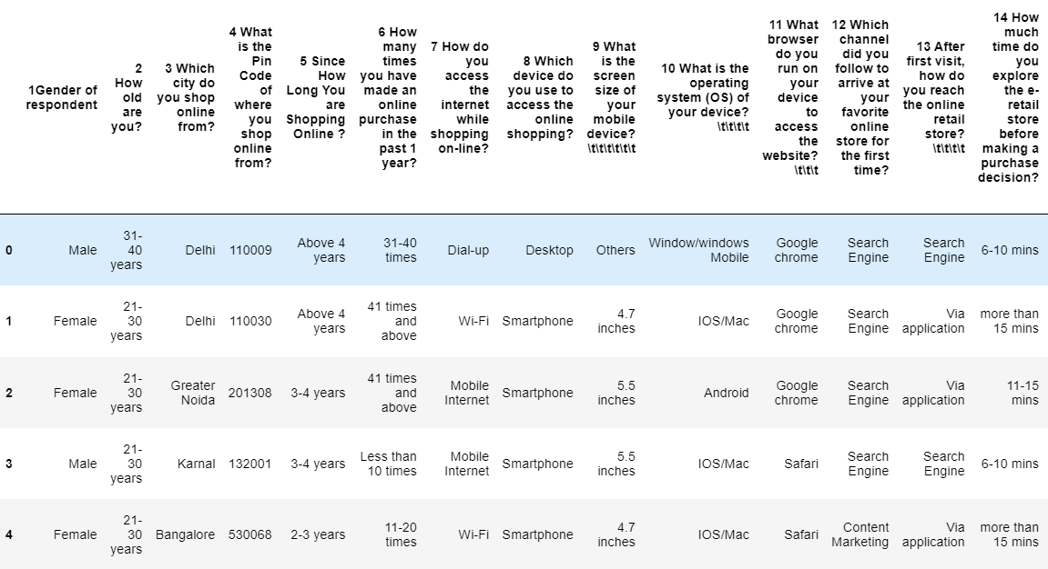

All the data points are of categorical variables, describe method describes the number of categories and the most frequent value from categorical variable. The data set does not have any missing values.  
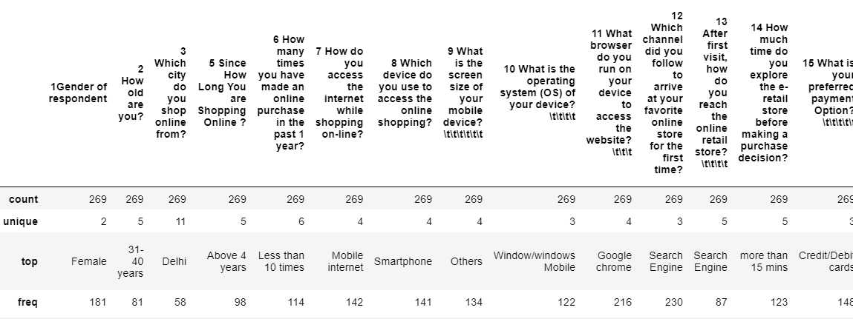

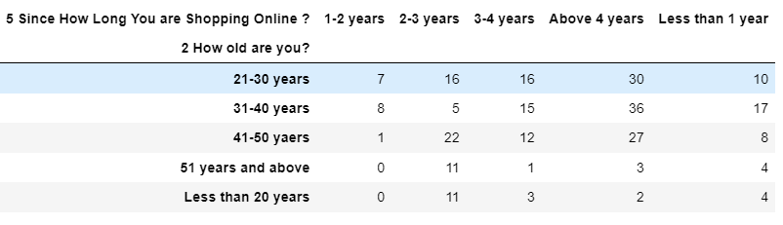  
 With the above cross table, we can say that many of the customers who started online shopping are continuing to shop more. The density of the above 4 years is more compare to all other categories. Also, the people from age group 21 to 50 years are more interested in online shopping compared to above 50 years and less than 20 years. This can be due to financial dependency.

21-30 years customers have made more than 40 times online purchases. We can say the youngsters are more prefer to online shopping compare to other age group.

As we see the mobile internet is present times with different names, we can rename it into same form to combine these for better visualization and understanding.



Most customers use Mobile Internet for their online purchases. The number of internet users are growing rapidly. Hence the online retails are also growing. This is handy and easy to use also can be accessed from anywhere with mobile network.

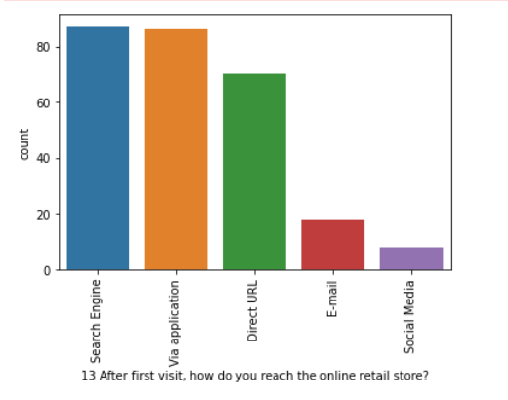

Most of the customers use the Search Engine or application for online purchases due to the ease of access to the website. The quality of the website/application plays a powerful role here. If the front end is not simple and easy to browse user may change the decision.

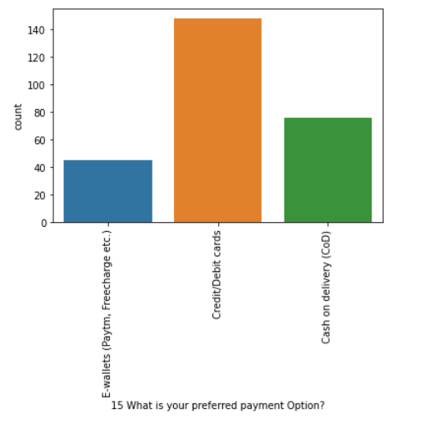

When it comes to the payment methods, most of the customers choose the Online credit/Debit card option. Even though the Cash on delivery option is safer, customers choose the online payment. This shows the trust of a customer on the e-retailer. Trust plays a very important role in online shopping.

Now let’s look at the customer satisfaction. The customers agree for the below:

* The content on the website must be easy to read and understand
* Information on similar product to the one highlighted is important for product comparison
* Complete information on listed seller and product being offered is important for purchase decision
* All relevant information on listed products must be stated clearly
* Loading and processing speed must be faster.
* User friendly interface of the website
* Convenient payment methods
* Trust that the online retail will fulfil its part of the transaction at the stipulated time
* Empathy towards the customer
* Being able to guarantee the privacy of the customer
* Responsiveness, availability of several communication channels (email, online rep, twitter, phone etc.)
* Online shopping gives monetary benefit and discounts
* Enjoyment is derived from shopping online
* Shopping online is convenient and flexible
* Return and replacement policy of the e-tailer is important for purchase decision
* Gaining access to loyalty programs is a benefit of shopping online
* Displaying quality Information on the website improves satisfaction of customers
* 36 User derive satisfaction while shopping on a good quality website or application
* Net Benefit derived from shopping online can lead to users satisfaction
* User satisfaction cannot exist without trust
* Offering a wide variety of listed product in several category
* Provision of complete and relevant product information
* Monetary savings
* The Convenience of patronizing the online retailer
* Shopping on the website gives you the sense of adventure
* Shopping on your preferred e-tailer enhances your social status
* You feel gratification shopping on your favourite e-tailer
* Shopping on the website helps you fulfil certain roles
* Getting value for money spent

Most of the customers have chosen the Strongly Agree or Agree option for the above survey. The overall rating of the application and the product review is very good from most of the customers. Whoever has chosen the Strongly Agree and Agree option will definitely shop again from the online store. the ratings show us the trust of the customers with the online stores. Higher the Strongly Agree and Agree more the Customer satisfied. This also shows the quality of the product.

With the e-retail website/application survey, Amazon stands higher. Amazon is the most customers preference, its easier to use, the website quality is very good, fast loading, visually appealing website followed by Flipkart. Offers, discounts and variety of products are huge in Amazon and Flipkart. Among financial privacy and security also amazon stands on the top, they give more value to the customers privacy policy. The online applications keep getting updated to newer versions and enhanced, this strengthens the security.

**CONCLUSION**

For a successful online retail business, the emphasis must be given to the customer satisfaction. The preferences may differ from user to user, but some of the factors like the quality of the product, detailed description of the product, service delivery/return, website quality, Trust will have high impact on the business and its success. These factors motivate the customers to revisit and purchase more and more items from the e-retail. Trust can be built from the other successful factors. Attention to the customer specific content is very much vital. And finally, each online shopping experience make the users to prefer online shopping.