DEPARTMENT OF BACHELOR COMPUTER APPLICATION

BCA Vᵗʰ Semester
SRS On Minor Project
Project Title : Canteen Sales and Wastage Report System

Submited by
Name : Pallavi H 01FE24ICA003
Name : Manjari B 01FE24ICA060
Name : Anusha K 01FE24ICA032

UNDER THE GUIDANCE OF
Prof: Prajna Bhat

KLE TECHNOLOGICAL UNIVERSITY
B. V. B COLLEGE VIDYANAGAR
HUBBALLI-580031
1. INTRODUCTION
1.1 Purpose
The purpose of this project is to develop a web-based Canteen Sales and Wastage Report System. It helps canteen staff record daily food sales and food wastage and view organized reports. The system stores item, sales, and wastage details in a database and calculates totals for a selected period.
1.2 Scope
The system allows authorized canteen staff to manage food item details, record sales, and record wasted food quantities with dates and reasons. It calculates total sales and estimated wastage value and generates daily, weekly, or monthly reports. The main focus is to provide a simple way to monitor sales and wastage. Automatic billing, online payments, supplier management, and advanced inventory control are outside the basic scope unless added separately.
1.3 Objectives
- To provide a simple interface for managing canteen item details.
- To record daily sales of food items.
- To record food wastage quantities and reasons.
- To calculate total sales and estimated wastage value.
- To generate item-wise and period-wise sales and wastage reports.
- To help canteen staff monitor wastage and make better decisions.
- To test the accuracy of data entry, calculations, and reports.
1.4 Intended Audience
- Canteen staff or administrators who manage sales and wastage records.
- Students and project evaluators who want to understand the system.
- Developers who may maintain or improve the application in the future.

1.5 Document Overview
This document explains the purpose, scope, objectives, functional requirements, non-functional requirements, business rules, system constraints, diagrams, hardware and software requirements, references, future enhancements, and conclusion of the Canteen Sales and Wastage Report System.
1.6 Foundational Concepts Used
The project uses the following concepts:

- Database Management: Stores and retrieves food item, sales, and wastage details.
- Data Entry and Validation: Checks the details entered by canteen staff.
- Calculation Logic: Calculates sales totals and estimated wastage values.
- Reporting: Organizes records into daily, weekly, or monthly reports.
- Web Technologies: Provides the user interface.
- Software Testing: Checks whether data entry, calculations, and reports work correctly.
System Architecture
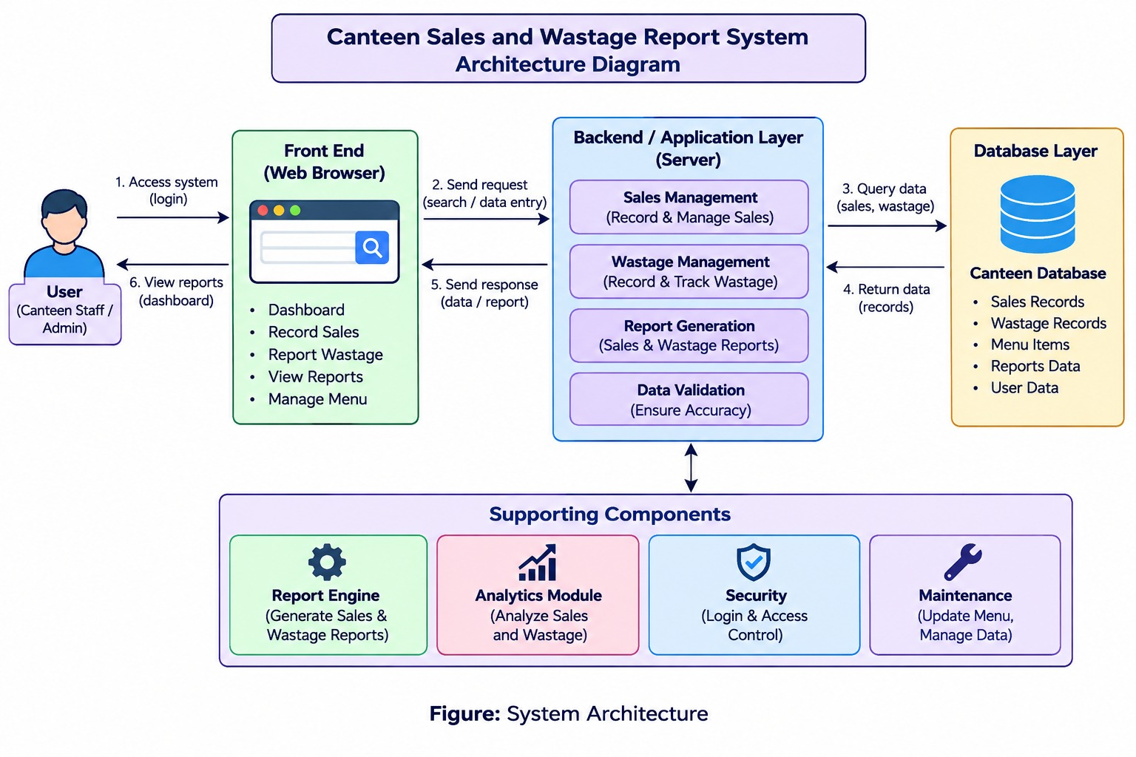
2. SPECIFIC REQUIREMENTS
2.1 Functional Requirements
The system shall:
- Display a home page or dashboard with options to manage items, record sales, record wastage, and view reports.
- Allow authorized users to add, view, update, and delete food item details.
- Allow users to enter sales details such as item, quantity sold, price, and date.
- Retrieve and store sales records in the database.
- Allow users to record wasted item, wasted quantity, date, and reason.
- Calculate total sales amount using quantity sold and item price.
- Calculate total wasted quantity and estimated wastage value.
- Generate daily, weekly, or monthly sales and wastage reports.
- Display item-wise sales and wastage information.
- Display a message when no records are available for the selected period.
- Validate empty, invalid, or negative quantity and price inputs.
- Allow users to select another report period or return to the dashboard.
2.2 Non-Functional Requirements
- Performance: The system should generate reports within a reasonable time.
- Usability: The interface should be simple and easy to understand.
- Reliability: The system should save records correctly and handle errors properly.
- Accuracy: Sales totals and wastage calculations should be accurate.
- Maintainability: The system should allow the project team to update item details and improve report features.
- Compatibility: The application should work in commonly used web browsers.
- Security: Only authorized users should be allowed to modify records, and user inputs should be validated.
2.3 Business Rules and System Constraints
Business Rules
- Only food items stored in the database can be selected for sales and wastage entries.
- Each sales record must contain a valid item, quantity, price, and date.
- Each wastage record must contain a valid item, wasted quantity, date, and reason, where provided.
- Sales amount is calculated using quantity sold multiplied by the applicable selling price.
- Wastage value is an estimate based on the item cost or price value stored in the system.
- Reports include only records within the selected date or period.
- If no records are found for the selected period, the system displays an appropriate message.
System Constraints
- The accuracy of reports depends on the correctness of information entered by users.
- The system can generate reports only for records stored in the database.
- Wastage value is an estimate and depends on the cost or price information available.
- Automatic stock deduction, barcode scanning, online payments, and supplier management are not included unless separately implemented.
- The system depends on the selected hardware, software, and database.
ER Diagram - Canteen Sales and Wastage Report System
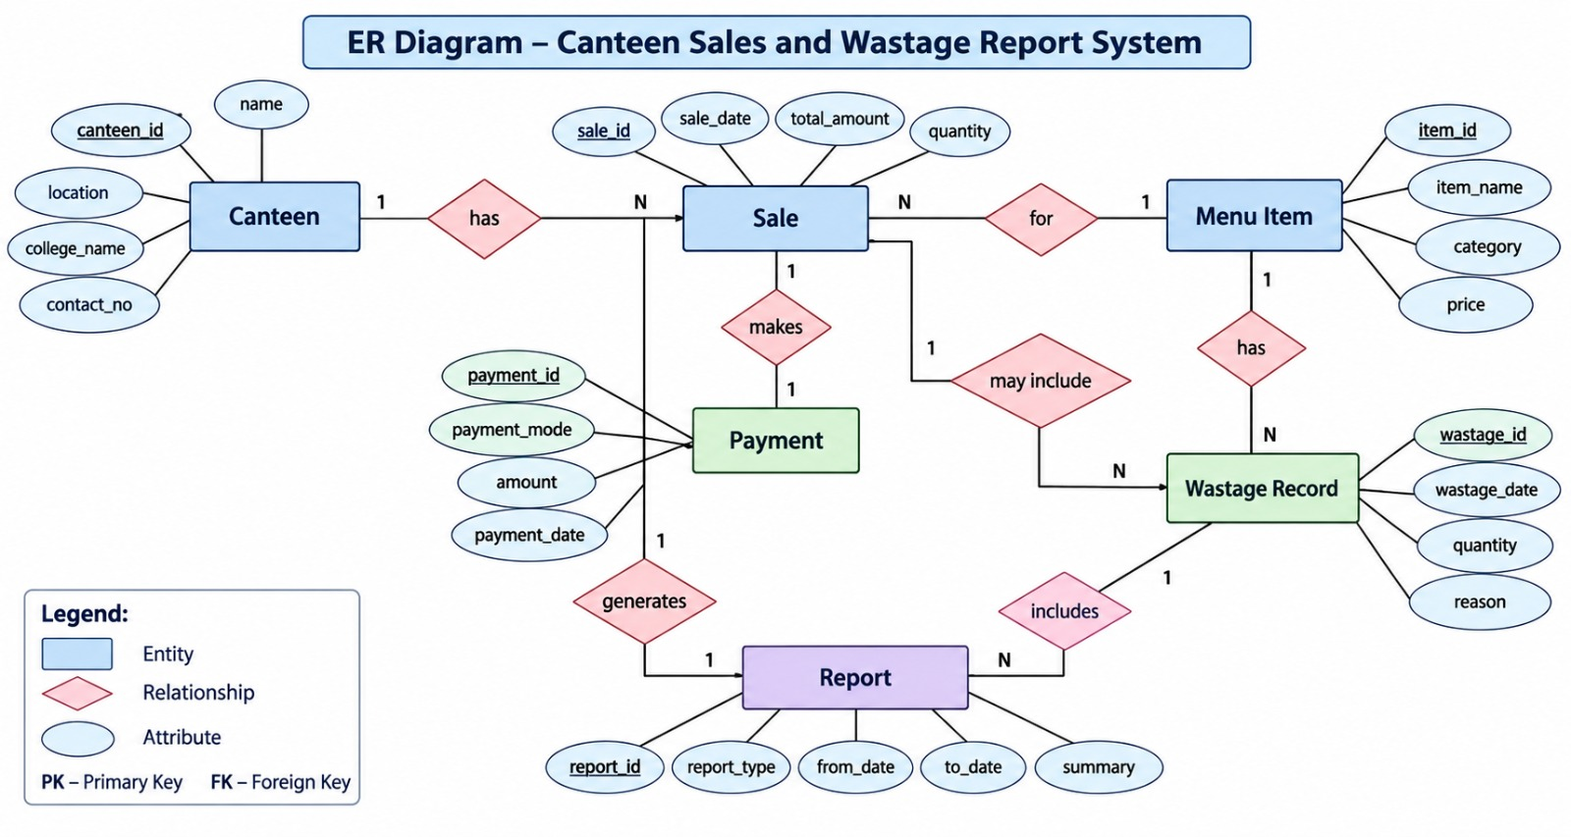
2.4 Data Flow Diagrams (DFD)
1. Level 1 DFD — Main flow of data through the system

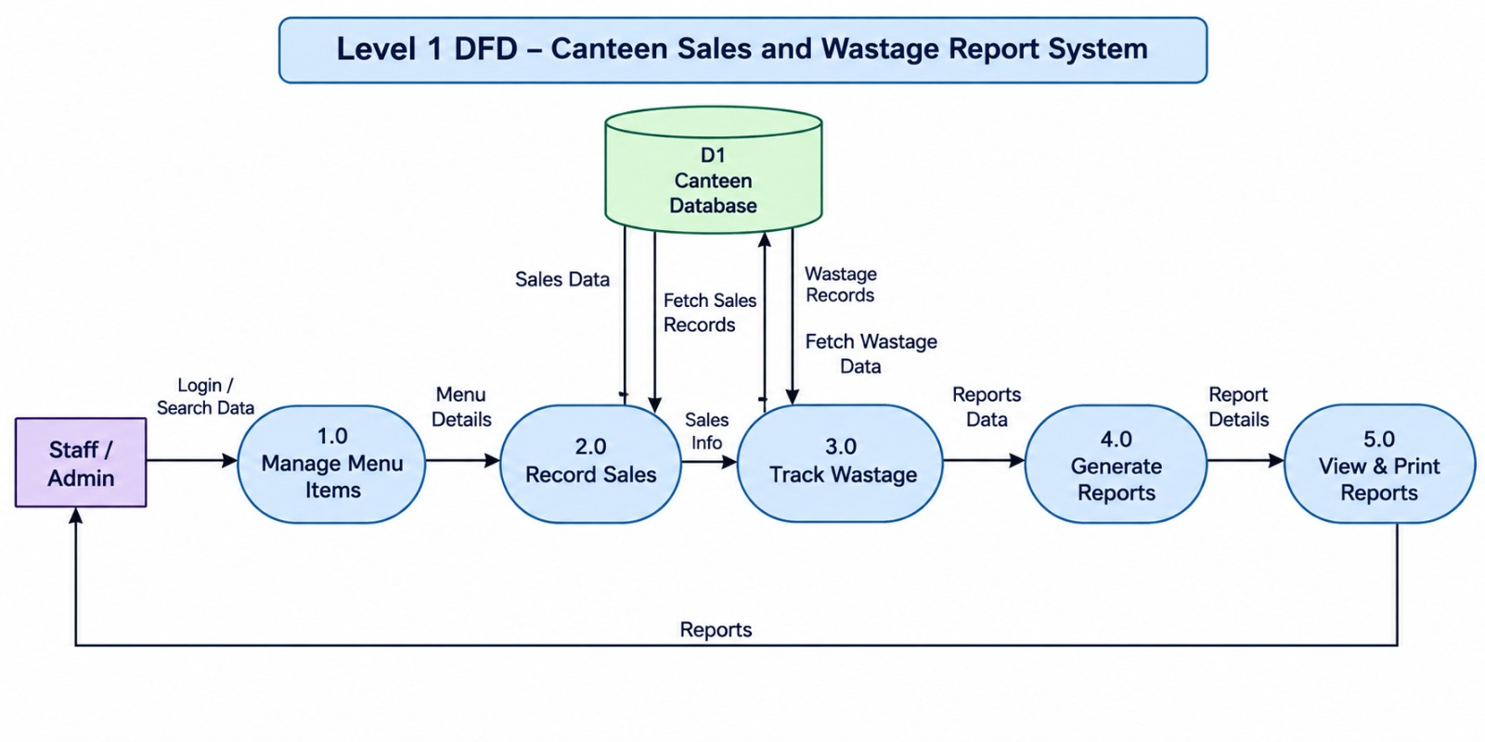

2. Level 2 DFD — Detailed sales and wastage reporting process
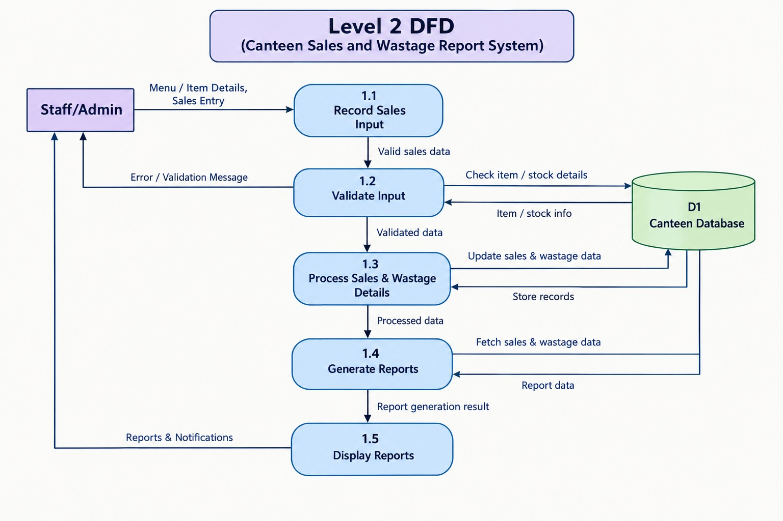

3. Use Case Diagram - Canteen Sales and Wastage Report System
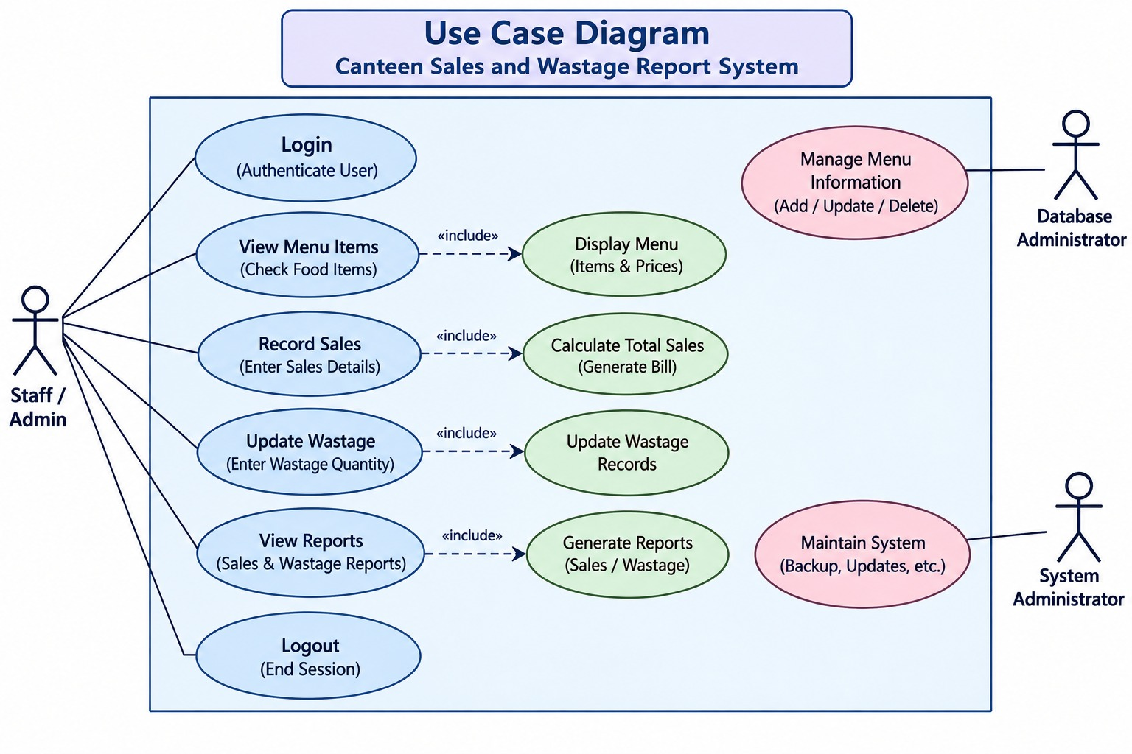
4. Class Diagram - Canteen Sales and Wastage Report System
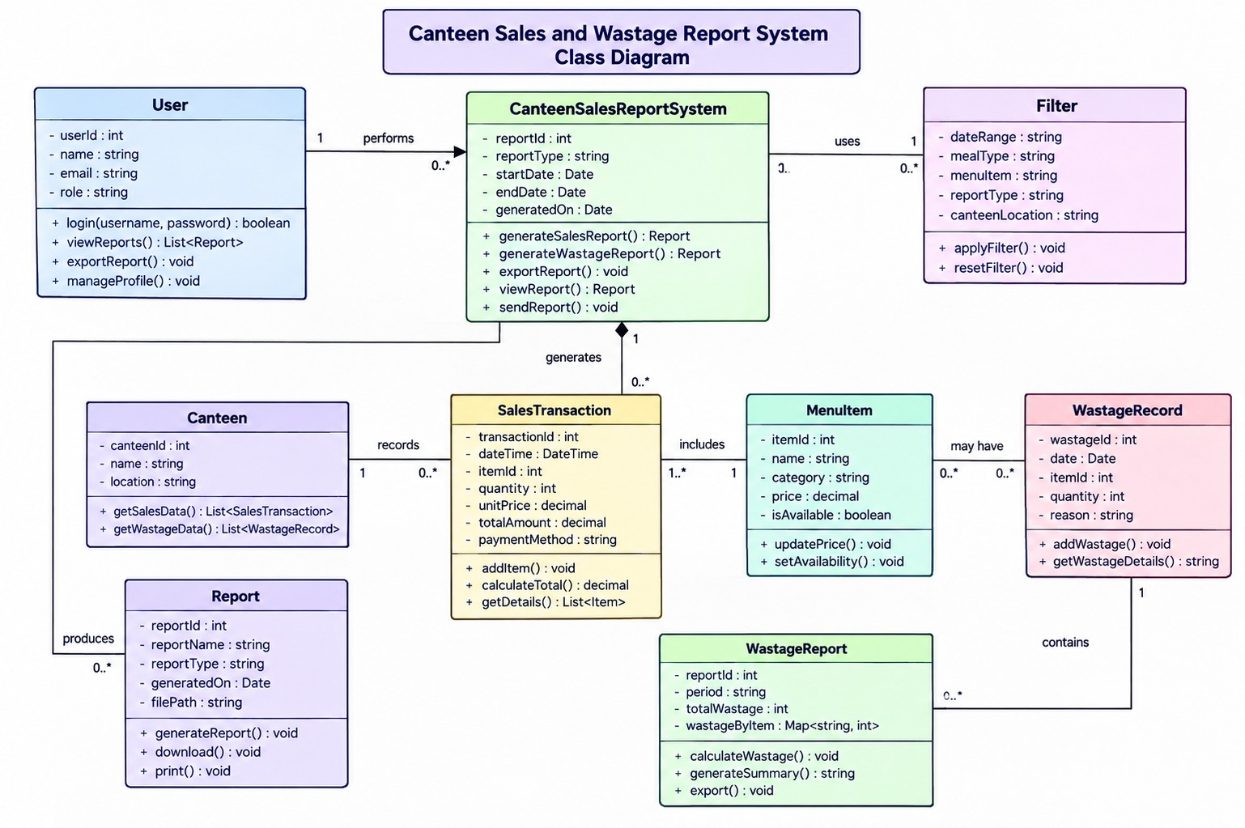

5. Sequence Diagram - Canteen Sales and Wastage Report System
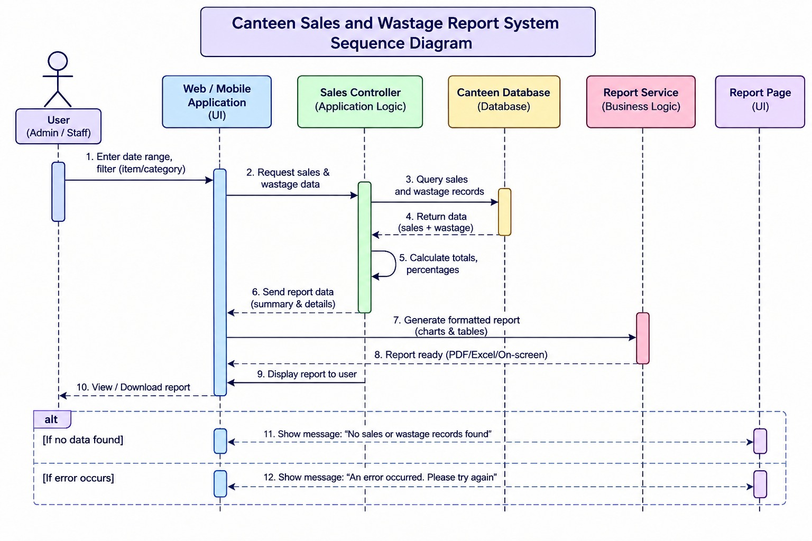
3. HARDWARE AND SOFTWARE REQUIREMENTS
3.1 Hardware Requirements
- Computer or laptop.
- Dual-core processor or equivalent.
- Minimum 4 GB RAM.
- At least 1 GB of free storage for project files and database.
- Keyboard and mouse or touchpad.
- Internet connection for online access and downloading required tools, if needed.
3.2 Software Requirements
- Operating System: Windows, Linux, or macOS.
- Frontend: HTML, CSS, and JavaScript.
- Frontend Framework: React, if selected by the team.
- Backend: Node.js and Express.js, if a separate backend is used.
- Database: MySQL or MongoDB.
- Web Browser: Google Chrome, Microsoft Edge, or Firefox.
- Code Editor: Visual Studio Code or another suitable editor.
- Testing: Sample item, sales, and wastage records and test cases to verify calculations and reports.
4. REFERENCES
- KLE Technological University, Department of Computer Applications, BCA Mini Project Orientation Material.
- Official documentation for the selected frontend technology.
- Official documentation for the selected backend technology, if used.
- Official documentation for the selected database.
- Software Engineering and Database Management System course materials.
5. FUTURE ENHANCEMENT
The system can be improved in the future by:
- Adding stock and inventory tracking.
- Providing graphical charts for sales and wastage trends.
- Adding user login with administrator and staff roles.
- Generating downloadable PDF or Excel reports.
- Adding alerts when wastage exceeds a defined limit.
- Adding billing and receipt generation.
- Supporting multiple canteen branches, if required.
- Adding daily sales comparison and item-demand analysis.
6. CONCLUSION
The Canteen Sales and Wastage Report System is designed to help canteen staff maintain sales and food wastage records through a simple web interface. It stores item, sales, and wastage information in a database, calculates totals, and generates reports for selected periods. The project applies database management, programming logic, web technologies, reporting, and software testing. It provides a practical way to monitor canteen sales and wastage. In the future, additional features can make the system more useful and efficient.

