DEPARTMENT OF BACHELOR COMPUTER APPLICATION

BCA Vᵗʰ Semester
SRS On Minor Project
Project Title : Tourist Place Search and Ranking

Submited by
Name : Pallavi H 01FE24ICA003
Name : Manjari B 01FE24ICA060
Name : Anusha K 01FE24ICA032

UNDER THE GUIDANCE OF
Prof: Prajna Bhat

KLE TECHNOLOGICAL UNIVERSITY
B. V. B COLLEGE VIDYANAGAR
HUBBALLI-580031

1. INTRODUCTION

1.1 Purpose
The purpose of this project is to develop a web-based Tourist Place Search and Ranking System. It helps users search for tourist places and view matching results in a useful order. The system stores tourist-place details in a database and uses a ranking formula to arrange search results according to their relevance.

1.2 Scope
The system allows users to search for tourist places using keywords and view details such as place name, location, category, and description. Users can also apply filters, such as location and category, depending on the available data. The system ranks matching places using a scoring formula designed by the project team. The main focus is to provide relevant search results in an organized order.

1.3 Objectives
The main objectives of the project are:
- To provide a simple interface for searching tourist places.
- To store and manage tourist-place information in a database.
- To display relevant results based on the user's search.
- To rank search results using a scoring formula.
- To arrange results from the highest score to the lowest score.
- To display a suitable message when no matching place is found.
- To test the accuracy of the search and ranking system.

1.4 Intended Audience
The intended audience includes:
- Users who want to find information about tourist places.
- Students and project evaluators who want to understand the system.
- Developers who may maintain or improve the application in the future.

1.5 Document Overview
This document explains the purpose, scope, objectives, functional requirements, non-functional requirements, business rules, system constraints, hardware and software requirements, references, future enhancements, and conclusion of the Tourist Place Search and Ranking System.

1.6 Foundational Concepts Used
The project uses the following concepts:
- Database Management: Stores and retrieves tourist-place details.
- Search: Finds tourist places that match the entered keyword.
- Programming Logic: Processes search conditions and calculates scores.
- Sorting: Arranges places according to their ranking scores.
- Web Technologies: Provides the user interface.
- Software Testing: Checks whether searching and ranking work correctly.
System Architecture:

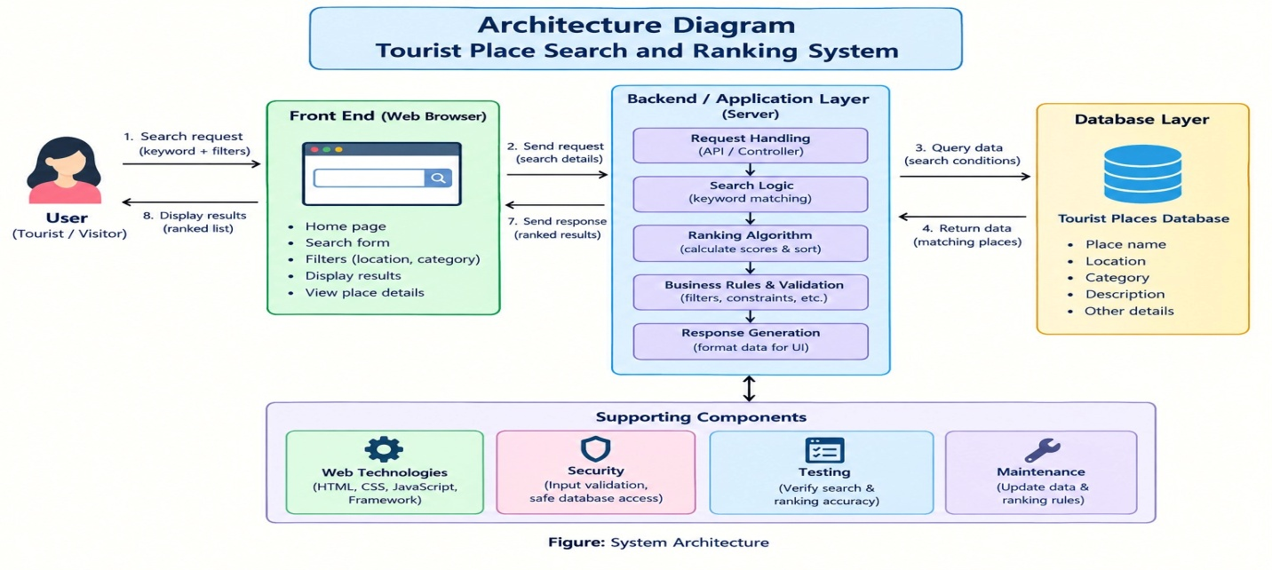

2. SPECIFIC REQUIREMENTS

2.1 Functional Requirements
The system shall:
- Display a home page with a search option.
- Allow users to enter keywords to search for tourist places.
- Retrieve matching places from the database.
- Display details such as name, location, category, and description.
- Provide supported filters to narrow down search results.
- Calculate a ranking score for each matching place.
- Display results from the highest score to the lowest score.
- Use a defined rule to arrange places with equal scores.
- Display a message when no matching results are found.
- Allow users to perform another search or clear filters.
- Handle empty or invalid search input appropriately.

2.2 Non-Functional Requirements
- Performance: The system should display search results within a reasonable time.
- Usability: The interface should be simple and easy to understand.
- Reliability: The same search should produce consistent results when the data and ranking rules remain unchanged.
- Accuracy: Search results should follow the defined search conditions and ranking formula.
- Maintainability: The system should allow the project team to update tourist-place details and ranking rules.
- Compatibility: The application should work in commonly used web browsers.
- Security: User inputs should be validated, and database access should follow safe practices.

2.3 Business Rules and System Constraints
Business Rules
- Only tourist places stored in the database can appear in the results.
- Places must match the search conditions to be displayed.
- Each matching place receives a score using the ranking formula.
- Results are arranged from the highest score to the lowest score.
- If two places have equal scores, they are arranged alphabetically by place name.
- If no matching place is found, the system displays an appropriate message.
- Filters can use only the information available in the database.
System Constraints
- Search results depend on the accuracy and completeness of the stored data.
- The ranking system depends on the formula designed by the project team.
- The system is limited to the features implemented in the project.
- Live maps, online bookings, and real-time travel prices are not included in the basic system unless separately implemented.
- The system depends on the selected hardware, software, and database.

ER Diagram - Tourist Place Search and Ranking System
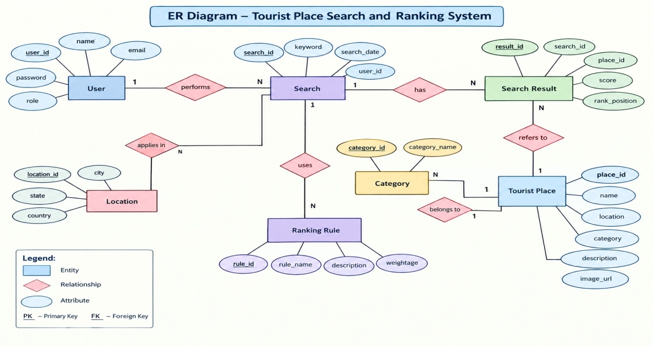

2.4 Data Flow Diagrams (DFD)
1. Level 1 DFD — Tourist Place Search and Ranking System
Diagram 1: Main flow of data through the system

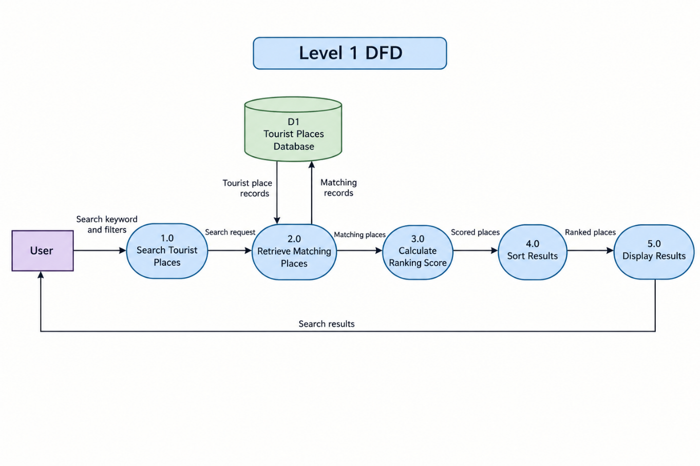
2. Level 2 DFD — Detailed Search and Ranking Process
Diagram 2: Detailed breakdown of the search and ranking process

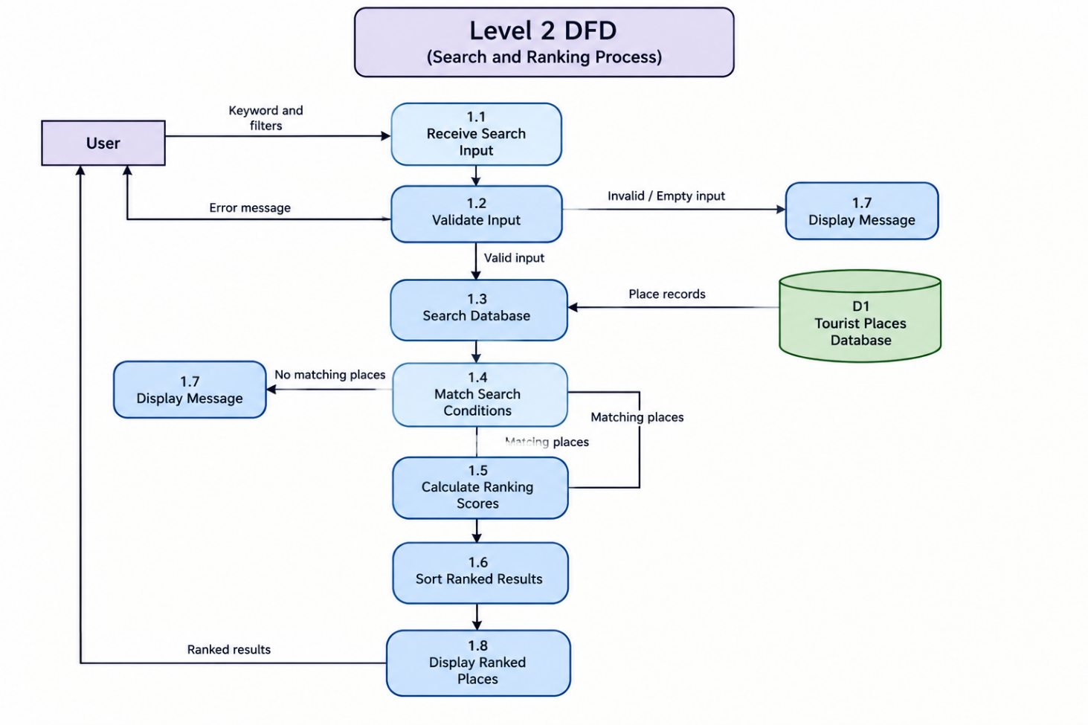
3.Use Case Diagram- Tourist Place Search and Ranking System.
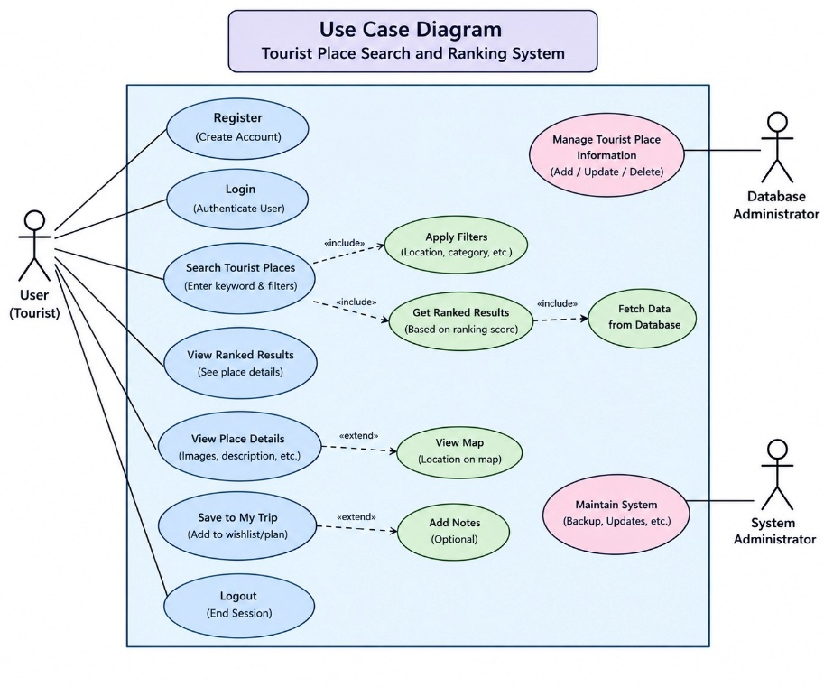
4.Class Diagram - Tourist Place Search and Ranking System.
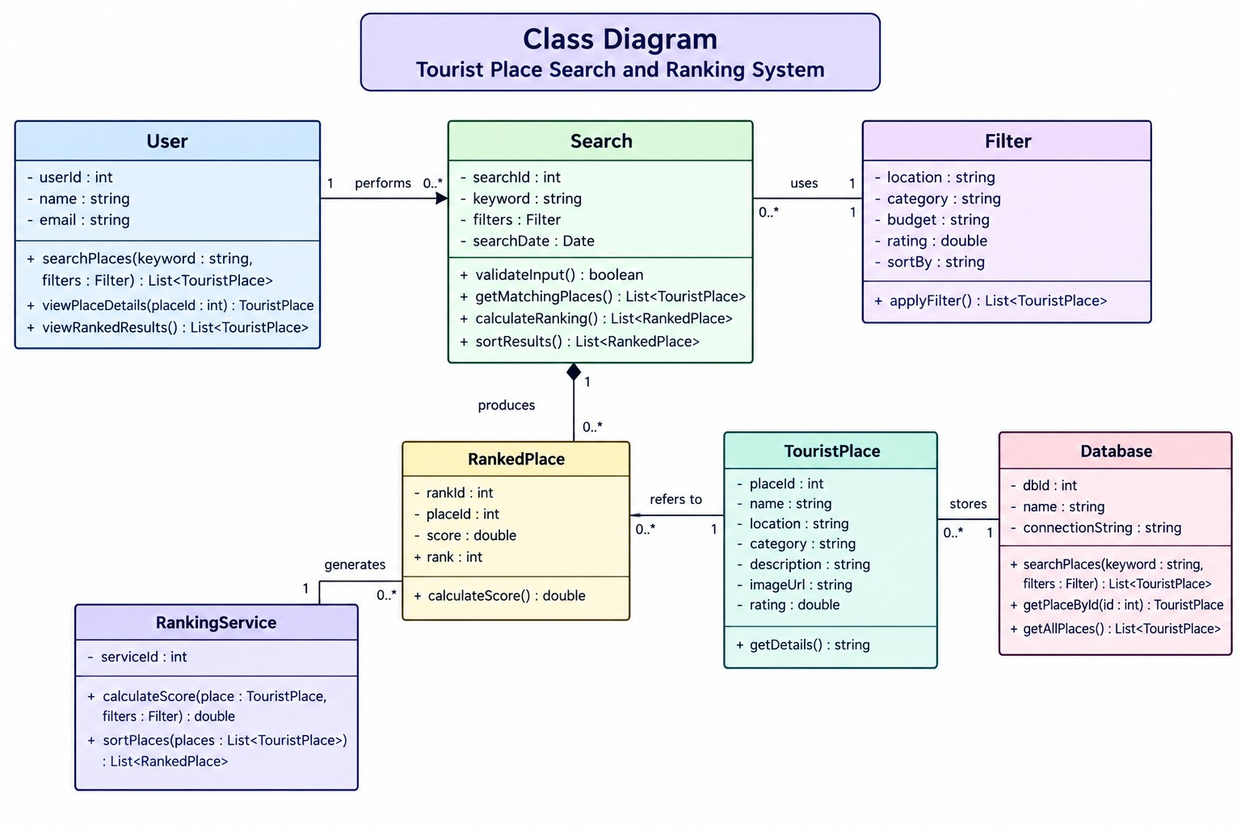

5.Sequence Diagram - Tourist Place Search and Ranking System.
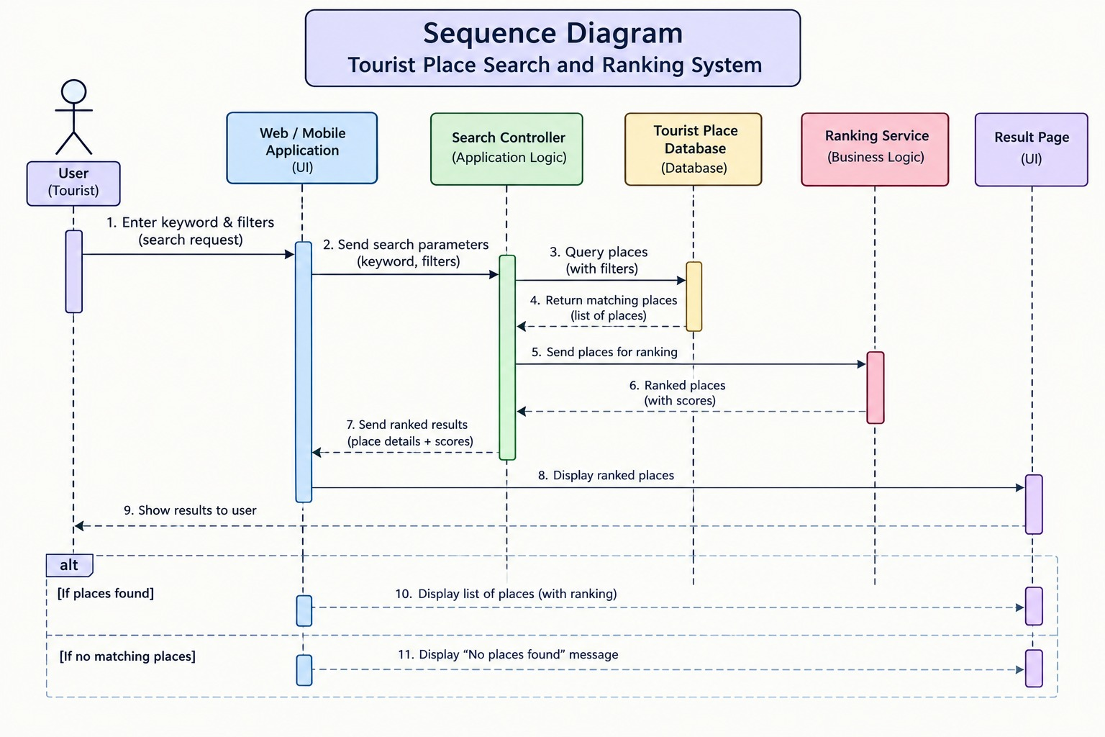
3. HARDWARE AND SOFTWARE REQUIREMENTS

3.1 Hardware Requirements
- Computer or laptop.
- Dual-core processor or equivalent.
- Minimum 4 GB RAM.
- At least 1 GB of free storage for project files and database.
- Keyboard and mouse or touchpad.
- Internet connection for online access and downloading required tools.

3.2 Software Requirements
- Operating System: Windows, Linux, or macOS.
- Frontend: HTML, CSS, and JavaScript.
- Frontend Framework: React, if selected by the team.
- Backend: Node.js and Express.js, if a separate backend is used.
- Database: MySQL or MongoDB.
- Web Browser: Google Chrome, Microsoft Edge, or Firefox.
- Code Editor: Visual Studio Code or another suitable editor.
- Testing: Sample search queries and test cases to verify search results and ranking order.

4. REFERENCES
- KLE Technological University, Department of Computer Applications, BCA Mini Project Orientation Material.
- Official documentation for the selected frontend technology.
- Official documentation for the selected backend technology, if used.
- Official documentation for the selected database.
- Software Engineering and Database Management System course materials.

5. FUTURE ENHANCEMENT
The system can be improved in the future by:
- Adding more tourist places and detailed information.
- Integrating maps to help users locate destinations.
- Adding user reviews and ratings.
- Providing additional filters based on available information.
- Improving the ranking formula using user preferences.
- Making the application more suitable for mobile devices.
- Supporting multiple languages.
- Adding an administrator page to manage tourist-place details.

6. CONCLUSION
The Tourist Place Search and Ranking System is designed to help users find tourist destinations through a simple search interface. It stores tourist-place information in a database, retrieves matching records, and ranks the results using a defined scoring formula. The project applies database management, programming logic, sorting techniques, web technologies, and software testing. It provides a practical way to understand how search results can be organized according to relevance. In the future, additional features can make the system more useful and convenient for users.

