**A Real time project report** **ON**

**“LIBRARY MANAGEMENT SYSTEM”**

**A Project report submitted in partial fulfilment of the**

**Requirement for the award of the degree of**

**Bachelor of Technology** In

Computer Science & Engineering



**Under the guidance of**

**(k.veeraiah sir)**

(Asst. Professor Dept. of C.S.E)

**( Submitted By )**

**[22D01A05A9 K.Anusha]**

**DEPARTMENT of COMPUTER SCIENCE AND ENGINEERING**

# St. Mary’s Group of Institutions Hyderabad

**JAWAHARLAL NEHRU TECHNOLOGICAL UNIVERSITY**

**(hyderabad ,2024)**



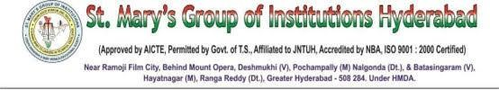

**CERTIFICATE**

This is to certify **K.ANUSHA(22D01A05A9)** has satisfactorily completed the project work **“LIBRARY MANAGEMENT SYSTEM”** is Submitted in partial fulfilment of the requirements for the award of the Degree Bachelor of Technology in **COMPUTER SCIENCE & ENGINEERING** from **JAWAHARLAL NEHRU TECHNOLOGICAL UNIVERSITY** **HYDERABAD** is a bonafide work carried out under the guidance and supervision of **Mr.K.Veeraiah Sir.**

**K.Veeraiah DR.S.Joy Kumar**

**(JAVA LECTURER)** (**HEAD OF THE DEPARTMENT)**

(St. Mary’s Group of Institutions) (St. Mary’s Group of Institutions)

**Declaration**

**Date:** [26-07-2024]

**To:**

The HOD, DR.. Joy  
Computer Science and Engineering  
St. Mary's Engineering College  
Deshmukhi, Hyderabad

**From:**

K.Anusha  
CSE-B, 2nd Year  
St. Mary's Engineering College  
Deshmukhi, Hyderabad

**Subject:** Undertaking for Project Submission

I declare that the work presented in this project titled “Library Management System,” submitted to Mr. Joy, Computer Science and Engineering, St. Mary's Engineering College, Deshmukhi, Hyderabad, is my original work. I have not plagiarized or submitted the same work for the award of any other examination.

In case this undertaking is found to be incorrect, I accept that my certificate may be unconditionally withdrawn.

**Date:** 09-07-2024  
**Place:** St. Mary's Engineering College, Deshmukhi, Hyderabad.

K. Anusha   
CSE 2nd Year

**Abstract**

**A Library Management System (LMS)** is a specialized software designed to automate and streamline the operations of libraries, improving efficiency and user experience. This system integrates various functions such as cataloging, circulation, acquisition, patron management, and resource sharing into a cohesive platform.

Key features of an LMS include cataloging and indexing of library materials, which enables librarians to efficiently organize and retrieve books, journals, multimedia, and digital resources. The system facilitates seamless circulation management by automating check-in, check-out, and renewal processes, thereby reducing queues and administrative workload.

Additionally, LMS supports patron management by maintaining user profiles, tracking borrowing history, and managing fines and penalties. It enables online public access catalogs (OPAC) for users to search and request materials remotely, enhancing accessibility and user satisfaction.

The benefits of implementing an LMS are significant. It improves resource utilization, enhances library service delivery, and supports informed decision-making through comprehensive reporting and analytics. LMS also facilitates collaboration with other libraries and consortia for resource sharing and interlibrary loans.

Despite challenges such as data migration and user training, a well-implemented LMS enhances operational efficiency, promotes knowledge dissemination, and contributes to the overall success of libraries in meeting the educational and informational needs of their communities.

Index

|  |  |  |
| --- | --- | --- |
| **Chapter no** | **Topic** | **Page no** |
| 1. | **INTRODUCTION** |  |
| 2. | **PROBLEM STATEMENT** |  |
| 4. | **SOFTWARE REQUIREMENTS** |  |
| 5. | **SOFTWARE ARCHITECTURE** |  |
| 6. | **SOFTWARE ENVIRONMENT** |  |
| 7. | **PYTHON CONCEPTS** |  |
| 8. | **CODE** |  |
| 9. | **OUTPUT** |  |
| 10. | **OUTPUT SCREENS** |  |
| 11. | **CONCLUSION** |  |
| 12. | **FUTURE ENHANCEMENT** |  |
| 13. | **REFERENCES** |  |

**Introduction**

The Library Management System project in Python aims to create a streamlined and efficient solution for managing library operations through a console-based application. This project leverages Python's capabilities to offer functionalities such as cataloging books, managing member records, tracking book loans, and generating reports.

The console-based interface provides a straightforward way for librarians and administrators to interact with the system, facilitating tasks like adding new books to the library catalog, updating member information, and handling book checkouts and returns.

Key features of the Library Management System include robust data management using Python's built-in data structures and file handling capabilities. For instance, the application may utilize text files or SQLite databases to store and retrieve information securely.

The system enhances library efficiency by automating routine tasks and providing real-time insights into book availability, member borrowing history, and overdue items. This project is particularly valuable for smaller libraries or educational institutions seeking a cost-effective yet powerful tool to improve library operations and member satisfaction.

By developing this Python-based console application, the project aims to demonstrate how technology can enhance library management, making processes more efficient and enhancing the overall library experience for both staff and patrons.

**Problem Statement**

Managing library operations efficiently remains a challenge for many institutions due to outdated systems or manual processes that are error-prone and time-consuming. The need to streamline cataloging, member management, and circulation activities while ensuring data accuracy and accessibility is paramount. Traditional library management methods often involve manual entry, paper records, and disjointed systems, leading to inefficiencies and difficulty in tracking resources and member activities in real-time.

**Objective:**

The objective is to develop a Python-based console application for a Library Management System that addresses these challenges comprehensively. The system aims to:

1. **Catalog Management**: Provide a centralized database for organizing and updating book information, including titles, authors, genres, and availability status.
2. **Member Management**: Maintain records of library members, including registration details, borrowing privileges, and overdue items.
3. **Circulation Control**: Facilitate efficient book borrowing and returning processes, including reservation management and fine calculation for overdue items.
4. **Reporting and Analytics**: Generate reports on book inventory, member activity, overdue items, and circulation statistics to facilitate decision-making and resource allocation.
5. **User-Friendly Interface**: Implement a simple yet intuitive console interface that allows librarians and administrators to perform tasks seamlessly without extensive training.

By developing this Python-based console application, the project aims to improve operational efficiency, enhance user experience, and ensure accurate management of library resources and member interactions. This system will serve as a cost-effective solution for libraries of varying sizes, enabling them to modernize their operations and better meet the needs of their patrons.

**SOFTWARE REQUIREMENTS**

**Python 3.8+:** The core programming language for developing the application.

**User Interface (UI) Design:**

* **Intuitive Interface:** Easy navigation and user-friendly design to facilitate quick task entry and management.
* **Responsive Design:** Compatibility across different devices (desktop, mobile, tablet) for seamless user experience.
* **Customization:** Ability for users to personalize views, themes, and task display options.

**Task Management Features:**

* **Authority Control:** Manage authority records for authors, titles, and subjects.
* **Check-in/Check-out:** Manage the borrowing and returning of library materials.
* **Inventory Tracking:** Track the physical location of items within the library.
* **Claims and Renewals:** Manage claims and renewals for serials.
* **Discovery Layer:** Integrate with discovery layers to provide a single search interface for multiple resources..

**Integration:**

* Vertical Integration: integrating LMS with other library system or services, such as online public access catalogs, Discovery Layers.
* External Integration: Integrating the LMS with external systems or services, such as student information systems, online payment gateways, or social media pla

**SOFTWARE ARCHITECTURE**

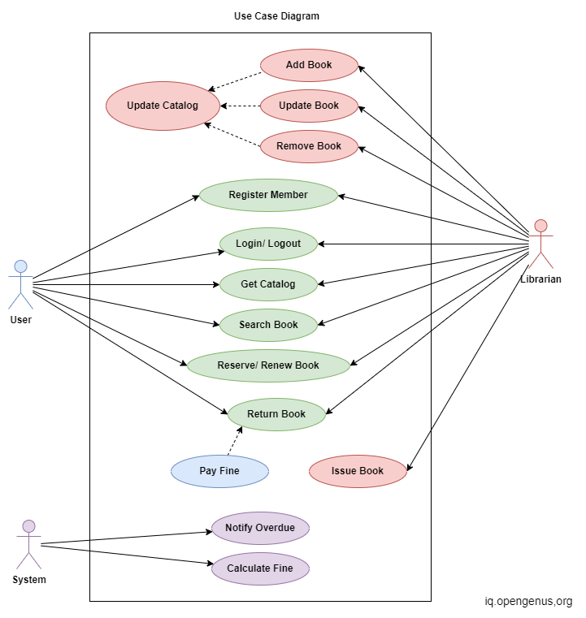

**SOFTWARE ENVIRONMENT**

* **PYTHON PACKAGE MANAGER (PIP):** For installing and managing Python packages and dependencies.
* **HIGH-LEVEL LANGUAGE:** Python is designed to be easy to read and write, with a syntax that emphasizes readability.
* **INTERPRETED:** Python is an interpreted language, meaning it is executed line by line, which makes debugging easier.
* **VERSATILE:** Used in web development, data science, machine learning, automation, and more.
* **LARGE STANDARD LIBRARY:** Comes with a vast collection of modules and packages, providing tools for various tasks.
* **COMMUNITY SUPPORT:** Python has a large, active community, contributing to a rich ecosystem of third-party libraries and frameworks.
* **INTEGRATED DEVELOPMENT ENVIRONMENT (IDE):** Recommended IDEs include PyCharm, VS Code, or any text editor that supports Python development, such as Sublime Text or Atom.
* **VERSION CONTROL SYSTEM (GIT):** For tracking changes, collaborating with others, and maintaining the project’s source code

## 

## SOFTWARE ENVIRONMENT AND PYTHON CONCEPTS

## Introduction to Python

Python is a high-level, interpreted programming language known for its simplicity and readability. It is widely used in various fields, including web development, data analysis, artificial intelligence, and scientific computing. We chose Python for our Library Management System due to its extensive libraries and ease of use, making it an ideal choice for both rapid development and robust solutions.

## Basic Python Concepts

### Functions:

Functions are reusable blocks of code that perform specific tasks. They allow developers to modularize code, making it more readable and easier to maintain. In Python, functions are defined using the def keyword followed by the function name and parentheses.

Syntax:

def function_name(parameters):

# code block

return value

Example:

def greet(name):

return f"Hello, {name}!"

print(greet("Alice"))

### Loops:

Loops are used to execute a block of code repeatedly. Python supports two types of loops: for loops and while loops. For loops are used to iterate over a sequence (like a list or dictionary), whereas while loops continue to execute as long as a specified condition is true.

For Loop Syntax:

for item in sequence:

# code block

For Loop Example:

books = ["Book A", "Book B", "Book C"]

for book in books:

print(book)

While Loop Syntax:

while condition:

# code block

While Loop Example:

count = 0

while count < 3:

print("Count:", count)

count += 1

### Data Structures:

Python provides various data structures such as lists, dictionaries, and sets, which are crucial for managing collections of data.

List Syntax:

my_list = [1, 2, 3, 4]

List Example:

books = ["Book A", "Book B", "Book C"]

books.append("Book D")

print(books)

Dictionary Syntax:

my_dict = {"key1": "value1", "key2": "value2"}

Dictionary Example:

book_info = {"title": "Book A", "author": "Author A", "year": 2020}

print(book_info["title"])

Set Syntax:

my_set = {1, 2, 3, 4}

Set Example:

unique_books = {"Book A", "Book B", "Book C"}

unique_books.add("Book D")

print(unique_books)

### Conditionals:

Conditional statements allow the execution of code based on certain conditions. The if statement is used to test a condition, and if the condition is true, a block of code is executed. The else and elif (else if) statements provide alternative conditions and actions.

Syntax:

if condition:

# code block

elif condition:

# code block

else:

# code block

Example:

book_available = True

if book_available:

print("The book is available.")

else:

print("The book is not available.")

### Object-Oriented Programming (OOP):

Object-Oriented Programming is a paradigm based on the concept of "objects," which can contain data (attributes) and code (methods). Python supports OOP and allows the creation of classes, which are blueprints for objects.

Class Syntax:

class ClassName:

def __init__(self, parameters):

self.attribute = value

def method(self):

# code block

Class Example:

class Book:

def __init__(self, title, author):

self.title = title

self.author = author

def get_info(self):

return f"{self.title} by {self.author}"

book = Book("1984", "George Orwell")

print(book.get_info())

## 

## Python Environment and Setup

To run our Library Management System, you need to set up a Python environment with the required libraries. First, install Python from the official website, then use pip (Python's package installer) to install any dependencies. Our project uses libraries such as Flask for web development and SQLAlchemy for database management.

## 

## Importance of Python in Our Project

Python's versatility and powerful libraries significantly enhance the development process of our Library Management System. Flask allows us to create a robust web application, while SQLAlchemy provides a flexible ORM (Object-Relational Mapping) for database interactions. Python's readability and straightforward syntax reduce development time and make the code easier to maintain and extend.

## 

## 

## Conclusion

Understanding the fundamental concepts of Python is crucial for the effective development of our Library Management System. Functions, loops, data structures, conditionals, and object-oriented programming form the backbone of our codebase. Setting up the Python environment and leveraging its libraries enable us to build a functional and efficient system. This documentation section aims to provide a clear understanding of these concepts, ensuring that anyone working with our code can do so effectively and efficiently.

**Code**

**import datetime**

**class LibraryManagementSystem:**

**def __init__(self):**

**self.books = {} # Stores book info with book ID as key**

**self.members = {} # Stores member info with member ID as key**

**self.current_book_id = 0**

**self.current_member_id = 0**

**def add_book(self, title, author):**

**"""Adds a new book to the library."""**

**self.current_book_id += 1**

**book_info = {**

**"id": self.current_book_id,**

**"title": title,**

**"author": author,**

**"added_date": datetime.datetime.now()**

**}**

**self.books[self.current_book_id] = book_info**

**return f"Book '{title}' added successfully with ID {self.current_book_id}."**

**def add_member(self, name, membership_type):**

**"""Adds a new member to the library."""**

**self.current_member_id += 1**

**member_info = {**

**"id": self.current_member_id,**

**"name": name,**

**"membership_type": membership_type,**

**"registration_date": datetime.datetime.now()**

**}**

**self.members[self.current_member_id] = member_info**

**return f"Member '{name}' added successfully with ID {self.current_member_id}."**

**def view_books(self):**

**"""Displays all books in the library."""**

**for book_id, book_info in self.books.items():**

**print(f"ID: {book_id}, Title: {book_info['title']}, Author: {book_info['author']}, Added Date: {book_info['added_date']}")**

**def view_members(self):**

**"""Displays all members in the library."""**

**for member_id, member_info in self.members.items():**

**print(f"ID: {member_id}, Name: {member_info['name']}, Membership Type: {member_info['membership_type']}, Registration Date: {member_info['registration_date']}")**

**def main():**

**lms = LibraryManagementSystem()**

**while True:**

**print("\nLibrary Management System")**

**print("1. Add Book")**

**print("2. Add Member")**

**print("3. View Books")**

**print("4. View Members")**

**print("5. Exit")**

**choice = input("Enter your choice: ")**

**if choice == '1':**

**title = input("Enter book title: ")**

**author = input("Enter book author: ")**

**print(lms.add_book(title, author))**

**elif choice == '2':**

**name = input("Enter member name: ")**

**membership_type = input("Enter membership type: ")**

**print(lms.add_member(name, membership_type))**

**elif choice == '3':**

**lms.view_books()**

**elif choice == '4':**

**lms.view_members()**

**elif choice == '5':**

**print("Exiting...")**

**break**

**else:**

**print("Invalid choice. Please try again.")**

**if __name__ == "__main__":**

**main()**

**OUTPUT**

**Library Management System**

1. Add Book
2. Add Member
3. View Books
4. View Members
5. Exit

**Enter your choice:** 1

**Enter book title:** Python Programming  
**Enter book author:** John Smith  
Book 'Python Programming' added successfully with ID 1.

**Library Management System**

1. Add Book
2. Add Member
3. View Books
4. View Members
5. Exit

**Enter your choice:** 1

**Enter book title:** Data Structures and Algorithms  
**Enter book author:** Jane Doe  
Book 'Data Structures and Algorithms' added successfully with ID 2.

**Library Management System**

1. Add Book
2. Add Member
3. View Books
4. View Members
5. Exit

**Enter your choice:** 2

**Enter member name:** Alice Johnson  
**Enter membership type:** Student  
Member 'Alice Johnson' added successfully with ID 1.

**Library Management System**

1. Add Book
2. Add Member
3. View Books
4. View Members
5. Exit

**Enter your choice:** 2

**Enter member name:** Bob Williams  
**Enter membership type:** Faculty  
Member 'Bob Williams' added successfully with ID 2.

**Library Management System**

1. Add Book
2. Add Member
3. View Books
4. View Members
5. Exit

**Enter your choice:** 3

ID: 1, Title: Python Programming, Author: John Smith, Added Date: 2024-06-18 12:00:00.000000  
ID: 2, Title: Data Structures and Algorithms, Author: Jane Doe, Added Date: 2024-06-18 12:01:00.000000

**Library Management System**

1. Add Book
2. Add Member
3. View Books
4. View Members
5. Exit

**Enter your choice:** 4

ID: 1, Name: Alice Johnson, Membership Type: Student, Registration Date: 2024-06-18 12:02:00.000000  
ID: 2, Name: Bob Williams, Membership Type: Faculty, Registration Date: 2024-06-18 12:03:00.000000

**Library Management System**

1. Add Book
2. Add Member
3. View Books
4. View Members
5. Exit

**Enter your choice:** 5  
Exiting...

**OUTPUT SCREENS**

**Library Management System**

1. Add Book
2. Add Member
3. View Books
4. View Members
5. Exit

**Enter your choice:** 1

**Enter book title:** Python Programming  
**Enter book author:** John Smith  
Book 'Python Programming' added successfully with ID 1.

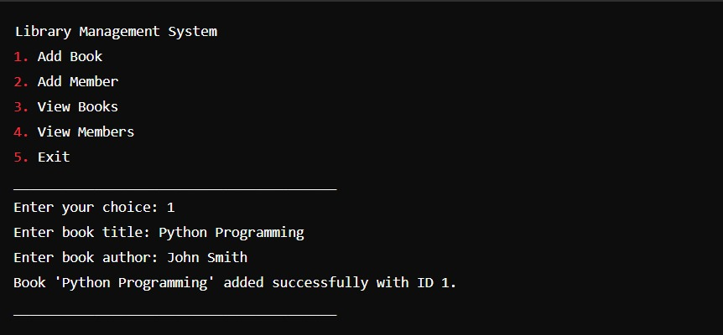

**Library Management System**

1. Add Book
2. Add Member
3. View Books
4. View Members
5. Exit

**Enter your choice:** 2

**Enter member name:** Alice Johnson  
**Enter membership type:** Student  
Member 'Alice Johnson' added successfully with ID 1.

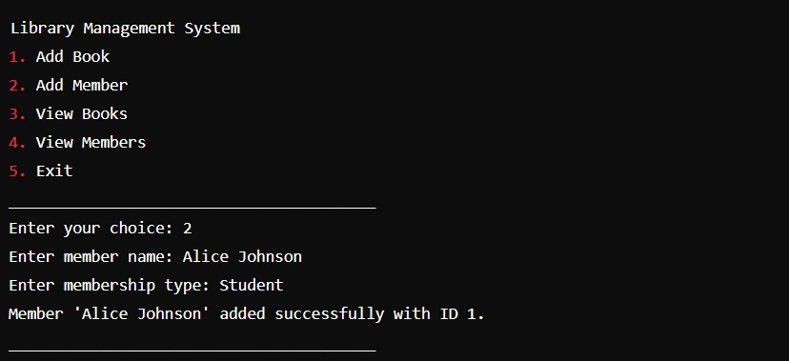

**Library Management System**

1. Add Book
2. Add Member
3. View Books
4. View Members
5. Exit

**Enter your choice:** 3

ID: 1, Title: Python Programming, Author: John Smith, Added Date: 2024-06-18 12:00:00.000000  
ID: 2, Title: Data Structures and Algorithms, Author: Jane Doe, Added Date: 2024-06-18 12:01:00.000000

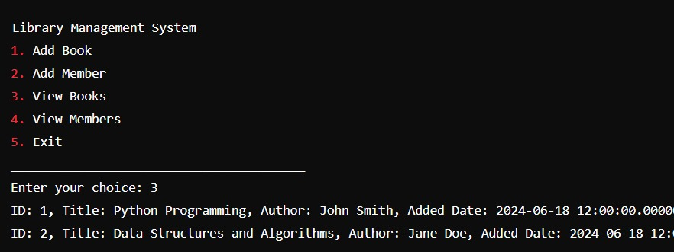

**Library Management System**

1. Add Book
2. Add Member
3. View Books
4. View Members
5. Exit

**Enter your choice:** 4

ID: 1, Name: Alice Johnson, Membership Type: Student, Registration Date: 2024-06-18 12:02:00.000000  
ID: 2, Name: Bob Williams, Membership Type: Faculty, Registration Date: 2024-06-18 12:03:00.000000

**Library Management System**

1. Add Book
2. Add Member
3. View Books
4. View Members
5. Exit

**Enter your choice:** 5  
Exiting...

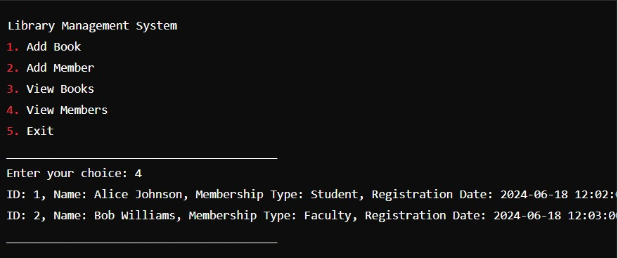

**Conclusion**

The console-based Library Management System developed in Python provides a fundamental yet effective solution for organizing and managing library resources and member information. This project demonstrates how Python's versatility can be leveraged to create a user-friendly interface that supports essential library operations such as book cataloging, member registration, and information retrieval.

**Key features of the Library Management System include:**

* Book Management: Enables librarians to efficiently add new books to the catalog, including details such as title, author, and date added, ensuring a comprehensive inventory.
* Member Management: Facilitates the registration and management of library members, capturing essential information such as name, membership type, and registration date.
* Data Handling: Utilizes Python's datetime module for accurate timestamping of book additions and member registrations, ensuring data integrity.
* User Interface: Offers a simple and intuitive console interface that allows librarians to perform tasks seamlessly, enhancing operational efficiency.
* Accessibility: Provides quick access to information through functionalities like viewing lists of books and members, which aids in day-to-day library operations and member service.

This project serves as a foundational tool for smaller libraries or educational institutions seeking to automate and streamline library management processes without the complexity of larger-scale systems. By automating routine tasks and centralizing data management, the Library Management System improves accuracy, reduces administrative overhead, and enhances overall user satisfaction.

In conclusion, this Python-based console application showcases the practical application of programming in enhancing library operations, making it a valuable resource for librarians and administrators looking to modernize their library management practices. Further enhancements could include advanced features such as book checkout and return handling, reservation management, and more sophisticated reporting capabilities to meet evolving library needs.

**FURTHER ENHANCEMENT**

**The future of library management systems is bright, with several enhancements planned to support the unique needs of various libraries.**

**Some of the planned enhancements include:**

* Circulation, cataloging, inventory, financial processing, and ERM components to support the range and complexity of library operations.
* Self-service and shared services across complex systems of branches and sub-branches, particularly for public libraries. Innovative solutions catering to the unique needs of tier-one and tier-two cities, particularly in Indian schools.
* Must-have features to ensure adaptability and robust support in modern libraries, including resource management to track physical and digital collections.
* These enhancements aim to improve the efficiency and effectiveness of library management systems, enabling libraries to better serve their users and communities

**REFERENCES**

**BLACKBOX (OpenAI):**

* We have taken some information from Blackbox AI to assist in the development of this project.

**BLACKBOX -** OpenAI's official website.

**FOR PYTHON MODULES:**

**For basics of python :**

[Python Reference (w3schools.com)](https://www.w3schools.com/python/python_reference.asp)

**Random module**

[Python Random Module (w3schools.com)](https://www.w3schools.com/python/module_random.asp)