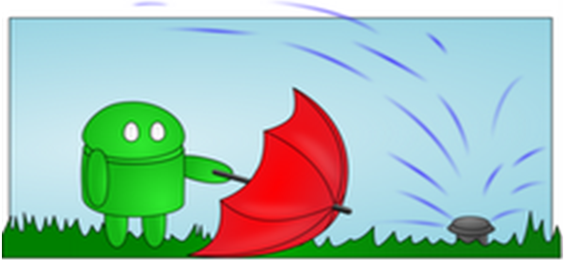

**Android Irrigation Application**



User Manual

prepared by

Corey Pennycuff

O'Neil Georges

Samantha Tomeï

Srilasya Brundavanam

November 27, 2012

**Table of Contents**

**Table of Contents i**  
**1.  Introduction 1**

1.1. Intended Users 1

1.2. Applicability 1

1.3. Purpose 1  
1.4. How to use this document 1

**2. Installation 1**

**3. Getting Started 3**  
3.1. Running the Application 3  
3.2. User Interface Layout 4   
3.3. Layers/Tabs 5

3.4. Pan/Zoom 6

**4. Working with aCAD 6**

4.1. Starting a new project 6

4.2. Adding objects to the layout 7

4.2.1. Adding a house 7

4.2.2. Adding a sprinkler 10

4.2.3. Adding a fence 13

4.2.4. Adding a driveway 13

4.3. Saving the layout 14

4.4. Exiting the application 15

1. **INTRODUCTION**

**1.1 Intended users**

This document covers the use for the following users of the aCAD application:

* irrigation system specialist
  1. **Applicability**

This Application User Manual applies to the aCAD application, prototype.

**1.3 Purpose**

The purpose of this Application User Manual is to assist the user in installing and using the aCAD application.

**1.4 How to use this document**

* Section 2 explains how to install the application unto an android device.
* Section 3 contains information that enables users to get started quickly.
* Section 4 contains tutorials for common tasks.

1. **INSTALLATION**
2. Connect Android device to computer via the USB.
3. Insert disc into drive.
4. Copy the file “socs.acad-final.apk”.
5. Paste the .apk file that was copied onto the internal or removable storage of the Android device.
6. Locate the .apk file on the device using a file browser of your choice and tap it to run the installation
7. An installation dialog will appear, tap “Install”.

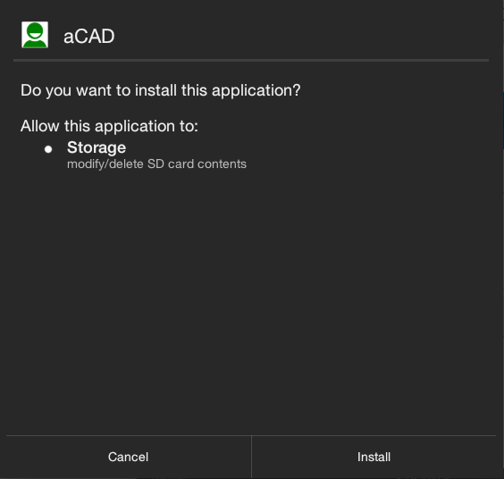

1. Installing…

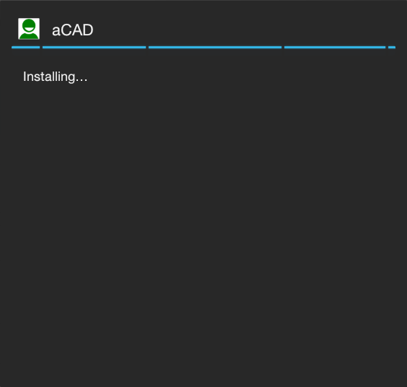

1. Application has been installed.

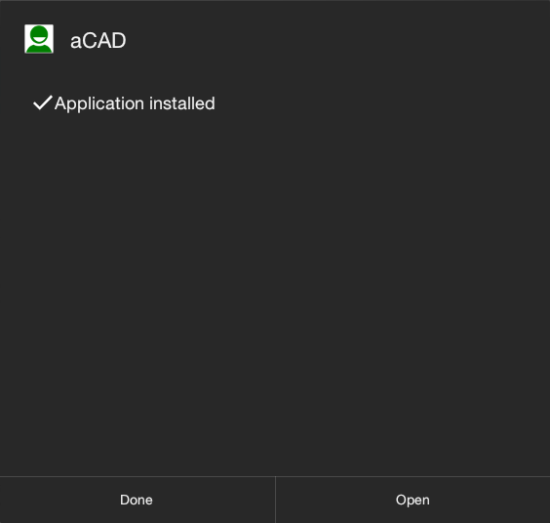

1. **GETTING STARTED**

**3.1 Running the Application**

1. 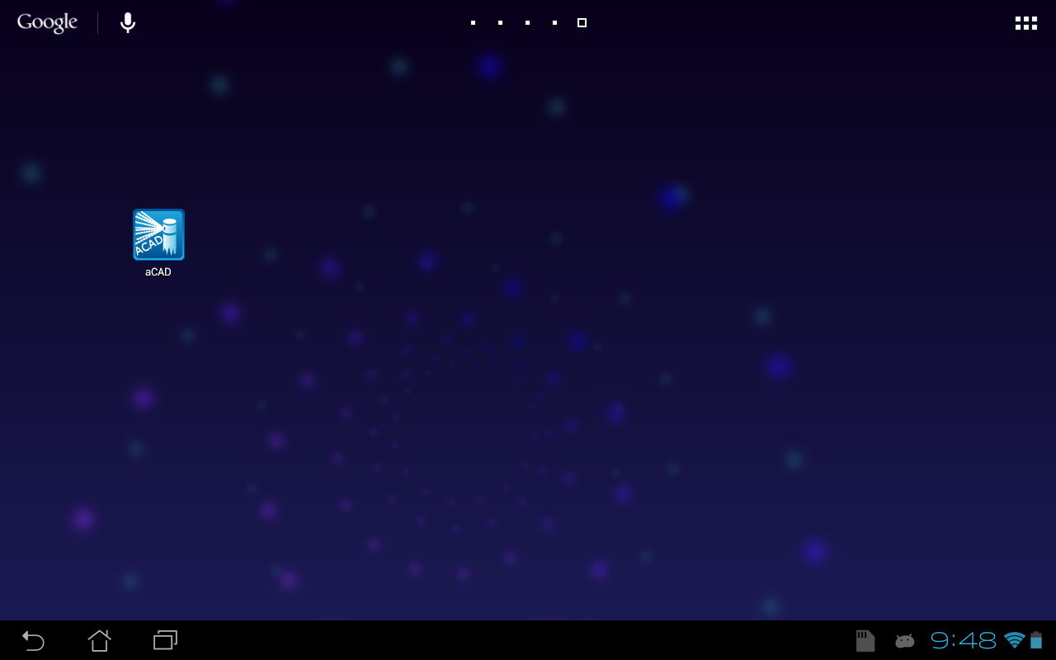Tap the newly installed aCAD icon.
2. A splash screen will appear after launching the application.

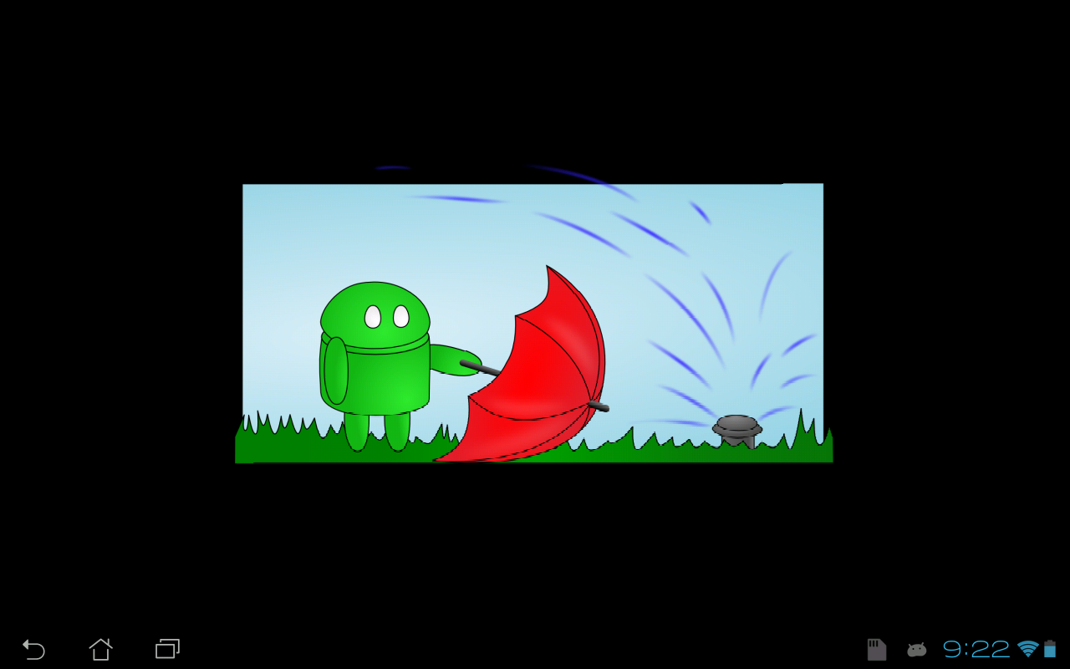

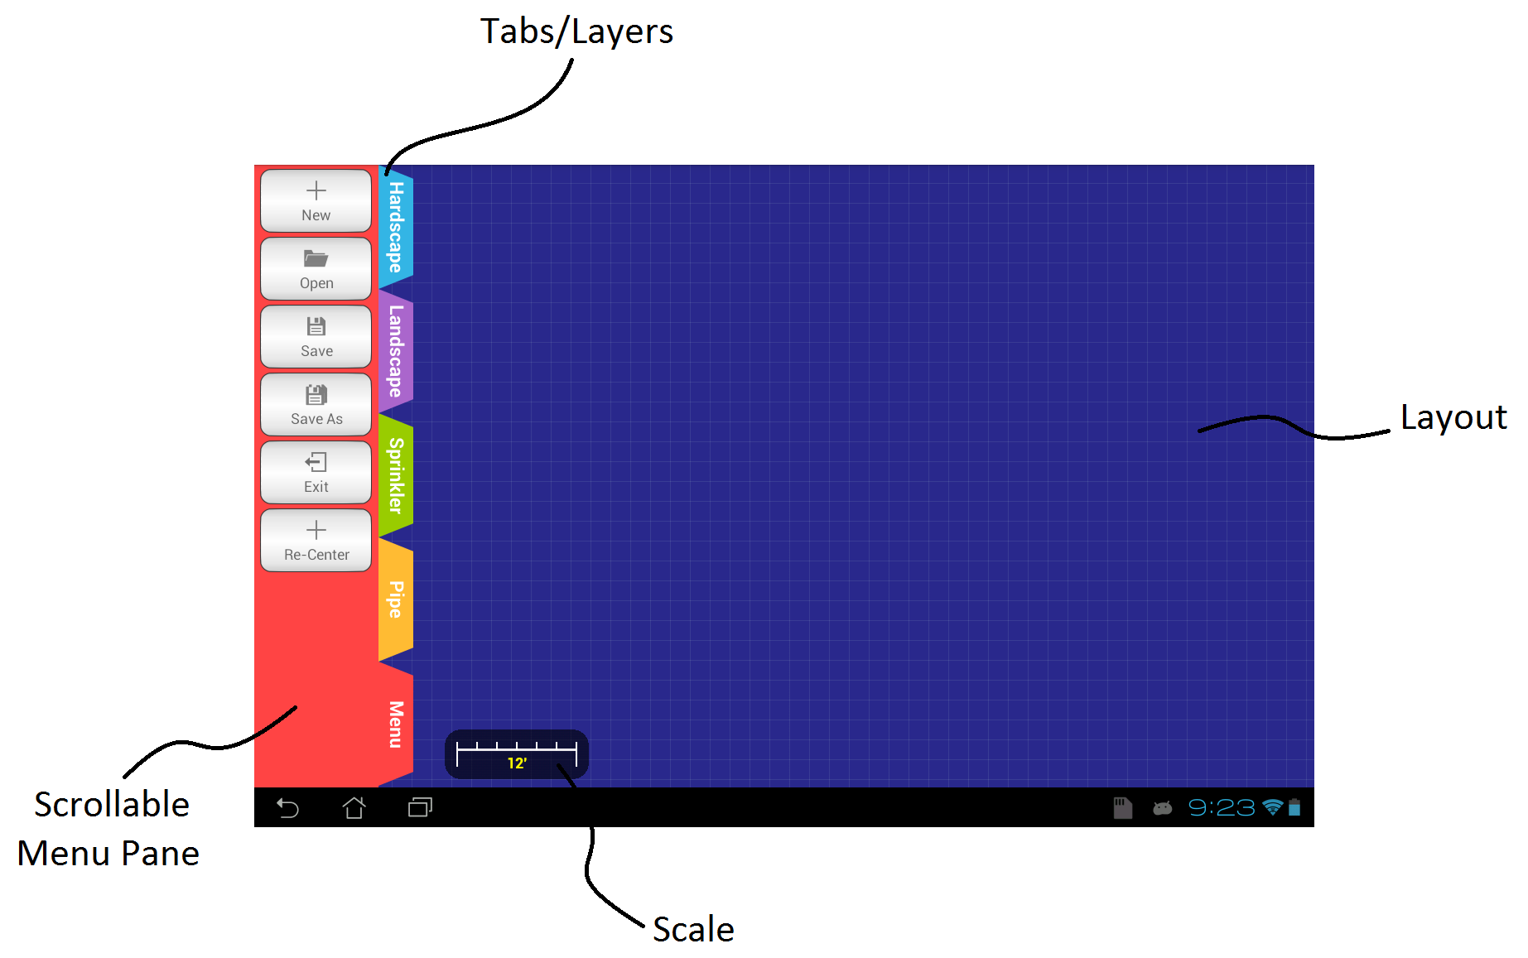

**3.2 User Interface Layout**

The basic user interface layout includes the following:

* Tabs/Layers – Tabs represent the different layers.
* Scrollable Menu Pane – Displays available options in a given layer/tab.
* Scale – The scale of a given drawing layout.
* Layout – Drawing area.

**3.3 Layers/Tabs**

Access to different tools is available by selecting tab in the tab bar. Tabs are 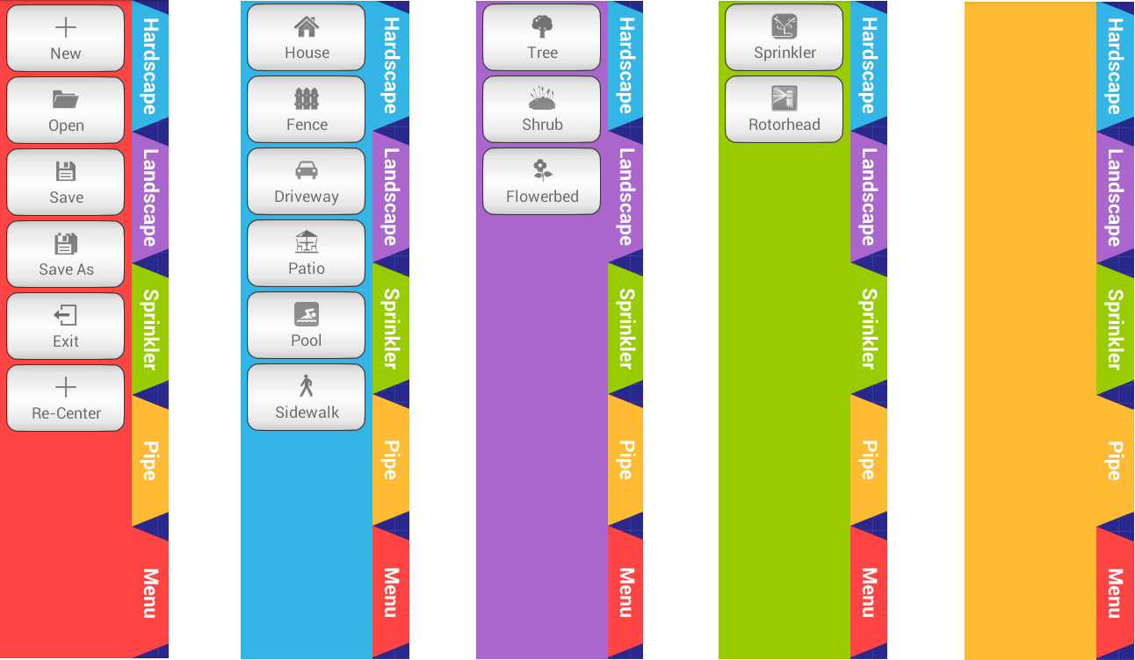illustrated bellow

*Menu Hardscape Landscape Sprinklers Pipes*

Menu:

* New
* Open
* Save
* Save As
* Exit
* Re-Center

Hardscape:

* House
* Fence
* Driveway
* Patio
* Pool
* Sidewalk

Landscape:

* Tree
* Shrub
* Flowerbed

Sprinklers:

* Sprinkler
* Rotor head

Pipes: Options for pipe layer/tab has not yet been implemented.

**3.4 Pan/Zoom**

Dragging one finger across the layout when no object is selected in the tab layer will pan the entire layout.

Pinching in and out with two fingers will zoom in and zoom out of the layout, respectively.

**4. WORKING WITH aCAD**

**4.1 Starting a new project**

1. 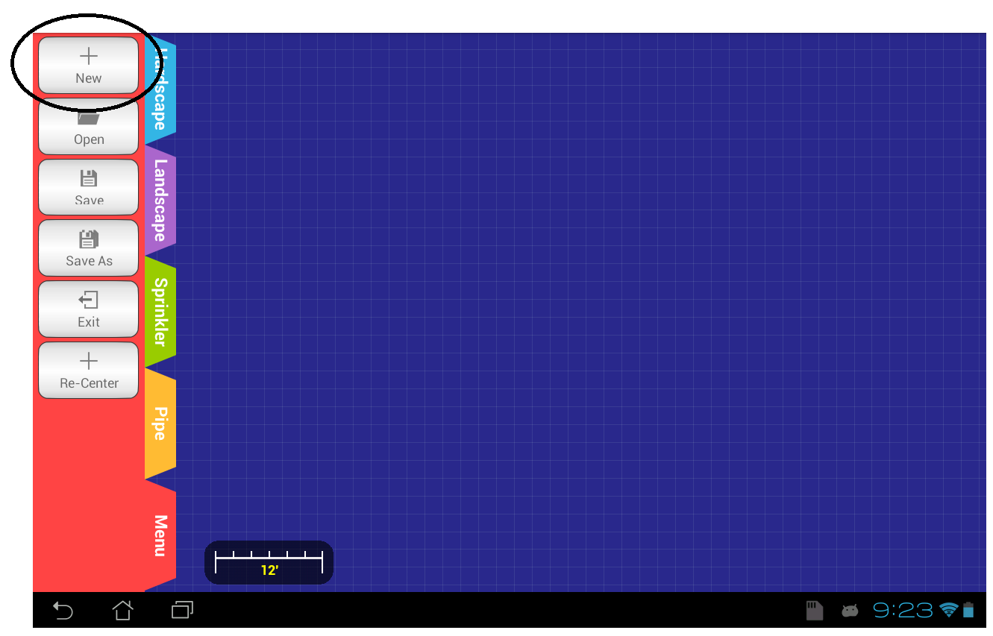Tap on the “New” button in the “Menu” tab.
2. In the dialog that appears, enter the length and width of the plot in feet. Only number are accepted as in put

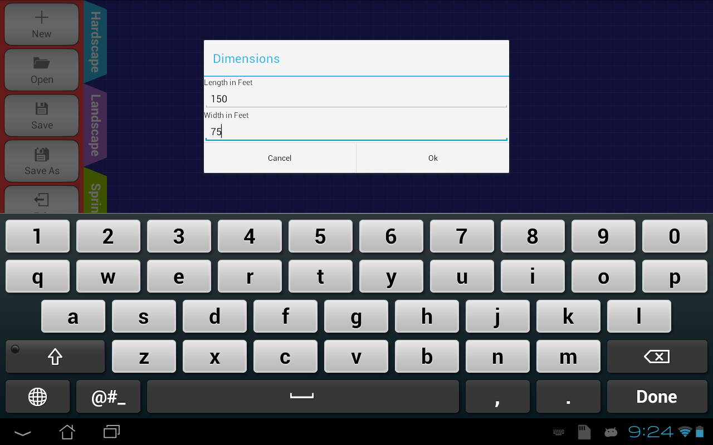

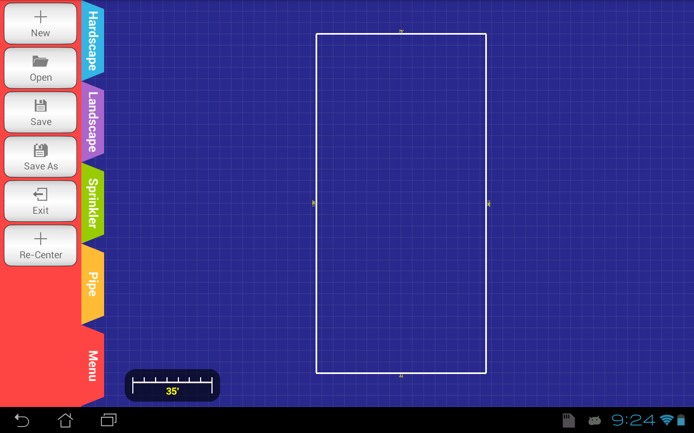3. The resulting screen should look similar to the following based on dimensions entered:

**4.2. Adding objects to the layout**

**4.2.1 Adding a house.**

1. 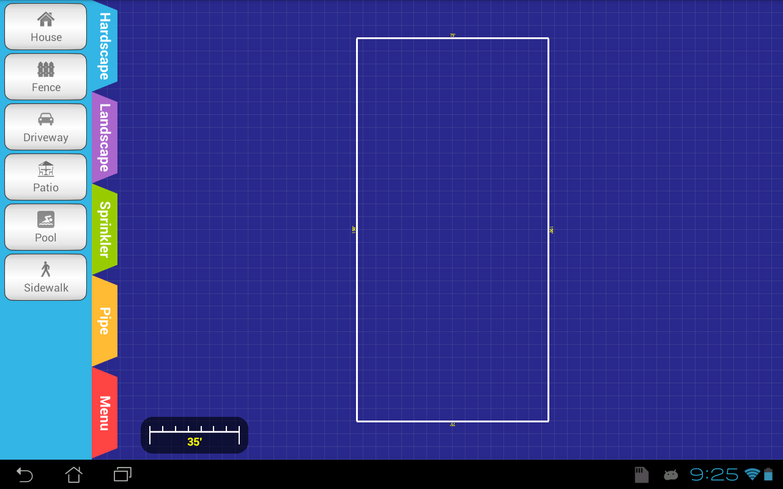Select “Hardscape” layer/tab.
2. Tap the “House” icon.
3. Tap on the layout to indicate where the basic shape of a house should be place and 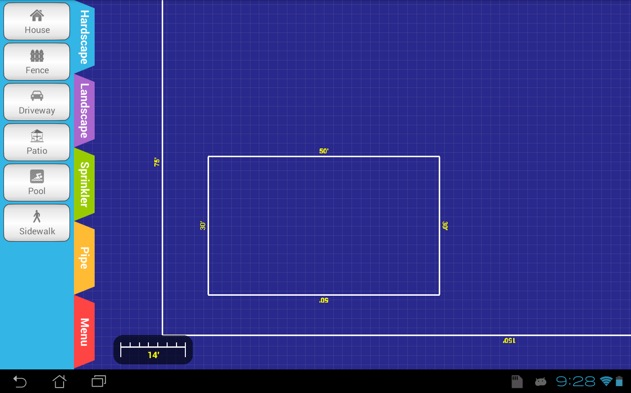enter the dimensions for the length and width in feet. In the dialog box that appears press “Ok”.

After a house is placed on the layout it is possible to edit it.

1. 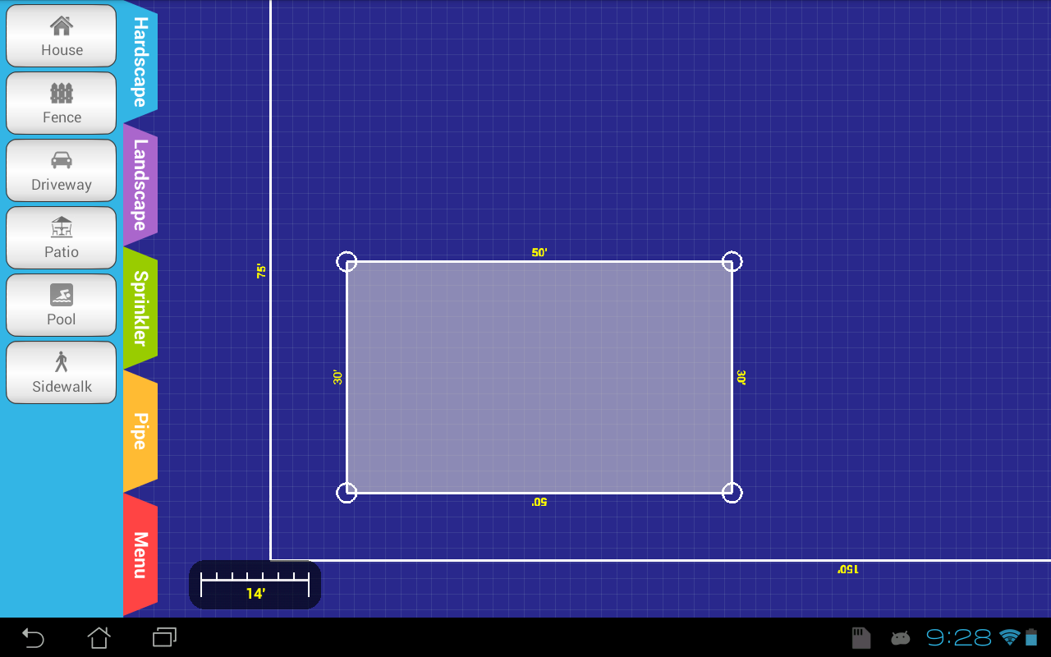Select the house object by tapping it.
2. Click on any of the four sides of the polygon will create new vertices. Create new 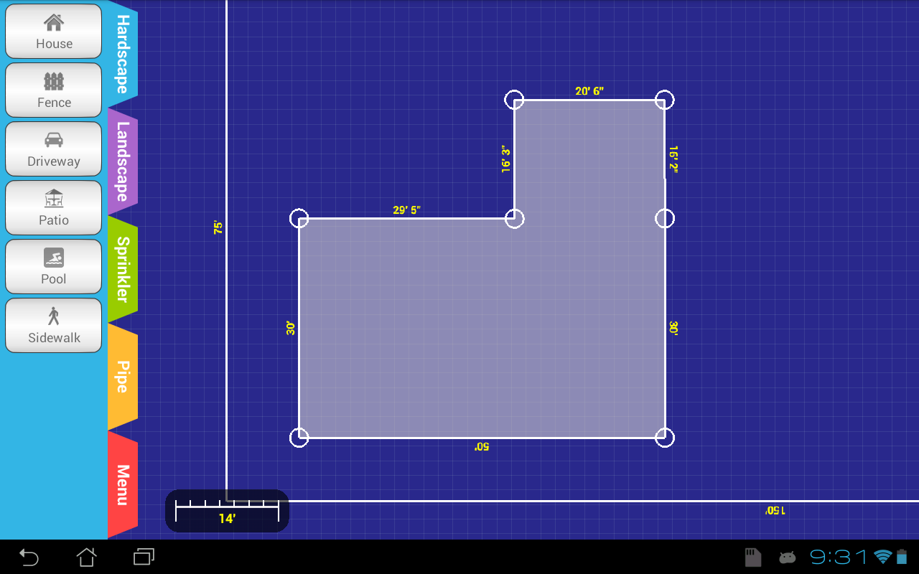vertices and refine shape of the house.
3. The house can also be rotated by touching the interior of the shape and dragging with your finger.

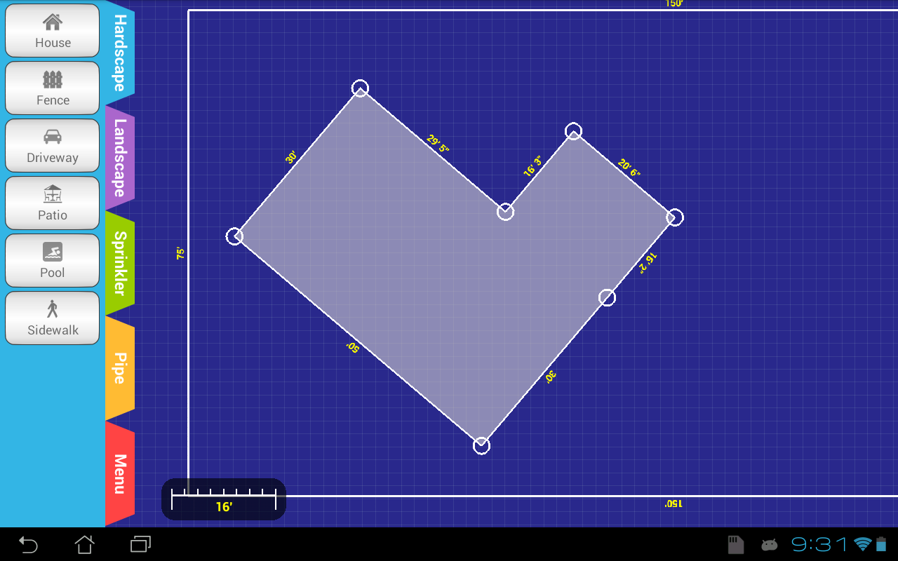

**4.2.2 Adding a sprinkler.**

1. Select “Sprinkler layer/tab
2. Tap on the “Sprinkler” icon.
3. Tap inside the layout to draw a sprinkler.

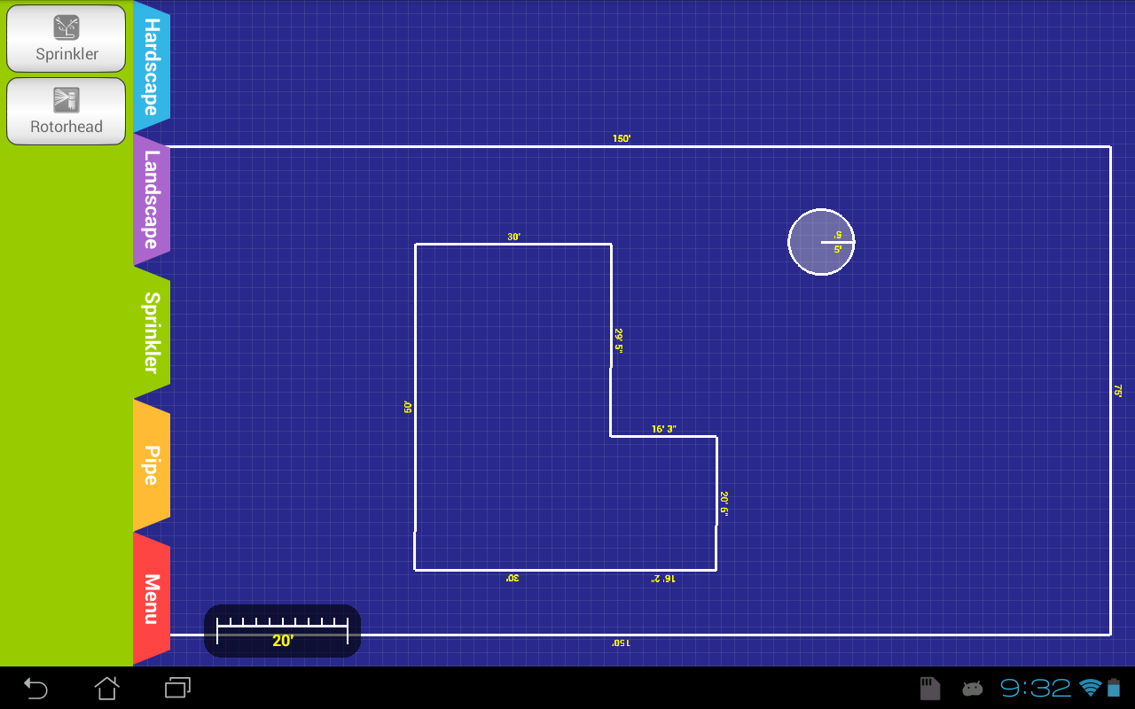

1. As with any object, a sprinkler can also be selected and edited by tapping on it.

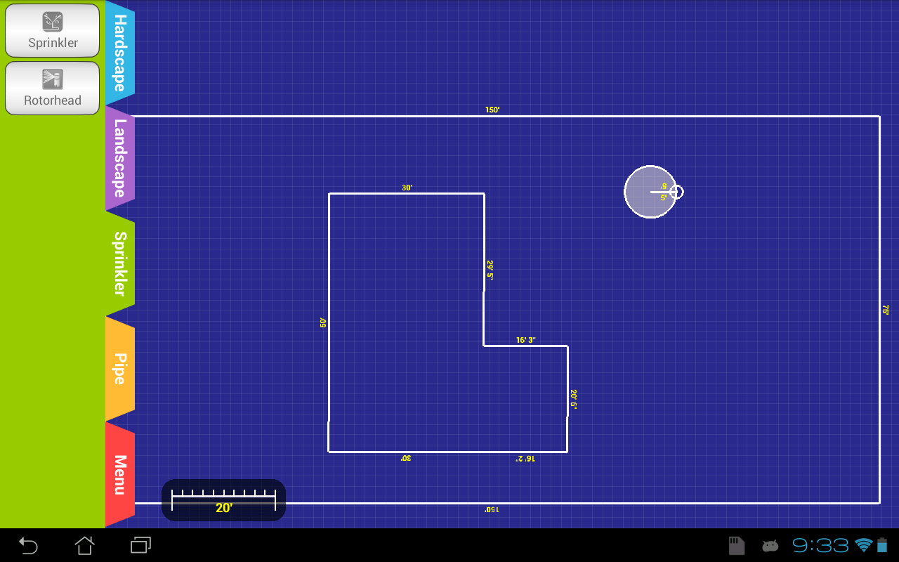

1. Adjust the spray angle of the sprinkler head by clicking on the point and rotating accordingly.

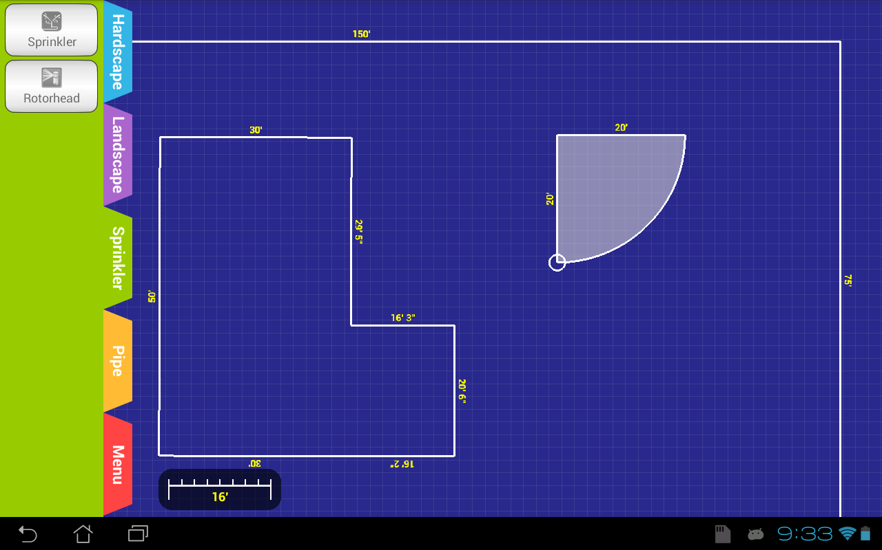

1. Position as necessary by leaving Edit Mode (touching outside of the object) anf then by touching and dragging the shape.

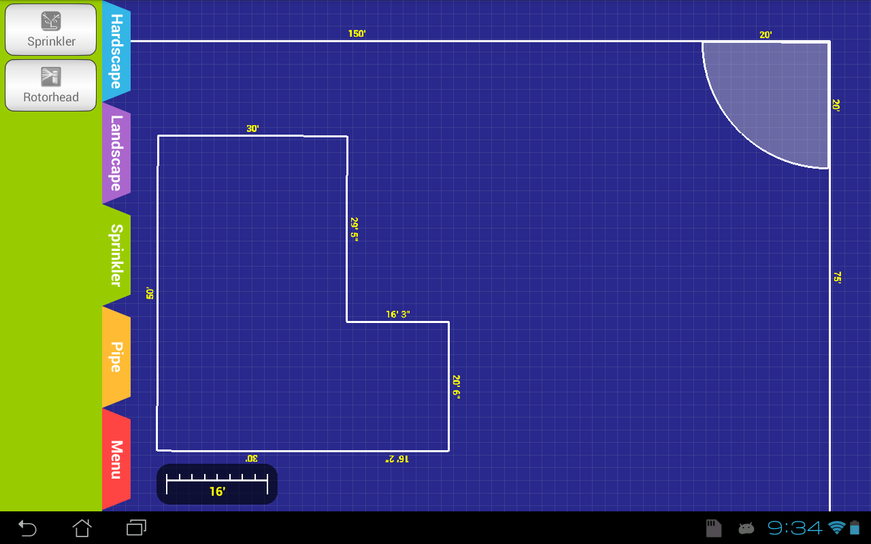

1. Place as many sprinklers or objects as needed.

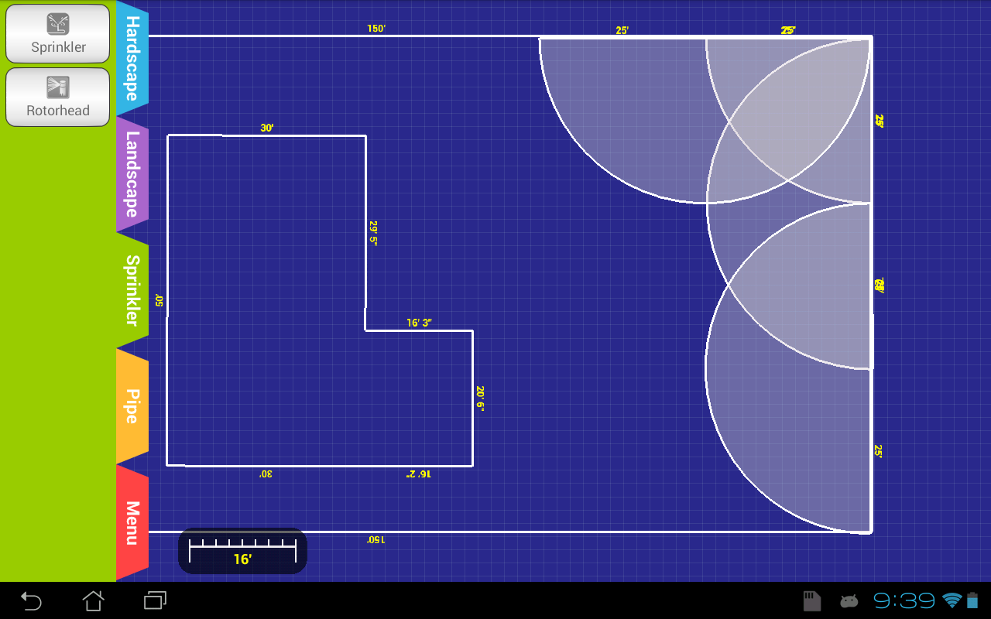

**4.2.3 Adding a fence.**

1. Select the “Hardscape” layer/tab
2. Tap on “fence” icon.
3. Tap the layout to place a fence in the layout.
4. Position the fence by dragging it across the layout to the desired position.
5. The length of a fence can also be increased or decreased by dragging from either of the end points.
6. Tap on the fence line to create new vertices for various directions or angles in the fence.

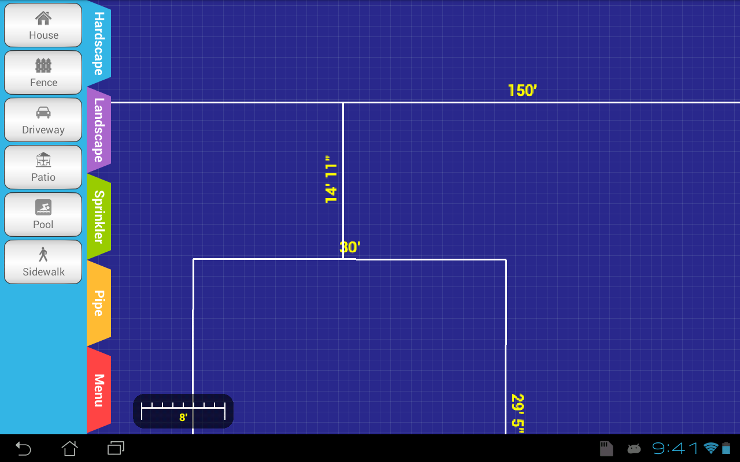

**4.2.4 Adding a driveway.**

1. Select the “Hardscape” layer/tab
2. Tap on the “Driveway” icon.
3. Tap the layout to place a driveway in the layout then enter the initial dimensions int the dialog box that appears. Click “OK”.
4. Position the driveway by dragging it across the layout to the desired position.
5. Click any of the four corner point and drag to resize the driveway.

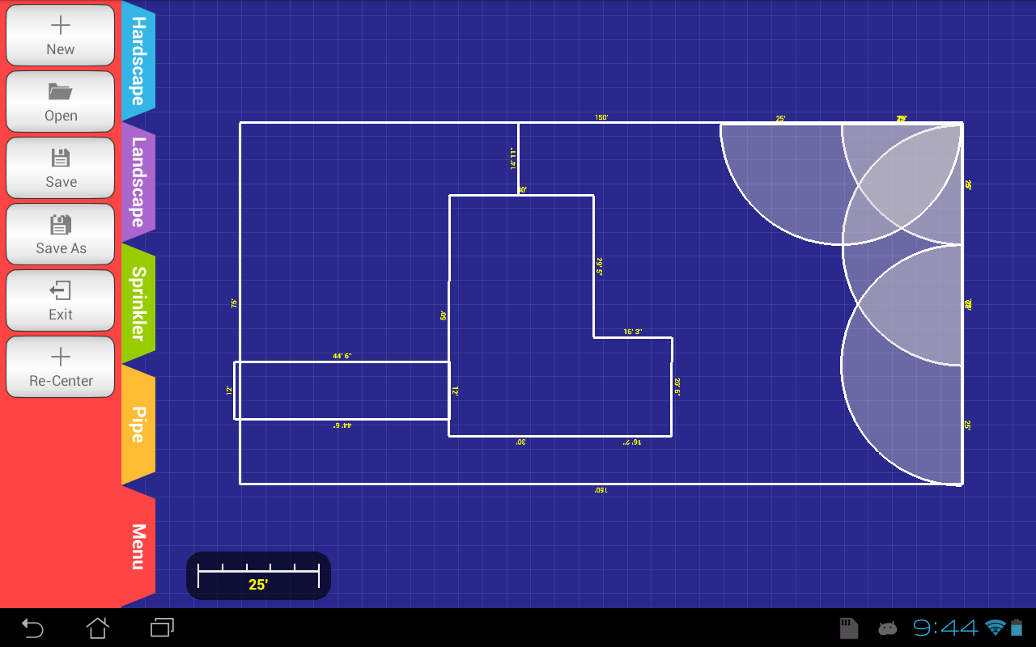

**4.3 Saving the layout.**

1. Select the “Menu” tab.
2. Tap on the “Save” icon.

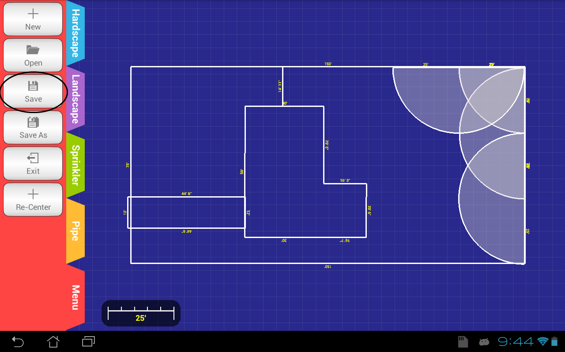

1. In the dialog box that appears type the desired name of the file.

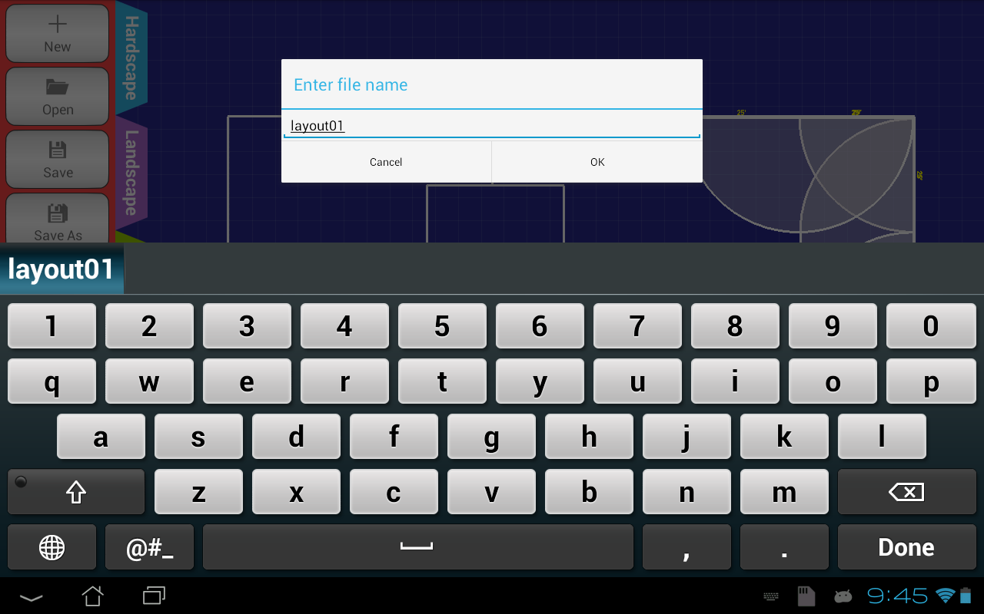

1. Tap “OK”.

**4.4 Exiting the application.**

1. Select the “Menu” tab.
2. Tap on the “Exit” button.

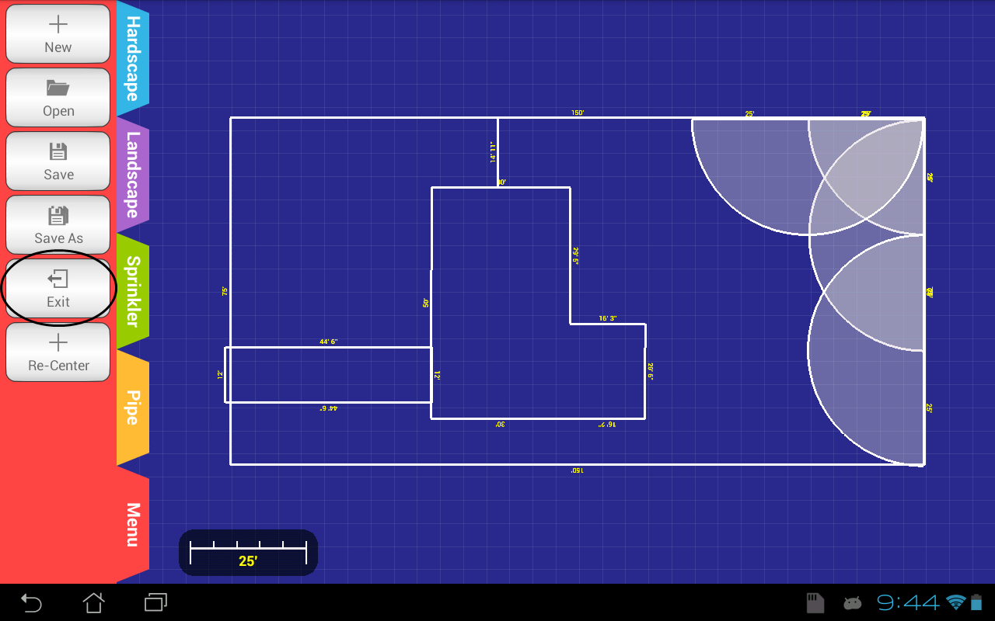

1. Tap “Yes” on the pop-up dialog message.

