Table of Contents
Table of Contents i
1. Introduction 1
A. Purpose of Plan 1
B. Project Scope and Objectives 1
1. Statement of Scope 1
2. Major Functions 2
3. Performance Issues 2
4. Management and Technical Constraints 2

II. Project Estimates 2
A. Historical Data Used for Estimates 2
B. Estimation Techniques 2
C. Estimates of Effort, Cost, Duration 5
III. Risks Management Strategy 6
IV. Project Resources 6
A. People 6
B. Hardware and Software 7
C. Special Resources 7
V. Staff Organization 8
A. Team Structure 8
B. Management Reporting 8
VI. Tracking and Control Mechanisms 8
A. Quality Assurance and Control 8
B. Change Management and Control 9
VII. Schedule 9

Introduction

A. Purpose
The purpose of this plan is to ensure that the conditions as set forth in the requirements specification document for the Munitions Storage Area are met. Major functions and constraints of the system are reviewed. Estimates of efforts, cost, and duration are covered. Risks and strategies for dealing with them are addressed. A breakdown of the project along with a timeline of milestones and deliverables is presented. Methods for reporting, quality assurance, and change management are specified.

B. Project Scope and Objectives

1. Statement of Scope
It is certainly beyond the realm of possibility for a group of Software Engineering students in one or two semesters to develop the proposed system. The main objective is to produce a prototype that the users can present to their superiors at the Utilization and Training Workshop. The prototype will provide a user-friendly, graphical user interface that works on top of the database and should demonstrate enough features to persuade the Chiefs to allocate money to hire a professional software development firm to develop the full-blown version. The development process will take place over a two-semester period. Phase 1 has been completed. This project plan, along with a draft of a user manual and a test plan of the Phase 1 functions, will be delivered to the second semester group. They will then expand and refine the prototype that will be delivered to the customer.

2. Major Functions
While the final version of the proposed software has many requirements, the prototype will focus on asset management and must be able to at least show asset management activity as follows. The requirements are shown for Phase 1 and 2.

Phase 1 Functions
- Search database for components or assembled parts
- Move individual component(s) from one or more structures (storage areas) to a trailer
- Update database entries of individual components and assembled parts as a result of movement activities

At the end of Phase 1, the prototype successfully allows the user to search for components. It successfully provides for the movement of components from a structure to a trailer. Rather than drag and drop, the movement is currently described as "click to move." This allows the user to click on the asset to be moved and input how many components to move. The prototype successfully updates the database to reflect the move. Phase 1 did not implement assembly of components and the resulting addition of a new component to the database.

Phase 2 Functions
- Move a trailer to Conventional Maintenance where the parts are assembled
- Assemble components
- Move assembled parts from Conventional Maintenance to one or more structures or flight line
- Move assembled parts from structures to flight line

3. Performance Issues
Efficiency and reliability are not a major concern for the prototype. However, the application must correctly interface with a database that is a reasonable facsimile of the actual database currently in use. The prototype should also be user-friendly and easy to understand. It must behave well enough so that the Chiefs will be convinced that the proposal is plausible.

4. Management and Technical Constraints
This project must run on a standard Windows 2000 system. Likewise, the development environment will also be Windows 2000. The project is to be written in Visual C++ with Microsoft Foundation Class for user input. OpenGL was a possibility for implementing the graphical interface, but was not utilized during Phase 1. Delivery date for the Phase 1 prototype along with all appropriate documents was December 5, 2003.

II. Project Estimates

A. Historical Data used for Estimates
Historical data available for purposes of estimation consists of knowledge of time and effort spent completing projects in previous formal coursework. While hardly quantitative, such knowledge permits some sense of time and effort required to complete certain tasks that are part of this project. Such tasks are known to include learning to use unfamiliar class libraries, debugging moderately complex programs, lucidly and adequately commenting modestly sophisticated source code, and preparing supplementary documentation such as reports.

B. Estimation Techniques
The estimation program COCOMO II was used to formulate projected effort and duration. Costs were essentially nil, since all labor was provided by team members (all of whom are students), consultants volunteered time and knowledge, and all materials were either provided gratis or had been previously purchased by team members (personal hardware and software).
An estimation of source lines of code (“SLOC” in COCOMO) was made using function point analysis. Function types were identified and converted to function points as follows:

(1) The prototype was considered to have one of each function type as described in function point analysis. The graphics aspect of the prototype was considered to have one
external input (EI) function, one external output (EO) function, and one external query (EQ) function. The database was considered to have one internal logical file (ILF) function and one external interface (EIF) function.

(2) The complexity of each function type occurrence was determined from the following table in the COCOMO User’s Manual:

For ILF and EIF |  |  |  | For EO and EQ |  |  |  | For EI
Record Element s | Data Elements |  |  | File Types | Data Elements |  |  | File Types | Data Elements
 | 1 - 19 | 20 - 50 | 51+ |  | 1 - 5 | 6 - 19 | 20+ |  | 1 - 4 | 5 - 15 | 16+
1 | Low | Low | Avg | 0 or 1 | Low | Low | Avg | 0 or 1 | Low | Low | Avg
2 - 5 | Low | Avg | High | 2 - 3 | Low | Avg | High | 2 - 3 | Low | Avg | High
6+ | Avg | High | High | 4+ | Avg | High | High | 3+ | Avg | High | High

(3) The complexity-weight for each function-type occurrence was determined from the following table (COCOMO User’s Manual):

Function Type | Complexity-Weight
 | Low | Average | High
Internal Logical Files | 7 | 10 | 15
External Interfaces Files | 5 | 7 | 10
External Inputs | 3 | 4 | 6
External Outputs | 4 | 5 | 7
External Inquiries | 3 | 4 | 6

(4) The function-point total was calculated as shown in the following table:

Graphics |  |  |  | Database
Function  Type | No. | Complexity | Unadjusted  Function  Points | Function  Type | No. | Complexity | Unadjusted  Function  Points
ILF | 0 |  |  | ILF | 1 | Avg | 10
EIF | 1 | Low | 5 | EIF | 0
EI | 1 | Low | 3 | EI | 0
EO | 1 | Avg | 5 | EO | 0
EQ | 1 | Avg | 3 | EQ | 0
 |  |  | 16 |  |  |  | 10
Total Function Points for Graphics and Database |  |  |  |  |  |  | 26

(5) The project’s language, C++, is not included in COCOMO’s automatic function-point-to-SLOC conversion function. However, the COCOMO II User’s Manual suggests 29 SLOC (source lines of code) per UFP (unadjusted function point):

16 UFP times 29 SLOC / UFP = 464 SLOC (graphics)
10 UFP times 29 SLOC / UFP = 290 SLOC (database)

754 SLOC (total)

(6) These values were entered into the COCOMO Component Level Estimation Form, resulting in a 2.1 person-months (PM) estimate for project effort, as shown below (total of PM estimates, in columns labeled “Nom EFFORT Dev” and “Est EFFORT Dev”, of 1.3 PM for graphics and 0.8 PM for database efforts). This translates, based on a 168-hour workmonth, to approximately 350 person-hours. This is the value that is used for the project schedule (see Section IV).

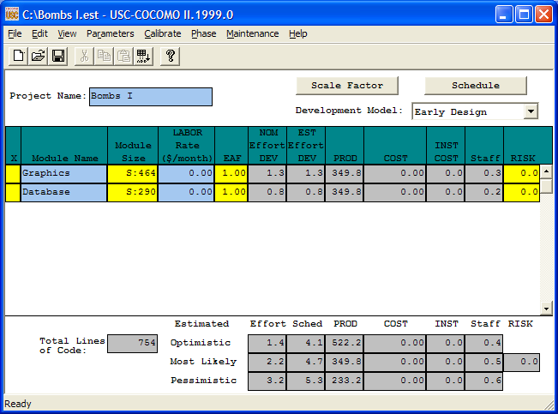

(7) The Phase 2 project was considered to have additional functions of the external query (EQ type) and the number of these additional functions was arbitrarily set at two: there are actually approximately six query types in the Phase 2 project as opposed to one or two in Phase 1, but similarities among the queries suggests that three functions of the external query type should encompass this aspect of the Phase 2 project. Calculations as elaborated above yield a total of 32 function points, translating to 928 source lines of code. COCOMO II assigns a total of 2.7 person-months to this project, or about 450 person-hours.
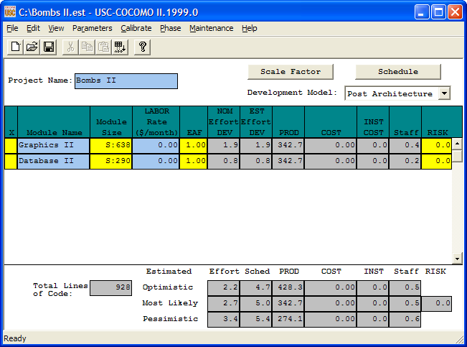

C. Estimates of Cost, Time, and Effort
To summarize the findings from the above:

There is no monetary cost associated with the project.
The Phase 1 project is estimated to require approximately 350 person-hours to complete.
The Phase 2 project is estimated to require approximately 450 person-hours to complete.

Note that
(1) The assignment of function types to “Graphics” and “Database” is arbitrary; for this reason, effort in terms of person-hours is not subdivided into these categories.
(2) COCOMO II makes the disclaimer that it is not “calibrated” for total lines of code fewer than 2000.
(3) COCOMO II uses “unadjusted” function points because the “adjustments” that are usually made in calculating function points do not agree with COCOMO’s experience.

III. Risks Management Strategy
Major identified risks are outlined in the table below.

Risk Table
Risk | Chance | Impact | Strategy
Illness of Team Members | Low | Tolerable | Allow a few days buffer.  Redistribute sick member's work
Procrastination | Low | Serious | Have frequent meetings to monitor progress
Changes in Requirements | Moderate | Moderate | Follow appropriate configuration management procedures
Compatibility Constraints | Low | Serious | Extra Research
Learning Curve for use of MFC classes may be too great | High | Serious | Find and use as much reference material as possible. Consult Mr. Simpson

Risk Management

Risk analysis, monitoring, and management will be employed throughout the design process. Constant reference to the requirements specification document along with the project plan and Gantt chart will help to keep the team members focused.

Learning to use MFC classes proved to be the greatest obstacle for Phase 1 of the project. It is strongly recommended that the Phase 2 participants start learning MFC as soon as possible.

IV. Project Resources

A. People
(1) The project team for Phase 1 consisted of
(a) one member experienced in programming computer graphics systems
(b) one member experienced in programming database management systems
(c) one member who concentrated on interacting with the user advisory group
(see below)
(d) one member who maintained communication with the customer and coordinated all of the activities described above.

There was considerable overlap between each of the roles outlined above, and many tasks were approached as a joint effort.

(2) Phase 2 members should consult as needed experts in database management (Dr. Passos), graphical user interface (Mr. Simpson), and general software engineering issues (Dr. Stringfellow). They should also feel free to consult Phase 1 members. Their email addresses are:

bobbadoc@aol.com (Bob Moss)
otto131699@yahoo.com (Otto Iskandar)
cerise.wuthrich@esc9.net (Cerise Wuthrich)
mark.jones.0112@wichita.mwsu (Mark Jones)

(3) The user advisory group consists of Steven Schied and John Warehime, who currently operate the Munitions Depot at Sheppard Air Force Base, Wichita Falls, Texas. Their email addresses are:

John.Warehime@sheppard.af.mil

Steven.Schied@sheppard.af.mil

The composition of the entire Phase II software engineering team is currently unknown. Available consultants and user advisory group are anticipated to be the same.

B. Hardware and Software

Hardware for the development phases (in both Phase 1 and Phase 2) of the project consists of personal desktop and laptop computers, as well as the computing facilities available to team members in the Midwestern State University computer science laboratories.

Software for both Phase I and Phase II includes, but is not limited to
Microsoft Windows XP
Microsoft Windows 2000 Professional
Microsoft Visual C++ 6.0
Microsoft Project
Microsoft Access
Togethersoft Together

C. Special Resources

Considerable information regarding both munitions materials and use of various software packages will be obtained from the World Wide Web. In addition, guided physical access to the munitions training facility of Sheppard Air Force Base will enhance the team’s understanding of the purpose of the project prototype.

V. Staff Organization

A. Team Structure
During Phase 1, the team used the democratic decentralized model for team structuring. All members contributed something to all parts of the process - requirements specification, project design, coding, implementation, and testing. A consensus was reached among the group concerning all major decisions. No one member was considered to be the leader for the duration. Whoever had the most expertise during a particular phase took on a leadership role. Bob had the greatest expertise in database design and integration. Otto had the most contact with the customer and has the best grasp of the user interface design that is required. Mark was the lead OpenGL consultant. Cerise was responsible for assembling and formatting documents and presentations required from the team.

The team used an evolutionary process model with incremental development. Prototyping was included.

B. Management Reporting
In the beginning of the project, three meetings with the customer were held, two of those at MSU and one at Sheppard Air Force Base. After that, communication with the customer was primarily via e-mail.

The team had weekly meetings in person and frequent communication via e-mail and telephone. Minutes were kept for most meetings. Files were exchanged electronically and final hard copies of document deliverables were distributed to all team members.

It is recommended that Phase 2 members start with the prototype from Phase 1. Whenever any significant function or improvement is made to the system, all members should then use that version as the basis for any further modifications.

VI. Tracking and Control Mechanisms

A. Quality Assurance and Control
Procedures and standards were implemented during Phase 1 in an effort to produce high quality software. While it is preferable to have a quality assurance team independent from the project plan team, for the students involved in this project, this was not possible. Phase 2 will be responsible for assuring that the design of the project conforms to the requirements. Periodic inspection and testing will be performed. Corrective action will be taken when the project does not behave as expected.

Documentation of all code will be done to insure readability. Programming will be done in C++ using the MFC classes. When periodic quality tests are done, if the quality is acceptable, the particular process will be standardized. If not acceptable, the process will be improved.

Goals include reliability, robustness, understandability, adaptability, modularity, portability, usability, efficiency, and learnability.

Informal tests will check for proper integration with the database, proper representation of the user interface, implementation of drag and drop capabilities, and appropriate update of the database. A test plan will be produced and used at the end of the project.

B. Change Management and Control
If a change in the requirements (as set forth in the requirements specification document) is needed, a formal process for change management will assure that all change proposals are treated consistently and changes are made in a controlled manner. The following process will be followed:
1. The problem will be identified
2. A change will be proposed
3. An analysis of the effects and cost of the change will be discussed
4. A decision will be made whether to proceed with the change or not
5. If a change is agreed upon, modifications to the requirements document will be made first. Then appropriate changes to system design and system implementation will be detailed.

VIII. Schedule
Charts and diagrams attached.

