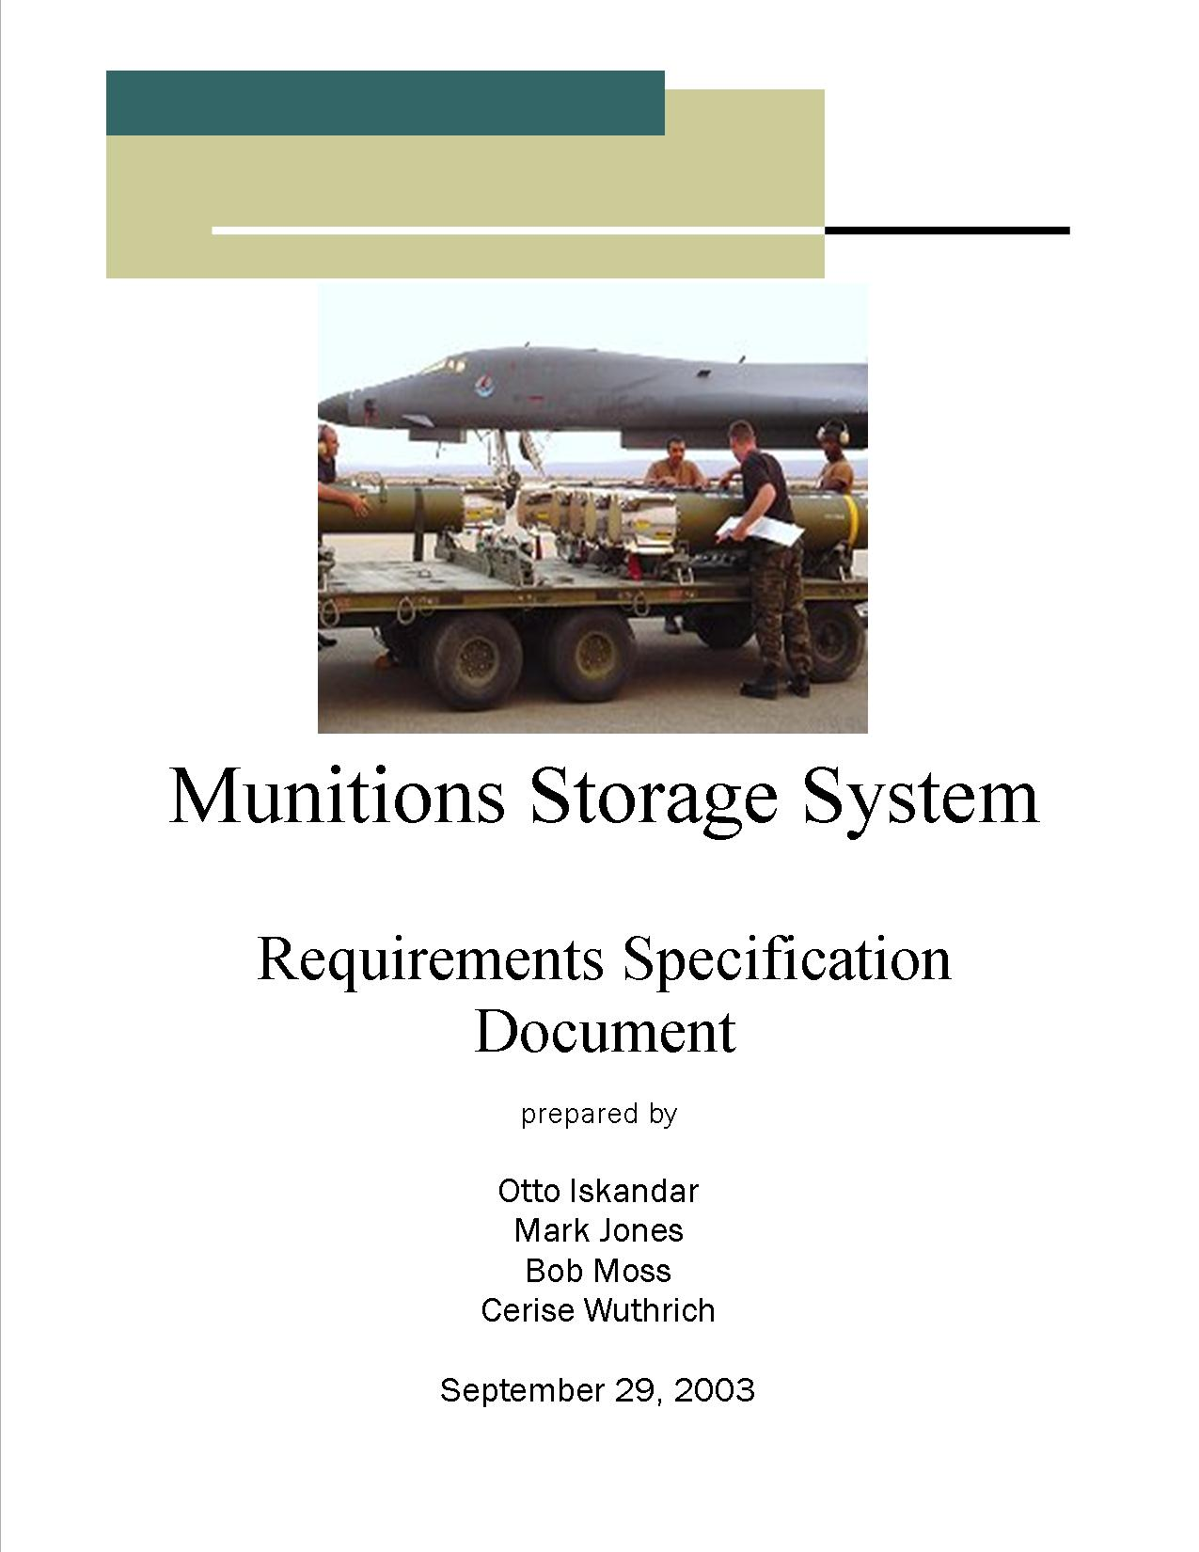Table of Contents
Table of Contents ii
1. Introduction/Overview 1
1.1 Purpose 1
1.2 Scope 1
1.2.1 Main Objective 1
1.2.2 Specific Goals 2
1.3 Overview of Document 2
2. System 2
2.1 Target Environment 2
2.2 Who are users? 3
2.3 Functional Requirements 4
2.3.1 Issues 4
2.3.2 Major Subsystems or Functions 4
2.3.3 Minor System Functions 5
2.3.4 Major Classes Identified 6
2.4 User Interface Specification 6
2.5 Non-functional requirements (constraints) 7
2.5.1 Management 7
2.5.2 Technical 7
2.5.3 Performance 7
2.5.4 Security 7
2.5.5 Ethics 8
2.6 System Evolution/Maintenance 8
3. Other Deliverables required 8
4. Risks 8
5. Glossary 8
6. References 9
7. UML Diagrams 10

Introduction/Overview

Purpose
The customer receives, stores, inspects, maintains, and transports components for bombs and other munitions in support of war fighting capabilities. In addition, individual components can also be assembled into various bombs and missiles. Inventories on the assets are periodically performed. All individual components, along with partially assembled and fully assembled bombs, must be tracked by the system until they are used, recalled, or their service life expires.

The current system for management of the assets is CAS – Combat Ammunition System. It uses Kermit to interface with a local DB2 server that contains a Microsoft Access database of all pertinent information. The current system allows the user to search the database for a given component, check its location, quantity, condition, and availability. It is possible to change any of this information about the component by interfacing with the database through a series of screens and manually updating all information through the keyboard.

The current system is old, slow, and prone to error due to extensive entry of complex alphanumeric data. The customer wants a system which will be easier to use and graphical in nature. While the current system requires the user to enter considerable amounts of data from the keyboard and navigate among many screens to accomplish one simple task, the customer envisions a system that accomplishes the same task using icons, drag and drop capabilities, pull-down menus, and other GUI characteristics.

In addition, the customer would like to add several features to the system. The customer would like to be able to track personnel within the system and determine who is available for a particular task. They also want to be able to track equipment needed in the inspection, transport, and assembly process. Furthermore, they would like to be able to visually inspect a storage facility.

Scope

Main Objective
It is certainly beyond the realm of possibility for a group of Software Engineering students in one or two semesters to develop the proposed system. The main objective is to produce a prototype that the users can present to their superiors at the Utilization and Training Workshop. The prototype will provide a user-friendly, graphical user interface that works on top of the database and should demonstrate enough features to persuade the Chiefs to allocate money to hire a professional software development firm to develop the full-blown version. The development process will take place over a two-semester period. During the first semester, a Phase One prototype, along with specifications for further requirements, will be delivered to the second semester students. They will then expand and refine the prototype that will be delivered to the customer.

Specific Goals
The customer desires a system that is graphical in nature. Icons, toolbars, use of a mouse and drop-down menus will be implemented. A visual layered approach with tabs representing various segments of the operation is envisioned. With each layer, icons representing objects relevant to that part of the operation will be visible. It will be possible to use drag and drop capabilities to represent movement and storage of assets.

Overview of Document
The remainder of the document is intended to inform the customer, along with Phase 1 and Phase 2 developers, of the intended system. Hardware and software requirements, major users, both major and minor functions, constraints, and intended user interface are described.

System

Target Environment
The project development environment will be as follows:
Hardware will include a personal (desktop or notebook) computer with the following specifications:
- a Pentium 4 microprocessor running at 2.0 GHz or above
- a minimum of 128 megabytes of system RAM
- a CD-RW drive
- a v.92-compliant 56K modem
- a hard drive with at least 2 gigabytes of free space
- an XGA screen display 14” or larger
- a graphics card with 16 megabytes or more of RAM

Software utilized will include:
- Windows 2000
- Microsoft Visual C++ 6.0
- Database software
- Microsoft Project
- Togethersoft 6.0.1

The prototype developed in Phases 1 and 2 will utilize the following:
Hardware - a personal notebook computer with the following specifications:
- a Pentium 4 microprocessor running at 2.0 GHz or above
- a minimum of 128 megabytes of system RAM
- a CD-RW drive
- a v.92-compliant 56K modem
- a hard drive with at least 2 gigabytes of free space
- an XGA screen display 14” or larger
- a graphics card with 16 megabytes or more of RAM

Software:
- Windows 2000
- Executable file developed by the project team
- Database software

Who are the users?
The users of the Phase 1 system, as well as the Phase 2 system, are the munitions depot personnel who will enter commands into the system computers. These personnel execute the role of ultimate prime actor in all use cases that describe the actual computer/software system in both phases. There are, however, many stakeholders. Munitions inspection officers, workers in the accounting system, weapons manufacturers, custodians, transporters, individuals involved in training efforts, munitions accountability officers, senior officers, and governmental regulatory agencies all have vested interests in the system.

The respective values that each of these entities receives from the system are as follows:

Munitions Inspection Officers:
- entry of a newly arrived and inspected asset into the system
- cataloguing of assets requiring a time-triggered (i.e., periodic) inspection
- exit of an asset from the system when it is inspected and released to a custodian

Accounting Personnel:
- tracking flow and inventory of assets
- generating required reports

Weapons Manufacturers:
- can use a more efficient, less error-prone system to enable more timely and appropriate asset delivery

Custodians:
- can use a more efficient, less error-prone system to enable more timely and appropriate completed munitions round receipt

Transporters:
- benefit from more efficient trailer use and inventory

Trainers and Trainees:
- a less arcane, more informative user interface will be more easily taught and learned

Munitions Accountability Officers:
- easier tracking of depot inventory and of rounds released to custodians

Senior Officers:
- greater efficiency in carrying out the war effort

Governmental Regulatory Agencies:
- greater accuracy and easier visualization of the depot’s compliance with regulations and policies

Functional Requirements

Issues
While the final version of the proposed software has many requirements, the prototype will focus on asset management and must be able to at least show asset management activity as follows. The issues are shown for Phase 1 and 2.

Phase 1
- Search database for components or assembled parts
- Move individual component(s) from one or more structures (storage areas) to a trailer
- Update database entries of individual components and assembled parts as a result of movement activities

Phase 2
- Move a trailer to Conventional Maintenance where the parts are assembled
- Assemble components
- Move assembled parts from Conventional Maintenance to one or more structures or flight line
- Move assembled parts from structures to flight line

Major Subsystems or Functions

Phase 1
- Move Asset: show visual movement of component(s) or assembled part(s) and update database accordingly
- Asset search or query: dialog with user for search input and perform database query
- Explore asset: explore asset database
- Show asset data in text format: display asset database search or explore result in text format
- Show asset data in map format: display asset database search or explore result in map format

Phase 2
- Move Trailer: show visual movement of a trailer and update database accordingly (database update is optional for the prototype)
- Assemble component: create assembled part(s) from individual components, display, and update database accordingly

Minor System Functions
- Display asset movement: visual representation of asset movement
- Asset movement compatibility check: check if asset movement follow compatibility rules and display dialog box (to show warning and to allow user overwrite)
- Asset movement constraint check: check if asset movement is valid or not and display dialog box (to show warning)
- Asset database update: asset database update upon completion of asset management activity
- Display trailer movement: visual representation of trailer movement
- Display text window (text format): display asset data in text format
- Display map window (map format): display asset data in map (visual) format
- Display main window: display ammunition dump at SAFB map
- Explore structure: query and display all asset data in a structure. If text format is selected, display in spreadsheet representation. If map format is selected, display layout of structure and lots containing asset data (short format to fit lot).
- Explore structure lot or stack (side view): query and display all asset data in a lot. If there are stack of containers in a lot, display side view (2-D) representation of the stack if map format is selected. If in text format, display asset data in spreadsheet representation.
- Explore container: query and display all asset data in a container. If text format is selected, display in spreadsheet representation. If map format is selected, display layout of container and components containing data (short format to fit component).
- Display component and assembled part: query and display asset data for the selected component in text format.
- Search database by text: handle user input and perform database query
- Display database search: display search result either in spreadsheet (text) or visual (map) representation (correspond to format selection)
- Explore flight line: query and display all asset data in flight line. If text format is selected, display in spreadsheet representation. If map format is selected, display layout of flight line and aircrafts(s) containing data (short format to fit aircraft).
- Display aircraft: query and display asset data for the selected aircraft in text format
- Display trailer: query and display asset data for the trailer in text format

Major Classes identified
- Main Window
- Menu Bar
- Common Toolbars
- Tabs Child Window
- Map View Child Window
- Text View Child Window
- Component
- Assembled Part
- Container
- Container Stack
- Storage Lot
- Storage Structure
- Trailer
- Conventional Maintenance
- Flight Line
- Aircraft

User Interface Specification
The customer's idea of the preliminary user interface is shown below:
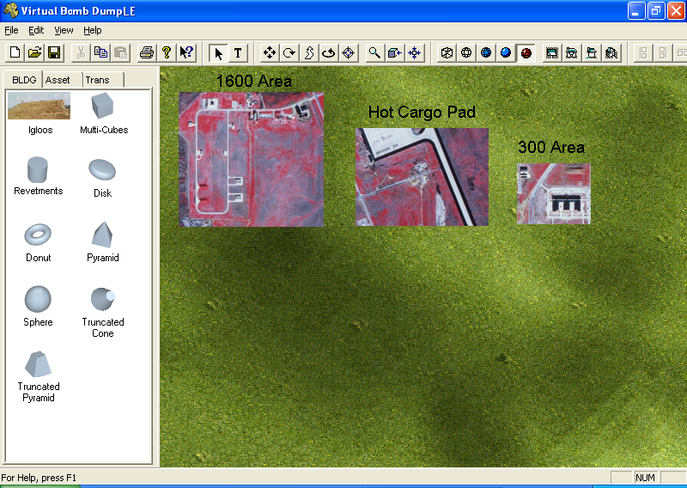
In accordance, the preliminary user interface should consist of at least the following:
- Main window with title text and window management buttons
- Main menu bar (file, edit, view, help, etc.)
- Standard toolbar (save, new, copy, paste, etc.)
- Child window that can show both map view and text view
- Asset tab (child window) containing buttons for asset management functions or activities
- Structure tab (child window) containing buttons for structure management functions (optional)
- Equipment tab (child window) containing buttons for equipment management functions (optional)
- Personnel tab (child window) containing buttons for personnel management functions (optional)
- Tasks tab (child window) containing buttons for tasks management functions (optional)
- Mobility tab (child window) containing buttons for mobility management functions (optional)
- Planning tab (child window) containing buttons for planning functions (optional)

Non-functional requirements (constraints)

Management
Due to this being a student-developed project, there will be no cost incurred on our part. Phase 1 must be developed during the Fall semester and completed by December 2003. Phase 2 is to be developed during the Spring semester and completed by May 2004. Periodic reviews and testing of the listed functions should be conducted to insure that each phase of the prototype meets the requirements. This includes verifying the database while interacting with the prototype.

Technical
This project must run on a standard Windows 2000 system. Likewise, the development environment will also be Windows 2000. The project is to be written in Visual C++ with Microsoft Foundation Class for user input. OpenGL will be used to handle the graphical interface.

Performance
Efficiency and reliability are not a major concern for the prototype. However, there should be a reasonable effort to insure that the database this project interfaces with is not unnecessarily cluttered and that there are no major errors that occur. The prototype should also be user-friendly, in that it needs to impress those of whom it is demonstrated to.

Security
The customer has requested that the completed program contain a keycard system to be used to restrict unauthorized access into the system. The Phase 2 prototype will have a standard password access to demonstrate that security is possible in later versions.

Ethics
The final product, as well as the prototype, should only enable the functions available to the current user, thus preventing unauthorized activities. When viewing properties of an entity (Structure, Asset, etc), only those fields relative to the user’s role should be displayed.

System Evolution/Maintenance
This project should be written with expansion in mind. The customer desires that upon approval of their superiors this prototype will be developed into a full-fledged application encompassing the entire scope of their operations.

Other Deliverables
At the end of Phase 1 (December 2003), a project plan, requirements specification document, test plan, prototype, and user manual outline will be delivered to the second semester students. At the end of Phase 2 (May 2004), a revised and updated specification document, an extended prototype, and a user manual will be delivered to the customer.

Risks
The risks involved in the development of the system include lack of communication. Phase 1 students must communicate not only with the customers, who could possibly be transferred to another base or deployed, but also with Phase 2 students who are at this time unknown.

There is also the risk that the developers do not have a complete understanding of the entire munitions storage system in general. Lack of access to the current CAS system by the developers could result in a misunderstanding of certain tasks. Also, the developers do not have access to the existing database that could result in problems with integration of the system.

Glossary

3B2 – server manufactured by AT&T and used mostly by government entities

AUR – All Up Round – a ready to go bomb

CAS – Combat Ammunition System (does not include nuclear weapons)

Compatibility properties –net explosive weight and incompatibility group assigned to each asset which should be checked prior to movement

Condition Code – a code given to components indicating the current status (Ex. – condition code G means the part is missing something in order to be operational)

Conventional Maintenance – the part of the Munitions Storage System which assembles individual components into more complex munitions

FSC – Federal Stock Class – a general classification (such as grenades or bombs) given to a component

Kermit - a family of file transfer, management, and communication software programs

Lot number – identifies what batch an item comes from
MFC – Microsoft Foundation Classes – Microsoft's C++ class library that serves as a wrapper for the Windows Application Programming Interfaces. A class is defined for each Windows object that is managed through a handle, and also for predefined windows and common controls.

NIIN – National Item Identification Number

NSN – National Stock Number – a number assigned to a particular component when the Air Force and manufacturer of the component agree to a deal

OpenGL - cross-platform standard for 3D rendering and 3D hardware acceleration

SRAN – Stock Record Account Number – identifies the particular Air Force Base

References
Schied, Steven J. TSgt 363 TRS/TTMB

Stringfellow, Dr. Catherine

Warehime, John TSgt 363 TRS/TTMB

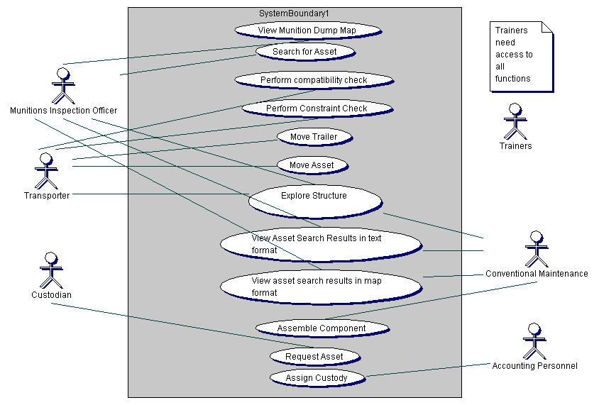
Comprehensive Use Case Diagram

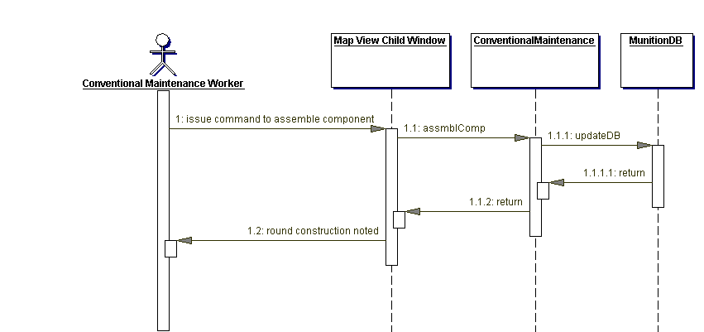
Assemble Component Sequence Diagram
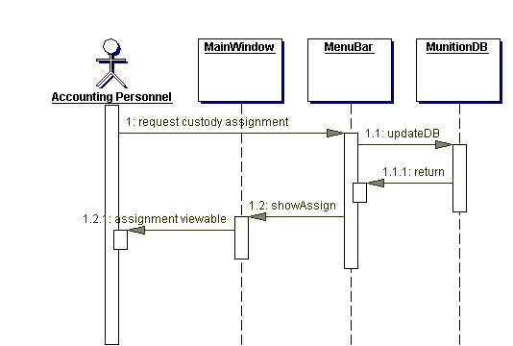
Assign Custody Sequence Diagram

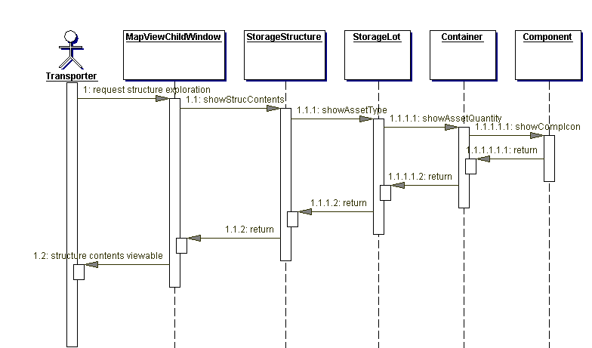
Explore Structure Sequence Diagram

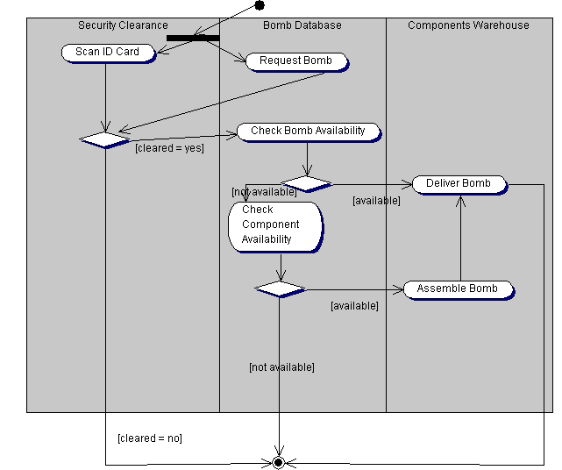
Get A Bomb Activity Diagram
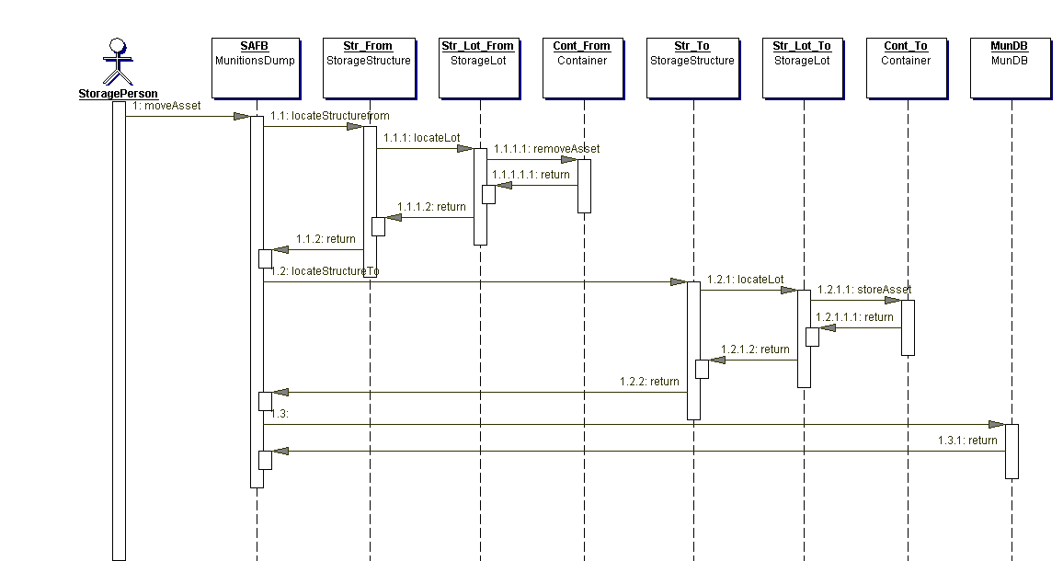
Move Asset Interaction Diagram

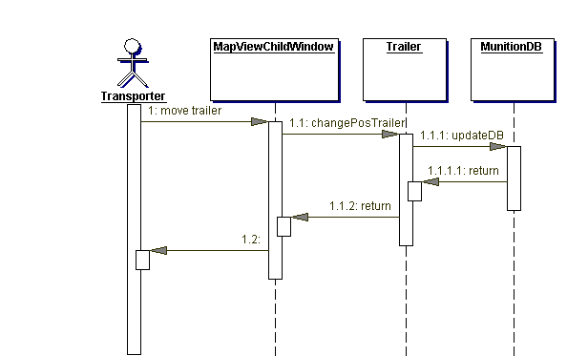
Move Trailer Sequence Diagram

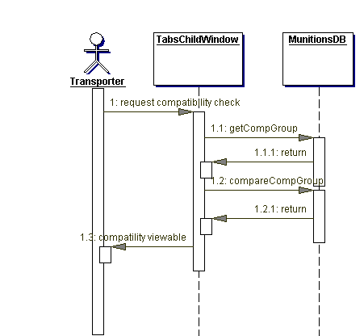
Perform Compatibility Sequence Diagram

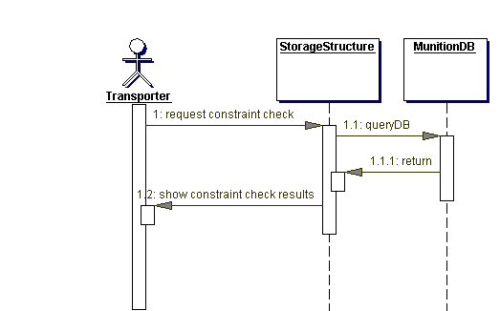
Perform Constraint Check Sequence Diagram

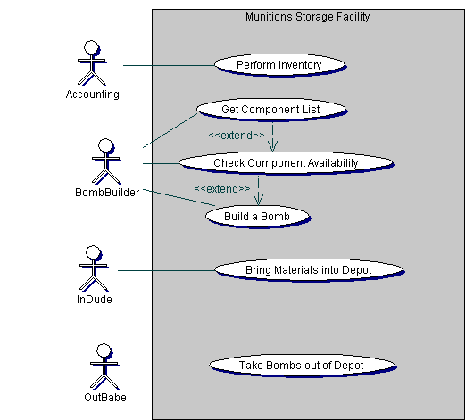

Preliminary Use Case Diagram

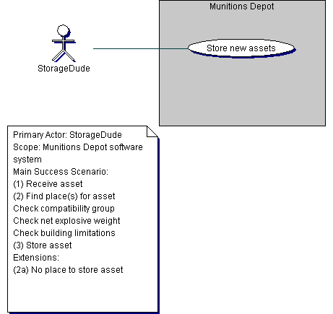
Preliminary Store Asset Use Case Diagram

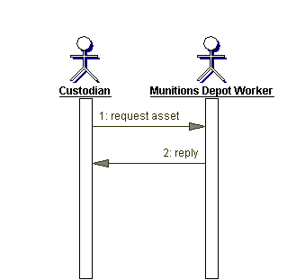
Request Asset Sequence Diagram

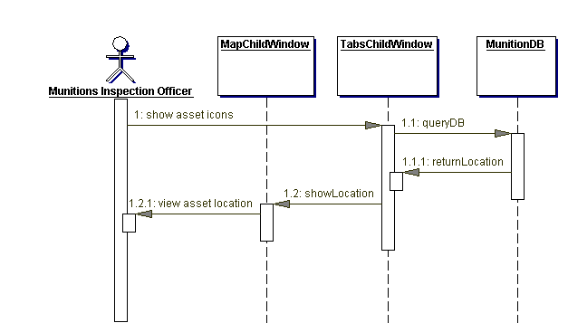
Search for Asset Sequence Diagram

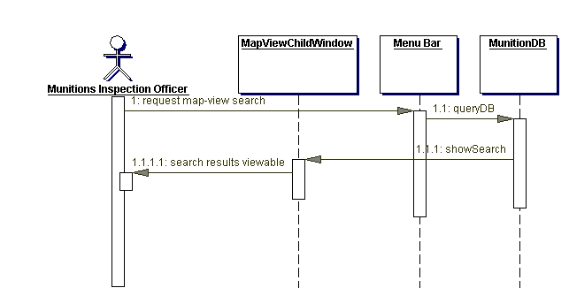
Search Results Map Sequence Diagram

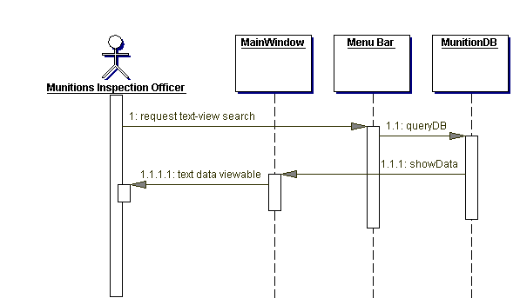

Search Results Text Sequence Diagram

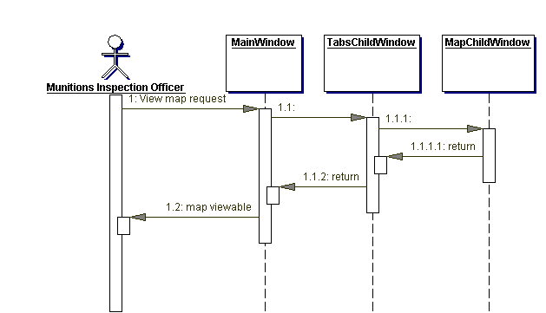
View Munition Dump Map Sequence Diagram

