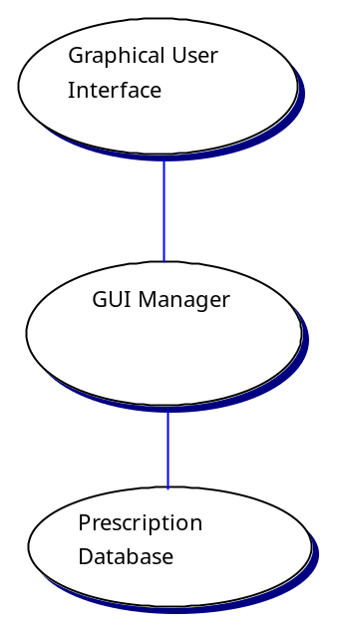

The model used above is an ideal one rather than a practical one but it is certainly possible to have separate interfaces for different classes of users that interact with the same underlying system. The figure above shows a graphical interface to an underlying operating system, such as Windows.

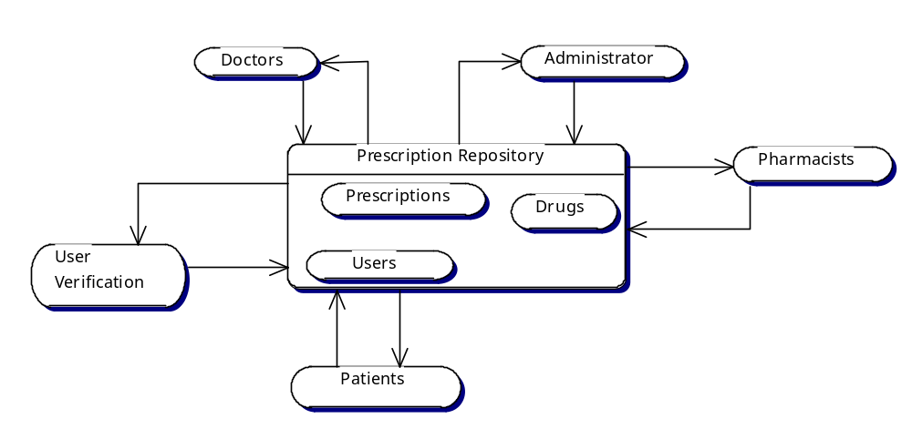

The above figure is the architecture based on a shared repository. All shared data is held in the central prescription repository can be accessed by the doctors, pharmacists, patients, and others with user verification. Each of the users that access the repository can share data with other users by passing messages.

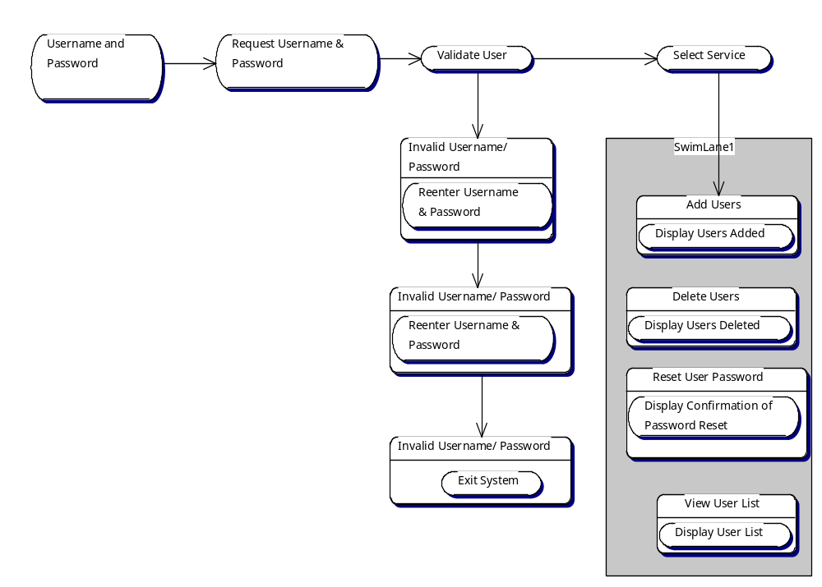

The figure above is a scenario of an administrator. The administrator must have a user name and password. The system should validate the user. The administrator will have three tries to log in to the system before it’s exited. After log in the administrator has the option of adding users, deleting users and to reset the user password.

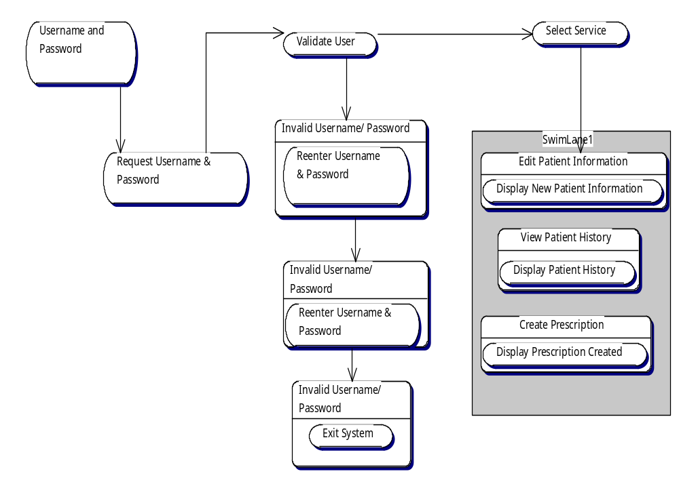

The figure above is a scenario of a doctor. The doctor must have a user name and password. The system should validate the user. The doctor will have three tries to log in to the system before it’s exited. After log in the doctor has the option of editing patients information, viewing a patient’s history record, and to create a prescription for a patient.

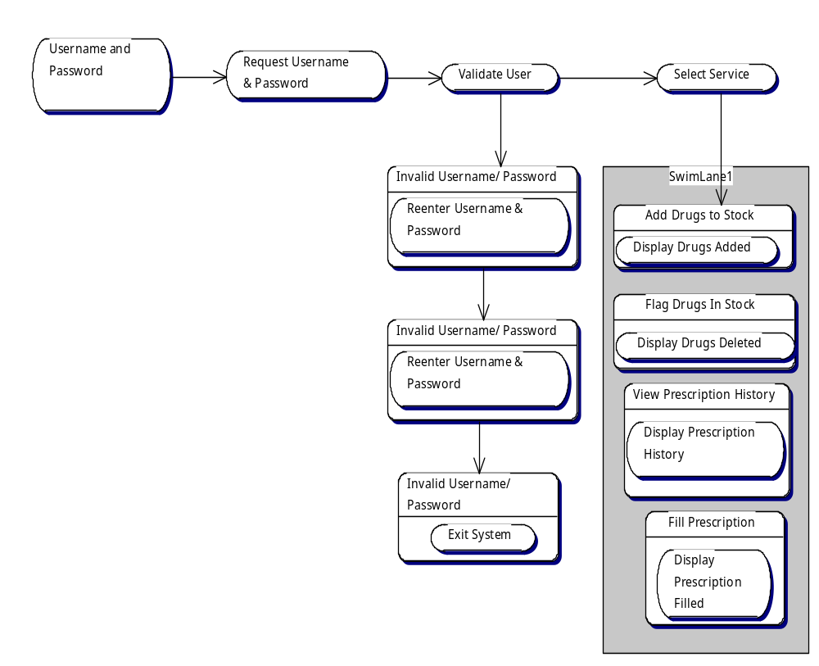

The figure above is a scenario of a pharmacist. The pharmacist must have a user name and password. The system should validate the user. The pharmacist will have three tries to log in to the system before it’s exited. After log in the pharmacist has the option of adding drugs, flagging drugs that are in stock but possibly no longer being offered, viewing the history of a drug, and filling in a prescription.

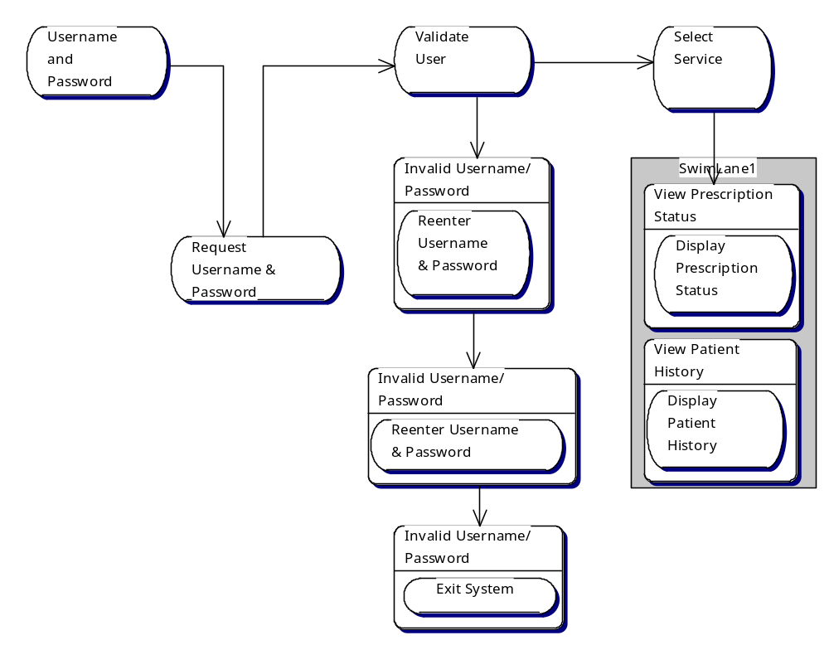

The figure above is a scenario of a patient. The patient must have a user name and password. The system should validate the user. The patient will have three tries to log in to the system before it’s exited. After log in the patient has the option of viewing his/her prescription status and to view his/her own history.

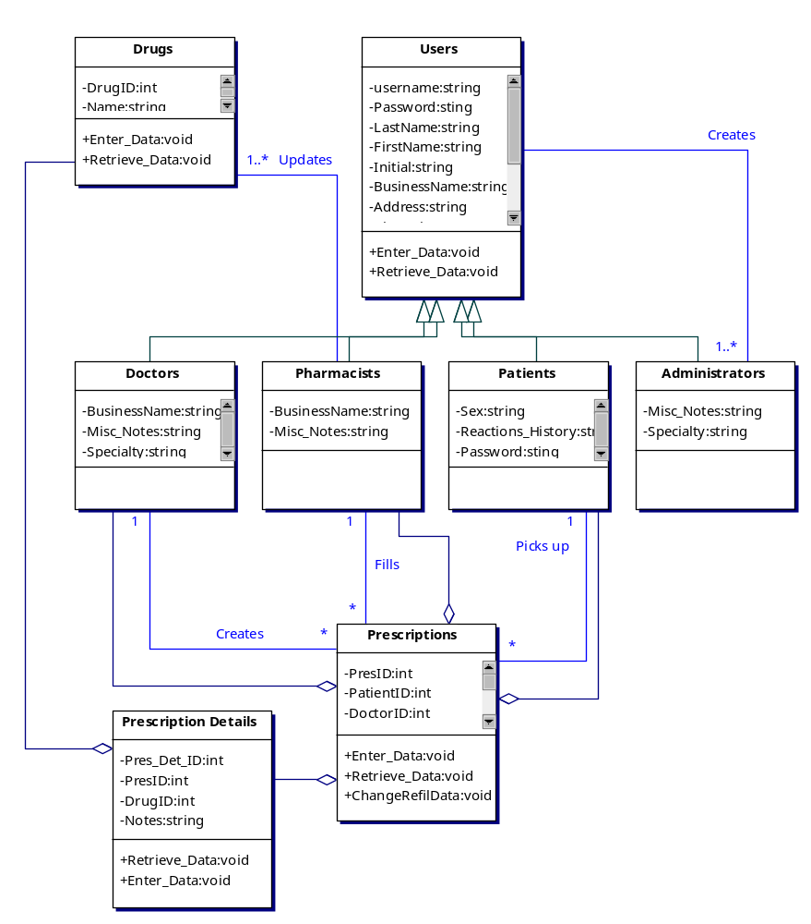

The above figure shows not only a hierarchy diagram between the doctors, pharmacist, patients and administrators to the users but it also shows the relationship between the rest of the classes. It shows the relations of what one class might do to another, such as create or update, and it also shows which class belongs with another but could be in the system on it’s own by the aggregation arrows.

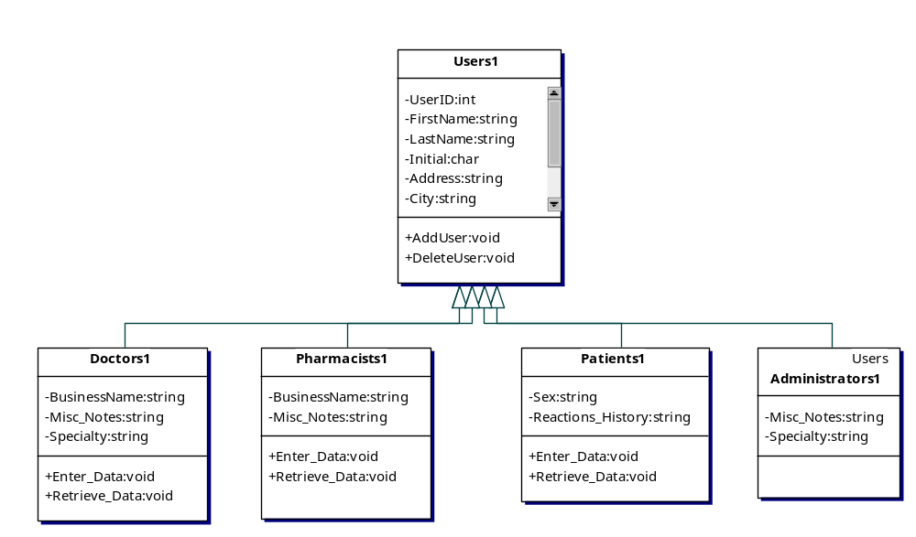

The class Users in the figure above has all of the attributes and operations of the class Doctors1, Pharmacists1, and Patients1, Administrators1 in addition there are new attributes that record the business name, miscellaneous notes, and specialties from the doctor. It records the business name and miscellaneous notes of the pharmacist, and it records the sex and reactions history of the patients. Objects of the class Doctors1, Pharmacists1, Patients1, or Administrators1 may therefore be used anywhere where an object of class Users1 is required.

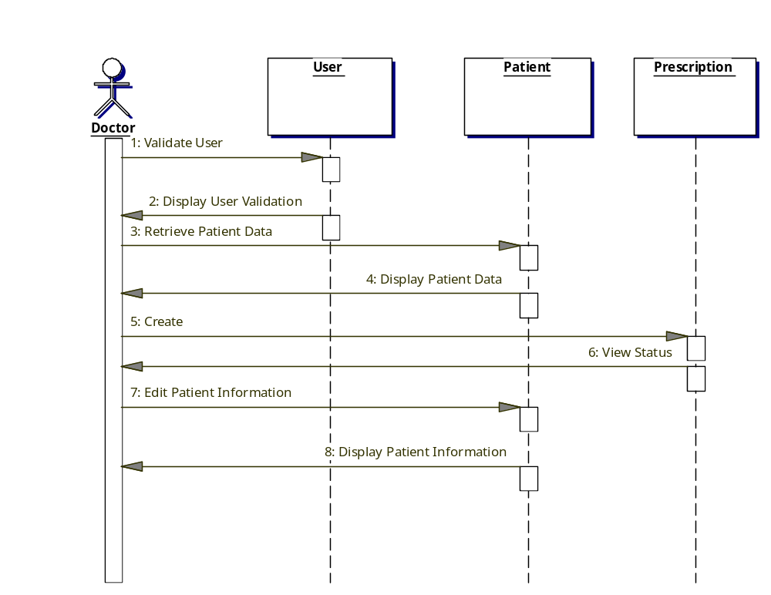

The above figure shows the interactions involved between a doctor and the prescription database. First the figure illustrates that the user must log in to the system and has a user validation before continuing. Then, the figure illustrates that there are three objects of classes User, Patient and Prescription. The sequence of actions is from top to bottom and the labels from the arrows between the doctor and the three objects indicate the names of operations. Therefore when a new patient visits a doctor the doctor can retrieve a patient (record) and the file will be displayed back. And if a patient need a prescription the doctor can create (prescribe) the prescription to that patient, and then he’ll be able to double-check the prescription by viewing the status. The doctor can also edit information on the patient according to his visit.

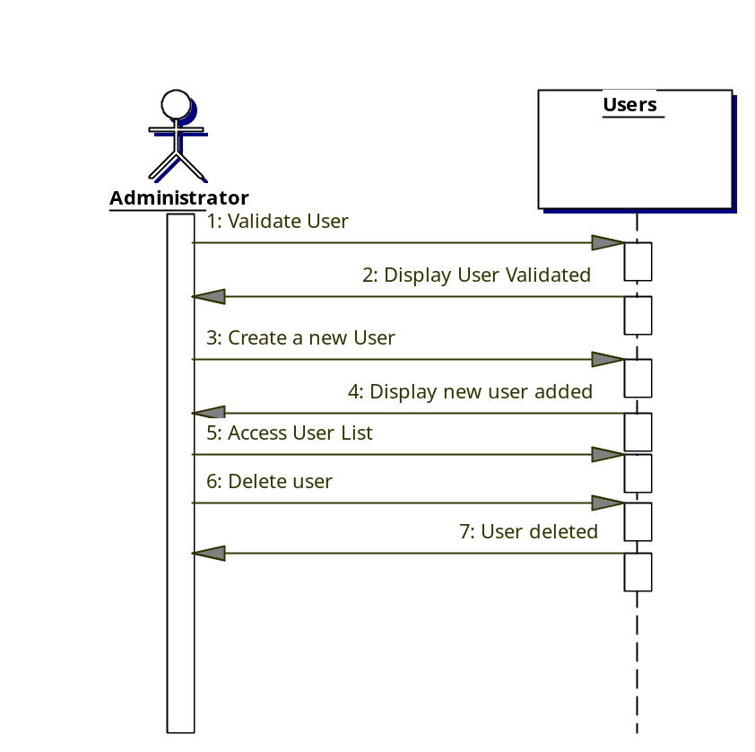

The above figure shows the interactions involved between an administrator and the prescription database. First the figure illustrates that the user must log in to the system and has a user validation before continuing. Then, the figure illustrates that there is one object of class Users. The sequence of actions is from top to bottom and the labels from the arrows between the administrator and the objects indicate the names of operations. Therefore when there is a new user that needs to be added into the system the administrator adds that user to the database. Then a display would be shown to confirm that the user was added. Also, if a doctor, pharmacist, patient or an administrator member is going to be leaving then the administrator would delete them from the database. After this is done there will be a display showing that the user was successfully removed from the system

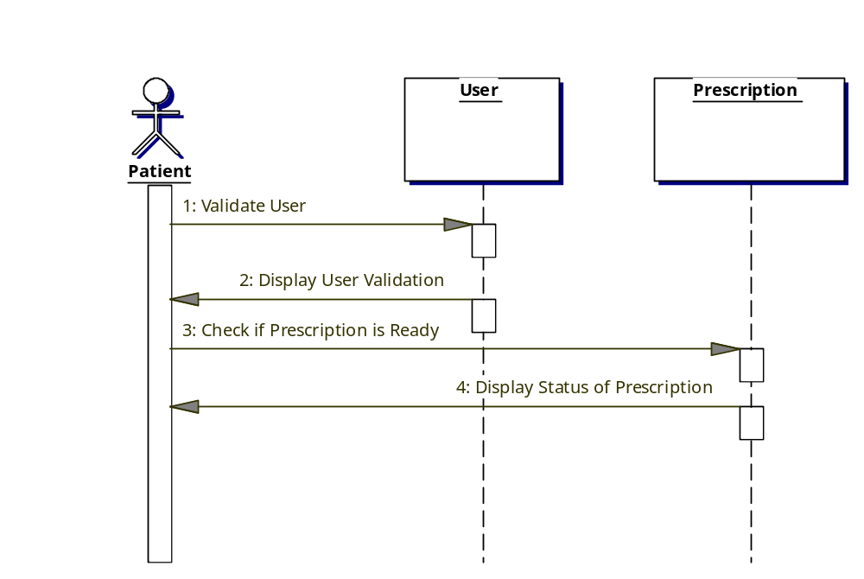

The above figure shows the interactions involved between a patient and the prescription database. First the figure illustrates that the user must log in to the system and has a user validation before continuing. Then, the figure illustrates that there is an object of class Prescription. The sequence of actions is from top to bottom and the labels from the arrows between the patient and the object indicate the name of the operations. Once the patient has gone to the doctor is he receives a prescription he can get on to the system to view if his prescription is ready to be picked up or not.

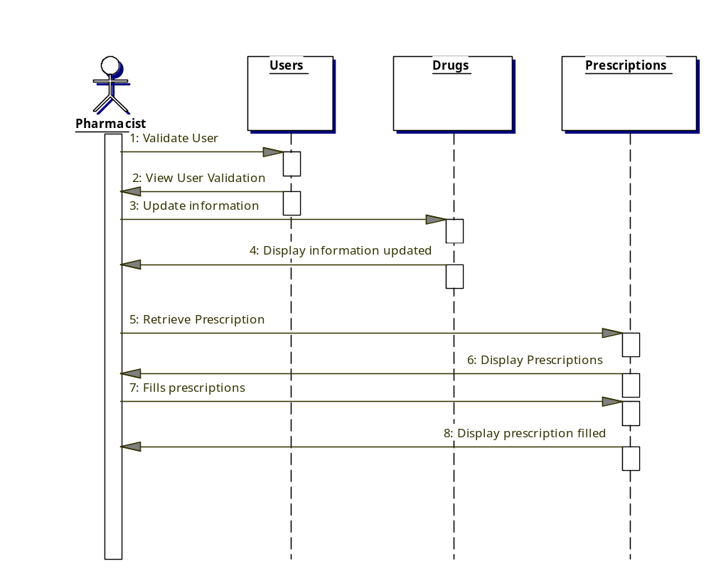

The above figure shows the interactions involved between a pharmacist and the prescription database. First the figure illustrates that the user must log in to the system and has a user validation before continuing. Then, the figure illustrates that there are two objects of classes Drugs and Prescription. The sequence of actions is from top to bottom and the labels from the arrows between the pharmacist and the two objects indicate the names of operations. Therefore when a new drug comes out in the market the pharmacist can update that drug into the system, if it is decided that a drug shall not be used any longer the pharmacist must then update that information. Once all information is updated there is a display letting the pharmacist know that the information has been updated. Also, when a patient visits a doctor if the doctor prescribes them something the pharmacist must fill that prescription and once that is done a display should show up confirming the pharmacist that the prescription was filled.

