ABBREVIATIONS AND ACRONYMS
For a complete list of abbreviations and acronyms, see the Tell ME How help file. To access help files, see WWW.TJR&PC.com.

_________________
Information in this document is subject to change without notice.
© 2003 TJR&PC Software Incorporated. All rights reserved.

Reproduction in any manner whatsoever without the written permission of TJR&PC Software incorporated is strictly forbidden.
Trade marks used in text: TJR&PC Software Incorporated.

Other trademarks and trade names may be used in this document to refer to either the entities claiming the marks and names of their products. TJR&PC Software Incorporated disclaims any proprietary interest in trademarks and trade names other than its own.
March 2003

Contents
WELCOME .3
INTRODUCTION 4
INSTALLATION & SETTING UP 5
- System requirements 5
- Installing Network Prescription Software 5

LOGGING IN 6
SYSTEM SECURITY 6
APPLICATION USERS 6
- Administrator 6
- Doctor 6
- Patient 6
- Pharmacist 6
USER INTERFACE 7-22
Appendix
Forgotten Passwords 23
Contacting TJR&PC Software Inc 23
Contact Numbers and Addresses 23

WELCOME 

Get ready for a whole new experience in software.
This book explains how to get TJR&PC Software set up and
running, and also how to use it.
Enjoy and let’s get started!



INTRODUCTION

This information has been compiled to assist users in maneuvering the Network Based Prescription System. The system uses a centralized database of patient prescriptions that can facilitate communication between doctors and pharmacists. A web- based interface is used by Doctors to prescribe medicine for patients and a similar interface is used by the pharmacists to verify the prescription and mark it as filled, while the doctors office can then view or verify that the patient is complying with doctor orders. Doctors and pharmacists are also alerted when the patient is early or late getting refills. The patients can also access the system at anytime to view their prescription.

INSTALLATION & SETTING UP


SYSTEM REQUIREMENTS
- Windows 9X or later operating system
- Microsoft Office 2000 or later.
- Web Browser (e.g. Internet Explorer, Netscape…)

Installing Network Prescription Software
Pen or Pencil You may want to write down settings or other important information.
Read each selection on your screen carefully before you accept it, to make sure it is appropriate for you! Default responses are provided only as a guideline.
Using the CD-ROM:
  - Start Windows
  - Insert the software CD
  - Click Continue or Finish on any subsequent screens. Then the software installation screen appears.
  - Click install Network Prescription software

LOGGING IN
Different users have different levels of access. The first screen (See Figure 1) that appears gives users the option of either logging onto the system via internet or via the local system. The user is enabled to fully access the system regardless of the option chosen. In order to access the system, each user needs to create a user name and password. This function can only be performed by the system administrator or by a designated employee of the medical cooperation; therefore, be sure to contact the systems administrator before attempting to log in. Users are allowed three chances to enter their correct username and password to log into the system. After that, the user is automatically locked out from the system by the system’s security features. To reenter the system, the system’s administrator must be contacted (See contact numbers and addresses). Once the user has successfully logged onto the system, he has the option of changing his username or password.
SYSTEM SECURITY
- Users are allowed three chances to enter their correct username and password. After that, the user is automatically locked out from the system by the system’s security features. To reenter the system, the systems administrator must be contacted.
- Different categories of system users have different access privileges. Patients, Pharmacist and Doctors have limited system access, while the system administrator has unlimited access.

APPLICATION USERS
The four major types of system users are:
- System Administrators- System administrators may includes any representative from T J R & P C or a designated employee from the medical cooperation.
- Doctors- Doctors can view or change patient profiles.
- Patients- Patients are only able to view their own personal data.
- Pharmacist-Can fill prescriptions and view a patient’s history.

Exploring the User Interfaces:

Figure 1 shows the first screen that the user encounters. From this screen the user can select the way he wants to access the system. He accesses the system in one of two ways. These are:
- Local System- allows users access to the system via the local network or in absence of the internet.
- Web system- allows users to access the system via the World Wide Web.
Figure 1
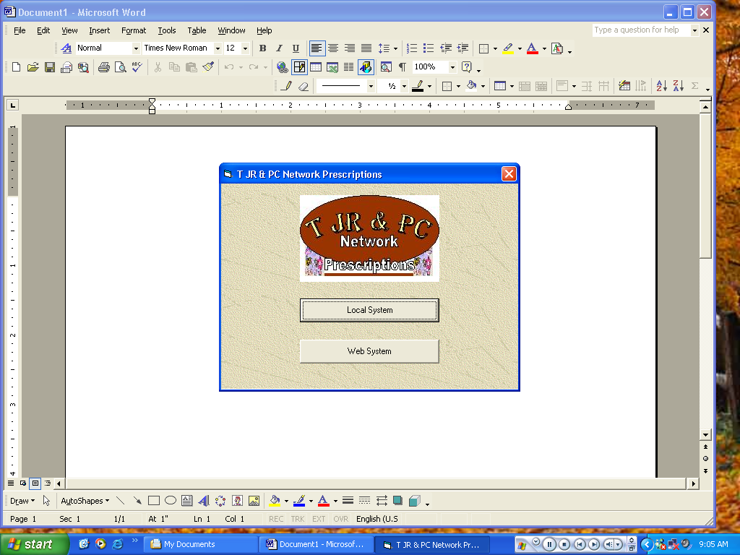

Figure 2 displays the welcome page (of the web based application). Users can access the system from this screen via the internet/World Wide Web (See text describing Fig. 4 and the section on Logging In for more details.)
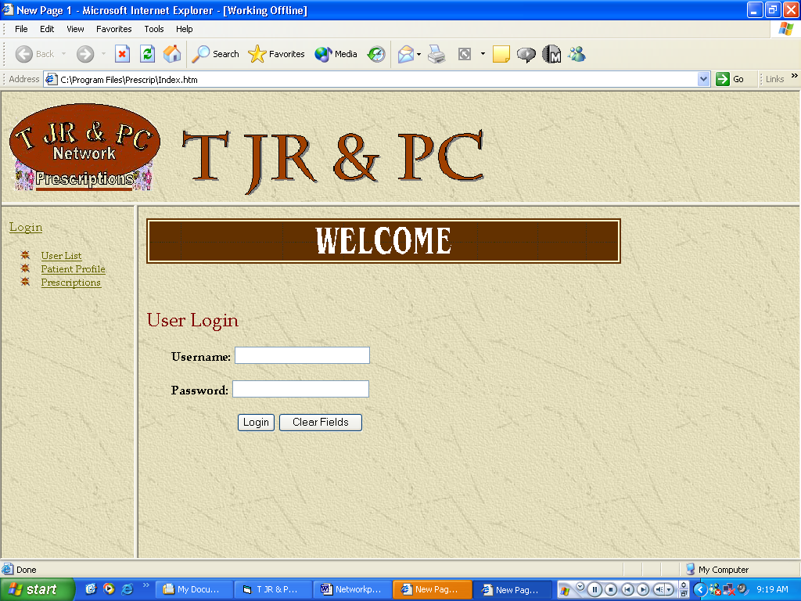
Figure 2

Figure 3 is shows the first page that is displayed once a user has successfully logged into the system. The user at this point has access to the system.

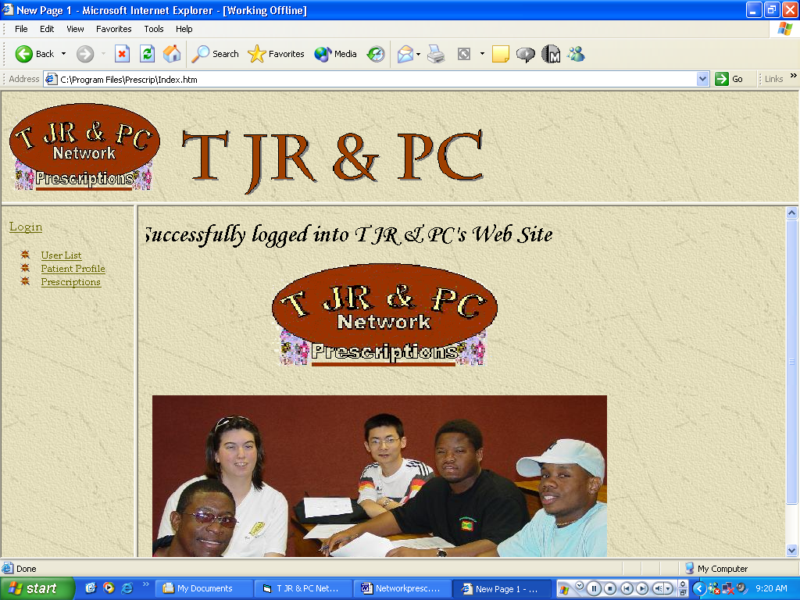
Figure 3

Fig.4 displays the logging in screen for the local (non-web base) system. Each user is required to have a separate username and password to access the system (See section on Logging in for more details).

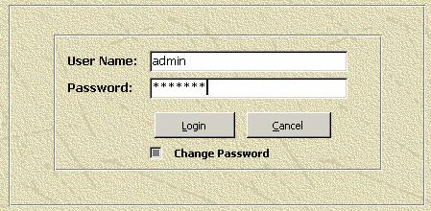
Figure 4

Systems Administrator:
Figure 5 displays the administrator’s main menu. It is the first screen seen by the administrator once he has logged into the system. By selecting the appropriate option, the administrator is taken to a screen from which he can add new users (pharmacists, doctor’s etc.) to the system by creating new usernames and passwords for each new user, reset existing user passwords, or create and\or view reports of the list of users in the system. The ‘exit system’ button permits the administrator to exit system at any point.
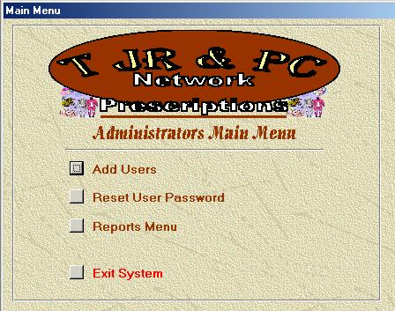
Figure 5

Figure 6 displays the profile of a user. This screen is used by the administrator to create new and/or edit current user profiles. He gains access to this screen by selecting the ‘Add Users button in figure 5. Each user’s information is typed into the text boxes (rectangular boxes with white backgrounds). The following is a list of the buttons that appears in the above screen and their actions/functions:

- First- tabs user to the first record (patient etc.) in the data-base.
- Prev- tabs user to the previous record in the data-base (in relation to current record being viewed).
- Next- tabs user to the next record in the data-base.
- Last- tabs user to the last record in the data-base.
- Add- adds a new or modified patient, doctors etc. to the data-base.
- Delete-deletes an existing user from the data-base.
- Search-allows the user to search for an existing record.

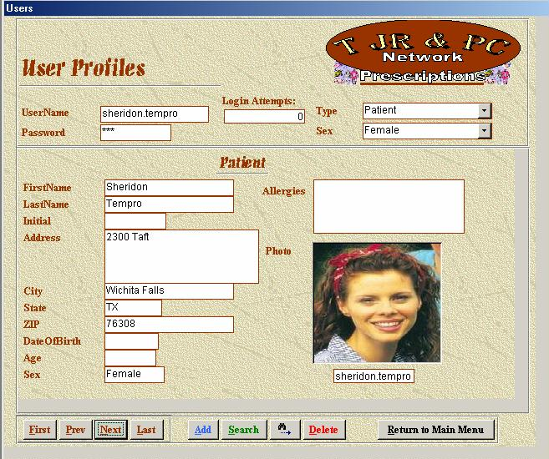
Figure 6

Doctor:

Figure 7 is a display of the Doctor’s main menu. This is the first screen displayed after a member doctor logs into the system. By selecting a button, the doctor is taken to a different screen where he can add a patient, create a prescription, view a patient’s prescription history or view the reports menu. To log out from system, he selects the ‘Exit System’ button.

Figure 7
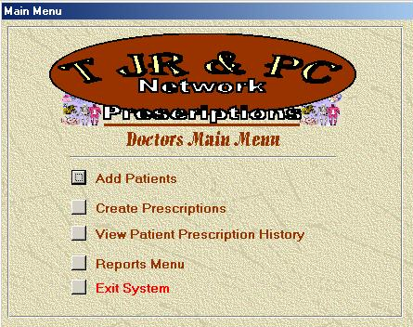

Figure 8 is a display of a patient’s prescription history record. Selecting the ‘view patient prescription history button’ takes the doctor to the screen shown in Figure 8. This screen gives information on patient prescriptions prescribed in the past and indicates whether or not they were filled (Buttons shown in Figure 8 work similarly to buttons described and shown earlier in Figure 6). The Doctor can also tab between figure 8 & 9 from this screen by clicking on either ‘personal info’ or ‘prescription history’ respectively.

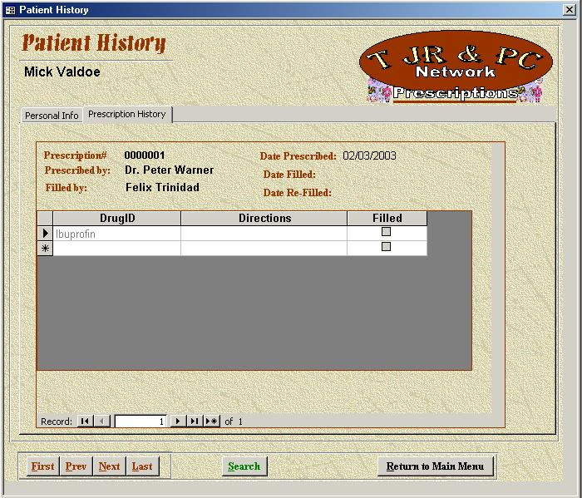
Figure 8

Figure 9 displays the patient’s personal information record. Selecting the ‘view patient prescription history button’ also takes the doctor to the screen shown in Figure 9. This particular screen displays personal information of a selected patient, such as Name, Address, Date of Birth, Age, Sex and Allergies(See fig. 6 for button functions). All of these fields (except patients) may be changed by the doctor. The Doctor can also tab between figure 8 & 9 from this screen by clicking on either ‘personal info’ or ‘prescription history’ respectively.
Figure 9
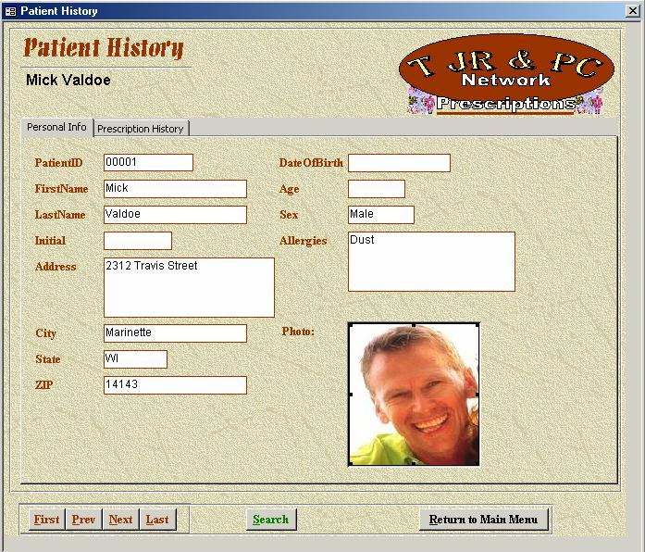

This Screen (Figure 10) displays a patient profile created by his doctor. This screen is used by the doctor to create and/or edit a new or current patient. He gains access to this screen by selecting the ‘Add Patient’ button in figure 7. Each patient’s information is typed into the text boxes. (Similar to Figure 10 is figure 6. See text describing Figure 6 for more details on buttons and their functions).

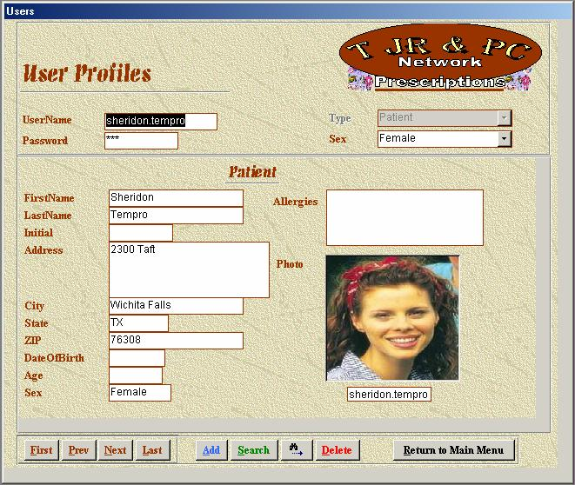
Figure 10

Fig.11 displays a patient’s prescription. This screen is accessed by selecting the ‘create prescription’ button on the doctor’s main menu. The doctor can use this screen to create a new patient prescription or edit an existing one. By selection of the appropriate patient name on the drop down menu bar that patient’s prescription information is displayed (See Fig. 6 for similar description of button functions) along with the date it were issued.

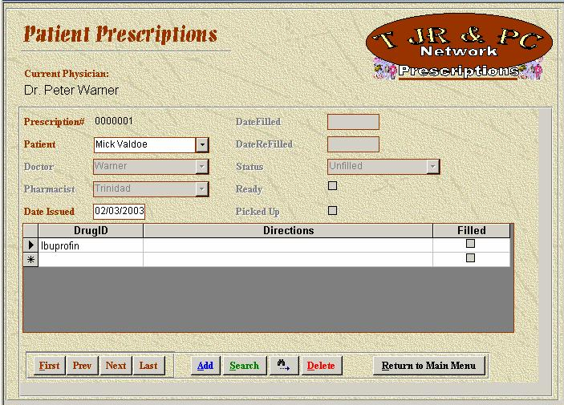
Figure 11

Patients:

Figure 12 displays the Patient’s main menu. By clicking on the view prescription status/history’ button, the user is taken to an interface where he can view his/her prescription history/status. To exit system, select the ‘Exit System’ button.

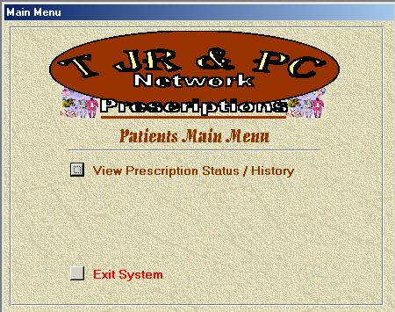
Figure 12

Figure13 displays a patient’s history record. This particular screen gives information on patient prescriptions prescribed in the past, and tells whether or not they were filled or not (See text describing figure 8 & 9 for a similar description of function button functions).

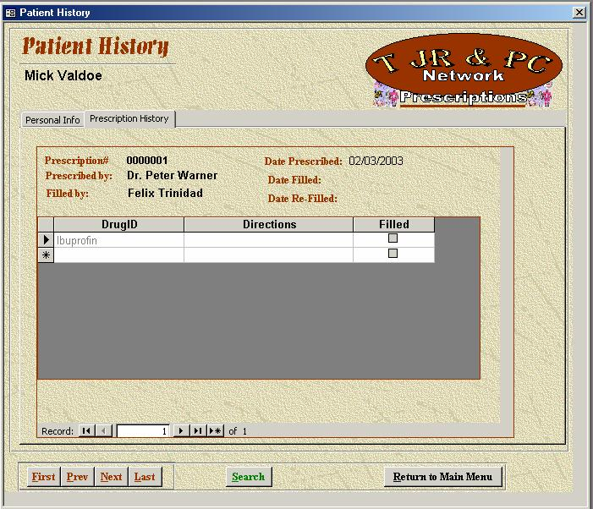
Figure 13

Pharmacist:

Figure 14 displays the Pharmacist’s main menu. By clicking on the appropriate button, the user is taken to a screen where he can view the patient’s history, fill a prescription, or also maintain the drugs in the system (See Figure17). To exit system, select the ‘Exit System’ button.

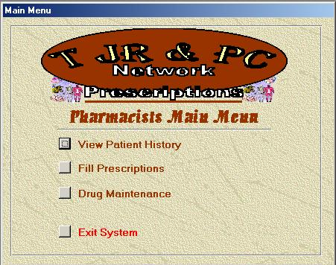
Figure 14

Figure 15 shows the history of the patient. See Figure 8 or 9 for similar details.

Figure 15

Figure 16 displays the prescription to be filled. Information is typed into the text boxes (Rectangular boxes with white backgrounds). This screen is accessed by selecting the ‘Fill Prescription’ button on the pharmacist’s main menu. The pharmacist can use this screen to create a new patient prescription or edit an existing one. See Fig.6 for list of buttons and their actions/functions:
Figure 16
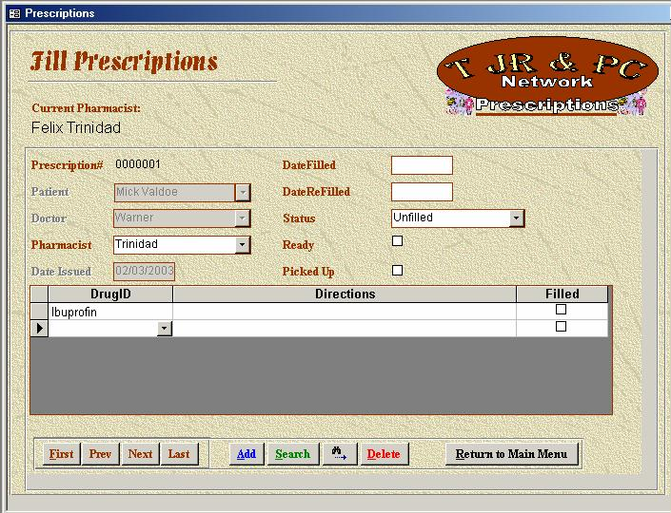

Figure17 displays an interface which is aids in drug maintenance. This screen is accessed by selecting the ‘drug maintenance’ button on the pharmacist’s main menu. The doctor can use this screen to create a new patient prescription or edit an existing one. Details corresponding to a particular drug are typed into the corresponding fields (Rectangular boxes with white backgrounds). See Fig.6 for list of buttons and their actions/functions.

Figure 17
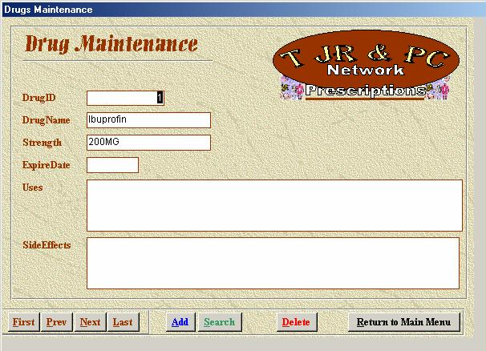
Figure 16

Appendix:
Clearing Forgotten Passwords
- The administrator is the only one that has the authority to modify or reset usernames and passwords.

Contacting T J R & P C Software Inc.
Contact Numbers and Addresses:
TJR&PC,
4700 Taft Blvd,
P.O box # 19,
Wichita Falls, TX 76308.
Telephone: (940)-692 7527.
(940)-691 0279.

