Overview
This testing plan is concerned with setting out standards for the testing process. It is intended for our software development team, T J R & P C to design and carry out system tests.

Test Process

Figure 1 shows the test process: United testing by T J R & P C; integrate testing by T J R & P C; system tests are designed and executed by T J R & PC

Unit Tests are programs written to run in batches and test classes. Each typically sends a class a fixed message and verifies that it returns the predicted answer.

Integration Tests are developed after individual program components have been tested. Each involves building a system and testing the resultant system for problems.

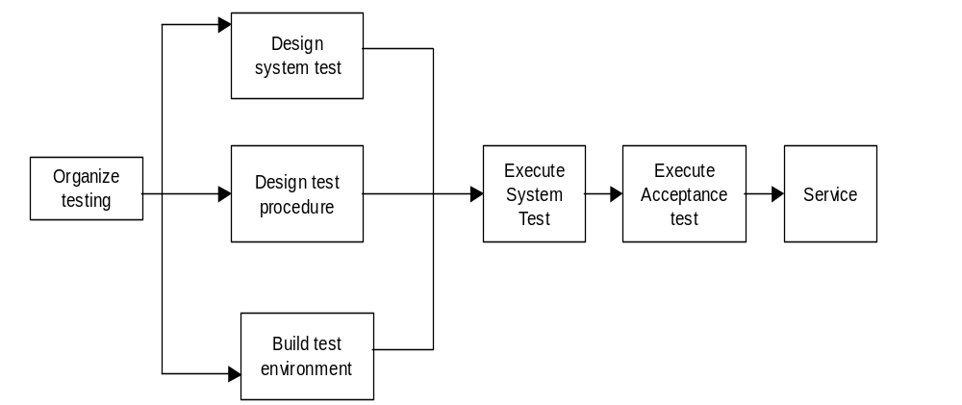
Figure 1

Hardware and software requirements for test environments
Hardware Required:

One PC (PIII, 4G HD, 64M RAM)

Test Environment Software:
Windows 2000 or later
Microsoft Access 2000 or later

Tested items
T J R & P C tests the items: Duplicate data; interface; error handling.

Constraints

The major constraint is lack of test experience.

Testing schedule

Test Process | Date | Executer | Duration
Test Environment Setup | 03/21/2003--- 04/04/2003 | T J R & P C | 14 days
Preparing test plan | 03/21/2003--- 04/04/2003 | T J R & P C | 14 days
Specify test condition | 03/21/2003--- 04/04/2003 | T J R & P C | 5 days
Identify test data | 03/21/2003--- 04/04/2003 | T J R & P C | 5 days
Test execution | 04/06/2003---04/11/2003 | T J R & P C | 6 days
Test Report Release V.01 | 03/21/2003---03/28/2003 | T J R & P C | 8 days
Test Report Release V.02 | 03/29/2003---04/09/2003 | T J R & P C | 11 days
Test Report Release V.03 | 04/09/2003---04/13/2003 | T J R & P C | 5 days

Requirements Traceability

LG 011- LG052 tests the requirements concerning Login in requirement document 2.4.1 & 2.4.2
AD 011 – AD 052 tests the requirements concerning Administrator Functions in the requirements document 2.4.1
DC 011-DC 031 tests the requirements concerning Doctor Functions in the requirements document 2.4.1.
PH 011-PH 031 tests the requirements concerning Pharmacist Functions in the requirements document 2.4.1.
PT 011-PT 021 tests the requirements concerning Patient Functions in the requirements document 2.4.1.

Test recording procedures

Test cases | Step& Input | Expected Results | What is tested
Login
LG 011  Log in as administrator | Input correct administrator name and password; Click “login” button | Enter into main menu | Input class/Interface
LG 012  Log in as administrator | Input incorrect administrator name and password; Click “login” button | Error message1; still display login screen and allow 2 more attempts | Input class; interface; error handling
LG 021  Log in as doctor | Input correct doctor name and password; Click “login” button | Enter into main menu | Input class/Interface
LG 022  Log in as doctor | Input incorrect doctor name and password; Click “login” button | Error message 2; still display login screen and allow 2 more attempts | Input class; Interface; error handling
LG 031  Log in as pharmacist | Input correct pharmacist name and password; Click “login” button | Enter into main menu | Input class/Interface
LG 032  Log in as pharmacist | Input incorrect pharmacist name and password; Click “login” button | Error message 3; still display login screen and allow 2 more attempts | Input class; interface; error handling
LG 041  Log in as patient | Input correct patient name and password; Click “login” button | Enter into main menu | Input class/Interface
LG 042  Log in as patient | Input incorrect patient name and password; Click “login” button | Error message 4; still display login screen and allow 2 more attempts | Input class; interface; error handling
LG 051 Change password | Input and confirm passwords are same. | Display successful changed message | Interface
LG 052 Change password | Input and confirm passwords are different. | Error message 5, not match | Interface; error handling
Administrator Functions
AD 011 Add administrators | Add a new administrator | Display instructions to add | Interface
AD 012 Add doctors | Add a new doctor | Display instructions to add doctor | Interface
AD 013 Add pharmacists | Add a new pharmacist | Display instructions to add pharmacist | Interface
AD 014 Add patients | Add a now patient | Display instructions to add patient | Interface
AD 021 Add duplicate doctor | Add a duplicate user | Error message 6; reprompt | Duplicate data
AD 022 Add duplicate pharmacist | Add a duplicate user | Error message 7; reprompt | Duplicate data
AD 023 Add duplicate patient | Add a duplicate patient | Error message 8; reprompt | Duplicate data
AD 031 Delete administrators | Search a administrator;  Delete searched administrator. | Confirmation | Interface
AD 032 Delete doctors | Search a doctor; delete searched doctor | Confirmation; | Interface
AD 033 Delete pharmacists | Search a pharmacist; delete searched pharmacist. | Confirmation; | Interface
AD 034 Delete patients | Search a patient; delete searched patient. | Confirmation; | Interface
AD 041 Reset administrators’ password | Reset an administrator’s password. | Set attempt time back to zero | Interface
AD 042 Reset doctors’ password | Reset a doctor’s password | Set attempt time back to zero | Interface
AD 043 Reset pharmacists’ password | Reset a pharmacist’s password | Set attempt time back to zero | Interface
AD 044 Reset patients’ password | Reset a patient’s password | Set attempt time back to zero | Interface
AD 051 View user list | View users’ list | Display users’ list | Interface; data
AD 052 View patients’ list | View patients’ list | Display patients’ list | Interface; data
Doctor Functions
DC 011 Edit patient information | Edit patient information | Display the instructions to edit | Interface
DC 021 View patient history | View history | Display patient history | Interface
DC 031 Create Prescription | Create a new prescription | Display instructions to create | Interface
Pharmacist Functions
PH 011 Add drug | Add a new drug | Display instructions to add drug | Interface
PH 021 View patient history | View patient history | Display patient history | Interface
PH 031 Fill prescription | Fill prescription | Display instructions to fill | Interface
Patient Functions
PT 011 View prescription | View prescription status | Display prescription status | Data; interface
PT 021 View history | View history | Display patient history | Data; interface

