Questions -

1. Give the output for the following commands:

a. echo “hello world”

Sol:-

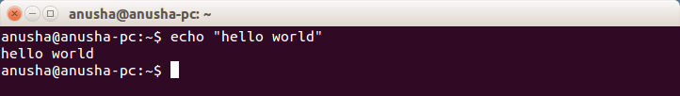

b. List all the files(hidden included) present in the current directory in long format displaying files in reverse order , sorted based on the modification time .

Sol:-

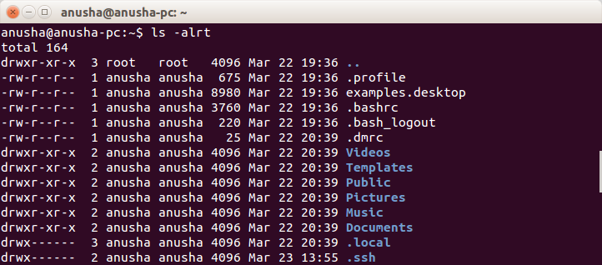

c. Change your current password.

Sol:-

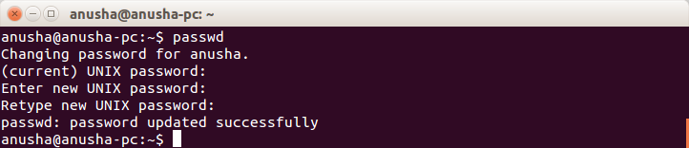

d.How to get the current date

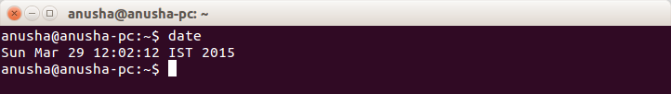

e. How to get the current logged in user

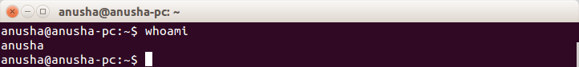

f. How to get the current working directory.

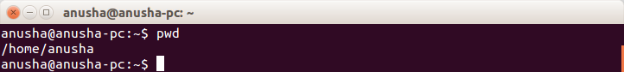

g. How to get the list of all commands that you have typed so far

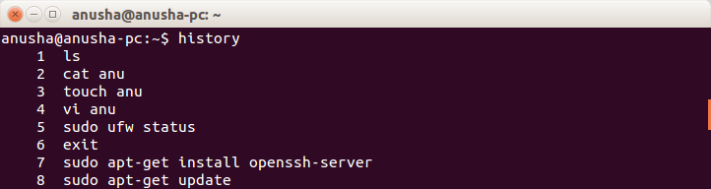

h. To get the information on the tcp ports

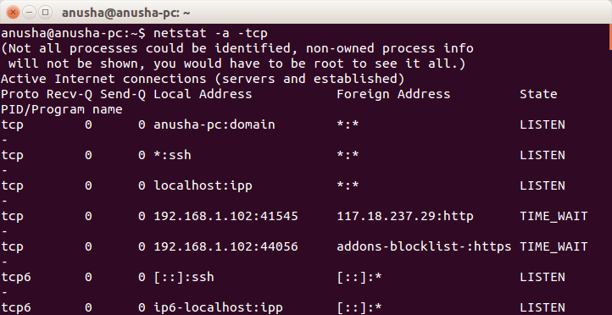

i. To get the information about the running processes.

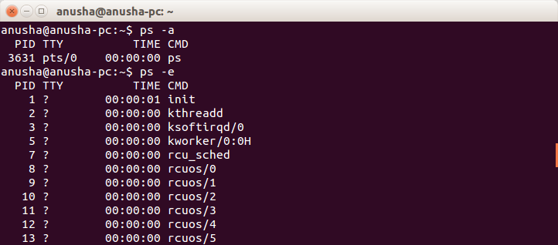

j. Search for a word in a file. (Hint – grep)

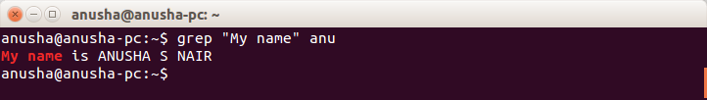

k. Search for a specific process. (Hint - use | with ps )

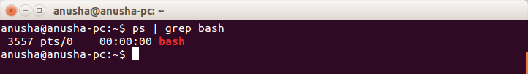

1. Create a directory “exercises” inside your home directory. **cd** to this new directory.

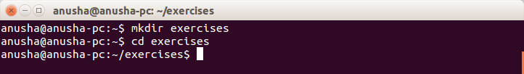

3. Create 3 empty files , file1.txt,file2.txt,file3.txt in current directory (exercises).

Sol:-

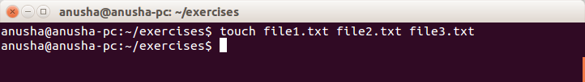

4. Add some text to **file1.txt** and copy this to **~/exercises/files**.

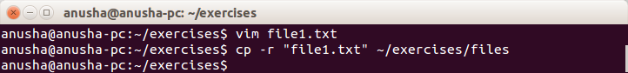

5. Copy the entire **exercise** directory to this **files** directory.



6. Create a symlink “testlink” in your home directory that points to this file1.txt i.e. **~/exercises/files/file1.txt.**

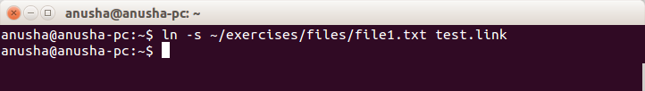

7. Try creating a hard link in your home directory that points to **“files”** directory .

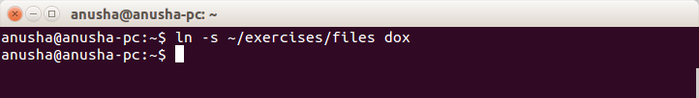

8. Difference between soft and hard link.

Symbolic links or Symlinks are the easiest to understand, because for sure you have used them, at least when you were using Windows. Soft links are very similar to what we say “Shortcut” in windows, is a way to link to a file or directory. Symlinks doesn’t contain any information about the destination file or contents of the file, instead of that, it simply contains the pointer to the location of the destination file. In more technical words, in soft link, a new file is created with a new inode, which have the pointer to the inode location of the original file.

Hard link is a bit different object when compared to a symlink. In softlink a new file and a new Inode is created, but in hard link, only an entry into directory structure is created for the file, but it points to the inode location of the original file.

9. Change permissions for **files** directory such that nobody other than the user who created the directory, can write/update anything in that directory.

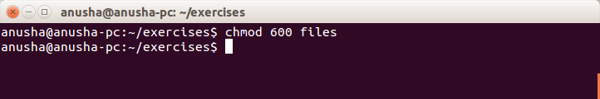

10. Create a new user “test”.

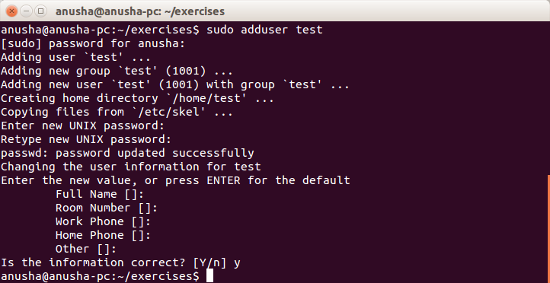

11.Change the owner of **file1.txt** to **test**

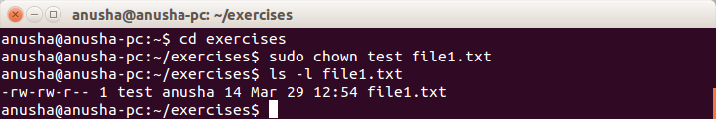

12. create following directory structure with single command -

home

|-john

|-work

|-scripts

|-bash

Assume that you are currently in ‘home’ directory.

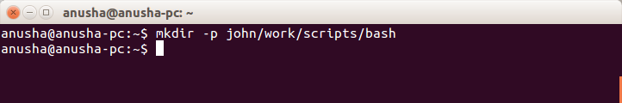

13.Try deleting the ~/exercises/files/exercises directory. See what happens.

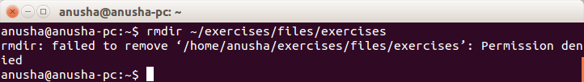

14.A file named employees.odt has a mode of rw-r- -r- -. If John is not the file's owner but is a member of the group that owns this file, what can he do with it?

Sol:-

only read

15.Create an alias for clearing the screen.

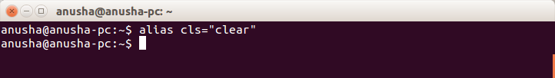

16. Create a tar archive of all the files in the current directory.

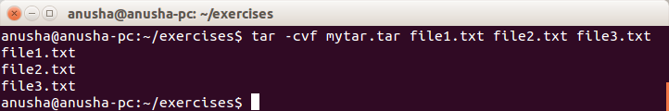

17. How to find if a jar file contains a particular class file?

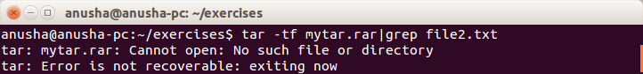

18.How to find files greater than a certain size

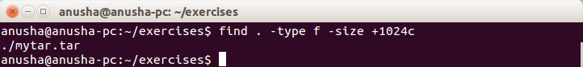

20. How do u add and remove a variable in the shell environment.

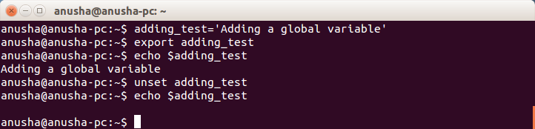

21. Install openssh-server on your system

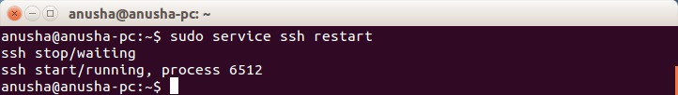

22. try remote login to your friend’s machine using ssh.

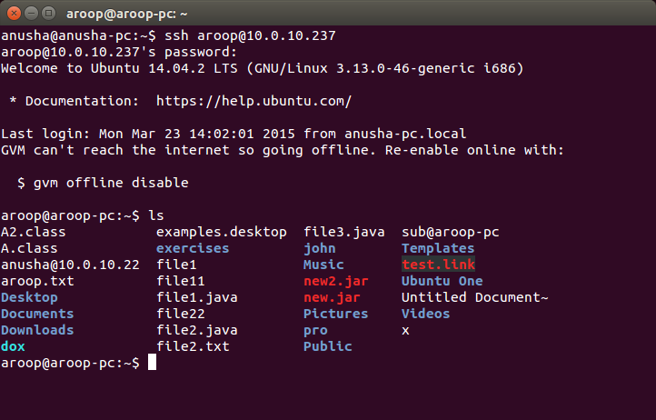

23. Copy some files from your machine to your friend’s machine. (Hint – scp)

