GIT EXERCISE SOLUTION

1. Initialize the Git repository-

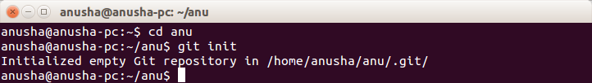

2. Add files to the repository and make changes to the file and again add it

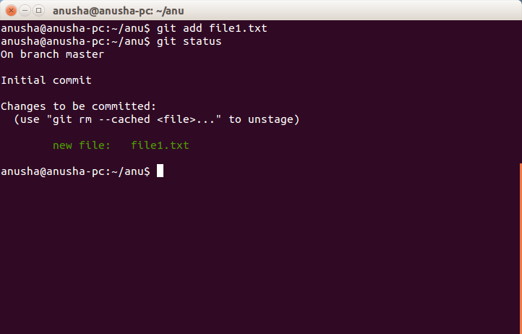

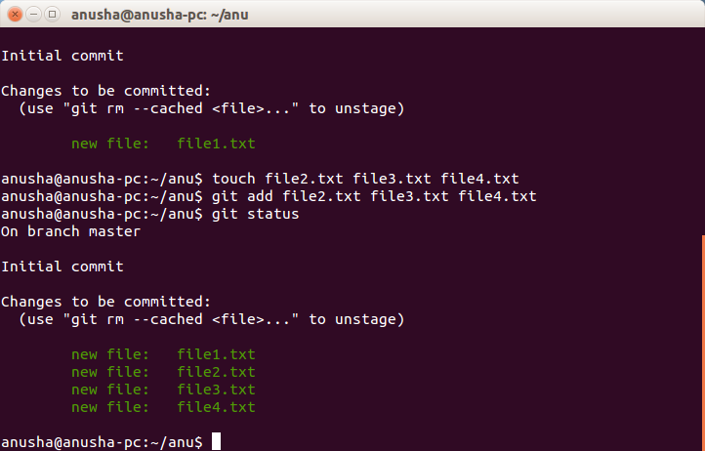

3. Unstaging file1.txt from git

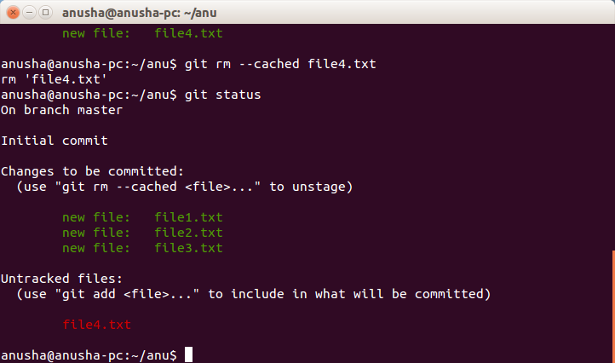

4. Commit the file in git

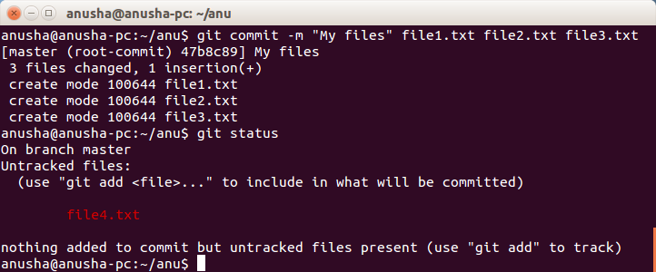

5. Add a remote , undo changes in the file and pushing changes to github-

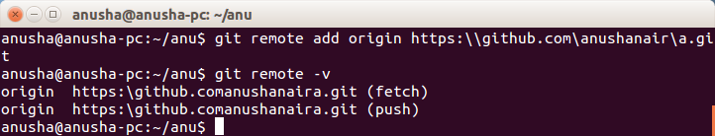

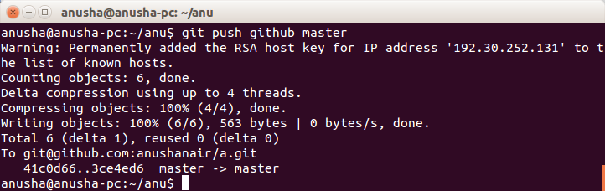

6. Clone the repository -

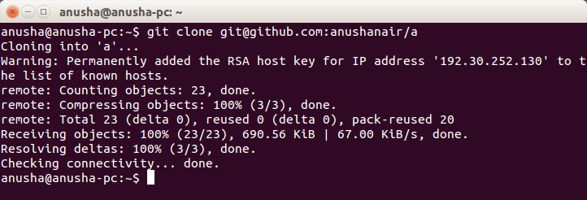

7. Add changes to one of the copies and pull the changes in the other.-

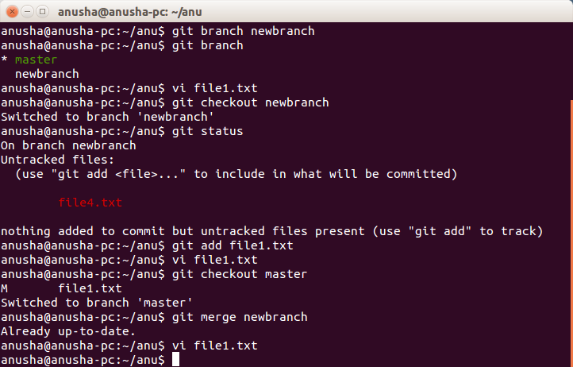

8. Add changes to both repos, try to push from both without taking a pull.-

- At first edited github repository file after the pull-

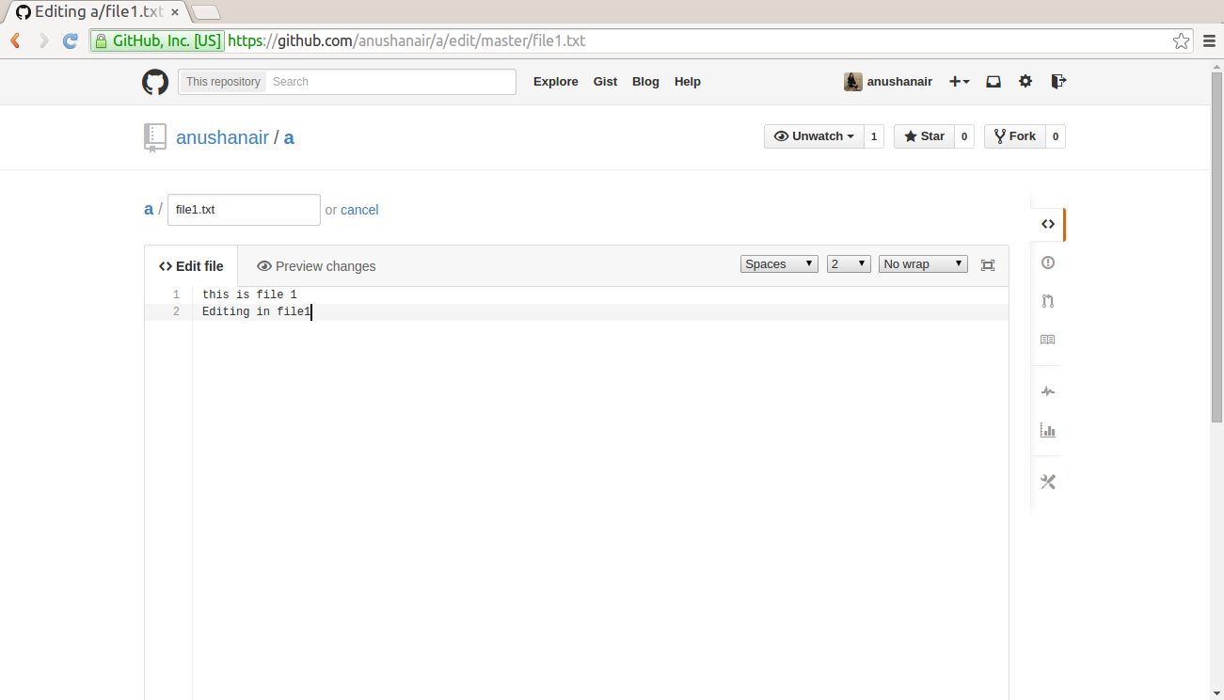

and then then push from both repository without the pull-

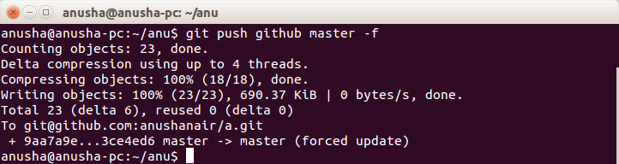

9. Check differences between a file and its staged version-

--git diff file1.java

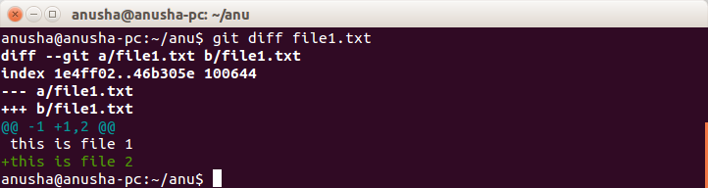

10. Create a new branch. Diverge them with commits-

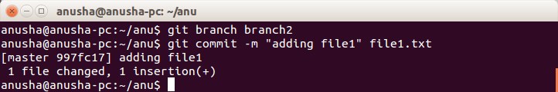

11. Edit the same file at the same line on both branches and commit

- Try merging and resolve merge conflicts

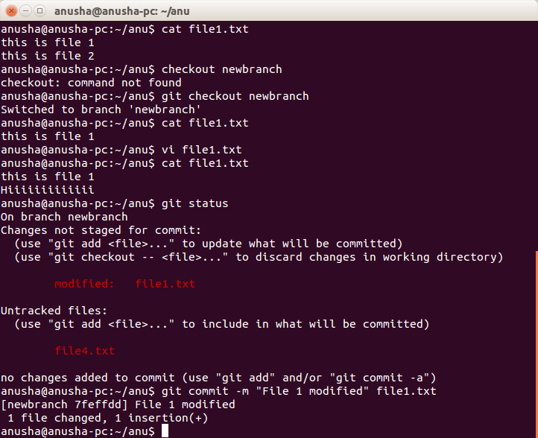

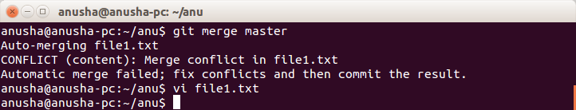

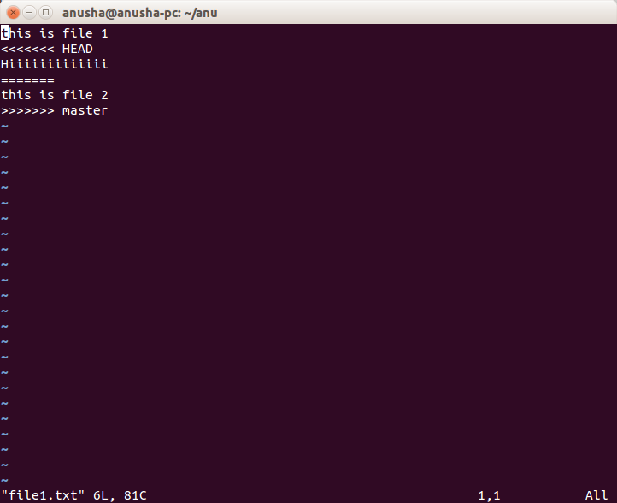

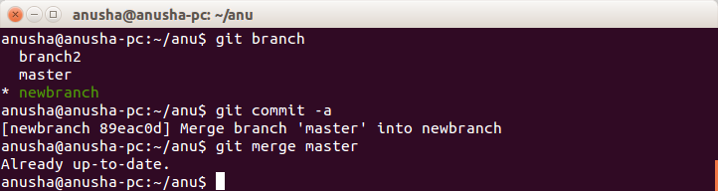

Q12:-Stash the changes and pop them

