**Introduction to JavaScript – Exercise**

**Q1:-** In Application.js Make a function which returns the current date/time.

Sol:-<!DOCTYPE html>

<html>

<head>

</head>

<body onload="cal()">

<script src="application.js">

</script>

</body>

</html>

Application1.js

function date1()

{

return new Date();

}

function cal()

{

var d = date1();

document.write(d.getDate()+" "+d.getMonth()+" "+d.getFullYear()+" "+d.getHours()+":"+d.getMinutes()+":"+d.getSeconds());

}

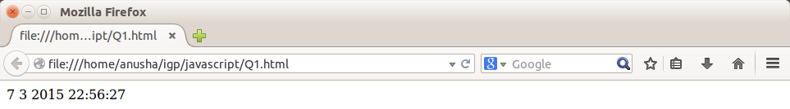

Q2:-Also make another function which returns the Date passed in a defined format.(“dd Month, yyyy HH:MM:ss”);

Sol:-

<!doctype html>

<head>

<script type="text/JavaScript" src="Application1.js">

</script>

</head>

<body>

<input type="button" onClick="ret_date()" value="Check date">

<input type="button" onClick="ret_time()" value="Check Time">

<input type="button" onClick="ret_DateTime()" value="Check DateTime">

</body>

</html>

Application1.js

function ret_date()

{

var d=new Date();

var day=d.getDate();

var mon=(d.getMonth()+1);

var year=d.getFullYear();

var dt=day+"/"+mon+"/"+year;

alert("DATE= "+dt);

}

function ret_time()

{

var d=new Date();

var hr=d.getUTCHours();

var m=d.getUTCMinutes();

var s=d.getUTCSeconds();

var time=hr+":"+m+":"+s;

alert("TIME= "+time);

}

function ret_time2()

{

var d=new Date();

var hr=d.getUTCHours();

var m=d.getUTCMinutes();

var s=d.getUTCSeconds();

var time=hr+":"+m+":"+s;

return time;

}

function ret_DateTime()

{

var d=new Date();

var day=d.getDate();

var mon=(d.getMonth()+1);

var year=d.getFullYear();

var dt=day+"/"+mon+"/"+year;

var hr=d.getUTCHours();

var m=d.getUTCMinutes();

var s=d.getUTCSeconds();

var time=hr+":"+m+":"+s;

dtt=dt+" | "+time;

alert("FULL DATE: "+ dtt);

}

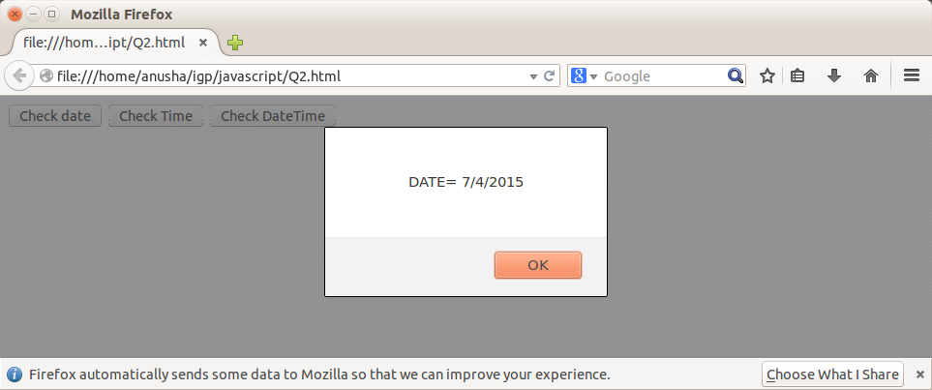

Q3:-Make A Function which takes the “ID”, of the element and “HTML” as the parameter, And replaces the content of the element by the HTML supplied.

Sol:-

<!doctype html>

<head>

<script type="text/JavaScript">

function good()

{

var idd=prompt("Enter the Id U want to Modify:");

var val=prompt("Enter the HTML to Set");

document.getElementById(idd).value=val;

}

</script>

</head>

<body>

<input type="button" id="v1" OnClick="good()" value="CHANGE CONTENT">

</br>

<input type="textbox" id ="t1">

</body>

</html>

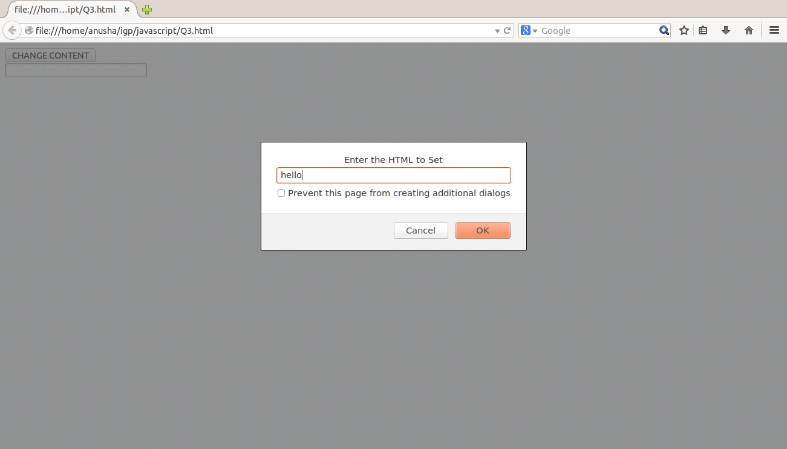

Q4:-Make a “div” on the Html Page with id=”timeDisp”. Write a function which uses all the functions developed in previous exercises to display current formatted time in the “div” created above.

Sol:-

<html>

<head>

<title></title>

<script type="text/JavaScript" src="Application1.js">

</script>

<script type="text/JavaScript">

function good()

{

var tm=ret_time2(); //method already defined in external js file

alert(tm);

document.getElementById("timeDisp").innerHTML=tm;

}

</script>

</head>

<body>

<input type="button" OnClick="good()" value="SET TIME IN DIV"></input>

</br>

<div id="timeDisp" style="background-color:yellow;position:relative;left:10;width:300;height:300; value="red">

GOOD

</div>

</body>

</html>

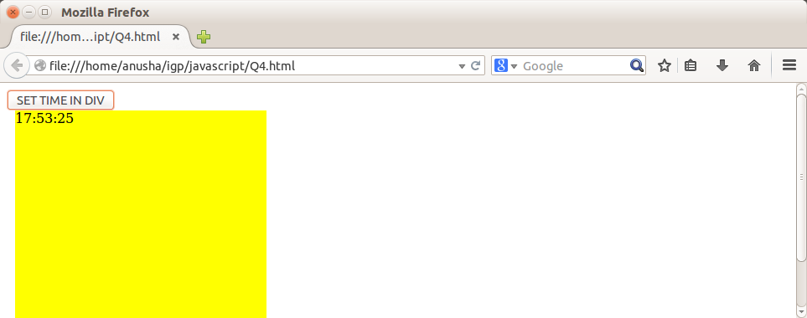

Q5:Make an Interval which calls the method updateTime every one second.

Make a button which can stop this interval.

Sol:-

<html>

<head>

<title></title>

<script type="text/JavaScript">

var ref,str=1;

function start()

{

ref=setInterval(updateTime,1000);

}

function updateTime()

{

document.getElementById("h1").innerHTML=str+"<br/>";

str=str+1;

}

function stoptimer()

{

clearInterval(ref);

}

</script>

</head>

<body>

<input type="button" onClick="start()" value="START TIMER"></input>

<input type="button" onClick="stoptimer()" value="STOP TIMER"></input>

<br/>

<p align="center" id="h1"></p>

</body>

</html>

Output:-

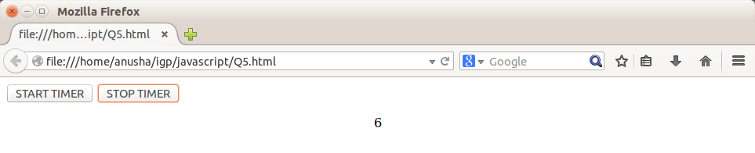

**Q6) Prompt for amount, interest rate and no. of years and calculate simple interest.**

<html>

<head>

<title></title>

<script type="text/JavaScript">

function si ()

{

var p,r,t,si;

p=parseInt(prompt("Enter the Principal"));

r=parseInt(prompt("Enter the rate"));

t=parseInt(prompt("Enter the time"));

si=p*r*t/100;

alert("Simple Interest= "+si);

}

</script>

</head>

<body>

<input type="button" value="CALCULATE Simple Interest" onClick="si ()">

</body>

</html>

Output:-

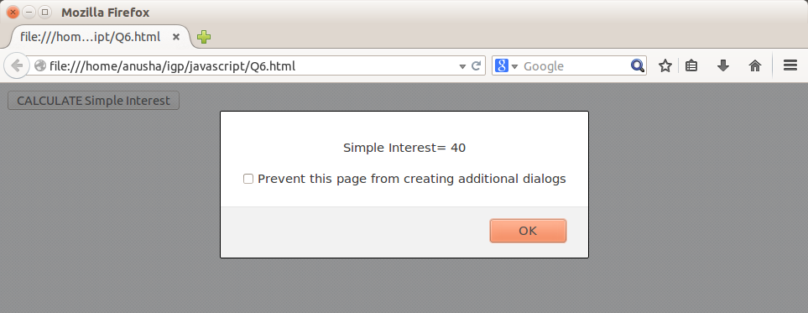

**Q7) Is palindrome string?**

<html>

<head>

<title></title>

<script type="text/JavaScript">

function palin()

{

var i,n,rev="";

n=prompt("Enter any string");

for(i=n.length-1;i>=0;i--)

rev=rev+n.charAt(i);

if(n==rev)

alert("Palindrome String");

else

alert("Not Palindrome String");

}

</script>

</head>

<body>

<input type="button" value="FIND PALINDROME" onClick="palin()">

</body>

</html>

Solution:-

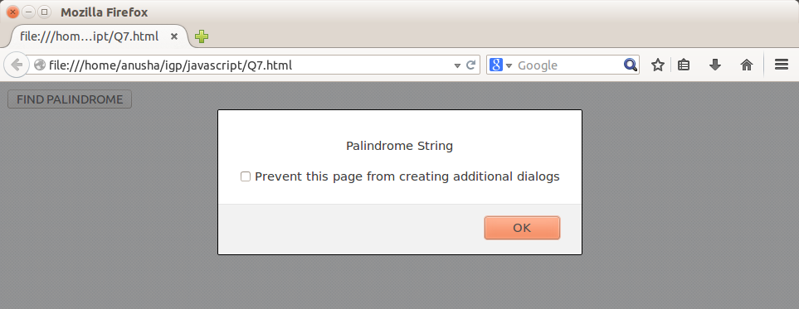

**Q8) Area of circle**

<html>

<head>

<title></title>

<script type="text/JavaScript">

function area()

{

var r,area;

n=parseInt(prompt("Enter any radius of circle:"));

area=Math.PI*n*n;

alert("Area of Circle= "+area);

}

</script>

</head>

<body>

<input type="button" value="FIND AREA" onClick="area()">

</body>

</html>

Solution

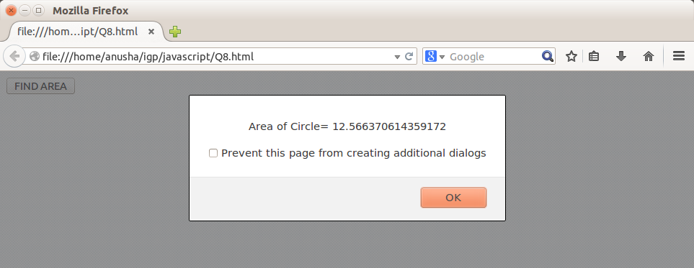

**Exercises Using Form**

**Q9) On click of a button ask for the name of user and display it inside the text box.**

<html>

<head>

<title></title>

<script type="text/JavaScript">

function name1()

{

var nm;

nm=prompt("Enter your name");

document.forms["first"]["t1"].value=nm;

}

</script>

</head>

<body>

<form name="first">

<input type="button" value="ENTER YOUR NAME" onClick="name1()">

<br/><br/>

<input type="text" id="t1">

</form>

</body>

</html>

Output:-

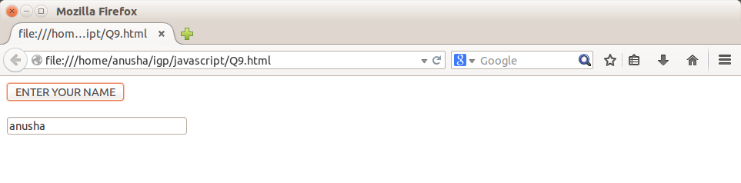

**Q10) Copy text of one text field to another on change of text in first text box.**

<html>

<head><title>text change</title>

<script type = "text/JavaScript">

var n;

function changex()

{

n = document.getElementById("v1").value ;

document.getElementById("v2").value = n;

}

</script>

</head>

<body>

<form>

<input type= "text" id="v1" onChange = "changex()">

<input type= "text" id="v2">

</form>

</body>

</html>

Output:-

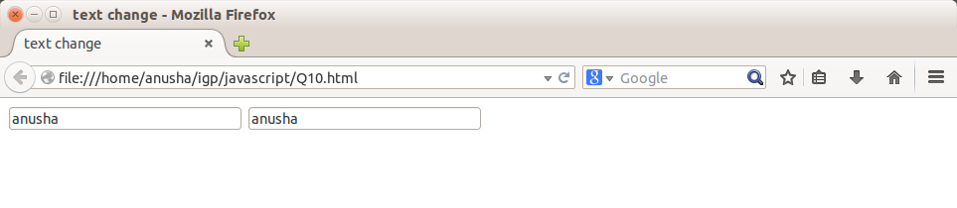

**6) Allow submission of form only if the user has entered his name (not empty) and age is greater than or equals to 18**

<html>

<head><title>Registration</title>

<script type = "text/JavaScript">

function validate()

{

var x = document.forms["reg"]["fname"].value;

var y = document.forms["reg"]["age"].value;

if(x=="")

{

alert("name field is mandatory");

return false;

}

if(y<18)

{

alert("your age is below 18");

return false;

}

}

</script>

</head>

<body>

<form name ="reg" action="aft_reg.html" onsubmit= "return validate()" method ="post">

NAME: <input type ="text" name="fname"><br><br>

COLLEGE: <input type ="text" name ="clg"><br><br>

AGE: <input type = "text" name ="age"><br><br>

<input type = "submit" name ="Submit">

</form>

</body>

</html>

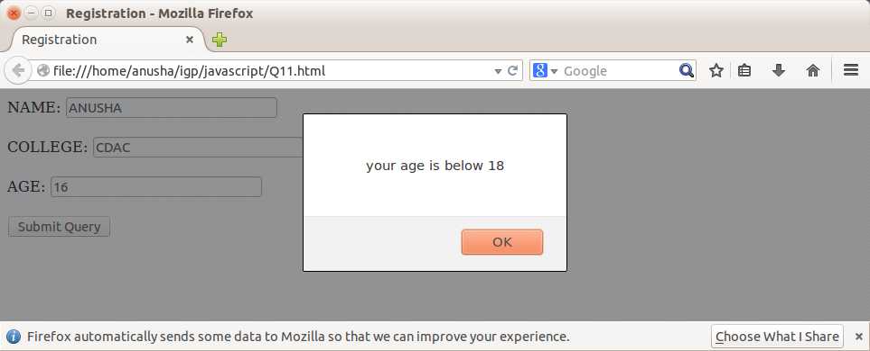

**Q12) Change color of the div when mouse is moved over it and restore the color when mouse moves out of it.**

<html>

<head><title>hovering</title>

</head>

<body>

<div id="mydiv" style="width:900px;color:white" onmouseover="this.style.color='Green';" onmouseout="this.style.color='Red';">

<h1><u><i>Example of mouse hovering<i><u></h1>

</div>

this is out of the div area,,Move over on the text.

</body>

</html>

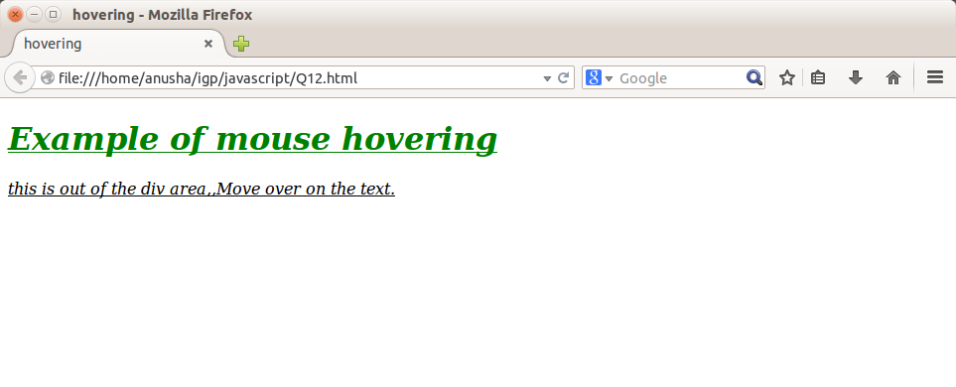

**Q13:- Externalize java Script file in previous exercises.**

Application1.js

function ret_date()

{

var d=new Date();

var day=d.getDate();

var mon=(d.getMonth()+1);

var year=d.getFullYear();

var dt=day+"/"+mon+"/"+year;

alert("DATE= "+dt);

}

function ret_time()

{

var d=new Date();

var hr=d.getUTCHours();

var m=d.getUTCMinutes();

var s=d.getUTCSeconds();

var time=hr+":"+m+":"+s;

alert("TIME= "+time);

}

function ret_time2()

{

var d=new Date();

var hr=d.getUTCHours();

var m=d.getUTCMinutes();

var s=d.getUTCSeconds();

var time=hr+":"+m+":"+s;

return time;

}

function ret_DateTime()

{

var d=new Date();

var day=d.getDate();

var mon=(d.getMonth()+1);

var year=d.getFullYear();

var dt=day+"/"+mon+"/"+year;

var hr=d.getUTCHours();

var m=d.getUTCMinutes();

var s=d.getUTCSeconds();

var time=hr+":"+m+":"+s;

dtt=dt+" | "+time;

alert("FULL DATE: "+ dtt);

}

file1.html

<!doctype html>

<head>

<script type="text/JavaScript" src="Application1.js">

</script>

</head>

<body>

<input type="button" onClick="ret_date()" value="Check date">

<input type="button" onClick="ret_time()" value="Check Time">

<input type="button" onClick="ret_DateTime()" value="Check DateTime">

</body>

</html>

