Twitter Sentiment Analysis on COVID-19

MOHAMMED SHOEBUDDIN HABEEB | ANUSHA PALISETTY
Data Science and Analytics | Data Science and Analytics
Georgia State University, | Georgia State University,
Atlanta | Atlanta
mhabeeb2@student.gsu.edu | apalisetty1@student.gsu.edu

Abstract—Sentiment analysis is a interesting field which has attracted much attraction recently. As part of this project, we are performing Twitter data sentiment analysis. Performing this on the twitter data is challenging with the huge volume of data available. To resolve this, we make use of Spark Frame to do the sentiment learning. We get data by using Twitter API from start till March 12 which is about 180 MB and implement Machine Learning modeling techniques. We can also get more data for each day as the number of tweets exponentially increased every day. The main idea is to implement the Big Data techniques used in the coursework with the limited amount of data available.

Keywords: Apache Spark · Big Data · Sentiment Analysis · Social Media Analytics

- INTRODUCTION

The pandemic occurred in 2020 created lot of chaos across the globe. In these days people share experiences and feelings through social network. Microblogging platforms namely Twitter has become very popular recently. People use Twitter to share experiences and emotions with their friends about movies, products, events etc., so a system that extracts sentiments through an online community may have many real-life applications such as recommendation systems. We are performing some sentiment analysis on the COVID-19 twitter data analysis. Data can be downloaded from many options but we have decided to take a predownloaded historical data csv file for 2 datasets. The first dataset contains all the related tweets from 1st March to 12th March. But the prectical issue with that file was COVID 19 was still in its initial phase. We then decided to take data from 14th April which is almost around the time when coronavirus spread and impact was at its peak. These datasets are typically ~200Mb on average.

The first dataset contains the Tweets of users who have applied the following hashtags:
#coronavirus,#coronavirusoutbreak,#coronavirusPandemic,#covid19, #covid_19
This second dataset also contains #epitwitter, #ihavecorona tweets.

The sentiment analysis which is part of Natural Language Processing is implemented utilizing Spark Framework. Data Preprocessing is performed on the tweets and from the clean we tell the reaction of user if its positive or negative or neutral. Through this we can provide some valuable insights on how people feel about the pandemic. The Preprocessing of the data is implemented using pyspark and the modelling is performed using Machine Learning algorithm in Python.

- RELATED WORK

Sentiment Analysis is studied in many different levels. We are presenting a novel method for Sentiment Learning in the Spark framework.

Spark Framework
Spark Framework1 is a newer framework built in the same principles as Hadoop. While Hadoop is ideal for large batch processes, it drops in performance in certain scenarios, as in iterative or graph based algorithms. Another problem of Hadoop is that it does not cache intermediate data for faster performance but

instead, it flushes the data to the disk between each step. In contrast, Spark maintains the data in the workers’ memory and as a result it outperforms Hadoop in algorithms that require many operations. Spark offers API in Scala, Java, Python and R and can operate on Hadoop or standalone while using HDFS, Cassandra or HBase.

MLlib
Spark’s ability to perform well on iterative algorithms makes it ideal for implementing Machine Learning Techniques as, at their vast majority, Machine Learning algorithms are based on iterative jobs. MLlib2 is Apache Spark’s scalable machine learning library and is developed as part of the Apache Spark Project. MLlib contains implementations of many algorithms and utilities for common Machine Learning techniques such as Clustering, Classification, Regression.

Implementation
The overall architecture of the proposed system is depicted in Figure taking into account the corresponding modules of our approach. Inititally, a pre-processing step, as shown in following subsection, is utilized and in following the classifiers for estimating the sentiment of each tweet, are used.

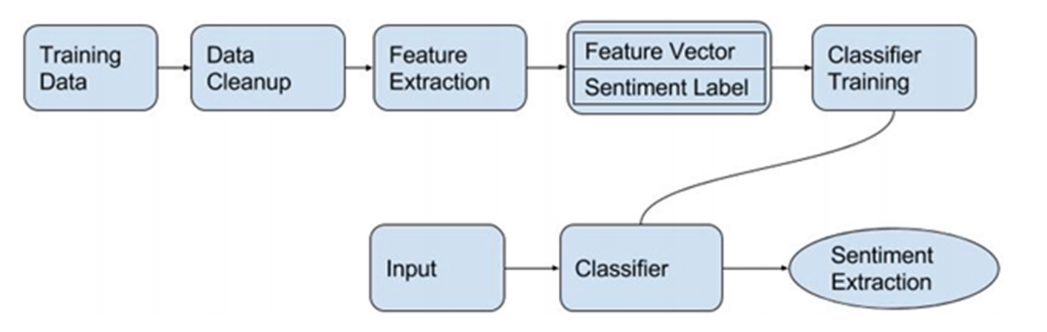
Fig 1 Architecture

- COVID-19 Data Visualizations and Preprocessing

From the past 2 months we observe that the tweets are mostly related to the pandemic more than any other topics. We perform Visualization to understand insights into data.
The raw data available is not suitable to process the Machine Learning algorithm. In order to process the data to modeling we perform some preprocessing technqiques using pyspark libraries like SparkContext, SQLContext, SparkSession, CountVectorizer and more. We also utilize the the packages form the nltk as part of this process. We extract the tweets and perform the preprocess steps using Pyspark:

- Tokenization
- Splitting the sentence into words
- Removing stopwords,
- Removing punctuations
- Handling Emoticons
- Stemming/Lemmatization
- Getting key phrases

- Tweet Sentiment Analysis

The data obtained after preprocessing is used to perform the sentiment analysis using the SparkMLlib, SparkML available in the pySpark package. We will try to understand the general consensus and mood (optimism vs pessimism) in the general public towards the pandemic. After preprocessing the data, we have the key phrases through which we will be able to categorize the tweet as positive, negative or neutral. To perform this functionality, we utilize the packages provided by the Natural Language Processing Tool Kit.

A number of our features are based on prior polarity of words. For obtaining prior polarity of the words, we consider a dictionary with 8000 English words assigns every word a pleasantness score (∈ R) between 1 (Negative) - 3 (Positive). We first normalize the scores by diving each score my the scale (which is equal to 3). We consider words with polarity less than 0.5 as negative, higher than 0.8 as positive and the rest as neutral. If a word is not directly found in the dictionary, we retrieve all synonyms from Wordnet.

With the sentiment polarity: positive and negative we can classify all the positive to one class , negative to one class and neutral to another class.

Tweet Classification:

Once we get the polarity, we classify the tweets Positve as 1, neutral as 0 and negative as 2. We are performing MultiClassification here. Here the feature extraction is implemented using TF-IDF and proceed for modelling. Preprocessing must be implemented before modelling.

Then we perform “randomsplit” on the data into training and test data where input column is “features” and output column is “label”. We consider the training data to be 70% and the test data as 30%.Then we fit the data to machine learning algorithms.

Among all the machine learning algorithms Naïve Bayes is considered as base model for our project as this algorithm is best suited for text analysis.We fit the training test on the NaïveBayes Classifier and perform predictions.

Based on the prediction we calculate the accuracy. A confusion matrix is also created to view all the data.All this is achievable with power of Spark. With Spark as a base we are performing sentiment analysis on the Twitter COVID-19 data. All the tweets are read into the memory spread across bunch of nodes in the cluster and perform Natural language processing in a distributed manner.

- PROBLEM FORMULATION

We read the dataset from the csv file using Spark SQL context, since we have a text column with quotes data we enable the option multiline as Ture and represent quoted text with “\”. As shown the dataset has 22 columns showing information of a particular user whose tweet we are considering of which we majorly work with text, country_code and place

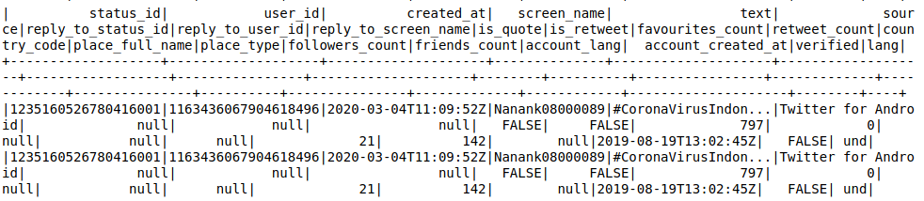
Fig 2 Sample Data

Data Preprocessing:

The preprocessing of the text data is an essential step as it makes the raw text ready for mining, i.e., it becomes easier to extract information from the text and apply machine learning algorithms to it. If we skip this step then there is a higher chance that you are working with noisy and inconsistent data. The objective of this step is to clean noise those are less relevant to find the sentiment of tweets such as punctuation, special characters, numbers, and terms which don’t carry much weightage in context to the text.
To perform the preprocessing step we make use of udf library available in the pyspark.sql.functions

Text cleaning

Before performing feature extraction from the tweets,the given text(tweets) must be cleaned from emoticons, symbols hyperlinks,punctuations, retweets, emoji’s and any extra spaces. For this operation we define a method clean_text and deEmojify which filters and returns cleared text.

Input : Text column(Tweets)
Output: Text column(cleaned)

Tokenizing

From the cleaned text we tokenize each word using Tokenizer from pyspark.ml.feature library.
This will split the text based on space and return array of strings.
Input: Text column(cleaned)
Output: words column(Array of strings)

Remove stop words

A stop word is a commonly used word (such as “the”, “a”, “an”, “in”). The words will help much while performing classification techniques. StopWordsRemover from the pyspark.ml.feature is used to perform this action.All the stopwords provided by that library will be removed.

Input: words column(From Tokenizer)
Output: words column(Removes all stop words)

TextBlob- Polarity and Subjectivity

TextBlob is a Python (2 and 3) library for processing textual data. It provides a simple API for diving into common natural language processing (NLP) tasks such as part-of-speech tagging, noun phrase extraction, sentiment analysis, classification, translation, and more.

Polarity is float which lies in the range of [-1,1] where 0 means neutral statement anything more than 0 implies positive statement and less than 0 means a negative statement. Subjective sentences generally refer to personal opinion, emotion or judgment whereas objective refers to factual information. Subjectivity is also a float which lies in the range of [0,1].

Feature Extraction
- TF-IDF stands for “term frequency-inverse document frequency”, meaning the weight assigned to each token not only depends on its frequency in a document but also how recurrent that term is in the entire corpora.
- We vectorize every word in the corpus to a numerical form. By vectorizing the documents we can further perform multiple tasks such as finding the relevant documents, ranking, clustering and so on. The lower the IDF value of a word, the less unique it is to any particular document.

- Count Vectorizer: The most straight-forward one, it counts the number of times
a token shows up in the document and uses this value as its weight.
- An encoded vector is returned with a length of the entire vocabulary and an integer count for the number of times each word appeared in the document.
- Since we are not using CV set for our ML model we are getting a better performance score from Count Vectorizer
Input : words column
Output: Features

- DATA VISUALIZATION

Data visualizations are the graphical representation of the data. Through this we understand the trends, outliers and patterns in data.

Figure 3 shows the Sentiment Category with respective to their counts. We observed that more positive tweets are high than neutral and negative. Positive tweets include Any tweet that wishes Speedy Recovery, Appreciate the doctors or the front line workers etc.

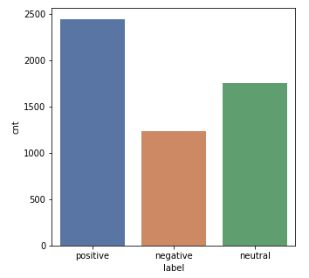
Fig 3 Sentiment Counts

Figure 4 shows the plot for Countries which posted high number of tweets. We observe that there are highest tweets from US.

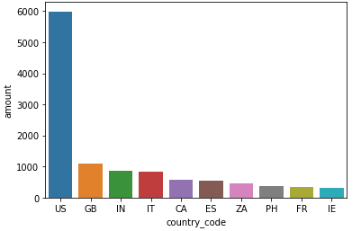

Fig 4 Country Counts

NRC Lexicon Analysis

Once we understand the text, the next step is to understand the emotion or opinion of the text. NRC dictionary contains a sentiment for the English words. After tokenizing and cleaning the

text for each word there is a corresponding sentiment attached to it like joy, fear, surprise etc. Figure 5 shows the Sentiments with respect to their counts.

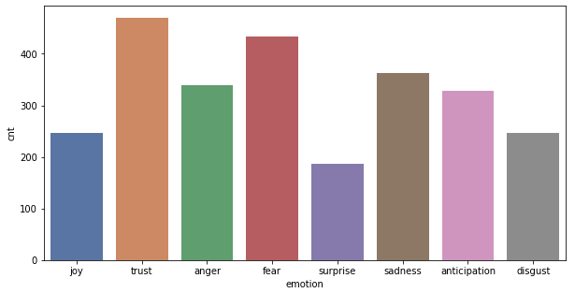
Fig 5 Emotions

- ALGORITHM DESIGN

Sampling:
After data preprocessing the next step is Data modelling. To perform data modelling we split the data using Stratified sampling instead of random sampling which take the equal data from each group of the labelled data.We split the dataset into samples of 60:40 where instead of random sampling.

Naive Bayes :
Naive Bayes are mostly used in natural language processing (NLP) problems. Naive Bayes predict the tag of a text. They calculate the probability of each tag for a given text and then output the tag with the highest one.

- EXPERIMENTAL RESULTS

Accuracy : Gives the total correct predictions divided by total predictions

Precision and Recall
Recall expresses the ability to find all relevant instances in a dataset whereas precision expresses the proportion of the data points our model says was relevant actually were relevant.

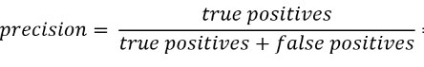
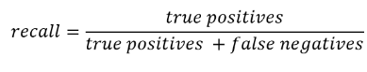

F1 Score
F1 score is defined as the harmonic mean between precision and recall. It is used as a statistical measure to rate performance. In other words, an F1-score (from 0 to 9, 0 being lowest and 9 being the highest) is a mean of an individual's performance, based on two factors i.e. precision and recall.

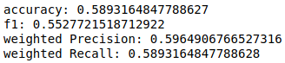

ROC Curve Evaluation

A receiver operating characteristic curve, or ROC curve, is a graphical plot that illustrates the diagnostic ability of a binary classifier system as its discrimination threshold is varied. The ROC curve is created by plotting the true positive rate against the false positive rate at various threshold settings.

AUC provides an aggregate measure of performance across all possible classification thresholds. One way of interpreting AUC is as the probability that the model ranks a random positive example more highly than a random negative example.

ROC curve is similar for both the datasets which hints that model works similarly on both given data
AUC score = 0.6665

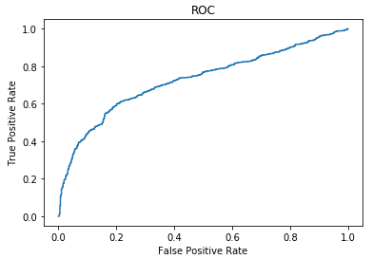
Fig 6 ROC Curve

Exceptions and Assumptions

- Twitter data is only available in countries where twitter is not banned
- There are many accounts which usually are not registered with all the details of the 22 columns. This includes location and country names
- Such data has been discarded when using country wise or location wise analysis.

References:
- https://www.kaggle.com/sudalairajkumar/novel-corona-virus-2019-dataset
- https://towardsdatascience.com/see-the-coronavirus-for-yourself-88ce06b88f5e

