**EXECUTION OUTPUT**

I used the script command to capture the output results, which makes a typescript of everything printed on the terminal. I have copied those results into the typescript.txt file and also included the typescript respectively in the folder Program4. Since the 8 nodes were not working all the time, there are many typescripts.

**Executuion output** :

typescript1: Most of the execution output results are in this

typescript2: Shows Node 8 : Thread 4 output with the connection failures

typescript3: Shows Node 8 : Thread 4 outputs

typescriptBinker : BLINKER pattern. With the print turned on (to print all the turns) and the input from input file option. Node 1 : Thread 1 and Node 4 : Thread 4.

Below are the few snap shots.

SnapShot: Turns:4 Size:20 x 20 Node:1 Threads: 1

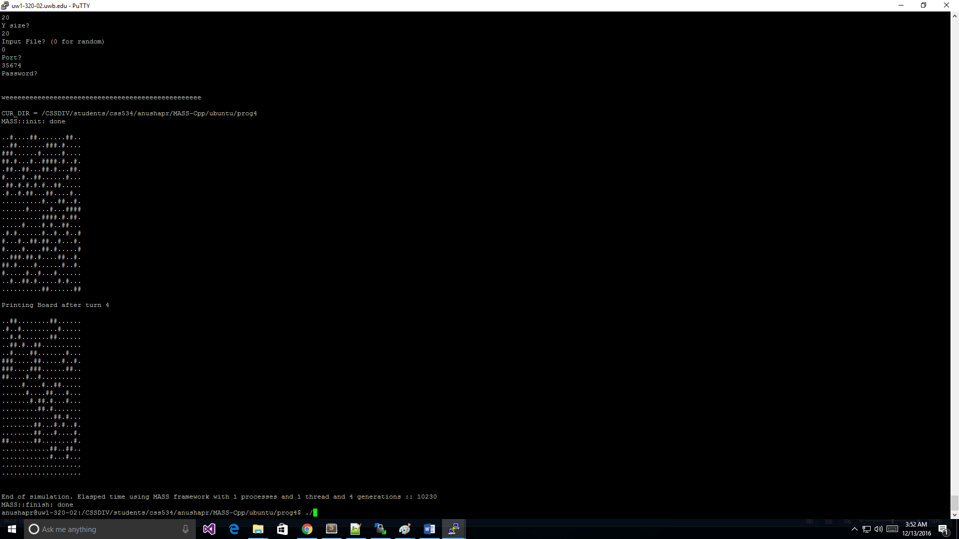

SnapShot: Turns:4 Size:20 x 20 Node:2 Threads: 2

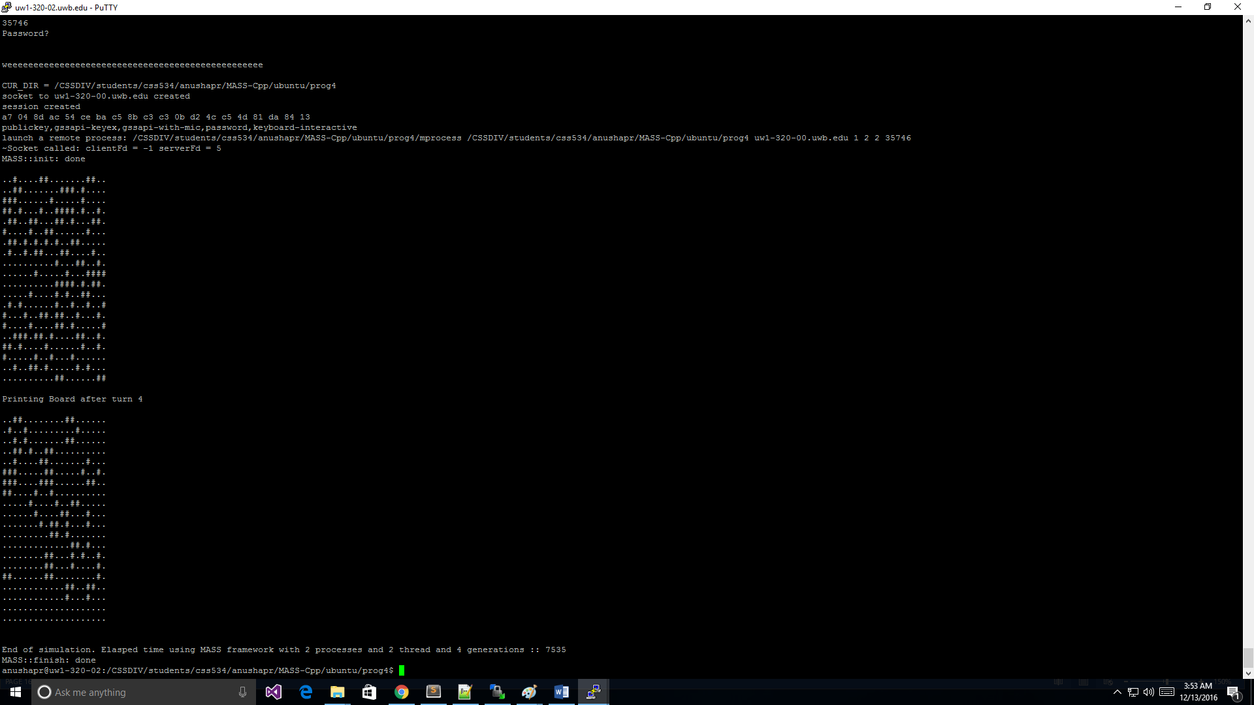

SnapShot: Turns:4 Size:20 x 20 Node:4 Threads: 4

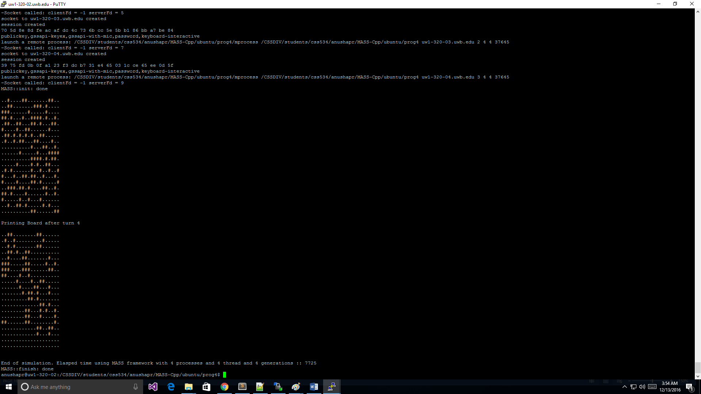

SnapShot: Turns: 80 Size:160 x 160 Node:1 Threads:1

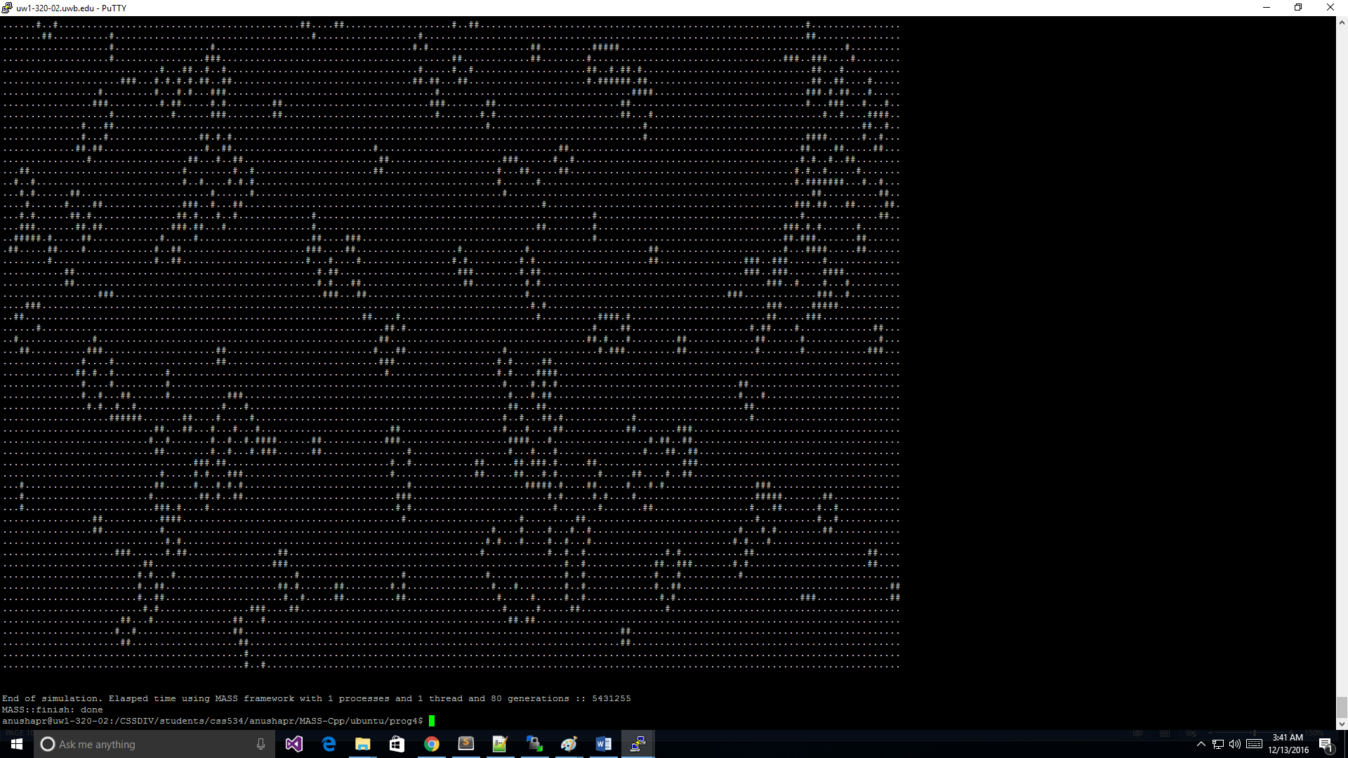

SnapShot: Turns: 80 Size:160 x 160 Node:2 Threads:2

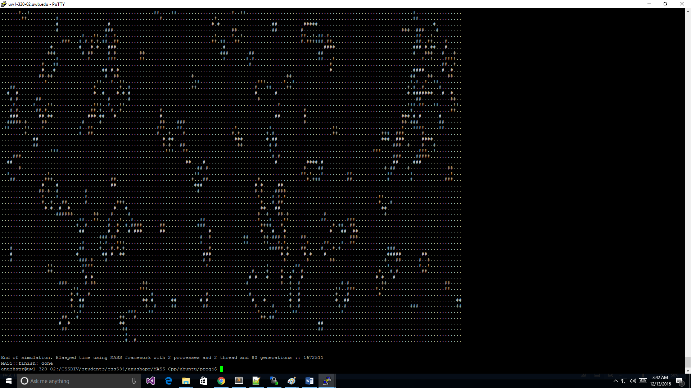

SnapShot: Turns: 80 Size:160 x 160 Node:4 Threads:4

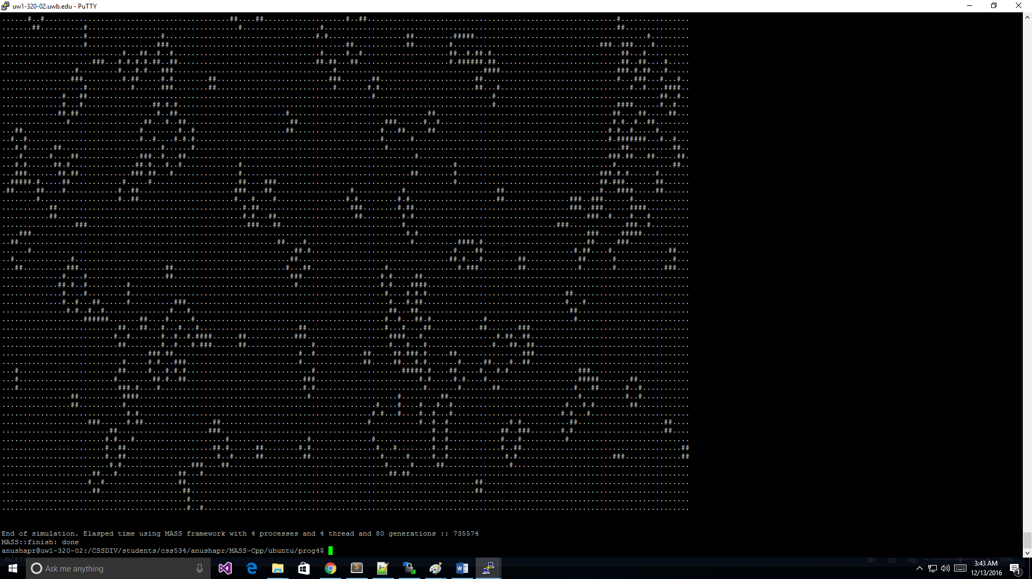

SnapShot: Turns: 80 Size:160 x 160 Node:8 Threads:4

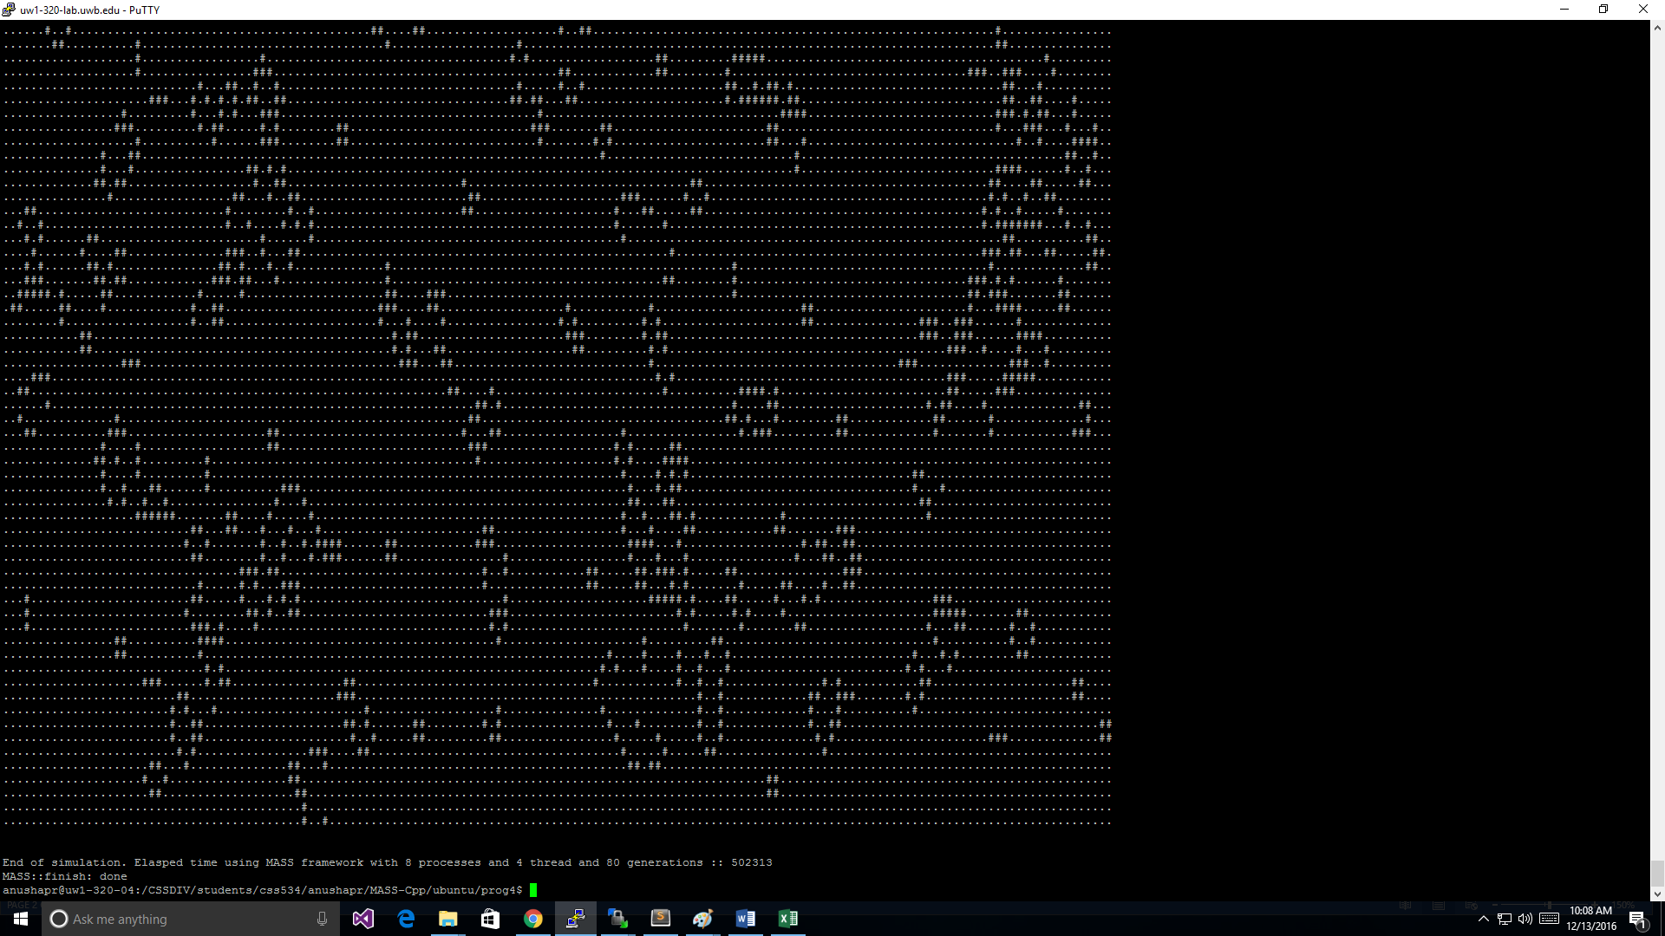

SnapShot: Turns:40 Size:80x80 Node:1 Threads:41

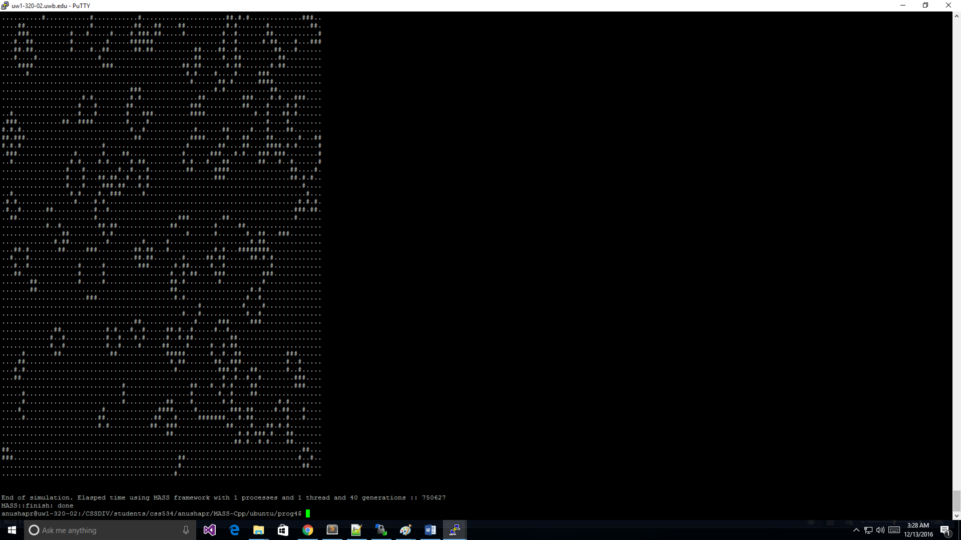

SnapShot: Turns:40 Size:80x80 Node:2 Threads:2

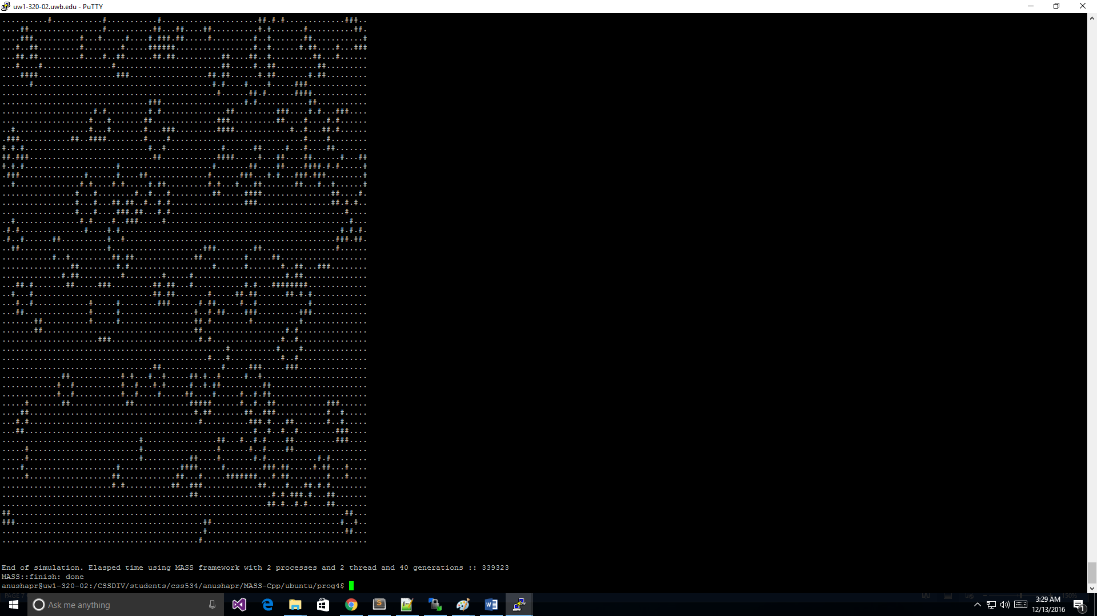

SnapShot: Turns:40 Size:80x80 Node:4 Threads:4

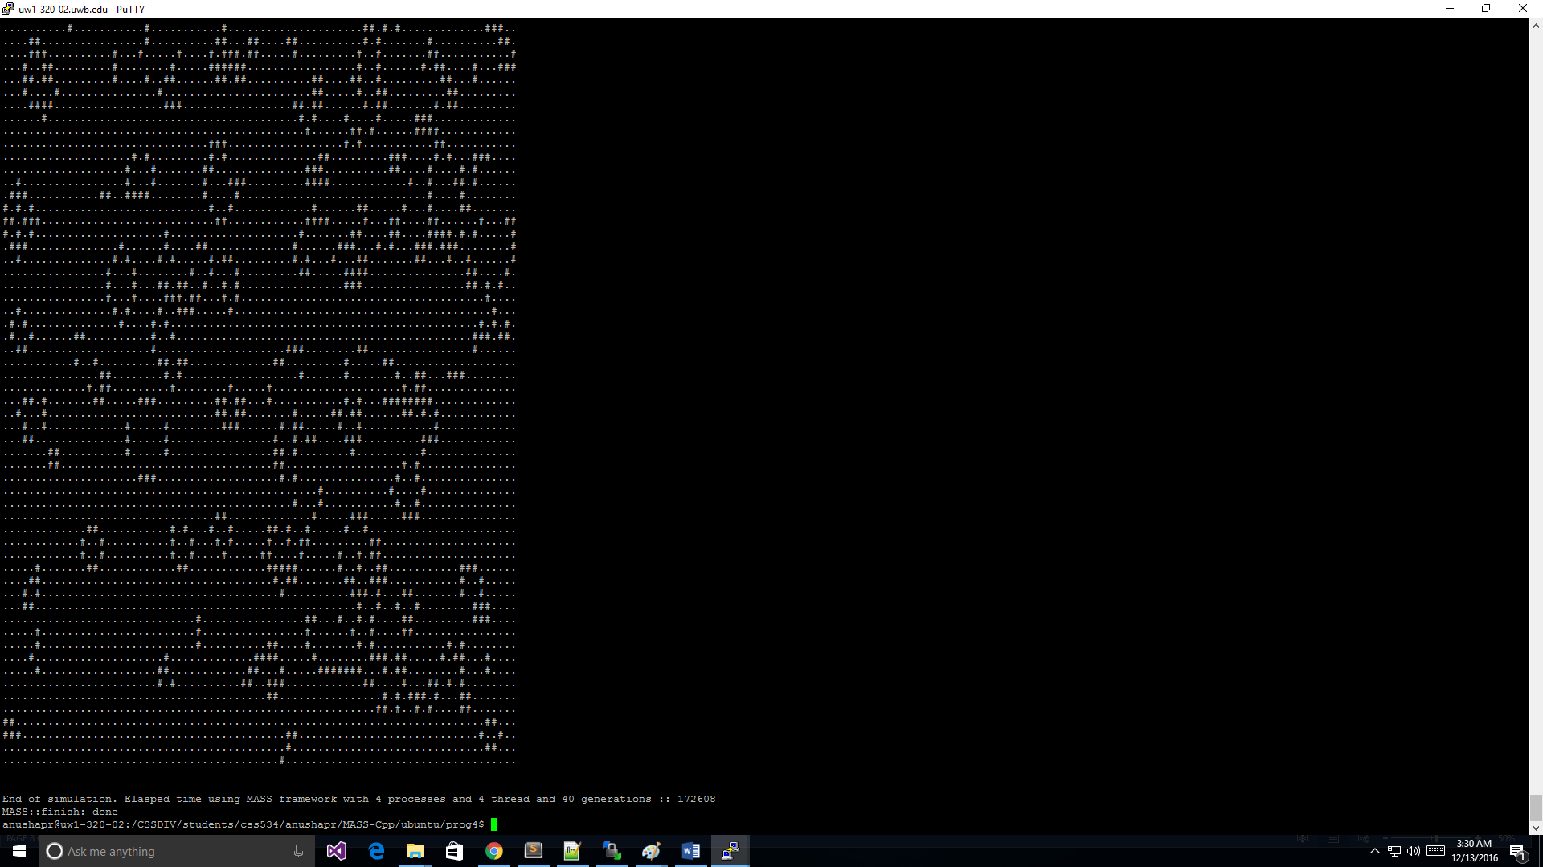

SnapShot: Turns:40 Size:80x80 Node:8 Threads:4

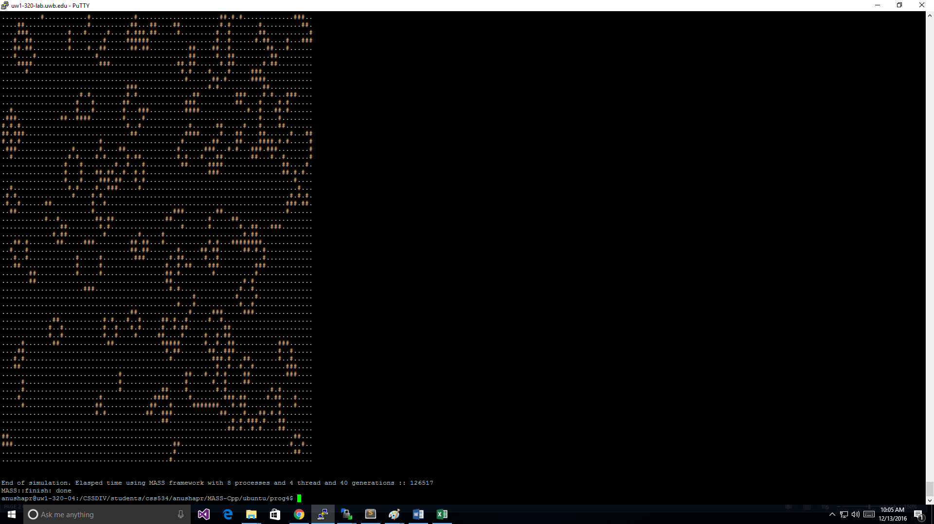

SnapShot: BLINKER: With the print turned on (to print all the turns) and the input from input file

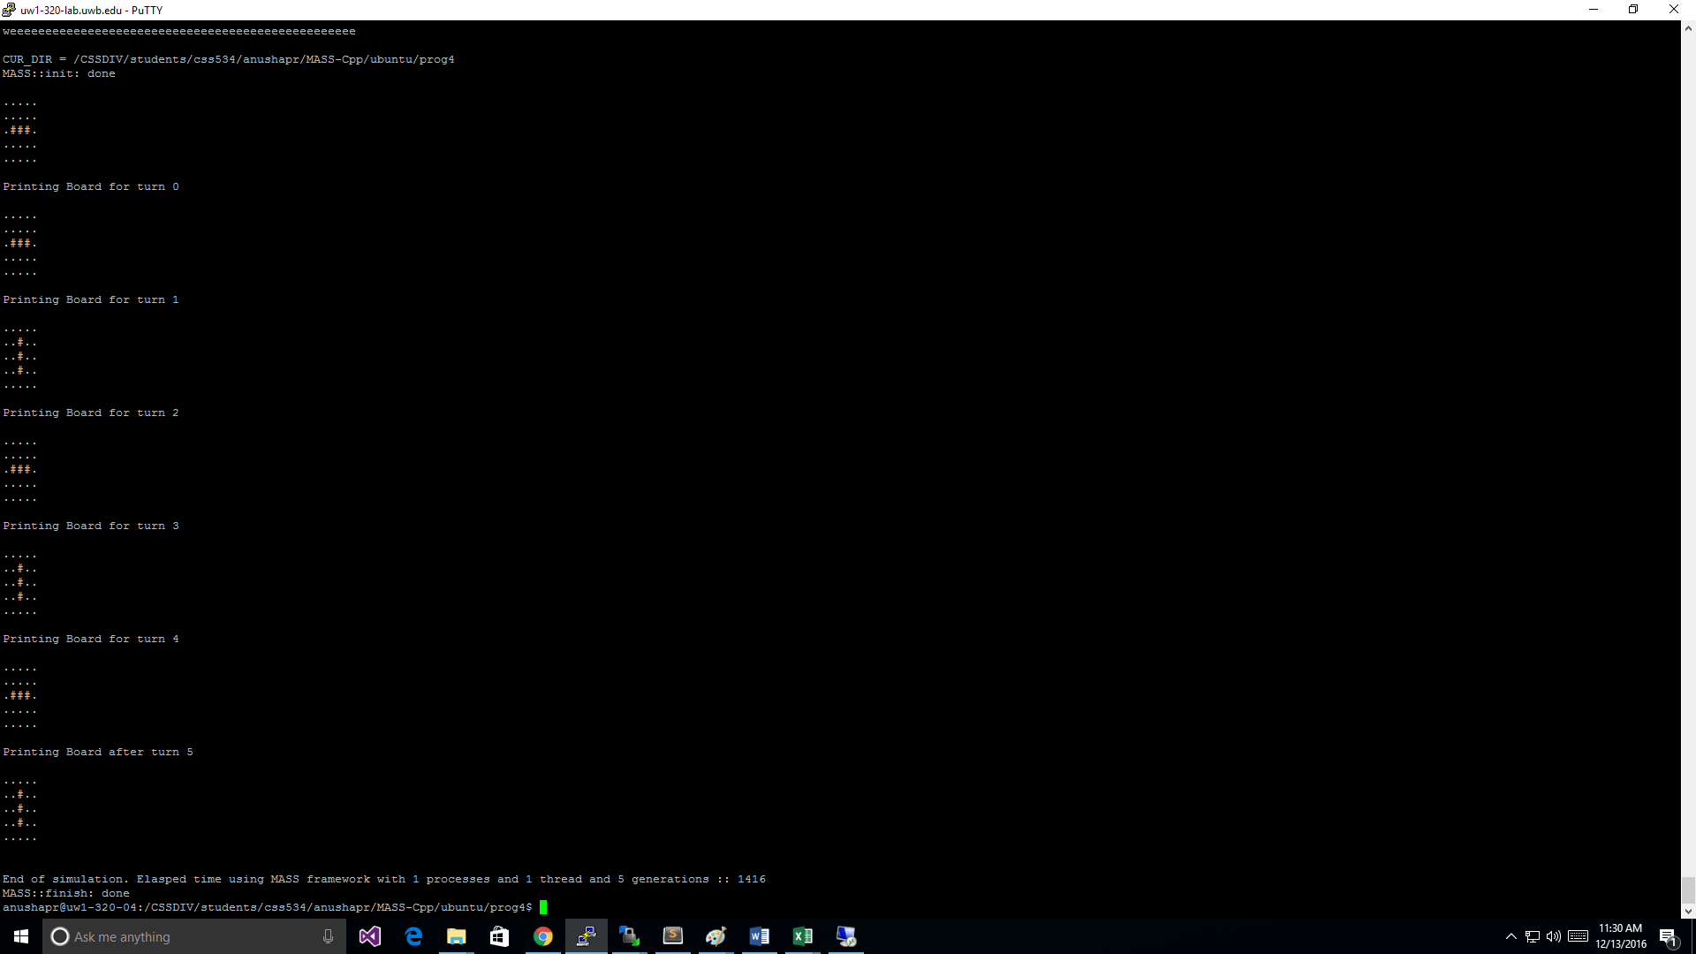

**EXECUTION OUTPUT**

I used the script command to capture the output results, which makes a typescript of everything printed on the terminal. I have copied those results into the typescript.txt file and also included the typescript respectively in the folder Program4. The

**Executuion output** :

Below are the screen shots of some outputs.

10 20 20 1:1

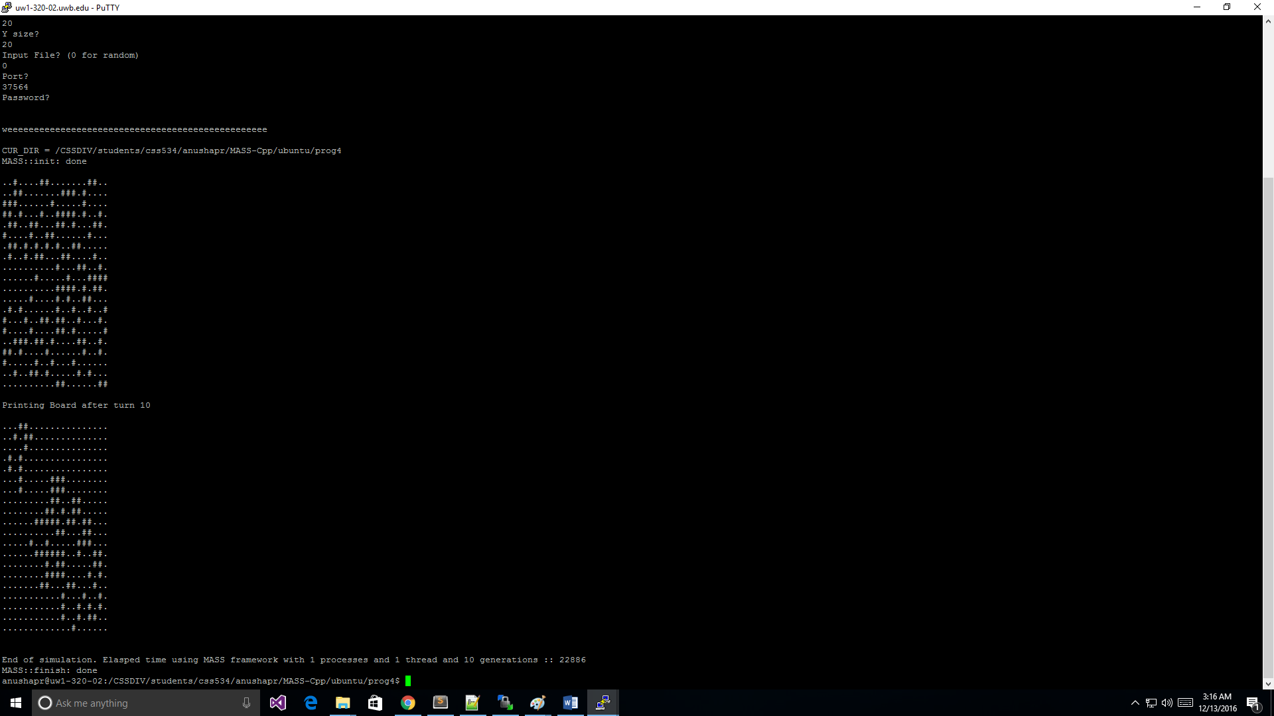

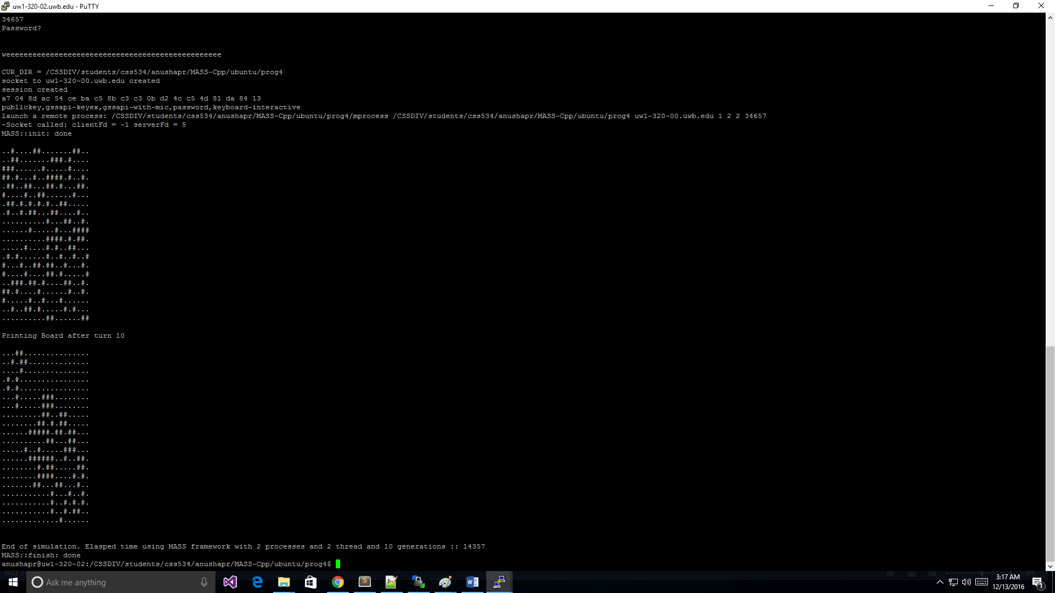

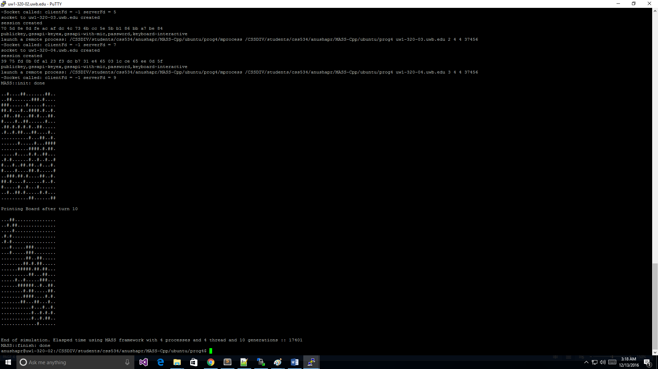

**10 40 40 1:1**

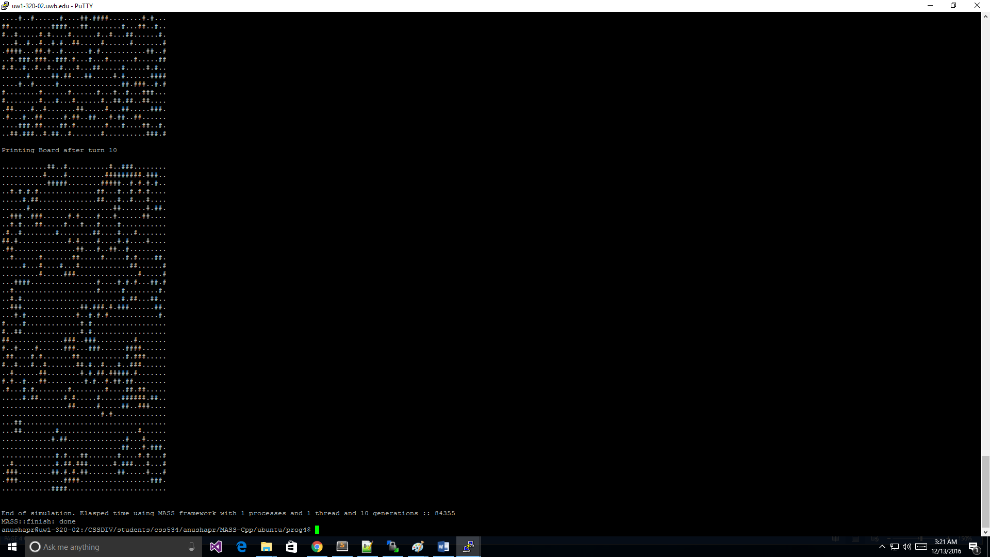

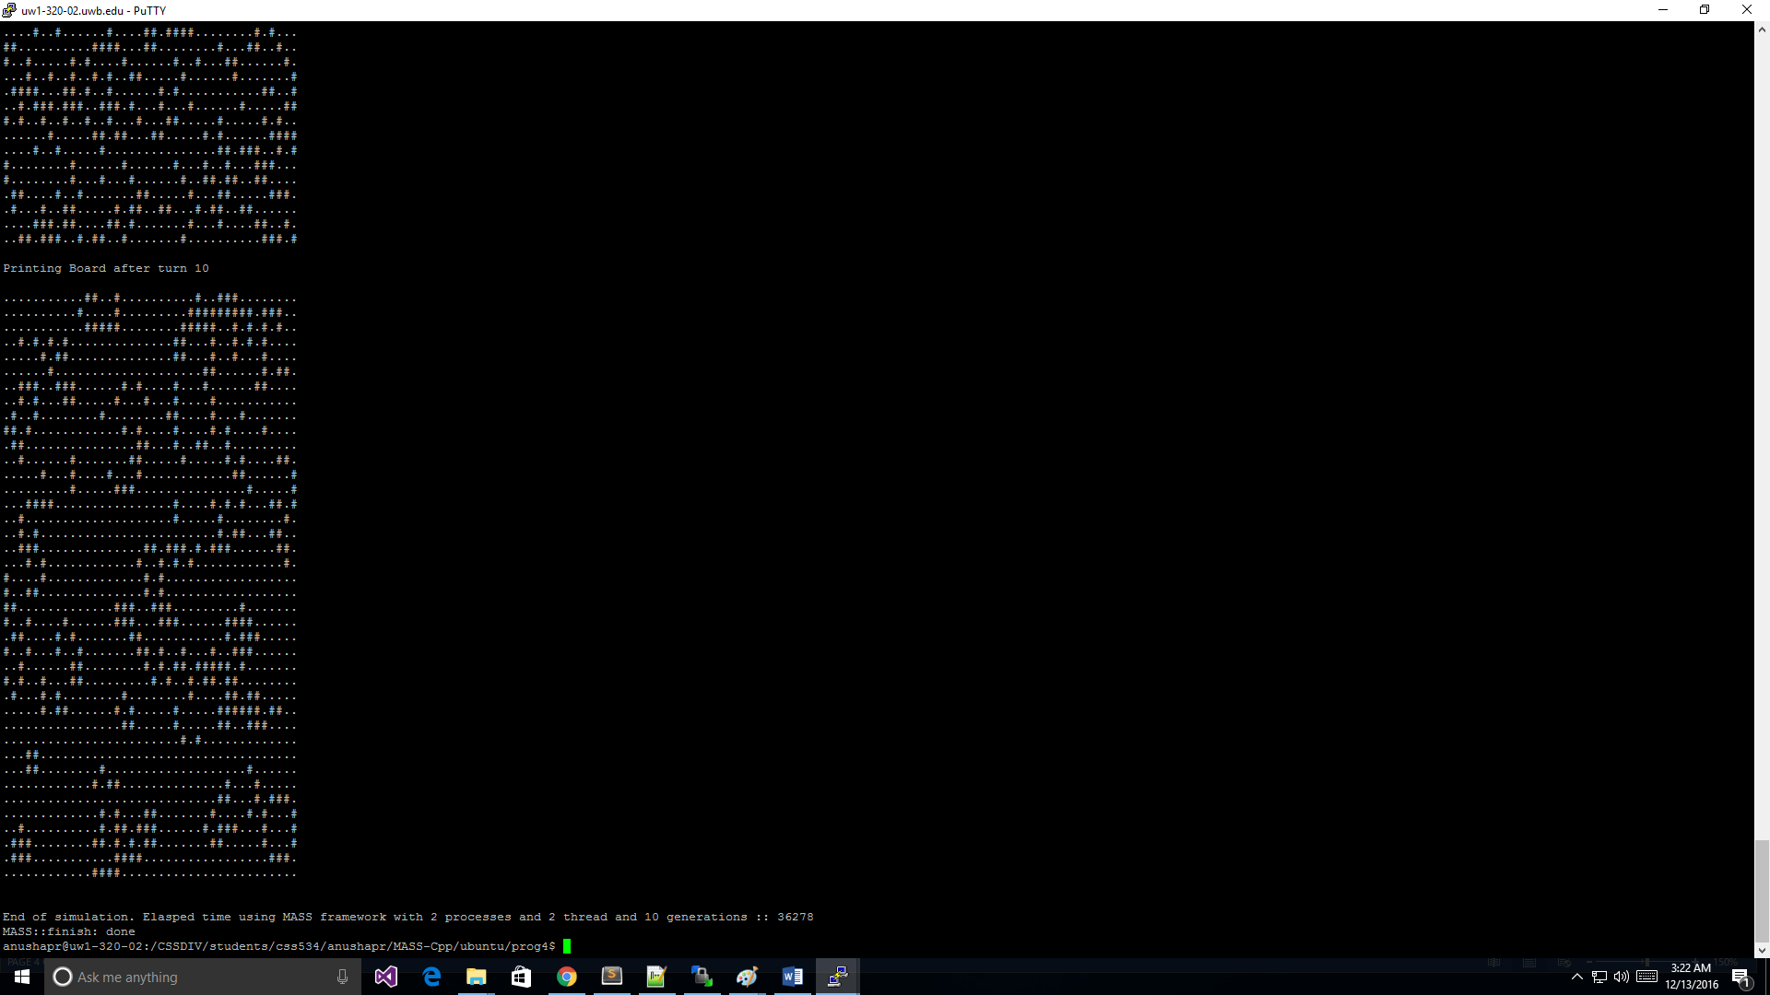

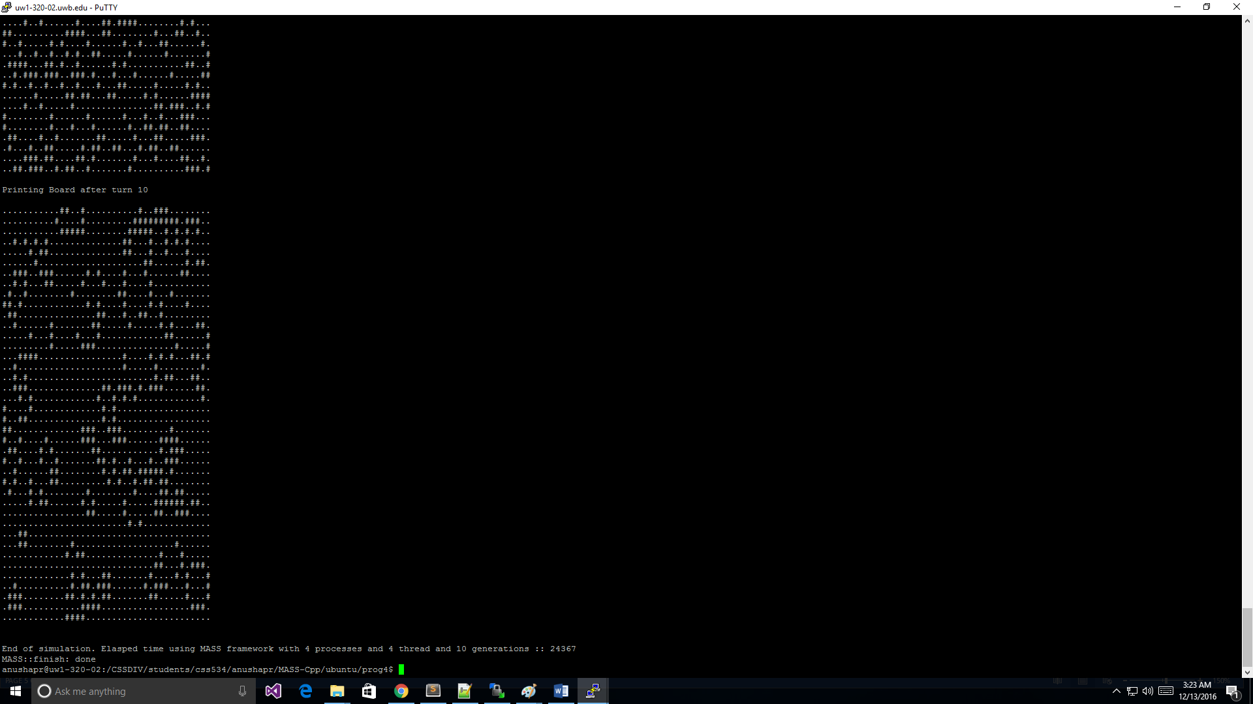

**20 80 80 1:1**

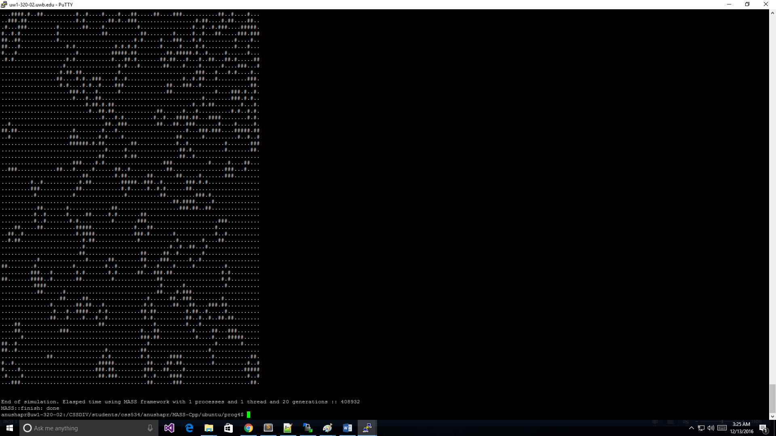

**4:4**

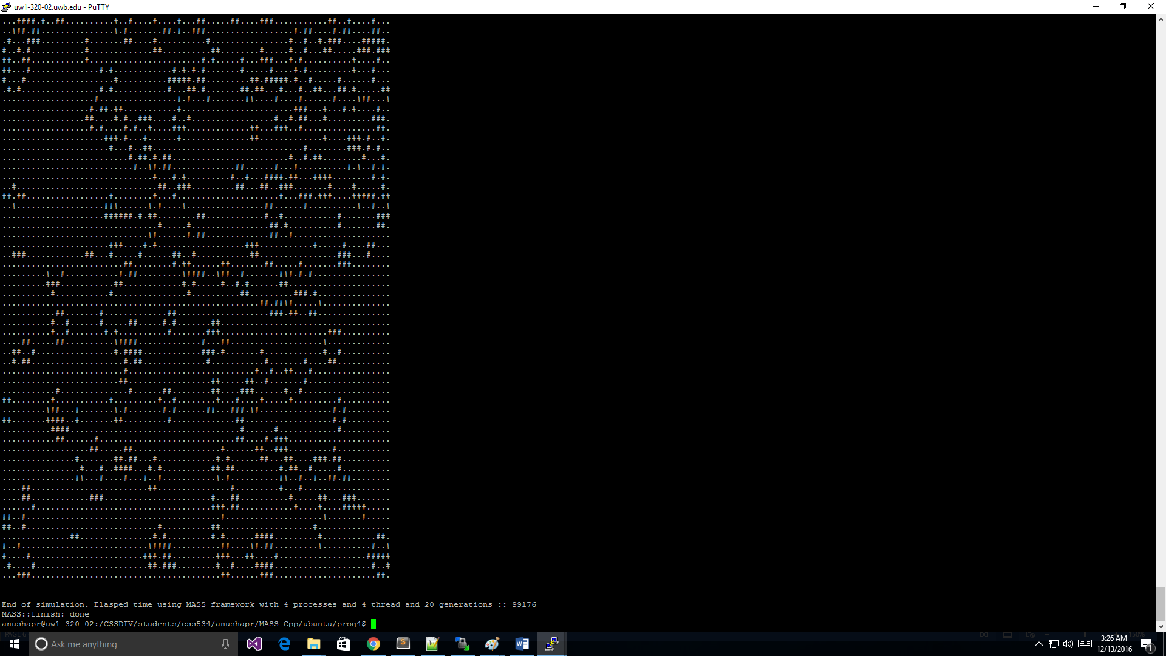

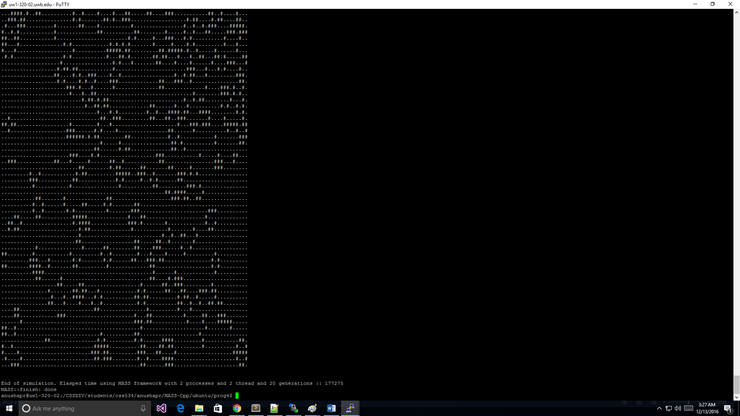

**40 80 80 1:1**







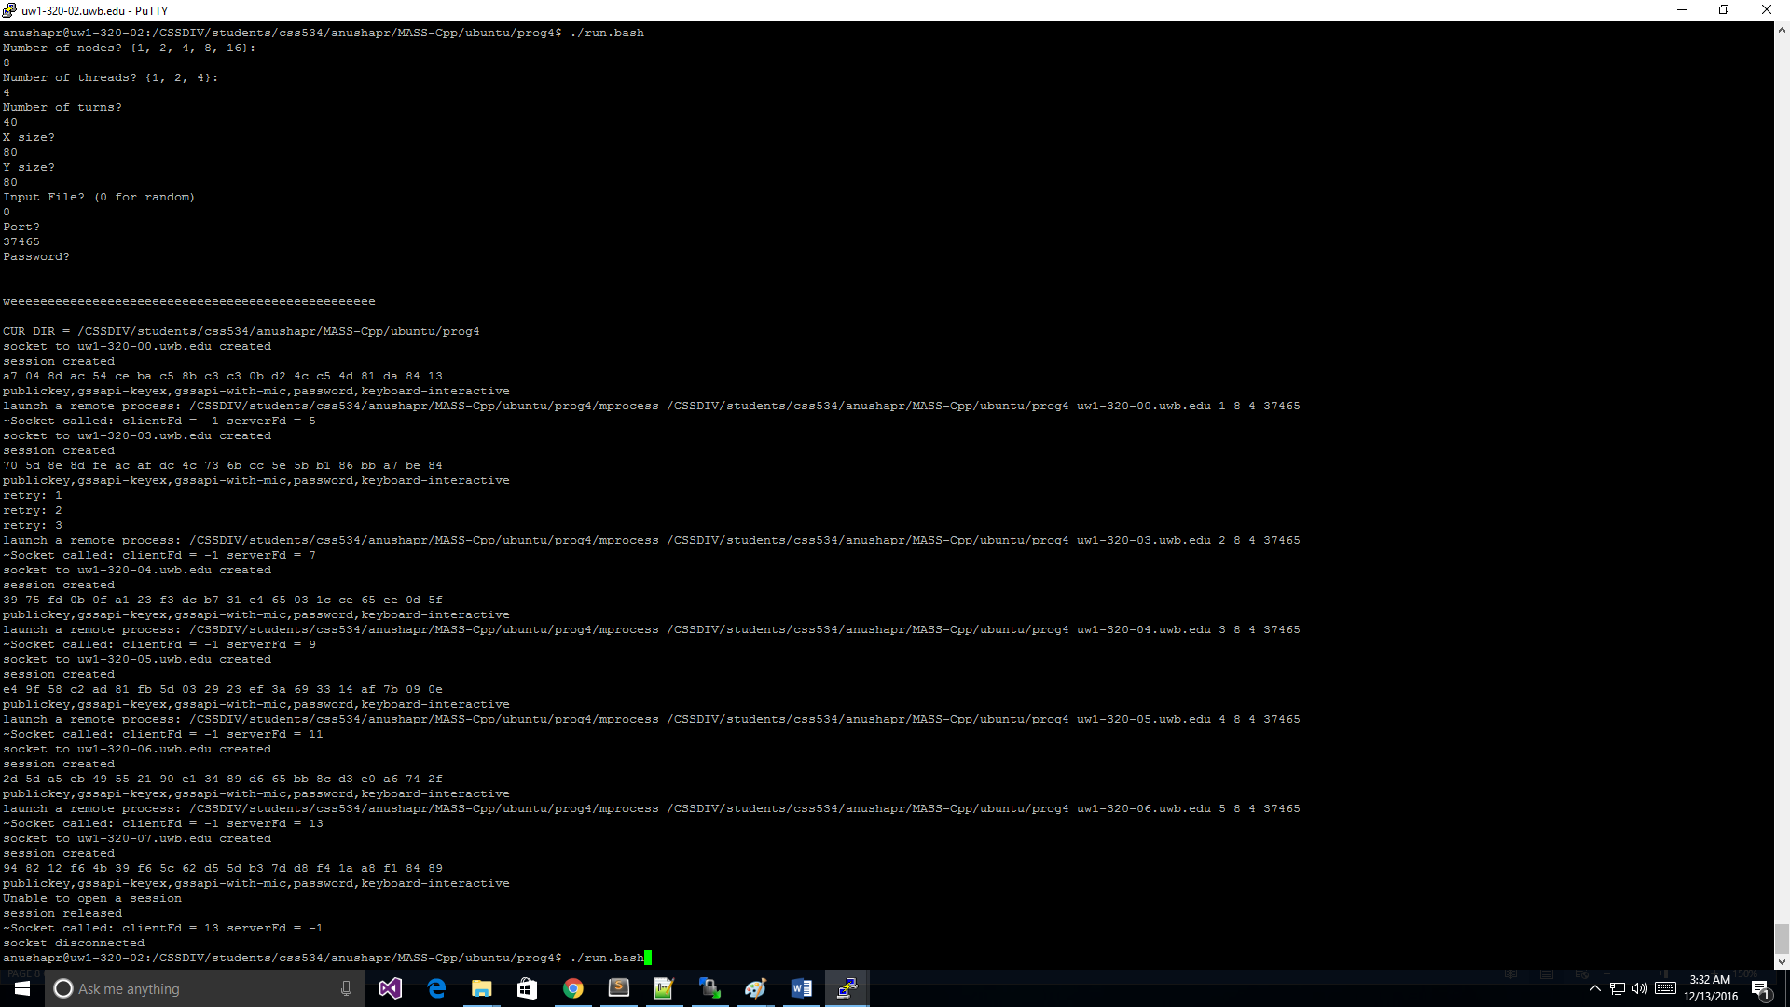

**40 160 160 1:1**

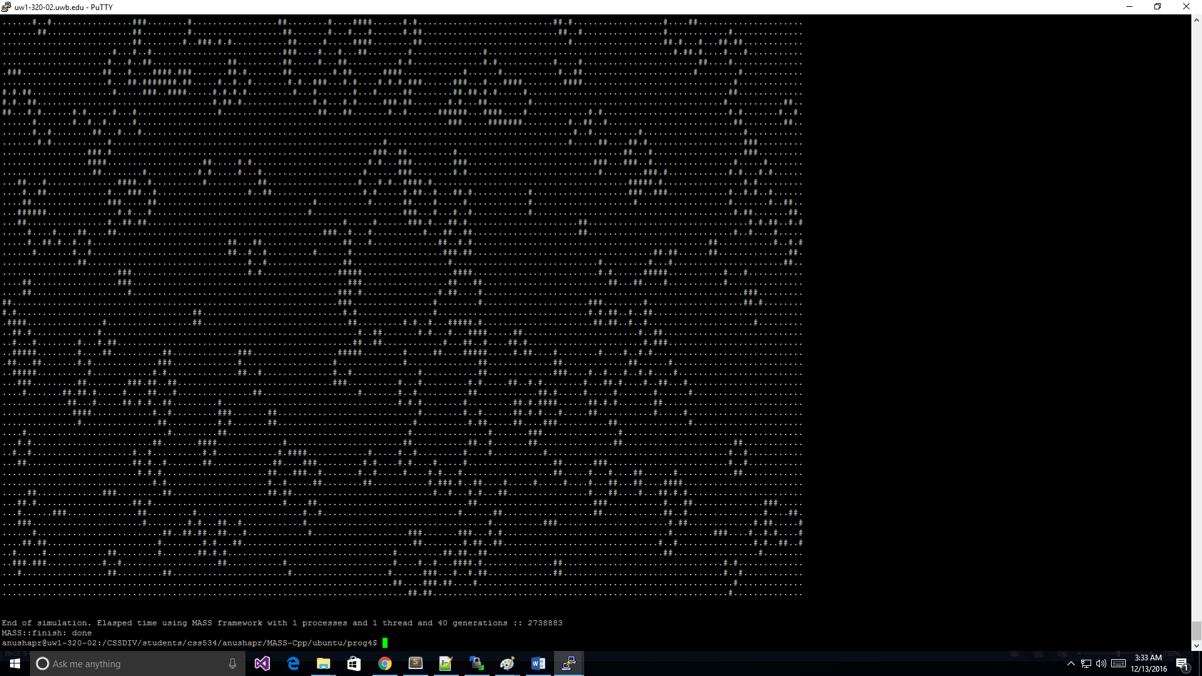

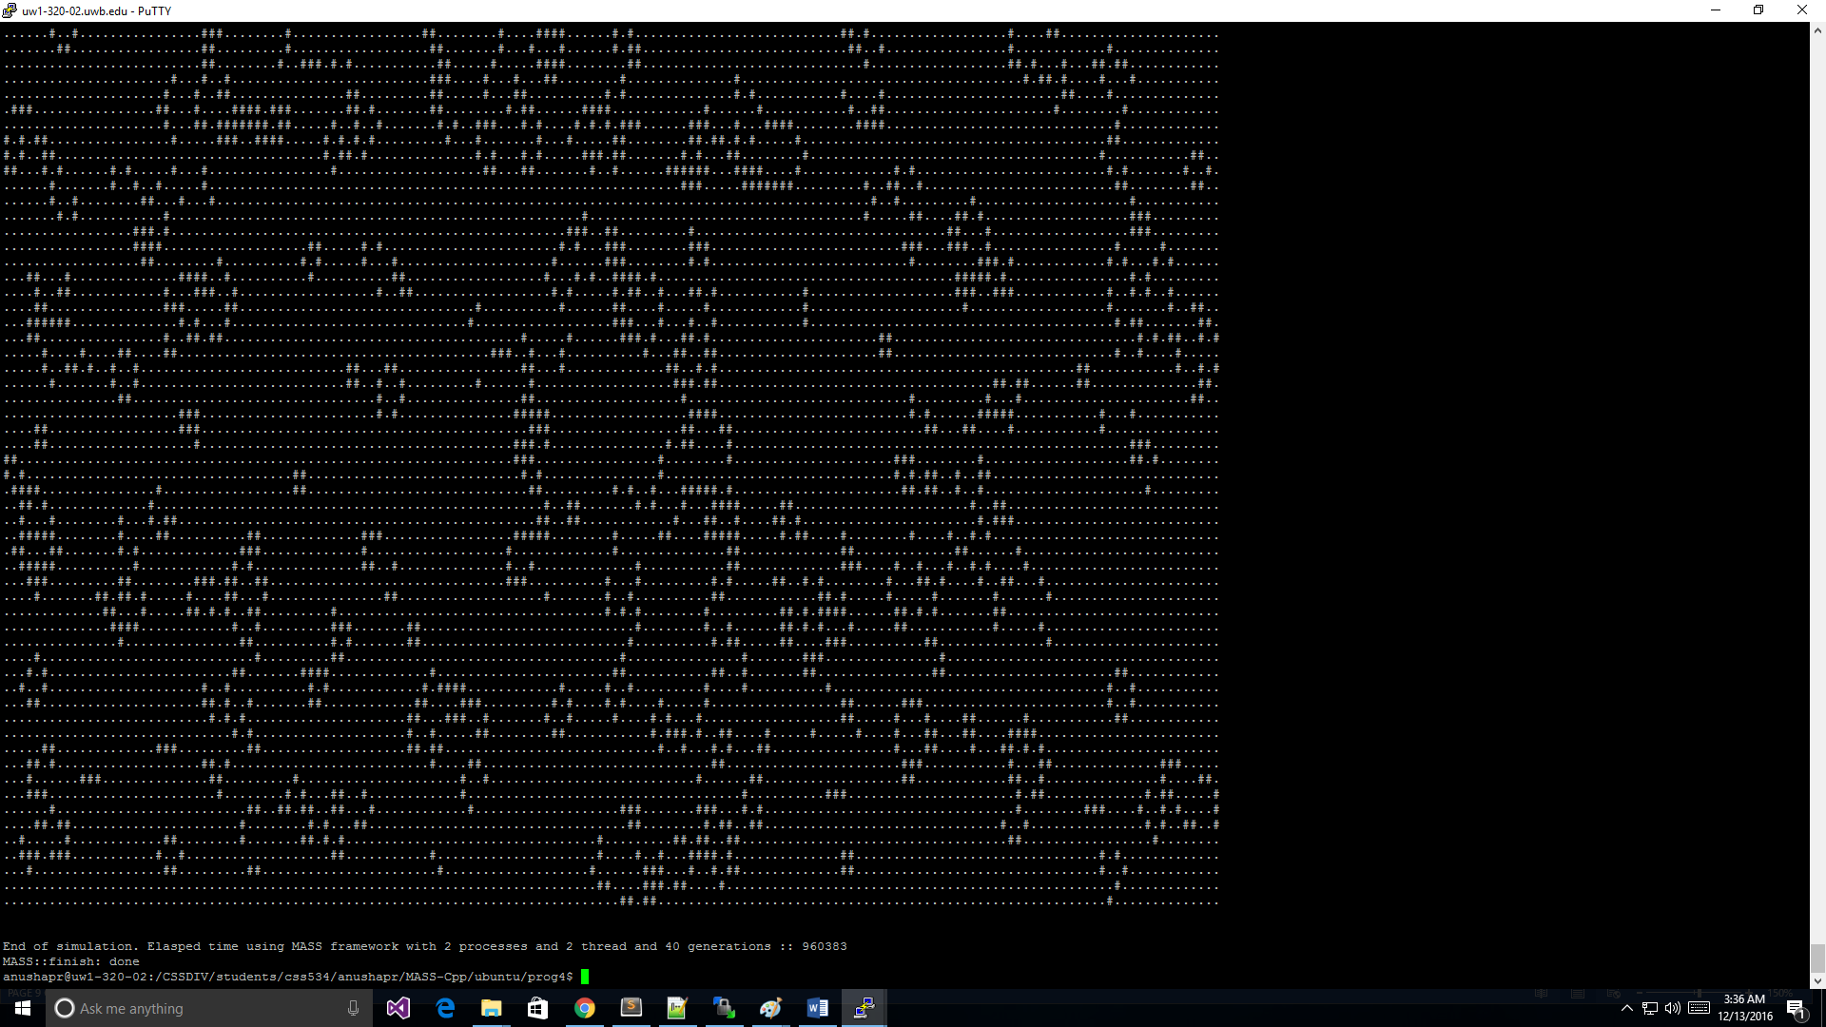

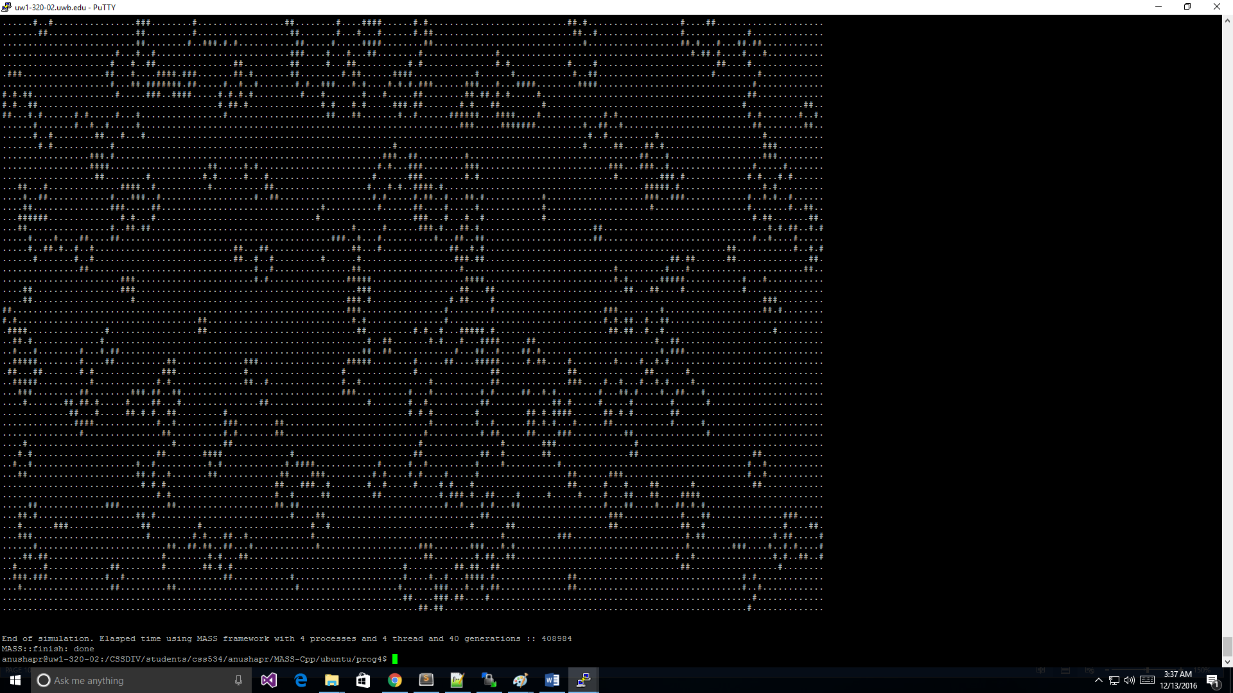

**80 160 160 1:1**







**4 8 8 1:1**

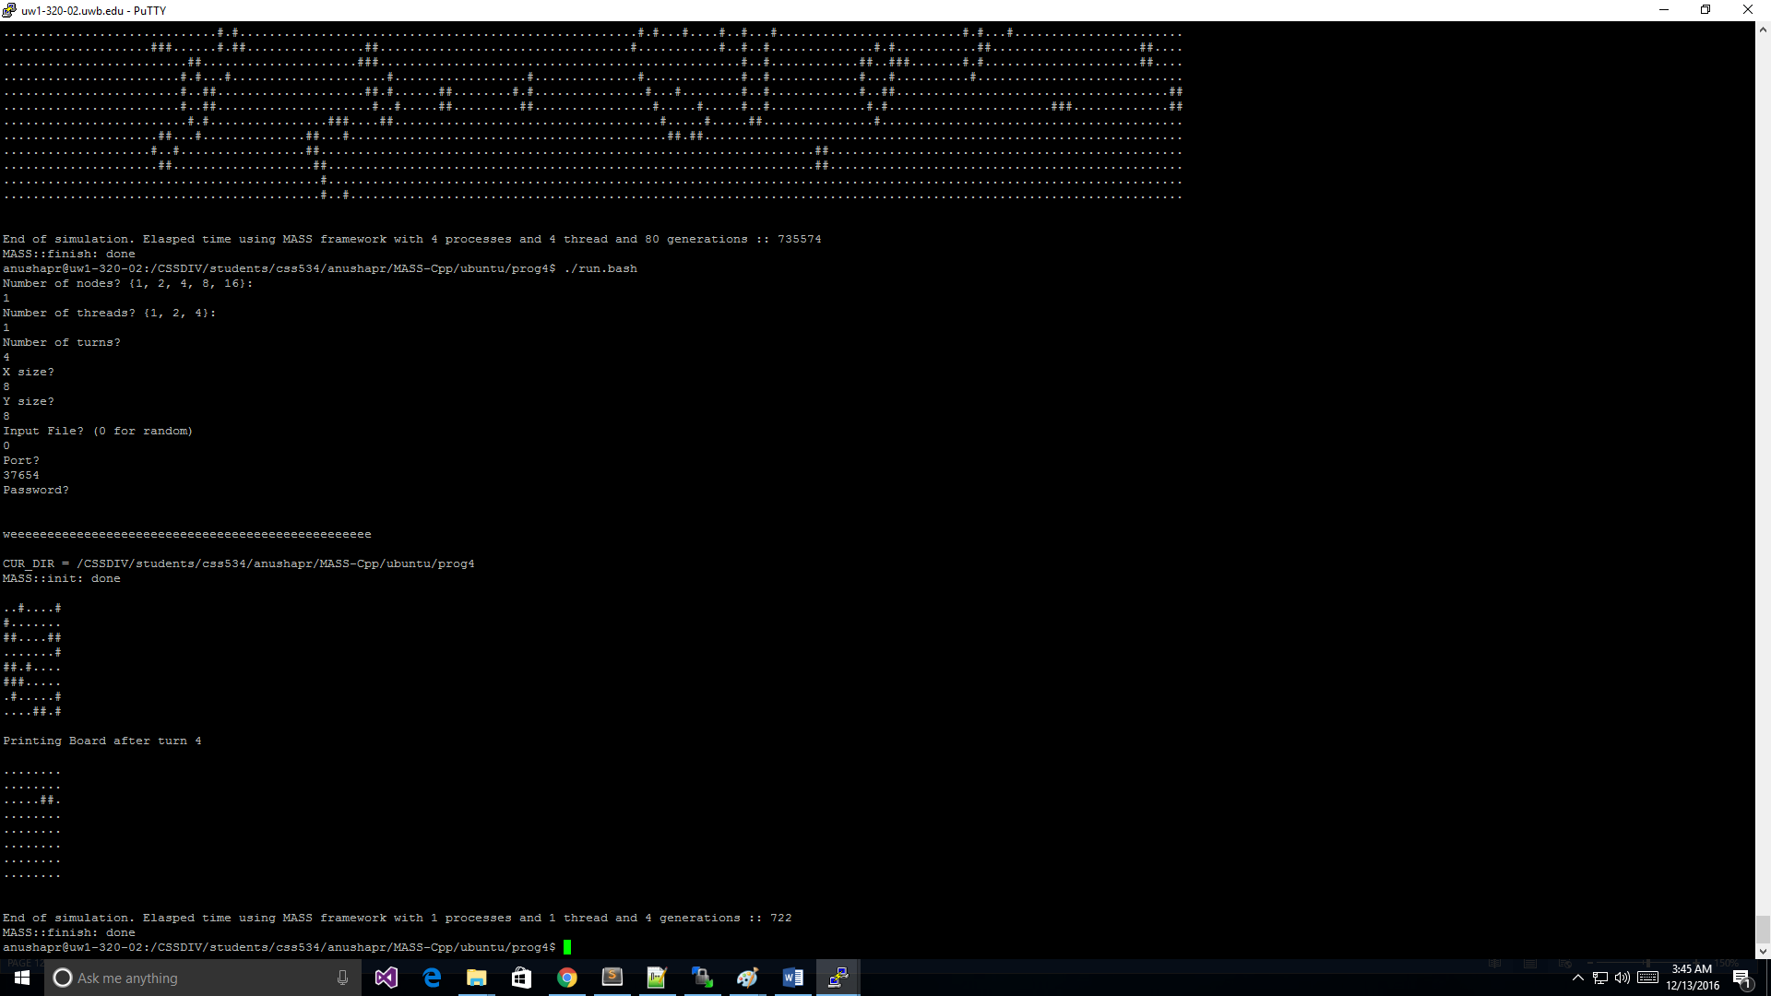

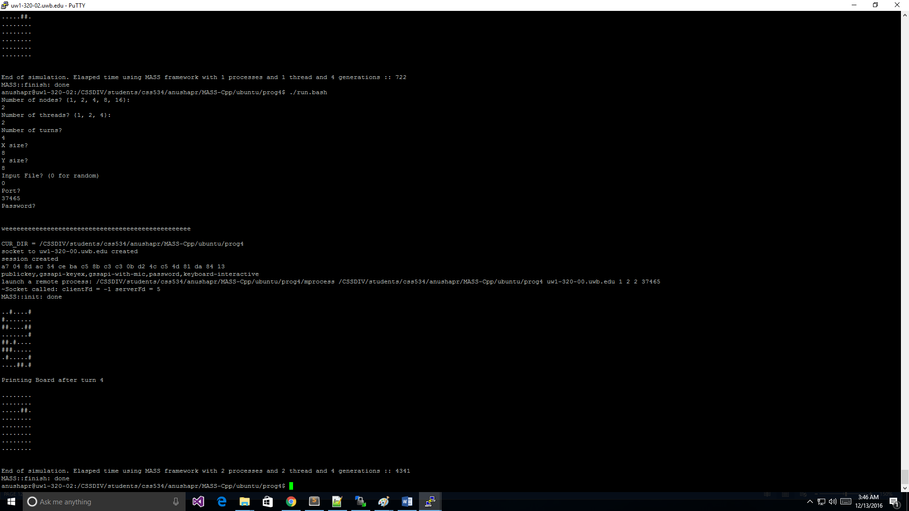

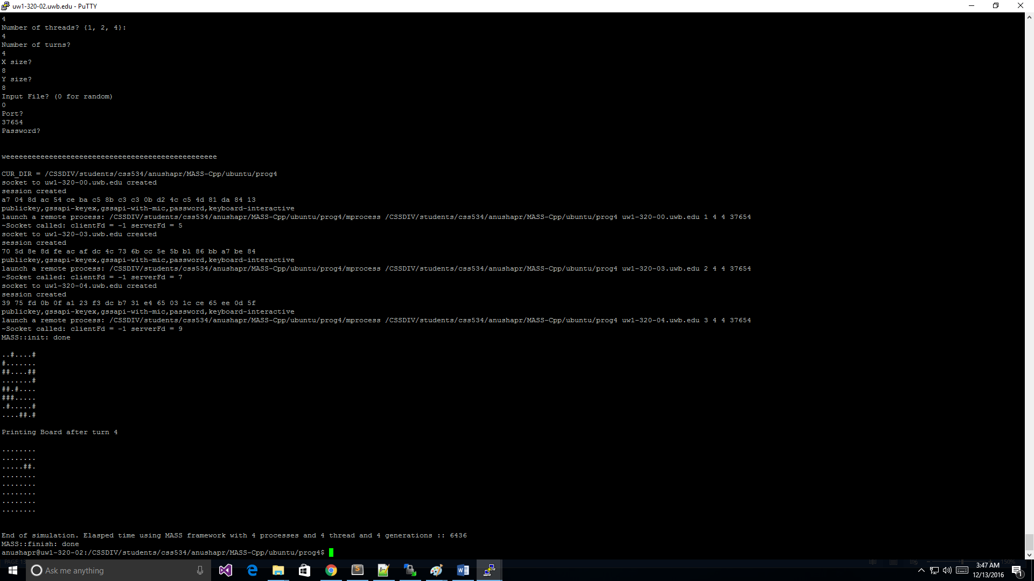

**4 16 16**

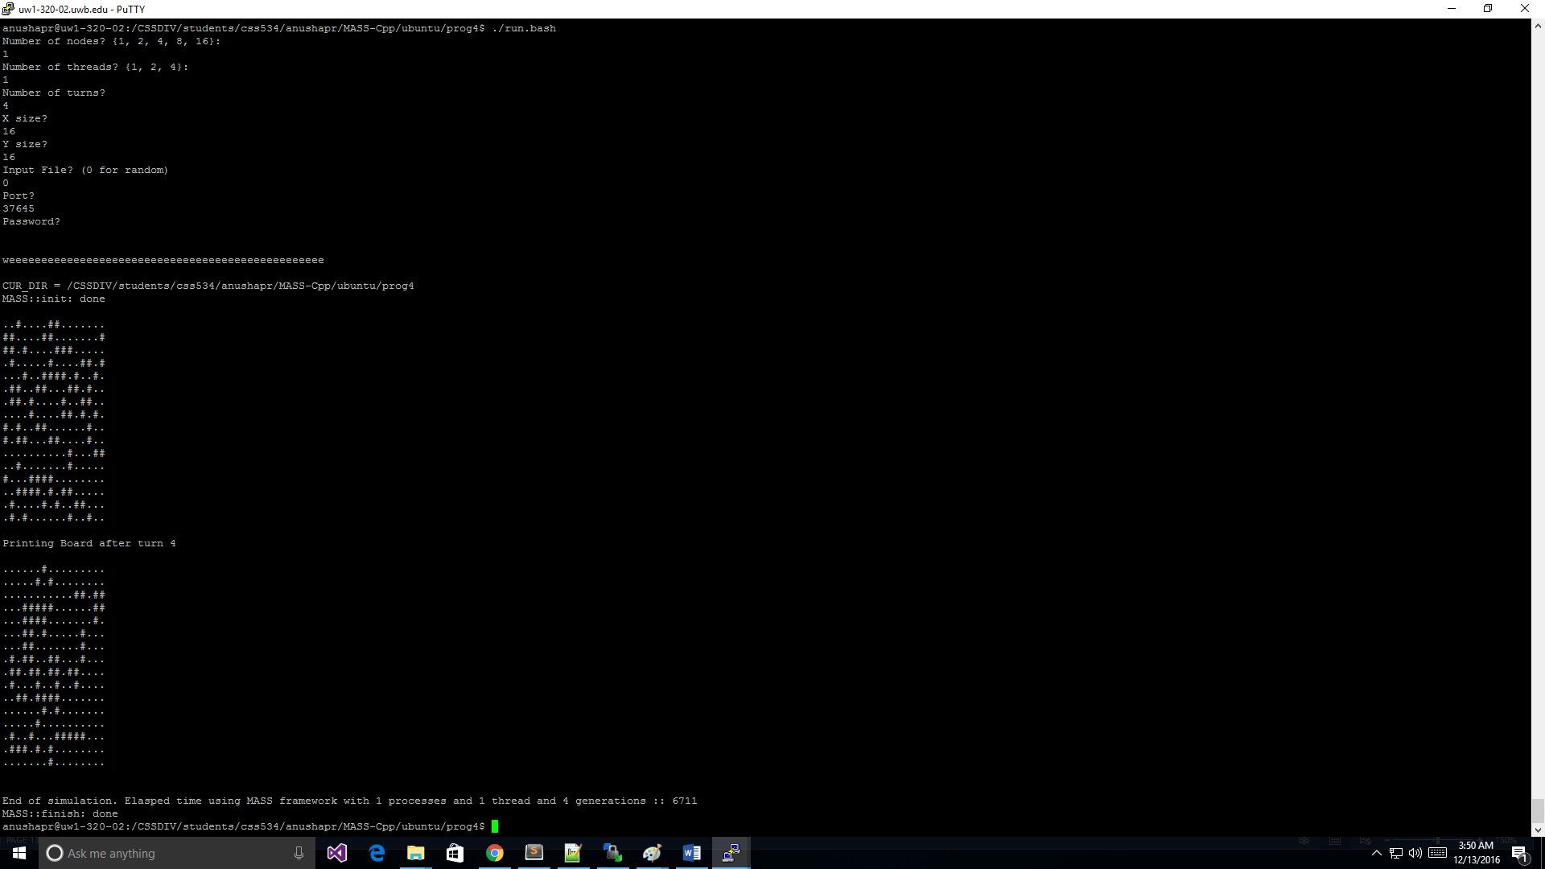

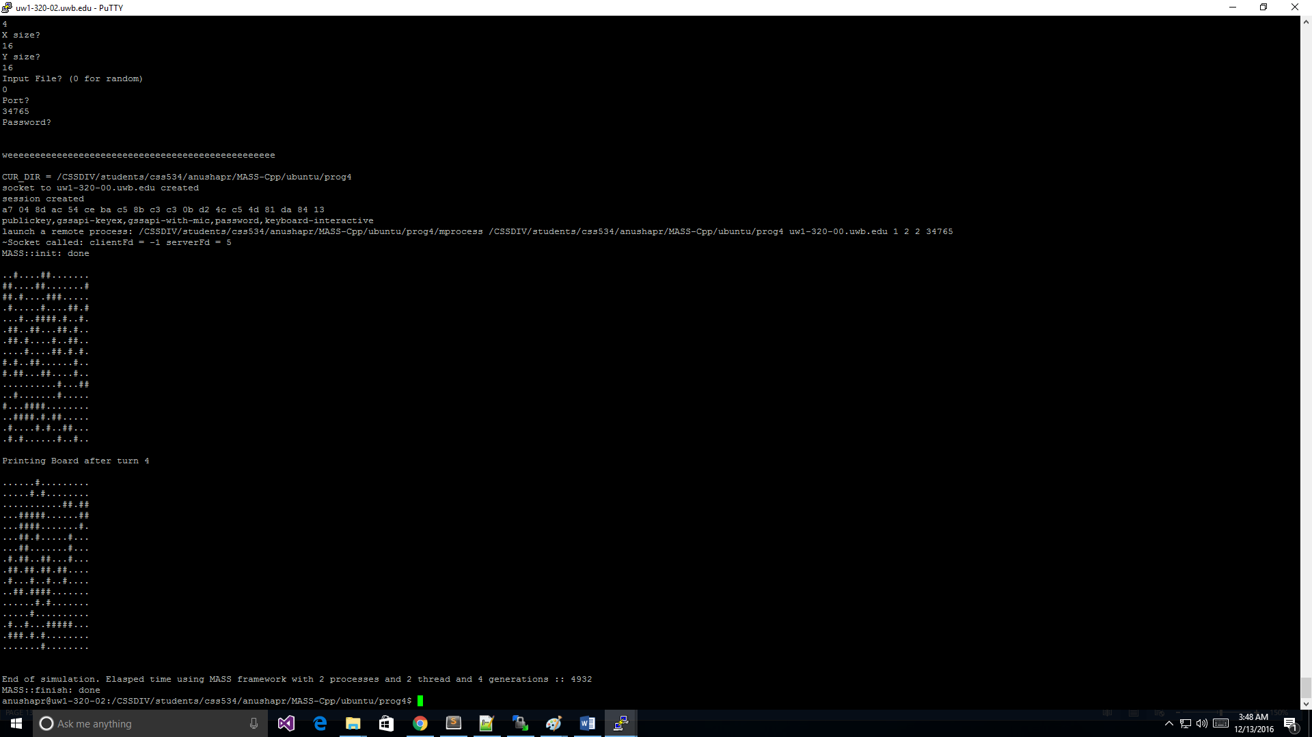

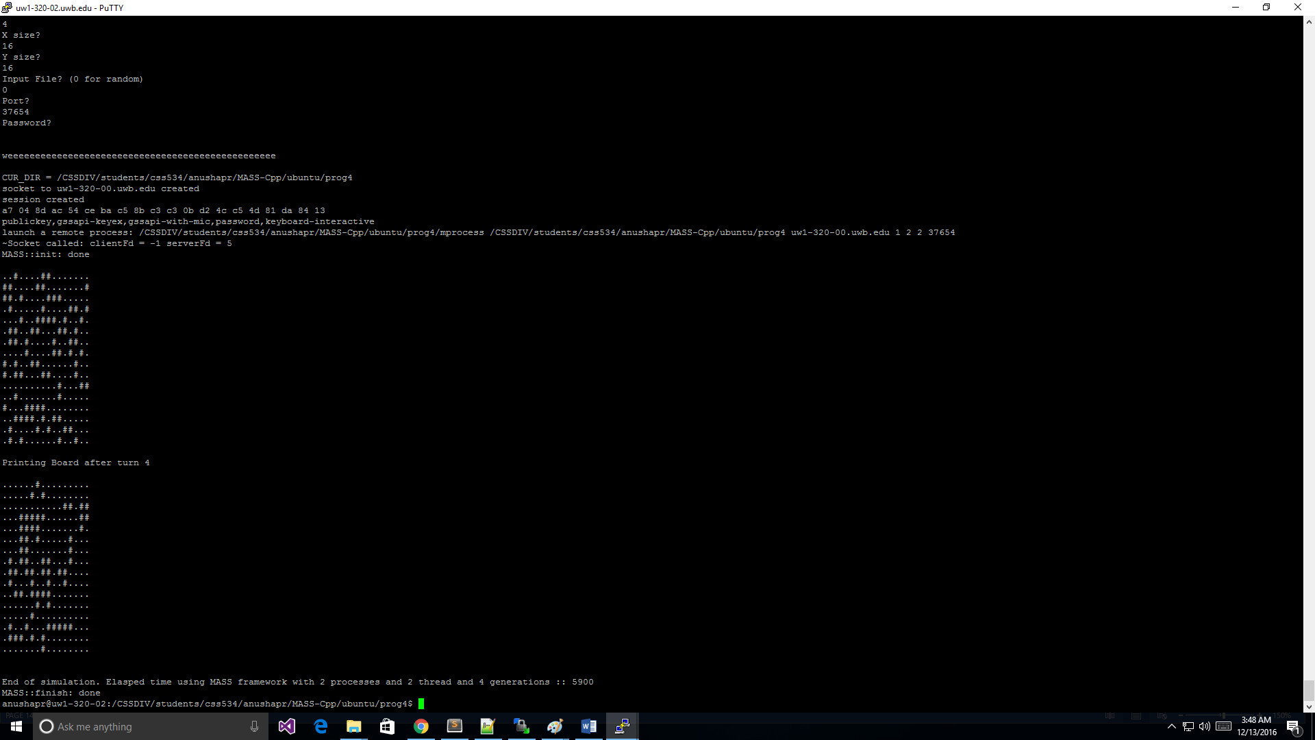

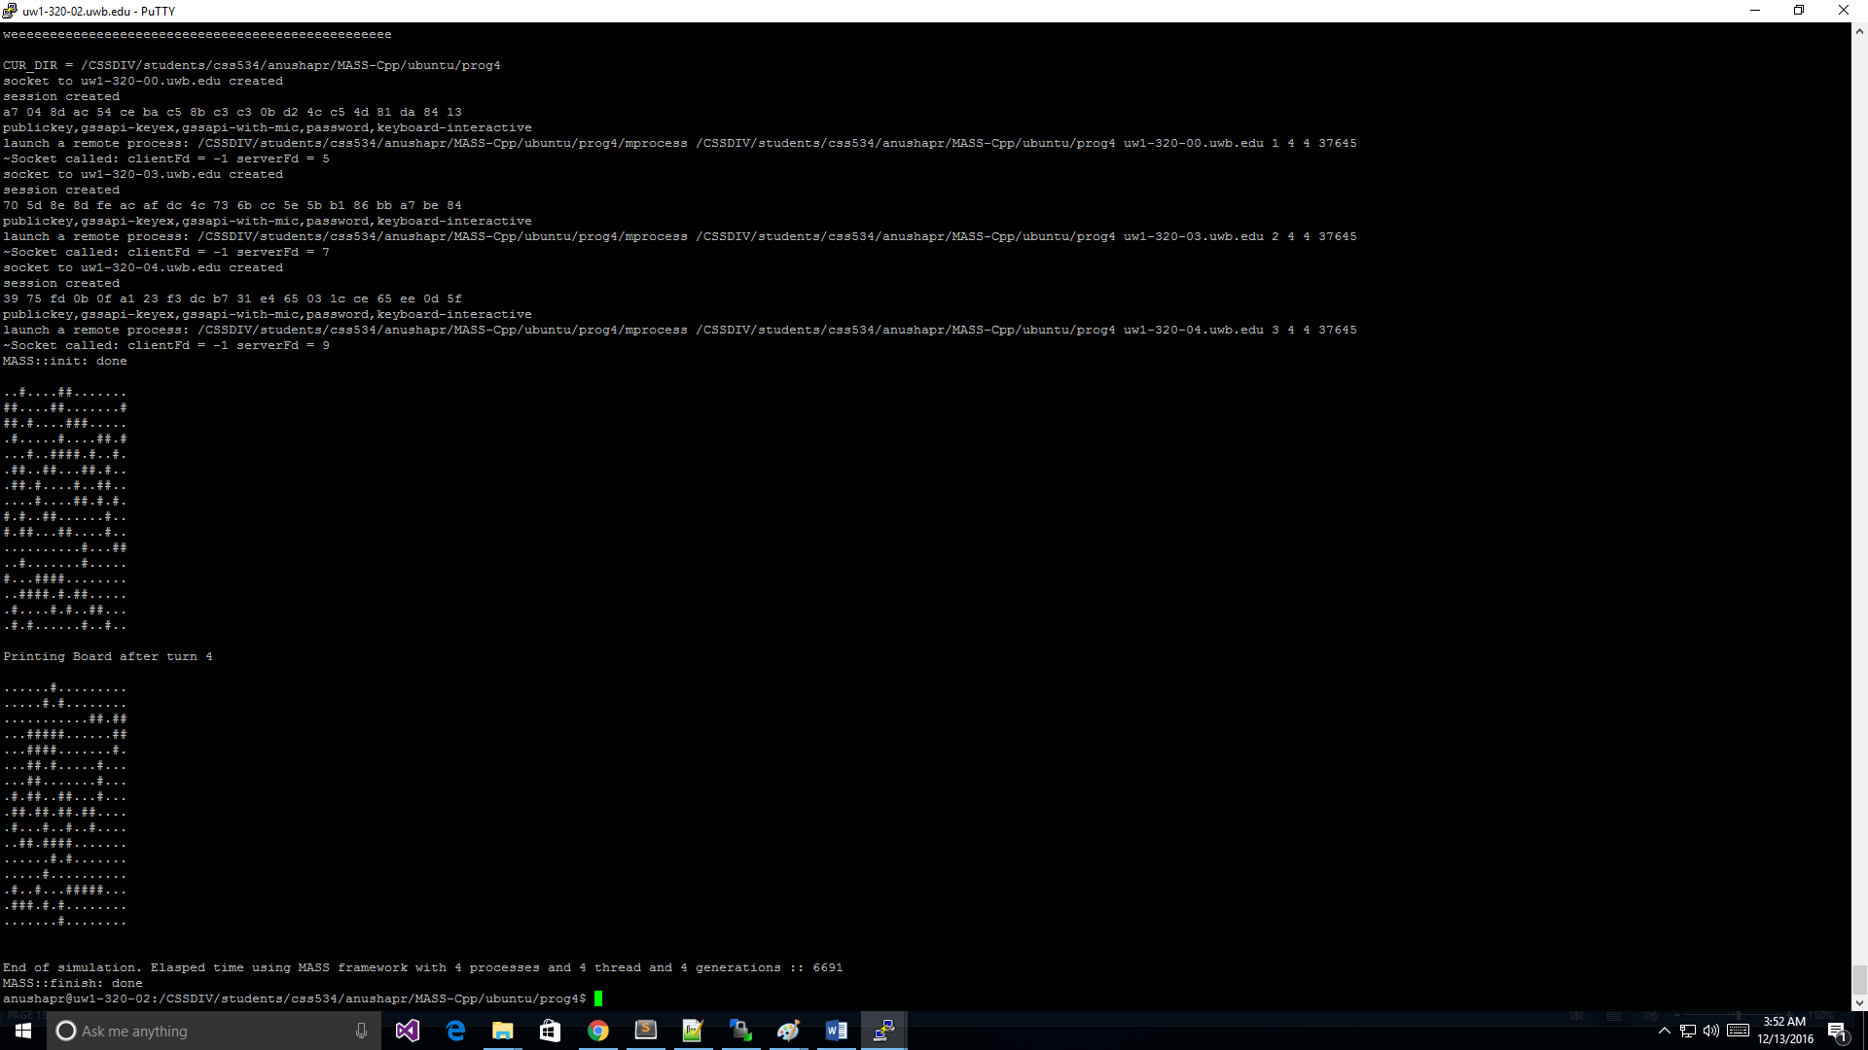

**4 20 201:1**







**4 40 40 1:1**

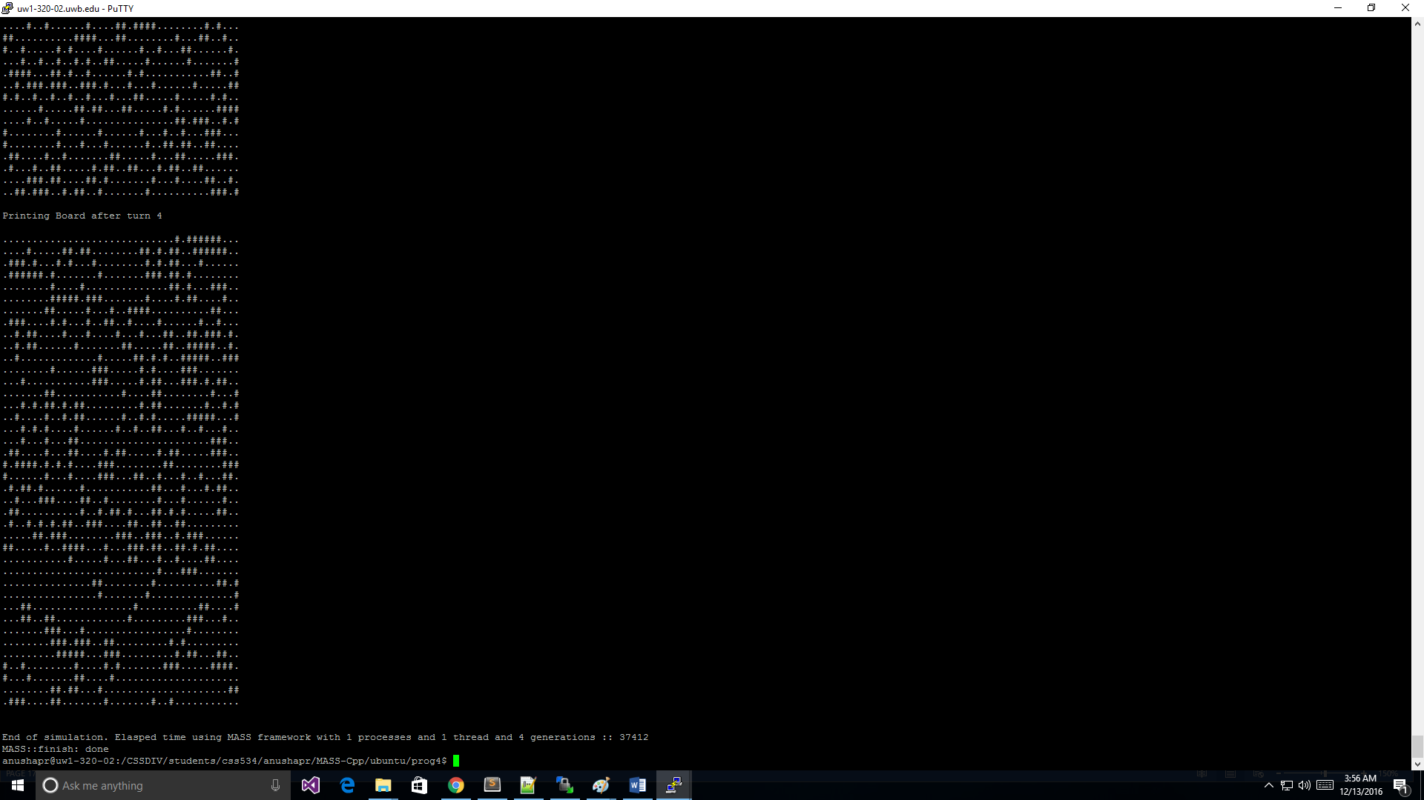

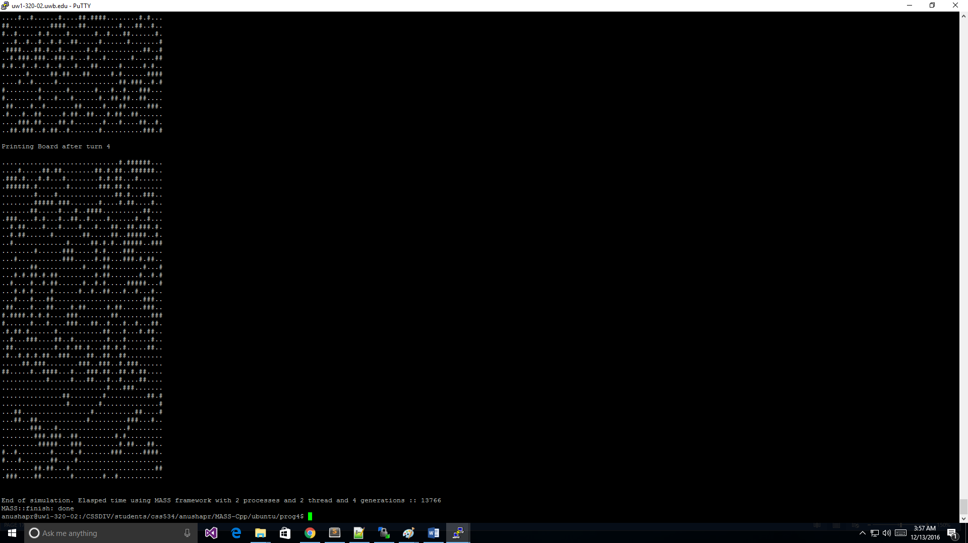

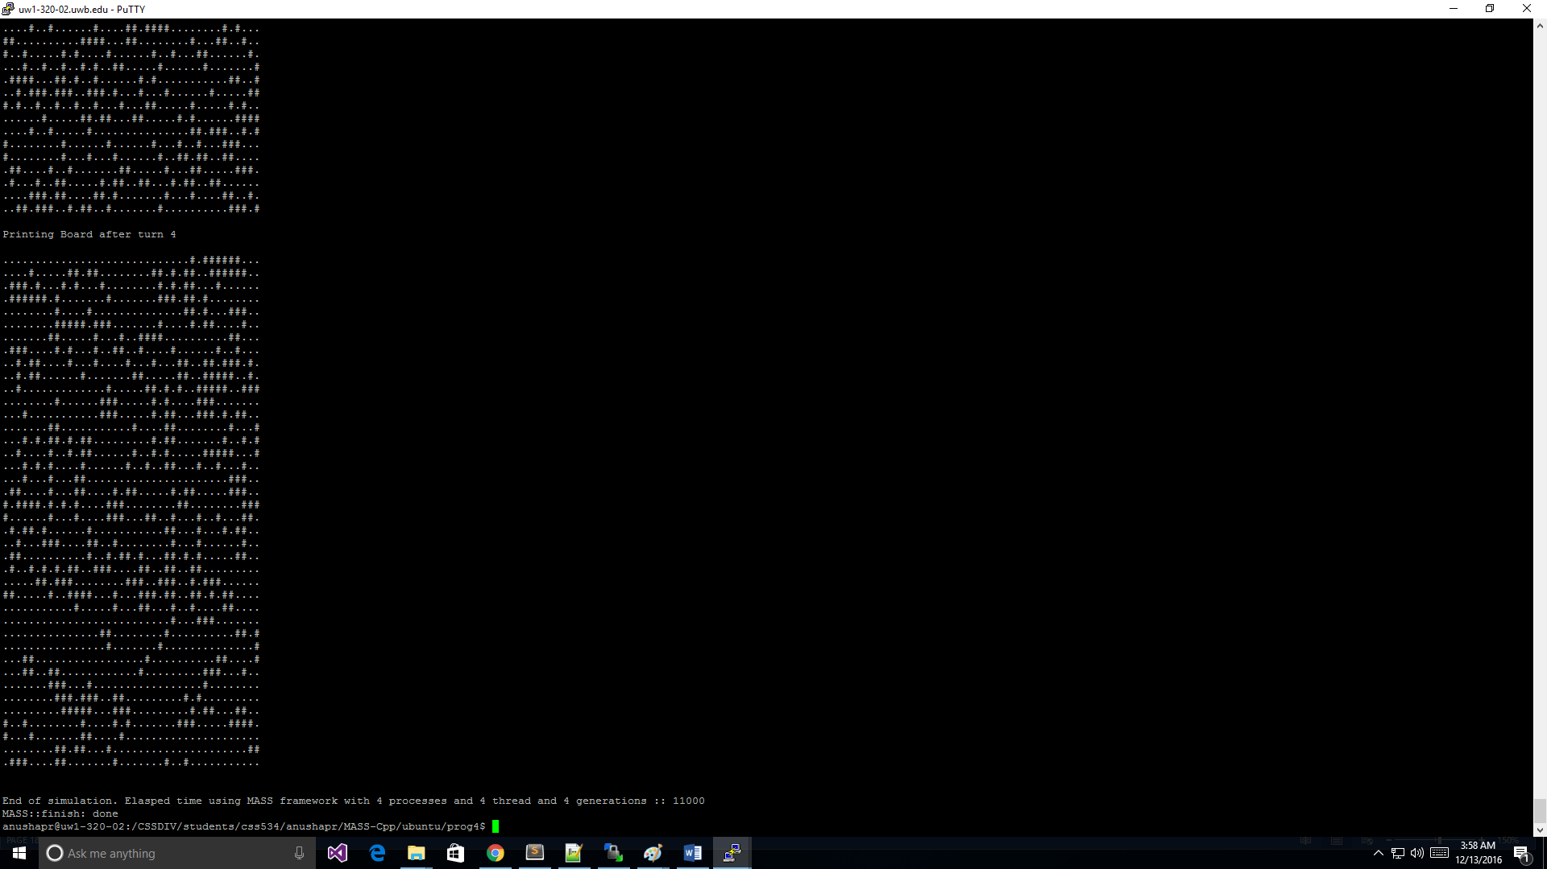

**Input**

**Source Code**

I have included all the source code as separate files in the folder Program3

**Source code** : InvertedIndexing.java

**InvertedIndexing.java**

