Name: Employee Id:

Duration: 20 minutes Marks: 20 (10*2)

Instruction: Kindly highlight the correct option/s using **yellow** color and save the file with the name format: “**ReactJS_Ans_<Name>_<ID>.docx**” consisting your name and id, separated by underscore.

------------------------------------------------------------------------------------------------------------------------------------------

1. Which of the following statements is/are true?
   1. React JS is a JavaScript library for building web applications
   2. React JS is complete framework like Angular for building web applications
   3. React JS is a scripting language
2. Which language(s) can be used to write code for React JS?
   1. JavaScript
   2. Typescript
   3. Python
3. Which packages from the following list are mandatorily used for building React JS applications?
   1. react-dom
   2. react
   3. webpack
   4. http-server
4. Which of the following statements are true about functional components in React JS?
   1. You can use ‘this’ keyword inside functional components
   2. You can maintain ‘state’ inside a functional component
   3. You can use ‘props’ inside a functional component
5. Which of the following statements are correct?
   1. In JavaScript object can created using function constructor call
   2. In JavaScript ‘class’ keyword can be used to create a class
   3. Arrow function solves ‘lexical this’ problem of JavaScript
6. Which function in JavaScript can be used to bind a function with a current class, where it has been declared?
   1. apply
   2. call
   3. bind
7. In React JS application I have declared a function in a class component which will be passed to a child component via a property and will be invoked from within the child component as a result of some event of a React element. Which one is the proper code to do that?

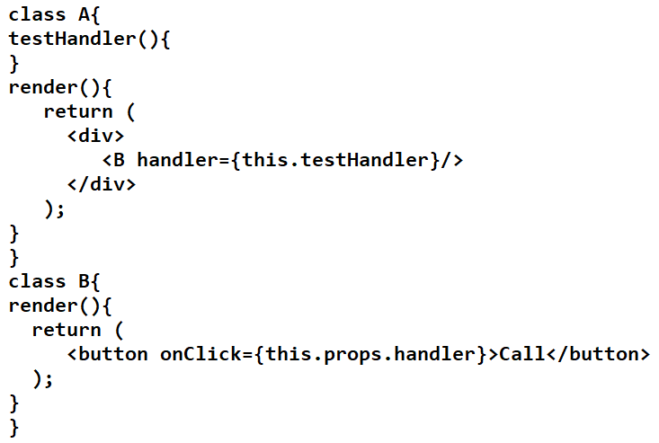

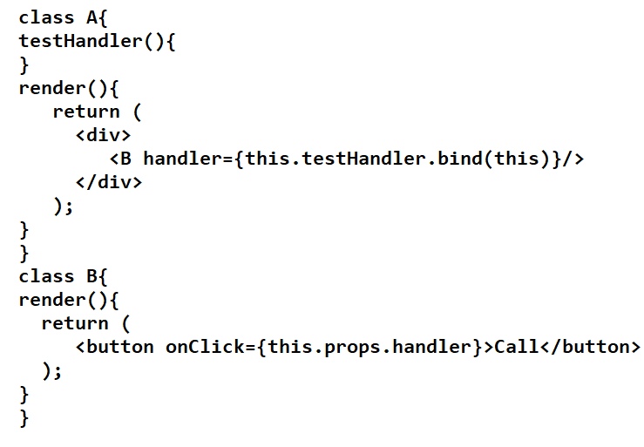

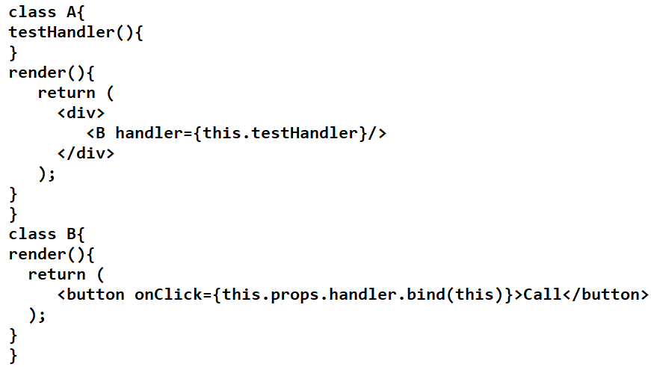

1. You are passing some data from parent component (A) to the child component (B) as in the following code.

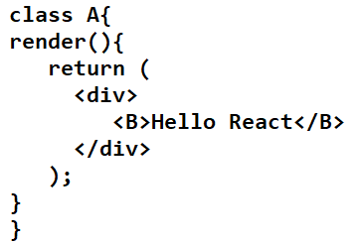

How will access the same in child (B) component to render the value (Hello React) in the DOM? Choose proper code.

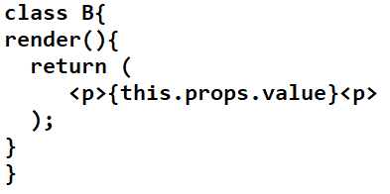

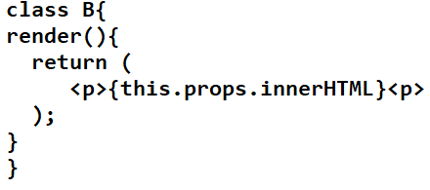

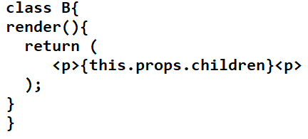

1. On submission of a form using submit button click, generally the page is reloaded, which is pretty unnecessary in case of React JS, since the form is never submitted back to the server. Which way you can stop that default behavior of form submission?
   1. By using code window.load() and pass **false** to it
   2. By calling preventDefault() method of event object in React JS
   3. By returning **false** from the method which is called on submission of the form
2. Which statement is useful for Pure Component?
   1. It implements **shouldComponentUpdate** mandatorily
   2. It uses shallow **props** and **state** comparison
   3. It uses deep **props** and **state** comparison