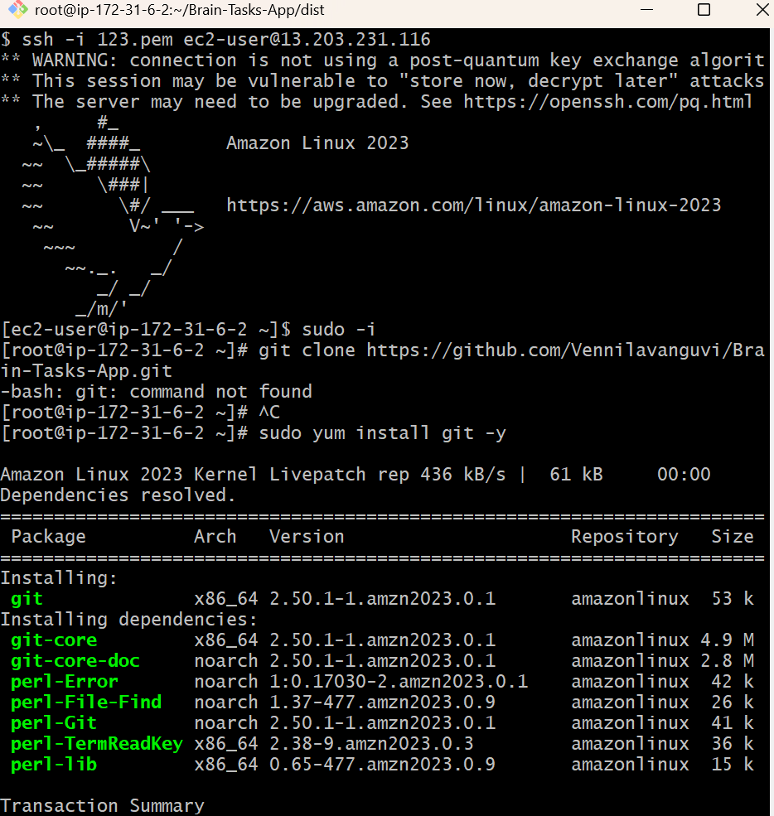
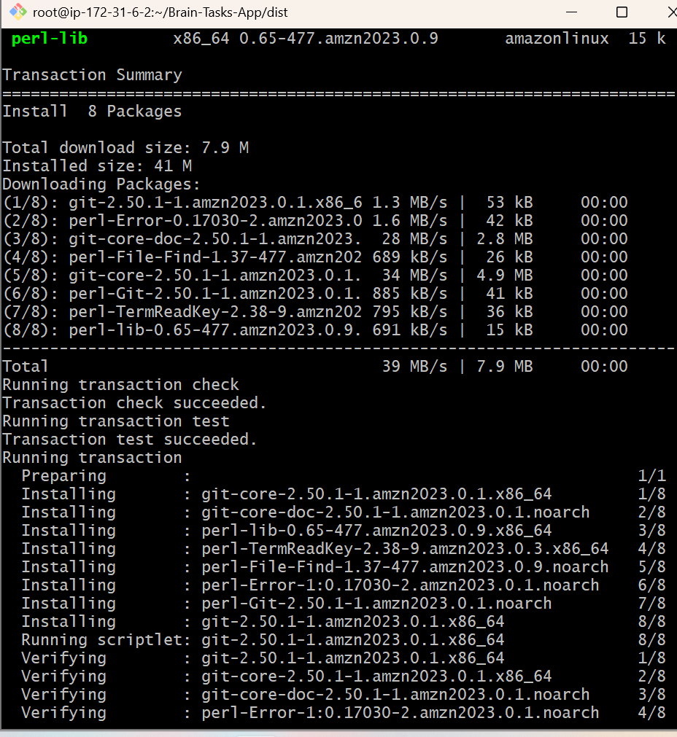
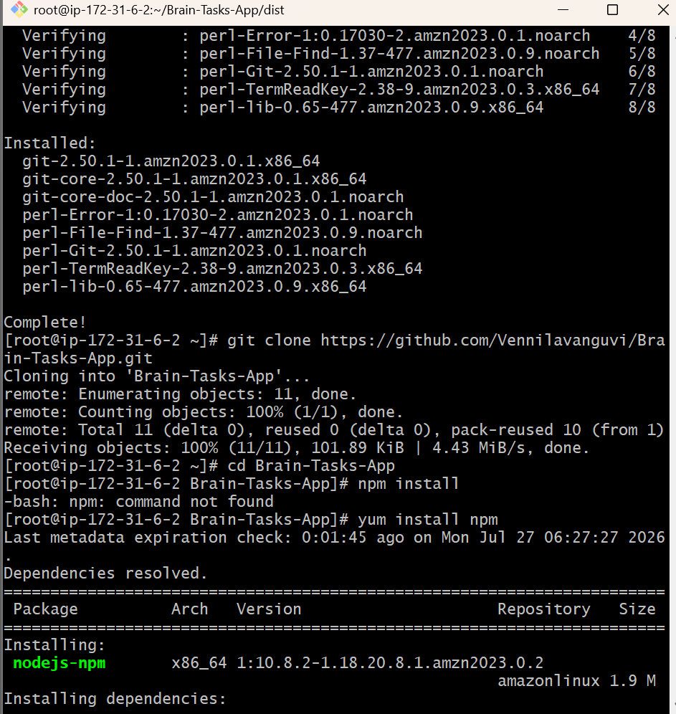
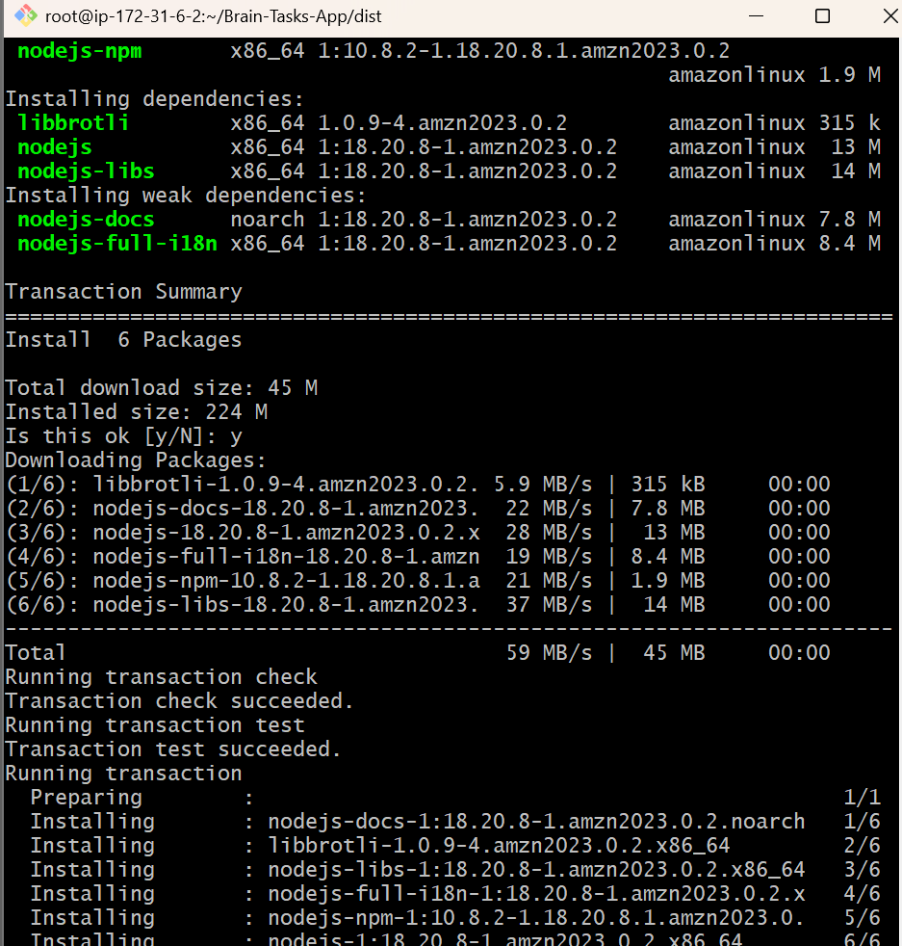

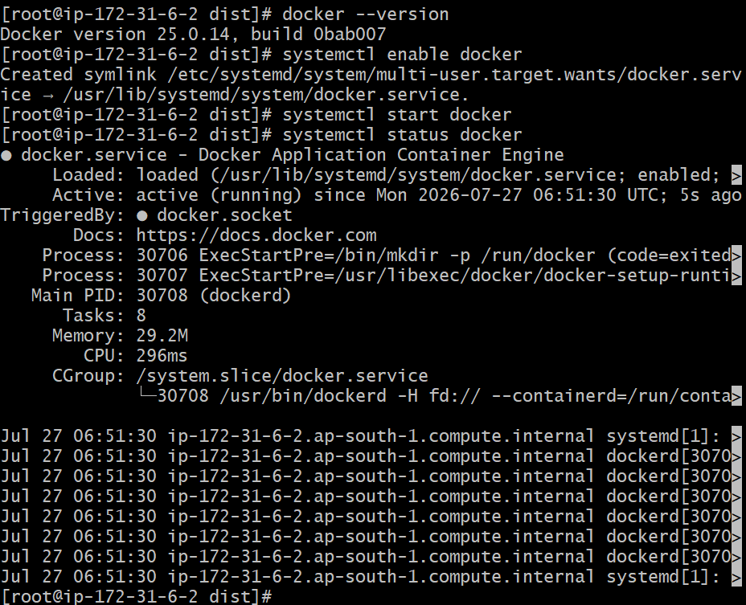

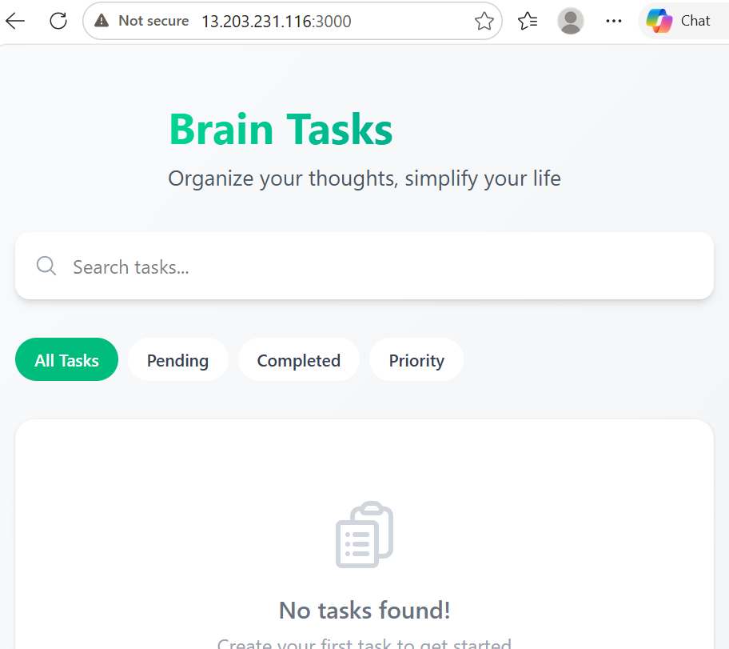
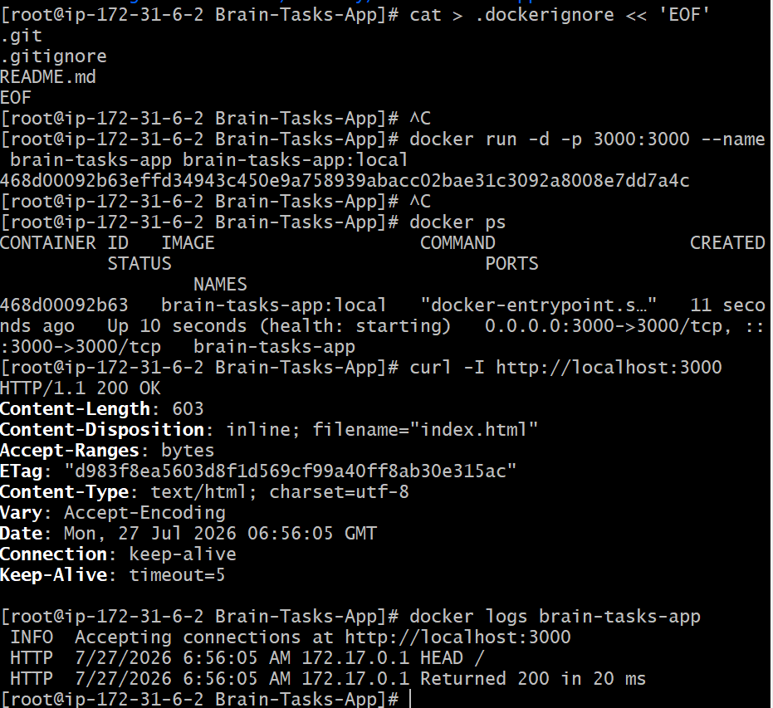
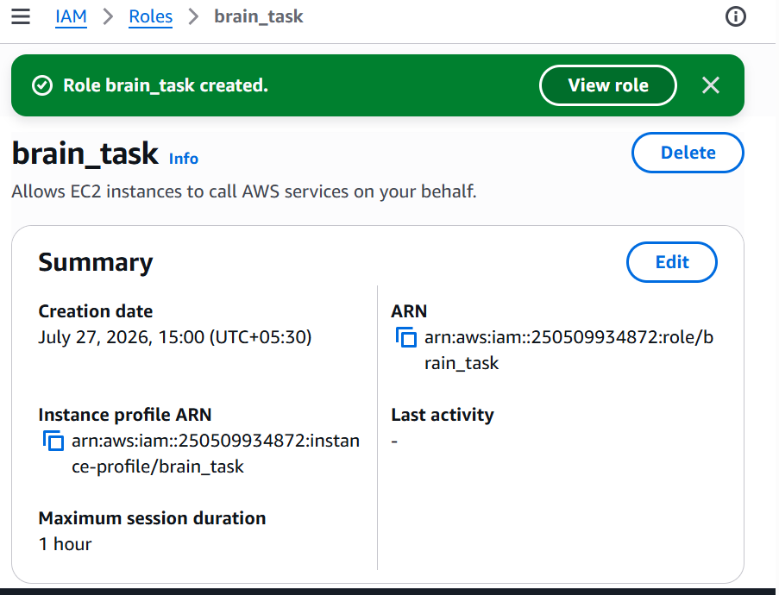

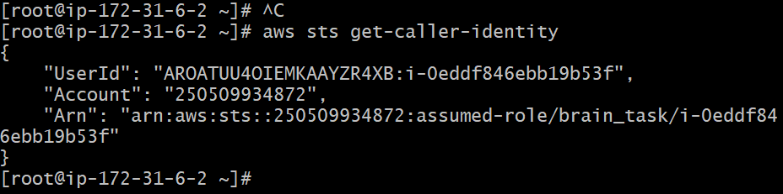

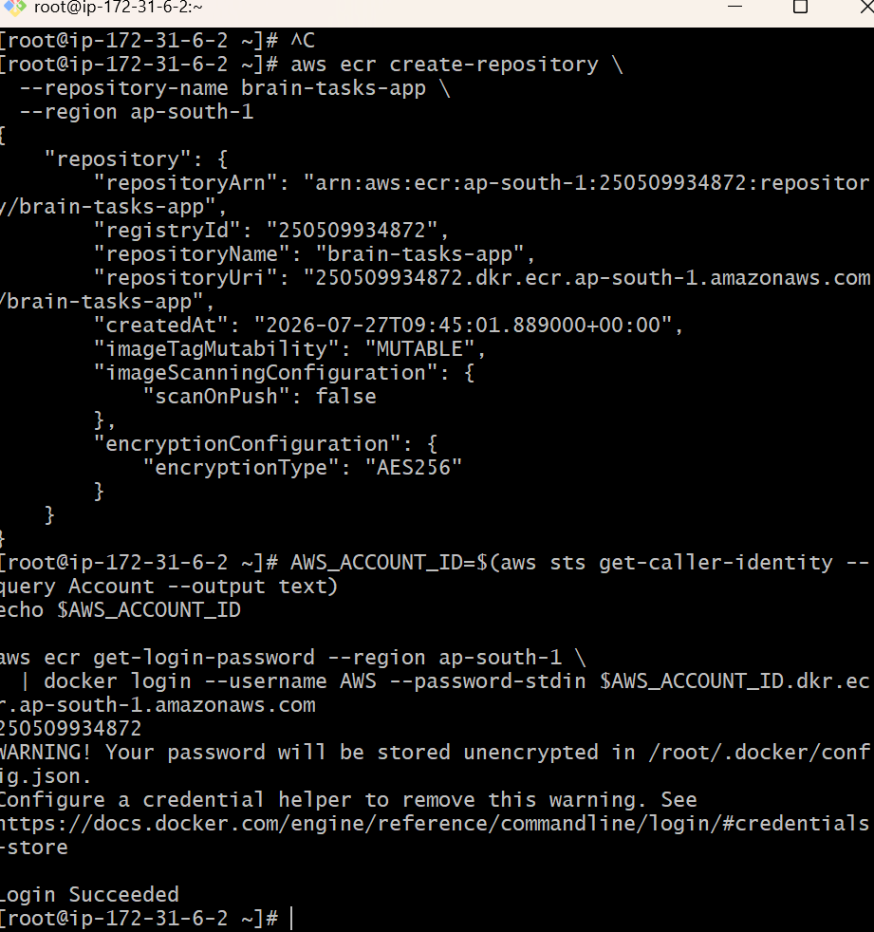
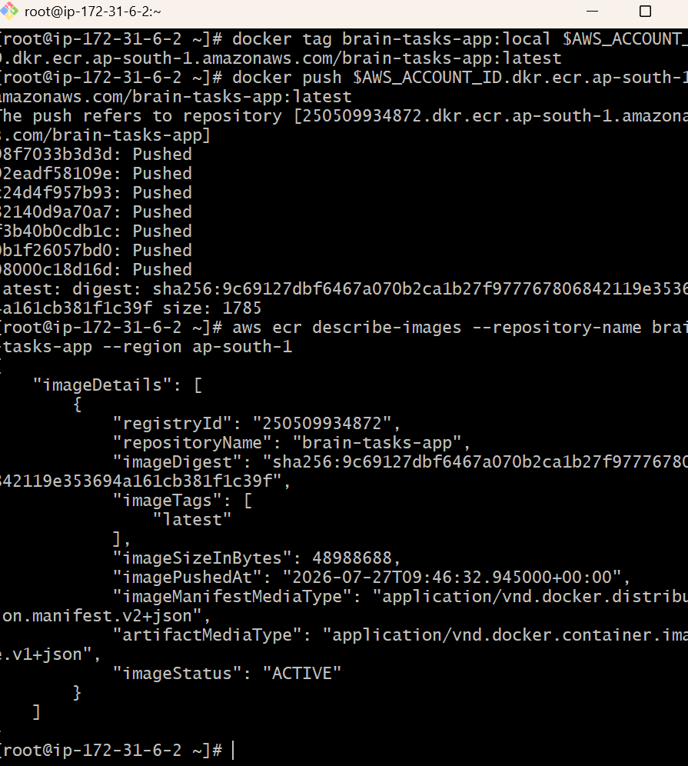
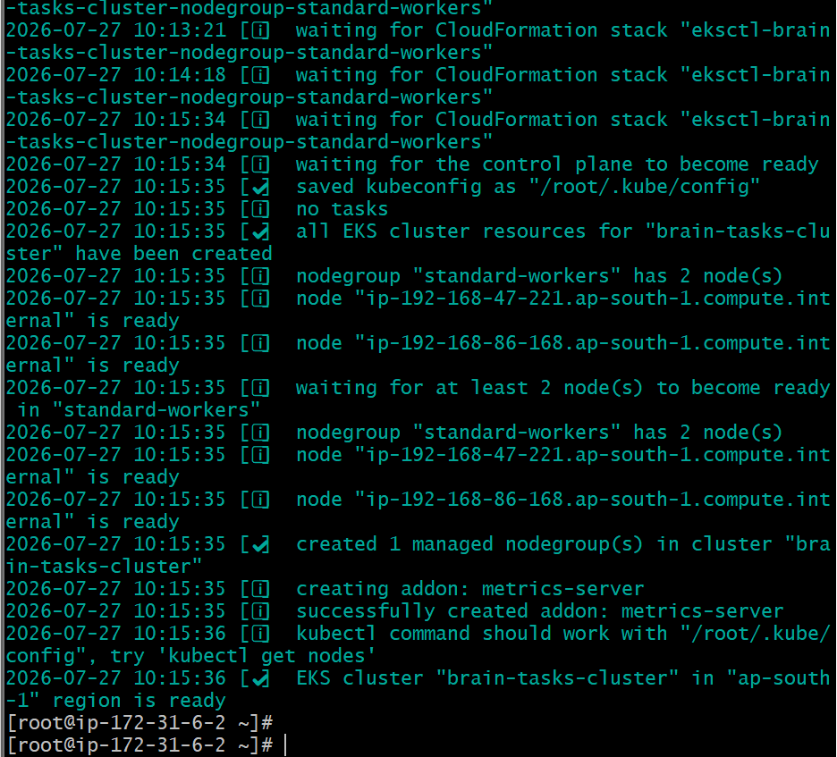
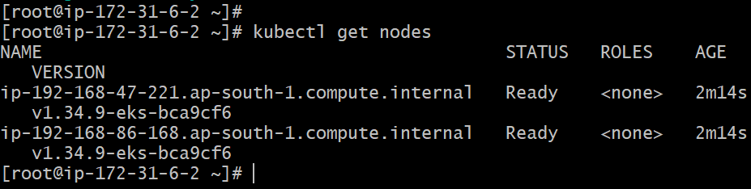

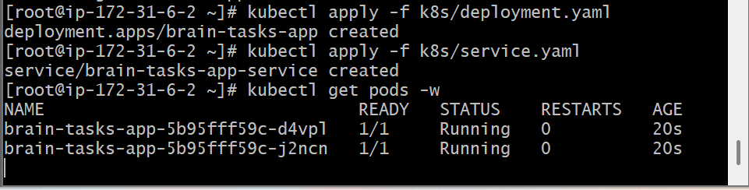
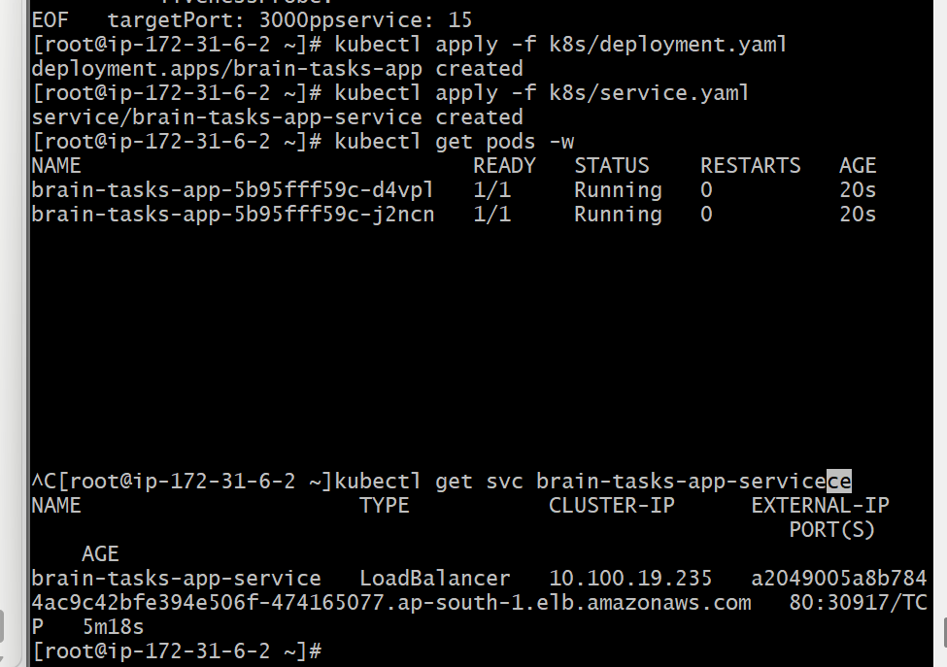

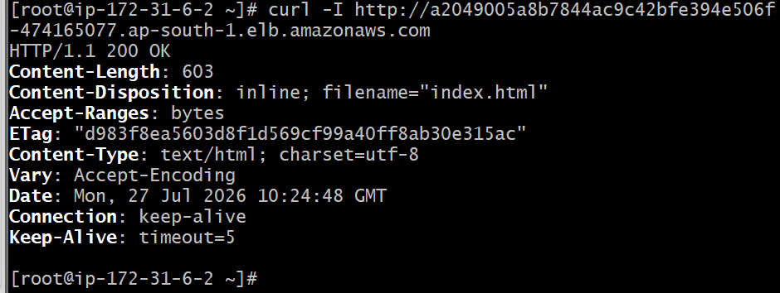
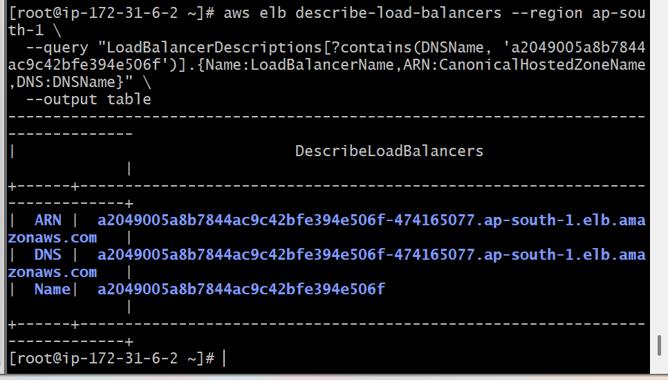
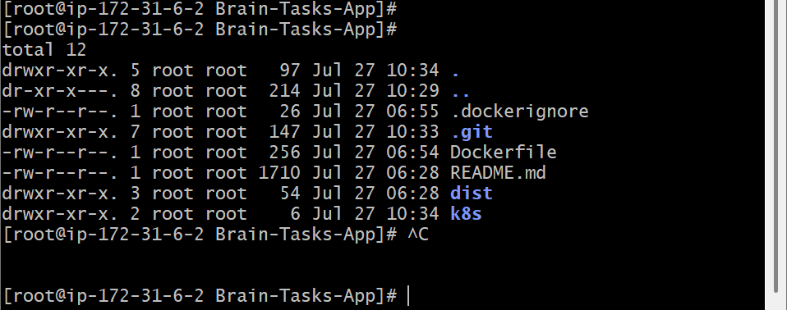

Build:

cat > Dockerfile << 'EOF'
FROM node:18-alpine AS build
WORKDIR /app
COPY package*.json ./
RUN npm ci --legacy-peer-deps
COPY . .
RUN npm run build

FROM node:18-alpine AS production
WORKDIR /app
RUN npm install -g serve
COPY --from=build /app/dist ./dist
RUN addgroup -S appgroup && adduser -S appuser -G appgroup
USER appuser
EXPOSE 3000
HEALTHCHECK --interval=30s --timeout=5s --start-period=10s --retries=3 \
CMD wget -qO- http://localhost:3000 || exit 1
CMD ["serve", "-s", "dist", "-l", "3000"]
EOF

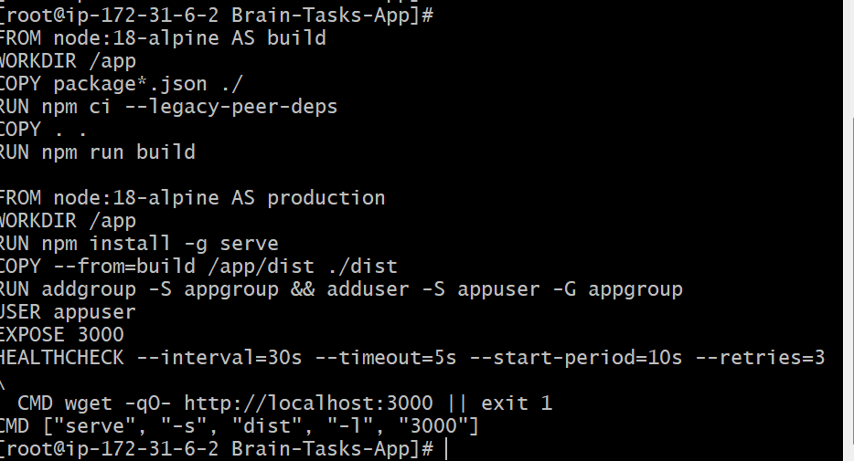

Deployment file:

cat > k8s/deployment.yaml << 'EOF'
apiVersion: apps/v1
kind: Deployment
metadata:
name: brain-tasks-app
labels:
app: brain-tasks-app
spec:
replicas: 2
selector:
matchLabels:
app: brain-tasks-app
template:
metadata:
labels:
app: brain-tasks-app
spec:
containers:
- name: brain-tasks-app
image: 250509934872.dkr.ecr.ap-south-1.amazonaws.com/brain-tasks-app:latest
ports:
- containerPort: 3000
resources:
requests:
cpu: "100m"
memory: "128Mi"
limits:
cpu: "300m"
memory: "256Mi"
readinessProbe:
httpGet:
path: /
port: 3000
initialDelaySeconds: 5
periodSeconds: 10
livenessProbe:
httpGet:
path: /
port: 3000
initialDelaySeconds: 15
periodSeconds: 20
EOF
cat k8s/deployment.yaml

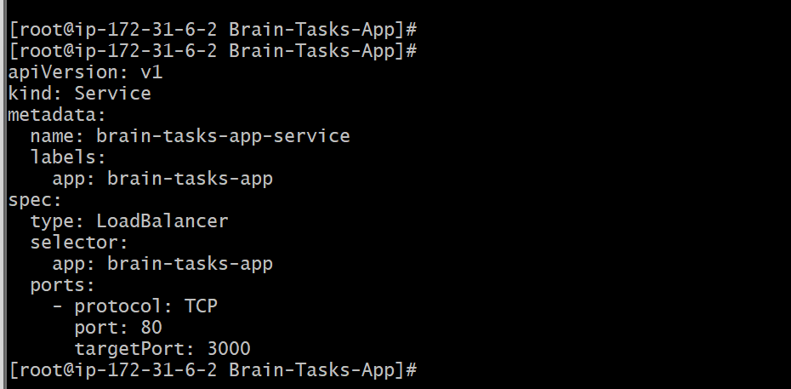

[root@ip-172-31-6-2 Brain-Tasks-App]#
apiVersion: apps/v1
kind: Deployment
metadata:
name: brain-tasks-app
labels:
app: brain-tasks-app
spec:
replicas: 2
selector:
matchLabels:
app: brain-tasks-app
template:
metadata:
labels:
app: brain-tasks-app
spec:
containers:
- name: brain-tasks-app
image: 250509934872.dkr.ecr.ap-south-1.amazonaws.com/brain-tasks-app:latest
ports:
- containerPort: 3000
resources:
requests:
cpu: "100m"
memory: "128Mi"
limits:
cpu: "300m"
memory: "256Mi"
readinessProbe:
httpGet:
path: /
port: 3000
initialDelaySeconds: 5
periodSeconds: 10
livenessProbe:
httpGet:
path: /
port: 3000
initialDelaySeconds: 15
periodSeconds: 20
[root@ip-172-31-6-2 Brain-Tasks-App]#
[root@ip-172-31-6-2 Brain-Tasks-App]#
[root@ip-172-31-6-2 Brain-Tasks-App]#
version: 0.2

env:
variables:
IMAGE_REPO_NAME: "brain-tasks-app"
CLUSTER_NAME: "brain-tasks-cluster"

phases:
install:
runtime-versions:
docker: 20
commands:
- echo "Installing kubectl..."
- curl -LO "https://dl.k8s.io/release/v1.29.0/bin/linux/amd64/kubectl"
- chmod +x ./kubectl && mv ./kubectl /usr/local/bin/kubectl
- kubectl version --client

pre_build:
commands:
- echo "Logging in to Amazon ECR..."
- aws ecr get-login-password --region $AWS_DEFAULT_REGION | docker login --username AWS --password-stdin $AWS_ACCOUNT_ID.dkr.ecr.$AWS_DEFAULT_REGION.amazonaws.com
- IMAGE_TAG=$(echo $CODEBUILD_RESOLVED_SOURCE_VERSION | cut -c 1-8)
- if [ -z "$IMAGE_TAG" ]; then IMAGE_TAG=latest; fi

build:
commands:
- echo "Building Docker image..."
- docker build -t $IMAGE_REPO_NAME:$IMAGE_TAG .
- docker tag $IMAGE_REPO_NAME:$IMAGE_TAG $AWS_ACCOUNT_ID.dkr.ecr.$AWS_DEFAULT_REGION.amazonaws.com/$IMAGE_REPO_NAME:$IMAGE_TAG
- docker tag $IMAGE_REPO_NAME:$IMAGE_TAG $AWS_ACCOUNT_ID.dkr.ecr.$AWS_DEFAULT_REGION.amazonaws.com/$IMAGE_REPO_NAME:latest

post_build:
commands:
- echo "Pushing image to ECR..."
- docker push $AWS_ACCOUNT_ID.dkr.ecr.$AWS_DEFAULT_REGION.amazonaws.com/$IMAGE_REPO_NAME:$IMAGE_TAG
- docker push $AWS_ACCOUNT_ID.dkr.ecr.$AWS_DEFAULT_REGION.amazonaws.com/$IMAGE_REPO_NAME:latest
- echo "Updating kubeconfig for EKS cluster..."
- aws eks update-kubeconfig --name $CLUSTER_NAME --region $AWS_DEFAULT_REGION
- sed -i "s|<ACCOUNT_ID>.dkr.ecr.<REGION>.amazonaws.com/brain-tasks-app:<TAG>|$AWS_ACCOUNT_ID.dkr.ecr.$AWS_DEFAULT_REGION.amazonaws.com/$IMAGE_REPO_NAME:$IMAGE_TAG|g" k8s/deployment.yaml
- kubectl apply -f k8s/deployment.yaml
- kubectl apply -f k8s/service.yaml
- kubectl rollout status deployment/brain-tasks-app --timeout=120s
- printf '[{"name":"brain-tasks-app","imageUri":"%s"}]' $AWS_ACCOUNT_ID.dkr.ecr.$AWS_DEFAULT_REGION.amazonaws.com/$IMAGE_REPO_NAME:$IMAGE_TAG > imagedefinitions.json

artifacts:
files:
- imagedefinitions.json
- k8s/deployment.yaml
- k8s/service.yaml
[root@ip-172-31-6-2 Brain-Tasks-App]#

