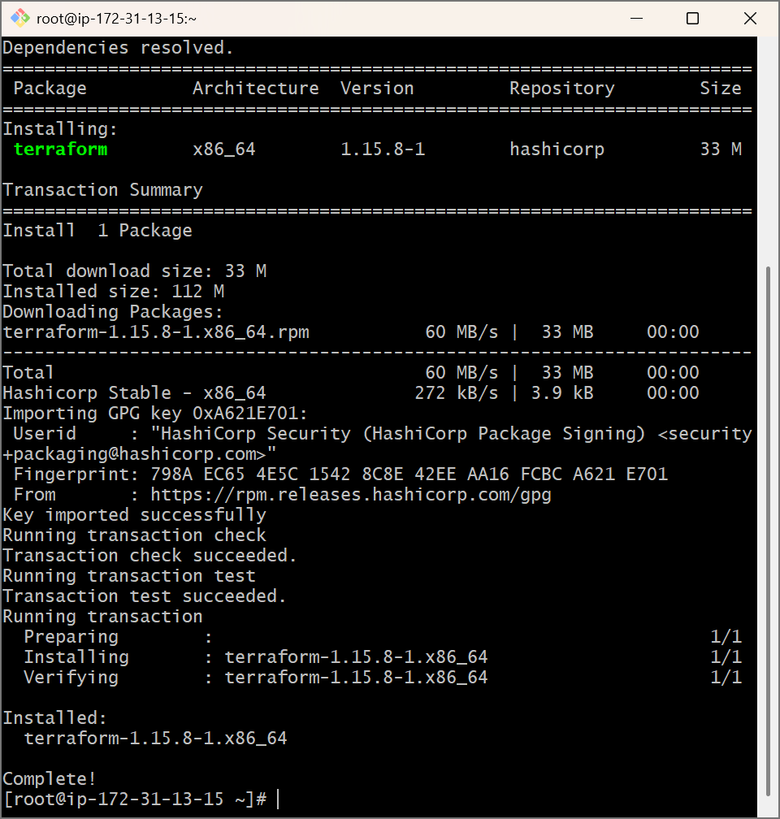

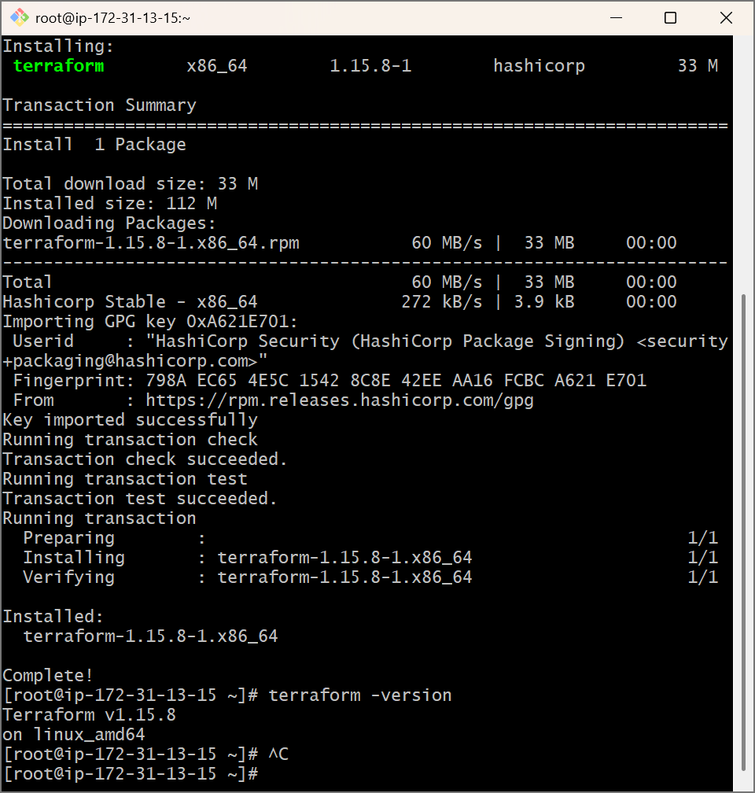

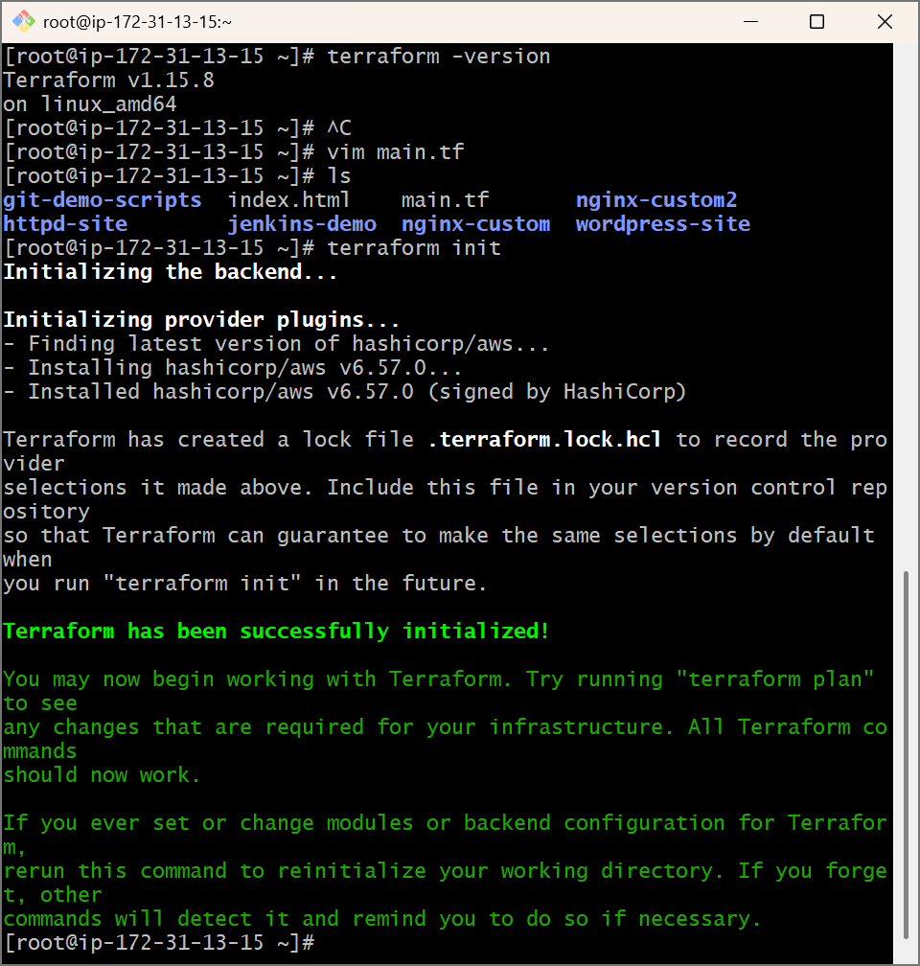
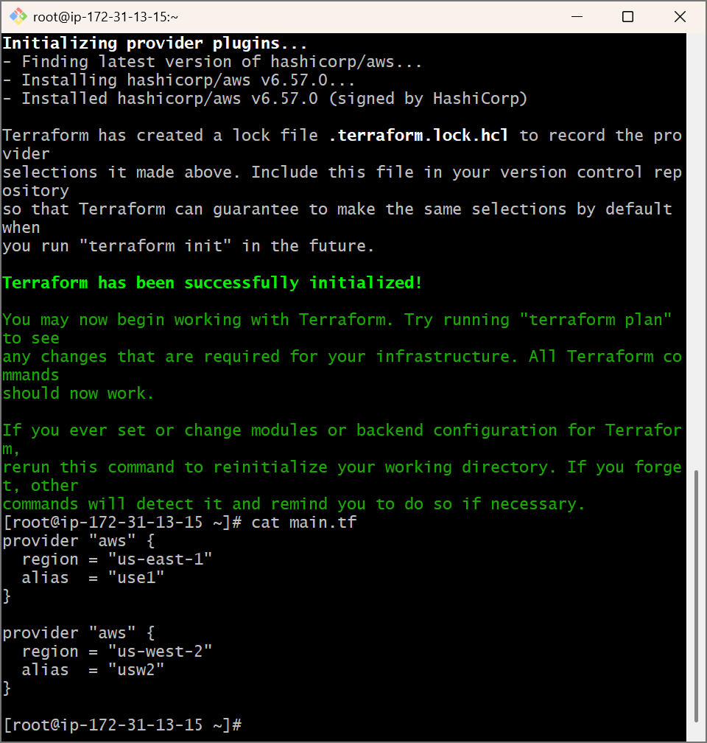

Main.tf:

╵
[root@ip-172-31-13-15 ~]# cat main.tf
provider "aws" {
region = "us-east-1"
alias = "use1"
}

provider "aws" {
region = "us-west-2"
alias = "usw2"
}

# Security group for us-east-1
resource "aws_security_group" "allow_http_use1" {
provider = aws.use1
name = "allow_http_use1"
description = "Allow HTTP inbound traffic"
vpc_id = "vpc-xxxxxxxx" # Replace with your VPC ID

ingress {
from_port = 80
to_port = 80
protocol = "tcp"
cidr_blocks = ["0.0.0.0/0"]
}

egress {
from_port = 0
to_port = 0
protocol = "-1"
cidr_blocks = ["0.0.0.0/0"]
}
}

# Security group for us-west-2
resource "aws_security_group" "allow_http_usw2" {
provider = aws.usw2
name = "allow_http_usw2"
description = "Allow HTTP inbound traffic"
vpc_id = "vpc-yyyyyyyy" # Replace with your VPC ID

ingress {
from_port = 80
to_port = 80
protocol = "tcp"
cidr_blocks = ["0.0.0.0/0"]
}

egress {
from_port = 0
to_port = 0
protocol = "-1"
cidr_blocks = ["0.0.0.0/0"]
}
}

[root@ip-172-31-13-15 ~]#

