Lotus Notes Contact Update Process

How to export the Lotus Notes Original Contact Database
Note: This process will be done only once to update the Contact Management Database
- Select the database to be extracted
- Select File – Menu – Export. The following screen will be displayed:
    - Save as Type: Select Structured Text
    - Enter File Name
    - Click on the Export button to complete the export process

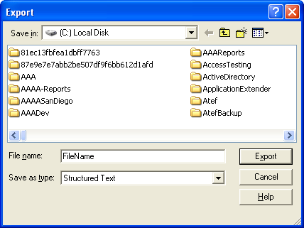

3. When the export process is completed, a text file will be created with similar structure and content as below:
$AddressFormat: 1
$NameFormat: 1
$BusinessAddressFormat: 1
$PersonalAddressFormat: 1
$PreviewFormat: 1
FirstName: Mark
MiddleInitial: M
LastName: Not Known
Title: Mr.
Suffix: Sr.
MailAddress: abakir@Att.nett
CompanyName: Dyna-SD
JobTitle: IT Manager
OfficeStreetAddress: My Address
OfficeCity: My City
OfficeState: My State
OfficeZIP: My Zip
OfficeCountry: My Country
OfficePhoneNumber: (858)810-0033
OfficeFAXPhoneNumber: My Fax
CellPhoneNumber: My Cell
PhoneNumber_6: My Pager two
FullName: Mark Not Known
NameDisplayPref: 2
-- Form Feed Character
$AddressFormat: 1
$NameFormat: 1
$BusinessAddressFormat: 1
$PersonalAddressFormat: 1
$PreviewFormat: 1
FirstName: Mark
MiddleInitial: M
LastName: Not Known
Title: Mr.
Suffix: Sr.
MailAddress: abakir@Att.nett
CompanyName: Dyna-SD
JobTitle: IT Manager
OfficeStreetAddress: My Address
OfficeCity: My City
OfficeState: My State
OfficeZIP: My Zip
OfficeCountry: My Country
OfficePhoneNumber: (858)810-0033
OfficeFAXPhoneNumber: My Fax
CellPhoneNumber: My Cell
PhoneNumber_6: My Pager two
FullName: Mark Not Known
NameDisplayPref: 2
-- Form Feed Character

How to Import the Contact File
1. Delete the Original Contact Database
2. Create a new database with the same name:
a. Select: File - Database - New
b. Enter required items as below:
- Select the Server where the database will reside
- Enter the database title
- Enter the file name or leave as default
- Select the template
- Uncheck Inherit Future Design Changes
c. Press OK to process
d. The new contact database will be created

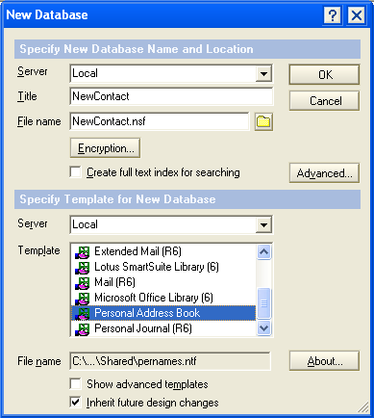

3. Select the contact databases to which import the contacts
2. Select Menu: File-Import. The following screen will be displayed:
a. Files of Type: Structured Text
b. File name: Select the file created by Contact Management Module
c. Click on the Import button

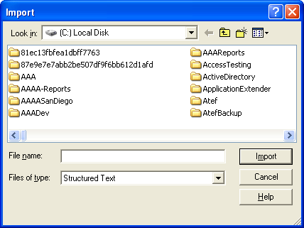
3. When clicking the Import Button, the following screen will be displayed:
a. How to Import Documents:
- Import as: Select the default value “Main Document(s) “
- Using Form: Select Contact
b. Separator between Documents:
- Select Form-Feed
c. Options for Imported Documents:
- For body text: Select Justify
- Check Calculate fields on form during document import
d. Click on the OK button

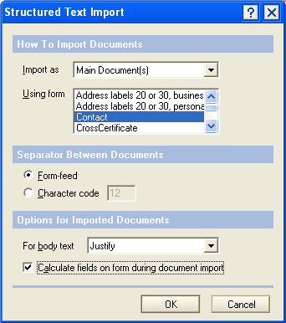

4. When clicking the OK Button, the import process will be completed and contacts will be listed in the new database.

