Deploying WordPress application using docker-compose  
github- https://github.com/anushasamala/Docker-compose.git

Step-1 Launch an EC2 instance with instance type t2.micro and image amazon Linux.

To install docker compose   
url - https://acloudxpert.com/how-to-install-docker-compose-on-amazon-linux-ami/

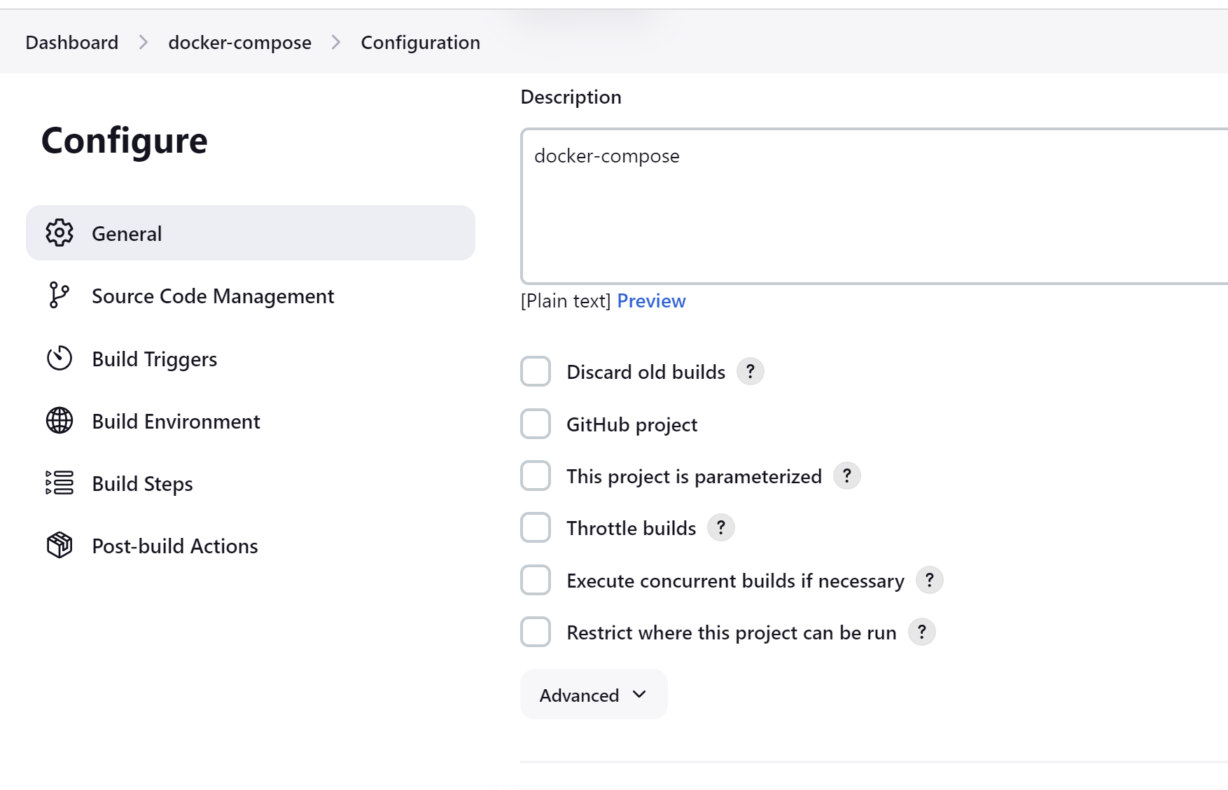

#!/bin/bash

sudo yum update -y

sudo yum -y install docker

sudo systemctl start docker

sudo systemctl enable docker

sudo systemctl status docker

sudo curl -L sudo curl -L https://github.com/docker/compose/releases/download/1.21.0/docker-compose-`uname -s`-`uname -m` | sudo tee /usr/local/bin/docker-compose > /dev/null

sudo chmod +x /usr/local/bin/docker-compose

vi docker-compose.yaml

sudo chmod 666 /var/run/docker.sock

cd /var/lib/jenkins/workspace/docker-compose

docker-compose up -d