**Products Display Module – Unit test (Manual)**

1. Host the php code on the git repository to a application server, preferably in a XAMPP server
2. Also, import the “saitow_testcase” database into your local mysql server, it contains initial 2 products for the purpose of testing
3. Navigate to the corresponding ./**MVC_App/public/Home/searchProducts** path in a browser
4. The page already shows the list of all products – 4 Products, 2 from database, and 2 from a local xml file (see below screenshot)

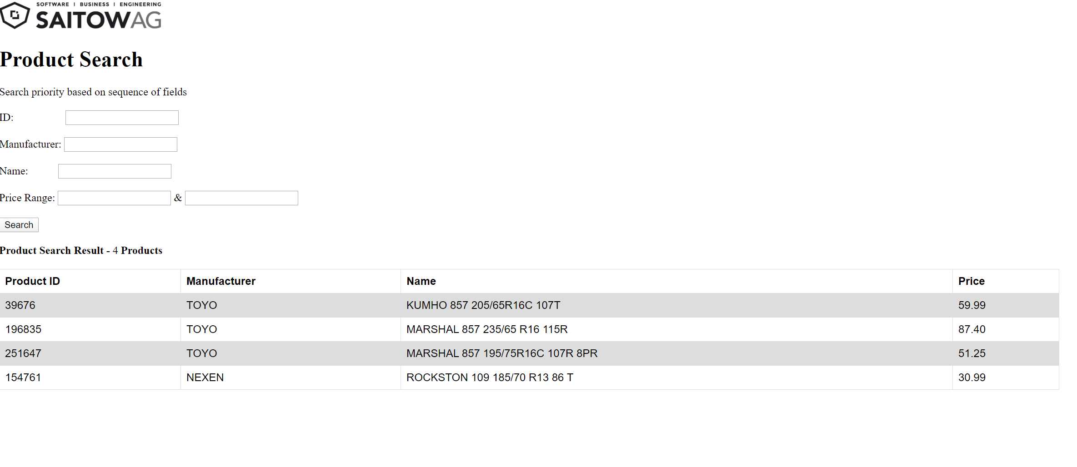

1. Enter a search criteria such as ID, Manufacturer, Name or price range, and click on “search” (click below screenshot for results).

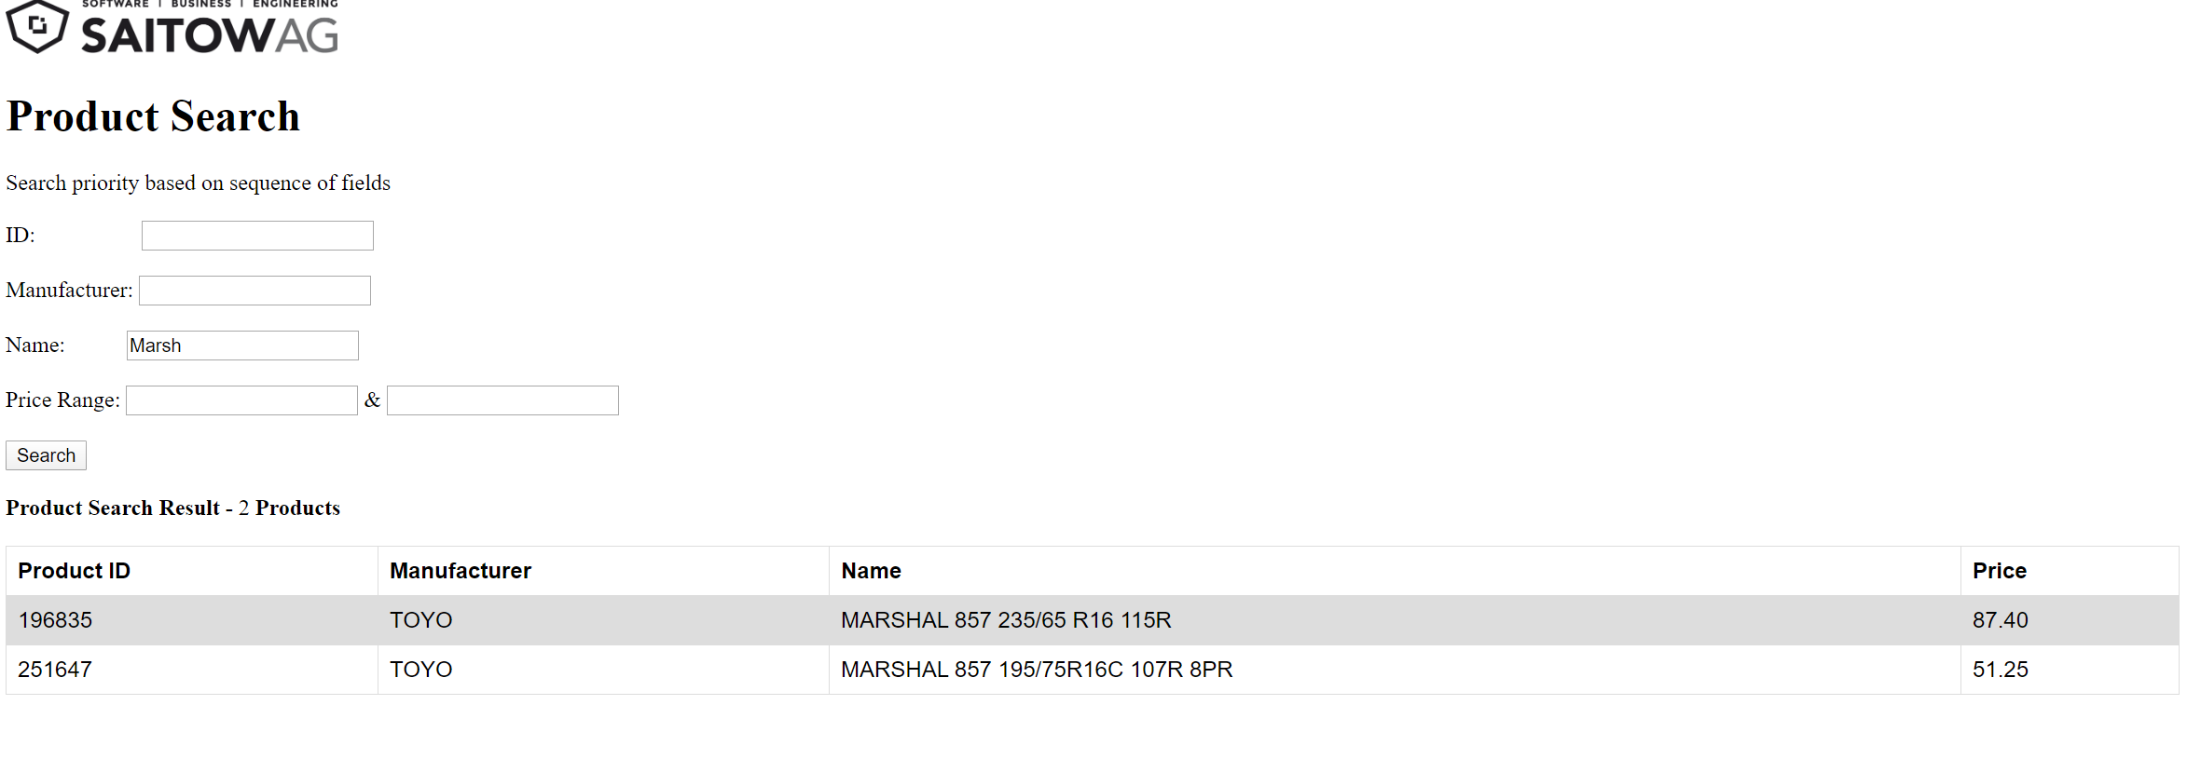

1. Individual product in the result section is clickable
2. Clicking on a product navigates to product details page (refer screenshot)

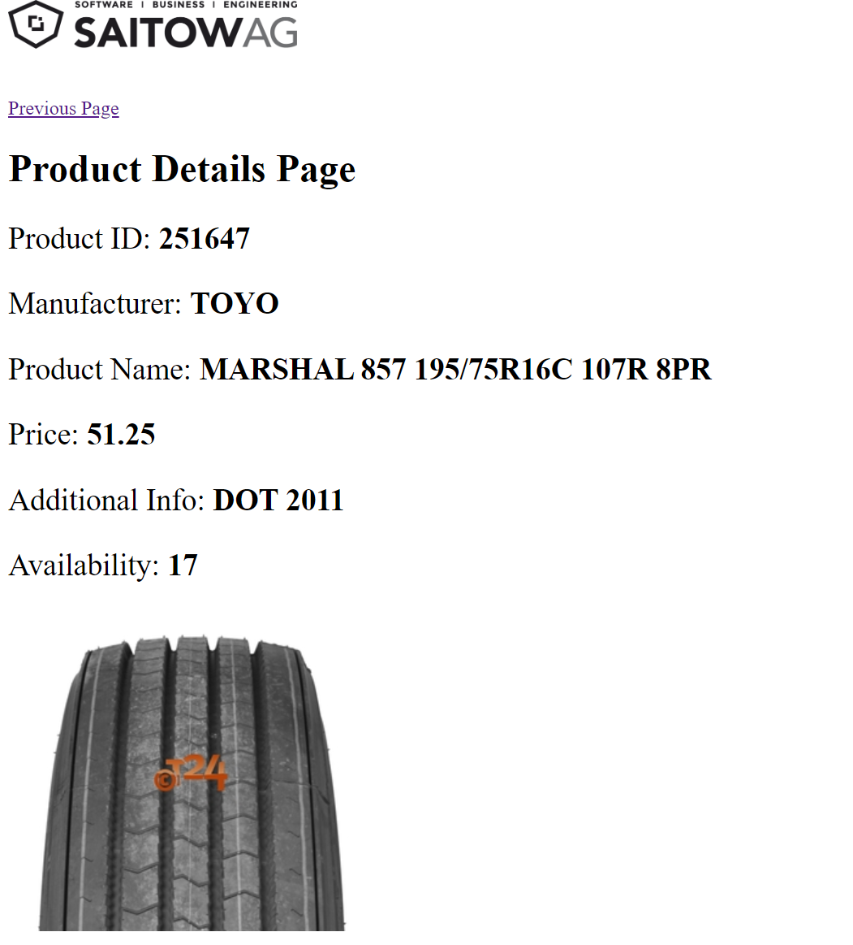

1. Product details page has a navigation link back to main “search and results” view