**Topic Name:**

The main aim of this lab session is to provide hands-on experience on

* Explore file structure
* File management commands
* Absolute path and Relative path
* Globbing - Scripting

File Structure

1. Under the root directory there are many files like /bin , /boot , /dev , /etc , ….

Find out the importance of those files

Example : /etc is for user account details

|  |  |  |
| --- | --- | --- |
| **S.N o** | **Directory** | **Usage** |
| 1 | / | Root directory |
| 2 | /bin | Binary files |
| 3 | /boot | To store files necessary for boot process |
| 4 | /dev | Provide access to peripheral devices such as hard disks, to resources on peripheral devices such as disk partitions, and pseudo devices such as random number generator |
| 5 | /etc | A central location for storing system configuration files and directories that are essential for the proper functioning of the system and its installed applications |
| 6 | /home | A personal working space for all the users except root |
| 7 | /lib | A personal working space for all the users except root |
| 8 | /proc | To obtain information about the system and to change certain kernel parameters at runtime |
| 9 | /sbin | Primarily used by the system administrator for system maintenance and management tasks. |
| 10 | /tmp | To provide a space for temporary files generated by running programs and processes |
| 11 | /var | Used by busy applications such as accounting, mail, and the print spooler. |
| 12 | /mnt | Mount points to removable or temporary files storage |
| 13 | /opt | Providing a clear and hierarchical organization of installed software |

1. In Linux, there are three different files

Regular file

Directory

Special file

Block file

Character file

Socket file

Pipe file

Fill the below table:

|  |  |  |  |  |  |  |
| --- | --- | --- | --- | --- | --- | --- |
| File Type | Represented  by (Hint ls ) | Role | How to create | How to check | Location | Screen shot |
| Regular file |  | In computing, a regular file is a type of [file](https://www.javatpoint.com/file) that contains user-created data in a specific format | Touch filename | NA |  |  |
| -Text file | - | These files contain plain text and are usually saved with a .txt extension. | Touch filename.txt | NA |  |  |
| -Compressed file | - | These files contain one or more files that have been compressed to reduce their size. | Zip [options] [zipfile] [file1] [file2] […] | NA |  |  |
| -Image | - | These files contain digital images. | NA | NA |  |  |
| Directory | d | A directory is a special type of file that serves to store a list of file names and their associated metadata, organizing files within a hierarchical structure known as the directory tree | mkdir  <filename> | NA |  |  |
| Block file | b | A block file, also known as a block device file, represents a type of device that allows for buffered access to hardware devices. | NA | NA | ‘/dev’ directory |  |
| Character file | c | Character files, also known as character device files, are a type of special file that provides a way for the operating system to communicate with hardware devices. | NA | NA | ‘/dev’ directory |  |
| Socket file | s | Socket files are a critical component of IPC in Linux, enabling efficient communication between processes on the same machine. | NA | NA | ‘/tmp’, ’, or ‘/run’ application-specific directories, depending on the application's configuration and requirements |  |
| pipe file | | | Pipes are an essential mechanism for IPC in Linux, facilitating efficient data transfer between processes. | NA | NA |  |  |

1. Globbing
2. Go back to CYS
3. Create multiple subdirectories using single command

LS

Unit1

command

glob

Unit2

command

grep

Unit3

constructs

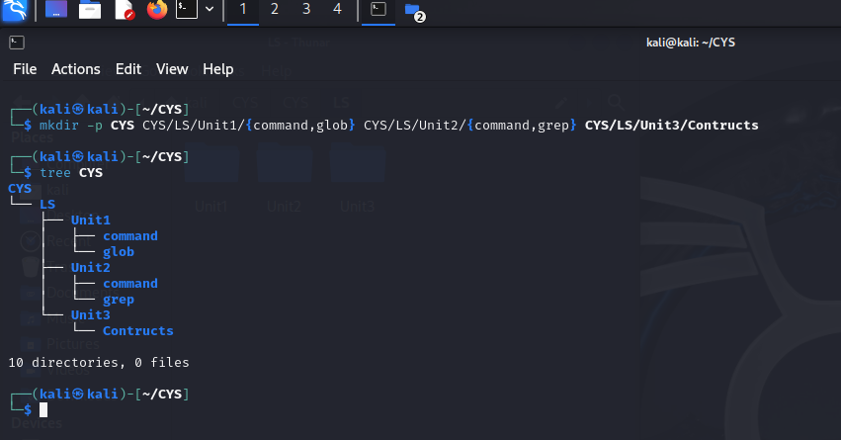

1. Navigate to unit1/glob
2. Create the following files :

Commands.txt

Commands1.txt Commands2.txt page1.html page2.html page3.html file1 file10 file11 file2 File2 File3 file33 fileAB filea fileA fileAAA file(

file 2

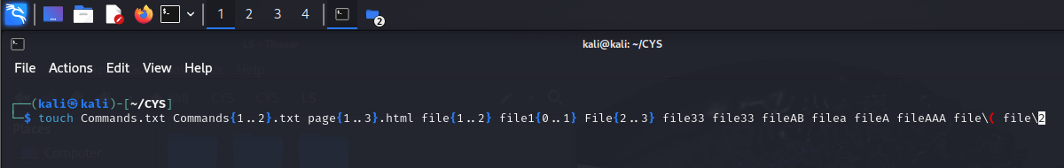

1. List all files starting with file IMG_256
2. List all files starting with File

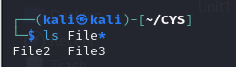

1. List all files starting with file and ending in a number.

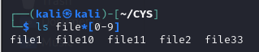

1. List all files starting with file and ending with a letter

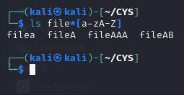

* 1. List all files starting with File and having a digit as fifth character.

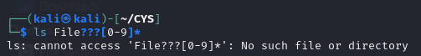

* 1. List all files starting with File and having a digit as fifth character and nothing else.

IMG_256

* 1. List (with ls) all files starting with a letter and ending in a number.

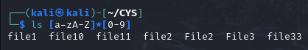

* 1. List (with ls) all files that have exactly five characters.

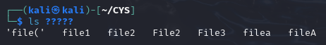

* 1. List (with ls) all files that start with f or F and end with 3 or A.

IMG_256

* 1. List (with ls) all files that start with f have i or R as second character and end in a number.

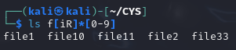

* 1. List all files that do not start with the letter F.

IMG_256

* 1. Remove all the \*.html

IMG_256

* 1. Rename \*.txt to \*.json

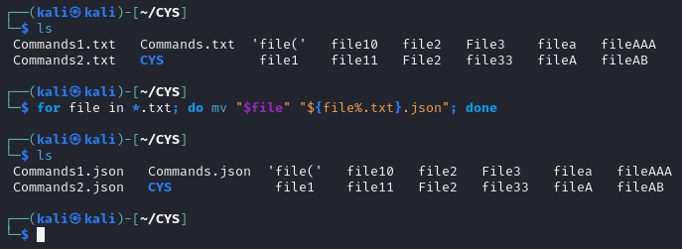

1. Absolute path and relative path

Use rm, mv, cp, ls with absolute path and relative path as per your choice.

|  |  |  |
| --- | --- | --- |
| Command | absolute path | relative path |
| ls | IMG_256 | IMG_256 |
| rm | IMG_256 | IMG_256 |
| mv | IMG_256 | IMG_256 |
| cp | IMG_256 | IMG_256 |

1. Wildcards

|  |  |  |  |
| --- | --- | --- | --- |
| Notation | Use | Example | Screenshot |
| \* | One or many | ls \* | IMG_256 |
| ? | Match only one character | ls Commands?.json | IMG_256 |
| [ ] | used to match a single character from a set of specified characters. | ls file[1-3] | IMG_256 |
| [! ] | Matches any character that is not a member of the set characters | ls file[!1] | IMG_256 |
| { } | Used to generate multiple arguments by separating the values with commas | Echo Commands{1..2}.txt | IMG_256 |

More on Character class

|  |  |  |  |
| --- | --- | --- | --- |
| Notation | Use | Example | Screenshot |
| [:alnum:] | Matches any alphanumeric character | grep ‘[[:alnum:]]’ anushapatil.py | IMG_256 |
| [:alpha:] | Matches any alphabetic character | grep ‘[[:alpha:]]’ anushapatil.py | IMG_256 |
| [:digit:] | Matches any numeric digit (0-9). | grep ‘[[:digit:]]’ anushapatil.py | IMG_256 |
| [:lower:] | Matches any lowercase alphabetic character | grep ‘[[:lower:]]’ anushapatil.py | IMG_256 |
| [:upper:] | Matches any uppercase alphabetic character (A-Z) | grep ‘[[:upper:]]’ anushapatil.py | IMG_256 |

4. change permission

1. Change the permission set of /work/readme.txt so that only the user (owner) can read,write, and execute it. Use absolute mode.

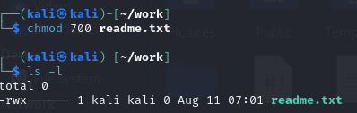

1. Change the permission set of /work/readme.txt so that any user can read it, the group can read/write to it and the user (owner) can read/write/execute it. Use absolute mode.

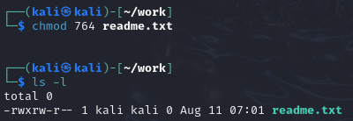

1. Change the permission set of /bin/bash so that only the user (owner) can read/write/ execute, group, and any user can execute it. However, whenever anyone executes it, it should run with the privileges of the owner user. Use absolute mode.

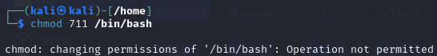

1. Change the permission set of /work/readme.txt so that only the user (owner) can read, write, and execute it. Use relative mode.

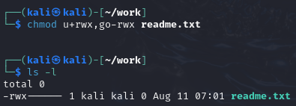

1. Change the permission set of /work/readme.txt so that any user can read it, the group can read/write to it and the user (owner) can read/write/execute it. Use relative mode.

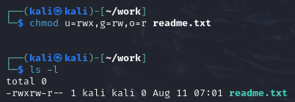

1. Change the permission set of /work/readme.txt so that only the user (owner) can read/write/ execute, group, and any user can execute it. However, whenever anyone executes it, it should run with the privileges of the group. Use absolute mode.

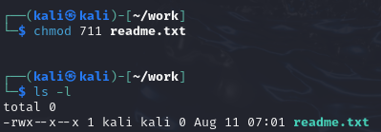

1. Change the permission set of /work/readme.txt so that only the owner can rename or delete this file while maintaining the existing permissions. Use absolute mode.

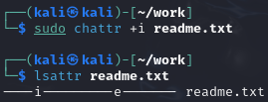

1. What are the default permissions for the new file?

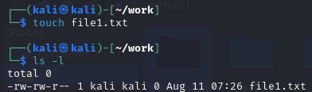

1. What was the command to view the file permissions?

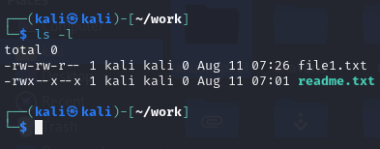

1. Change chmod.exercises permissions to -r--r--r

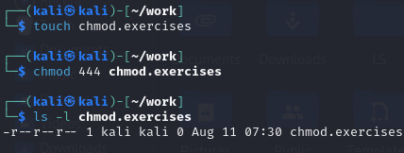

1. Change the file permissions to Read only for the owner, group and all other users.

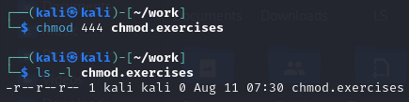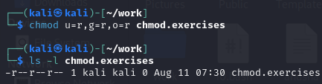

1. What was the command for changing the file permissions to -r--r--r--?

IMG_256

1. Change chmod.exercises permissions to -rw-r-----

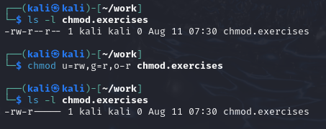

1. Change the file permissions to match the following:
   1. owner: Read and Write
   2. group: Read
   3. other: no permissions (None)



1. What was the command for changing the file permissions to -rw-r-----?

IMG_256

1. Change chmod.exercises permissions to -rwxr-x—x

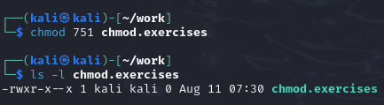

1. Change the file permissions to match the following:
   1. owner: Read, Write and Execute
   2. group: Read and Execute
   3. other: Execute



1. What was the command for changing the file permissions to -rwxr-x--x?



Evaluation :

Marks : 10 (Deadline : 4 – Originality :3 – Completeness :3 )

Deadline: 06.08.2024

In life there are no shortcuts. All things are connected. For success there is no fast lane. Work hard. Focus your energy, practice, remain honest, Truthful, loyal and committed.

-unknown