The main idea of this lab exercise to give hands on experiance on

grep

constructs

command line arguments

1. write a shell script to get value the pattern and file name from the user and check the pattern exists or not. If the pattern exists print the relavent

message , if pattern not found print relevent message.

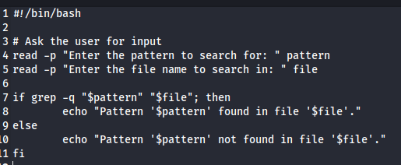

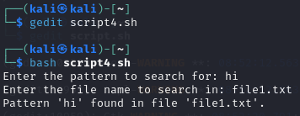

1. Modify the above script to pass the arguments from command line arguments.

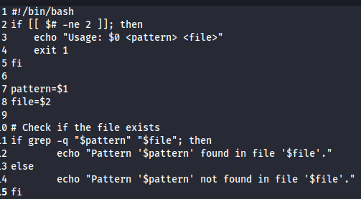

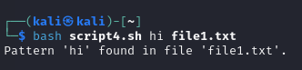

1. Modify the above script to pass the values inside the script.

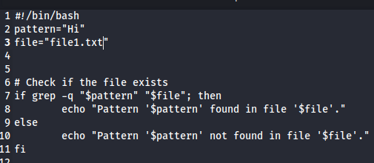

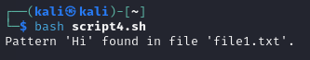

4. validate the script (script 1, script 2)

- the file exists or not

- arguments passed or not

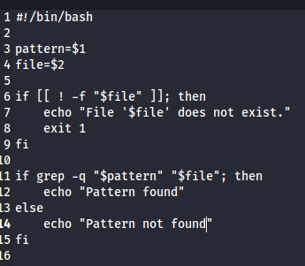

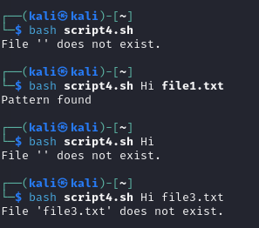

5. Apply grep commands

Note: Make sure to use the options -e -c -n -q -s -f -A -B -C -i -h, -l -o -w

Frame the questions (as per your choice)

to extract user information

to extract network information

to extract login details

1. to extract network information

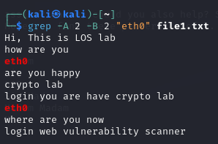

1. to extract login details



1. using multiple options

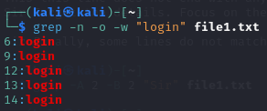

1. check whether a pattern exist in file without showing in output



1. To search multiple patter using -e

