1. text.txt

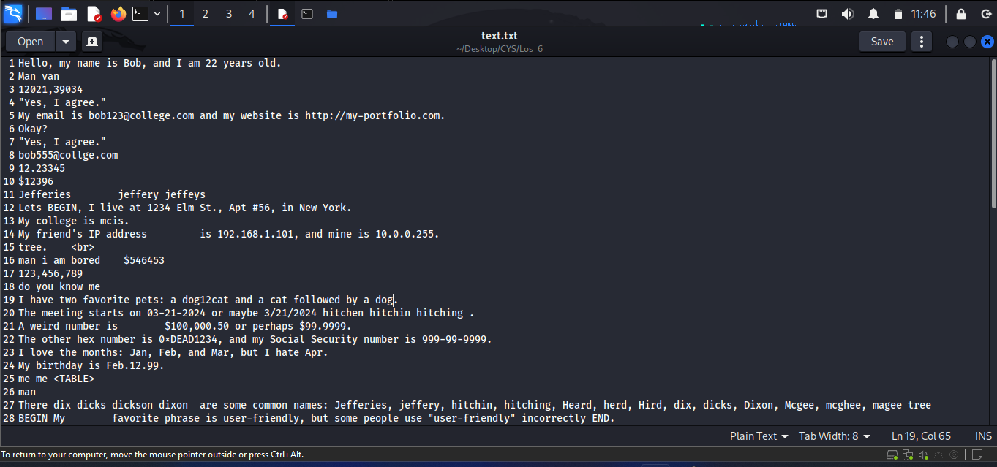

1. text1.txt

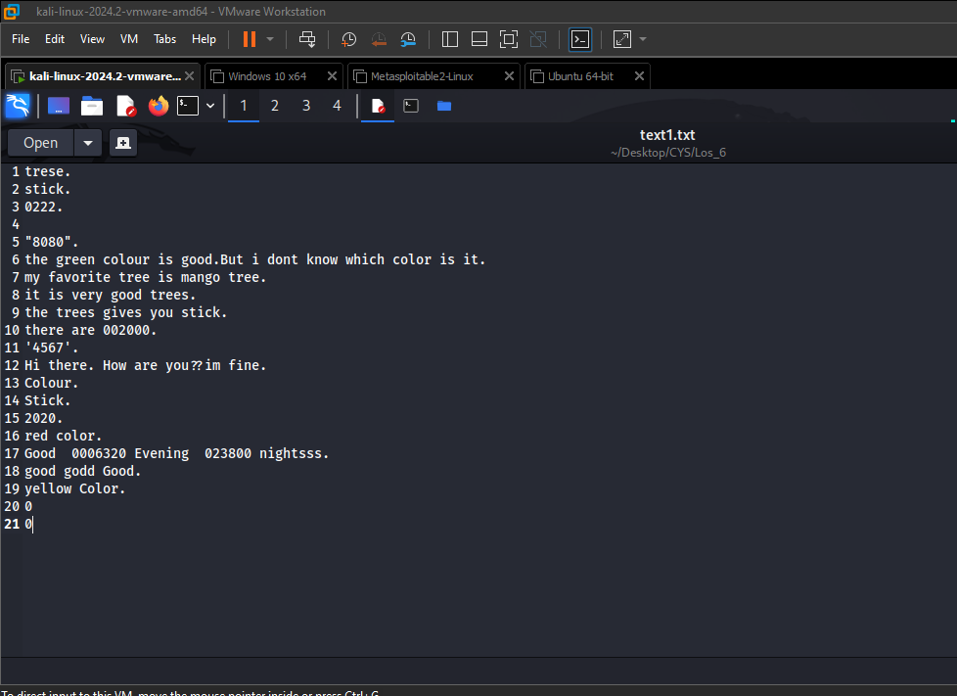

1. Text2.txt

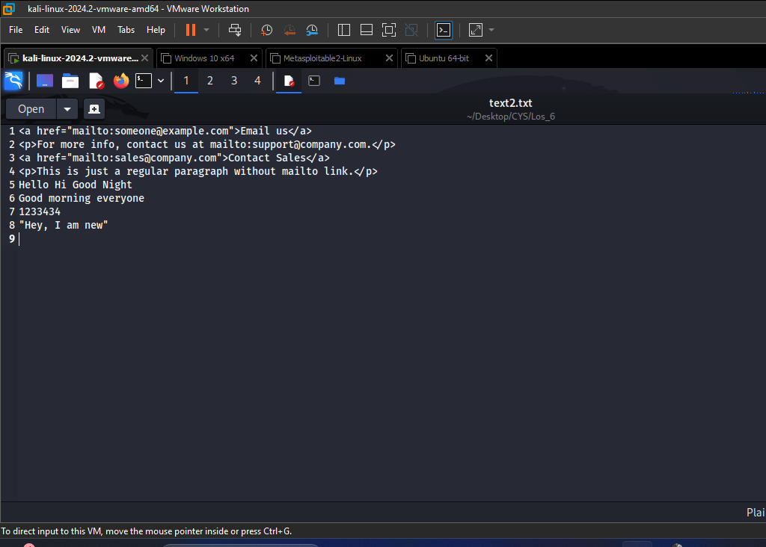

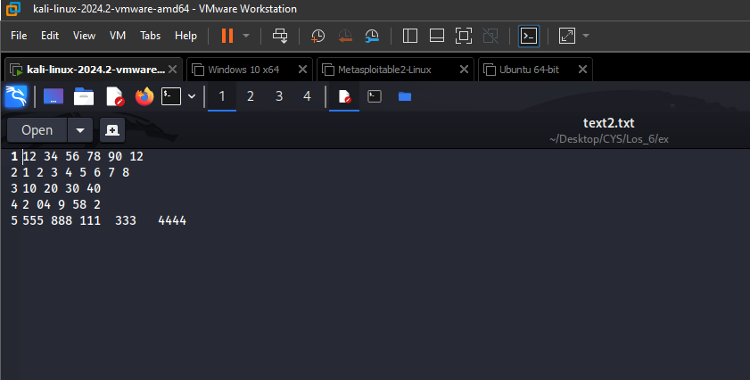

Write a sed command to

1. Print lines numbers of lines beginning with “O”

sed -n '/^O/=' file.txt

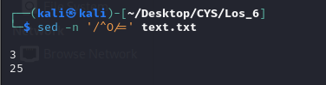

1. Delete digits in the given input file.

sed 's/[0-9]//g' file.txt

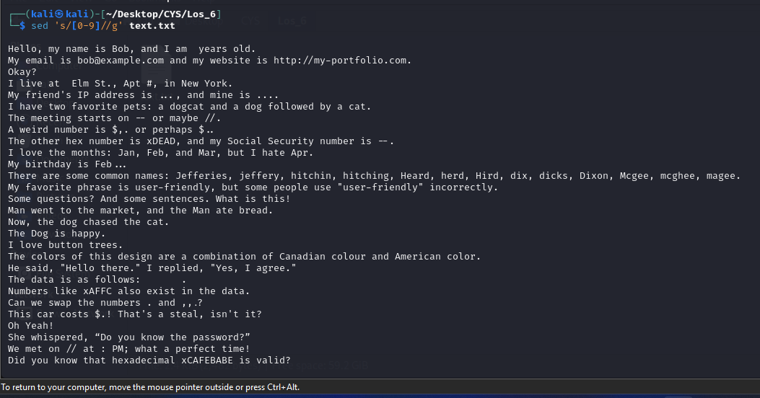

1. Delete lines that contain both BEGIN and END

sed '/BEGIN.*END/d' file.txt

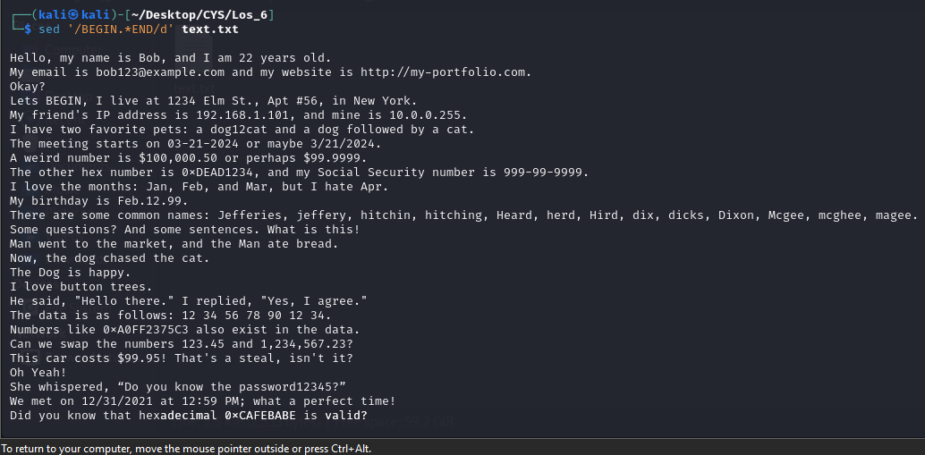

1. Delete lines that contain BEGIN but not END

sed '/BEGIN/ { /END/!d; }' file.txt

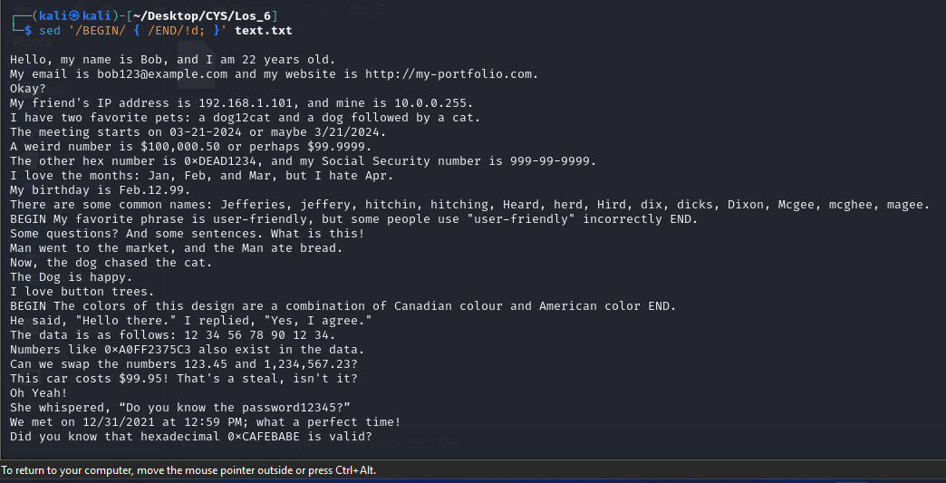

1. Delete the first character in each line in a file

sed 's/^.//' file.txt

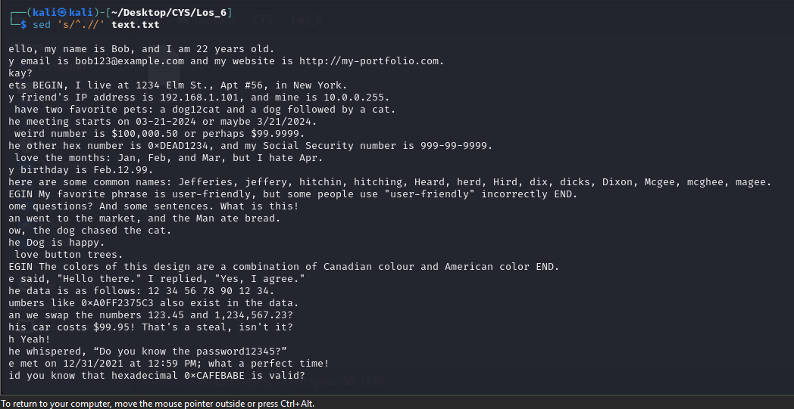

1. Delete the last character in each line in a file

sed 's/.$//' file.txt

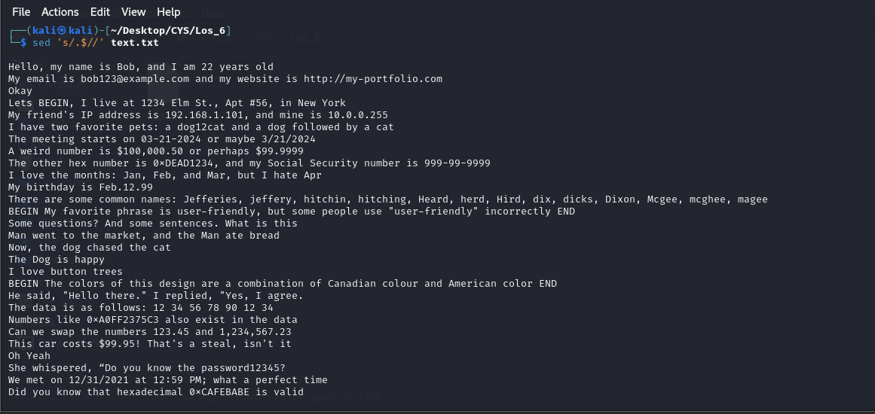

1. Deletes the first character, (if it numeric ) in each line in a file.

sed 's/^[0-9]//' file.txt

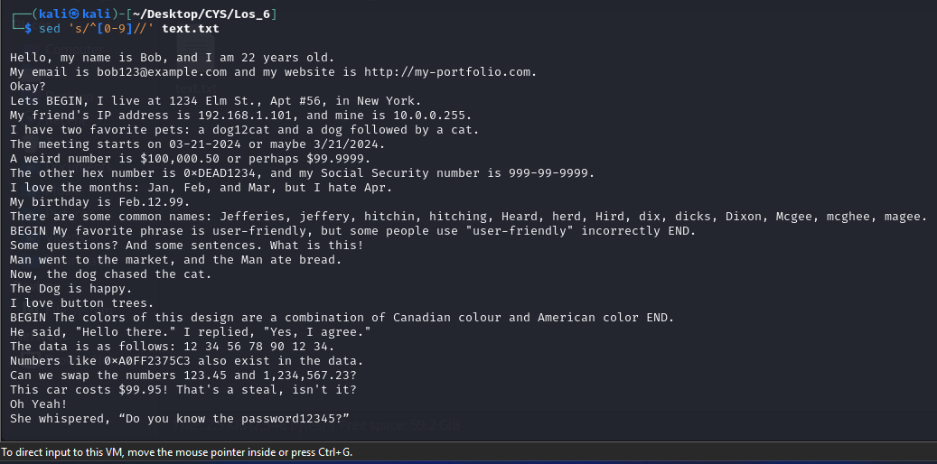

1. Deletes the character before the last character in each line in a file.

sed 's/.\(.\)$/\1/' file.txt

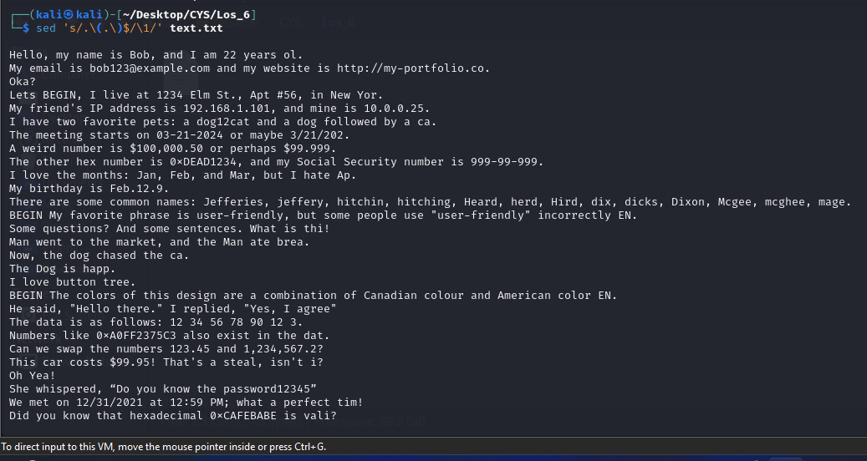

1. That swaps the first and second words in each line in a file.

sed 's/^\([^ ]*\) \([^ ]*\)/\2 \1/' file.txt

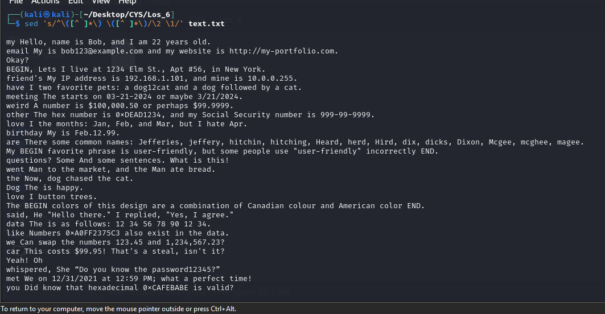

1. Replace the word “mcis” with “sois” in the first five lines in a file

sed '1,5s/mcis/sois/' file.txt

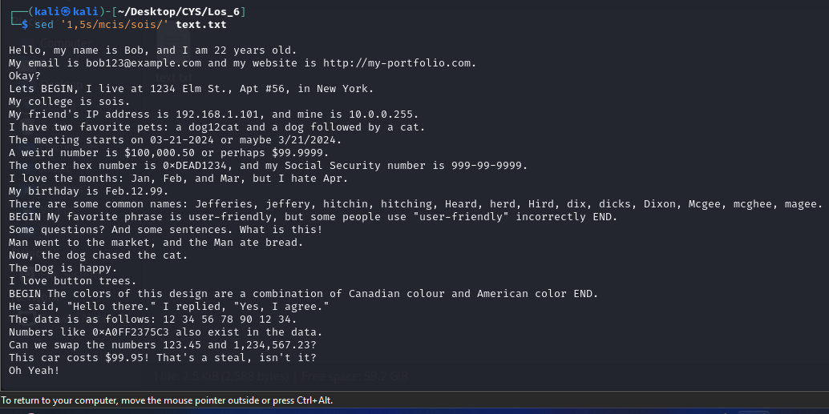

1. Add “SOIS” prefix to all the lines

sed 's/^/SOIS /' text.txt

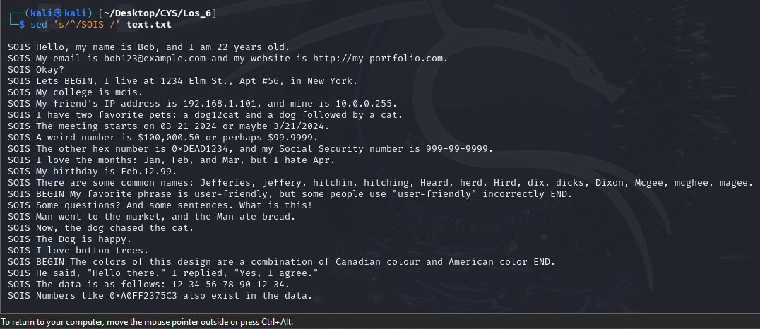

1. add “.” at the end of each line in the file.

sed 's/$/./' text.txt

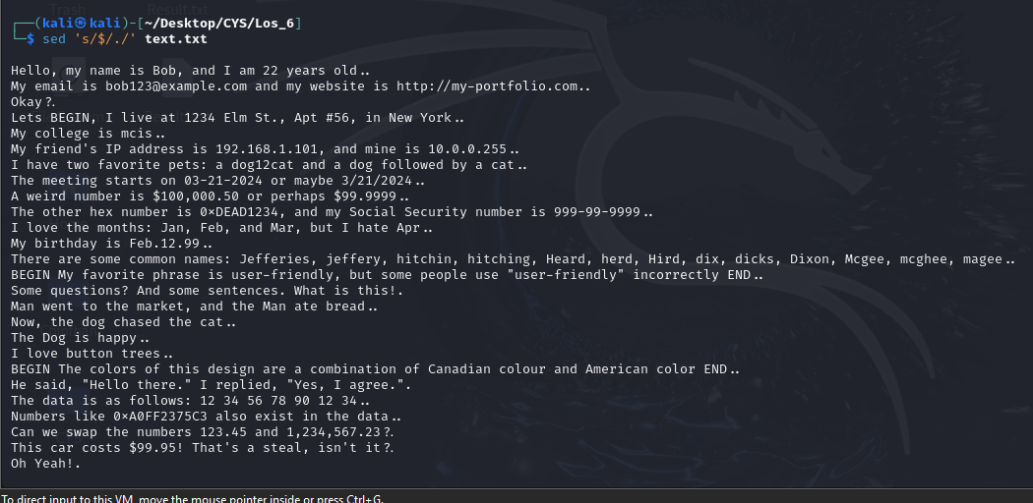

1. Pick the line with Social security number in the format of 999-99-9999

sed -n '/[0-9]\{3\}-[0-9]\{2\}-[0-9]\{4\}/p' text.txt

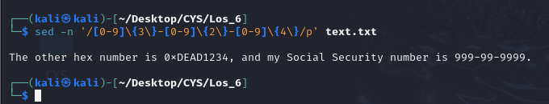

1. Pick the Valid IP address of the computer (4 numbers separated by ‘.’). (e.g. 192.168.0.1)

sed -n '/\b[0-9]\{1,3\}\.[0-9]\{1,3\}\.[0-9]\{1,3\}\.[0-9]\{1,3\}\b/p' text.txt

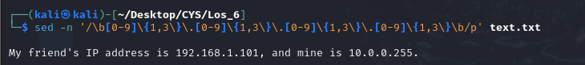

1. Pick the Valid URL beginning with “http://”. (e.g. <http://manipal.edu>)

sed -n '/^http:\/\//p' text.txt

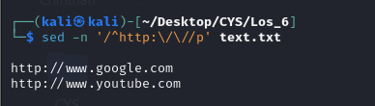

1. Pick the Valid email address, assuming ‘a-z’,’0-9’,’-‘,’.’ are the valid characters for user ID, and domain name has to end with either “.com” or “.net”

sed -n '/[a-zA-Z0-9._%-]+@[a-zA-Z0-9.-]+\(\.com\|\.net\)/p' text.txt

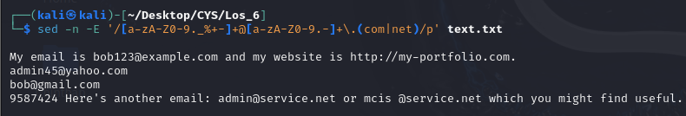

1. Print all lines containing words that start with "f" and end with "s".

sed -n '/\bf.*s\b/p' text.txt

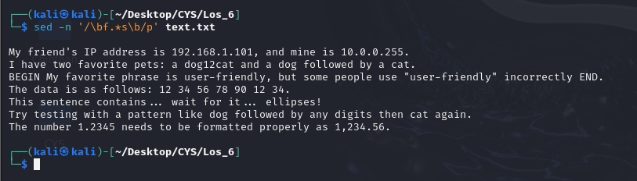

1. Print lines containing a capital "L", but not as the first character on the line.

sed -n '/^[^L]*L/p' text.txt

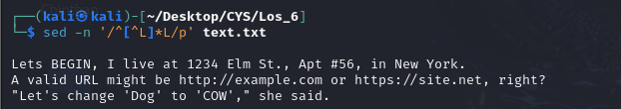

1. Matches dates in the American MM-DD-YYYY format where months and days can be 1 or 2 digits, years must be 4 digits starting with a 1 or a 2, and the delimiter is either "-" or "/" but not both.

sed -n '/\b\(0[1-9]\|1[0-2]\)[-/]\(0[1-9]\|[12][0-9]\|3[01]\)[-/][12][0-9]\{3\}\b/p' text.txt

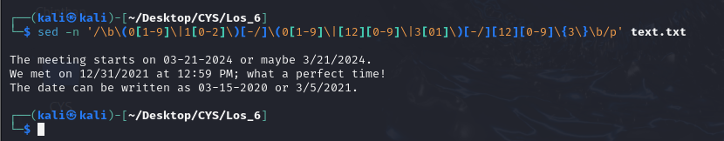

1. Print all the lines of a file that are less than 10 characters in length.

sed -n '/^.\{,9\}$/p' text.txt

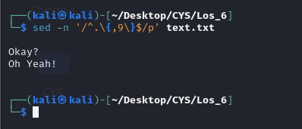

1. Replace all occurrences in a file of "the" with "a" and "The" with "A".

sed 's/\bthe\b/a/g;s/\bThe\b/A/g' text.txt

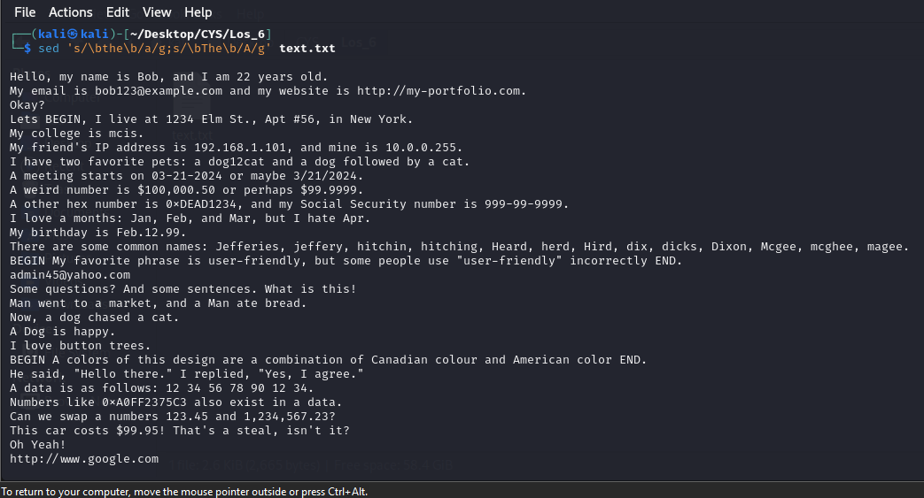

1. Substitute the word "button" for "tree", only if tree occurs at the end of a line.

sed 's/tree$/button/' text1.txt

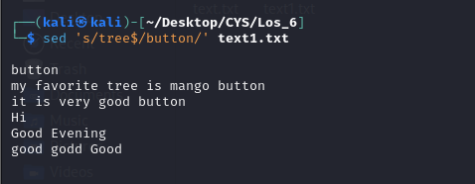

1. Substitute the word foible for the word tree but not the word trees.

sed 's/\btree\b/foible/g' text1.txt

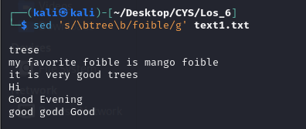

1. Change a text so that every period at the end of a sentence is changed to an exclamation point (!) and every question mark is replaced with an ellipsis (...)

sed 's/\.\s*$/!/g; s/?/.../g' text.txt

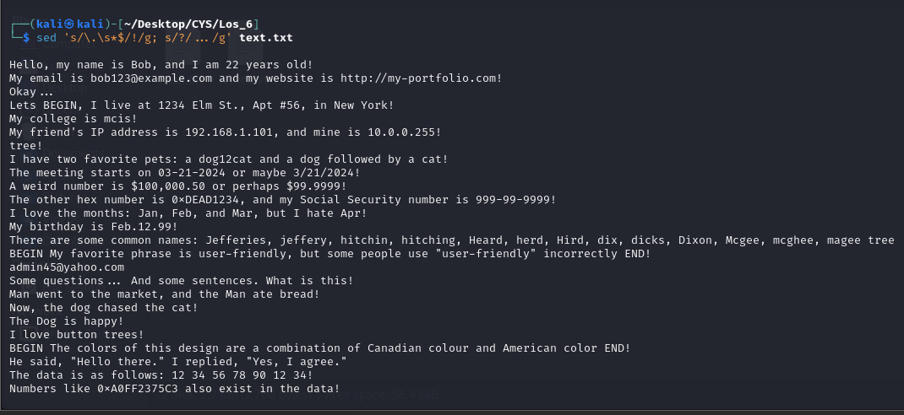

1. Change every occurrence of the word 'me' with 'you' but only at the end of a line.

sed 's/me$/you/' text.txt

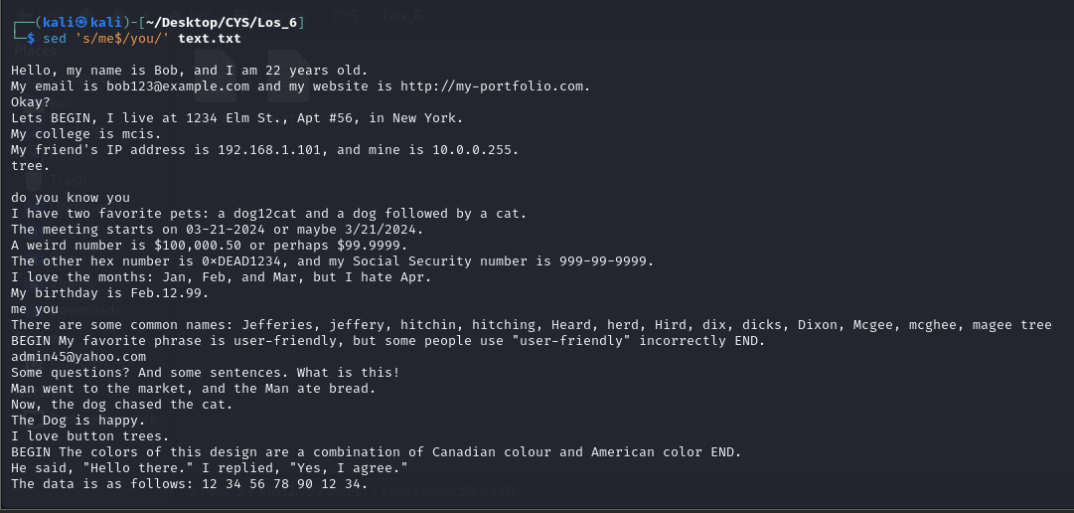

1. Change a document so that every occurrence of a three-letter abbreviation for a month is replaced by the appropriate number, i.e., Jan is replace by 1, Feb by 2 etc.

sed -e 's/\bJan\b/1/g' -e 's/\bFeb\b/2/g' -e 's/\bMar\b/3/g' text.txt

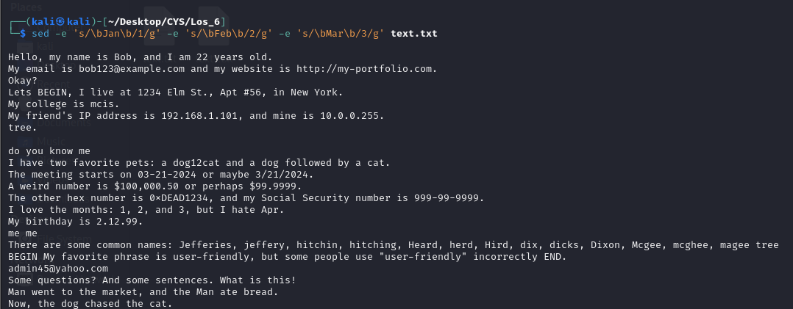

1. match lines containing (i) Jefferies jeffery jeffeys (ii) hitchen hitchin hitching (iii) Heard herd Hird (iv) dix dicks dickson dixon (v) Mcgee mcghee magee.

sed -n '/\(Jefferies\|jeffery\|jeffeys\|hitchen\|hitchin\|hitching\|Heard\|herd\|Hird\|dix\|dicks\|dickson\|dixon\|Mcgee\|mcghee\|magee\)/p' text.txt

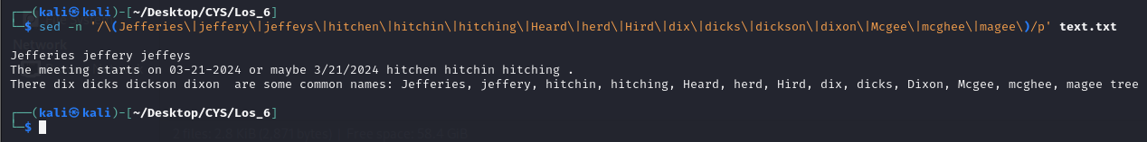

1. Replace all multiple spaces in a string by only one space.

sed 's/ \{1,\}/ /g' text.txt

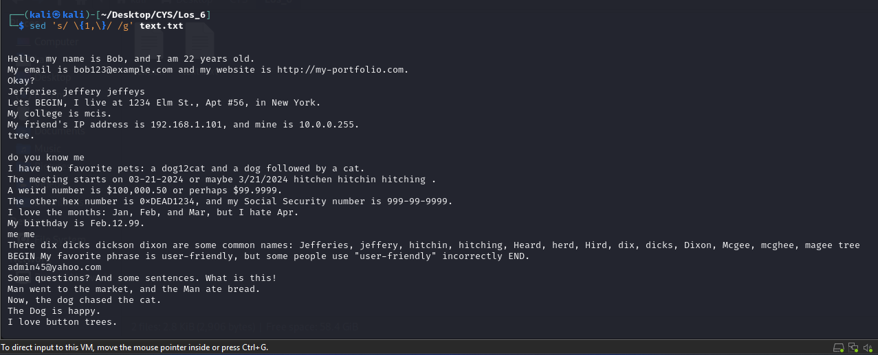

1. A line comment in C is introduced by the sequence //. Alternatively the comment can be enclosed by /* and */. Write a sed command which transforms the // comments to the enclosed ones.

sed 's|//\(.*\)$|/* \1 */|' text.txt

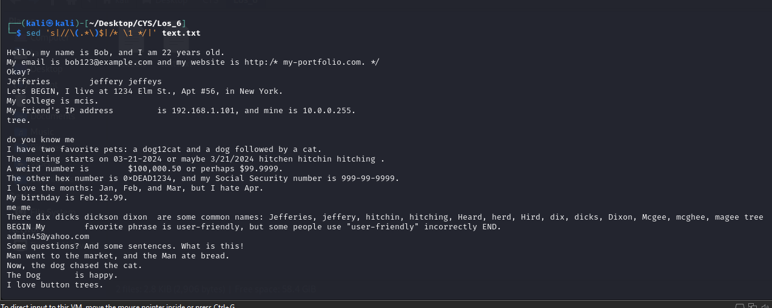

1. Print alternative lines (line1,3,5…)

sed -n '1~2p' text.txt

