1. Use the ping command to test the connectivity to a remote server (e.g., example.com).

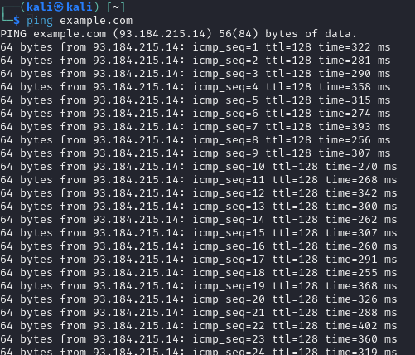

1. Write a script to measure the round-trip time for each packet and analyze the results.

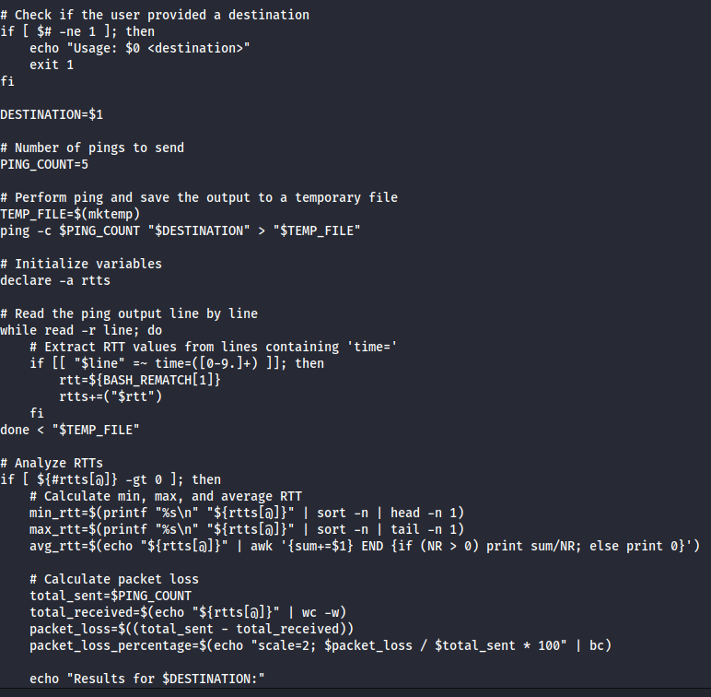

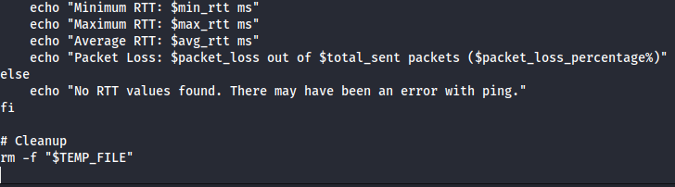

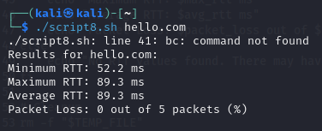

1. Use the traceroute to trace the route packets take to a destination

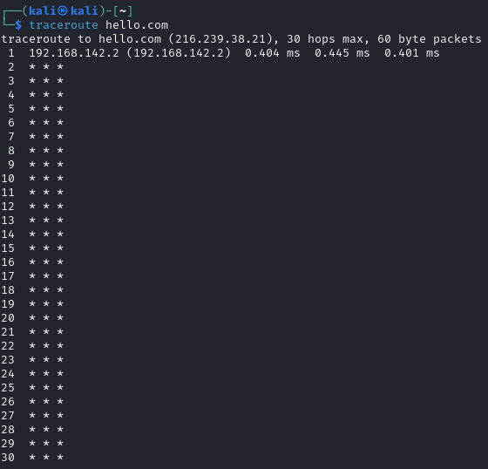

1. Analyze the output to identify any potential bottlenecks or points of failure in the route.

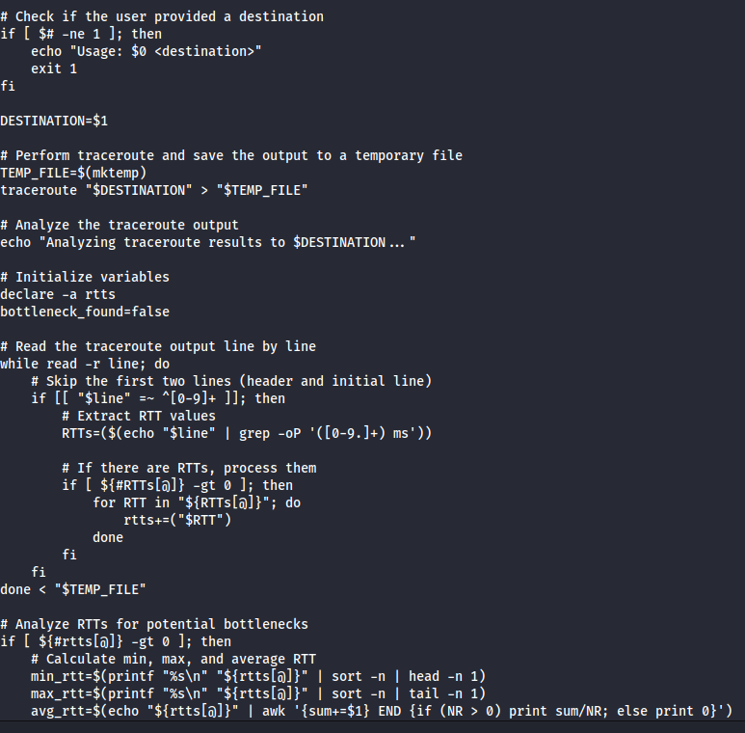

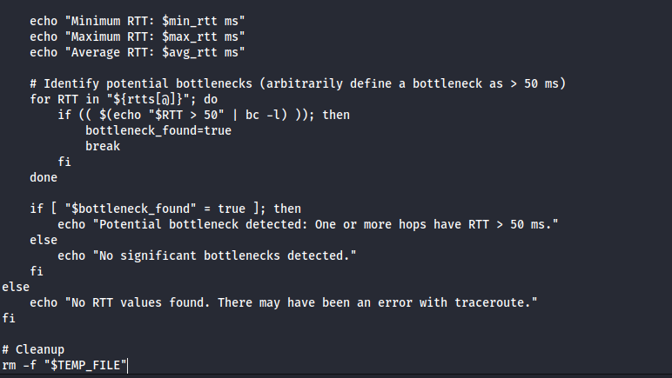

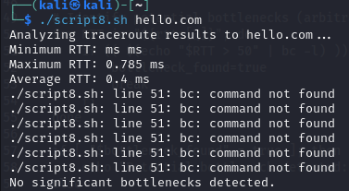

1. Use the nslookup command to find the IP address of a given domain (e.g., example.com).

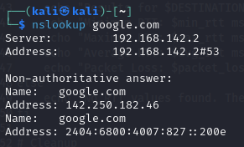

1. Use the netstat command to view active connections and listening ports on your machine.

View all active connections

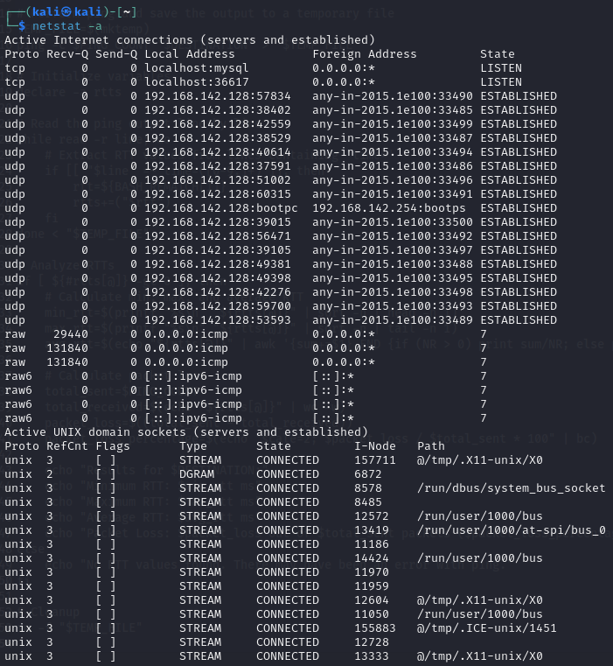

Listening ports

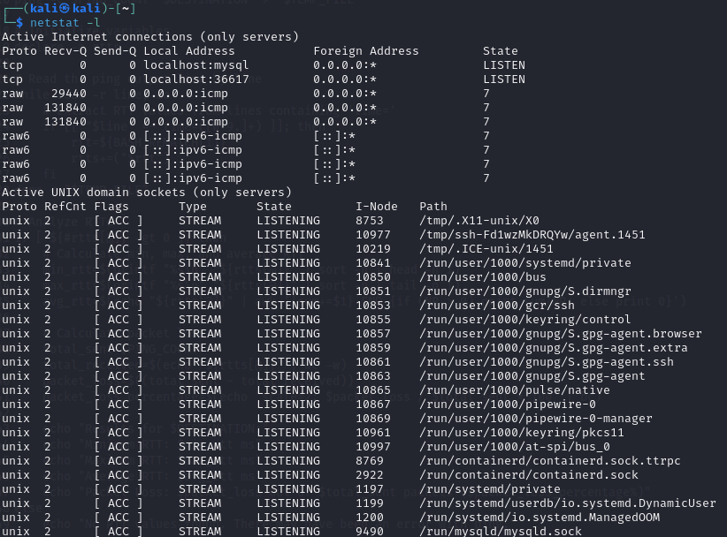

1. Use the ifconfig (Linux) or ip a command to display network interface configurations.

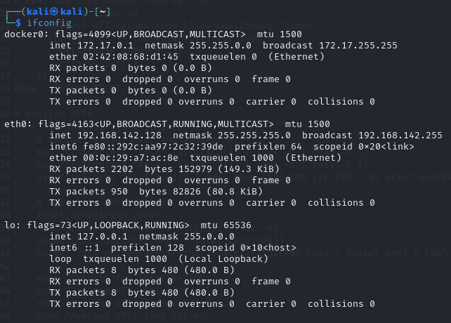

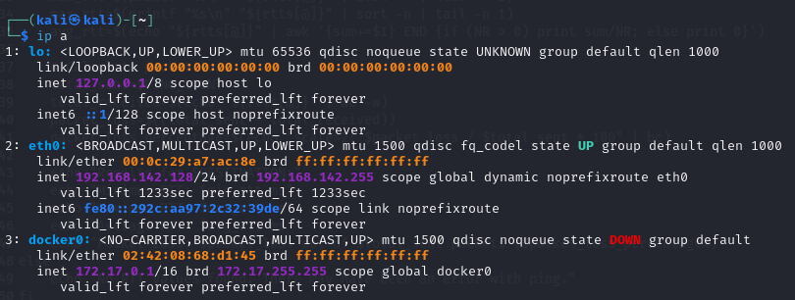

1. Write a script to report document the configuration of each interface, noting the IP address, subnet mask, and any other relevant information.

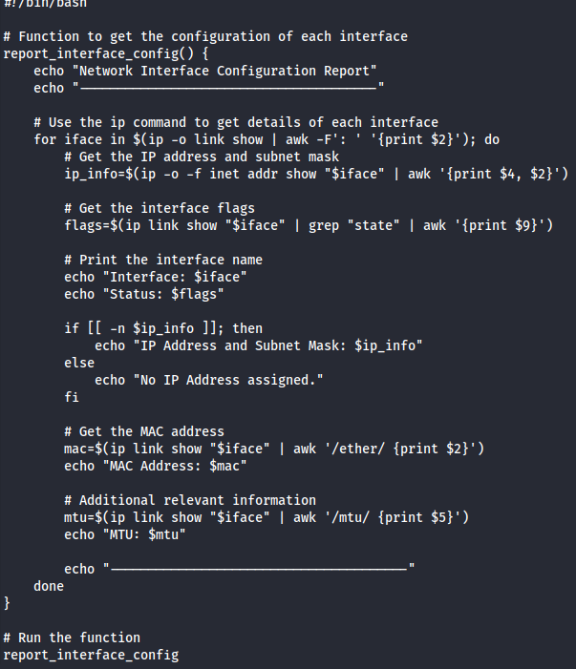

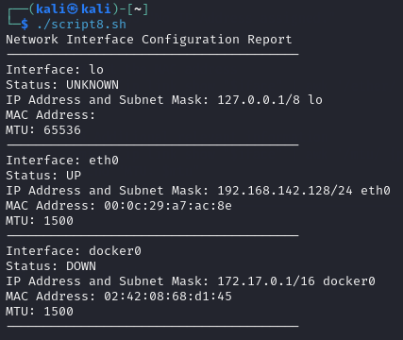

1. Perform a basic network scan using nmap on your local network to identify active devices and open ports.

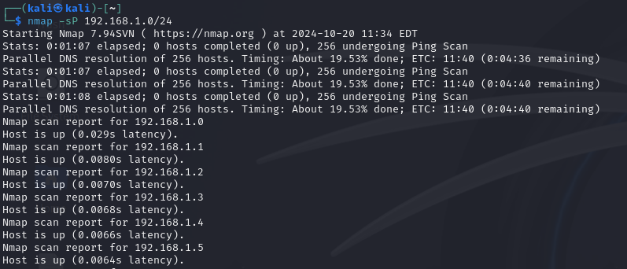

1. Create a report summarizing the devices found, their IP addresses, and the services running on the open ports.

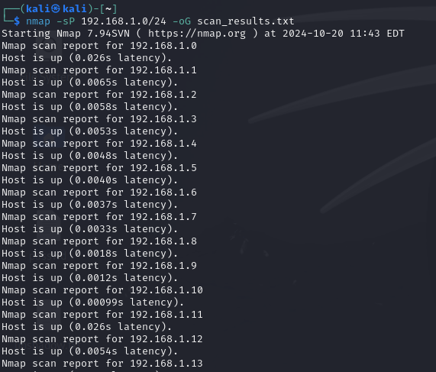

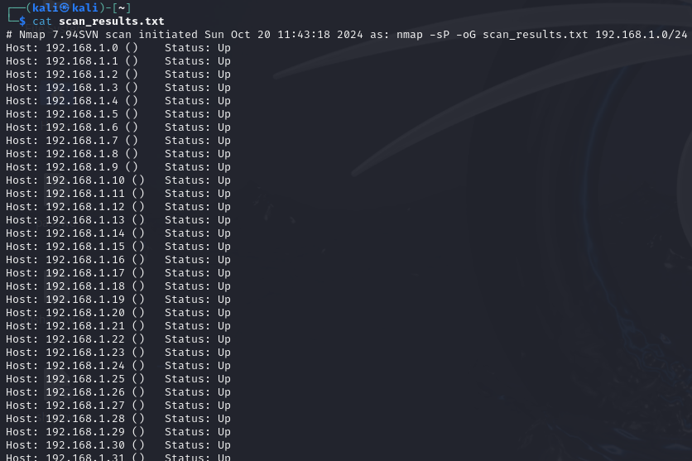

11. Capture network packets using tcpdump on a specific interface.

12. Analyze the captured packets for specific protocols (like HTTP or DNS) and summarize your findings.

13. Use the whois command to gather registration information about a domain.

14. Use the hostname command to display and change the hostname of your machine.

15. Use the finger command to gather information about users on a system.

16. Use the who command to see who is currently logged into the system and the last command to view the login history.

-------------------------------------------------------------------------------------------------------------------------

Xargs

-------------------------------------------------------------------------------------------------------------------------

1. Write a shell script called testurl.sh that accepts a list of urls in a separate file and tests if the website is up or not.

2. Create a shell script called diskhog.sh that lists the 5 largest items (files or directories) in the current directory in decreasing order of size.

3. compress all .log files found in the /var/logs/ directory?

4. delete all temporary files older than 7 days from the /tmp/ directory?

5. write a shell script to make all .sh files in your home directory executable?

6. search for the string "auth" in all .conf files in the /etc/ directory

7. count the number of "failed" login attempts in all .log files in /var/log/?

8. rename all .txt files in the current directory by appending .bak

9. Write a shell script to check if a list of users from users.txt exist in the system.

10. search for keywords like "ERROR" or "CRITICAL" in all log files over 1MB in size.

=================================================================================================================================================================

“If everyone is moving forward together, then success takes care of itself.” — Henry Ford