NETFLIX DATASET DASHBOARD

Project Documentation

Submitted By:
Anusha A Tambralli
AF ID : AF05087711
Course: Master of Computer Applications (MCA)
Guided By : Mupan Pruthvi Sir
College Name: RNS Institute of Technology
Date: 03-03-2026

NETFLIX DATASET DASHBOARD

1. Introduction
This document provides complete documentation of the Netflix Dataset Dashboard developed using Microsoft Power BI. The dashboard analyzes Netflix content data and provides insights into content type, country distribution, ratings, release trends, directors, cast analysis, duration patterns, and content growth over time.

2. Project Objective
The objective of this dashboard is to perform exploratory data analysis (EDA) on the Netflix dataset and generate meaningful business insights using Power BI visualizations.

3. Dataset Description
- Show ID – Unique identifier
- Type – Movie or TV Show
- Title – Name of the content
- Director – Director name
- Cast – Actors involved
- Country – Country of origin
- Date Added – Date added to Netflix
- Release Year – Year of release
- Rating – Content rating category
- Duration – Movie duration or number of seasons
- Listed In – Genre/category
- Description – Short summary

4. Dashboard Overview
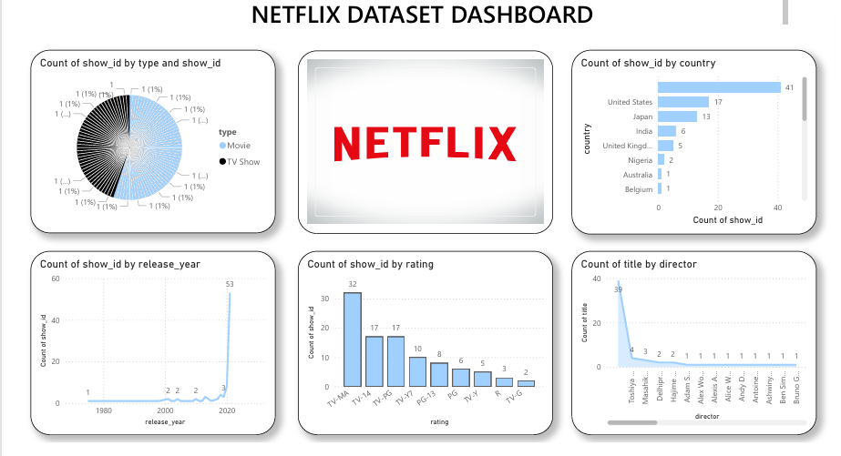
Explanation:
This dashboard overview displays content distribution by type, country-wise content count, rating breakdown, release year trends, and director analysis.

5. Title, Rating and Type Analysis
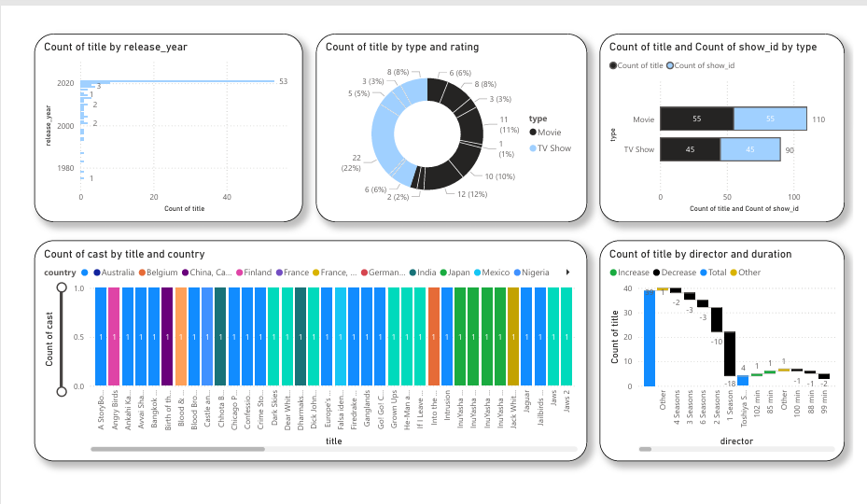
Explanation:
This section presents title distribution by release year, type and rating breakdown, and comparison between count of title and show ID by content type.

6. Cast and Duration Analysis
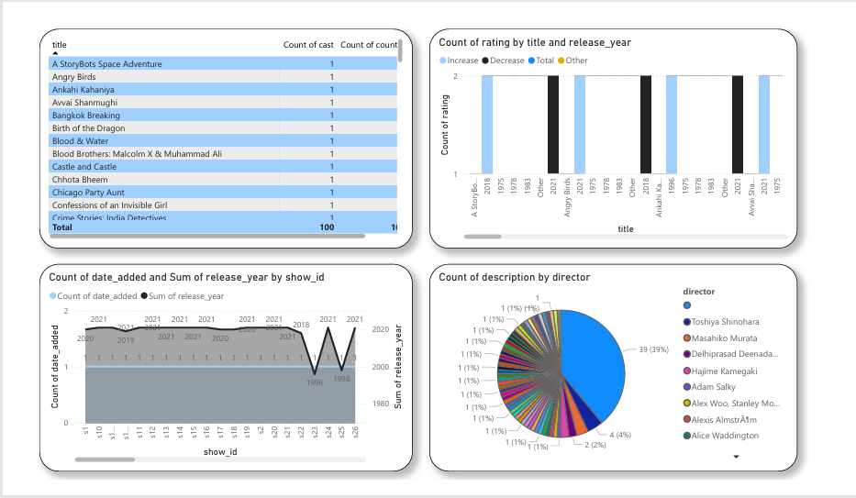
Explanation:
This screenshot shows cast count by title and country, along with duration analysis using waterfall visualization by director and duration.

7. Tabular and Trend Insights
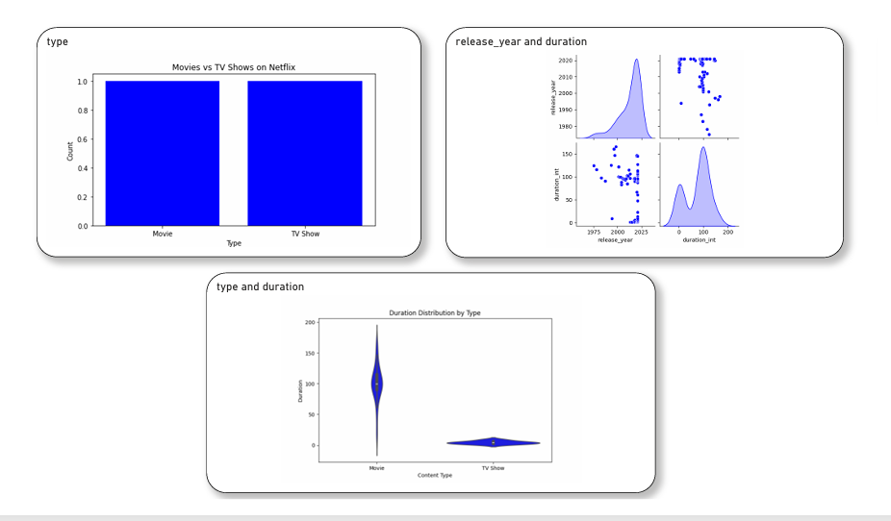

Explanation:
This section includes tabular insights such as cast count by title, rating trends across release years, and date added versus release year comparison.

8. Type and Duration Distribution
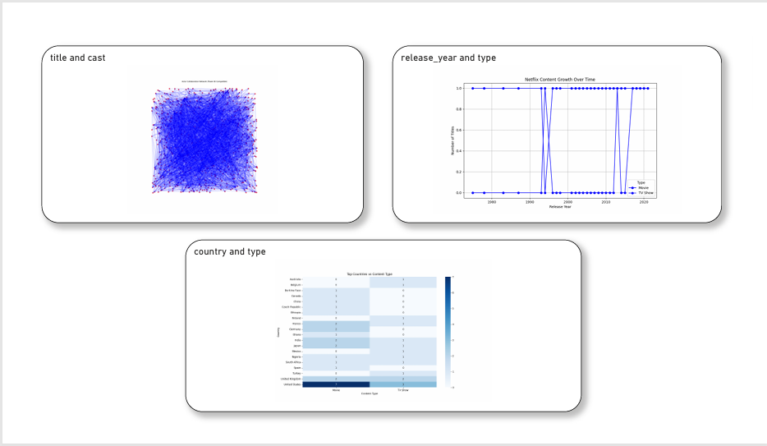
Explanation:
This screenshot highlights Movies vs TV Shows comparison and release year versus duration distribution using scatter and density plots.

9. Advanced Analysis
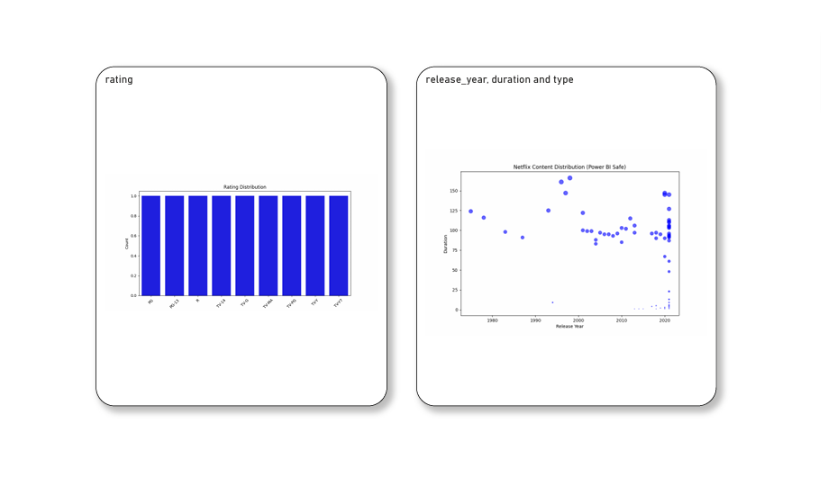
Explanation:
This final section shows advanced visualizations including title vs cast relationship, release year vs type trends, country and type heatmap, rating distribution, and duration distribution by type.

10. Conclusion
The Netflix Dashboard effectively visualizes content patterns and trends. It helps understand growth over the years, dominant countries, rating distribution, duration patterns, and comparison between Movies and TV Shows. The dashboard supports strategic business decisions related to content planning and regional targeting.

