<html>

<head>

<title>My First Table</title>

</head>

<body>

<table border="1" bordercolor="black" align="center" >

<caption>Details</caption>

<br>

<tr bgcolor="pink">

<th>Emp_Name</th>

<th>Department</th>

<th>Salary</th>

</tr>

<tr>

<td>Anjali</td>

<td>Physics</td>

<td>40000</td>

</tr>

<tr>

<td>Raj</td>

<td>Computer Science</td>

<td>50000</td>

</tr>

<tr>

<td>Amit</td>

<td>Economics</td>

<td>45000</td>

</tr>

<tr>

<td>Anuj</td>

<td>Mathematics</td>

<td>45000</td>

</tr>

</table>

</body>

</html>

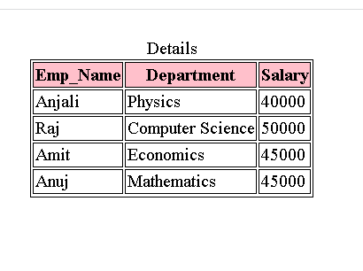S